**A FastAPI application for managing books and reviews, featuring recommendation capabilities.**

1. **Database Schema**

Book_management db createdin postgre sql.

Steps to connect to db ,

1. To start the server

Server start --pg_ctl start -D "C:\PostgreSQL\17\data" -l logfile

1. To start sending queries,

psql -U postgres -h localhost

DDL

-------------

CREATE TABLE books (

id SERIAL PRIMARY KEY,

title VARCHAR NOT NULL,

author VARCHAR NOT NULL,

genre VARCHAR NOT NULL,

year_published INTEGER NOT NULL,

summary TEXT

);

CREATE TABLE reviews (

id SERIAL PRIMARY KEY,

book_id INTEGER REFERENCES books(id) ON DELETE CASCADE,

user_id INTEGER NOT NULL,

review_text TEXT NOT NULL,

rating FLOAT CHECK (rating >= 1 AND rating <= 5)

);

**For this application, you can find data named books.csv,review.csv,book_reviews_data.csv.**

**Load those three into sql named books,reviews,book_rating from my script load_csv_to_sql.py**

References:

**2. Llama3 Integration**

**Setting Up Llama3 Model**

* **Model:** Sheared-LLaMA-1.3B
* **Location:** Cloned [princeton-nlp/Sheared-LLaMA-1.3B at main (huggingface.co)](https://huggingface.co/princeton-nlp/Sheared-LLaMA-1.3B/tree/main)

This files should be inside it.

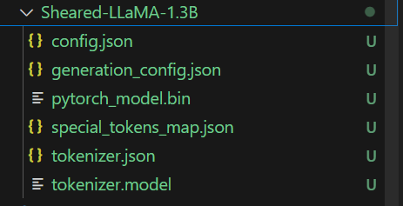

Running the script:

1. Scripts :
2. Book_manager.py: This code is developed in class structure so though all function are here but they are highly independent with each other and each functions are reusable.

It has following options:

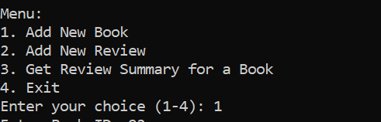

1. Add new book takes input about books to add. The summary field is optional so incase user doesn’t provide it then the summary will be generated from Llama model and inserted in the table.

Like in this example, I didn’t gave summary so model generated and inserted in db.

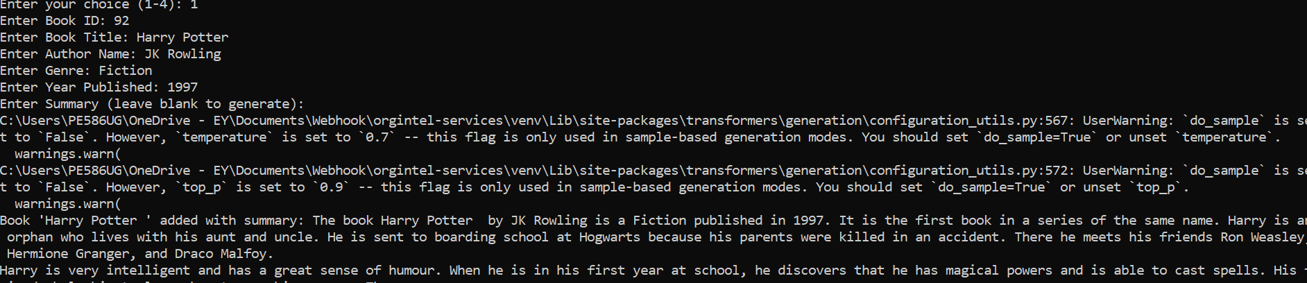

Data inserted in db,

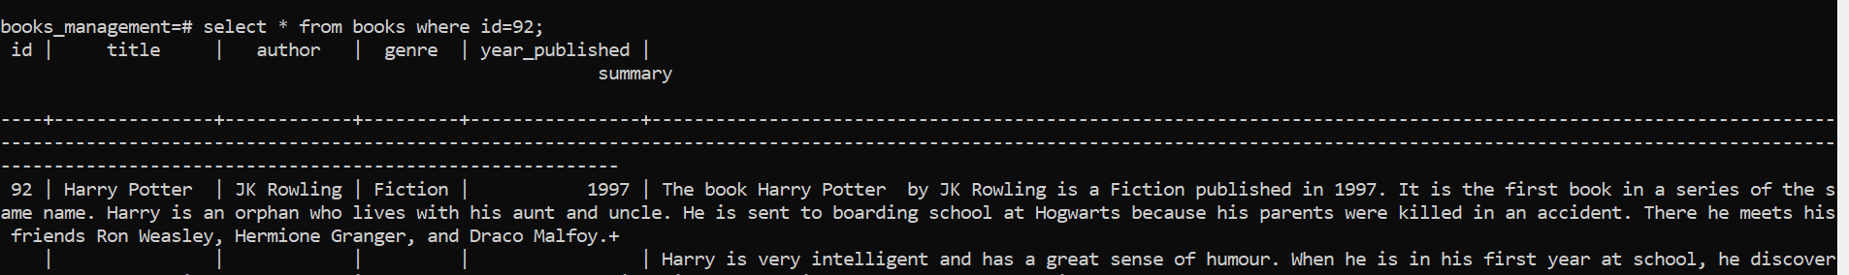

1. Add new review this option is to take input from users and add review.

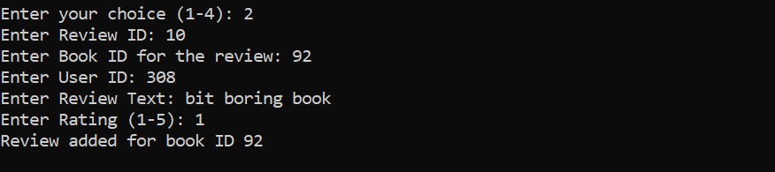

1. Get reviews summary this option is to take book-id as input and generate summary of review based on reviews in the review table.



**3.Machinelearning Models**

1. Downloaded dataset named book1-100k.csv from [Goodreads Book Datasets With User Rating 2M (kaggle.com)](https://www.kaggle.com/datasets/bahramjannesarr/goodreads-book-datasets-10m?resource=download)
2. Loaded that as table book_rating , used load_data.py for the same.
3. Then ran book_recommendations.py to generate book recommendations based on genre and rating.

**4.RESTful API**

1. Kept the code in app.py.
2. set FLASK_APP=app.py

References:



**5. Asynchronous Programming**

Switched to using SQLAlchemy's asynchronous by creating an asynchronous engine with create_async_engine and an asynchronous session with AsyncSession. This is done in asynchronous_db.py.

Made book recommendation process asynchronous in asyn_book_recommendation.py.

Similarly made changes in aysn_app.py. ( asynchronous version of app.py)

**6. Authentication**

1. server starting

set PGDATA=C:\PostgreSQL\17\data (your location)

pg_ctl start

pg_ctl status

1. updated code book_manager as asyn_book_manager.

Similarly asyn_book_recommendation.

1. Implemented token based authentication, code in jwt_utils.py

I haven’t added user-password but can be integrated with the same for better security and authorization.

1. Finally book_management_app.py which have all the api which can be called.

Steps to call api’s:

1. Run script from cmd by uvicorn book_management_app:app --reload
2. Go to <http://127.0.0.1:8000/docs>.

Refer all the api link, to use.

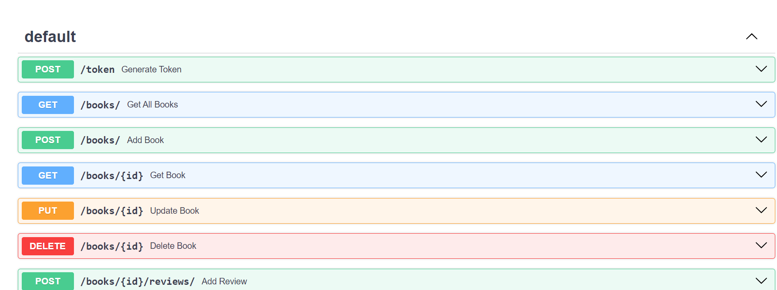

1. Generate token from /token.

1. Setup postman.

Go to new, give url appended with token.

http://127.0.0.1:8000/recommendations/?Authorization=Bearer {token} in url for example.

Or,

In params store,

Keys – Authorization

Values - Bearer {token}

You will get back response successfully.

References :

Adding book data.

Getting recommendations**--**

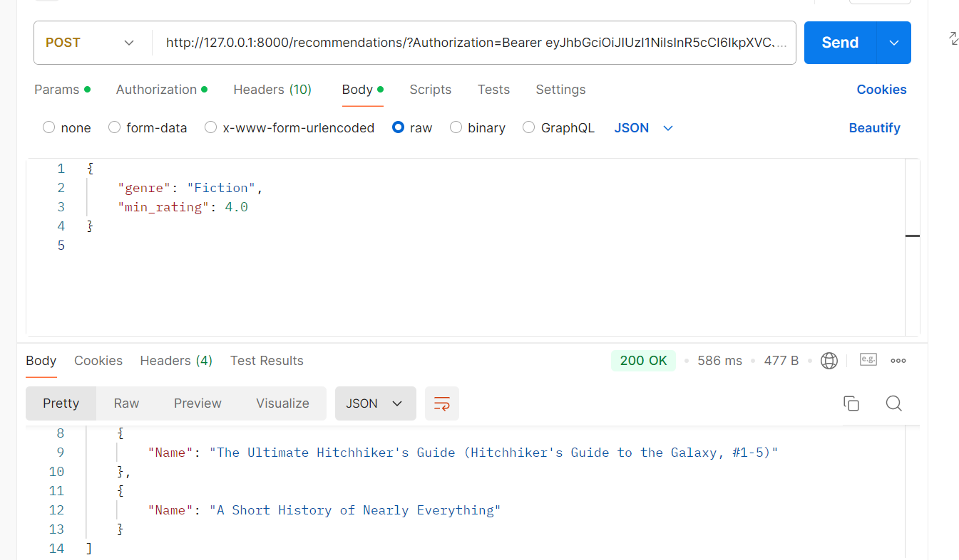

If running API from cmd, get token from ,

curl -X POST [http://127.0.0.1:8000/token?username={your username}](http://127.0.0.1:8000/token?username=%7byour%20username%7d)

Note ---In all scripts replace user, password in database_url and if password has @ then replace with %.