Exercise 1.-
You are merging data from two sources connected to a network Access point to créate a new data packet.
You must merge strings a and b, then return a single merged string. A merge operation on two string is described as follows:
- Append alternating characters from a and b, respectively, to some new string, mergedString.
- Once all of characters in one of the string have been merged, append the remaining characters in the other string to mergedString.
As an example, asume you have two strings to merge: ‘abc and stuvwx’. Alternate between the first and second strings as long as you can:
‘a’ + ‘s’ + ‘b’ + ‘t’ + ‘c’ + ‘u’. At this point you have traversed the first string and have generated ‘asbtcu’. The remainder of the second string, ‘vwx’ is now added to the end of the string, creating ‘asbtcuvwx’.
Function Descriptiva
Complete the function mergeString in the editor below. The function must return the merged string.

mergeStrings has the following parameter(s):
a: first string
b: second string
Constraints
- 1 <= |a|,|b|<= 25000
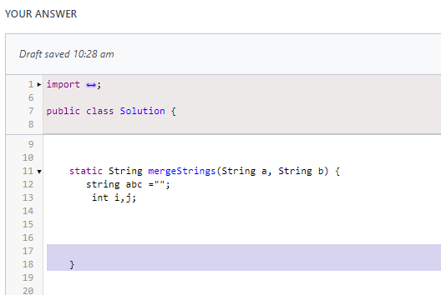

Exercise 2.-
You are designing a compiler for a C++ program and need to check that braces in any given file are balanced.
Braces in a string are considered to be balanced if the following criteria are met:
- All braces must be closed. Braces come in pairs of the form (), {} and []. The left brace opens the pair, and the right one closes it.
- In any set of nested braces, the braces between any pair must be closed.
For example, [{}] is a valid grouping of braces but [}]{} is not.
Function Description
Complete the function braces in the editor below. The function must return an array of strings where the string at each index i denotes whether or not the braces were balanced in a values. The array should consist of string “YES” or *NO* aligned with their indexes in values.
Braces has the following parameter(s):
Values[values_{0,…,}values_{n-1}] an array of strings to analyze
Constraints
- 1<= n<=15
- 1<= length of values_{i} <= 100
- It is guaranteed that each values_{i} consists of (, ), {, }, [, and] only.

Exercise 3.-
Tables EMPLOYEES has 5 rows. Consider the following sequence of SQL statements.
SQL>CREATE TABLE myTable SELECT AS (SELECT* FROM EMPLOYEE);
SQL> INSERT INTO myTable SELECT * FROM myTable;
SQL> INSERT INTO myTable SELECT * FROM myTable;
SQL> INSERT INTO myTable SELECT * FROM myTable;
SQL> INSERT INTO myTable SELECT * FROM myTable;
If the SQL statement
SELECT COUNT (*) FROM myTable;
Is executed after executing all the statements listed above, what will be printed is.

Pick one of the choices:
- 80
- 25
- 20
- 5

Exercise 4.-
Which testing is used for a program’s individual components functionality testing?
Pick one of the choices:
- Functionality Testing
- Unit Testing
- Security Testing
- Smoke Testing
- Regression Testing

Exercise 5.-
Consider the following Java code snippet:
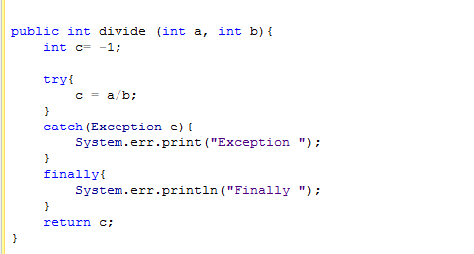

What will our code print when we call divide (4,0)?
Pick one of the choices:
- Exception Finally
- Finally Exception
- Exception

Exercise 6.-
The feature which allows different methods to have the same name and arguments type, but the different implementation is called?
Pick one of the choices:
- Overloading
- Overriding
- Java does not permit methods with same and type signature
- None of the above

Exercise 7.-
What does the following for loop output?
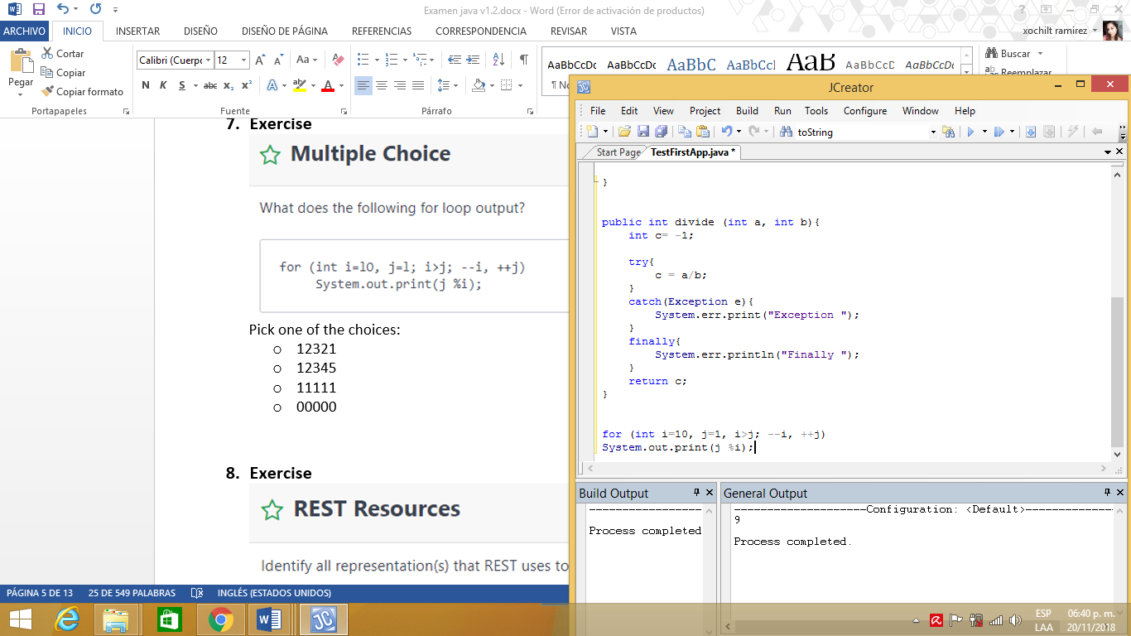

Pick one of the choices:
- 12321
- 12345
- 11111
- 00000

Exercise 8.-
Identify all representation(s) that REST uses to represent resources:
Pick all the choices that aply:
- Text
- Xml
- Json
- None of these

Exercise 9.-
There are multiple records in a table, and some of these records are duplicates. You need to fetch only one copy of each set of duplicate records. Which command will you use.?
Pick one of the choices:
- Select distinct
- Select unique
- Select different
- All the above

Exercise 10.-
Which SQL keyword is used to retrieve a máximum value?
Pick one of the choices:
- TOP
- MOST
- UPPER
- MAX

Exercise 11.-
We perform the following sequence of actions:
- Insert the following elements into a set: 1,2,9,1,2,3,1,4,1,5,7.
- Convert the set into a list and sort it in ascending order.
Which option denotes the sorted list?
Pick one of the choices:
- {1, 2, 3, 4, 5, 7, 9}
- {9, 7, 5, 4, 3, 2, 1}
- {1, 1, 1, 1, 2, 2, 3, 4, 5, 7, 9}
- None of the above

Exercise 12.-
Identify any ítem(s) in the list below that are not HTTP verbs:
Pick one of the choices:
- GET
- POST
- HEAD
- DELETE
- REMOVE
- PUT
- PATCH

Exercise 13.-
In this challenge, you will be asked to build on an abstract and initialize an instance of each class with a variable. The program will then test your implementation by retrieving the data you stored.
The locked code in the editor does the following:
- Declares an abstract class named Animal with the implementations for getIsMammal() and getIsCarnivorous() methods, as well as an abstract method named getGreeting().
- Creates Dog, Cow and Duck objects.
- Calls the getIsMammal(), getIsCarnicorous(), and getGreeting() methods on each of these respective objects.
Consider the following UML diagram:
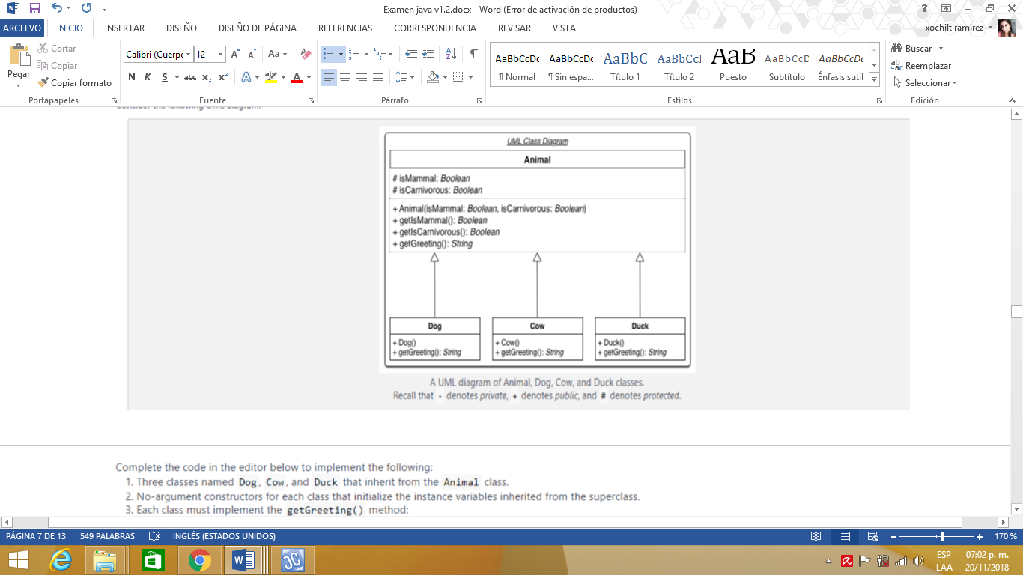
Complete the code in the editor below to implement the following:
- Three clases named Dog, Cow and Duck that inherit from the Animal class.
- No-argument constructors for each class that initialize the instance variables inherited from the superclases.
- Each class must implement the getGreeting() method:
  - For a Dog object, this must return the string ruff.
  - For a Cow object, this must return the string moo.
  - For a Duck object, this must return the string quack.
Input Format
There is no input for this challenge.
Output Format
The getGreeting() method must always return a string denoting the appropriate greeting for the implementing class.
Sample Output
A dog says ‘ruff’, is carnivorous, and is a mammal.
A cow says ‘moo’, is not carnivorous, and is a mammal.
A duck says ‘quack’, is not carnivorous, and is not a mammal.

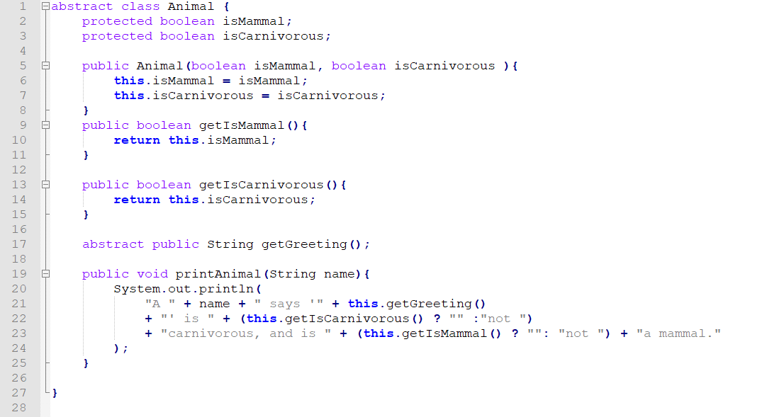
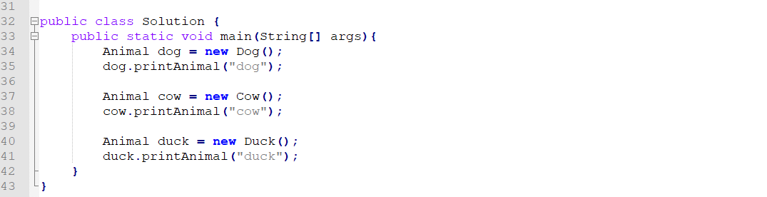

Write your code here, Do not use a “public” access modifier in your class declaration.

Exercise 14.-
What is the output for the below Java code?
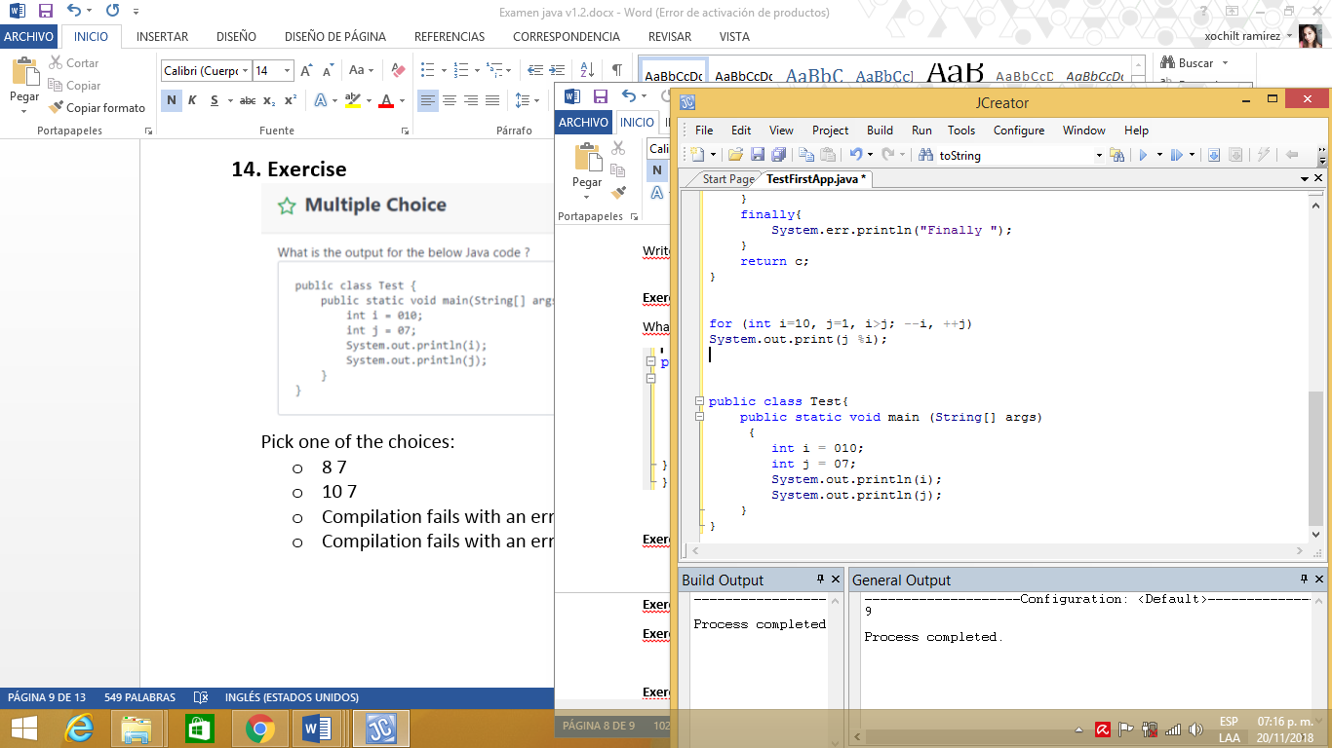
Pick one of the choices:
- 8 7
- 10 7
- Compilation fails with an error at line 3
- Compilation fails with an error at line 5

Exercise 15.-
A public data member with the same name is provided in both base as well as derived clases. Which of the following is true?
Pick one of the choices:
- It is a compiler error to provide a field with the same name in both base and derived class
- The program will compile and this feature is called overloading
- The program will compile and this feature is called overriding
- The program will compile and this feature is called as hiding or shadowing

Exercise 16.-
Given three clases A, B and C.
B is a subclass of A
C is a subclass of B
Which one of these boolean expressions is true only when an object denoted by reference o has actually been instantiated from class B, as opposed to from A or C?
Pick one of the choices:
- (o instanceof B) && ( ! (o instanceof A))
- (o instanceof B) && ( ! (o instanceof C))
- (o instanceof B)
- None of the above

Exercise 17.-
Which statement is true?
Pick one of the choices:
- Non-static member classes must have either default or public accessibility
- All nested classes can declare static member classes
- Methods in all nested classes can be declared static
- Static member classes can contain non-static methods

Exercise 18.-
A constructor is called whenever
Pick one of the choices:
- An object is declared
- An object is used
- A class is declared
- A class is used

Exercise 19.-
You are implementing a student registration and student information retrieval system for a school using a simple class roster in Java. When a stundent is registered, the system must assign an integer ID(enrollmentNumber), starting at 1 and adding 1 as each student is registered. The stundent’s name is stored with the assigned enrollmentNumber. The retrieval request should return a student’s registration information.
The student class should implement:
- The constructor. Student (String name)
- The method String toString() to return the string “(enrollmentNumber):(name)”
The locked stub code in the editor validates the implementation of the Student class.
After each student is registered, the code stub requests and prints the student’s information to test your code.
Constraints
- 1 <= numberOfStudents <=10³
Explanation
The three students are registered in the following order:
- The first student to be registered is Erica so she is assigned 1 as the enrollment number by the portal.
- Bob is second, so he is assigned the number2.
- Maria is third, so she es assigned the numer 3.
Now, the information of all the students is printed in the order in which they are registered.

Exercise 20.-
Which of the following data types in Java are primitive?
Pick one of the choices:
- String
- Struct
- Boolean
- char

Exercise 21.-
Which of the following are true for Java Classes?
Pick one of the choices:
- The Void class extends the Class class
- The Float class extends the Double class
- The System class extends the Runtime class
- The Integer class extends the Number class

Exercise 22.-
The following code snippet is a demostration of a particular design pattern. Which desing pattern is it?

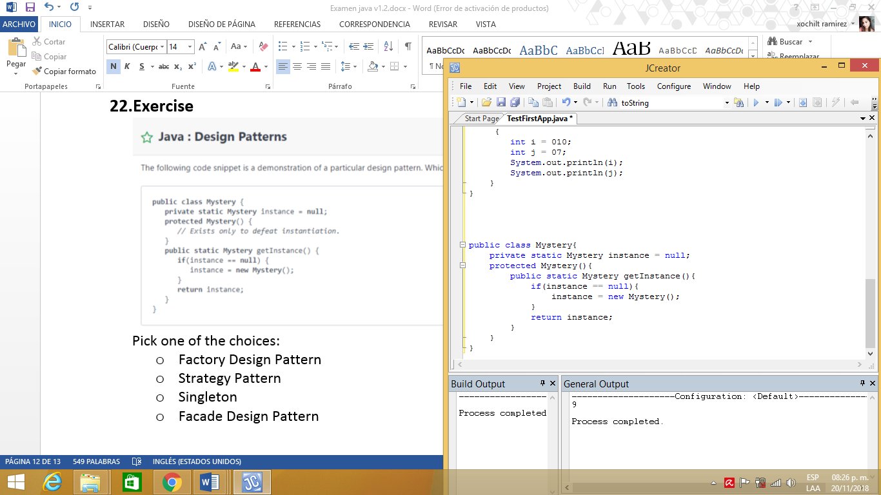

Pick one of the choices:
- Factory Design Pattern
- Strategy Pattern
- Singleton
- Facade Design Pattern

Exercise 23.-
Which of the following Java declaration of the String array is correct?
Pick one of the choices:
- String temp [] = new String {“j”, “a”, “z”};
- String temp [] = {“j” “b” “c”};
- String temp = {“a”, “b”, “c”};
- String temp [] = {“a”, “b”, “c”};

Exercise 24.-
Which is true of the following program?
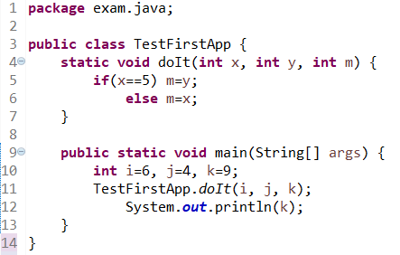
Pick one of the choices
- Doesn’t matter what the values of i and j are, the output will always be 5.
- Doesn’t matter what the values of k and j are, the output will always be 5.
- Doesn’t matter what the values of i and j are, the output will always be 9.
- Doesn’t matter what the values of k and j are, the output will always be 9.

Exercise 25.-
Which of the following statements are correct. Select the correct answer.
- Each Java file must have exactly one package statement to specify where the class is stored.
- If a java file has both import and package statement, the import statement must come before package statement.
- A java file has at least one class defined
- If a java file has a package statement, it must be the first statement (except comments).

Exercise 26.-
What is the output for the following program:
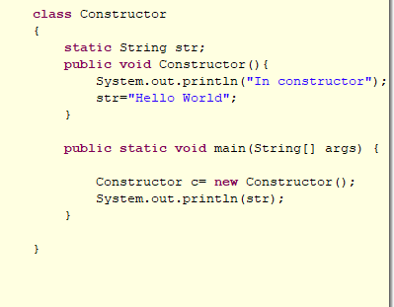

Pick one of the choices
- In Constructor
- Null
- Compilation Fails
- None of the above

Exercise 27.-
Given the following code, what is the most likely result.
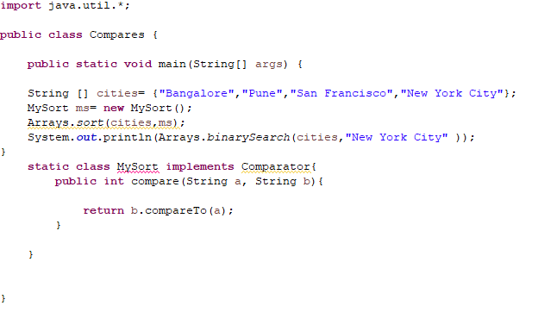

Pick one of the choices
- -1
- 1
- 2
- Compilation fails

Exercise 28.-
Anna has an array of n integers called num. She can reduce the array by 1 element by performing a move. Each move consists of the following three steps:
1. Pick two different elements numfij and numifi. i
2. Remove the two selected elements from the array.
3. Add the sum of the two selected elements to the end of the array.
Each move has a cost associated with it and this cost is equal to the sum of the two elements removed from the array during the move. Anna wishes to calculate the minimum total cost of reducing her array to one element.
For example, consider the array num = (4.6,8). Anna removes 4 and 6 in her first move at a cost of 4 + 6 = 10. and the resultant array is num₁ = [18,10]. She then removes 8 and 10 in her second move at a cost of 8 + 10 = 18, and the resultant array is num₂ = [18]. The total cost of reducing this array to one element using this sequence of moves is 10 + 18 = 28. This is just one set of possible moves. For instance, she could have started with 4 and 8.
Function Description
Complete the function reductionCost in the editor below. The function must return the minimum total cost of reducing the input array to one element
reductionCost has the following parameter(s):
num[num[0],...num[n-1]]: an array of integers
Constraints
- 2<= n <= 10⁴
- 0 <= num[i] <= 10⁵

Exercise 29.-
Consider a maze mapped to a matrix with an upper left comer at coordinates (row, column) = (0, 0). Any movement must be in increasing row or column direction. Determine the number of distinct paths through the maze. Always start at position (0, 0), the top left. and end up at (max(row), max(column)), the bottom right.
As an example, consider the following diagram where 1 indicates an open cell and 0 indicates blocked. It is only possible to travel through open cells, so no path can go through the cell at (0. 2). There are two distinct paths to the goal.
Possible Paths
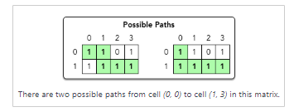
Function Description
Complete the function number0fParhs in the editor below. The function must return the number of paths through the matrix, modulo (10⁹ + 7).
numberOfeaths has the following parameter(s):
a [a[0],…a[n-1]]: an array of strings, each a row of the matrix where each character represents a column
Constraints
- 1 <=n, m <= 1000
- Each cell in matrix a contains either a 0 or a 1.

Explanation
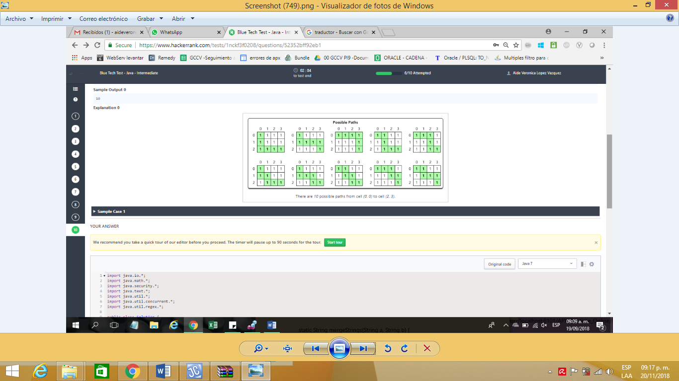

Exercise 30.-
Given an array of words representing your dictionary, you test each word to see if it can be made into another word in the dictionary. This will be done by removing characters one at a time. Each word represents its own first element of its string chain, so start with a string chain length of 1. Each time you remove a character, increment your string chain by 1. In order to remove a character, the resulting word must be in your original dictionary. Your goal is to determine the longest string chain achievable for a given dictionary.
For example, given a dictionary [a, and, an, bear], the word and could be reduced to an and then to a. The single character a cannot be reduced any further as the null string is not in the dictionary. This would be the longest string chain, having a length 3. The word bear cannot be reduced at all.
Function Description
Complete the function longestChain in the editor below. The function must return a single integer representing the length of the longest string chain.
longestChain has the following parameter(s):
words[words[0]....words[n-1]]: an array of strings to test
Constraints
- 1 <= n <= 50000
- 1 <= Iword[i] <= 60, where 0 <= i < n
- Each words[i] is composed of lowercase letters in ascii[a-z].
Sample Input 0
6, a, b, ba, bca, bda, bdca
Sample Output 0
4
Explanation 0
Sample Case 1: words = {“a”, “b”, “ba”, “bca”, “bda”, “bdca”}
Because 'a' and 'b' are single-character words, we cannot remove any characters from them as that would result in the empty string, so the length for both of these string chains is 1.
The word “ba” can create two different string chains each with a length of 2: ("ba” — “a” and “ba”— 'b'). This means our current longest string chain is 2.
The word “bca” can create two different string chains of length 3: ('bca” ---“ba” — "a" and “bca”— “ba”— “b”). This means our current longest string chain is now 3.
The word 'bda' can create two different string chains of length 3: ('bda" — 'ba' — “a” and “bda" — 'ba' — “b”. At this point, our current longest string chain is still 3.
The word 'bdca' can create four different string chains of length: 4 (“bdca” — 'bda' — "ba" — “a”, 'bdca' — "bda” — "ba” — 'b', 'bdca' — “bca” — “ba” — 'a', and 'bdca' — “bca” — "ba” — 'b'). This means our current longest string chain is now 4.
The long est string chain is 4.

Exercise 31.-
You are implementing a student registration and student information retrieval system for a school using a simple class roster in Java. When a student is registered, the system must assign an integer ID (enrollmentNumber), starting at 1 and adding 1 as each student is registered. The student's name is stored with the assigned enrollmentNumber. The retrieval request should return a student's registration information.
The Student class should implement:
- The constructor.Student(String name)
- The method String toString() to return the string "{enrollmentNumber}: {name}"
The locked stub code in the editor validates the implementation of the Student class.
After each student is registered, the code stub requests and prints the student's information to test your code.
Constraints
- 1 <= numberOfStudents <= 10³

Input Format For Custom Testing
The first line contains the value of numberOfStudents describing the total number of students being registered. Each of the next numberOfStudents lines contains the student name.
Sample Case 0
Sample Input For Custom Testing
3, Erica, Bob, Maria
Sample Output
1: Erica
2: Bob
3: Maria

Exercise 32.-
To delete all pairs of keys and values in a given HashMap, which of the following methods should be used?
Pick one of the choices
- clearAll()
- empty()
- remove()
- clear()

Exercise 33.-
Which pattern do you see in the code below:
java.util.Calendar.getInstance();
Pick one of the choices
- Singleton Pattern
- Factory Pattern
- Facade Pattern
- Adaptor Pattern

Exercise 34.-
What is the output of the following program:
interface BaseI { void method (); }
class BaseC
{
public void method()
{
System.out.printIn(“Inside BaseC: :method”);
}
}
class ImplC extends BaseC implements BaseI
{
public static void main (String []s)
{
(new ImplC()).method();
}
}
Pick one of the choices
- Null
- Complication fails
- Inside BaseC::method
- None of the above

Exercise 35.-
Consider the following three classes:
class A {}
class B extends A {}
class C extends B {}

Consider n object of class B is instantiated, i.e.,
B b = new B();
Which of the following Boolean expressions evaluates to true:
Pick one of the choices
- (b instanceof B)
- (b instanceof B) && (!(b instanceof A))
- (b instanceof B) && (!(b instanceof C))
- None of the above

Exercise 36.-
What is the output of the following program:
class Constructor
{
static String str;
public void Constructor(){
System.out.printIn(“In constructor”);
str = “Hello World”;
}
public static void main (String [] args){
Constructor C = new Constructor ();
System.out.printIn(str);
}
}

Pick one of the choices
- In Constructor
- Null
- Compilation fails
- None of the above

Exercise 37.-
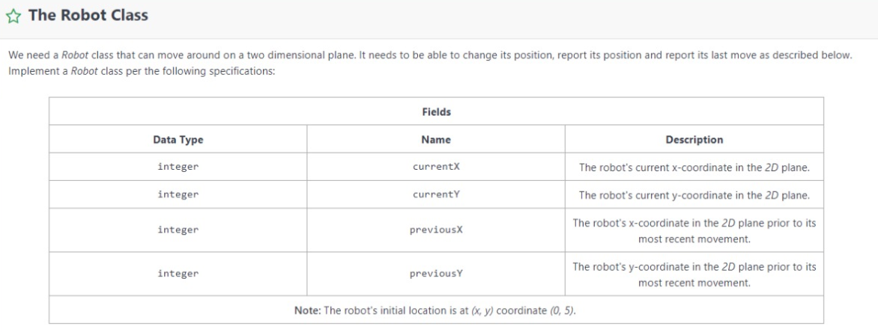

Parametrized constructor
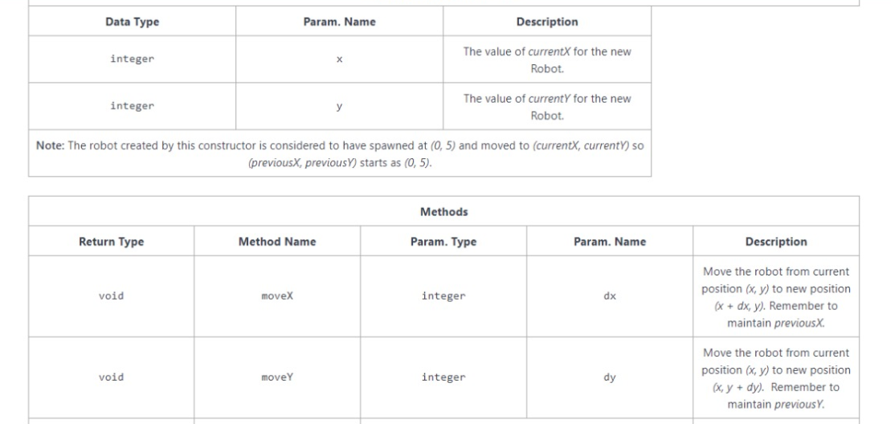
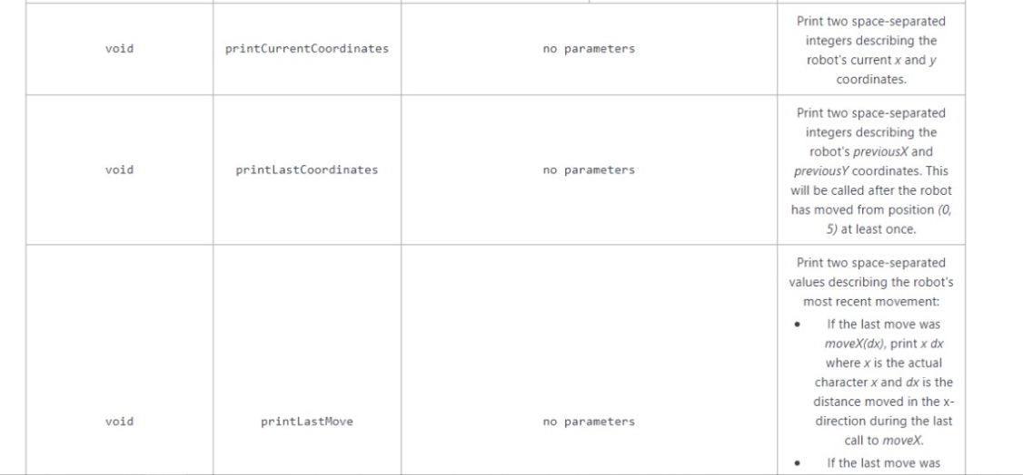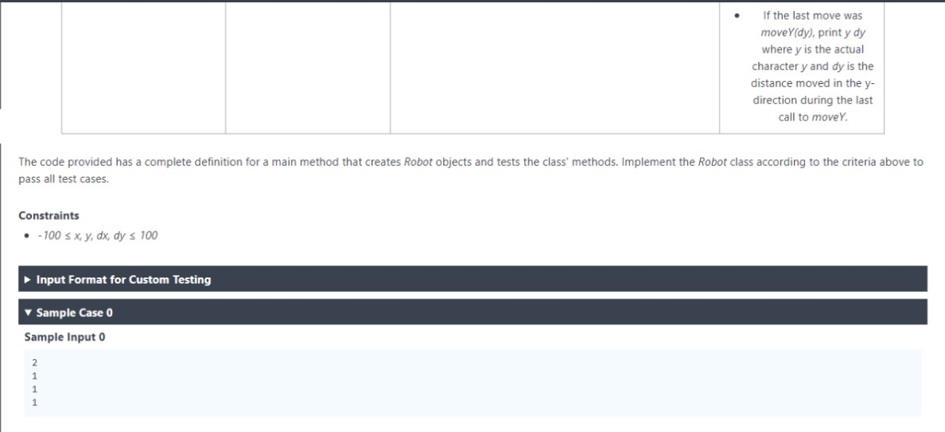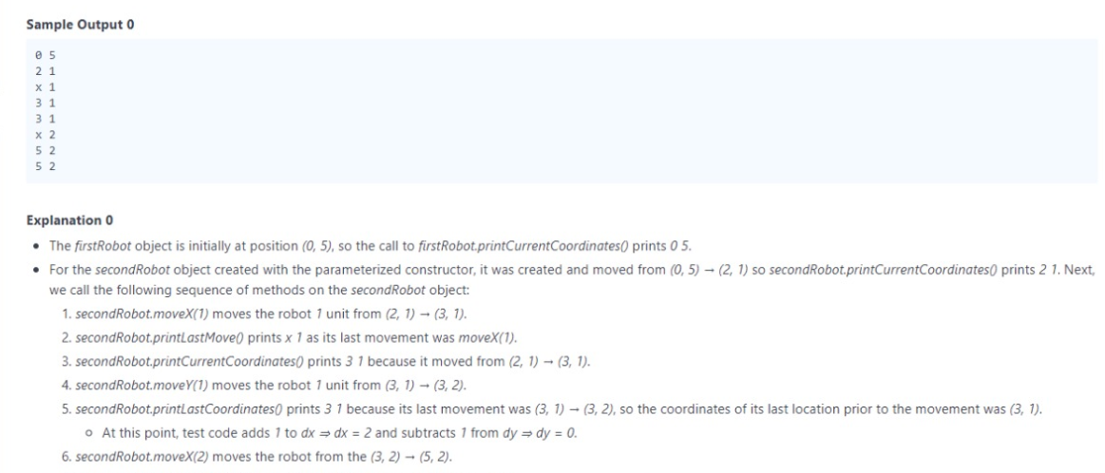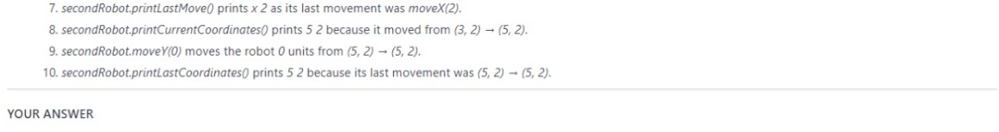

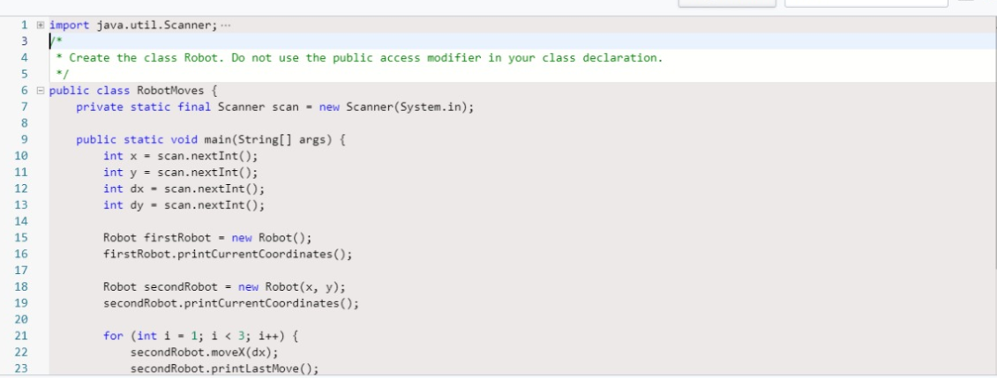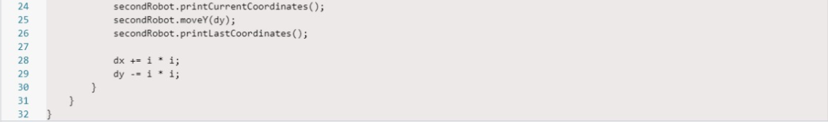

Exercise 38.-
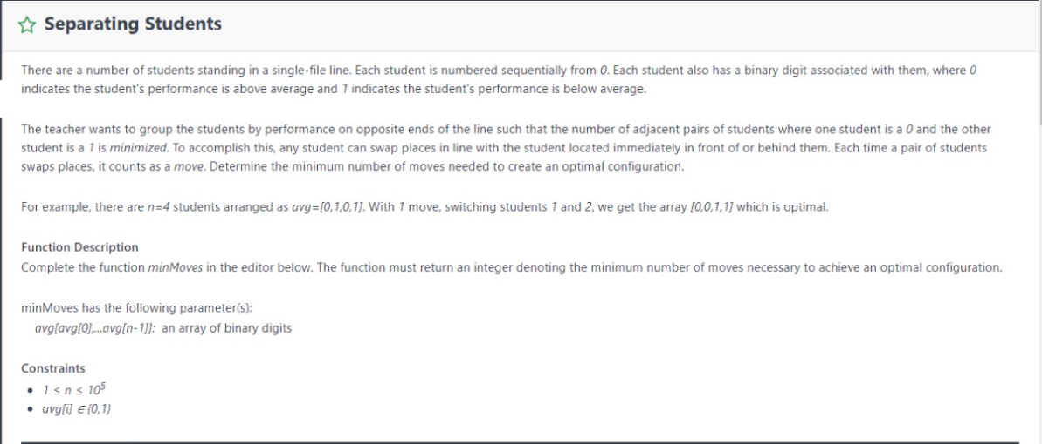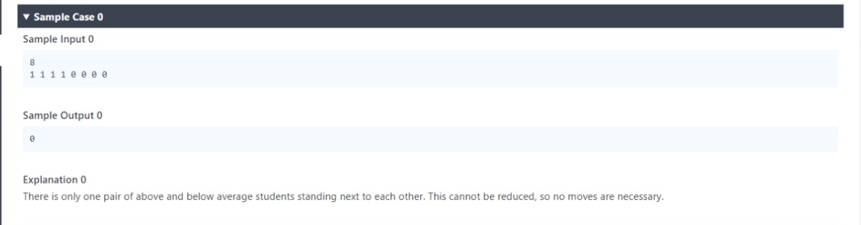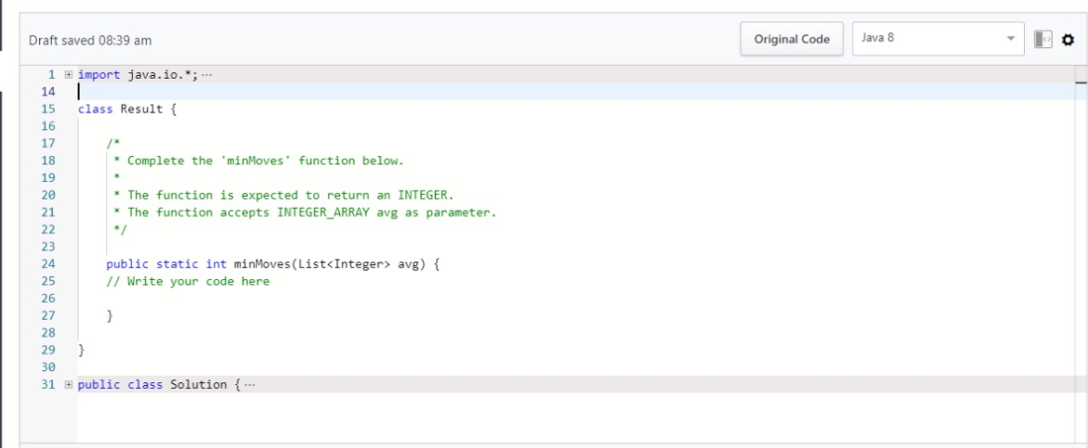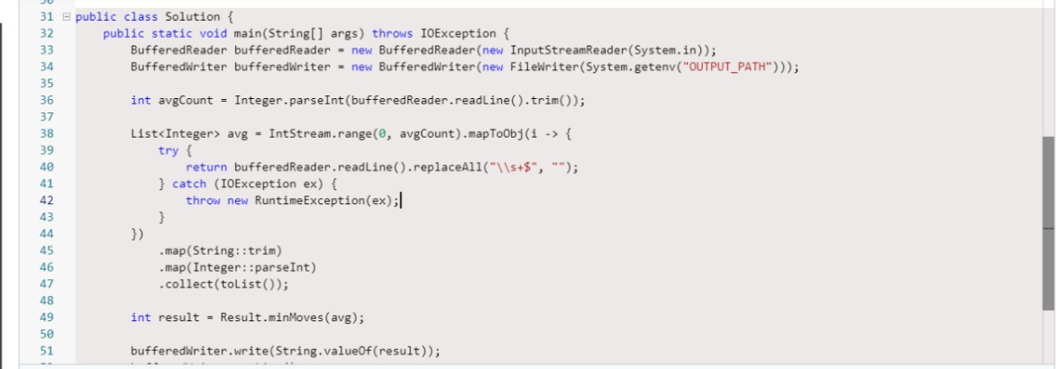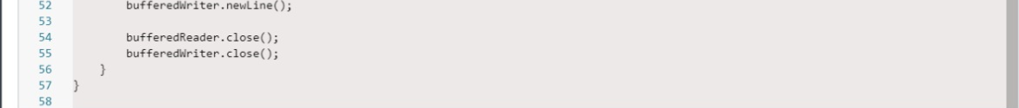

Exercise 39.-

