**COMSYS Hackathon-5 (Task A): Gender Classification – Technical Summary**

**📏 Architecture Overview**  
The architecture consists of a dual ResNet18 model pipeline enhanced with advanced augmentations, face detection logic, and adaptive ensemble learning.

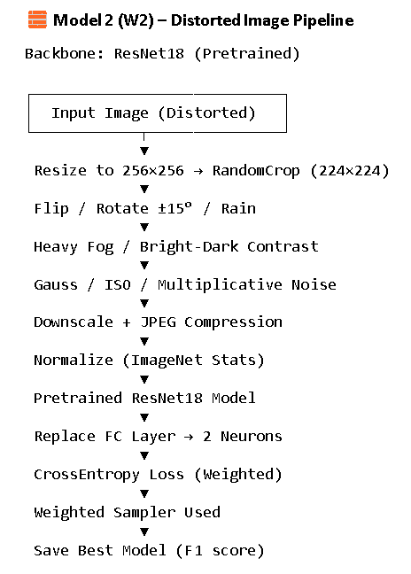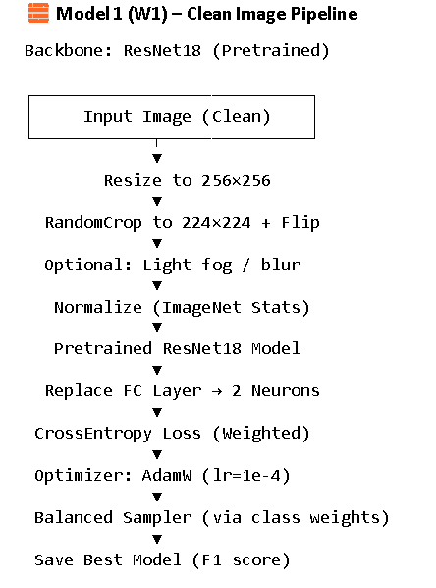

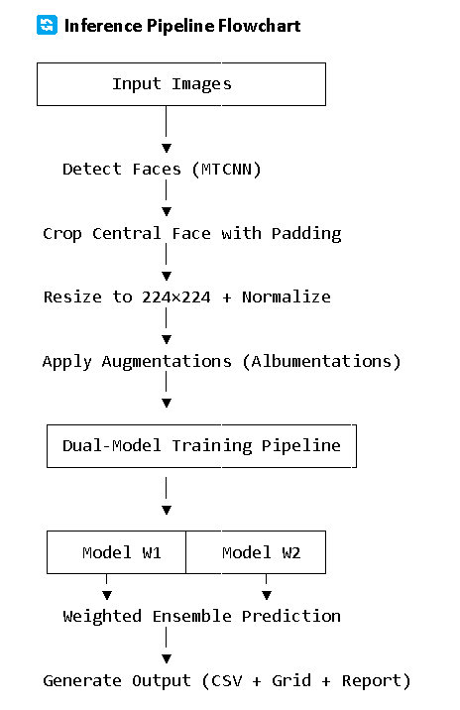**📈 Training Results Summary**

| Model | F1 Score | Accuracy | Notes |
| --- | --- | --- | --- |
| W1 | ~0.98 | ~98% | Slightly better on male faces |
| W2 | ~0.98 | ~98% | Slightly better on female faces |

**🧠 Ensemble Strategy**

* W1 and W2 trained with different seeds, augmentations.
* Used adaptive weight-based blending during inference:
  + If test folder = male: [0.85 * W1 + 0.15 * W2]
  + If test folder = female: [0.15 * W1 + 0.85 * W2]
  + If unknown/custom: [0.6 * W1 + 0.4 * W2]