COMSYS Hackathon-5(Task B) : Identity Recognition – Technical Summary

# 📏 Architecture Overview

The system is based on an embedding model using a ResNet18 backbone trained with triplet loss, followed by centroid-based identity matching via cosine similarity.

# 🔁 Inference Flowchart

# 🧱 Embedding-Based Architecture

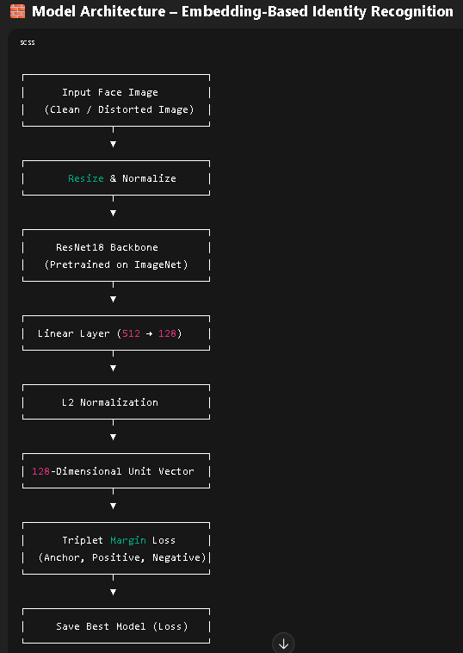

💡 Key Innovations

- Triplet Loss: Learns distance relationships rather than fixed label mapping.

- Open-set Support: Works with unseen identities using cosine similarity.

- Centroid Matching: Enables scalable and modular identity expansion.

- Generalization: Trained using 50+ triplets/identity across clean and distorted variants.