Experiment 8

Student Name: Aryan Saini UID: 24BAI70427
Branch: CSE - AIML Section/Group: 24AIT_KRG G1
Semester: 4 Date of Performance: 27/3/26
Subject Name: DBMS Subject Code: 24CSH-298

Aim
To understand the design and implementation of stored procedures in PL/SQL, focusing on the use of different parameter modes (IN, OUT, and INOUT) to encapsulate business logic and facilitate modular programming within a database.

Software Requirements
- Database Management System:
  - Oracle Database Express Edition (Oracle XE)
  - PostgreSQL Database
- Database Administration Tool / Client Tool:
  - Oracle SQL Developer (for Oracle XE)
  - pgAdmin (for PostgreSQL)

Objectives
- To create and execute a parameterized stored procedure that processes data from an employee table, utilizes multiple parameter types to return calculated results and execution status, and demonstrates the invocation of procedures using anonymous blocks.

Practical/Experiment Steps
- Database Schema Provisioning: Created the employees table with a primary key and defined specific data types for personal and financial attributes.
- Procedure Encapsulation: Developed a stored procedure get_employee_count_by_gender to encapsulate the logic for counting records based on specific criteria.
- Parameter Mode Configuration: Implemented a diverse set of parameters including IN for input, OUT for returning the count, and INOUT for tracking and updating the execution status.
- Procedural Logic Integration: Used the SELECT INTO clause within the procedure body to map aggregate query results directly to output variables.
- Anonymous Block Execution: Constructed a DO block to declare local variables, handle the procedure call, and manage the final communication of results to the user.

Procedure
- Established a connection to the PostgreSQL server and initialized the workspace.
- Executed the CREATE TABLE command to define the employee structure and populated it with a balanced dataset of male and female records.
- Defined the procedure signature, carefully assigning the IN, OUT, and INOUT modes to their respective variables.
- Wrote the PL/pgSQL body to perform a COUNT(*) operation filtered by the gender attribute.
- Assigned a 'SUCCESS' string to the STATUS variable within the procedure to indicate a completed execution path.
- Drafted a DECLARE section in an anonymous block to initialize the 'Male' gender filter and a 'Pending' status.
- Utilized the CALL statement to execute the procedure, passing the required arguments and capturing the returned values.
- Implemented the RAISE NOTICE command to print the final employee count and updated status to the console.
- Verified the output against the physical table records to ensure the aggregate logic and parameter passing were accurate.

Input/Output Analysis
SQL Input Queries
CREATE TABLE EMPLOYEES(
emp_id INT PRIMARY KEY,
emp_name VARCHAR(20),
gender VARCHAR(20),
salary NUMERIC(10, 2)
);

Output

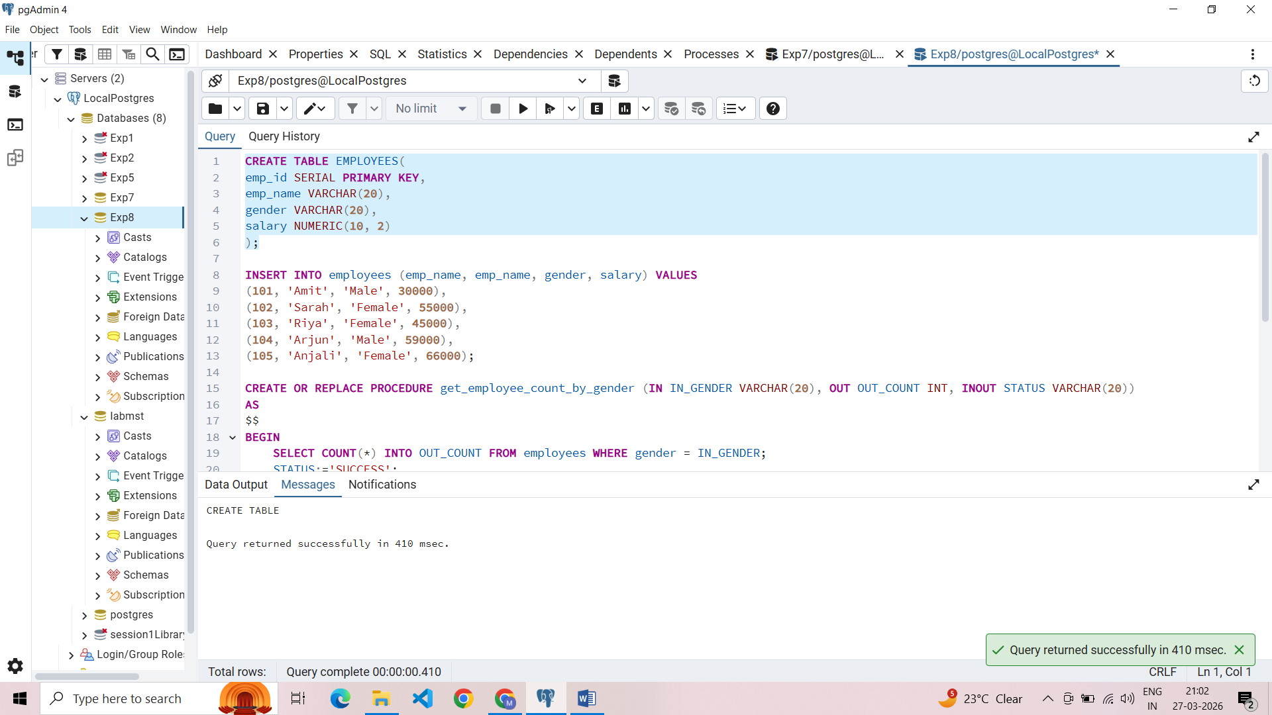

SQL Input Queries
INSERT INTO employees (emp_id, emp_name, gender, salary) VALUES
(101, 'Amit', 'Male', 30000),
(102, 'Sarah', 'Female', 55000),
(103, 'Riya', 'Female', 45000),
(104, 'Arjun', 'Male', 59000),
(105, 'Anjali', 'Female', 66000);

Output
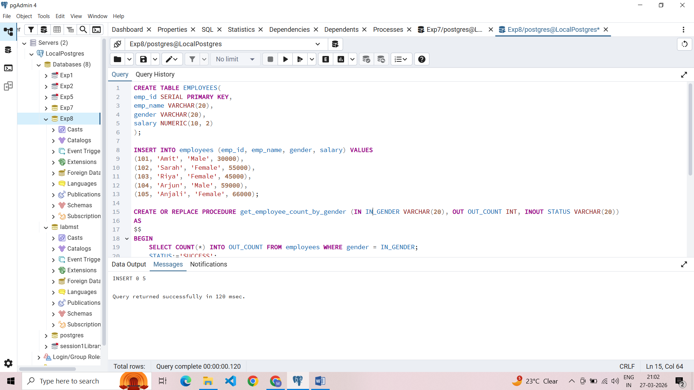
SQL Input Queries
CREATE OR REPLACE PROCEDURE get_employee_count_by_gender (IN IN_GENDER VARCHAR(20), OUT OUT_COUNT INT, INOUT STATUS VARCHAR(20))
AS
$$
BEGIN
SELECT COUNT(*) INTO OUT_COUNT FROM employees WHERE gender = IN_GENDER;
STATUS:='SUCCESS';
END;
$$ LANGUAGE PLPGSQL;

Output
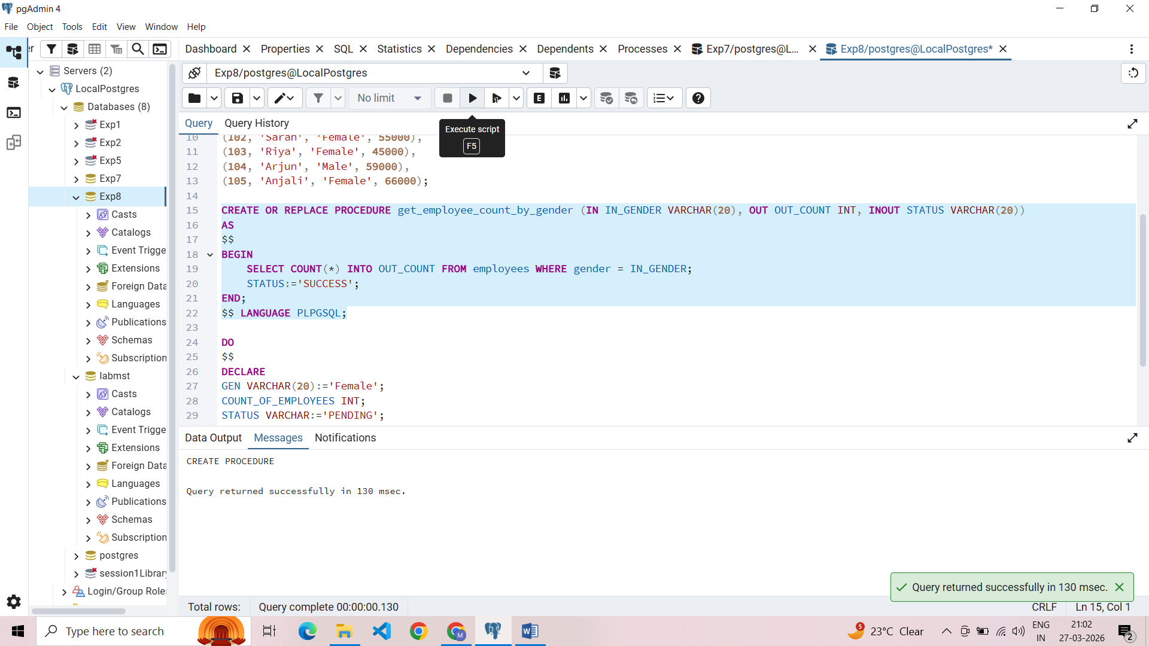

SQL Input Queries
DO
$$
DECLARE
GEN VARCHAR(20):='Female';
COUNT_OF_EMPLOYEES INT;
STATUS VARCHAR:='PENDING';

BEGIN
CALL get_employee_count_by_gender(GEN, COUNT_OF_EMPLOYEES, STATUS);
RAISE NOTICE 'COUNT OF % EMPLOYEES IS % AND STATUS IS %', GEN, COUNT_OF_EMPLOYEES, STATUS;
END;
$$

Output
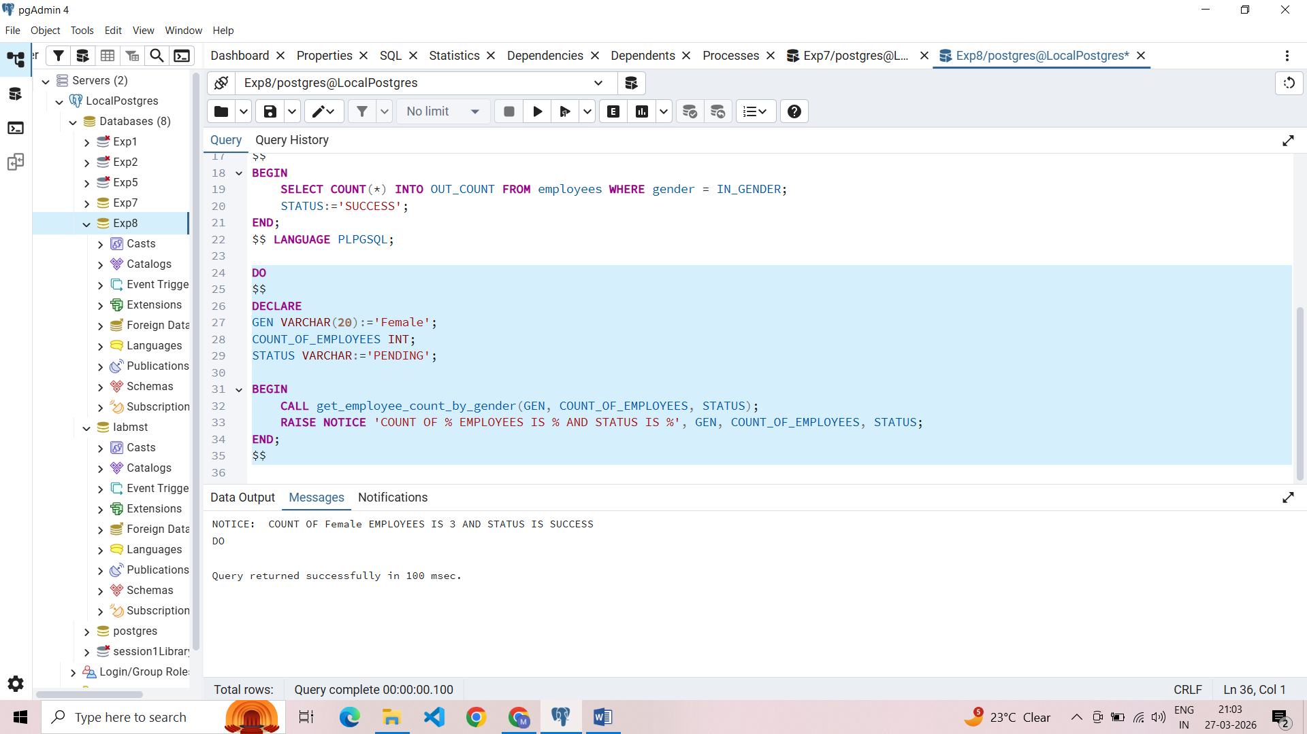

Learning Outcomes
- Understood how to encapsulate SQL logic into reusable procedures to improve code maintainability.
- Gained expertise in using IN, OUT, and INOUT modes to pass data into and retrieve results from stored subprograms.
- Learned to bridge SQL aggregate functions with PL/SQL variables using the INTO keyword.
- Developed skills in using status flags and notice alerts to track the success and results of procedural calls.

