Experiment 3

Student Name: Srijan Tripathi UID: 24BAI70081
Branch: CSE - AIML Section/Group: 24AIT_KRG G1
Semester: 4 Date of Performance: 28/1/26
Subject Name: Database Management System Subject Code: 24CSH-298

Aim
To develop and execute a PL/SQL program that demonstrates variable declaration, arithmetic computation, and conditional logic for employee data processing.

Software Requirements
- Database Management System:
  - PostgreSQL
- Database Administration Tool:
  - pgAdmin

Objectives
- Recall the syntax for declaring variables and using output statements in PL/SQL.
- Explain the purpose of each section (declaration, execution) in a PL/SQL block.
- Implement a PL/SQL script to calculate House Rent Allowance (HRA) and determine tax status based on income.
- Differentiate between taxable and non-taxable income using conditional statements.
- Differentiate between taxable and non-taxable income using conditional statements.
- Differentiate between taxable and non-taxable income using conditional statements.

Problem Statement
Design a PL/SQL program that accepts employee details, computes the House Rent Allowance as a percentage of income, and determines the tax status based on a specified income threshold. The program should display all relevant information in a clear, formatted manner using output statements.

Practical/Experiment Steps
- Create a PL/SQL block with declaration and execution sections.
- Declare variables for employee ID, name, income, and HRA.
- Assign sample values to the variables.
- Calculate HRA as 35% of the income.
- Use an IF-ELSE statement to check if the income meets the tax threshold.
- Display employee details, calculated HRA, and tax status using output statements.
- Format the output for clarity.

Procedure
- Open the Oracle SQL environment or compatible tool.
- Start the PL/SQL block with the DECLARE section.
- Define variables: v_id, v_name, v_income, v_hra.
- Assign values to v_id, v_name, and v_income.
- In the BEGIN section, compute v_hra as 35% of v_income.
- Print employee details and HRA using DBMS_OUTPUT.PUT_LINE.
- Apply IF-ELSE logic to determine and print tax status.
- End the PL/SQL block with END; and execute the script.
- Review the output to verify correctness.

Input/Output Analysis
SQL Input Queries

DECLARE

v_id NUMBER := 202;

v_name VARCHAR2(30) := 'PRIYA';

v_income NUMBER := 42000;

v_hra NUMBER;

BEGIN

v_hra := v_income * 0.35;

DBMS_OUTPUT.PUT_LINE('--- Employee Details ---');

DBMS_OUTPUT.PUT_LINE('ID: ' || v_id);

DBMS_OUTPUT.PUT_LINE('Name: ' || v_name);

DBMS_OUTPUT.PUT_LINE('Monthly Income: Rs. ' || v_income);

DBMS_OUTPUT.PUT_LINE('HRA (35%): Rs. ' || v_hra);

IF v_income >= 50000 THEN

DBMS_OUTPUT.PUT_LINE('Tax Status: Taxable');

ELSE

DBMS_OUTPUT.PUT_LINE('Tax Status: Not Taxable');

END IF;

DBMS_OUTPUT.PUT_LINE('------------------------');

END;

Output
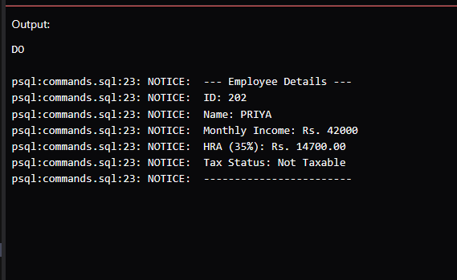

Learning Outcomes
- Understanding the fundamental organisation of PL/SQL declaration and execution sections.
- Learnt to declare, initialize, and use different data types within a procedural block.
- Implementing conditional branching and basic arithmetic operations to process data dynamically.
- Utilizing built-in procedures to format and display calculated results to the user.

