Name: Aryan Saini
UID: 24BAI70427
Course: B.E. CSE-H spl. AIML
Subject: Database Management Systems

Experiment 2:

1. Aim of the Session
The aim of this practical is to implement and analyze Group Functions and Conditional Filtering in SQL. The session focuses on using GROUP BY, HAVING, and ORDER BY clauses to extract meaningful insights from an employee dataset.

2. Objective of the Session
By completing this practical, I have achieved the following:
- Developed a schema for employee management using appropriate data types like NUMERIC and DATE.
- Mastered the use of Aggregate Functions (specifically AVG) to perform calculations on data groups.
- Learned to differentiate between the WHERE clause (row-level filtering) and the HAVING clause (group-level filtering).
- Gained proficiency in sorting aggregated results using the ORDER BY clause.
3. Procedure of the Practical
The experiment was conducted following these sequential steps:
- System Initialization: Logged into the PostgreSQL environment via pgAdmin 4 using localhost as the host server.
- Table Construction: Executed the CREATE TABLE command to define the structure for the employee dataset.
- Data Insertion: Ran multiple INSERT statements to populate the table with the provided employee data.
- Initial Verification: Used SELECT * to confirm that all employee records were correctly stored and formatted.
- Group Analysis: Executed a GROUP BY query to observe the distribution of average salaries across different departments.
- Applying Group Filters: Integrated the HAVING clause to restrict the output to high-paying departments (Average > 30,000).
- Final Refinement: Executed a comprehensive query that filtered individual employees (Salary > 20,000), grouped them by department, and sorted the results in descending order.
- Output Recording: Captured screenshots of the query results and saved the final SQL script for documentation.

4. I/O Analysis (Input / Output Analysis)

Input Queries
SQL
CREATE TABLE Students (
id NUMERIC(10,0) PRIMARY KEY,
name VARCHAR(50),
city VARCHAR(30),
marks NUMERIC(10,0)
);

INSERT INTO Students VALUES (1, 'Aman', 'Mohali', 85);
INSERT INTO Students VALUES (2, 'Rohit', 'Mohali', 78);
INSERT INTO Students VALUES (3, 'Neha', 'Mohali', 92);
INSERT INTO Students VALUES (4, 'Simran', 'Amritsar', 88);
INSERT INTO Students VALUES (5, 'Karan', 'Amritsar', 75);

SELECT * FROM students

SELECT city, COUNT(id) AS student_count
FROM Students
GROUP BY city;

SELECT name, marks
FROM Students
ORDER BY marks DESC;

SELECT city, AVG(marks) AS average_marks
FROM Students
GROUP BY city
HAVING AVG(marks) > 80;

SELECT city, COUNT(*) AS student_count
FROM Students
GROUP BY city
HAVING COUNT(*) > 1
ORDER BY city ASC

Output Details

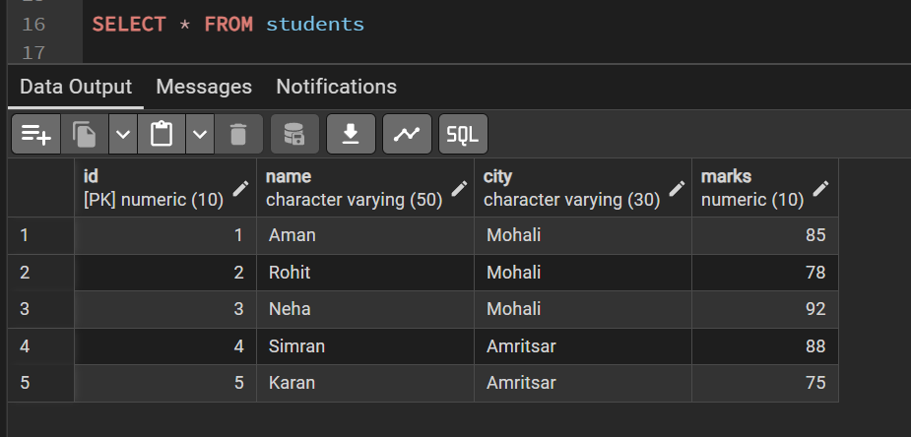

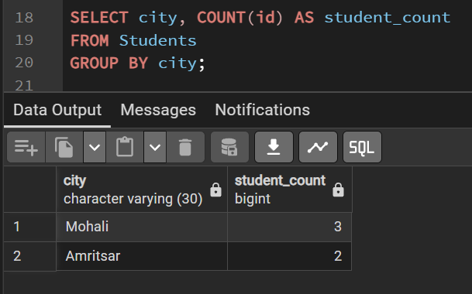

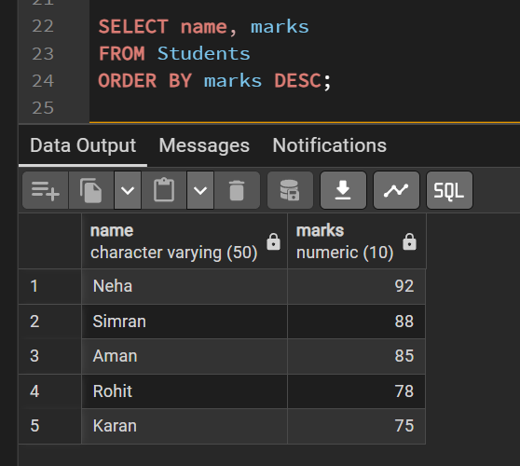

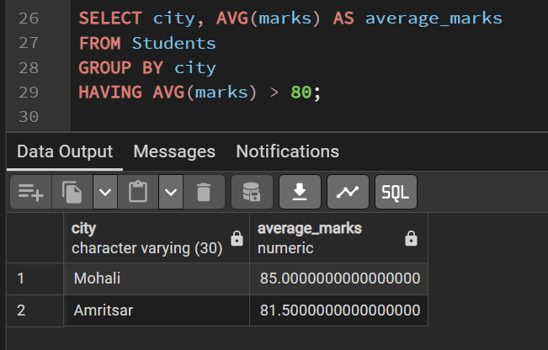

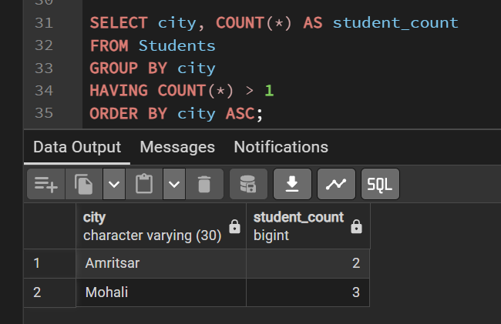

6. Learning Outcome
Through this session, I have developed the following competencies:
- Analytical Skills: Gained the ability to transform raw row-level data into high-level summary reports using aggregation.
- Query Logic: Understood the logical execution order of SQL clauses: FROM → WHERE → GROUP BY → HAVING → SELECT → ORDER BY.
- Practical Exposure: Experienced handling real-world data scenarios, such as department-wise salary analysis and performance-based filtering in a professional database environment.

