CURRICULUM VITAE

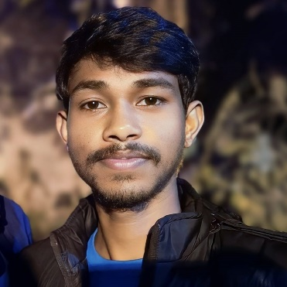**ARABINDU BAG**

## PHP Codeigniter Developer

Budge Budge, Kolkata –700137. Mobile: - 6290979670

Email: - [arabindubag0@gmail.com](mailto:arabindubag0@gmail.com)

# SUMMARY :

# I am an energetic and passionate PHP developer looking for an opportunity to enhance my abilities in a reputable organization. I have working experience in Codeigniter.

# SKILLS :

* MVC Codeigniter, MySQL
* Ajax
* Bootstrap, Jquery
* HTML, CSS, JavaScript,

Others: Django, Photoshop

# WORK EXPERIENCE :

Job Title : **PHP Codeigniter Developer (Internship)**

Job Role : Developing and maintaining web applications, Developing website, solving code problems.

Company : Oskings Tech Solutions.

Bishalaxmitala, Nodakhali, South 24 Pgs. [www.oskings.in](http://www.oskings.in/)

# WORK IN PROJECT :

## Development website of The Wedding Katha

Web address: <https://theweddingkatha.com/>

­­Role: Fully Developed.

## Development website of The Photographer House

Web address:<http://thephotographerhouse.com/>

Role: Fully Developed

## Development Management System of Datta Gold Finance (Girvi Software)

Web address: **offline**

Role: Fully Developed

## Development Management System of Manpower Shop

Web address: **offline**

Role: Fully Developed

## Development Management System of Oskings Clients

Web address:<https://clients.oskings.in/>

Role: Fully Developed

## Development website of Manas Dalapati

Web address:<https://manasdalapati.in/>

Role: Fully Developed

# Educational Qualification: -

2024 : B.A, 6th (Sem) (General) (Calcutta University)

Saheed Anup Chandra Mahavidyalaya

Nodakhali, South 24 PGS.

2020 : H.S. (W.B.C.H.S.E)

Burul High School (H.S.)

Nodakhali, South 24 PGS.

2018 : MADHYAMIK (W.B.B.S.E.)

Burul High School (H.S.)

Nodakhali, South 24 PGS.

# STRENGTHS: -

* Self-Disciplined, Sincere and have an inexhaustible stamina to work.
* To lead from the front and always open to ideas.
* Willingness to learn and improve constantly.
* Possess a positive attitude towards life.

# PERSONAL DETAIL’S: -

Name

Father’s Name

: Arabindu Bag

: Shambhu Bag

Sex : Male

D.O.B : 19th  OCT , 2002

Address : Burul, Nodakhali, Budge Budge II, South 24 PGS.

Nationality : Indian  
Religion : Hindu

Languages known : Bengali, Engalish & Hindi

# DECLARATION: -

I do here by declare that the details are furnished as stated above by me are true and Correct with best of my knowledge.

Place: Kolkata

Yours faithfully

......Arabindu Bag.......