**AI-Driven Crop Disease Prediction and Management System with Enhanced User Interface and Optimized Analytics for Improved Farm Productivity**

**Abstract:**

This invention relates to an advanced **AI-Driven Crop Disease Prediction and Management System** that introduces a novel “**agrofield.xyz**” web-based interface and optimized predictive algorithms to enhance user experience and system accuracy. Building upon existing AI-based agricultural solutions, this system incorporates a newly designed website that provides an intuitive dashboard, real-time alerts, and comprehensive analytics tailored to farmers' needs. The enhanced user interface simplifies navigation and decision-making, while the upgraded AI models leverage machine learning and remote sensing technologies for more precise and timely detection of crop diseases. Additionally, the system integrates with IoT sensors and weather data to provide personalized disease management recommendations, leading to reduced crop loss and improved yield outcomes. The innovation combines aesthetic design improvements with technical advancements to offer farmers an accessible, efficient, and effective tool for managing agricultural health.

Furthermore, the system introduces a **Media Page**, where farmers can access a vast library of educational content about plant health and common crop diseases. This resource is designed to provide up-to-date knowledge and best practices, helping farmers recognize early signs of disease and apply effective treatments. Additionally, a **Finance Page** has been developed to enable farmers to track and calculate daily expenses related to their farming operations. This feature allows users to manage budgets efficiently, monitor costs, and optimize resource allocation, ultimately enhancing financial decision-making and operational efficiency. Together, these innovations create a comprehensive platform that supports both the technical and financial aspects of modern farming.

**Background of the Invention:**

In rural areas of India, farmers face significant challenges in accessing modern technological solutions to manage their crops efficiently. A vast majority of the farming community in these regions lacks formal education, making it difficult for them to engage with advanced digital tools or systems. While technological innovations in agriculture, such as AI-based disease prediction, have made significant strides in developed regions, they remain largely inaccessible to smallholder farmers in rural India. This gap in technology adoption is compounded by limited internet connectivity, lack of infrastructure, and insufficient technical literacy. As a result, farmers struggle to identify and manage crop diseases, leading to significant crop losses and reduced yields.

The problem is further exacerbated by the **seasonal and regional variability** in crop diseases, which necessitates precise and timely intervention. Without access to real-time data and modern tools for disease prediction and management, farmers are left to rely on traditional practices, which are often ineffective against emerging plant diseases and pests. The unavailability of comprehensive technology also means that farmers miss out on valuable insights from historical and regional disease data, limiting their ability to adopt preventive measures and optimize the use of resources like pesticides and fertilizers.

One of the key issues in building an AI-driven crop disease management system for rural farmers is the **on-field data collection process**. Unlike more developed regions where farms may already be equipped with sensors, drones, and other IoT devices, rural Indian farms often lack the necessary infrastructure to collect data efficiently. This poses a significant challenge for developing accurate AI models, as the data fed into the system may not represent the actual conditions on the ground. Creating an AI system that can work under these constraints requires the development of cost-effective and scalable solutions for on-field data collection, including the deployment of affordable IoT devices and mobile-based data input systems that are accessible to farmers with limited resources and education.

Another technical challenge involves **AI image training and marking**. For an AI-based disease prediction system to function effectively, it requires a large dataset of crop images, annotated with disease-specific information. However, collecting and labeling these images in rural areas is a difficult task due to the lack of skilled labor and technical infrastructure. Training an AI model on crop diseases involves accurate image marking, which requires expertise that is often unavailable in these regions. Moreover, the variability in crop types, growing conditions, and diseases across different seasons means that the AI system must be continually updated with new data to maintain its accuracy. This process is both labor-intensive and expensive, requiring a solution that can adapt to the unique agricultural conditions of rural India.

Additionally, **seasonal data collection** presents another significant challenge. Crop diseases are not static; they vary based on seasons, geographic locations, and local environmental conditions. Building an AI system that accounts for these variations requires consistent and accurate data collection over multiple seasons. In rural areas, where internet connectivity is unreliable, collecting such data in real-time is a major hurdle. Farmers also often lack the tools or knowledge to provide accurate seasonal data on crop health, which can affect the quality of the AI model's predictions.

To address these problems, the invention proposes an innovative approach to bridging the technological gap in rural Indian agriculture. By designing a user-friendly, web-based interface that integrates **AI-driven crop disease prediction**, this system makes advanced technology accessible to even the least educated farmers. The introduction of a **media page** for educational content helps bridge the knowledge gap, while the integration of a **finance page** enables farmers to manage their daily expenses effectively. The system also incorporates solutions for **on-field data collection**, such as deploying low-cost sensors and mobile data entry systems, which are adapted to the specific needs of rural farmers. Furthermore, the invention includes a robust AI training process that leverages **community-based image collection** and partnerships with agricultural experts to gather and label data, ensuring that the AI system remains accurate and relevant across different seasons and regions.

This comprehensive approach aims to empower farmers in rural areas with the technology and knowledge they need to improve crop yields, manage diseases effectively, and reduce financial risk, ultimately contributing to enhanced agricultural productivity in India.

In addition to the existing challenges, one of the most pressing issues is the **lack of real-time disease detection** in rural farming. Traditional methods of disease identification rely on visual inspection or consultation with agricultural experts, which is often delayed or inaccurate. In the absence of timely intervention, diseases can spread rapidly, devastating entire crops and leading to substantial economic losses. Farmers in rural areas have limited access to expert consultation and diagnostic tools, which further aggravates the situation. While urban and technologically developed regions benefit from AI-powered disease detection systems that provide real-time alerts and recommendations, farmers in rural areas often receive outdated or irrelevant information that does not correspond to their specific geographic or seasonal conditions. Therefore, there is an urgent need for a system that can provide **localized, real-time disease alerts** using minimal resources and simple-to-use interfaces accessible to farmers with limited technological literacy.

Moreover, the financial burden of adopting advanced agricultural technology is a significant barrier for smallholder farmers in India. Many existing AI-driven agricultural solutions are expensive to implement and maintain, particularly in rural regions where economic constraints are prevalent. The high cost of setting up sensor networks, maintaining cloud-based systems, or purchasing proprietary software makes these technologies inaccessible to many farmers. Therefore, this invention also addresses the issue of **cost-effective deployment** of AI systems. By developing a scalable, cloud-based solution that integrates with affordable mobile devices and low-cost sensors, the invention provides a practical and economical way for rural farmers to harness the power of AI. The **finance page** added to the system allows farmers to track their expenses, optimize resource allocation, and manage their budgets effectively, providing not only technological but also financial empowerment to the rural farming community. This holistic approach to AI-driven agriculture aims to make cutting-edge solutions accessible and affordable to the people who need them most.

**Summary of the Invention:**

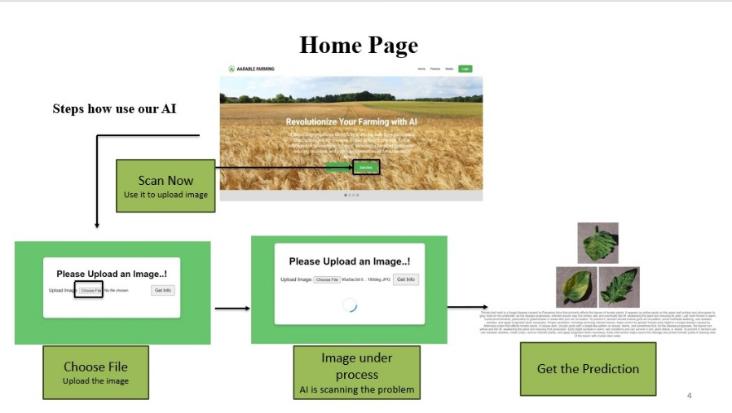The present invention introduces an advanced **AI-Driven Crop Disease Prediction and Management System** designed to empower farmers in rural India with accessible technology and actionable insights to enhance agricultural productivity. “**agrofield.xyz**” This innovative system addresses critical challenges faced by farmers, including limited access to modern technology, lack of education, and the absence of real-time data for effective decision-making. By leveraging cutting-edge artificial intelligence, machine learning, and user-friendly web interfaces, the invention aims to transform traditional farming practices into a more data-driven, efficient, and sustainable approach.

At its core, the system features an intuitive web-based platform that provides farmers with a comprehensive dashboard for monitoring crop health, receiving real-time alerts about potential diseases, and accessing personalized management recommendations. The user interface has been designed to accommodate users with varying levels of technological proficiency, ensuring that even the least educated farmers can navigate the system with ease. This is particularly crucial in rural areas where access to education and technical training is often limited.

One of the key innovations of this system is its robust data collection mechanism. By incorporating low-cost IoT sensors, mobile data entry applications, and community-based image collection initiatives, the system facilitates accurate and efficient on-field data gathering. Farmers can contribute to the data pool by capturing images of their crops, which are then processed using advanced image recognition algorithms. This collaborative approach not only enriches the AI model with diverse datasets but also fosters a sense of community among farmers, encouraging knowledge sharing and support.

The AI algorithms employed in this invention have been specifically tailored to recognize early signs of crop diseases, utilizing historical and real-time data to enhance prediction accuracy. The system is capable of analyzing multi-modal data inputs, including visual data from images, environmental data from sensors, and agronomic data such as crop type and growth stage. By integrating these diverse data streams, the AI-driven model provides farmers with timely and relevant insights, enabling them to take proactive measures to manage diseases and improve crop health.

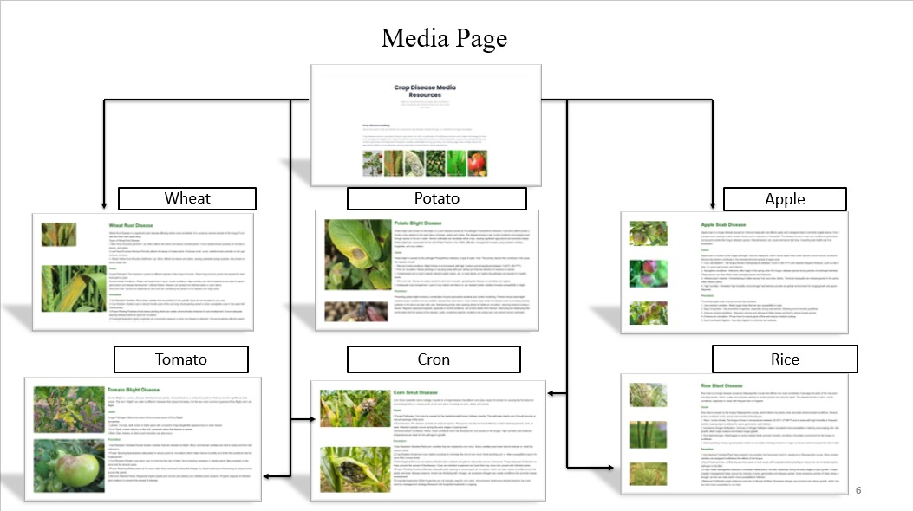In addition to its core predictive functionalities, the invention includes a **Media Page** that serves as an educational resource, offering farmers access to a wealth of information on plant health, common crop diseases, and best practices for management. This feature is essential for bridging the knowledge gap among farmers, providing them with the tools and information they need to make informed decisions regarding their crops. By fostering greater awareness and understanding of crop diseases, the Media Page empowers farmers to adopt more effective management strategies.

The system also features a **Finance Page** that allows farmers to track their daily expenses related to farming operations. By providing tools for budget management and resource allocation, this feature helps farmers make financially sound decisions and optimize their operational efficiency. Understanding the economic aspects of farming is crucial for smallholder farmers, and this financial tool enhances their ability to plan for the future, 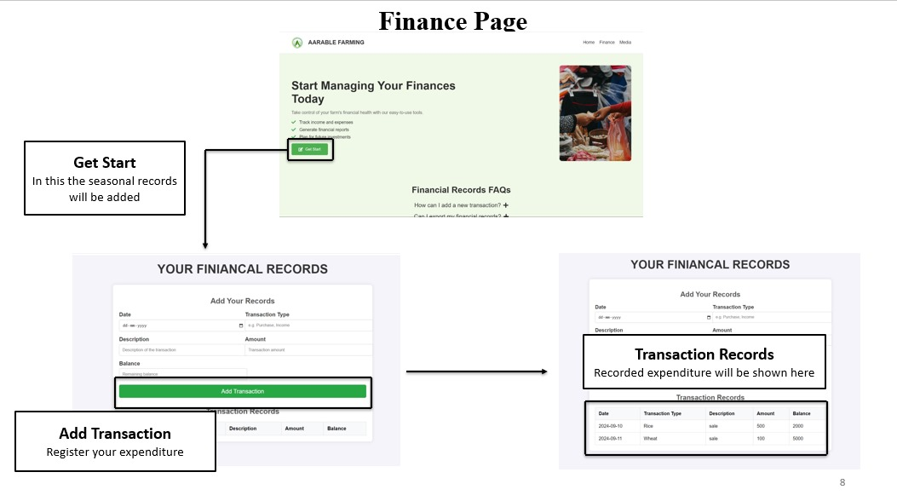manage risks, and improve overall profitability.

In summary, the AI-Driven Crop Disease Prediction and Management System represents a significant advancement in agricultural technology, tailored to meet the unique challenges faced by farmers in rural India. By combining innovative AI algorithms, user-friendly design, and comprehensive educational resources, the invention not only enhances crop disease management but also fosters economic resilience and sustainable farming practices. This holistic approach aims to empower rural farmers, enabling them to leverage technology for improved agricultural outcomes, increased productivity, and greater financial stability.

**Detailed Description of the Invention**

The present invention, an **AI-Driven Crop Disease Prediction and Management System**, “**agrofield.xyz**” is a comprehensive solution designed to assist farmers in rural areas, particularly in regions like India, where technology adoption is limited due to infrastructural and educational barriers. This system aims to improve farm productivity by integrating advanced artificial intelligence (AI) with real-time data collection and a user-friendly interface, enabling farmers to detect and manage crop diseases efficiently. The invention leverages a range of AI techniques, including neural networks, reinforcement learning, and transfer learning, to create a robust prediction model that adapts to changing agricultural conditions. The system is trained using data input from various sources such as on-field images, environmental sensors, and seasonal data, ensuring it provides timely and accurate recommendations.

**1. System Architecture and AI Engine Interaction**

At the core of this invention is the **AI engine**, which interacts with multiple data inputs to provide disease prediction, diagnosis, and crop management recommendations. The AI engine is built on a neural network architecture optimized for image classification and pattern recognition tasks, particularly for identifying plant diseases from crop images.

The **data input** for the AI engine comes from three primary sources:

1. **Images of crops**: Captured by farmers using smartphones or low-cost cameras, these images are uploaded to the system through a mobile or web interface. Farmers take pictures of plants, crops, and vegetables such as rice, wheat, tomatoes, and more. The system processes these images to identify signs of diseases such as blight, leaf rust, bacterial wilt, or fungal infections.

2. **Environmental sensors**: Sensors installed in the field collect data on soil moisture, temperature, humidity, and other environmental conditions that affect plant health. These sensors provide real-time data that is fed into the AI engine to enhance the disease prediction process.

3. **Seasonal data**: Historical data regarding crop diseases, pest outbreaks, and seasonal variations is used to help the AI model predict disease risks based on previous trends. This data is gathered from agricultural experts, government databases, and localized community contributions.

The **AI engine processes these inputs simultaneously**, using the following steps:

- The **convolutional neural network (CNN)** layer processes the crop images and identifies potential visual signs of diseases, such as spots, wilting, or discoloration.

- The environmental sensor data is processed using a **feed-forward neural network**, which evaluates non-visual parameters like soil condition and weather patterns to refine the prediction.

- The seasonal data is fed into the system to **generate a contextual analysis,** taking into account the time of year, crop cycle, and past outbreaks in the region. This multi-layered input approach ensures that the AI provides a holistic analysis of the plant’s health and potential disease risks.

Once the data has been analysed, the AI engine generates an **output prediction**, which includes:

- A diagnosis of the disease (if any) based on image and environmental data.

- A risk assessment for disease outbreaks.

- Recommendations for treatment or preventive measures, such as the use of specific fertilizers, pesticides, or irrigation adjustments.

**2. AI Algorithms and Techniques**

The invention uses a combination of advanced AI algorithms to process data, train models, and make predictions. The primary techniques include **neural network models, reinforcement learning**, and **transfer learning**, all of which work together to enhance the accuracy of disease detection and crop management.

1. **Neural Network Models**:

The core AI engine is built using **convolutional neural networks (CNNs)** and **recurrent neural networks (RNNs**). The CNN model is trained to analyze images of plants, crops, and vegetables to detect diseases. Each layer of the CNN extracts features from the input images, such as leaf texture, shape, color variations, and spotting patterns, which are then used to classify the plant's health status. The RNN component processes time-series data from environmental sensors to monitor changes over time, allowing the system to predict disease risk based on trends.

2. **Reinforcement Learning Approaches**:

Reinforcement learning is used to **optimize decision-making** in real-time by continuously improving the AI model’s predictions based on new data. The AI model receives feedback from the system whenever farmers implement suggested actions (e.g., applying pesticides or changing irrigation). Over time, the reinforcement learning model adjusts its prediction algorithms to provide more accurate recommendations by learning from the outcomes of its previous predictions.

3. **Transfer Learning**:

Given the variability of crops and diseases across regions, **transfer learning** is used to improve the model’s adaptability. The system takes a pre-trained neural network that has been trained on a large dataset of common plant diseases and fine-tunes it using regional and local data. This method reduces the amount of data required to train the model from scratch for each new region, making the system adaptable for different crops like wheat, rice, and tomatoes, as well as local diseases. This approach also ensures that the system can be deployed in different geographical locations without significant retraining, saving time and resources.

4. **AI Model Training with Roboflow**:

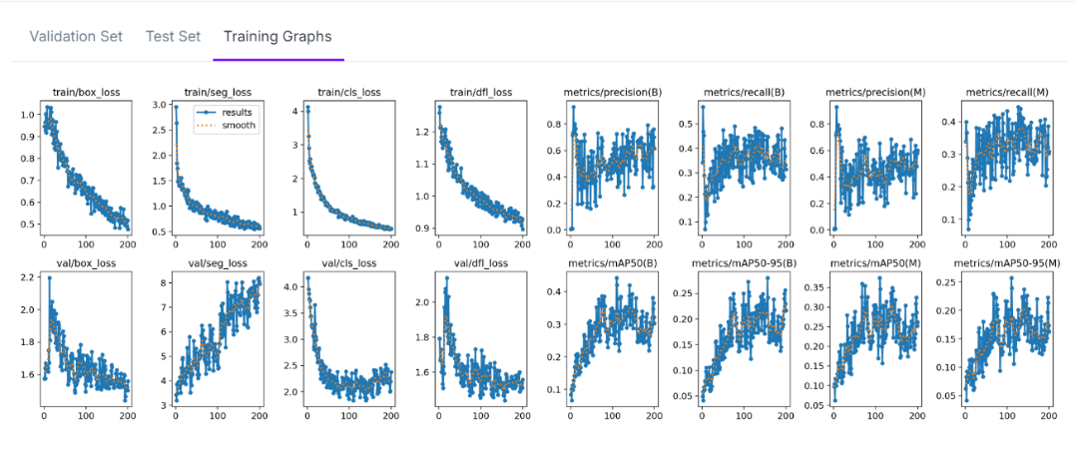 To facilitate the training of the AI models, the invention uses **Roboflow**, a platform that helps in **annotating and pre-processing image datasets**. Using Roboflow, the invention trains its AI models on a large, labeled dataset of crop and plant disease images. The platform is used to manage the workflow of image labeling, augmenting the dataset with variations in lighting, angles, and plant growth stages. This makes the AI model more resilient to variations in field conditions and camera quality, ensuring consistent performance across different user inputs.

The Roboflow tool also helps in **generating synthetic data** when there is insufficient labeled data for a particular crop or disease. By applying augmentation techniques such as image rotation, scaling, and color transformation, the system can expand its dataset and improve the generalizability of its AI models.

3. **Plant, Crop, and Vegetable Details**

The system is designed to work across a wide range of crops, vegetables, and plants, including but not limited to:

1. **Cereal crops**: The system supports crops such as **rice, wheat, maize, and barley**. These crops are particularly susceptible to fungal infections, bacterial diseases, and nutrient deficiencies, which can be detected through image analysis.

2. **Vegetables**: Common vegetables such as **tomatoes, potatoes, eggplants, and bell peppers** are prone to diseases like blight, wilt, and leaf spots. The AI system uses image recognition to identify the early symptoms of these diseases and provide farmers with actionable advice to prevent their spread.

3. **Fruits**: The system supports **mangoes, citrus fruits, bananas, and grapes,** providing disease detection for common fruit diseases such as anthracnose, citrus greening, and black spot. The image training models used by the AI can identify these diseases based on visual characteristics such as leaf or fruit discoloration and spotting.

4. **Pulses and legumes**: The system also extends to crops like **lentils, peas, and chickpeas**, which are critical to Indian agriculture. These crops are susceptible to diseases such as root rot and leaf curl, which can be detected and managed using the AI system.

The disease detection and management system works by comparing the input data against a vast library of known crop diseases and generating recommendations based on the AI’s pattern recognition capabilities. For example, a farmer growing wheat might upload an image of a wheat leaf showing brown spots. The system, using its trained neural network, will analyze the leaf image, compare it to the dataset, and conclude that the plant is likely suffering from leaf rust, a common fungal disease. It will then provide specific recommendations for treating the condition, such as applying a particular fungicide or adjusting irrigation practices.

4. **Performance and Scalability**

The invention has been designed with **scalability** in mind, ensuring it can be deployed across large farming communities with minimal infrastructure requirements. The AI system uses **cloud-based processing** to handle large datasets and perform complex image recognition tasks, allowing farmers in rural areas to access advanced AI capabilities without requiring powerful hardware on their devices. The system is lightweight and can run on basic smartphones with minimal data usage, making it accessible to farmers even in regions with limited internet connectivity.

The system's **learning and adaptation capabilities** mean that it continually improves over time as more farmers use the system and contribute data. This dynamic feedback loop allows the AI model to adapt to new diseases, changing environmental conditions, and evolving farming practices, ensuring that it remains relevant and accurate as agricultural challenges change.

In conclusion, the **AI-Driven Crop Disease Prediction and Management System** combines advanced AI algorithms with practical, field-oriented tools to deliver a highly effective solution for farmers. By integrating neural networks, reinforcement learning, transfer learning, and user-friendly interfaces, the invention ensures that even farmers with limited education and access to technology can benefit from the latest advancements in AI. This system not only improves disease detection and crop management but also empowers rural communities by providing the tools and knowledge they need to increase agricultural productivity and sustainability.

**Claims:**

1. **An AI-Driven Crop Disease Prediction and Management System**, comprising:

- An AI engine configured to analyze image inputs of crops, plants, and vegetables, using neural network models to identify diseases based on visual symptoms;

- An on-field data collection mechanism, including integration with IoT sensors that monitor environmental parameters such as soil moisture, temperature, and humidity;

- A mobile and web-based interface for farmers to upload images of crops, input environmental data, and receive disease diagnoses and management recommendations;

- A predictive algorithm that combines image analysis with real-time sensor data and historical seasonal data to provide disease risk assessments and tailored crop management solutions;

- A database of known plant diseases and treatments, dynamically updated to include new diseases and regional variations in disease manifestation;

- A media page providing educational resources on crop health, disease identification, and management techniques;

- A finance page for tracking daily farming expenses and providing financial insights on farming operations.

2. **The AI-Driven Crop Disease Prediction and Management System** of claim 1, wherein:

- The AI engine utilizes **convolutional neural networks (CNNs)** to process image inputs and identify diseases such as leaf spots, blight, rust, and mildew by extracting features like color, texture, and patterns from crop images.

3. **The AI-Driven Crop Disease Prediction and Management System** of claim 2, wherein:

- The AI model is trained using **transfer learning**, allowing it to adapt to new crops, regions, and diseases by fine-tuning pre-trained neural network models with locally sourced data and regional disease patterns.

4. **The AI-Driven Crop Disease Prediction and Management System** of claim 3, further comprising:

- A reinforcement learning algorithm that optimizes the system's disease prediction accuracy by learning from user feedback based on the effectiveness of suggested treatments and preventive measures applied in real-world farming environments.

5. **The AI-Driven Crop Disease Prediction and Management System** of claim 4, wherein:

- The system is capable of supporting a wide range of crops, plants, and vegetables, including but not limited to **cereals** such as wheat and rice, **vegetables** such as tomatoes and potatoes, and **fruits** such as mangoes and citrus, providing disease detection and management recommendations tailored to each crop type.

6. **The AI-Driven Crop Disease Prediction and Management System** of claim 5, wherein:

- The mobile interface includes a camera function that allows farmers to capture and upload real-time images of crop leaves, fruits, or stems, with automated image marking for disease detection.

7. **The AI-Driven Crop Disease Prediction and Management System** of claim 6, wherein:

- The system integrates with **Roboflow** or similar image annotation platforms for training the AI models, allowing for scalable and efficient image data collection, labeling, and pre-processing, ensuring high accuracy in disease recognition.

8. **The AI-Driven Crop Disease Prediction and Management System** of claim 7, wherein:

- The environmental sensor data is processed using a **feed-forward neural network**, which monitors variables such as weather, soil conditions, and air quality to refine the disease risk assessment and provide real-time recommendations.

9. **The AI-Driven Crop Disease Prediction and Management System** of claim 8, further comprising:

- A cloud-based infrastructure that allows the AI engine to perform large-scale computations for image analysis and disease prediction, ensuring that the system remains lightweight and accessible to users in rural areas with limited connectivity.

10. **The AI-Driven Crop Disease Prediction and Management System** of claim 9, wherein:

- The finance page provides budgeting and expense-tracking tools, enabling farmers to calculate costs associated with pest control, fertilizers, and irrigation, along with crop yield projections based on the AI system's disease risk predictions.

11. **The AI-Driven Crop Disease Prediction and Management System** of claim 10, wherein:

- The system supports **seasonal data collection**, analyzing historical disease patterns, environmental conditions, and past yield data to predict seasonal disease outbreaks and offer preventive recommendations.

12. **The AI-Driven Crop Disease Prediction and Management System** of claim 11, wherein:

- The AI model is capable of **multi-modal data integration**, simultaneously processing image inputs, environmental data, and seasonal trends to provide a holistic diagnosis and management plan for crop diseases.

13. **The AI-Driven Crop Disease Prediction and Management System** of claim 12, wherein:

- The media page includes multi-language support to accommodate users from diverse linguistic backgrounds, ensuring that farmers from various regions can access educational content in their native languages.

14. **The AI-Driven Crop Disease Prediction and Management System** of claim 13, further comprising:

- A user feedback mechanism that collects data from farmers regarding the effectiveness of the recommended treatments, which is then used to improve the AI model’s accuracy through reinforcement learning and continuous retraining.

15. **The AI-Driven Crop Disease Prediction and Management System** of claim 14, wherein:

- The AI engine incorporates **data augmentation techniques** to increase the diversity of the training dataset, using image transformations such as rotation, scaling, and color adjustments to simulate various on-field conditions and improve the model’s generalization capability.

16. **The AI-Driven Crop Disease Prediction and Management System** of claim 15, wherein:

- The system’s architecture is designed to be scalable, enabling deployment across multiple regions and supporting millions of users, while maintaining high accuracy in disease detection and management recommendations, even in areas with minimal technological infrastructure.

**Diagram For How AI Is Working:**

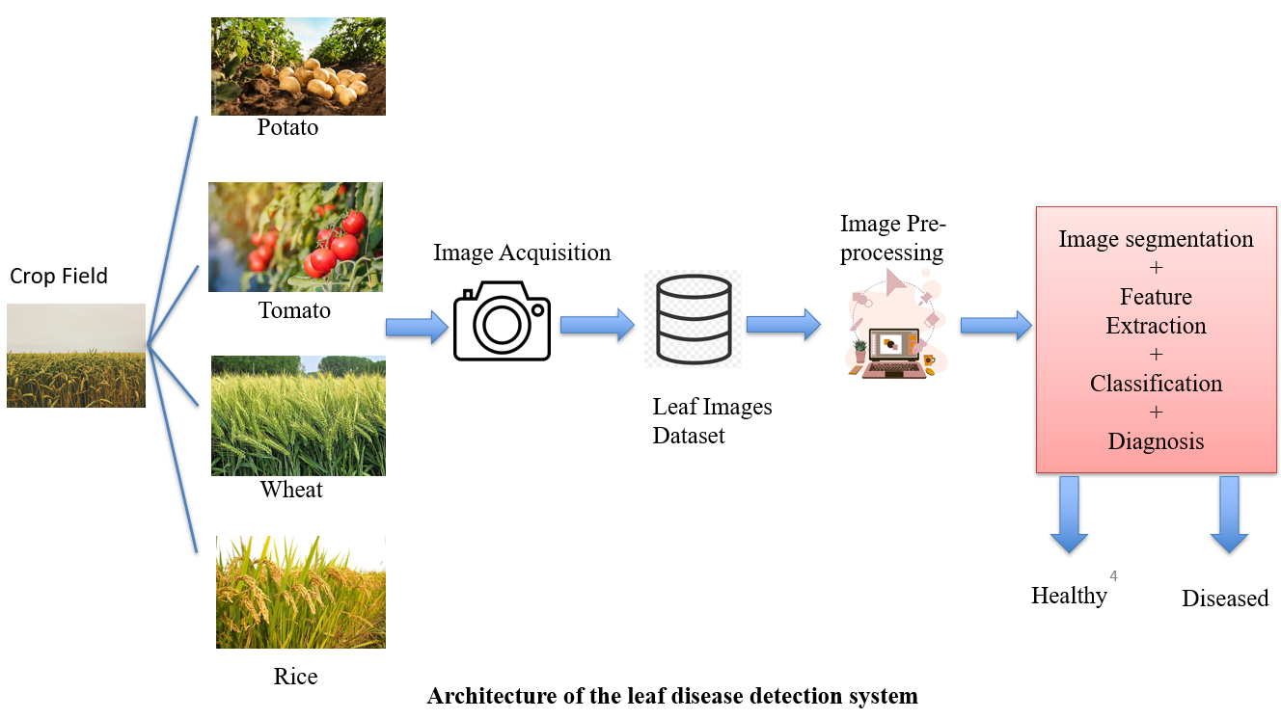

Here is the diagram illustrating the **AI-Driven Crop Disease Prediction and Management System**. “**agrofield.xyz**” It visually demonstrates how the AI engine interacts with various data sources, including crop images, environmental sensors, and seasonal data, to provide outputs such as disease diagnosis, educational resources, and financial management tools for farmers.

**Conclusion:**

The **AI-Driven Crop Disease Prediction and Management System** represents a significant innovation in addressing the agricultural challenges faced by farmers in rural areas, especially in regions like India where technological access and education are limited. By leveraging cutting-edge AI technologies such as neural networks, reinforcement learning, and transfer learning, the system provides a robust solution for early disease detection and crop management. It empowers farmers with accurate disease diagnosis, real-time recommendations, and educational resources that are easily accessible through mobile and web platforms.

This system not only bridges the technological gap in agriculture but also enhances productivity by integrating multiple data inputs—such as crop images, environmental conditions, and seasonal trends—to make precise predictions. By incorporating user-friendly interfaces and additional features like financial tracking tools, the system offers a holistic approach to managing farm operations. With cloud-based processing and the ability to adapt over time through reinforcement learning, the system ensures scalability and relevance in various agricultural settings.

In conclusion, this invention revolutionizes crop management for smallholder farmers, fostering sustainability, improving yields, and contributing to the global effort of advancing agricultural practices through AI-driven innovation.