Task 3a - Gathering Feedback

Plan for Feedback
To gather useful qualitative and quantitative feedback on the Greenfield Local Hub digital solution, I used a mixture of questionnaires, observations and a paired coding review. This helped me collect written opinions from normal users, practical task-based feedback from people using the website, and technical comments from users who understand web development.
The feedback was based on the main areas of the web application, including the home page, shop page, product details, producers page, shopping basket, checkout, address book, order history, loyalty rewards and the producer dashboard. I also asked users to look at the accessibility features such as dark mode, high contrast mode, text size controls and the read page option.
The methods I used were:
- Questionnaires - Non-Technical Audience
- Observations - Non-Technical Audience
- Paired Coding Reviews - Technical Audience

Methods of Use

Questionnaires - Non-Technical Audience
Method of Use:
I used an online Microsoft Forms questionnaire to gather feedback from non-technical users after they had tested the Greenfield Local Hub web application. This method was useful because it allowed me to collect both rating data and written comments from users who may use the website as customers. The questionnaire focused on what the user could see and use on the front end, rather than asking about the code.
Which audience is it for?
This method was for non-technical users. This includes ordinary customers who may want to browse local products, add items to a basket, place an order, use loyalty rewards and manage their account.
How will I tailor it?
I tailored this method by using simple language and avoiding technical terms. The questions were based on user experience, visual design, navigation, shopping features, loyalty rewards, accessibility and overall satisfaction. I included rating questions so that results could be compared, and open questions so that users could explain what they liked or found confusing.
How the method was delivered and recorded:
- The questionnaire was created using Microsoft Forms.
- The form link was sent to selected non-technical users.
- Users were asked to use the Greenfield Local Hub website before completing the form.
- Responses were collected automatically and anonymously through Microsoft Forms.
- The results were reviewed using the charts, average scores and written responses from the form.

Observations - Non-Technical Audience
Method of Use:
I used observed scenario testing with non-technical users. The users were given five realistic tasks to complete on the Greenfield Local Hub website. This method was useful because it showed whether users could complete important journeys on the website, such as registering, adding a product to the cart, using loyalty rewards and completing checkout.
Which audience is it for?
This method was for non-technical users because the tasks were based on normal user journeys. The scenarios did not require coding knowledge, but they did require the user to move around the website and use key features.
How will I tailor it?
The scenarios were written as simple tasks. I used common actions that a real customer or producer would need to complete, such as registering an account, shopping, applying a loyalty offer and editing product stock as a producer. I recorded whether each task was completed, the time taken, expected clicks, actual clicks and any comments made by the user.
How the method was delivered and recorded:
- An observed scenario testing sheet was created.
- Each user was given the same set of tasks to complete on the website.
- The time taken and number of clicks were recorded for each scenario.
- The result for each scenario was recorded as completed, partly completed or not completed.
- The comments were then reviewed to see what users said while completing the tasks.

Paired Coding Reviews - Technical Audience
Method of Use:
I used a paired coding review with technical users. During this method, the technical user reviewed the code and the working web application. The review focused on the MVC structure, controllers, models, views, database design, authentication, authorisation, loyalty functionality, shopping basket workflow and producer dashboard.
Which audience is it for?
This method was for a technical audience. This included users who understand web development and could comment on code structure, security, database relationships and maintainability.
How will I tailor it?
The form used technical language and asked questions about the areas of the solution that a developer would understand. This included model clarity, relationships between tables, database support for the main user journeys, architecture, security issues, accessibility and the strongest and weakest technical parts of the project.
How the method was delivered and recorded:
- A technical paired code review form was created using Microsoft Forms.
- A technical peer was selected to review the project.
- The reviewer looked through the code and the running web application.
- The review covered models, views, controllers, database design, Identity, roles, order handling, loyalty rewards and producer features.
- Feedback was recorded using the online form and then summarised from the form responses.

Feedback Sheets and Resources
The following feedback sheets and resources were used to collect the feedback:

- Non-Technical Questionnaire: https://forms.cloud.microsoft/e/bhTSZdpprk
- Non-Technical Questionnaire (Collaborate Link): https://forms.cloud.microsoft/Pages/DesignPageV2.aspx?subpage=design&FormId=sNuNM79BBkaNEj2FTSnwybcof-qqCoNIiTduGTaqczNUREFIUUVFS0pWQjNXUlowNlNGTUpEWEJTNi4u&Token=5bada7d4e4b741eb90836639cd55f883

- Observed Scenario Testing Form: https://forms.cloud.microsoft/e/ew8Q4GZL4X
- Observed Scenario Testing Form (Collaborate Link): https://forms.cloud.microsoft/Pages/DesignPageV2.aspx?subpage=design&FormId=sNuNM79BBkaNEj2FTSnwybcof-qqCoNIiTduGTaqczNUNDhUVEc4T1hQQlVQRjBXWjNaUVNIWkszVy4u&Token=b4f70dd2e7964d48a08d257d0322abc4

- Technical Paired Code Review: https://forms.cloud.microsoft/e/43QDzmabUJ
- Technical Paired Code Review (Collaborate Link): https://forms.cloud.microsoft/Pages/DesignPageV2.aspx?subpage=design&FormId=sNuNM79BBkaNEj2FTSnwybcof-qqCoNIiTduGTaqczNUQlhMTzhOV1k5NDFFQkZEN1A4NzZHUzI2My4u&Token=77f8a91fdabe4bb98156482d78bf3367

Summary of Findings
The feedback was collected from three non-technical questionnaire responses, three observed users completing five scenarios, and three technical paired coding review responses. The findings below only summarise the data and comments that were received from each method.

Questionnaires - Non-Technical Audience
The non-technical questionnaire received 3 responses. The first impression comments were positive. Users described the home page as welcoming, informative, warm, inviting, visually appealing and functionally working. One user said the website felt like a real business that values its customers, and another user said the website felt complete.
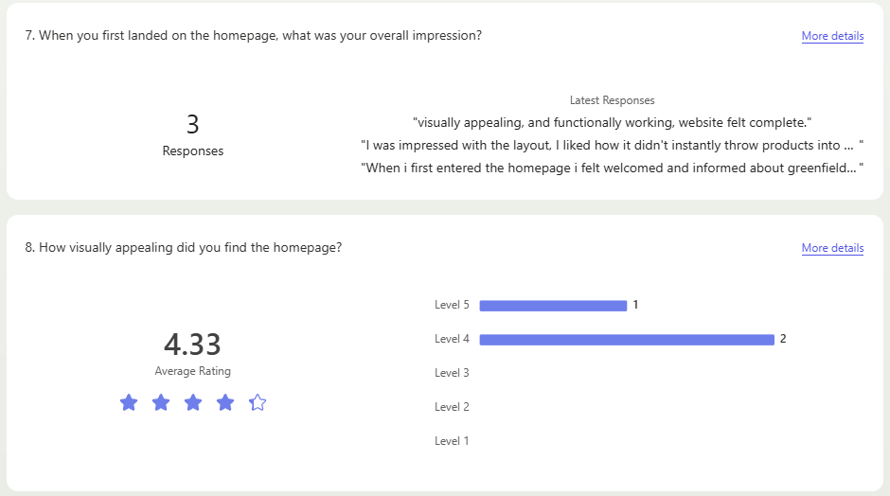
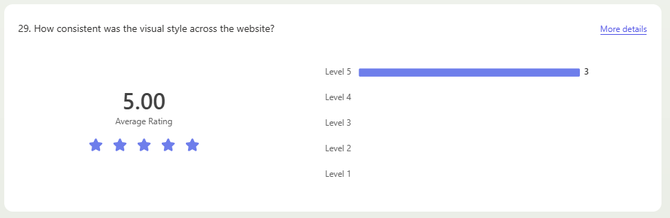
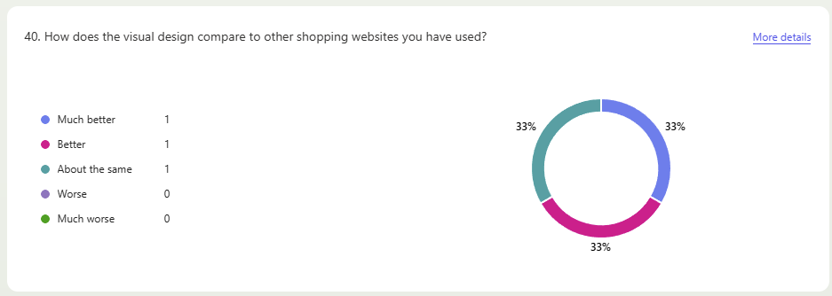
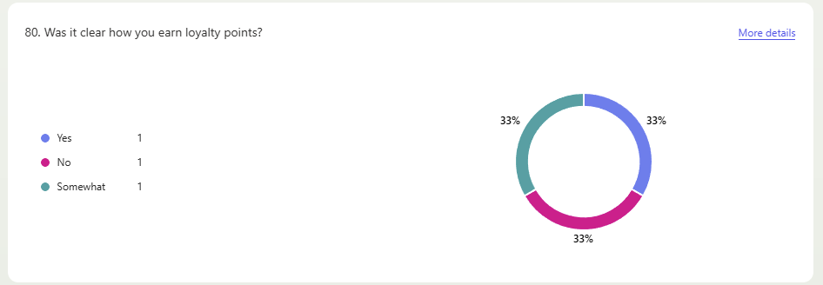
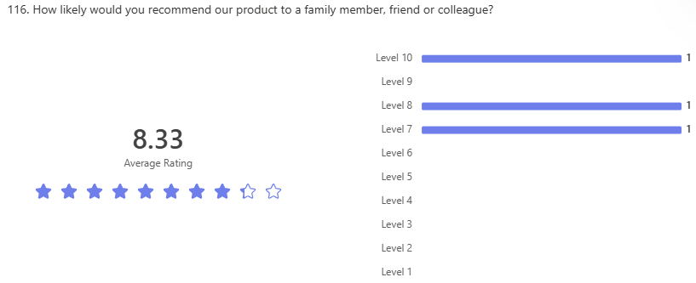
The written responses showed that users liked the checkout page, the option to select a click and collect date, the different delivery options, the loyalty rewards, the address book and the consistent front-end design. One user specifically mentioned the ability to redeem offers at checkout, including free delivery, as one of the best parts of the website.
For things users wished were easier to find, two responses said that they were able to find what they needed. One response said that the accessibility features would be easier to use if they were attached to the navigation bar rather than positioned at the top of the page.
The most confusing parts mentioned were finding the loyalty page and changing quantities in the basket. One user said the loyalty page was confusing to find because they had to navigate towards the bottom of the page. Another user said increasing and decreasing item quantity in the basket took longer because the page refreshed after each change and only one item could be changed at a time. One user said there was no frustrating part.
For missing features, one user mentioned page links on the navigation bar for loyalty rewards, one user said the website was very well rounded, and one user mentioned that there was no checkout system for entering test card details or downloading receipts and invoices.
The final experience comments were positive. Users said the website was memorable, easy to use after using it once, clear in its aim, matched the farm food cooperative theme and provided the functionality they expected.

Observations - Non-Technical Audience
The observation method was completed by 3 users. Each user completed 5 scenarios, which created 15 scenario results in total. All 15 scenarios were marked as completed.
The total time recorded across all observation tasks was 398 seconds, giving an average of 26.5 seconds per task. The total actual clicks recorded were 130 clicks across all tasks. Most of the actual click counts were lower than the expected click counts recorded on the sheet. The register and login scenario was the only scenario where two users took more clicks than expected, as both recorded 10 actual clicks against 8 expected clicks.
The comments recorded during observation were mainly short. One user said the shop and checkout task worked great and was fast. The loyalty voucher task was recorded as working fine. The click and collect order was completed smoothly, and the producer stock update went smoothly. One comment on the registration task said it worked, but it would be useful if accepting the terms of use was mandatory before signing up.

Paired Coding Reviews - Technical Audience
The technical paired coding review received 3 responses. The technical users reviewed the project structure, model classes, database relationships, architecture, security and accessibility areas of the Greenfield Local Hub web application.
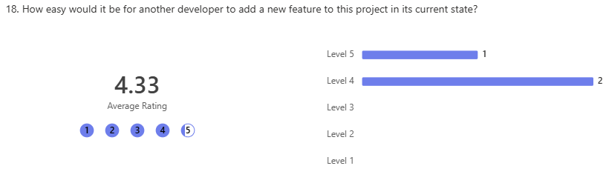
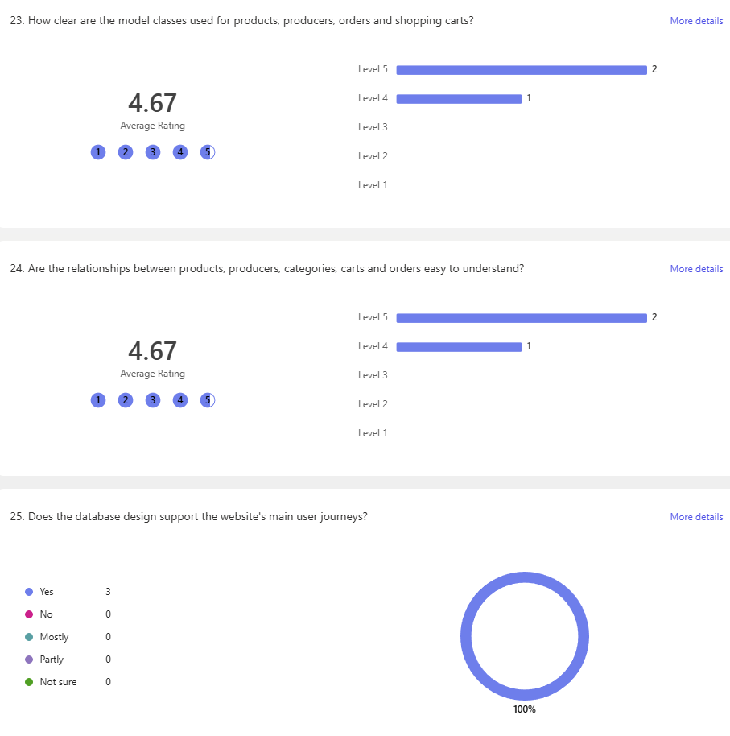

For the strongest part of the architecture, the responses mentioned the orders functionality, producer dashboard, Identity pages and CSS structure. One response said the orders functionality and producer dashboard were strong because they include features such as applying a discount and validation. Another response said the Identity pages are structured and scaffolded well, and another response said the CSS seemed to be structured the strongest.
For the weakest or most in need of improvement part of the architecture, the responses mentioned comments across the code, naming convention differences and controllers. One response said the comments could be expanded. Another response said some files use different naming conventions, such as HomeController using PascalCase while some folders and files use camelCase. One response answered controllers.
For model and database improvements, one response said all models seem necessary and no improvement was needed. Another response said validation checks are currently handled through controller logic and could be set inside models for consistency, and also mentioned using decimal instead of float for product prices. One response was unsure.
For security issues that should be treated as a priority before deployment, the responses mentioned address editing by URL manipulation and making terms of service acceptance mandatory during registration. The address response gave an example of changing the number in the URL to edit another address page.
For accessibility, the responses mentioned dyslexic support, improving some dark mode sections visually, and improving high contrast. For the strongest technical aspect overall, responses mentioned the loyalty rewards functionality, the workflow connecting loyalty rewards with orders, Identity, roles, basket behaviour and producer order management, and the design of the website.
For the weakest technical aspect overall, the responses mentioned role based access, code organisation in some of the larger controllers and some validation issues. Final technical feedback said most functions were up to standard and functional, with authorisation being the main issue mentioned. Another final response said the project has strong structure, commenting and a large variety of features that support the ecommerce logic of the application.

Overall Summary
Overall, the feedback collected gave information from both users and technical reviewers. The questionnaire gave rating data and written comments about the front-end experience. The observation sheet gave task completion data, timing data and click count data. The paired coding review gave technical comments about architecture, models, database design, security, accessibility and maintainability.

