
CityPoint room Hire
Business Proposal

Abdulkarim Naser
Mock Exam
T-Level Computing

Contents
Business Context 2
Project Aim 4
Functional Requirements and User Acceptance Criteria 5
Non-Functional Requirements 6
Hierarchy Diagram 7

Business Context

  - Room Hire & Facilities Information
The client, CityPoint Room Hire, has requested that the solution provides all the essential information about rooms available for hire and their facilities. Customers depend on this information to make informed decisions when planning to hire rooms, equipments and make bookings through their business. Without any detailed information of their service in the solution, customers would be frustrated, uncertain, or even disinterested. This could lead to abandoned plans, reservations, and even choosing competitors that are easier to work with. By providing this clear information about the rooms available for hire and their facilities, it will encourage more bookings, enhance the user experience, and initiate higher engagement and revenue. Higher revenue allows CityPoint Room Hire to strengthen its market position, build connections with other business that use their service, and achieve long-term financial stability and growth.

  - Booking Policies & Staff Details
CityPoint Room Hire wants the solution to provide customers with information about booking policies and staff details for the company. In order for customers to have a smooth experience and have access to all the information that is needed for them before making a booking, this functionality is essential. Without clear booking policies and staff information available, customers may feel confused, uncertain, or hesitant when trying to proceed with their bookings. This could lead to misunderstandings, abandoned bookings, or a lack of trust in the business. To improve transparency, build customer confidence, and enhance the overall user experience, the booking policies and staff contact details need to be clearly drawn. This helps CityPoint Room Hire present a professional image, reduce customer inquiries, and support stronger customer relationships.

  - Make a Booking Request
The client has requested that the solution allow customers to book rooms for specific dates and times pending confirmation. Customers value the ability to plan events and meetings in advance, and without this functionality, they may feel restricted or inconvenienced when trying to secure a suitable room. This could result in lost booking opportunities and customers choosing alternative providers that offer more flexible booking systems. By enabling customers to request bookings for specific dates and times, the solution will rationalise the booking process, improve convenience, and encourage more booking requests. Pending confirmations also allow CityPoint Room Hire to manage availability effectively while maintaining customer satisfaction and consistent revenue.

  - View & Manage Bookings
CityPoint Room Hire has requested that the solution allow customers to view and manage their existing bookings. Customers appreciate having control over their reservations, and without the ability to review or manage bookings, they may feel frustrated or powerless when changes are needed. This could lead to increased cancellations, dissatisfaction, or unnecessary contact with staff. By providing customers with access to their booking details, the solution will enhance convenience, reduce administrative workload, and improve overall user experience. This leads to better customer satisfaction, improved booking accuracy, and more efficient business operations.

  - Customer Accounts & Booking Management
The client requires that the solution allow customers to create personal accounts to manage their bookings and personal data. Customers value personalised and efficient experiences, and without account functionality, they may feel troubled by repeatedly entering same information. This could discourage repeat bookings and reduce customer loyalty. By implementing customer accounts, the solution will optimise the booking process, allow easier booking management, and support data security. Over time, this feature encourages repeat usage, strengthens customer relationships, and increases long-term revenue for CityPoint room Hire.

  - Accessibility Features
CityPoint Room Hire wants the solution to include accessibility features that support a wide range of users. Adding accessibility solutions will address issues where certain users may struggle to use digital platforms due to disabilities or other difficulties, and without these features, some customers may feel excluded or unable to complete bookings effectively. This could limit the company’s reach and reduce potential bookings. By implementing accessibility features such as clear navigation, readable content, and compatibility with assistive technologies, the solution will allow CityPoint Room Hire to expand its services to a wider range of users. This enhances user experience, demonstrates, inclusivity and supports business growth by increasing the potential user base and overall engagement.

  - Staff Admin Panel
The client has requested that the solution include a staff area to manage rooms and booking requests that the can confirm or deny. Staff require efficient tools to manage availability and booking requests, and without a dedicated management are, errors or delays may occur. This could lead to double bookings, missed requests, or operational inefficiencies. By providing a secure staff area, the solution will improve internal workflows, ensure accurate booking management, and allow staff to respond on time to customer requests. This results in smoother processes, better service quality, and improved customer satisfaction.

Project Aim

These are the essential requirements that the digital solution need to meet:
- Provide customers with information about rooms available for hire and their facilities
- Provide customers with information about booking policies and staff details for the company
- Allow customers to book rooms for specific dates and times pending confirmation
- Allow customers to view and manage their existing bookings
- Allow customers to create accounts to enable them to manage their bookings and data
- Offer accessibility features to support a wide range of users
- A staff area to manage rooms and booking requests that they can confirm or deny

Functional Requirements and User Acceptance Criteria

James - Small business owner who frequently books rooms for meetings and presentations. Values efficiency, clear information, and quick bookings.
Ethan - University student who occasionally books rooms for study groups and events. Tech‑savvy and expects self‑service features.
Linda - Bookings manager at CityPoint Room Hire. Manages rooms, reviews booking requests, and responds to customer enquiries.

Functional Requirement | User Story | User Acceptance Criteria | Justification
Registering | As James I want to register an account so that I can access all the features of the website. | - Find the registration page  - Enter a valid username  - Enter a valid email address  - Enter a strong password  - Submit form and receive confirmation | Having an account allows the user to access to all system features and personalised data. This will allow them access more resources, services, etc. By accessing this, they will have a better user experience which increases customer engagement and satisfaction.
Registering | As Ethan I want to register an account so that I can manage my bookings online. | - Find the registration page  - Enter a valid username  - Enter a valid email address  - Enter a strong password  - Submit form and receive confirmation
Sign in | As Linda I want to sign in to my account so that I can access the admin area and manage bookings. | - Find the log in page  - Enter a valid username  - Enter a valid password  - Log in successfully  - Redirected to dashboard
Sign in | As Ethan I want to sign in to my account so that I can access my features and personalised saved data. | - Find the log in page  - Enter a valid username  - Enter a valid password  - Log in successfully  - Redirected to dashboard | Signing in allows users to securely access personal data and saved features. That will be convenient for regular users.
Sign in
Account Information |  | - Log in to an existing account  - Navigate to account settings  - View current profile details  - Edit name, email, or password  - Save changes and receive confirmation
Account Information
Account Information
View room information
View booking policies
View staff details
Book rooms for specific dates and times pending confirmation
Accessibility Features
Admin Dashboard

Non-Functional Requirements

Performance
Non-Functional Requirement | Justification | KPI
Latency | Users want consistent and fast service and do not want to have to wait for long periods of time, trying to do simple activities on the solution. | - Under 100 ms  - End-to-End Response time should be under 500 ms
The solution should have an industry standard load time | This is industry standard and is integral to user experience, a slow system will lead to impatient users. Poor load time directly affects key business criteria; lower engagement, reduced session duration, fewer page views, and lost revenue. | - Pages should load up 2.5 seconds  - First text or image should appear in 1.8 seconds
Security
Non-Functional Requirement | Justification | KPI
Scalability
Non-Functional Requirement | Justification | KPI
Capacity
Non-Functional Requirement | Justification | KPI
Reliability
Non-Functional Requirement | Justification | KPI
Usability
Non-Functional Requirement | Justification | KPI
Accessibility
Non-Functional Requirement | Justification | KPI

Hierarchy Diagram

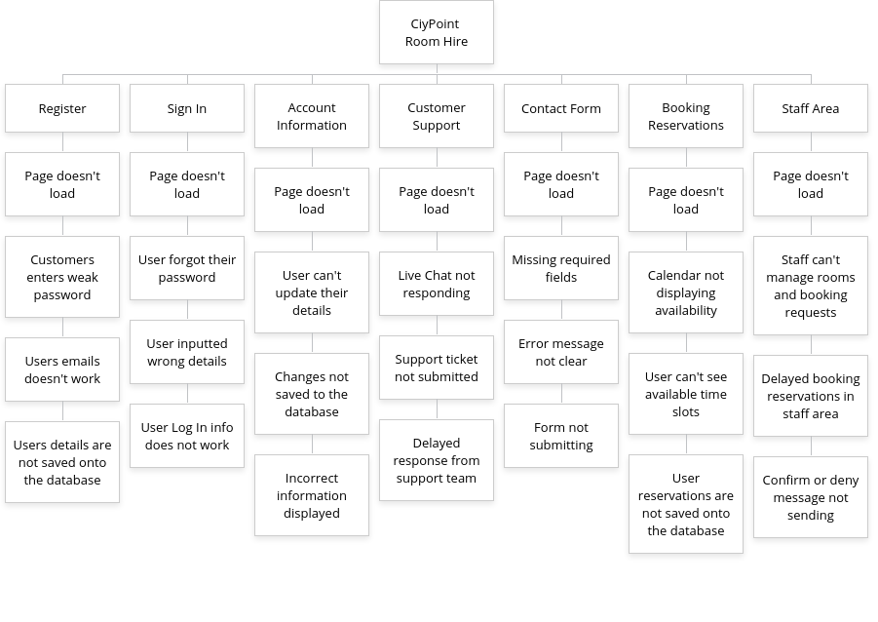

UI Consideration
- Briefly discuss the considerations that you will have to think about when making the user interface thinking about the target audience.
- Talk about colours, images, layout, text, content and more.
Security Considerations
- What security risks will be involved in creating your web-based solution?
- How will you mitigate these potential risks?
- Make sure each one is specific to your particular solution and is not just generic
Legal and Regulatory Guideline Considerations
- What legal guidelines must you consider when creating the web-based solution?
- Be specific about both computing legislation but also industry related legislation that you must follow

Set Task Brief
You work for a software development company. The company has secured a contract to develop a solution for a local venue hire business. CityPoint Room Hire specialises in:
- Room hire for meetings, training sessions and private events
- Equipment hire such as projectors, speakers and seating
- Short-term and day-long bookings for community groups and businesses
The clients (owners of CityPoint Room Hire) would like to develop a digital solution that will:
- Provide customers with information about:
  - Rooms available for hire and their facilities
  - Booking policies and staff details for the company
- Allow customers to:
  - Book rooms for specific dates and times pending confirmation
  - View and manage their existing bookings
The client has conducted market research with existing customers to identify features that could be included in the digital solution. The suggested features by the Client are:
- Account registration to allow customers to manage their bookings and data
- Accessibility features to support a wide range of users
- A staff area to manage rooms and booing requests that they can confirm or deny

