**Tarea 1: “Material de Preparación”**

**Video 1: “Alison Brown – The Urban Informal Economy”**

Informal Economy is made up of two major themes: Informal sectors and informal employments. The first are the small or unregistered enterprises the second is the workforce in the first and employment without social protection.

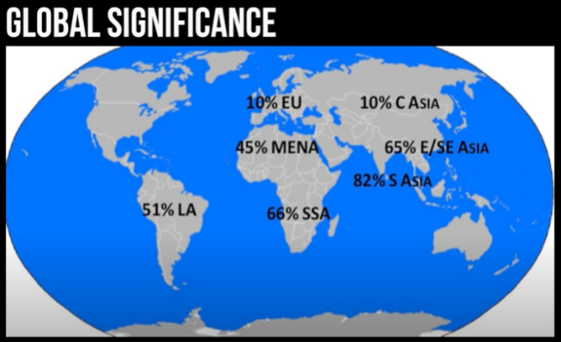Informal work is the norm in many countries, and most of the time it means precarious work, exploitation, harassment and evictions. For this reason, informal economy brings with it some challenges: Social protections don´t include informal workers, Urban regulations are complex, conflicting and outdated, working conditions are poor and gender implications are acute: women with lowest paid and most vulnerable work.

For this reason, that shows us this image informal economy should matter for the states and there are opportunities they can take advantage and start a transition between informal economy to a formal one, not only for states benefits but justice for workers that deserves equal treatment. The most relevant opportunities for states are: Enhancing productivity and productive potential.

**Video 2: “Spatial Data Mining II: A deep dive into space – Time Analysis”**

This video talks about space-time pattern mining tools:

Quantifying spatial clusters: they bring us very powerful information and they tell us a lot of the space of the data we are studying but it is lacking of time.

How we incorporate time in our analysis? The most commun are snapshots and flashing points on and of on a time slider, but both have their disadvantages.

Innovation

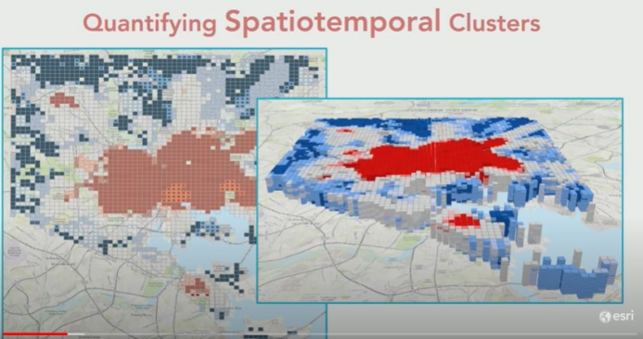The new purpose to aggregate the time in their studies is based in the next sentence: “everything is related to everything else, but near and recent things are more related than distance things.” This means that everything y spatial and temporary related.

The way they integrate time to their projects is with pattern mining toolbox through a hotspot analysis and a 3d visualization of a space-time cube.

1. 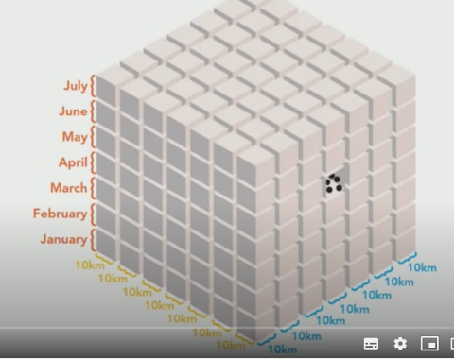Create Space Time Cube by aggregating Points: traditionally you have in a set of data and x and y dimension, so you must aggregate the z (time). You can make combinations of time and space.