## **Overview**

Take a few minutes to confirm you’re set up with the key tools below. You’ll use these tools during the boot camp and as a user experience (UX) professional.

*Note: The UX/UI Boot camp is not about teaching tools alone but rather how to use tools in the execution of a design process. There are many design tools available today and over your career, you will learn many tools. The tool does not make the designer. Learning one design tool makes it easy to pick up other design tools. For that reason, we work with Figma in this bootcamp. Figma is currently the most widely-used design tool, but as you gain skill and proficiency, we encourage you to check out the other design tools on the market. If you are interested in the statistical breakdown of what tools designers use, go and check out:* [*https://uxtools.co/*](https://uxtools.co/)*.*

## **Instructions**

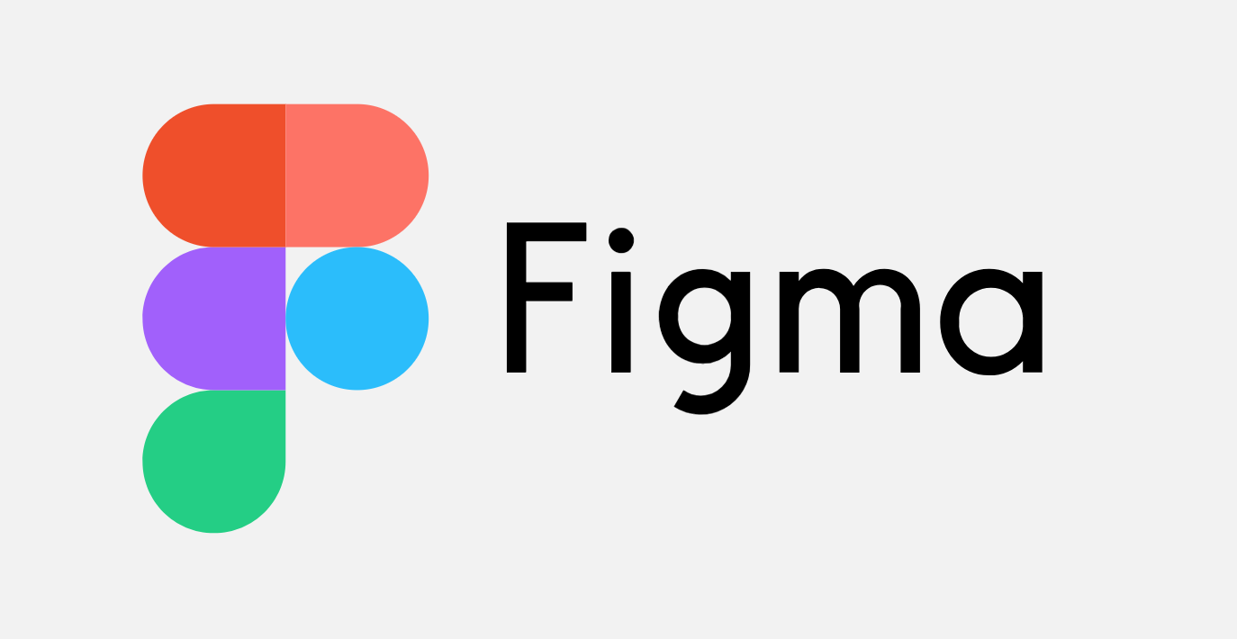

1. Create a Figma account and apply for a free education license.
   * Go to <https://www.figma.com> and select Sign Up and create an account.
   * Open the [Figma Education](https://www.figma.com/education/) select Apply for the free Education Plan.
   * Complete the application procedure.
   * Within a day or two, you may receive an email from [support@figma.com](mailto:support@figma.com) to confirm your enrollment status. Respond with a link to the boot camp and a screenshot of your enrollment email.
   * Share your Figma account email with your instructor in the 01.1-00-UX/UI-Bootcamp-Figma-Email-Sign-Up spreadsheet and your instructional staff will invite you to your class’ Figma Team.



1. Create a Miro account.
   * Go to <https://miro.com/education-whiteboard/> and select sign up for free.
   * Follow the sign up procedures.
   * Share “My first board” in Slack.
   * Share your Miro account email with your instructor via Slack.
   * **Note:** The free version of Miro only allows three boards to be active at a time. You do not have to purchase a Miro license to complete or be successful in the bootcamp. To overcome the board limit, we recommend that you maximize the amount of space used on a board and take frequent screenshots of your boards to save your work.

**In the Real World**

UX/UI design tools are constantly changing. As a UX/UI designer, your ability to pick up and use a variety of software tools effectively will make you more employable. We will use design tools in the boot camp, but you will need to practice and learn the basics at home. The design process takes precedence over the tool used to make the solution. More important is your ability to get good at tools and be effective and efficient to execute the design process.

## **Resources**

As part of your homework, you will need to devote time to better learning your tools. To help you out, we’ve created a [list of software resources for you to check out](https://docs.google.com/document/d/1cZFyb_bqD9_rgaJ_P45zPfdCCydSmi8NDfjOePYb_TU/edit?usp=sharing).