## **Overview** Your class has been hired by Airbnb.com to conduct user research. To begin the research process, your class is going to create a proto-persona for a potential user of the Airbnb website.

The goal of this exercise is to practice empathy for the people who use Airbnb.

## **Instructions** **Part 1: Activity Setup** (2 min)

1. Use the Miro board shared from the previous instructor demo.
2. Download the **01.1-02-Proto-persona-template.svg** found in the 01-Activities folder to your board.
3. Upload the template to your board.
   1. Right-click the template and select **Lock** (cmd + L).

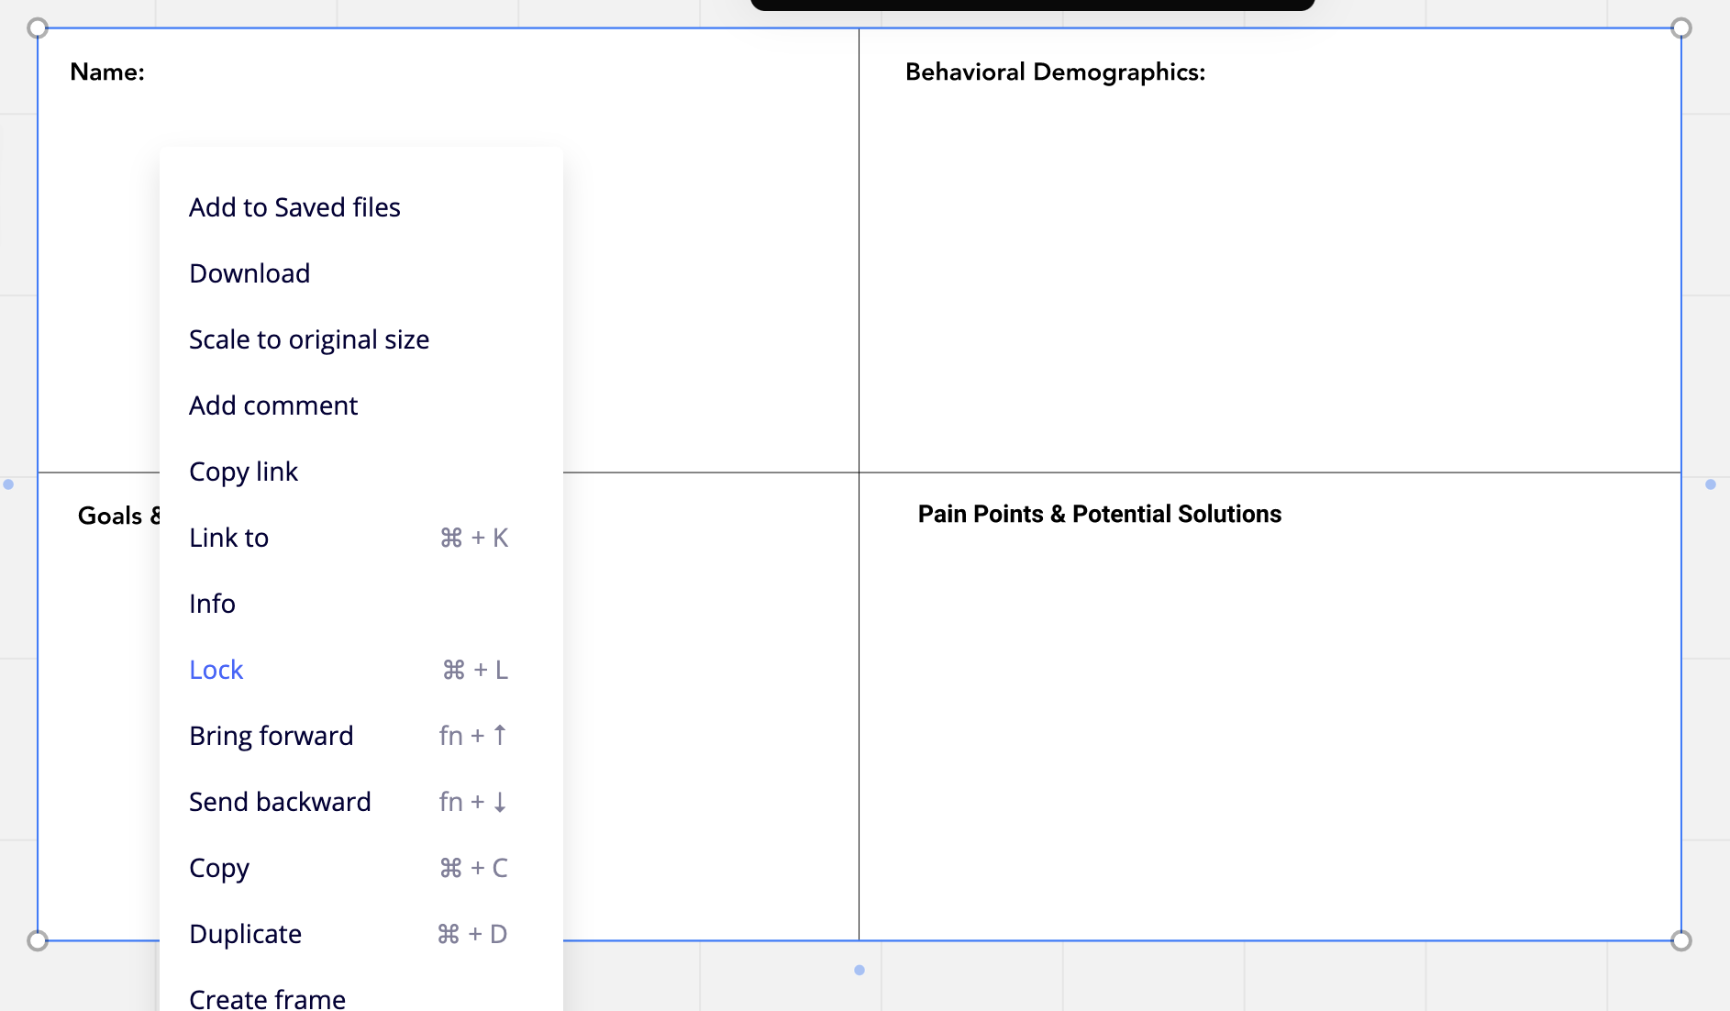

**Part 2: Proto-Persona Empathy** (12 min)

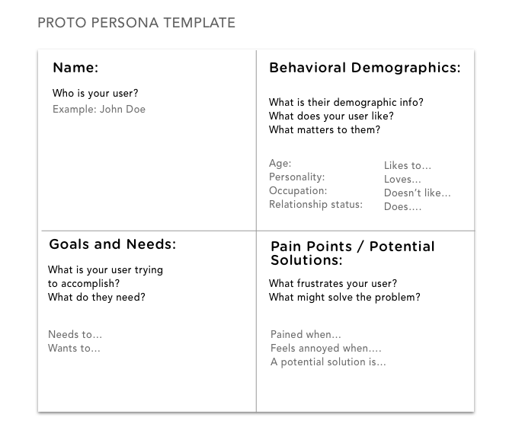

1. First, get into the mind of the typical Airbnb user.
   * Visit [Airbnb.](http://airbnb.com/)
   * Examine the site’s homepage, navigation, menus, and other pages.
   * *Tip! Notice how elements like imagery offer suggestions for who the user is, how the color palette reflects user sensibility, and how copy is written to suggest what problem the site solves for users.*
2. Next*,* create a proto-persona for an Airbnb user.
   * **Humanize the persona:** Give the user a name, age, and drawing (a stick figure is OK).
   * **Define it:** Use demographics like family status, income, location, devices owned, personality traits, etc.
   * **Explain their motivations:** Give the user needs and goals.
   * **Issues:** Define the user’s pain points.
3. As you fill in each section of the proto-persona, consider the following questions:
   * Who is the Airbnb user?
   * What is their demographic info?
   * What does the user like?
   * What matters to them?
   * What is the user trying to accomplish?
   * What frustrates the user?
4. What are some potential solutions for their frustrations?
   * Write some quick ideas.

*Tip! Remember that a proto-persona is speculative and subjective. As long as you are basing your answers and notes on elements of the Airbnb site, there is no “wrong” user proto-persona. Do your best to avoid stereotypes.*

1. Save your work by exporting your board as an image or pdf.

**In the Real World**

Designers use proto-personas as a tool for creating group consensus on the characteristics of a user. While proto-personas are hypothetical, they’re still a helpful starting point to help get the product teams on the same page quickly.

Although a proto-persona is a casual, ad-hoc tool, you'll use proto-personas as a professional when you need to get buy-in from a team or client, foster empathy for the user, or get stakeholders aligned on user needs.   
  
Proto-personas should be iterated throughout your user research and design process.