SILICON UNIVERSITY

NAME- ARADHANA MOHANTY

SIC-24MMCD89

DATE OF SUBMISSION -20/07/2025

Acknowledgement:
I am grateful to have successfully completed my summer internship at Ingenious-tech as part of my Master's program, where I gained valuable hands-on experience in Microsoft Azure. This internship provided me with deep insights into cloud computing, virtual networking, and full-stack deployment. I am now pleased to submit my final project, which is based on the practical knowledge and skills I acquired during this enriching learning journey.
AZURE CLOUD ASSIGNMENT

Full -Stack App Deployment with VNet,VM,Load Balancer Domain

Step 1- Create separate Virtual Network (VNets)for the frontend and backend /datbase parts of the application:

Definations:
- Virtual Network (VNet): A Virtual Network in Azure is a private, isolated network that allows Azure resources like VMs to securely communicate with each other, the internet, and on-premises networks.
- Subnet: A subnet is a segment within a virtual network where specific resources like virtual machines are placed. Subnets help organize and isolate resources for better management and security.
- Public IP: A public IP address is used to allow external access to a virtual machine over the internet. It makes the VM reachable from outside the Azure network.

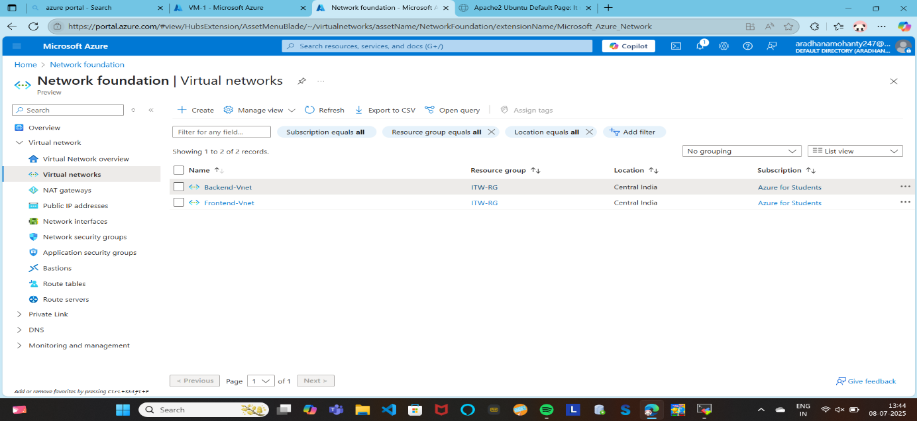

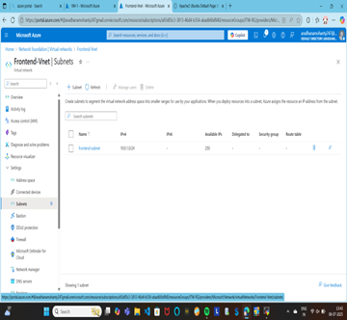

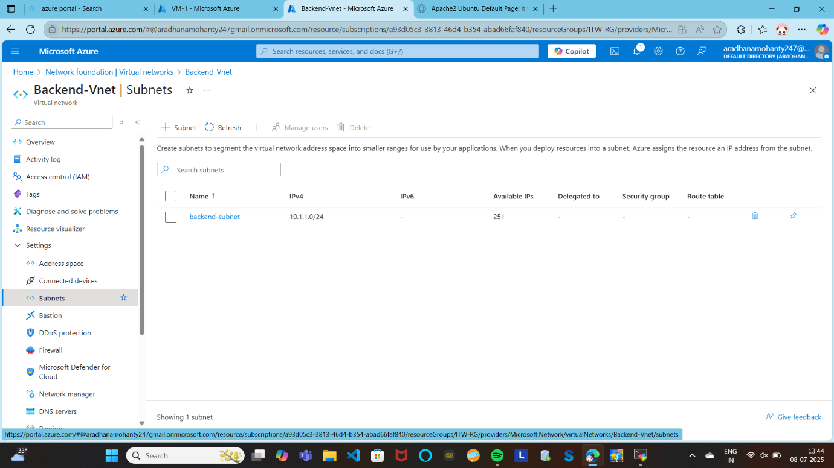
Step 2- Deploying Virtual Machines inside each VNet:
- One (or more) for the frontend
- One for the database/backend
- Include a Jump VM to security access both networks and perform changes.

In Step 2, we deployed virtual machines (VMs) within separate virtual networks (VNets) for frontend and backend operations. A Fronted-VM was created inside the frontend VNet to handle web server tasks. Another Backend- VM was deployed in the backend VNet for hosting the database. A Jump VM was also set up in a dedicated subnet with a public IP to securely access both frontend and backend VMs. To enable secure communication between VNets, we configured VNet peering between the frontend and backend VNets. This setup ensures proper isolation, security, and connectivity across different layers of the application.

Definations:
- Virtual Machine (VM): A virtual machine is a software-based emulation of a physical computer. It allows you to run applications, host services, and perform computing tasks without the need for physical hardware.
- Private IP: A private IP address is only accessible within the Azure virtual network. It's used for secure, internal communication between resources.
- Jump Server (or Bastion Host): A jump server is a virtual machine with a public IP that acts as a secure entry point to access other VMs in private subnets or VNets that do not have public access.
- VNet Peering: VNet peering connects two virtual networks in Azure, allowing resources in those VNets to communicate with each other using private IP addresses over Azure’s backbone network.
- SSH (Secure Shell): SSH is a secure protocol used to remotely access and manage Linux-based systems through a command-line interface.
- NSG (Network Security Group): NSGs are firewall-like rule sets that control the flow of network traffic in and out of Azure resources such as VMs or subnets.

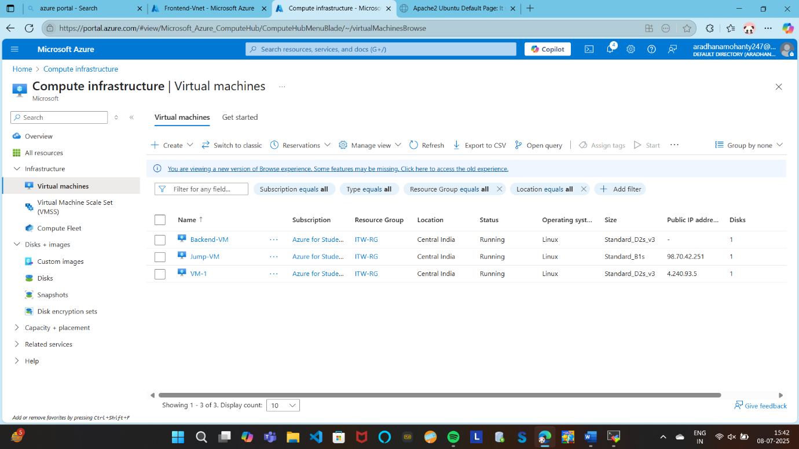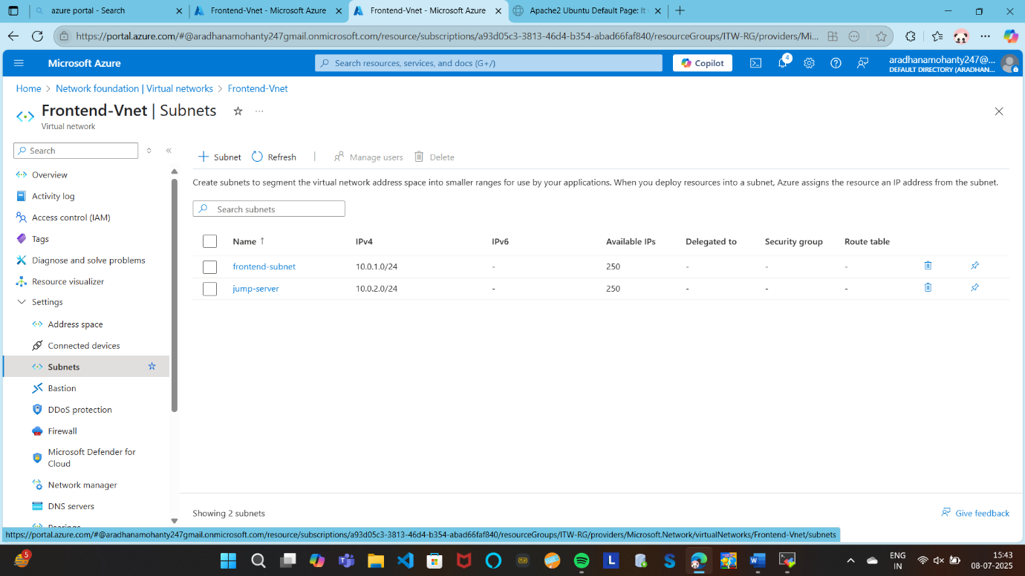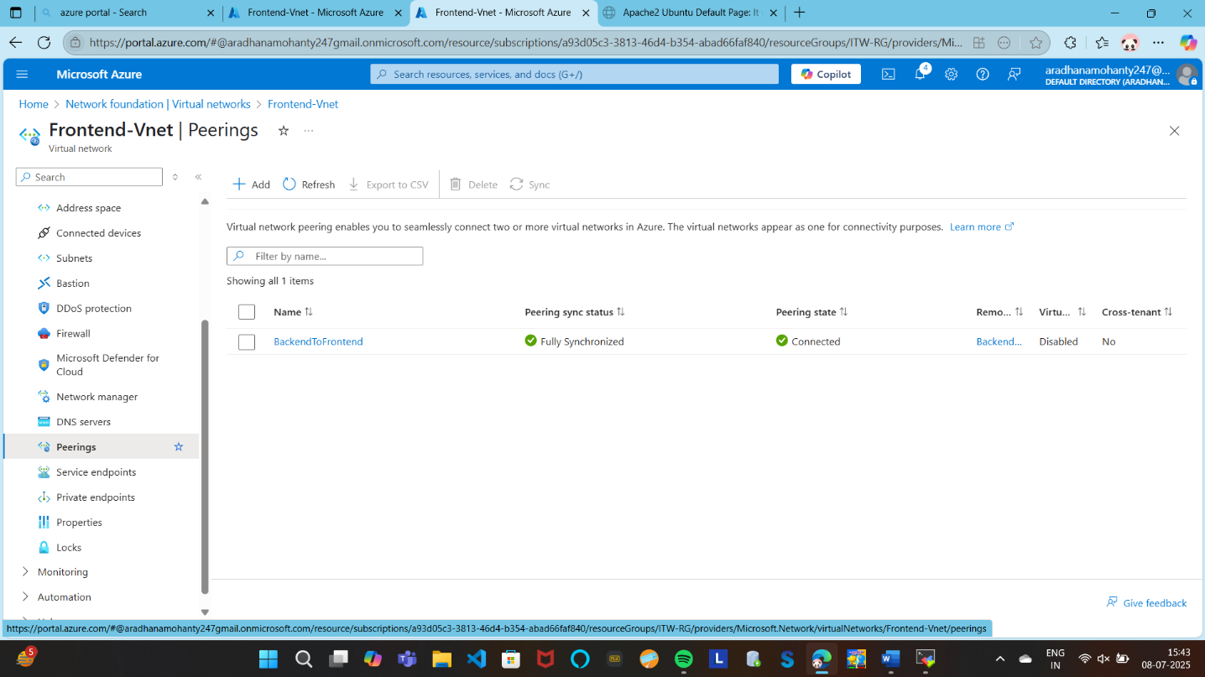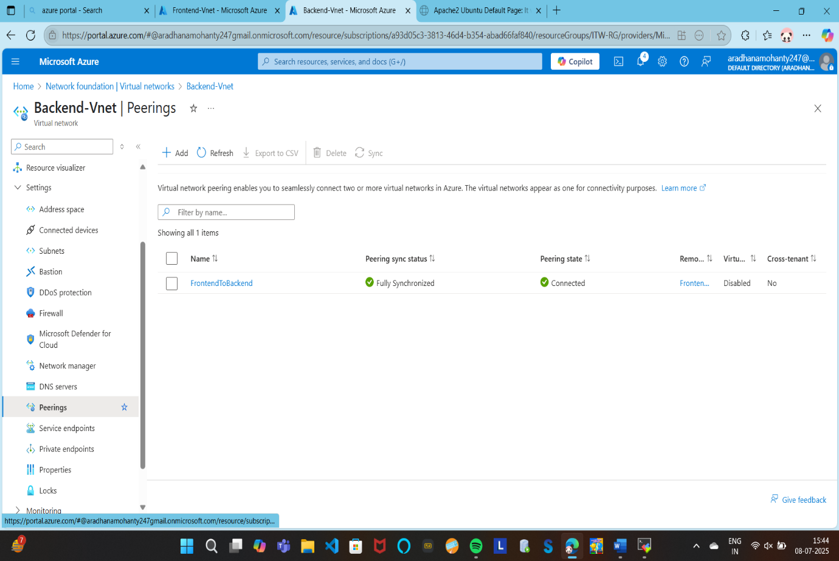s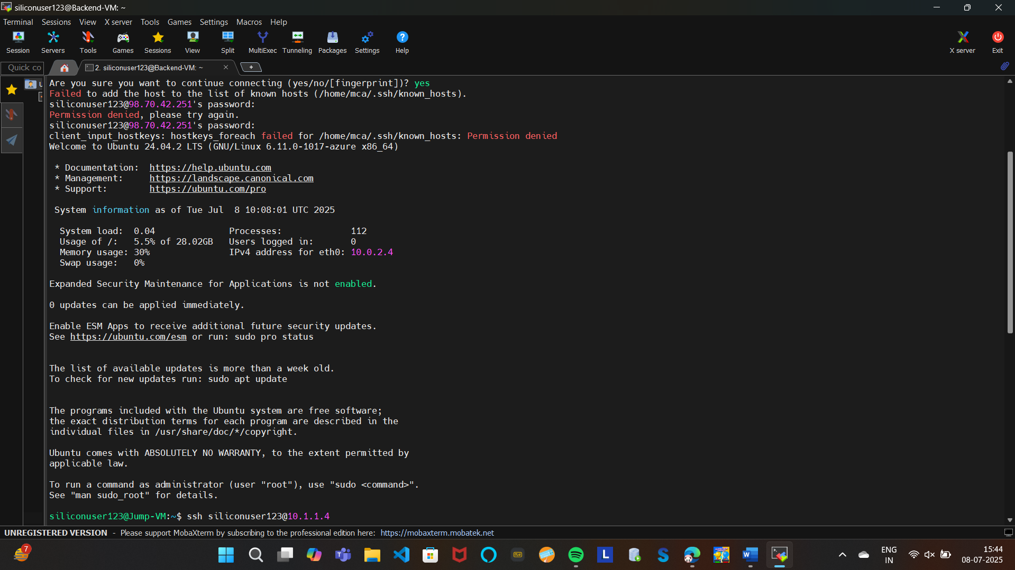
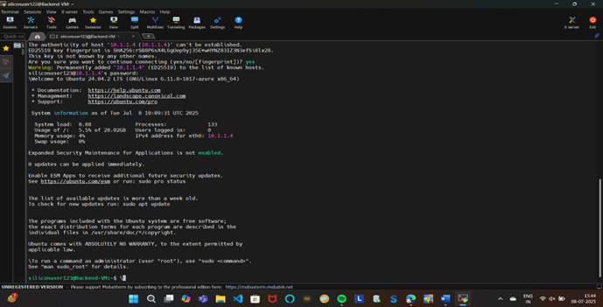
Step 3-Attach a Load Balancerin front of the frontend VMs ans assign a public id to load balacer only (not the individual VMs).

In this project, an Azure Standard Public Load Balancer named frontend-lb was configured to distribute incoming traffic across multiple VMs in a backend pool using port forwarding and health probes. A frontend IP was set up to listen on port 77, which forwards traffic to port 80 on the backend VMs. A health probe on port 80 ensures only healthy VMs receive traffic. An outbound rule with SNAT was also configured to allow backend VMs internet access without needing public IPs. This setup ensures high availability, scalability, and efficient traffic distribution for the stack application.

Definations:
- Azure Load Balancer: It is a Layer-4 (TCP, UDP) load balancer that distributes incoming traffic among healthy virtual machines (VMs) in a backend pool. It ensures high availability, scalability, and fault tolerance for your application.
- Frontend IP Configuration: The public IP that receives incoming traffic. In your case, traffic comes in on port 77
- Backend Pool: Contains the NICs of VMs (e.g., frontend, backend VMs). These VMs serve traffic.
- Health Probe: Monitors VMs on port 80. If a VM doesn’t respond, it’s removed from traffic routing.
- Load Balancing Rule: Routes external requests from port 77 (frontend) to port 80 (backend) of the VMs in the backend pool.
- Outbound Rule: Configures SNAT (Source Network Address Translation), so VMs without a public IP can still access the internet.
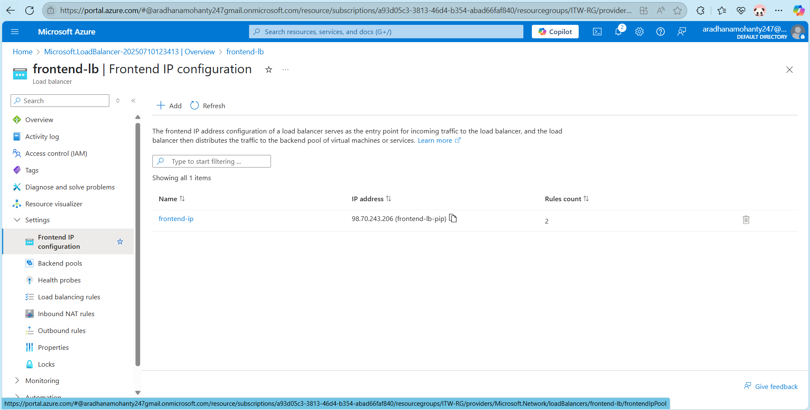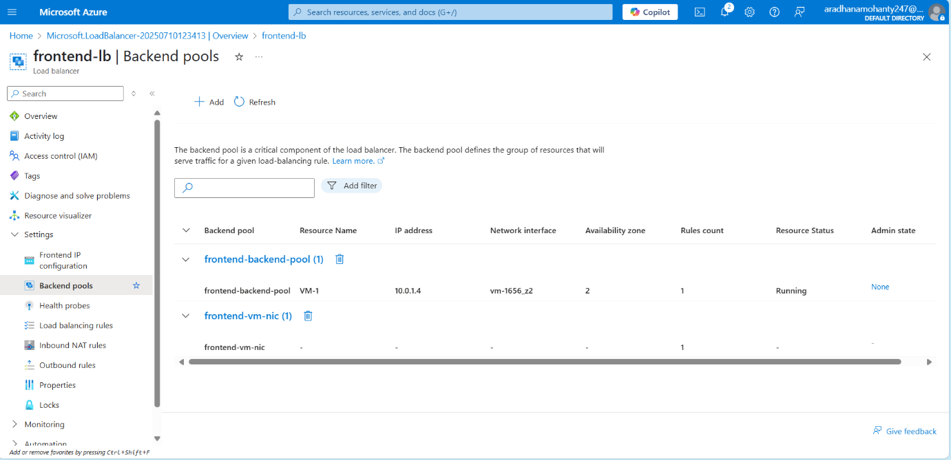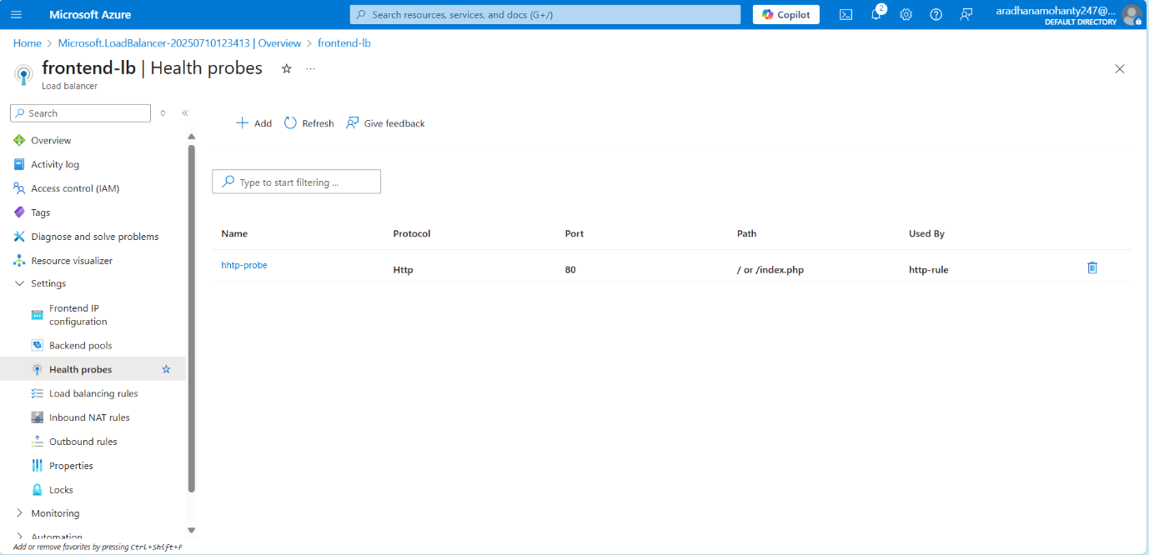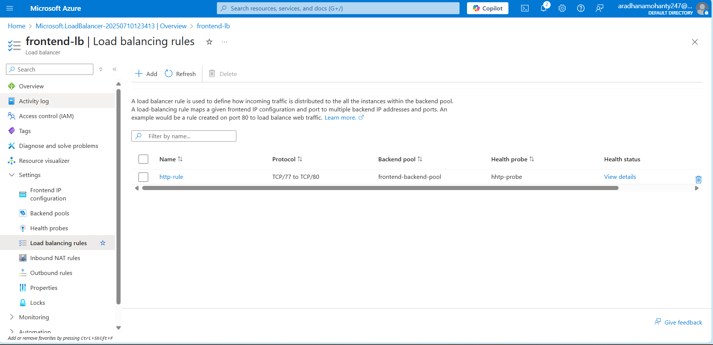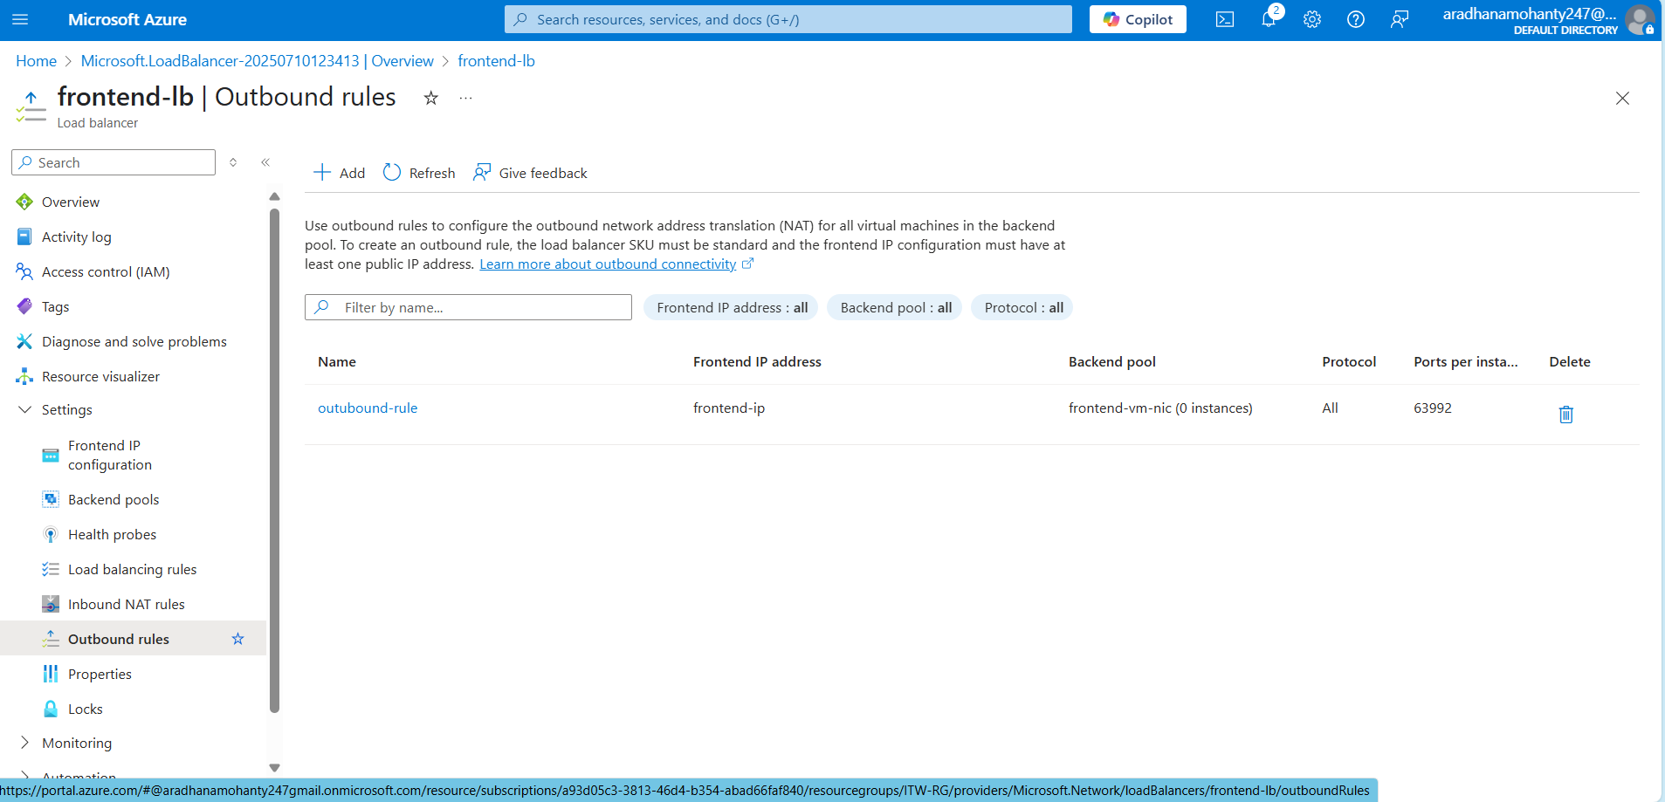
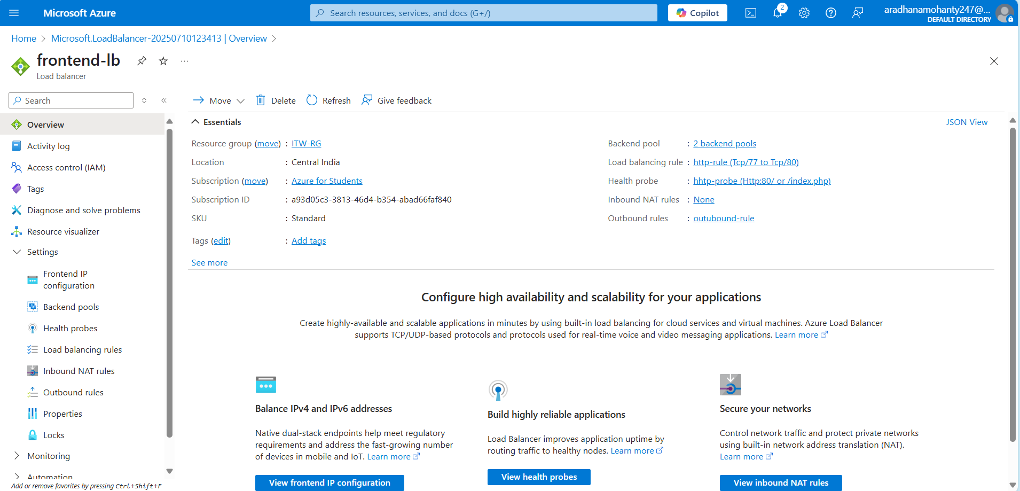

Step 4- Enabling Autoscaling on the frontend VMs to manage high traffic gracefully:

In this step, we implemented auto-scaling in Azure using a Virtual Machine Scale Set (VMSS) to ensure that our web application running on the frontend can scale automatically based on demand. First, we created a new VMSS within the same virtual network and subnet as our existing load balancer and frontend infrastructure. While creating the VMSS, we chose an existing image (custom or marketplace) to ensure all VM instances are identical in configuration. After successful deployment, we connected the VMSS to the backend pool of the load balancer, allowing it to receive traffic.
Next, we configured the Inbound NAT Pool on the load balancer to assign individual ports (like 50000, 50001, etc.) to each VMSS instance, enabling SSH access. For SSH to work, we ensured that port 22 was allowed in the inbound security rules of the load balancer and the Network Security Group (NSG) attached to the VMSS. After that, we manually SSH-ed into an instance using the public IP and NAT port, and installed Apache2 to test web server functionality.
Finally, we configured the auto-scaling rules based on CPU utilization. A rule was created to scale out (add a VM instance) when the CPU usage goes above a certain threshold (e.g., 70%) and scale in (remove an instance) when it goes below a defined level (e.g., 30%). This setup ensures our application is scalable, responsive under load, and cost-efficient during low usage periods.

Definitions:
- Virtual Machine Scale Set (VMSS): An Azure service that enables automatic deployment and management of a group of identical virtual machines for high availability and scalability.
- Auto-scaling: A process that automatically adjusts the number of VM instances in a scale set based on defined performance metrics or schedules.
- Load Balancer: A networking service that distributes incoming traffic across multiple VM instances to ensure even load and application reliability.
- Backend Pool: A group of VM or VMSS instances associated with a load balancer to receive and process network traffic.
- Inbound NAT Pool: A configuration that maps unique frontend ports on a load balancer to specific VMSS instances to allow individual access, such as SSH.
- Network Security Group (NSG): A set of firewall rules that controls inbound and outbound traffic to Azure resources, essential for enabling port access (e.g., SSH on port 22).
- Apache2: A widely used open-source HTTP server software installed to serve web pages from VM or VMSS instances.
- Custom Image: A user-defined VM image used to create uniform VMSS instances with preinstalled software and configurations.

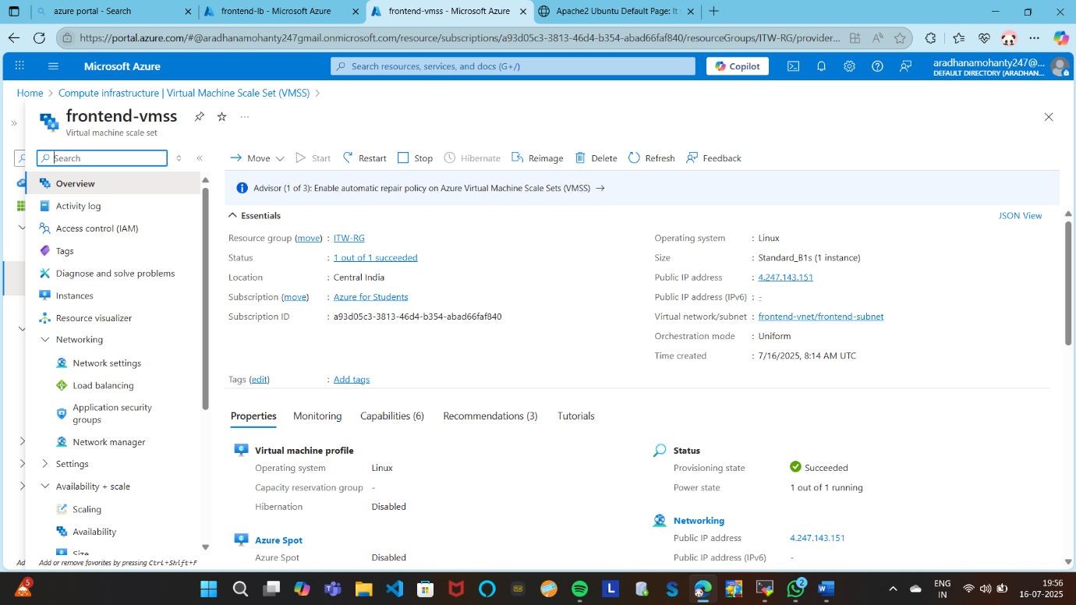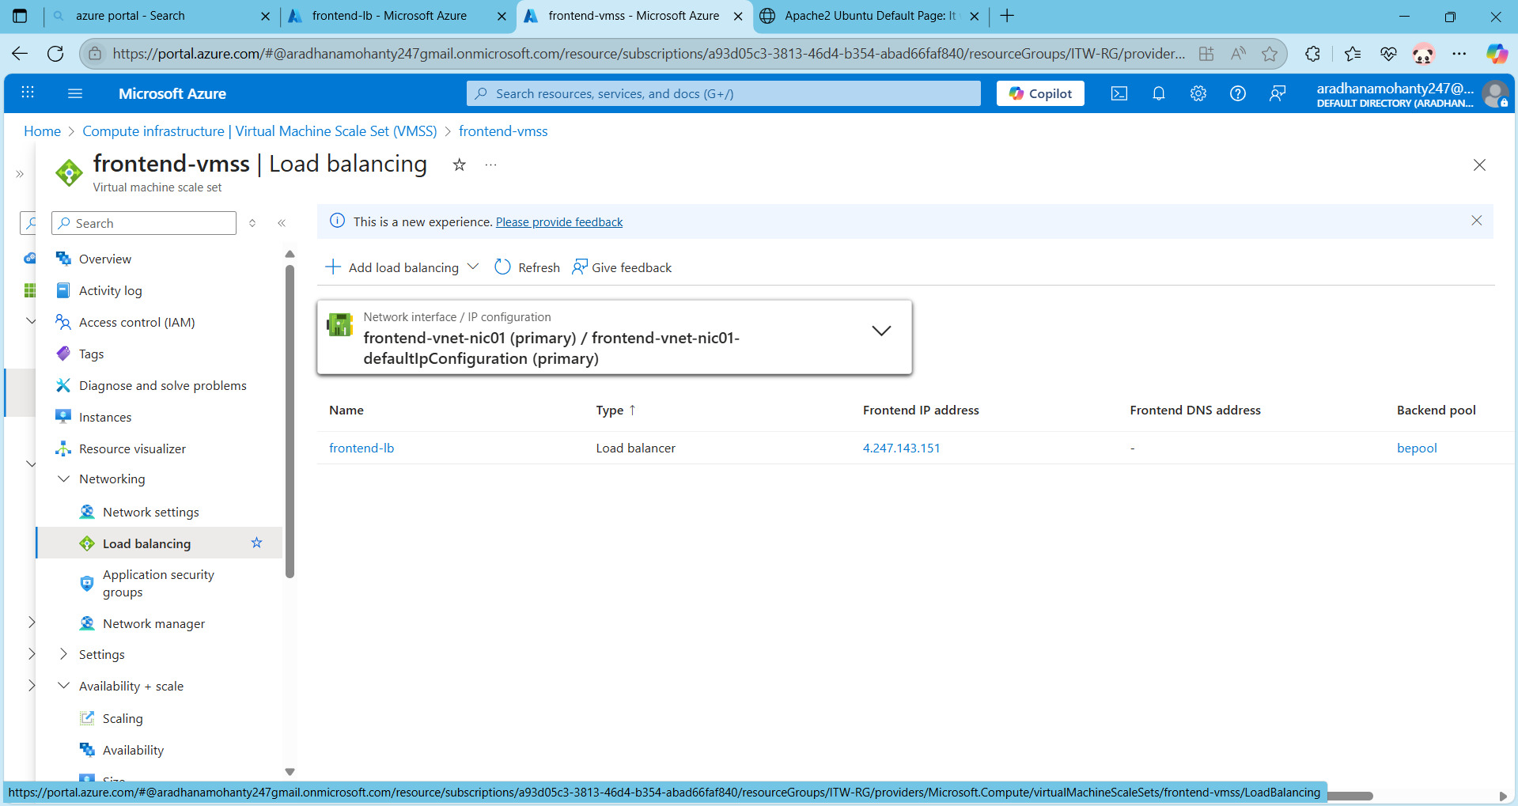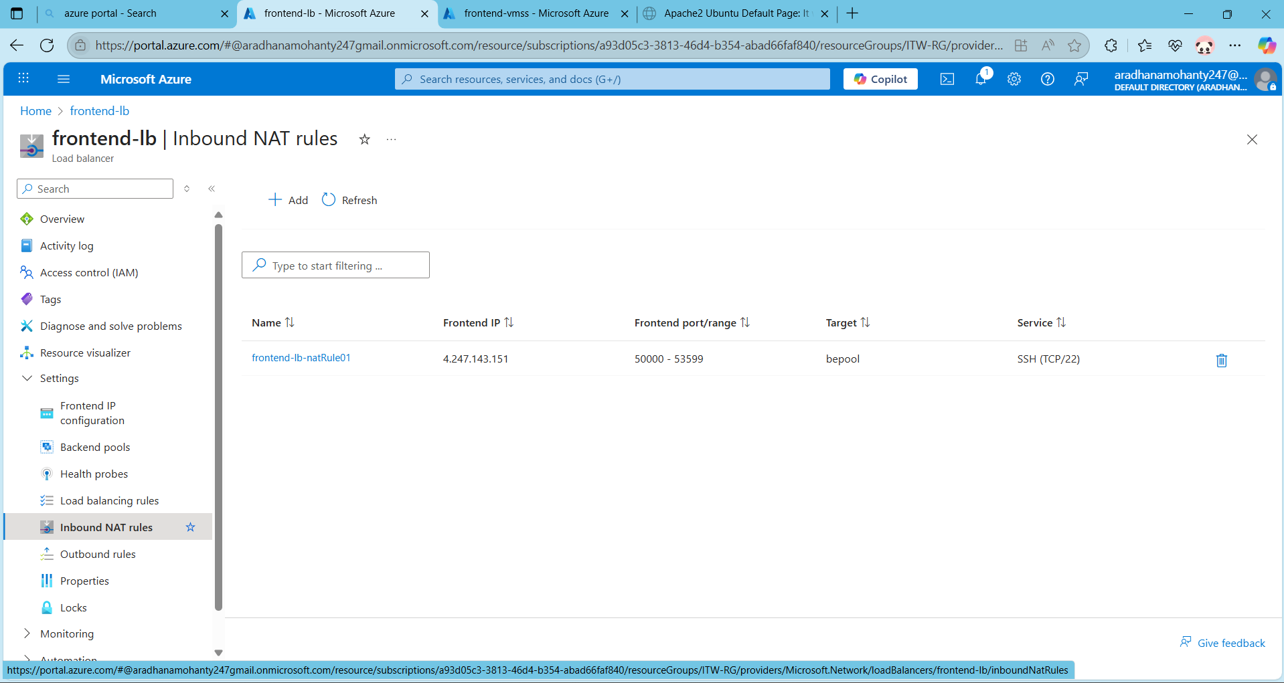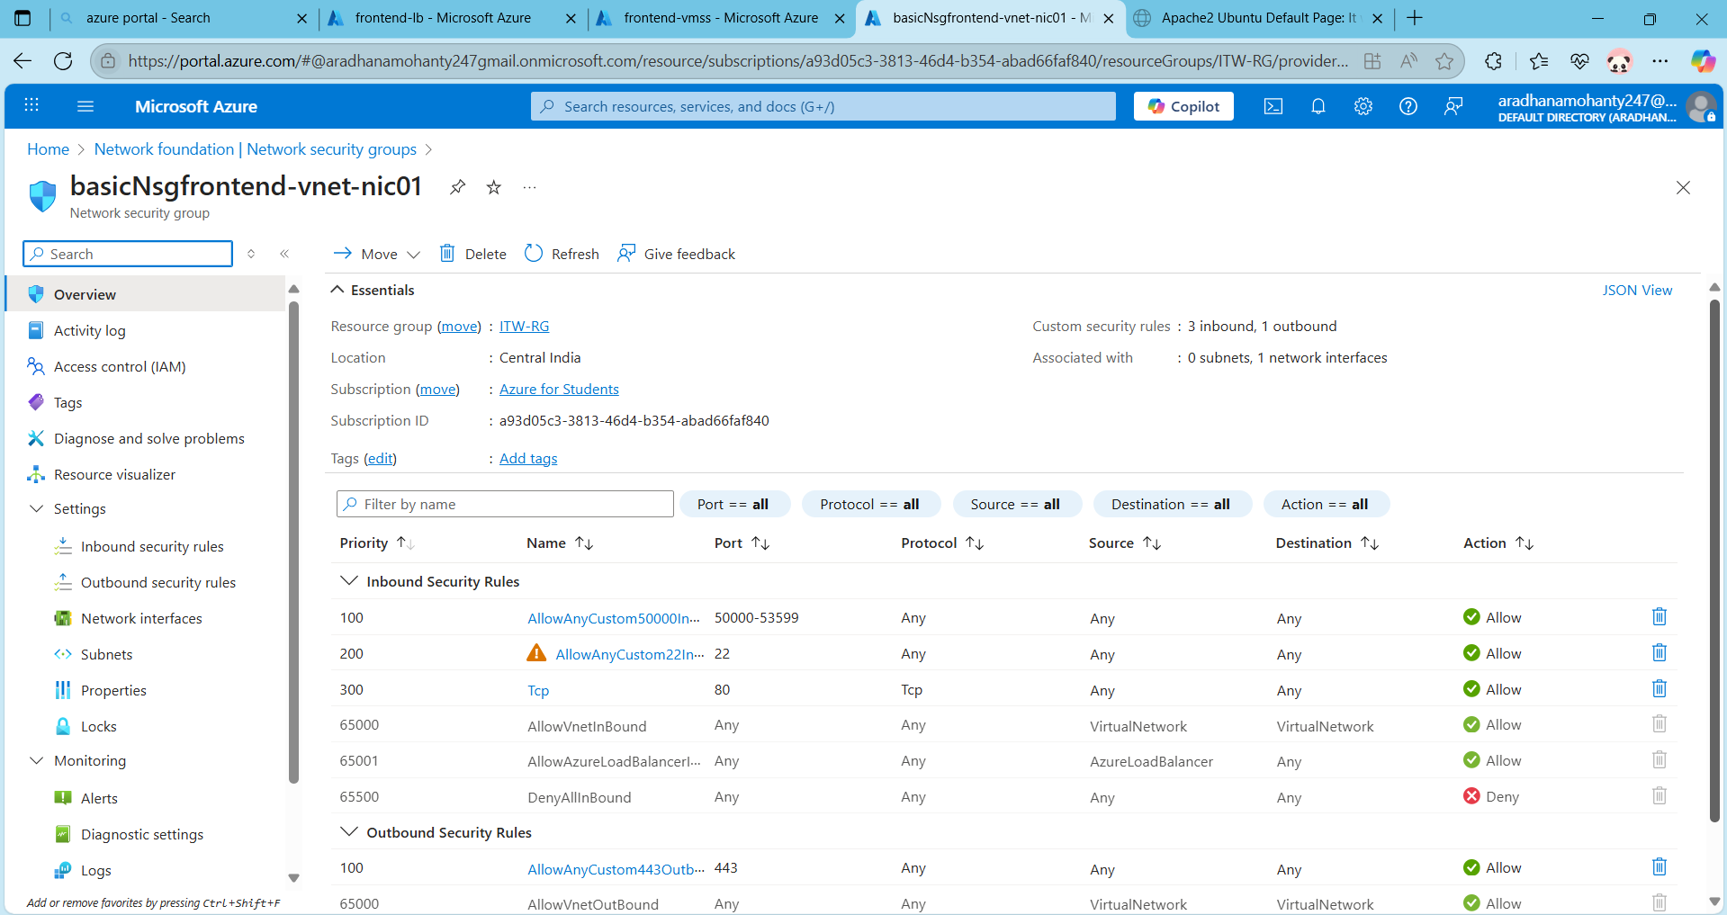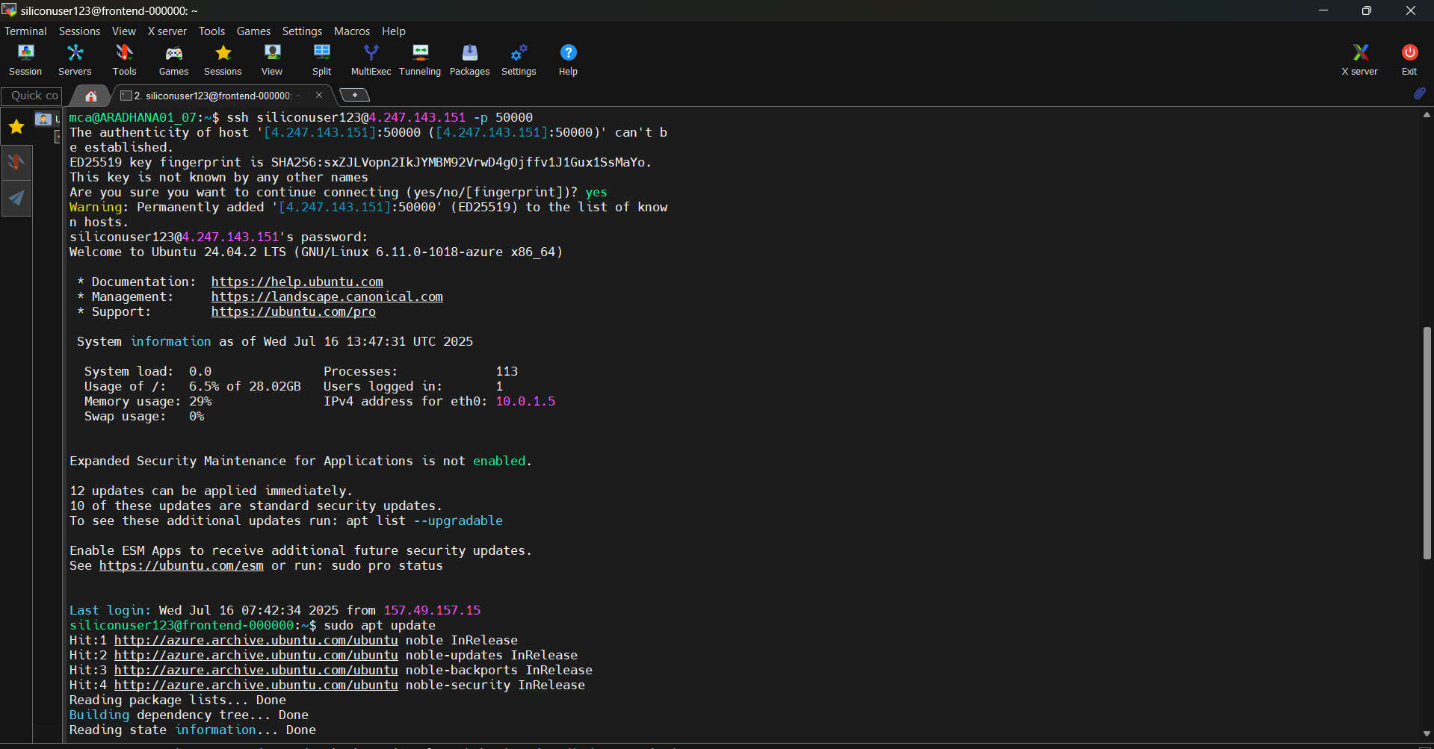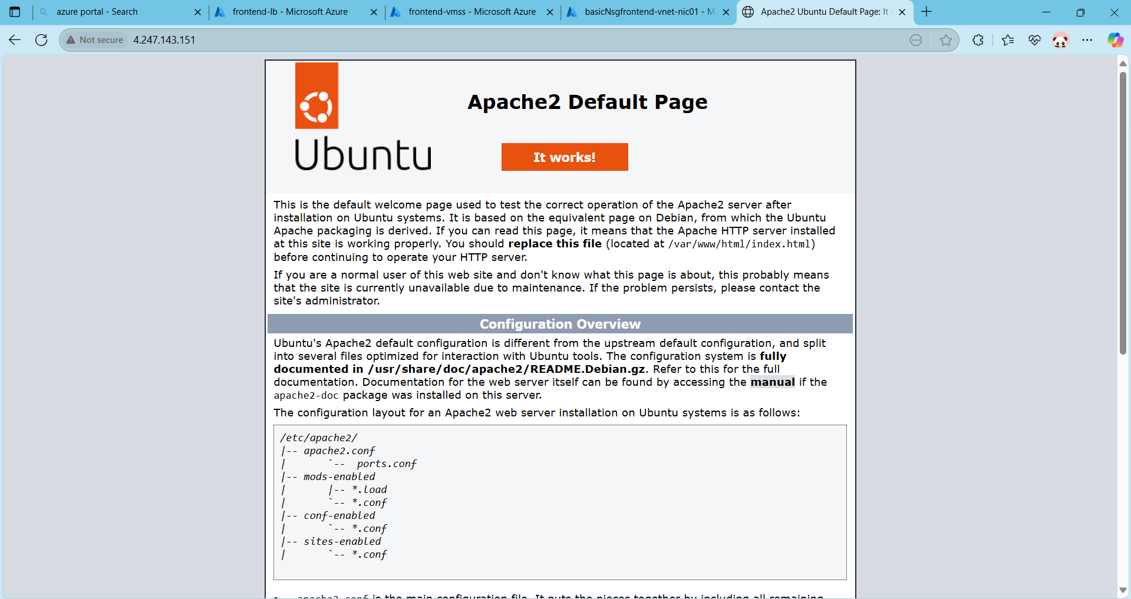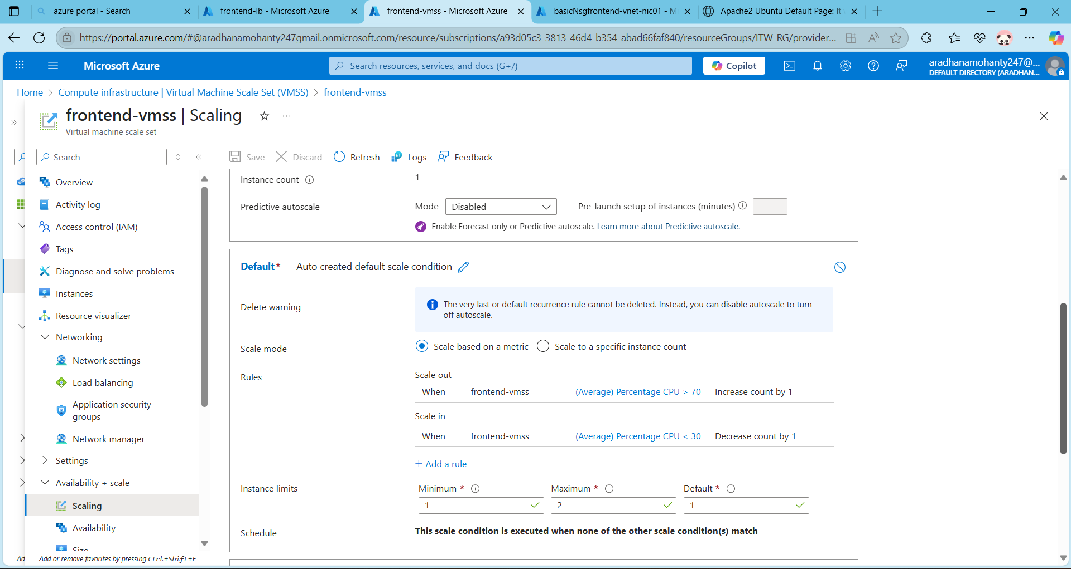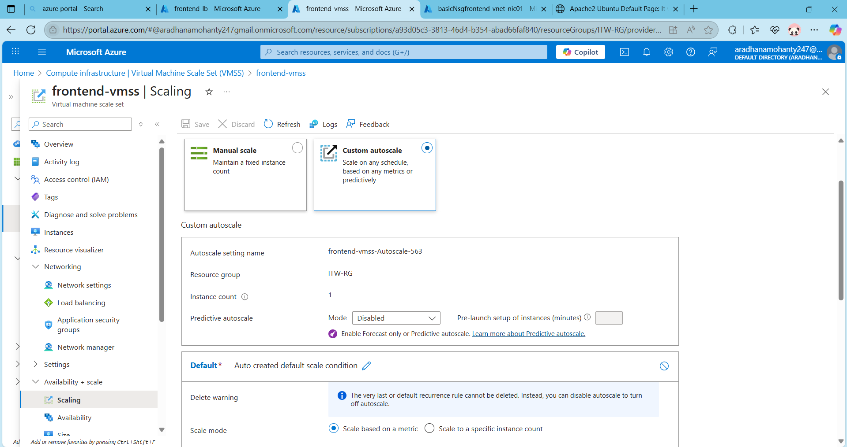

Step-5: Configure VPN access via the Jump VM, so all connections to the VMs happen through a private path.

Definitions:
- Jump VM (Bastion Host): A VM in a public subnet that acts as a gateway for accessing private VMs in a secure network.

- Private IP: IP address used within a virtual network. VMs in Azure Vnet can communicate via private IPs.
- SSH Proxy or Hop: The process of using the Jump VM to "hop" into other VMs using private IPs.
- VPN (Virtual Private Network): A secure tunnel allowing remote devices to connect to Azure network resources privately. (In your case, Jump VM is used instead of full VPN Gateway.

In Step 5, the objective was to securely access all virtual machines (frontend, backend, and VMSS instances) using private IP addresses only, by configuring a Jump VM (also known as a bastion host). This Jump VM was placed within the same virtual network (Vnet) as the other VMs and was assigned a public IP address with port 22 open for SSH access. Once connected to the Jump VM via SSH from the local system, we were able to access other internal VMs through their private IPs, ensuring that these VMs do not need public IPs or exposed ports. This step simulates VPN-like secure internal connectivity, where the Jump VM acts as a controlled gateway for managing resources within the private network, reducing attack surface and improving security posture for the cloud deployment.

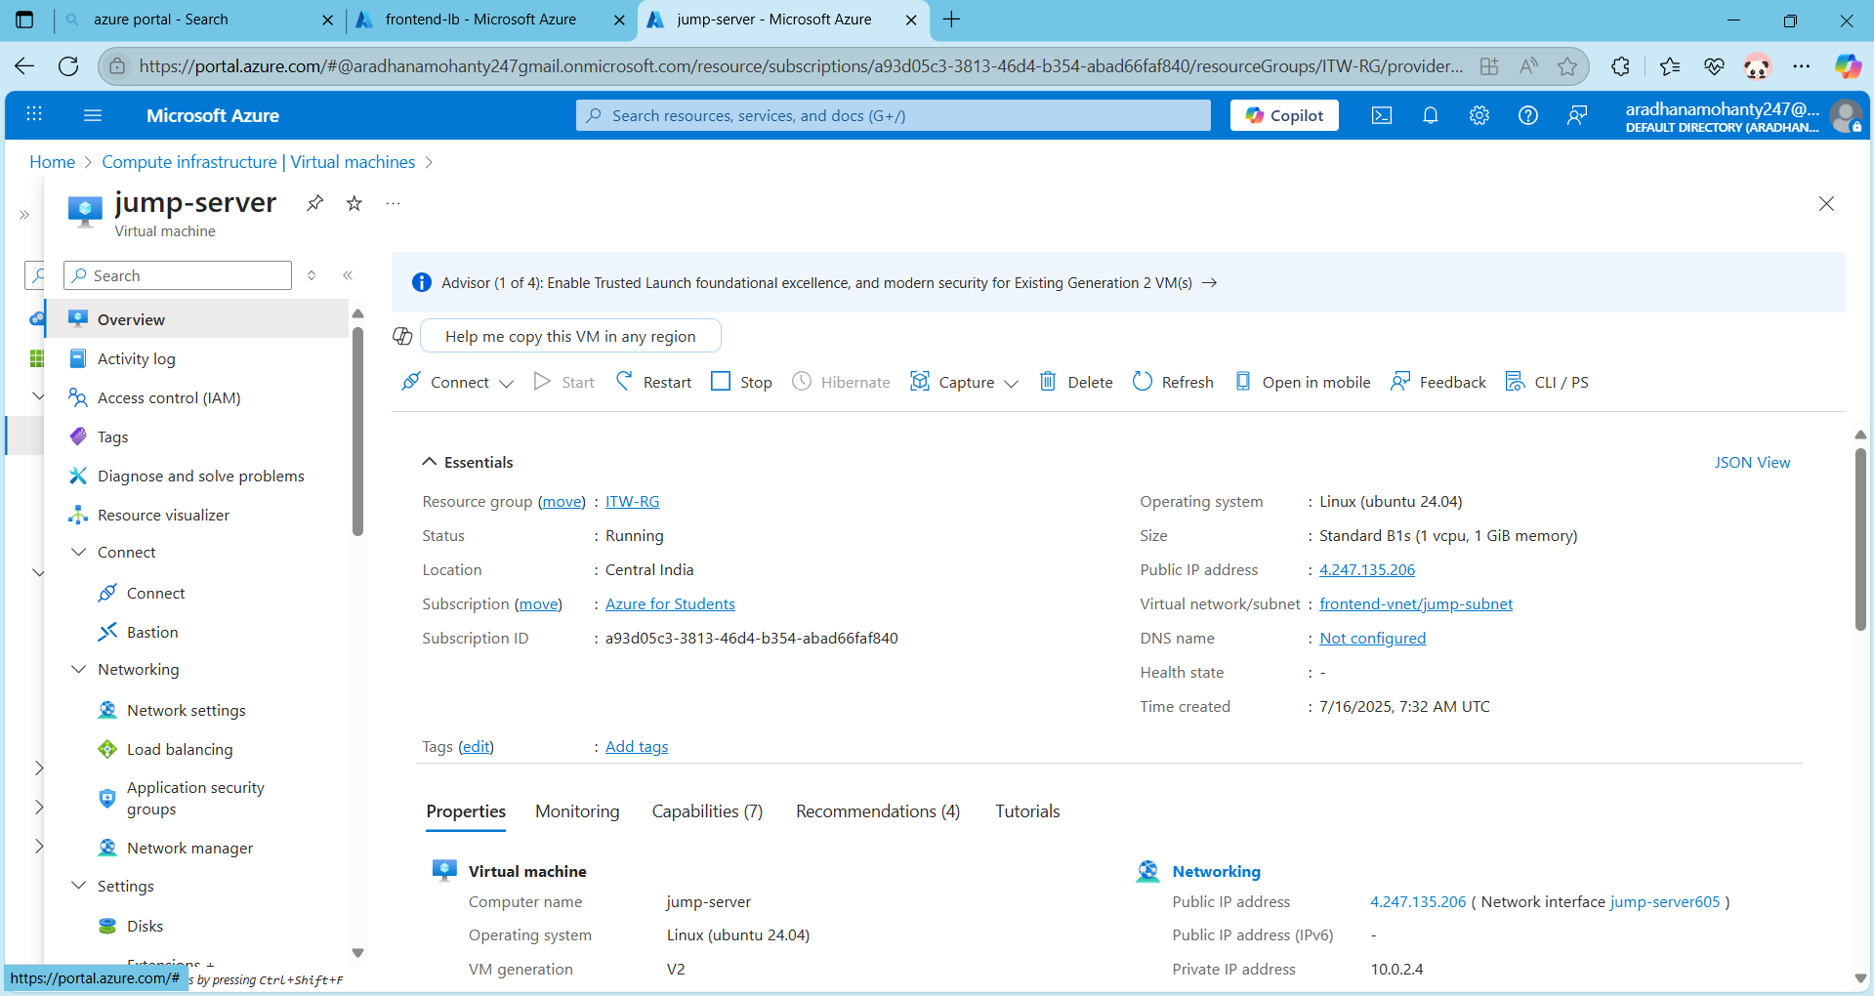
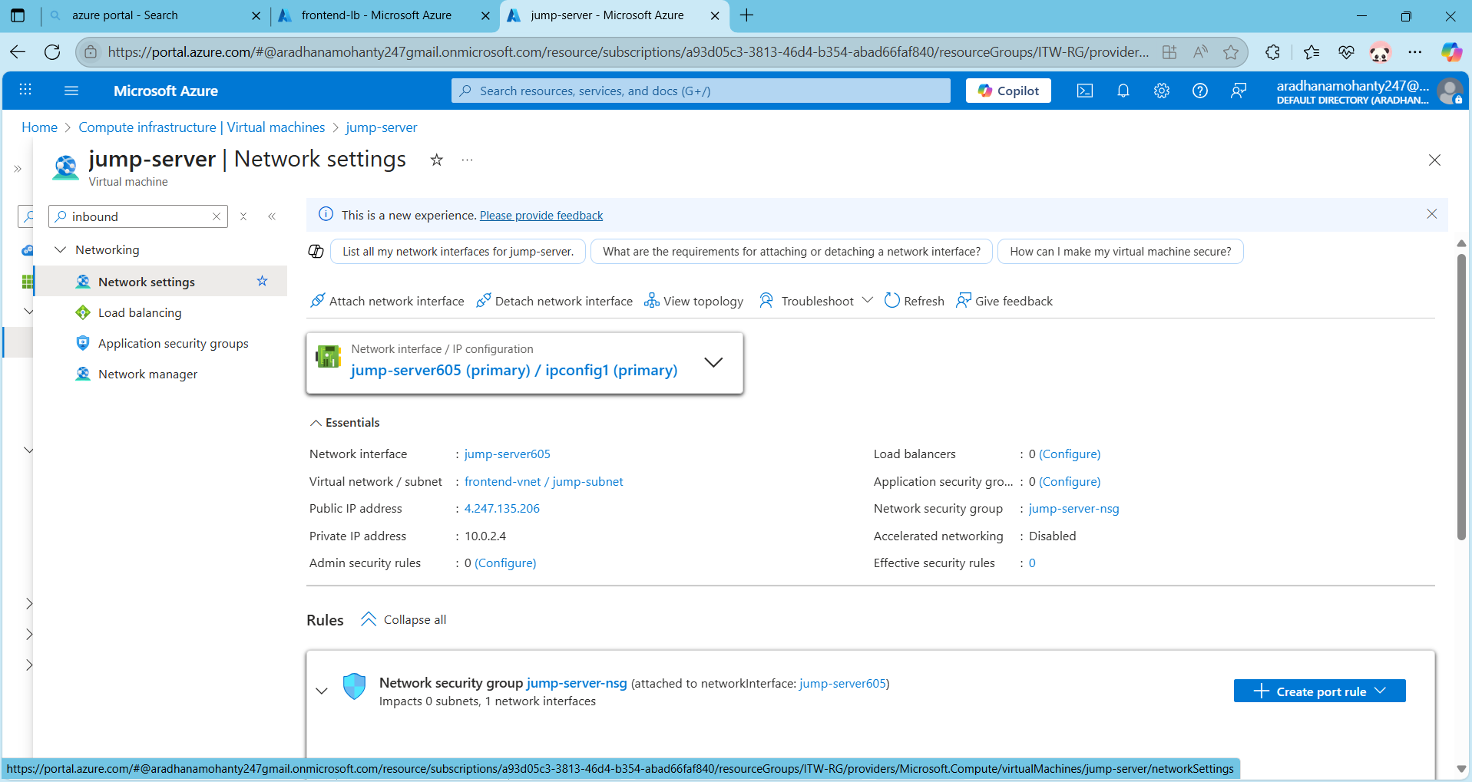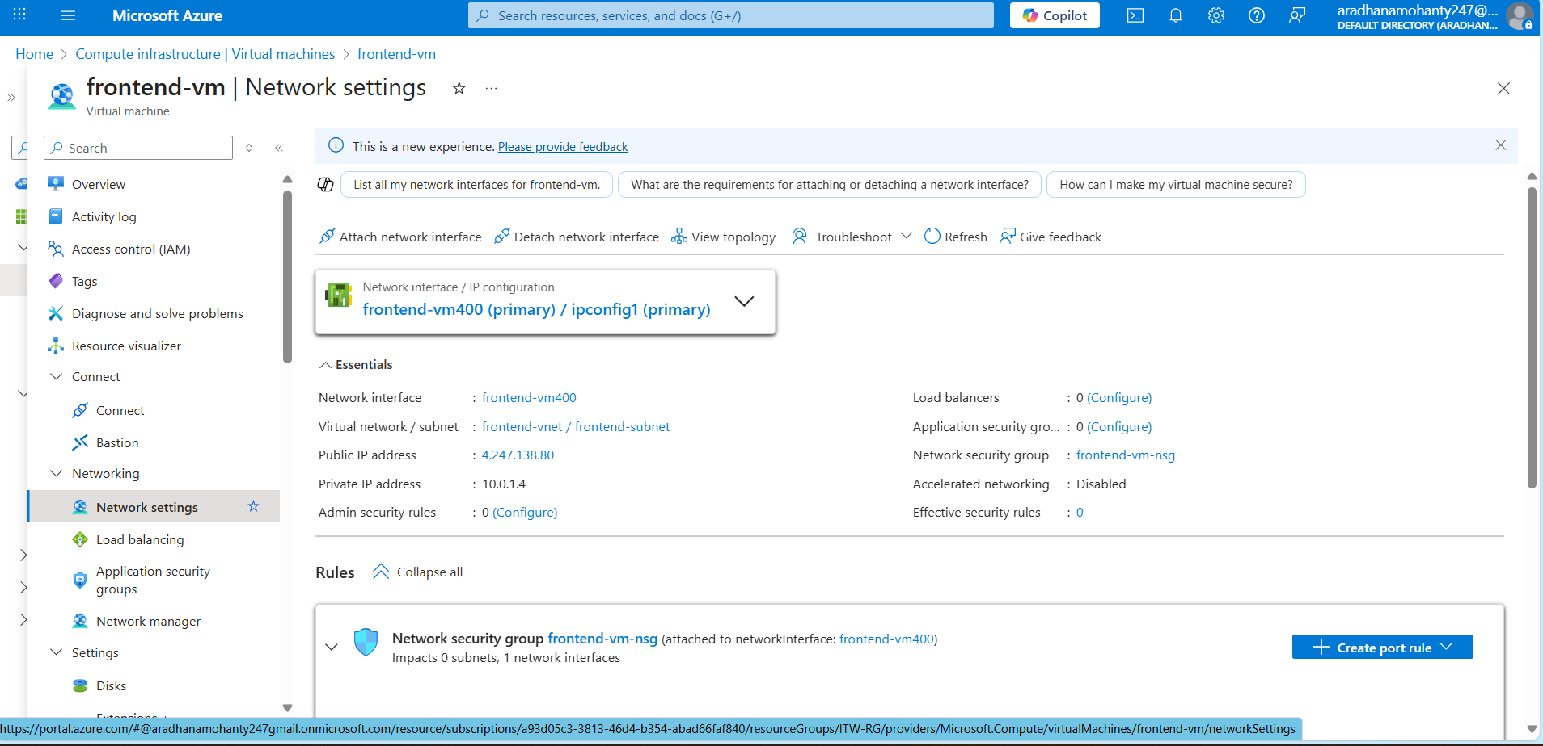s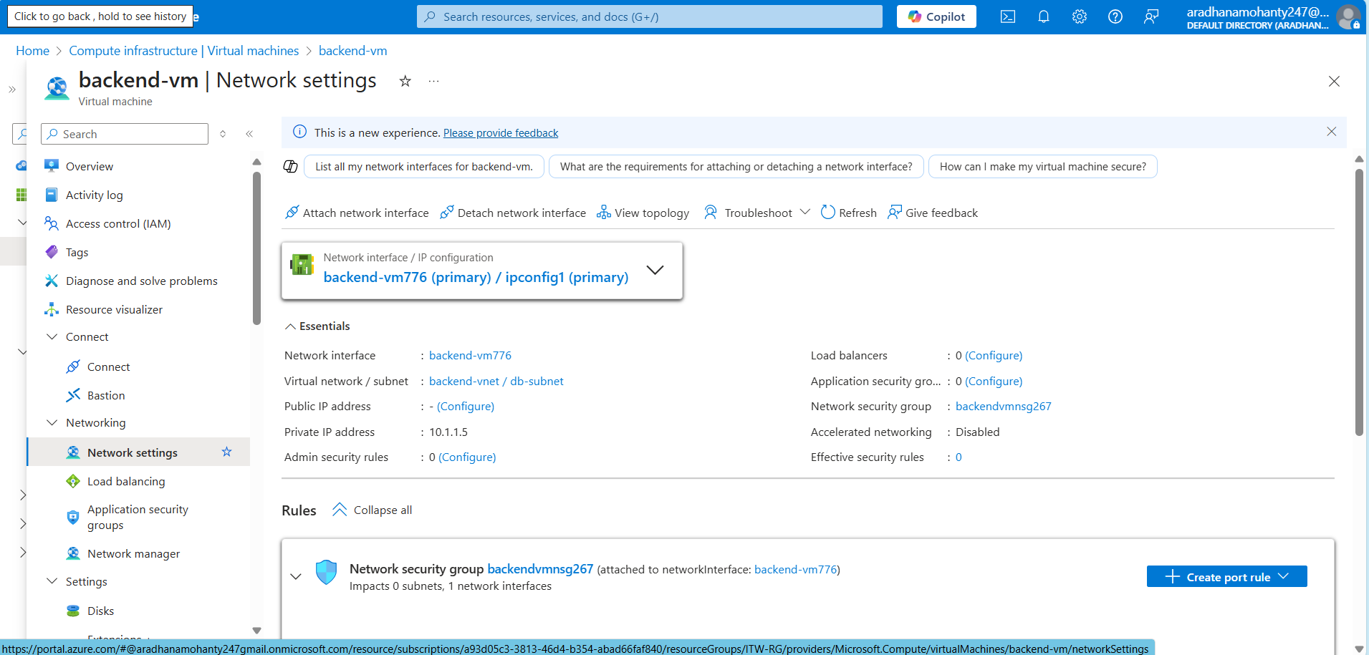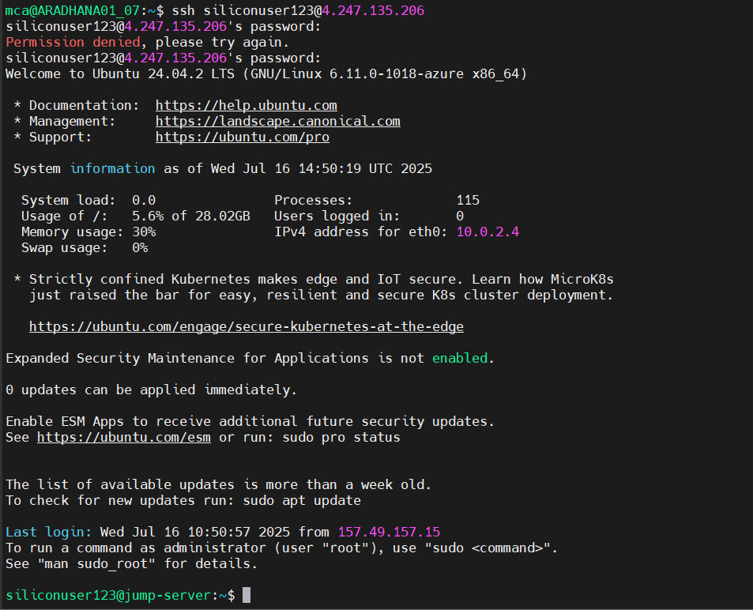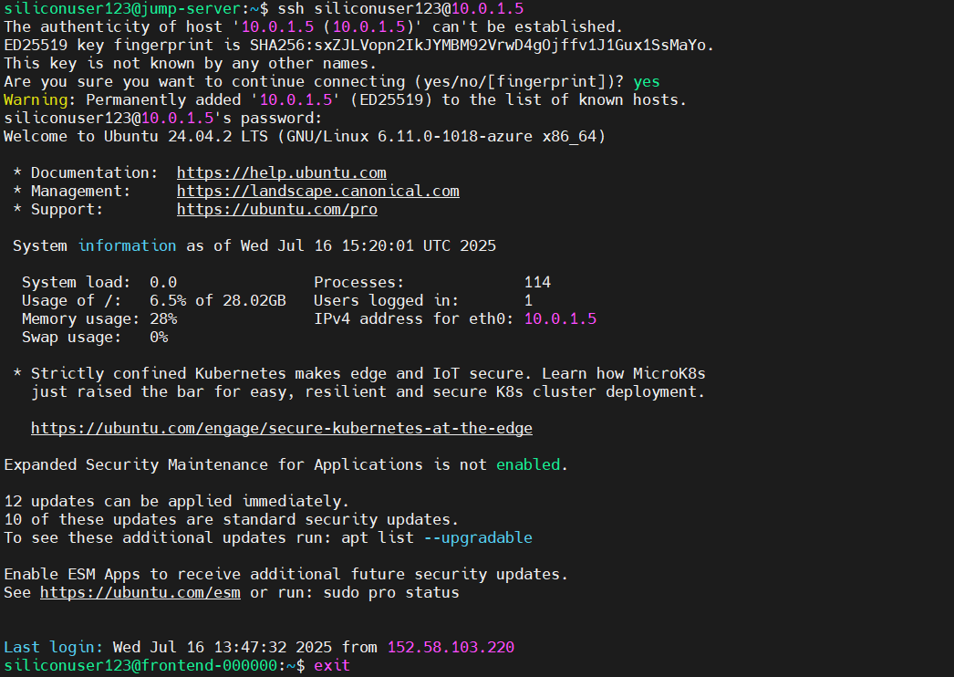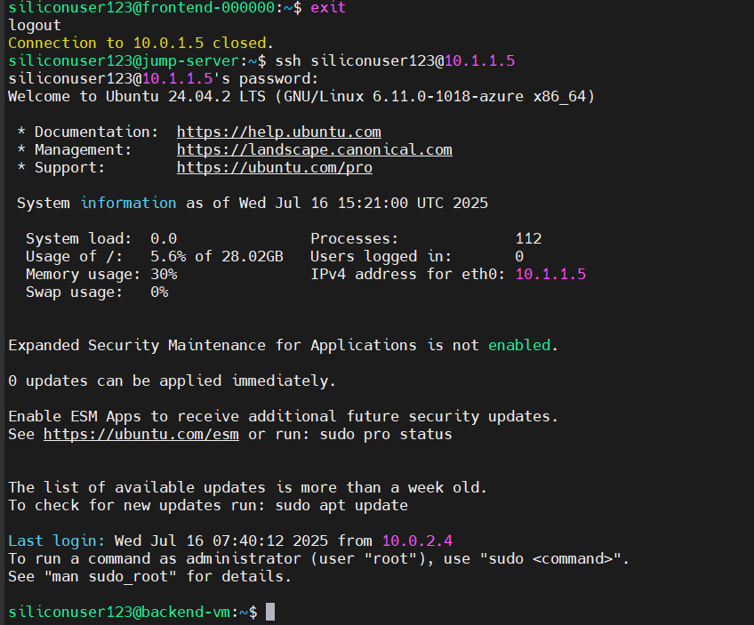

Step -6: Use Azure Hosting service to deploy your application and map your domain name to the Public IP of the load balancer.

Definition:
- Custom Domain Mapping: It is the process of linking a domain name purchased from a provider like GoDaddy to a cloud-based public IP (such as an Azure Load Balancer IP), allowing users to access the deployed application using a user-friendly domain (e.g., www.itwsit.xyz) instead of a numeric IP address.
- DNS (Domain Name System): A hierarchical naming system that translates human-readable domain names (like www.example.com) into IP addresses (like 20.198.10.15) that computers use to identify each other on the network.
- A Record (Address Record): A DNS record that maps a domain name to an IPv4 address. In Step 6, we used it to point the domain to the frontend Load Balancer's public IP.
- GoDaddy DNS Management: A dashboard provided by GoDaddy (domain registrar) where you manage DNS records such as A, CNAME, and MX to control how your domain connects to online resources.
- Propagation Time: The amount of time it takes for DNS changes (like adding or updating an A record) to be updated and recognized across the global DNS network. It can take a few minutes to several hours.
- Apache Web Server: A widely used open-source web server that serves HTTP content. It was installed on the VMSS instance to deliver a test web page linked to the domain.

In Step 6, we integrated a custom domain purchased from GoDaddy with our deployed web application on Azure. We pointed the domain to the frontend Load Balancer’s public IP using an A record in the DNS settings. After that, we tested DNS resolution and ensured that Apache was successfully serving the webpage from one of the VMSS instances. We also customized the web page using a simple HTML update to confirm the end-to-end connection between domain and cloud infrastructure.

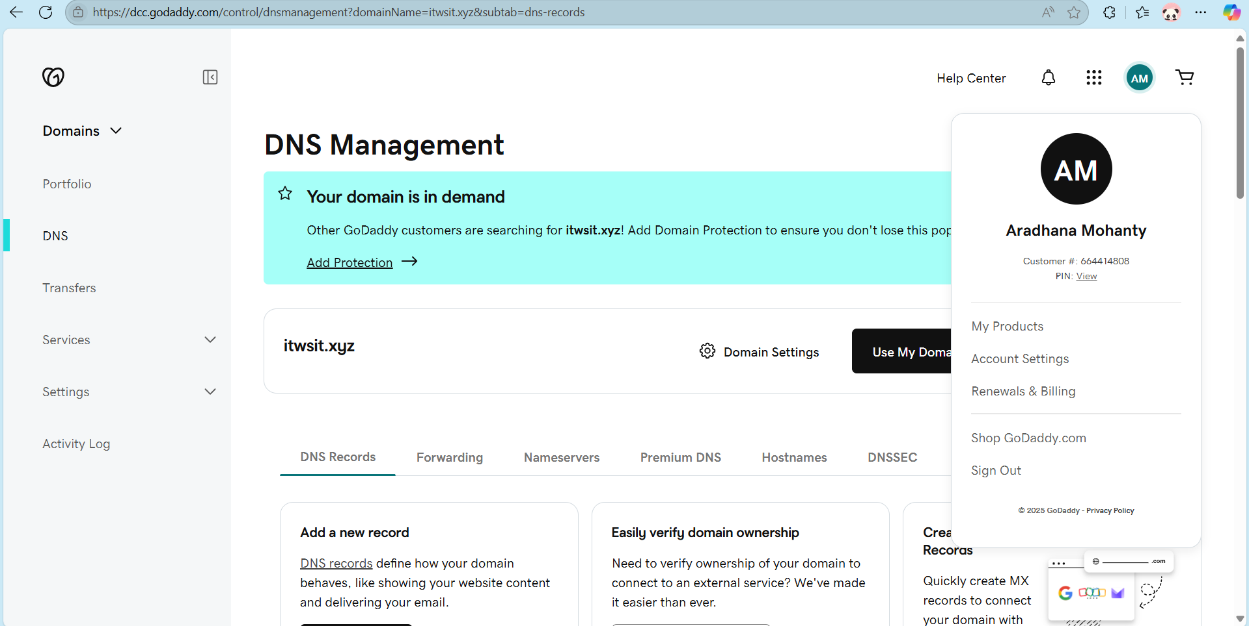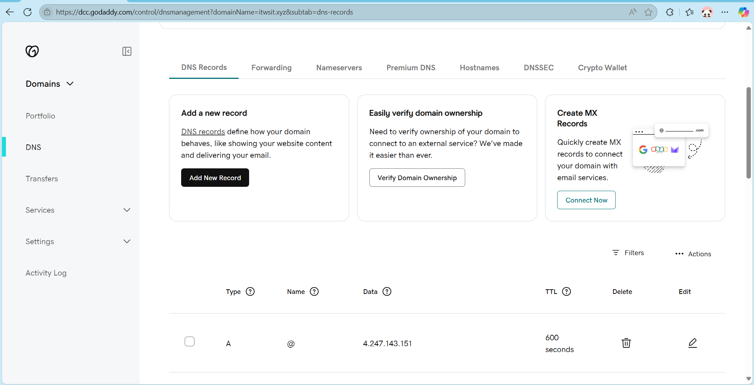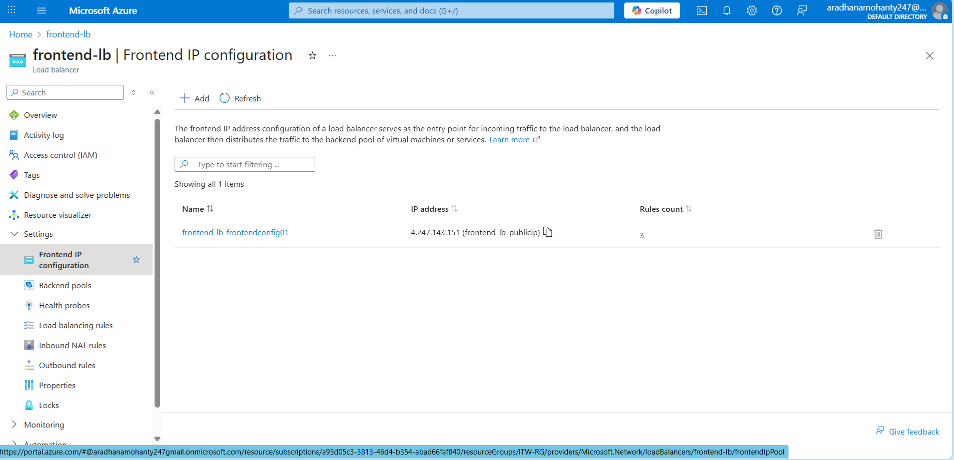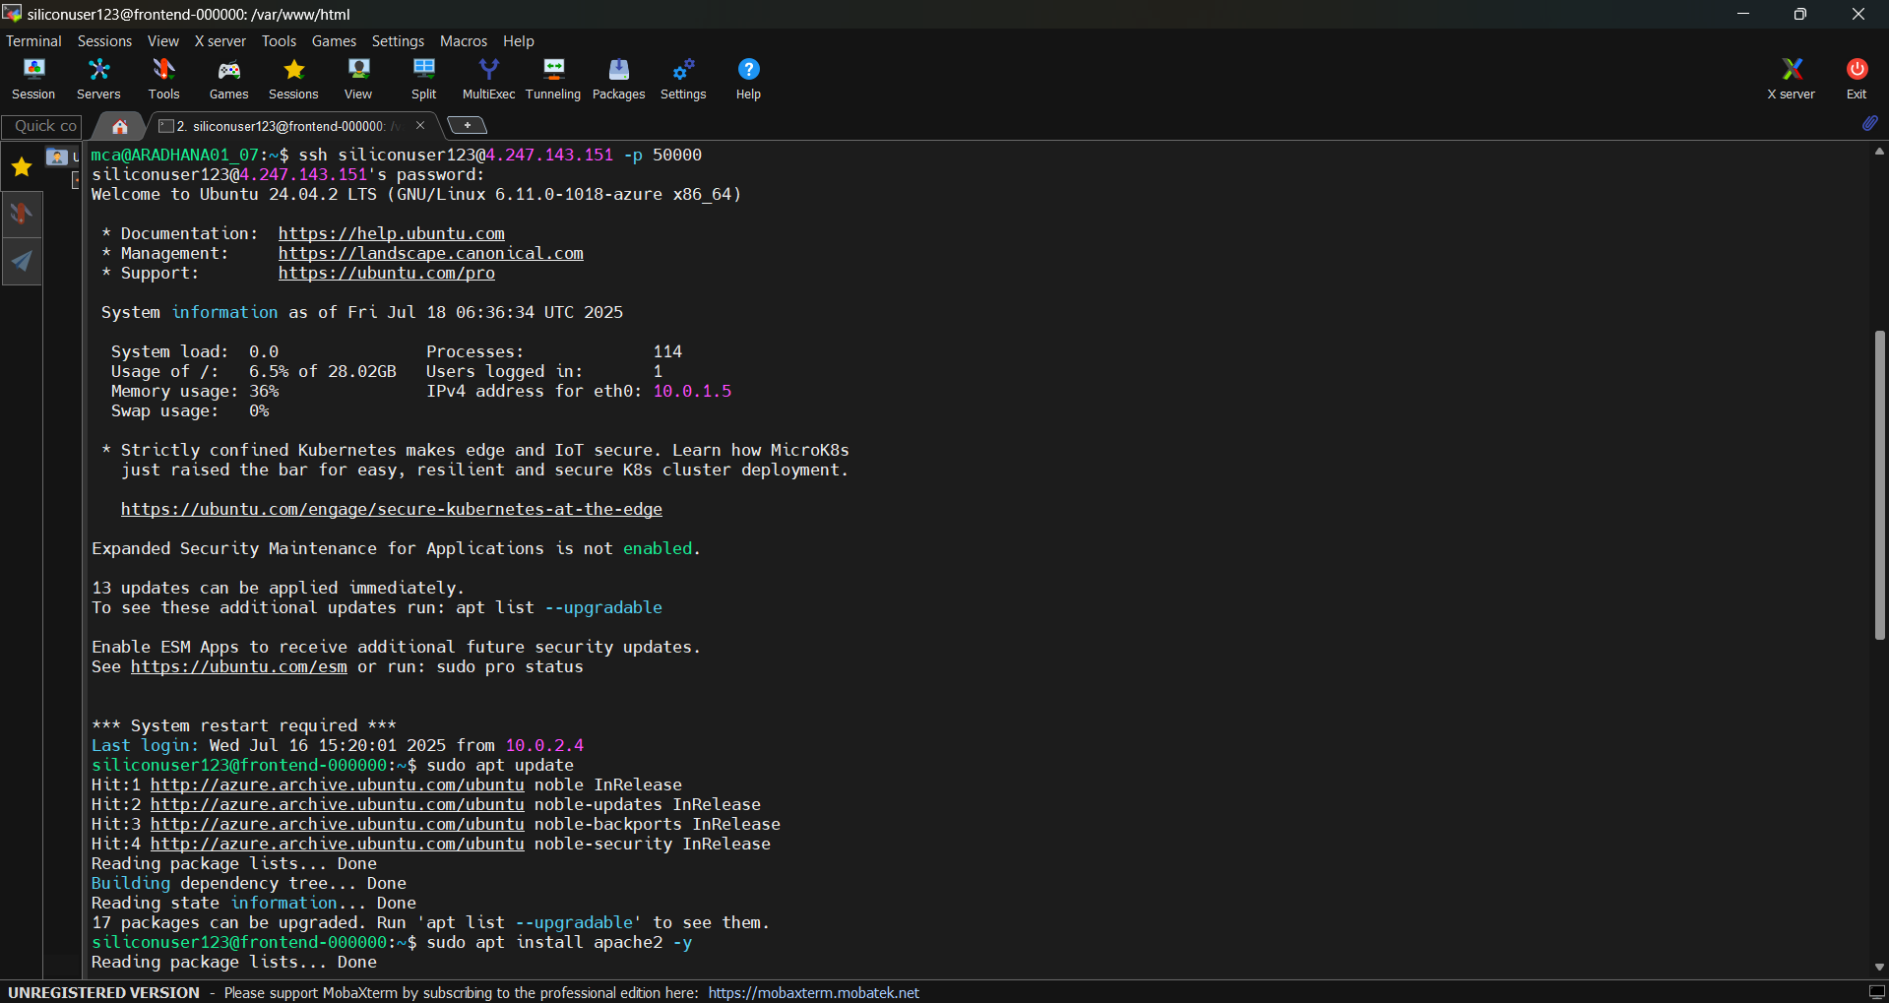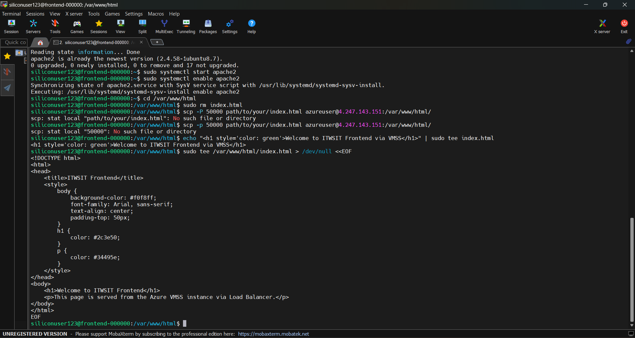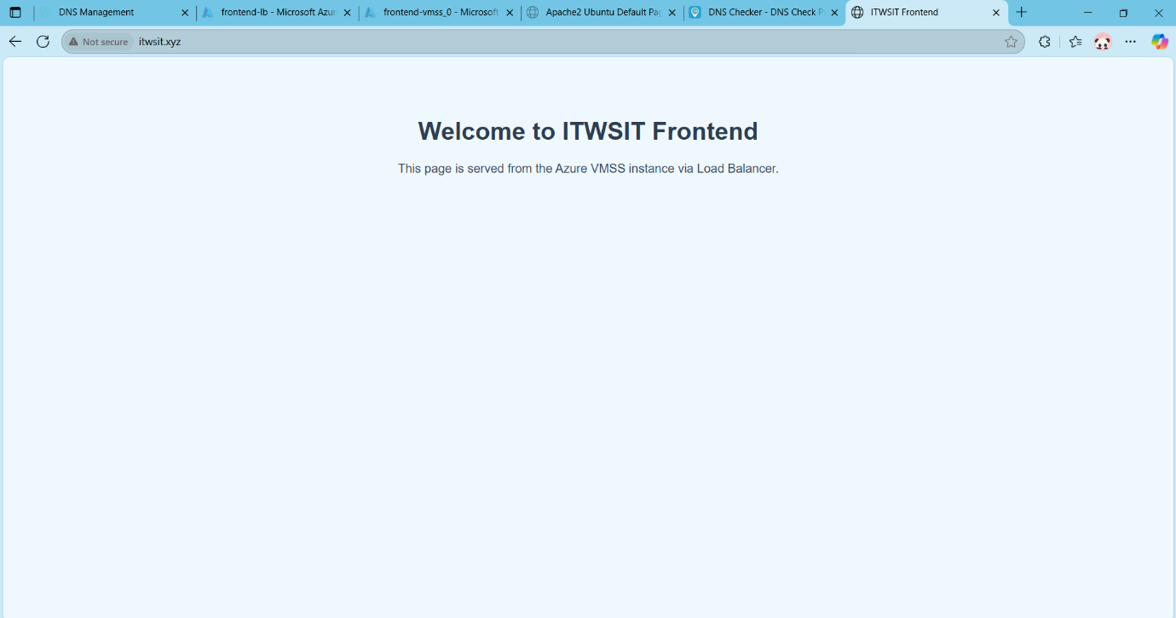

Step -7: Perform the sample user operations from the frontend, and verify that changes reflected in the backend database.

Definitions:
- DNS: A Record Maps a domain name to an IP address.
- Apache: Web server software that delivers web content.
- PHP: Server-side scripting language for dynamic content.
- MySQL: Open-source relational database to store form data.
- Load Balancer: Routes traffic to VMSS instances.
- VMSS: Auto-scaling group of identical frontend web VMs.
- Backend VM: Private VM hosting the database.
- Form Submission: HTML + PHP code to collect and save user input.

In Step 7, I linked the frontend application with a custom domain using Azure DNS and Load Balancer public IP. I installed and configured Apache on VMSS instances, set up PHP support, and verified connectivity with test pages. I then created a complete data flow system: a form that takes input, stores it in a MySQL database hosted on the backend VM, and displays the records. This step finalizes the full-stack connectivity between frontend, backend, and database, accessible through the domain.

1. DNS Integration:
1. DNS Integration: Mapped your domain itwsit.xyz to the Load Balancer public IP. Configured GoDaddy DNS A record correctly
2. Apache & PHP Configuration: Installed and verified Apache + PHP in the VMSS instance.
- Mapped your domain itwsit.xyz to the Load Balancer public IP.
- Configured GoDaddy DNS A record correctly2. Apache & PHP Configuration
- Installed and verified Apache + PHP in the VMSS instance.
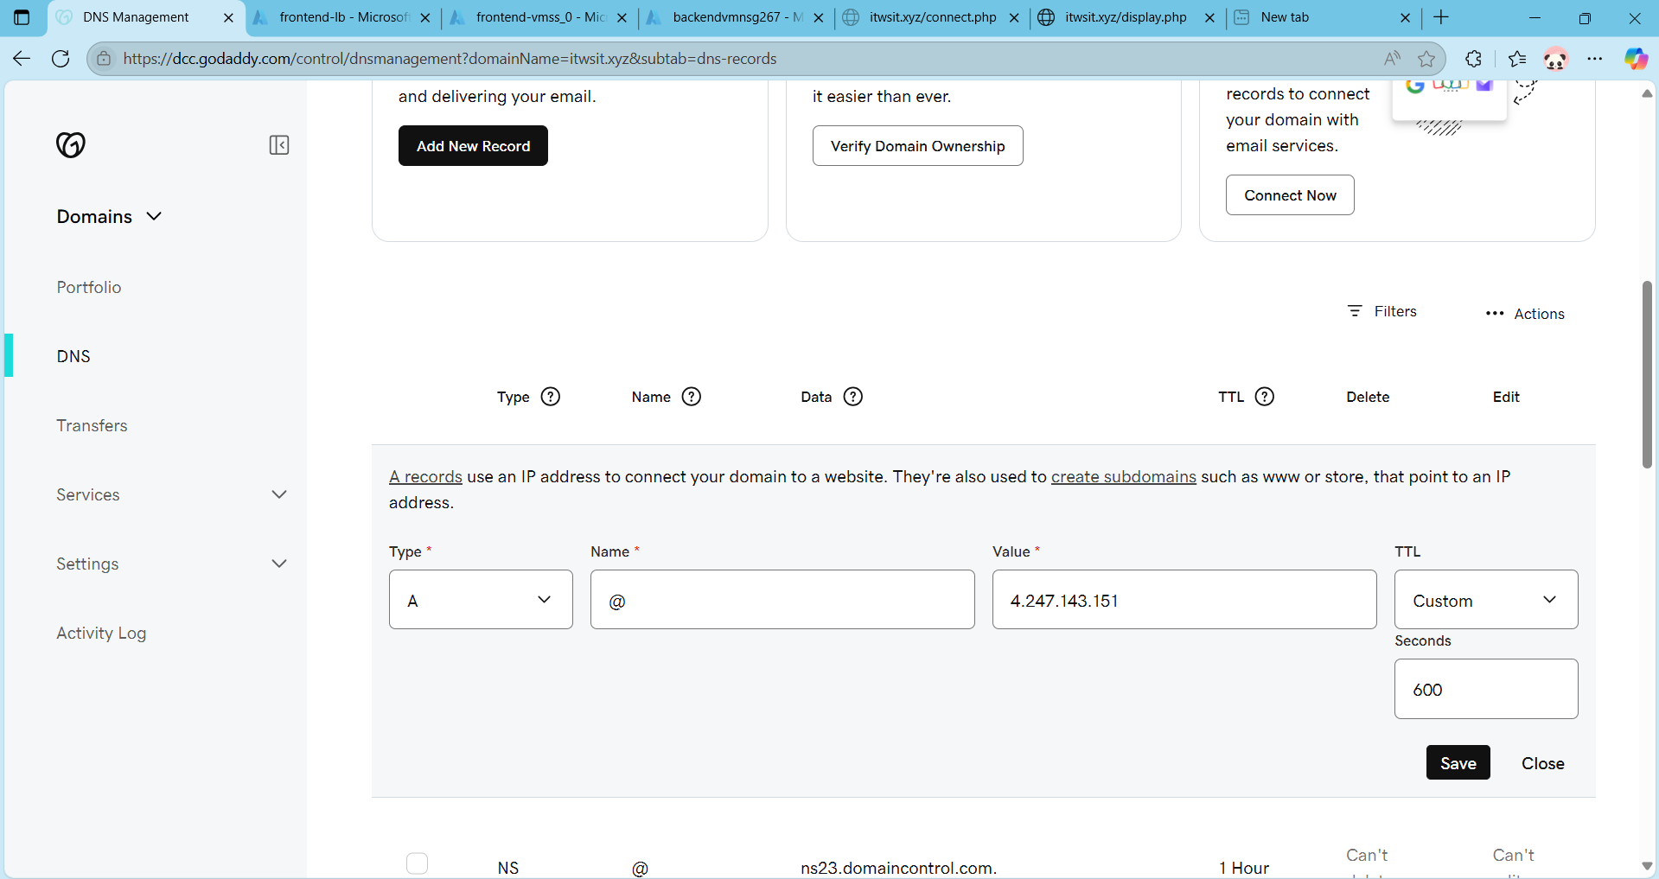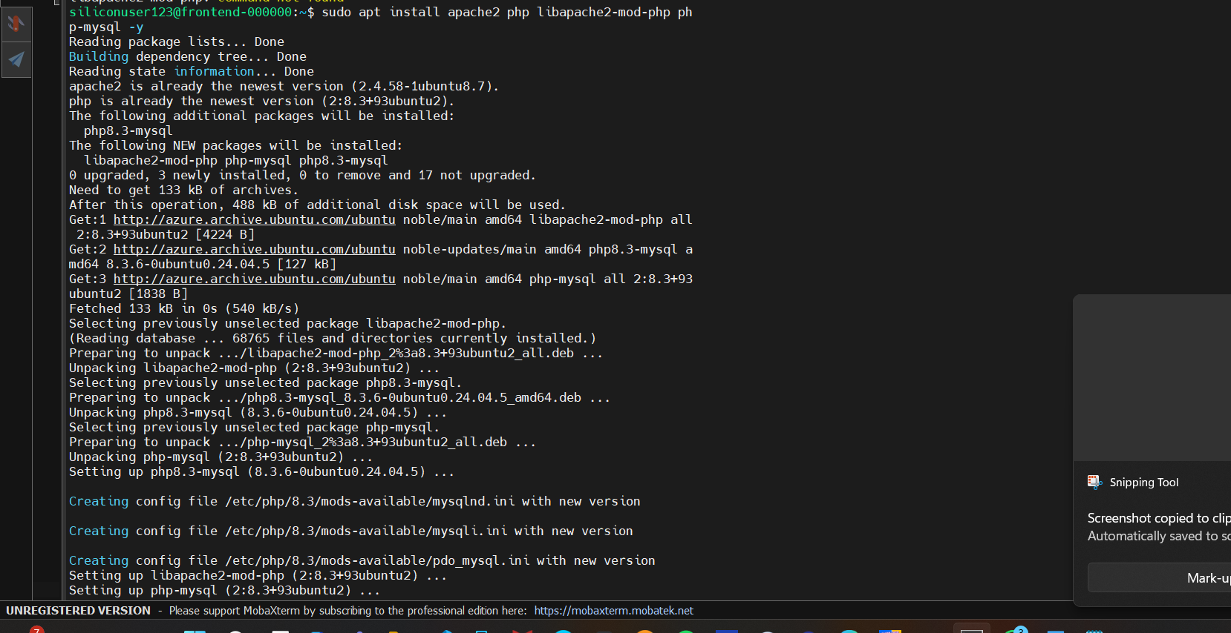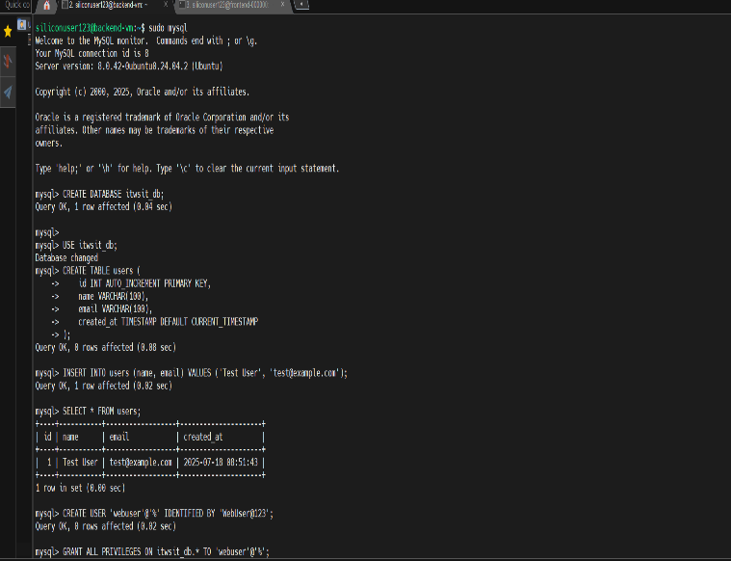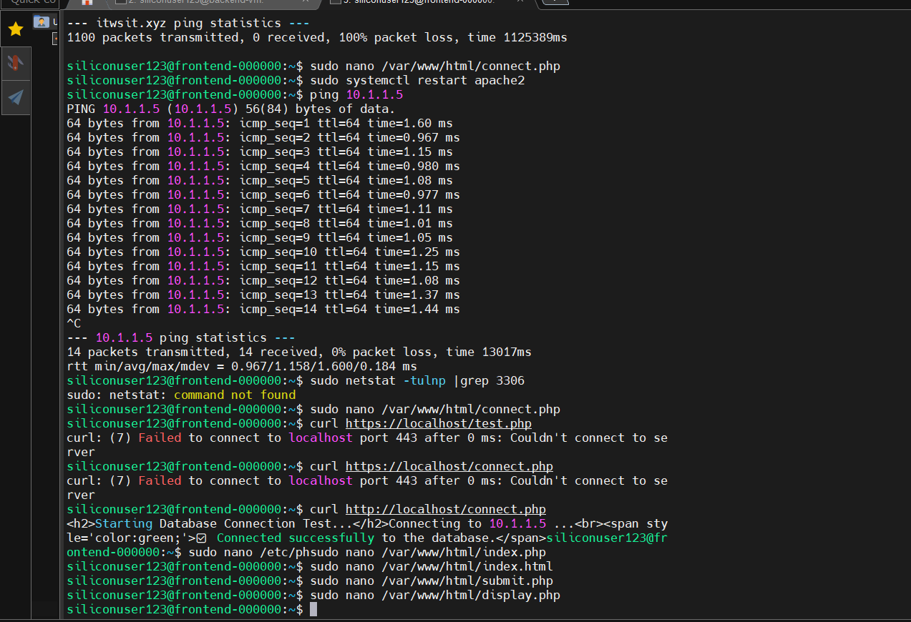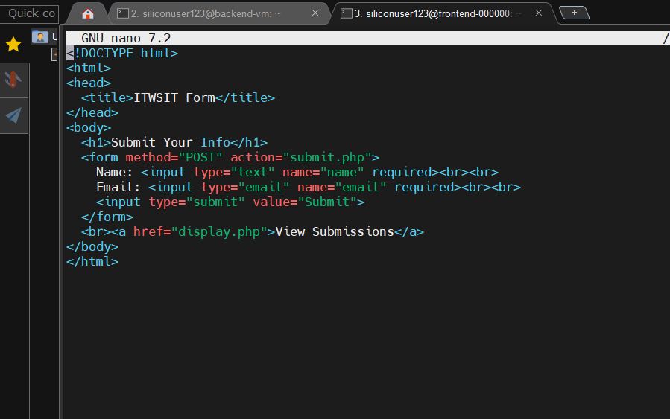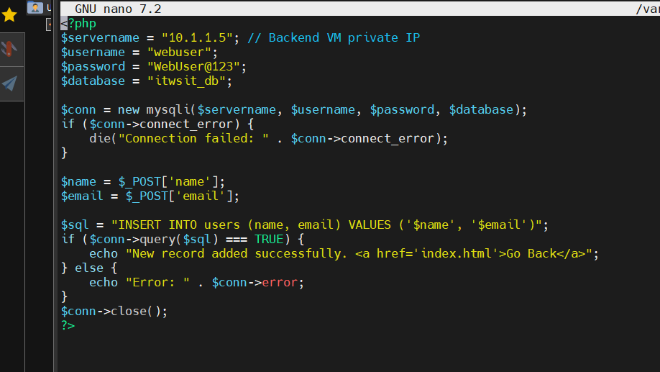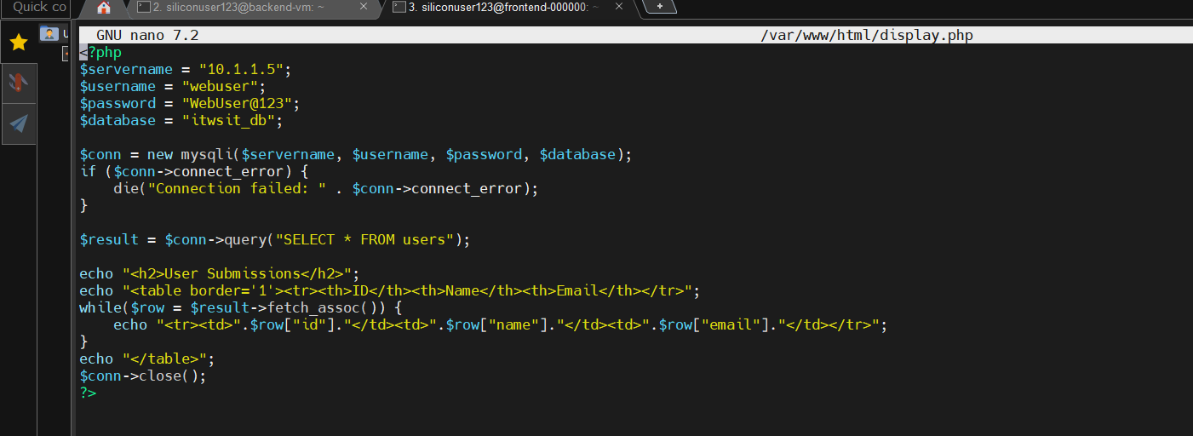
2. MySQL Setup
- Installed MySQL on the backend VM.
- Created database itwsit_db and table users.

4. Form Creation + PHP Scripts
- Created:
- index.html: A user form (name, email).
- connect.php: Handles DB connection.
- submit.php: Saves form data to DB.
- display.php: Shows saved entries from DB.
5. Verification
- Connected successfully to the database via connect.php
- Form submits data successfully
- Data is stored and displayed from backend VM via display.php.

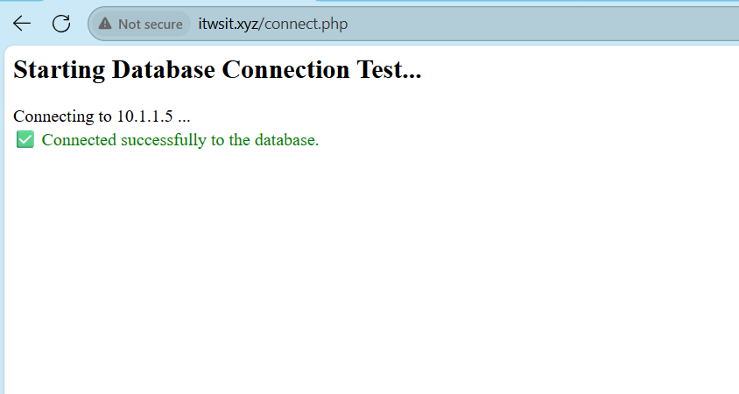
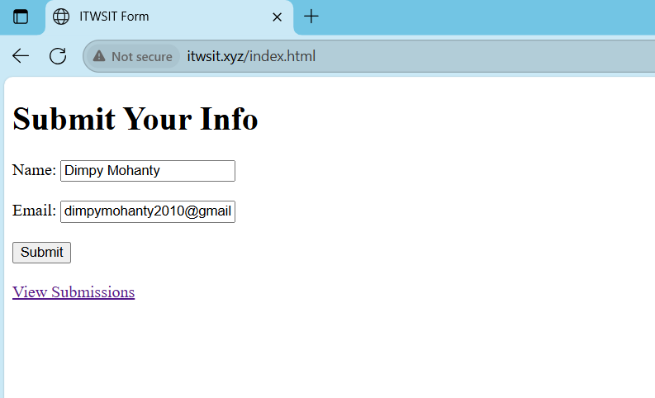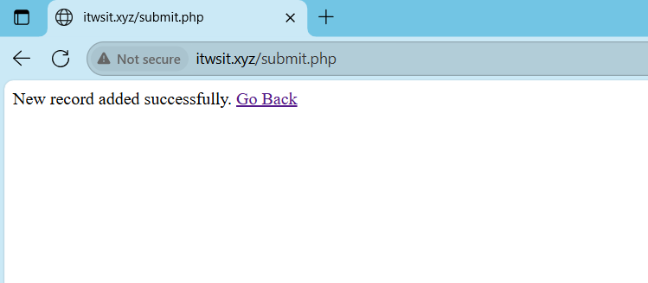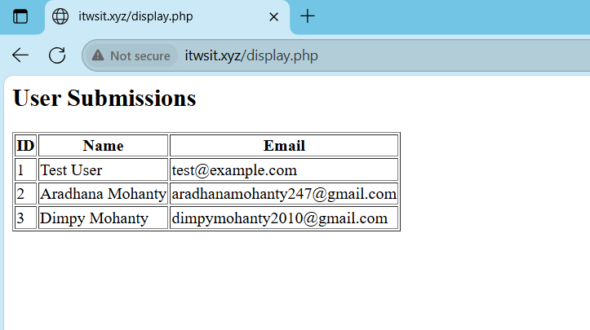

Step:8- Apply an SSL certificate to your domain to ensure secure access over HTTPS.

Definitions:
- Certbot: A tool to get free SSL certificates from Let's Encrypt.
- SSL/TLS: Encrypts the data between browser and server (used by HTTPS).
- Apache Virtual Host: Configuration block that defines how Apache responds to a domain or port.
- Port 443: Default port used by HTTPS for secure traffic.
- NSG: (Network Security Group) Controls inbound/outbound traffic to Azure resources.
- Load Balancer Rule: Maps public traffic (like port 443) to backend VM/VMSS.

In Step 7 of our Azure project, we secured our custom domain itwsit.xyz by installing a Let’s Encrypt SSL certificate on the frontend VMSS using Certbot with Apache. This allows our web application to be served over HTTPS, ensuring secure communication between clients and the server. We first verified that Apache was properly configured with a virtual host for port 443. Then we executed sudo certbot --apache and followed the prompts to issue an SSL certificate. After successful installation, we restarted Apache and confirmed the presence of the certificate files. We verified HTTPS access through the browser. Finally, since auto-renewal was optional in the project’s scope, we disabled any automated renewal mechanisms (like systemd timers or cron jobs) and opted for manual renewal closer to the expiry date (October 16, 2025). This step ensures that users visiting our web app experience a secure, trusted connection.

1. Installed Certbot on Apache (on the VMSS instance)
- sudo apt install certbot python3-certbot-apache.
- Generated a Free Let's Encrypt SSL Certificate.
- sudo certbot –Apache

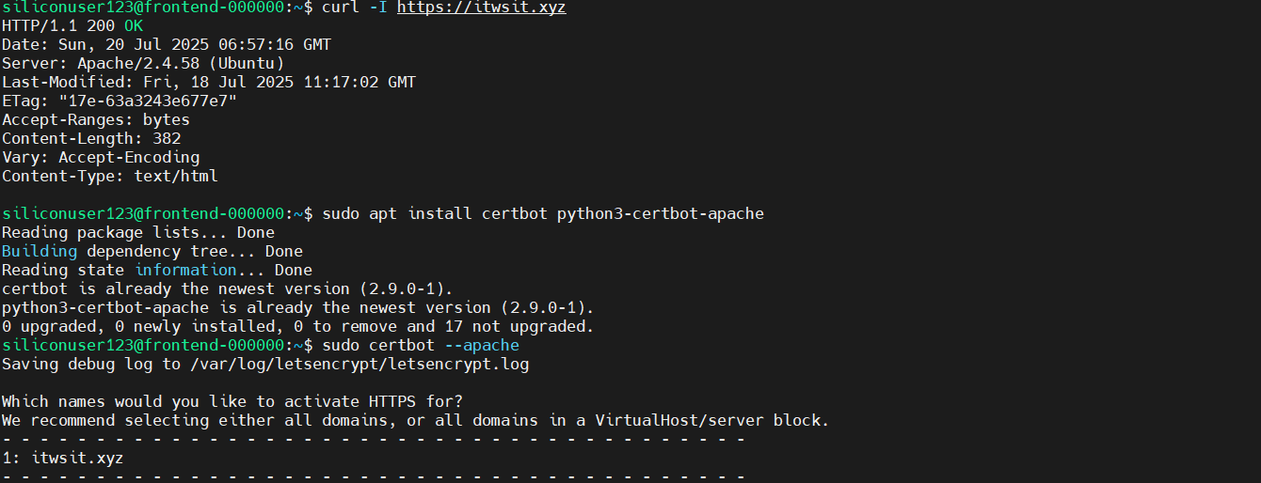

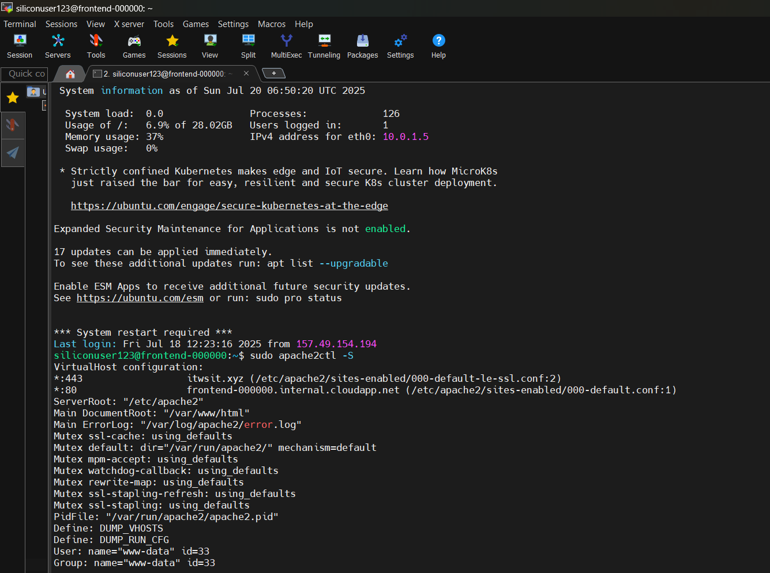

2.Azure NSG inbound rule for port 443 was added (priority 180, ).
3.Azure Load Balancer rule for port 443 was checked/added to allow HTTPS traffic to VMSS.
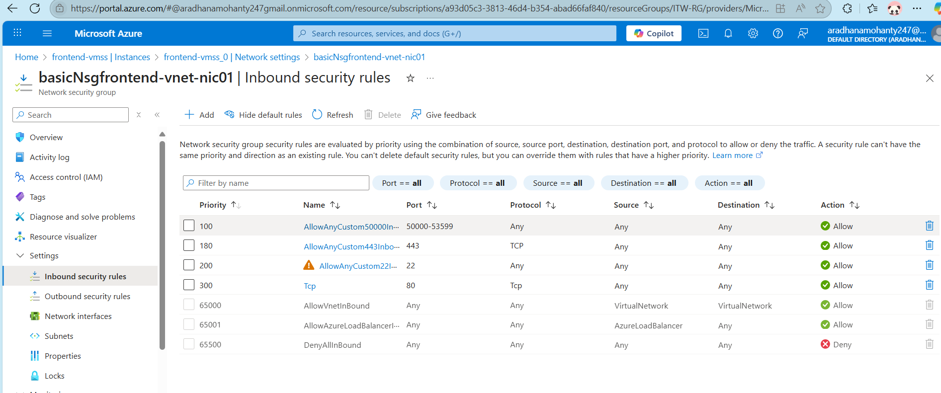

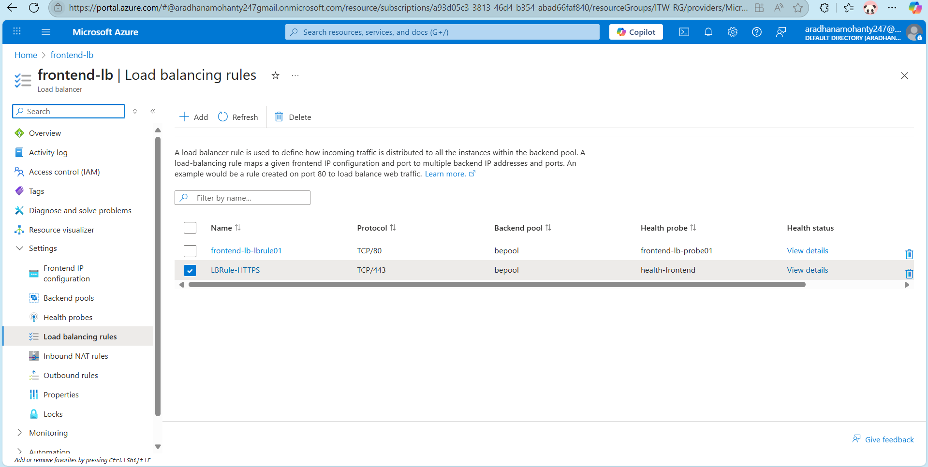
4.Tested HTTPS access using:
Browser (https://itwsit.xyz)
Terminal (curl -I https://itwsit.xyz)

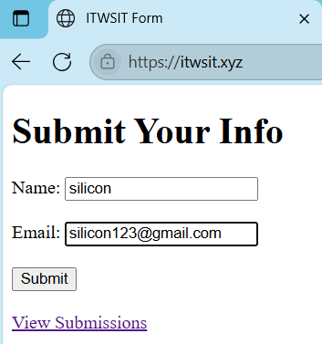

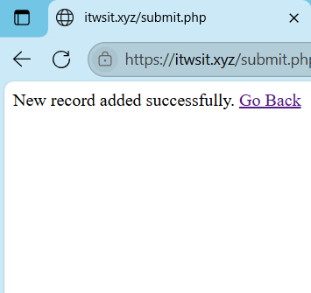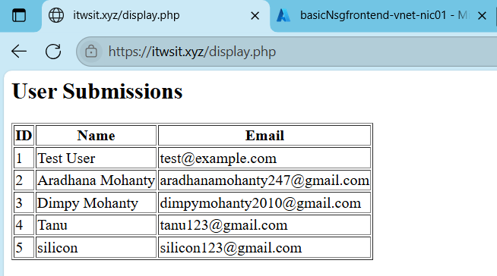

Architecture of the Project


HTTPS (Certbot) SSL
Custom Domain: itwsit.xyz
Load Balncer
Public-IP

VPN Gateway(P2S)

Distributed incoming traffic to Frontend-VM
Client with Certificate

Internet
Azure Data Centre

Backend Vnet
Frontend Vnet
Jump-VM

Backend Subnet
Frontend Subnet

VMSS
(Auto Scaling Enabled)
Frontend-VM1
Securely access both frontend & backend privately
Public IP
Database-VM
Private-IP

Frontend-VM2

Title: Full Stack App Development with VNet, VM, Load Balancer & Domain- Azure Cloud Project.

In this project, I deployed a full-stack web application on Microsoft Azure following a production-like architecture. I started by creating two separate Virtual Networks (VNets) — one for the frontend and one for the backend/database. This separation helps improve security and manageability by isolating traffic between tiers.
Within each VNet, I deployed Virtual Machines. For the frontend, I created a scalable VMSS (Virtual Machine Scale Set) so that it can handle more users when needed. For the backend, I deployed a standard VM hosting the database. I also added a Jump VM in a secure zone to act as a gateway for internal SSH connections, avoiding exposing VMs directly to the internet.
To handle incoming traffic, I placed a Load Balancer in front of the frontend VMSS. Only the Load Balancer has a public IP, while the actual VMs remain private. I then enabled autoscaling on the frontend VMSS to ensure it automatically adds or removes instances based on CPU load. This approach keeps the app responsive and cost-effective.
To securely connect to the Azure network, I configured a VPN Gateway and used Point-to-Site (P2S) VPN. I generated client and root certificates to ensure that only trusted clients can access internal resources. This setup follows industry best practices by preventing open SSH/RDP access.
After that, I mapped a custom domain (itwsit.xyz) to the public IP of the Load Balancer, and finally applied an SSL certificate using Certbot to enable HTTPS. This ensures encrypted traffic and better trust for users accessing the application. I chose not to auto-renew the certificate for now, since it's a demo deployment.
Overall, I followed cloud best practices like resource separation, minimal public exposure, VPN access for security, scalability, and SSL for secure communication, making this a reliable and realistic production-ready Azure deployment.

THANK YOU!

