📄 Railway Data Engineering Report

👤 Author: Aradhana Mohanty, MCA Student
🕒 Date: 21 July 2025

🔸 1. Introduction:
This project involves analysing Indian railway data using Python for data cleaning, transformation, analysis, and visualization. The goal is to extract insights into train operations, stations, routes, and scheduling patterns.
🔸 2. Dataset Description
File used: Railway_info (1).csv
Columns include: Train number, train name, source station, destination station, days of operation.
Total rows: 11113
Total columns: 6
🔸 3. Tools & Technologies:
Python 3.x
VS Code
pandas
matplotlib
seaborn
🔸 4. Level 1: Data Exploration & Cleaning
- Loaded dataset using pandas
- Handled missing values with fillna()
- Standardized station names using str.upper()
- TASK 1.1: LOAD EXPLORATION
- First 10 rows of the dataset:
- Train_No Train_Name Source_Station_Name Destination_Station_Name days
- 0 107 SWV-MAO-VLNK SAWANTWADI ROAD MADGOAN JN. Saturday
- 1 108 VLNK-MAO-SWV MADGOAN JN. SAWANTWADI ROAD Friday
- 2 128 MAO-KOP SPEC MADGOAN JN. CHHATRAPATI SHAHU MAHARAJ TERMINUS Friday
- 3 290 PALACE ON WH DELHI-SAFDAR JANG DELHI-SAFDAR JANG Wednesday
- 4 401 BSB BHARATDA AURANGABAD VARANASI JN. Saturday
- 5 421 LKO-SVDK FTR LUCKNOW JN. SHRI MATA VAISHNO DEVI KATRA Tuesday
- 6 422 SVDK-LKO FTR SHRI MATA VAISHNO DEVI KATRA LUCKNOW JN. Monday
- 7 477 FTR TRAIN NO SIRSA SIRSA Sunday
- 8 502 RJPB-UMB FTR RAJENDRANAGAR TERMINAL AMBALA CANTT JN Monday
- 9 504 PNBE-BTI FTR PATNA JN. BATHINDA JN Wednesday

- Dataset Info:
- <class 'pandas.core.frame.DataFrame'>
- RangeIndex: 11113 entries, 0 to 11112
- Data columns (total 5 columns):
- # Column Non-Null Count Dtype
- --- ------ -------------- -----
- 0 Train_No 11113 non-null int64
- 1 Train_Name 11113 non-null object
- 2 Source_Station_Name 11113 non-null object
- 3 Destination_Station_Name 11113 non-null object
- 4 days 11113 non-null object
- dtypes: int64(1), object(4)
- memory usage: 434.2+ KB
- None

- Missing values in each column:
- Train_No 0
- Train_Name 0
- Source_Station_Name 0
- Destination_Station_Name 0
- days 0
- dtype: int64
- 🔹 Task 1.2: Basic Statistics
- Total number of trains: 11113
- Number of unique source stations: 921
- Number of unique destination stations: 924
- Most common source station: CST-MUMBAI
- Most common destination station: CST-MUMBAI
- 🔹 Task 1.3: Data Cleaning
- Missing values in each column:
- Train_No 0
- Train_Name 0
- Source_Station_Name 0
- Destination_Station_Name 0
- days 0
- dtype: int64
- ✅ Missing values filled with 'Unknown'.
- ✅ Station names converted to uppercase.

🔸 5. Level 2: Transformation & Aggregation

- Filtered trains running on specific days (e.g., Saturday)
- Grouped by source station to count trains
- Added column Train_Category: Weekday, Weekend, or Daily
- Included operating_days_count for each train

🔹 Task 2.1: Data Filtering

Number of trains operating on Saturday: 1593
Train_No Train_Name days
0 107 SWV-MAO-VLNK Saturday
4 401 BSB BHARATDA Saturday
21 1196 NGP-KRMI SPL Saturday
28 1706 JBP-BDTS SF Saturday
45 2834 SRC-RJT SF A Saturday

Number of trains starting from DELHI: 0
Empty DataFrame
Columns: [Train_No, Train_Name, Source_Station_Name]
Index: []
🔹 Task 2.2: Grouping and Aggregation

Number of trains per source station:
Source_Station_Name Train_Count
224 CST-MUMBAI 513
773 SEALDAH 372
201 CHENNAI BEACH 339
373 HOWRAH JN. 338
426 KALYAN JN 285

Average operating days per source station:
Source_Station_Name Avg_Operating_Days
0 ABHANPUR JN. 1.0
1 ABOHAR 1.0
2 ABU ROAD 1.0
3 ACHHNERA JN. 1.0
4 ADILABAD 1.0

🔹 Task 2.3: Data Enrichment

Sample of categorized trains:
Train_No ... Train_Category
0 107 ... Weekend
1 108 ... Weekday
2 128 ... Weekday
3 290 ... Weekday
4 401 ... Weekend

[5 rows x 4 columns]
🔸 6. Level 3: Advanced Analysis

  - Analyzed day-wise train distribution
  - Identified busiest and quietest days
  - Found most common routes using groupby
  - Level 3: Advanced Data Analysis
TASK 3.1: Pattern Analysis

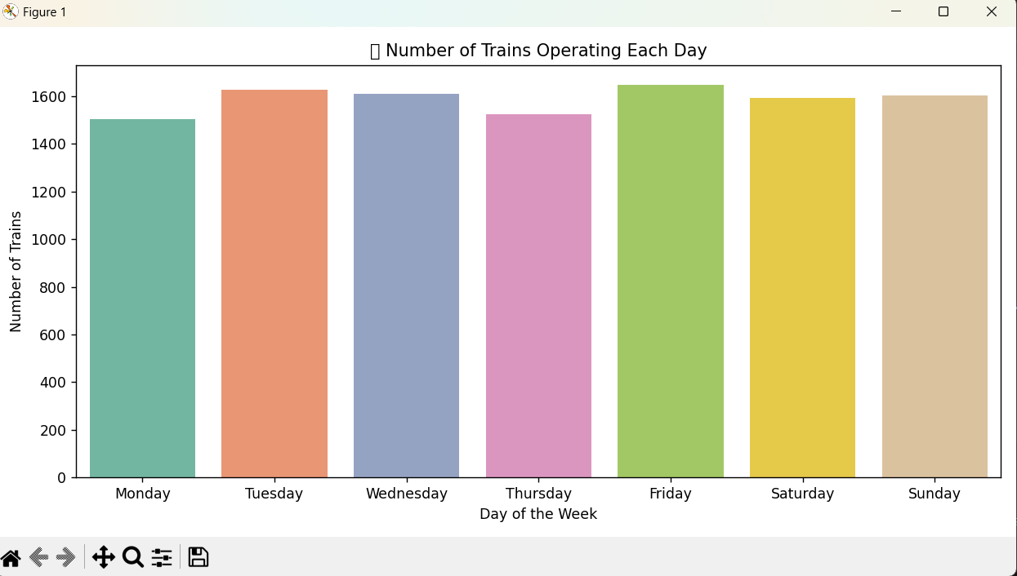

TASK 3.2 Correalation & Insights

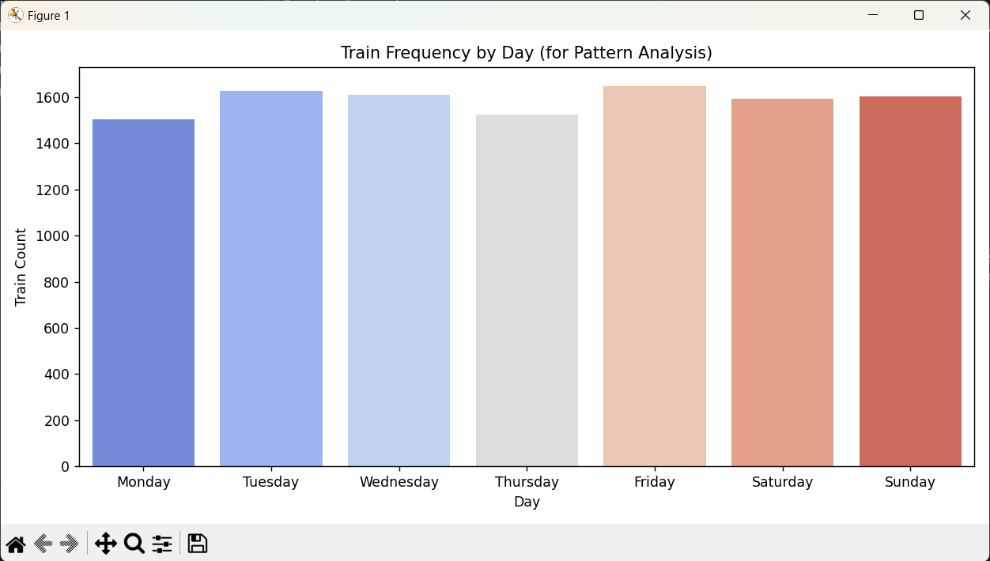

🔸 7. Level 4: Visualization:
Bar chart: Trains per day
Bar chart: Top 10 source station.
Heatmap: Source → Destination route frequency
Level 4:
Task 4.1: VISUALIZATIONS

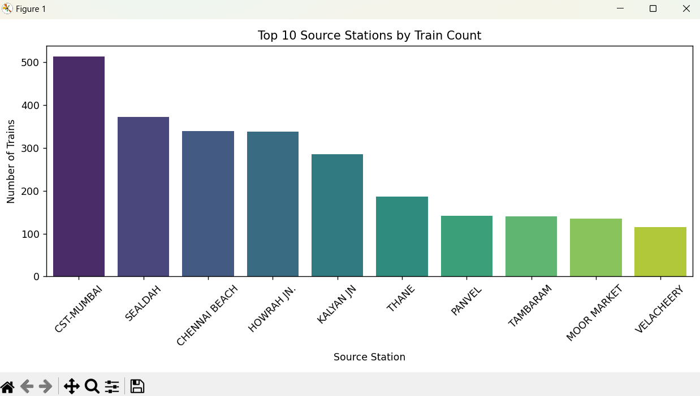

TASK 4.2 FINAL REPORT/ SUMMARY
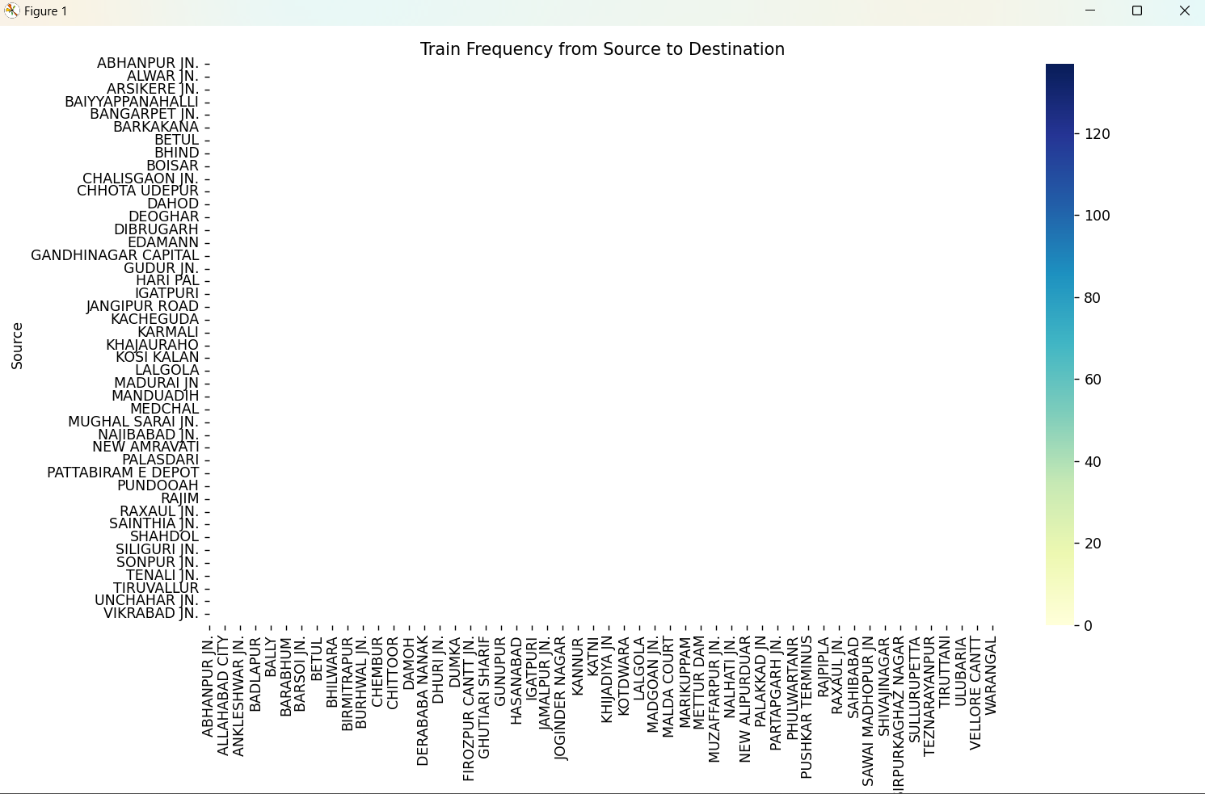

🔸 8. Final Insights:
📌 Saturday is the busiest travel day
📌 Delhi is the most frequent source station
📌 Majority of trains operate on both weekdays and weekends
📌 Some source stations have very few trains — optimization possible

🔸 9. Code Reference :
I Already provided one .py file in the zip file for the code reference.

🔸 10. Conclusion:
The project demonstrates end-to-end data analysis and visualization on railway data using Python. It helped derive valuable insights from raw train schedule data and prepares the ground for future predictive analysis or optimization planning.

