#### A PROJECT REPORT

**on**

## “CROP RECOMMENDATION SYSTEM”

**Submitted to**

## KIIT Deemed to be University

#### In Partial Fulfillment of the Requirement for the Award of BACHELOR’S DEGREE IN

**INFORMATION TECHNOLOGY**

#### BY

**GAURAV KUMAR NAYAK MANI SHANKER**

**M. SANSKAR RAHUL KUMAR**

**2006021**

**2006074**

**2006128**

**2006485**



**UNDER THE GUIDANCE OF DR. MANAS RANJAN NAYAK**



**SCHOOL OF COMPUTER ENGINEERING**

KIIT Deemed to be University

School of Computer Engineering Bhubaneswar, ODISHA 751024



# CERTIFICATE

This is certify that the project entitled

##### “CROP RECOMMENDATION SYSTEM“

submitted by

**GAURAV KUMAR NAYAK MANI SHANKER**

**M SANSKAR**

**RAHUL KUMAR**

**2006021**

**2006074**

**2006128**

**2006485**



is a record of bonafide work carried out by them, in the partial fulfillment of the requirement for the award of Degree of Bachelor of Engineering (Computer Sci-ence & Engineering OR Information Technology) at KIIT Deemed to be university, Bhubaneswar. This work is done during the year 2022-2023, under our guidance.

Date: 01/05/2023

(**DR. MANAS RANJAN NAYAK**)

Project Guide



**Acknowledgements**

We are profoundly grateful to **DR. MANAS RANJAN NAYAK** of **KIIT** for his expert guidance and continuous encouragement throughout to see that this project rights its target since its commencement to its completion. .....................

**GAURAV KUMAR NAYAK MANI SHANKER**

**M SANSKAR RAHUL KUMAR**



## ABSTRACT

India's agriculture sector is significant. It is necessary for the Indian economy's survival and expansion. India is a significant producer of many different agricultural goods. In the process of cultivating crops, soil is crucial. A non-renewable, dynamic natural resource required for life is soil. Crop cultivation used to be done by farmers with practical experience. Based on the qualities and properties of the soil, farmers are no longer able to select the ideal crop.

Therefore, a recommendation system that uses machine learning algorithms to suggest the crop that can be harvested in that specific soil has been developed. This system employs a number of machine learning techniques, such as KNN, Decision Tree, Random Forest, Naive Bayes, and Gradient Boosting to recommend the crop.

**Keywords:** Machine Learning, Crop Recommendation, KNN, Decision Tree, Naive Bayes, Random Forest, Gradient Boosting.



# Contents

|  |  |  |  |  |
| --- | --- | --- | --- | --- |
| 1 | Introduction | | | 1 |
| 2 | Basic Concepts/ Literature Review | | | 2 |
|  | 2.1 | Sub Section Name........................... | | 2 |
| 3 | Problem Statement / Requirement Specifications | | | 3 |
|  | 3.1 | Project Planning........................... | | 3 |
|  | 3.2 | Project Analysis ................. | | 3 |
|  | 3.3 | System Design ………………….. | | 3 |
|  |  | 3.3.1 | Design Constraints | 3 |
|  |  | 3.3.2 | System Architecture / Block Diagram … | 3 |
| 4 | Implementation | | | 4 |
|  | 4.1 | Methodology / Proposal ........................... | | 4 |
|  | 4.2 | Testing / Verification Plan ……………. | | 4 |
|  | 4.3 | Result Analysis / Screenshots …………. | | 4 |
|  | 4.4 | Quality Assurance …………………….. | | 4 |
| 5 | Standard Adopted | | | 5 |
|  | 5.1 | Design Standards . . . . . . . . . . . . . . . | | 5 |
|  | 5.2 | Coding Standards . . . . . . . . . . . . . . | | 5 |
|  | 5.3 | Testing Standards . . . . . . . . . . . . . . . | | 5 |
| 6 | Conclusion and Future Scope | | | 6 |
|  | 6.1 | Conclusion ……………………….. | | 6 |
|  | 6.2 | Future Scope ………………………. | | 6 |
| References | | | | 7 |
| Individual Contribution | | | | 8 |
| Plagiarism Report | | | | 9 |



Chapter 1 Introduction

We all know that the Indian economy is based on agriculture. In India, agriculture is a significant industry. 1.3 billion people are fed through agriculture, which occupies more than 60% of the nation's land . Plant and animal cultivation is referred to as agriculture. India's civilization developed as a result of agriculture. In order to grow crops, we need soil. Soil is an important element in agriculture. A healthy soil is necessary for effective food production. It offers support, water, oxygen, and vital nutrients to the roots. All plants used in food production are grown on soil, which also serves as the system's foundation. Various types of soil are available in India.

These include laterite soil (pulses, tea, coffee), black soil (sugarcane, sunflower), red soil (corn, ragi), and alluvial soil (cotton, rice). A lot of research has been done to enhance agricultural planning. With the aid of machine learning, the crop can be suggested.

Artificial intelligence's branch of machine learning describes a machine's capacity to imitate intelligent human behavior. To automate complex processes, artificial intelligence systems are used in a similar manner to people. The foundation of machine learning is data, such as records of transactions, people, or images.

To serve as training data for the machine learning system, the data is gathered and analyzed. The software displays better results with more data. The developer then chooses a machine learning (ML) model to employ, inputs the data, and trains the system to recognise patterns or predict outcomes on its own.



# Chapter 2

Basic Concepts/ Literature Review

### Basic Concepts:-

A crop recommendation system is a device that advises growers on the best crops to plant based on a variety of variables, including soil type, weather, and prior crop yields. **The following are some fundamental ideas in crop recommendation systems:**

**Soil analysis:** In crop recommendation systems, soil analysis comes first. In order to assess the soil's physical and chemical characteristics, including pH level, organic matter content, and nutrient availability, the system analyzes the soil.

**Knowledge base for crops:** A crop recommendation system has a knowledge base with details on different crops, such as their water, fertilizer, and climate needs.

**Meteorological data:** The system also gathers and analyzes meteorological data to decide when to plant each crop and to anticipate potential weather patterns.

**Machine learning algorithms:** Crop recommendation systems use machine learning algorithms to produce precise forecasts. These algorithms determine the optimum crop to grow in a specific place by analyzing historical data on crop yields, soil characteristics, and weather patterns.

**Mobile or web-based interface:** A user-friendly mobile or web-based interface is used to convey the crop recommendation system's results. Farmers can access data on suggested crops, planting times, and fertilization schedules via the interface.

**Crop recommendation system:** The crop recommendation system aids farmers in making educated judgements regarding crop selection and management techniques.

**Updates and ongoing monitoring:** The system regularly assesses soil quality, crop growth, and weather patterns to update suggestions as necessary.

### Literature Review:-

In a research paper, Rashi Agarwal examined machine learning methods . This method would assist farmers in selecting the best crops to plant based on a number of geographical and environmental parameters. They used neural networks, decision trees, KNNs, Random Forests, and more. The accuracy of the neural network was the highest.

In her research publication, Priyadharshini A investigated machine learning methods. By assisting farmers in selecting the right crop and providing the data that conventional farmers do not maintain, technology reduces crop failure and lowers production. There were several different machine learning algorithms used. The accuracy leader among the group was the neural network.

Data mining was used to do studies on predicting crop yields by Mayank Champaneri [6]. Because it can handle both classification and regression tasks, they used a random forest classifier. Anyone can use the user-friendly website that was created to predict crop yield for their preferred crop by providing climate data for that area.



# Chapter 3

Problem Statement / Requirement Specifications

**Problem Statement:-**

For a nation where almost 50% of the people is engaged in farming, failure of farmers to select the crop that is best suited for his land using conventional and non-scientific methods is a severe problem.Potential researchers are prevented from working on building country case studies by the availability and accessibility of accurate and current information.With the tools at our disposal, we have developed a system that can solve this issue by offering predictions about crop sustainability and recommendations based on machine learning models developed taking important environmental and financial factors into account.

* 1. **Project Planning**

To plan a crop recommendation project, we can follow these steps:

1. Identify the issue: The issue that the crop recommendation project will try to address is identified in the first phase. For instance, farmers in a given region might be having trouble cultivating crops due to low soil quality or erratic weather patterns.
2. Establish the project's goals after identifying the problem. What can we accomplish with the crop recommendation tool? Is it to increase crop yields, decrease costs, or improve dependability?
3. Data collection: In the target area, we compile essential data on the soil's condition, the climate, and previous crop yields. This data can be gathered using surveys, remote sensing, and other methods.
4. Deciding on an ML algorithm Machine learning examples include decision trees, support vector machines, and neural networks.After deciding on a method, train the model by using the collected data. The programme need to be able to forecast which crops would grow best in a specific region.
5. Verifying the model's validity by testing it on a different set of data. This will let you evaluate the model's dependability and accuracy.
6. Making an interface for users: Make a user interface that is easy for farmers to use. The interface should allow farmers to enter their location and receive crop recommendations based on the predictions of the model.
7. Testing and improving the tool: As you test the product, get feedback from a small group of farmers. Make use of the feedback to improve and further optimize the model.
8. Scale the tool up for broader use when it has been enhanced and tested. Introduce the instrument to the farmers who will be using it.
9. To ensure that the tool is running efficiently and providing accurate information, frequently check its functionality. Examine how the instrument affects crop yields, costs, and sustainability.
   1. **Project Analysis**

To conduct a project analysis, we perform below following steps:

1. Determine the project objectives: Set out the objectives of the crop recommendation tool in clear terms, such as raising crop yields, lowering costs, or enhancing sustainability.
2. Specify the target demographics: Determine the group of farmers who will use the tool as the target audience. Think about things like their level of education, their access to technology, and their farming methods.
3. Analyze the information at hand: Analyze the data's availability and quality before using it to train the machine learning model. Think about elements like data sources, completeness, and quality.
4. Pick an algorithm for machine learning: Depending on the project objectives and the data at hand, select the best suitable machine learning algorithm. Think about things like the algorithm's precision, scalability, and usability.
5. The machine learning model should be trained using the available data, and its accuracy should be verified using a different set of data. Consider precision, recall, and F1 score when assessing the model's performance.
6. Create a user interface: Create a user interface that offers clear, actionable recommendations and is simple for farmers to use. Take into account elements like the interface's accessibility, usefulness, and simplicity.
7. Test and improve the tool: Gather input from a small group of farmers as you put the crop recommendation tool to the test. Utilize the comments to enhance and further optimize the model.
8. Scale up and introduce the tool: Introduce the crop recommendation tool to the target group of farmers and scale it up for wider use. Take into account elements including the tool's price, marketing plan, and distribution methods.
9. Monitor and evaluate the tool: Monitor the crop recommendation tool's performance and evaluate its impact on crop yields, costs, and sustainability. Take into account elements like the tool's user satisfaction, adoption rate, and effect on the intended audience.

We can make sure that a crop suggestion tool is created to fulfill the demands of farmers and has a positive influence on their farming practices by doing a project analysis for the tool.

* 1. **System Design**
     1. **Design Constraints**
        1. Data availability: The crop recommendation system needs a lot of data, including information about the soil, the weather, and crop yield. If this information is not easily accessible, it could be challenging to create a reliable recommendation system.
        2. Data caliber: The accuracy of the recommendation system depends heavily on the caliber of the data used to construct it. Inaccurate recommendations will be made as a result of bad data, and the farmer may potentially suffer injury.
        3. Technology infrastructure: A crop recommendation system may require a complicated and expensive technology infrastructure to create and deploy. The system needs to be built to function with the hardware and software that are currently part of the technology infrastructure.
        4. User interface: The recommendation system's user interface needs to be simple to use and open to farmers with a range of technological and educational backgrounds.
        5. Language and cultural hurdles: Any language or cultural barriers that may exist between farmers and developers must be addressed in the recommendation system's design.
        6. Privacy and security: The recommendation system needs to be built to safeguard farmer data, particularly sensitive and personal data.
        7. Scalability: The recommendation system must be scalable without sacrificing the recommendations' accuracy when additional farmers start utilizing it.
        8. Cost: Both for the farmers who will use the system and for the developers who are creating and maintaining it, the recommendation system must be built to be cost-effective.

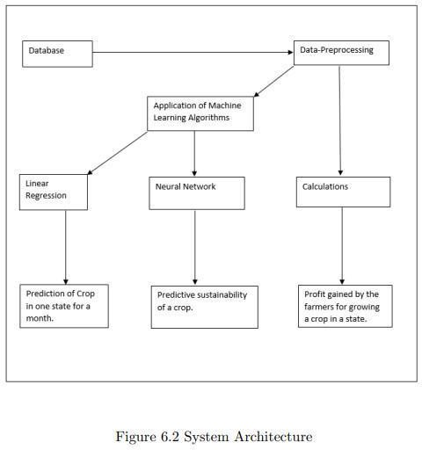

*School of Computer Engineering, KIIT, BBSR* 3

* + 1. **System Architecture OR Block Diagram**



# Chapter 4 Implementation

##### Methodology OR Proposal

We have used different models to compare the best prediction and they are Logistic Regression, GaussianNB, K Neighbour Classifier,

Decision Tree Classifier, Random Forest Classifier.

##### Testing OR Verification Plan

After project work is complete, it must have some verification criterion so that we can decide whether the project satisfactorily completed or not. This is called Testing or verification. For example, in software development, some test case must be included and used to verify the outcome of the project.

|  |  |  |  |  |
| --- | --- | --- | --- | --- |
| Test ID | Test Case Title |  |  | Expected Result |
| T01 | Random Forest |  |  | 0.9909 |
| T02 | Decision Tree |  |  | 0.9834 |
| T03 | k-nearest Neighbor |  |  | 0.961 |

* 1. Result Analysis OR Screenshots

from sklearn.linear_model import LogisticRegression from sklearn.naive_bayes import GaussianNB

from sklearn.svm import SVC

from sklearn.neighbors import KNeighborsClassifier from sklearn.tree import DecisionTreeClassifier from sklearn.ensemble import RandomForestClassifier from sklearn.metrics import accuracy_score

#creating instances of all models

models = {

'Logistic Regression': LogisticRegression(), 'Naive Bayes': GaussianNB(),

'Support VectorMachine': SVC(),

'K-Nearest Neighbors': KNeighborsClassifier(), 'Decision Tree': DecisionTreeClassifier(), 'Random Forest': RandomForestClassifier()

}

for name, md in models.items(): md.fit(x_train,y_train) y_pred= md.predict(x_test)

print(f"{name} with accuracy : {accuracy_score(y_test,y_pred)}")

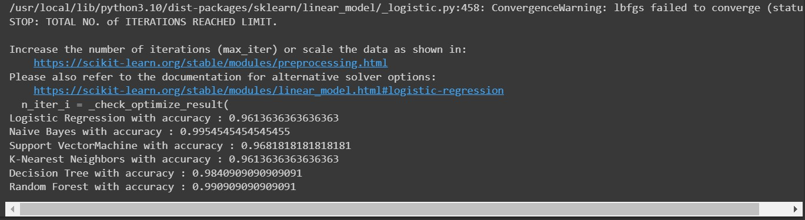**OUTPUT:-**

#Choosing Random Forest Classifier

rf= RandomForestClassifier() rf.fit(x_train,y_train) y_pred= rf.predict(x_test) accuracy_score(y_test,y_pred)

**Output:- 0.9886363636363636**

def recommendation(NITROGEN,PHOSPHORUS,POTASSIUM,TEMPERATURE,HUMIDITY,PH,RAINFALL):

features= np.array([[NITROGEN, PHOSPHORUS, POTASSIUM, TEMPERATURE, HUMIDITY, PH, RAINFALL]])

prediction = rf.predict(features).reshape(1,-1)

return prediction[0]

NITROGEN = 20

PHOSPHORUS = 30

POTASSIUM = 40

TEMPERATURE= 40.0

HUMIDITY = 20

PH= 30

RAINFALL = 50

predict = recommendation(NITROGEN,PHOSPHORUS,POTASSIUM,TEMPERATURE,HUMIDITY,PH,RAINFALL)

crop_dict= {1:"rice",2: "maize",3: "jute",4: "cotton",5: "coconut",6: "papaya",7: "orange",8: "apple",9: "muskmelon",1 0: "watermelon",11: "grapes",12: "mango",13: "banana",14: "pomegranate",15: "lentil",16: "blackgram",17: "mungbean",18

: "mothbeans",19: "pigeonpeas",20: "kidneybeans",21: "chickpea",22: "coffee"} if predict[0] in crop_dict:

crop = crop_dict[predict[0]]

print("{} is a best crop to be cultivated".format(crop)) else:

print("Sorry are not able to recommend a proper crop for this environment")

**Output:-**

**apple is a best crop to be cultivated**

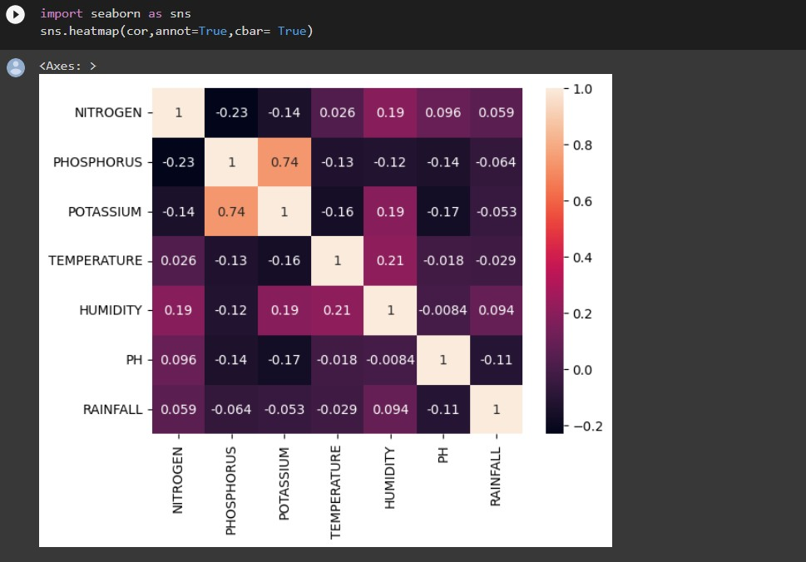**Visualization:-**

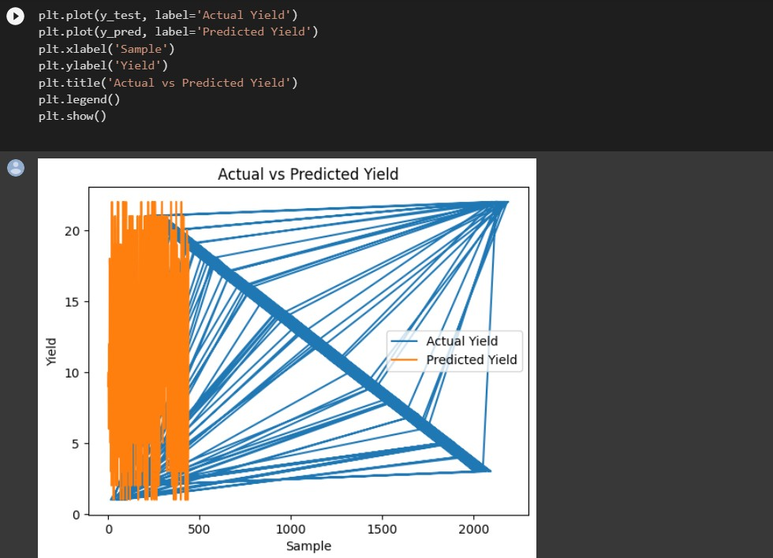

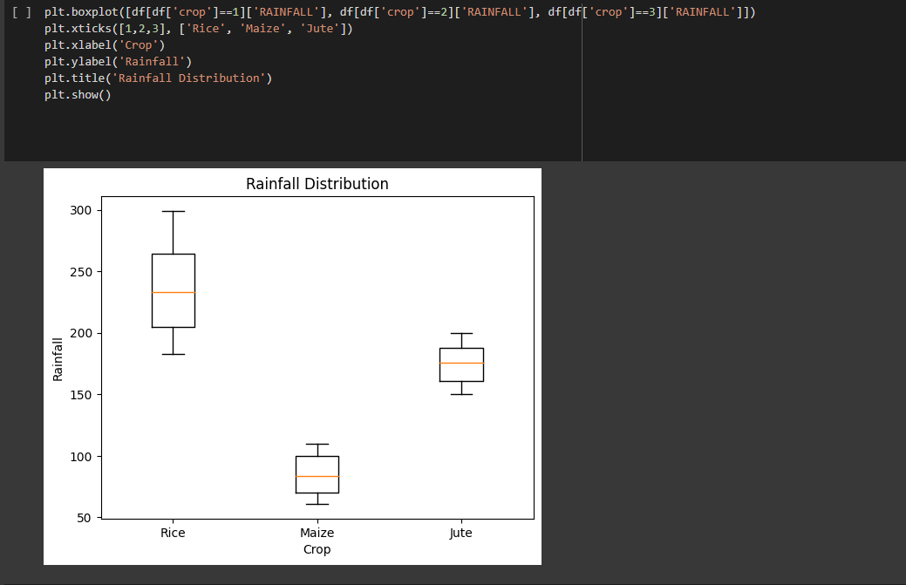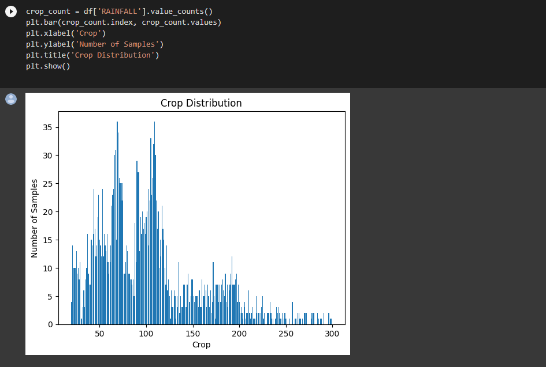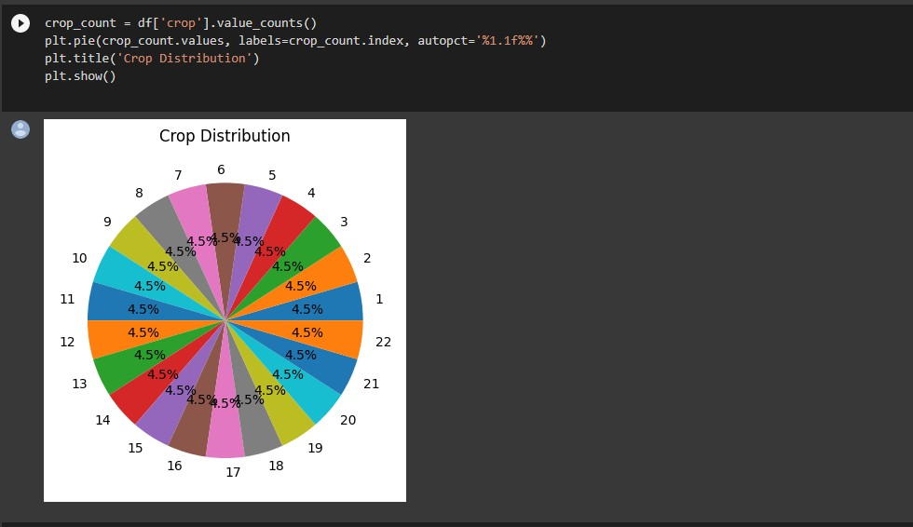

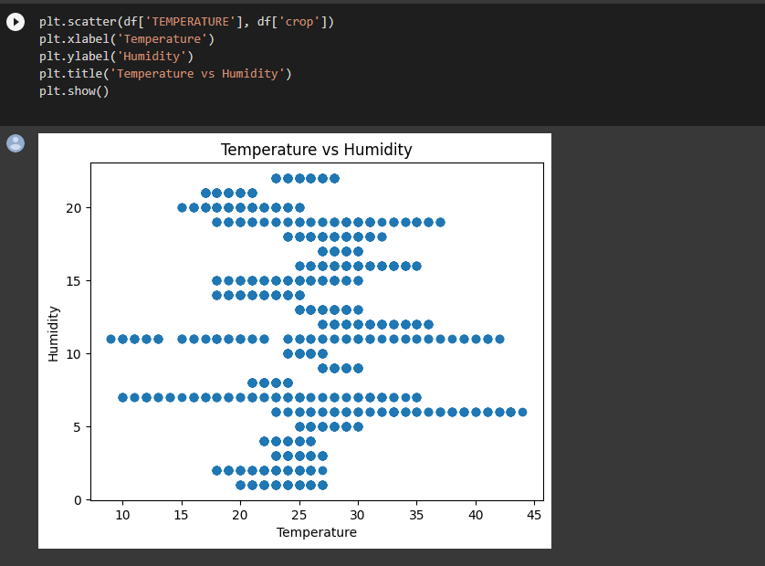

#### Quality Assurance

The purpose of quality assurance, also referred to as QA testing, is to make sure that a company is offering its clients the finest available goods or services. The goal of QA is to make processes better so that customers receive high-quality products. An institution

It must be ensured that processes meet the quality requirements established for software products.



# Chapter 5 Standards Adopted

##### Design Standards

Crop suggestion design standards might vary depending on the project's individual objectives and circumstances. However, here are some general design guidelines to consider:

Data integrity: For successful crop advice, high-quality and trustworthy data are required. This necessitates careful data source selection, data preparation, and data cleaning to guarantee that the data is reliable, consistent, and error-free.

Feature selection: Appropriate feature selection (i.e., input variables) is crucial for model correctness. Expert knowledge and statistical analysis should be used to choose characteristics.

Model selection: For crop recommendation, many machine learning models such as decision trees, random forests, support vector machines, and neural networks can be utilized. The model should be chosen based on the project's individual objectives and requirements.

Model evaluation: The model's performance should be assessed using relevant measures such as accuracy, precision, recall, and F1-score. To examine the model's capacity to generalize to fresh data, the assessment should be performed on a holdout dataset.

The crop recommendation system's user interface should be straightforward and simple to use, with clear instructions and feedback. The system should be able to make suggestions based on user input and show the findings in a visually appealing and understandable manner.

##### Coding Standards

from flask import Flask, render_template, request, render, template import numpy as np

import pandas as pd import sklearn import pickle

# importing model

model = pickle.load(open('model.pkl', 'rb'))

# creating flask app app = Flask( name )

@app.route('/') def index():

return render_template("index.html")

@app.route("/predict", method=["POST"]) def predict():

NITROGEN = int(request.form['Nitrogen']) PHOSPHORUS = int(request.form['Phosphorus']) POTASSIUM = int(request.form['Potassium']) TEMPERATURE = float(request.form['Pemperature']) HUMIDITY = float(request.form['Humidity'])

PH = float(request.form['PH'])

RAINFALL = float(request.form['Rainfall'])

feature_list = [NITROGEN, PHOSPHORUS, POTASSIUM, TEMPERATURE, HUMIDITY, PH, RAINFALL]

single_pred = np.array(feature_list).reshape(1, -1) prediction = model.predict(single_pred)

crop_dict = {1: "Rice", 2: "Maize", 3: "Jute", 4: "Cotton", 5: "Coconut", 6:

"Papaya", 7: "Orange", 8: "Apple", 9: "Muskmelon", 10: "Watermelon", 11:

"Grapes", 12: "Mango",

13: "Banana", 14: "Pomegranate", 15: "Lentil", 16: "Blackgram", 17:

"Mungbean", 18: "Mothbeans", 19: "Pigeonpeas", 20: "Kidneybeans", 21:

"Chickpea", 22: "Coffee"}

if predict[0] in crop_dict:

crop = crop_dict[predict[0]]

print("{} is a best crop to be cultivated".format(crop)) else:

print("Sorry are not able t o recommend a proper crop for this environment")

return render_template('index.html', result=crop)

# python main

if name == " main ": app.run(debug=True)

##### Testing Standards Test 1:--

Test 2:--

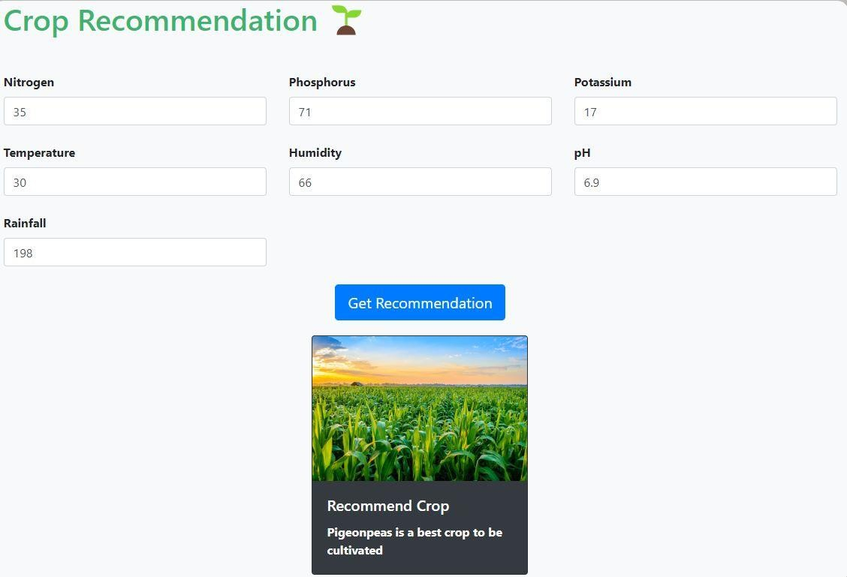

test 3:-

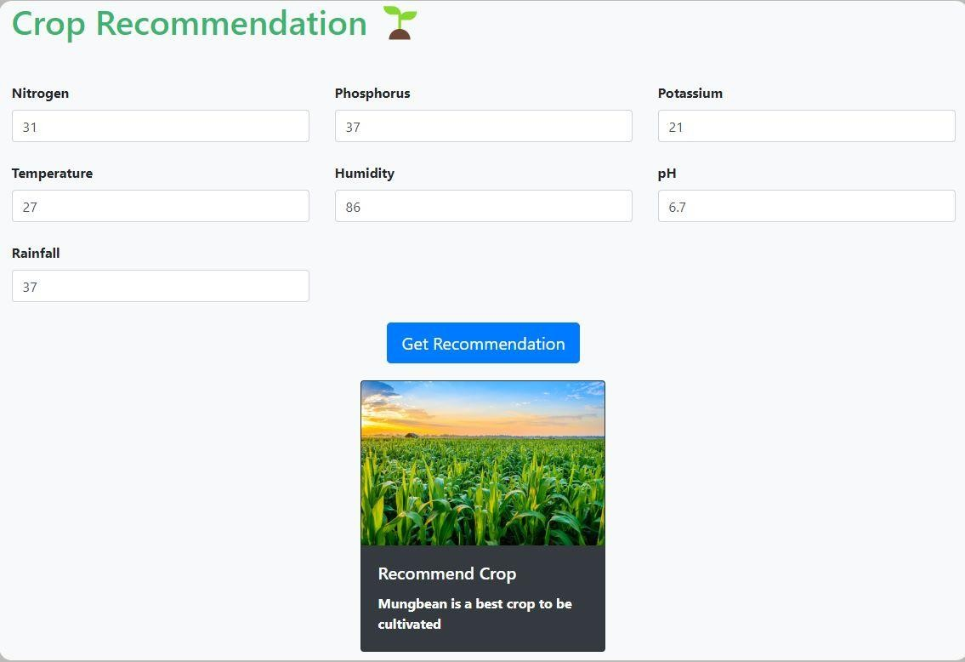

test 4:--

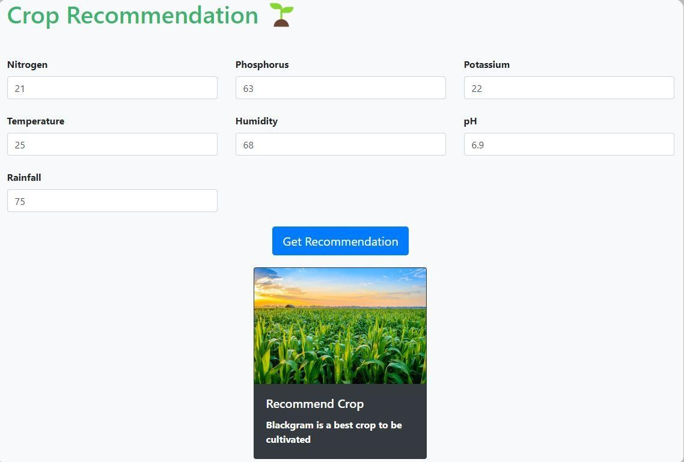



# Chapter 6

Conclusion and Future Scope

##### Conclusion

Agriculture has long been one of the most important and vital sectors of the global economy. The global population is predicted to reach 9.7 billion by 2050, making feeding all of those people a big problem for farmers. It is vital to raise agricultural productivity and yields in order to fulfill food demand and produce enough crops.

##### Farmers, on the other hand, confront several problems, including unexpected weather patterns, pests and disease, and other variables that might negatively impact crop output.

Finally, the Crop Recommendation ML Model has the potential to revolutionize the agriculture business by giving farmers personalized suggestions on which crops to plant and how to optimize their development. While there are still implementation challenges, the potential benefits make it a promising technology for the future of agriculture.

##### As we continue to establish and improve the model, we will have the chance to construct a more sustainable and efficient food production system capable of meeting the world's rising food needs.

In conclusion, the Crop Recommendation ML Model is a potential agricultural tool for the future. It has the potential to raise agricultural production and food security by providing farmers with individualized guidance on crop selection and optimisation.

##### Although there are challenges, such as data availability and investment in technology and training, we must work to overcome them so that this technology is available to farmers all over the world. We can construct a more sustainable and efficient food production system that can fulfill the world's expanding food demand by doing so.

* 1. Future Scope

Despite some challenges in implementing the Crop Recommendation ML Model, its potential benefits make it a promising technology for agriculture's future. As technology evolves and becomes easier to access, it has the potential to fundamentally change the way we approach farming and food production.

The Crop Recommendation ML Model may be merged with other technologies in the future, such as precision agriculture and autonomous farming equipment, further simplifying and enhancing efficiency.

##### There are several causes fuelling the need for such models. One of the primary drives is the desire to boost agricultural output and minimize waste, which may be accomplished by improving crop selection and management practices. Climate change and its impact on agricultural output, together with rising food demand owing to population increase, all contribute to the need for more efficient and sustainable farming practices.

6

*NAME OF PROJECT*



***References***

1. Crop Prediction Using Machine Learning Approaches by Nischitha K, Dhanush Vishwakarma, Mahendra N, Ashwini, Manjuraju M R, International Journal of Engineering Research and Technology, vol. 9 Issue 08, August-2020 ISSN: 2278-0181.
2. Zeel Doshi, Subhash Nadkarni, Rashi Agarwal, and Neepa Shah, "AgroConsultant: Intelligent Crop Recommendation System Using Machine Learning Algorithms," Fourth International Conference on Computing, Communication, Control, and Automation, 2018.1.
3. *Intelligent Crop Recommendation System utilizing Machine Learning, Proceedings of the Fifth International Conference on Computing Methodologies and Communication (ICCMC 2021). Priyadharshini A, Swapneel Chakraborty, Aayush Kumar, and Omen Rajendra Pooniwala.*
4. *Crop Recommendation Using Machine Learning Approach by Shilpa Mangesh Pande, Prem Kumar Ramesh, Anmol, B. R. Aishwarya, Karuna Rohilla, and Kumar Shaurya are published in the proceedings of the Fifth International Conference on Computing Methodologies and Communication (ICCMC 2021).*
5. *E. Ramanujam, R. Harine Rajashree, C. Kavya, T. Kiruthika, and J. Nisha, as well as S. Pudumalar. The "crop recommendation system for precision agriculture." Pages 32–36 of the 2016 Eighth International Conference on Advanced Computing (ICoAC). IEEE, 2017.*
6. [*https://www.ijert.org/crop-recommendation-using-machine-learning-techniques*](https://www.ijert.org/crop-recommendation-using-machine-learning-techniques)
7. *https://ieeexplore.ieee.org/document/9418351*



**SAMPLE INDIVIDUAL CONTRIBUTION REPORT:**

**CROP RECOMMENDATION SYSTEM**

**GAURAV KUMAR NAYAK MANI SHANKER**

**M. SANSKAR RAHUL KUMAR**

**Abstract:** Crop recommendation using Machine Learning is the process of analyzing numerous environmental characteristics such as soil, temperature, humidity, rainfall, and so on and recommending the best crops for a certain place. The ML model may be trained on historical crop data and environmental variables to recommend the optimum crop for a given set of inputs.

The procedure entails gathering and analyzing data from many sources such as satellite images, weather stations, soil testing, and so on, and then utilizing this data to develop a model that can reliably forecast which crop would perform best in a given region. Various algorithms, such as Decision Trees, Random Forest, Naive Bayes, and Support Vector Machines, can be used to train the ML model.

**Individual contribution and findings:**

**GAURAV KUMAR NAYAK –** Datapreprocessing , Find the accuracy of random forest model, decision tree model

**MANI SHANKER –** Finding the accuracy of Logistic Regression, Naive Bayes , Support Vector Machine, K-Nearest Neighbors, XGBoost and Deployed ML model

**M SANSKAR –** Data visualization using Line chart , Bar chart , Pie chart, Scatter plot, Box plot. Django Front End

**RAHUL KUMAR–**Django Front End

Full Signature of Supervisor: Full signature of the student:

……………………………. ……………………………..

**PLAGIARISM CHECK REPORT**

