# WEEK-4 TUTORIAL-WORKSHOP

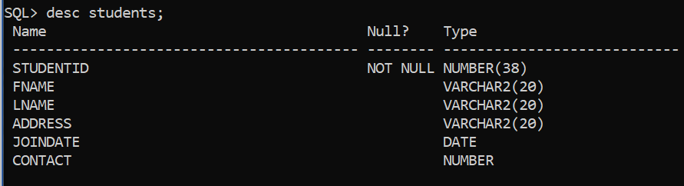

## Describing students table.

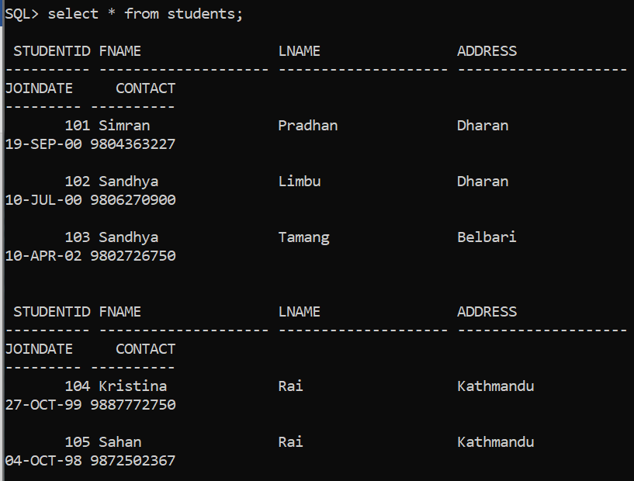

## Values entered in students table.

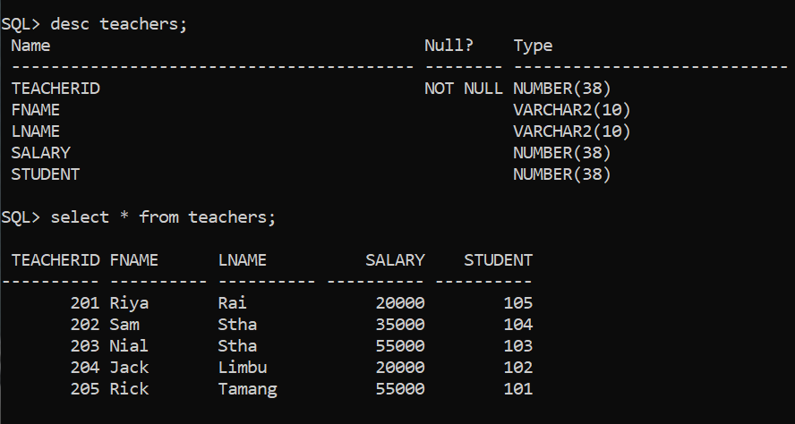

## Teachers Table with Foreign key from students table.

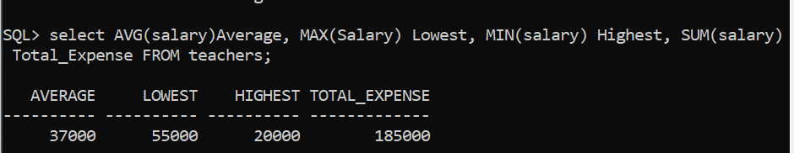

## Using AVG, MAX, MIN, SUM functions.

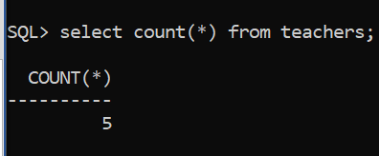

## Using count function

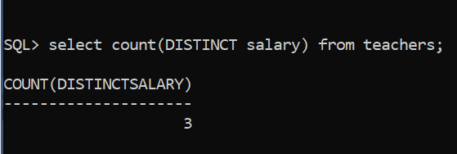

## Using distinct keyword and count function.

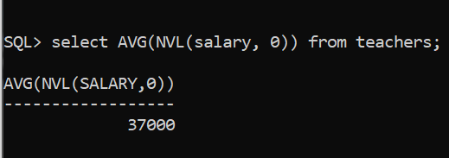

## Using NVL with group function.

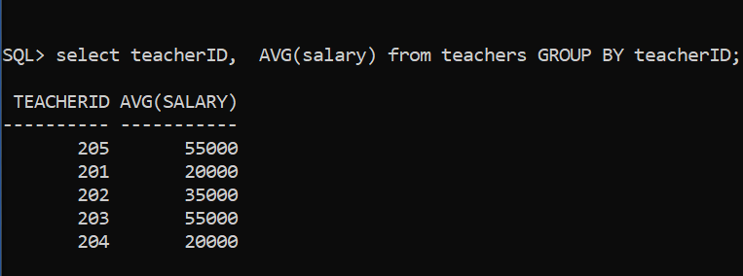

## Using group by clause.

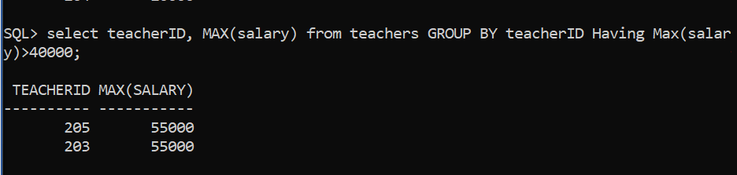

## Using Having Clause.

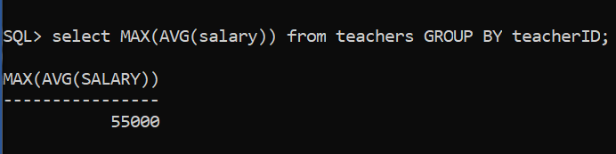

## Nesting Group Function.

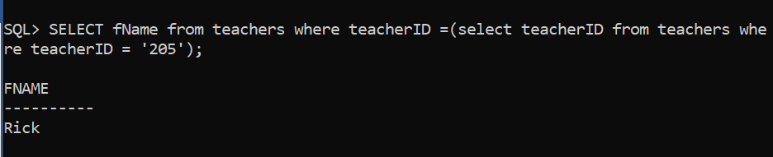

## Executing single- Row subqueries

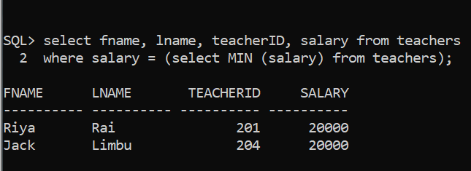

## Using Group Functions in a subquery

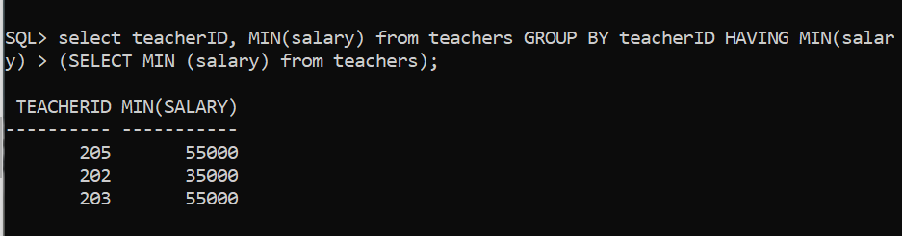

## The having clause with subqueries.