Worksheet 7

Student Name: Aradhya Sharma UID: 25MCC20042
Branch: MCA (Cloud Computing & Devops) Section/Group: MCC-101 A
Semester: 2 Date of Performance: 31-03-2026
Subject Name: Technical Training -I Subject Code: 25CAP-652

Aim

Implementation of joins in PostgreSQL (inner join ,left join,right join, multiple join and cross join)

Tools Used
- PostgreSQL
- pgAdmin
- Windows Operating System

Objectives

Apply joins to a real-world database schema (e.g., Students, Courses, Enrollments, Departments)

Theory

A JOIN in SQL is used to combine rows from two or more tables based on a related column between them. Joins are essential in relational databases because data is often stored in multiple tables to reduce redundancy and improve organization.

Types of Joins Used in this Experiment:
- INNER JOIN:
Returns only the matching records from both tables.
- LEFT JOIN:
Returns all records from the left table and the matching records from the right table. If no match is found, NULL values are returned for the right table columns.
- RIGHT JOIN:
Returns all records from the right table and the matching records from the left table. If no match is found, NULL values are returned for the left table columns.
- MULTIPLE JOIN:
A multiple join in SQL means joining more than two tables in a single query to combine related data.
- CROSS JOIN:
Returns the Cartesian product of two tables, i.e., all possible combinations of rows from both tables.

Experiment Steps

Step 0: Creating tables and inserting records

Code

CREATE TABLE Departments (

dept_id INT PRIMARY KEY,

dept_name VARCHAR(100)

);

CREATE TABLE Students (

student_id INT PRIMARY KEY,

student_name VARCHAR(100),

dept_id INT,

FOREIGN KEY (dept_id) REFERENCES Departments(dept_id)

);

CREATE TABLE Courses (

course_id INT PRIMARY KEY,

course_name VARCHAR(100)

);

CREATE TABLE Enrollment (

student_id INT,

course_id INT,

PRIMARY KEY (student_id, course_id),

FOREIGN KEY (student_id) REFERENCES Students(student_id),

FOREIGN KEY (course_id) REFERENCES Courses(course_id)

);

Students Table :

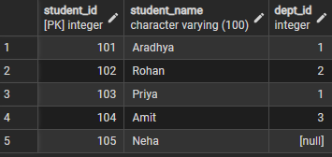

Courses Table:

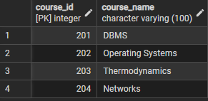

Enrollment Table:

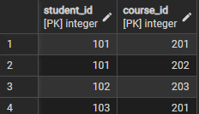

Departments Table :

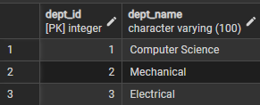

Step 1 : Queries to list students with their enrolled courses (INNER JOIN).

SELECT s.student_id, s.student_name, c.course_name

FROM Students s

INNER JOIN Enrollment e ON s.student_id = e.student_id

INNER JOIN Courses c ON e.course_id = c.course_id;

Output:

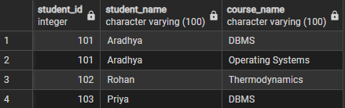

Step 2: Find students not enrolled in any course (LEFT JOIN).

SELECT s.student_id, s.student_name

FROM Students s

LEFT JOIN Enrollment e ON s.student_id = e.student_id

WHERE course_id IS NULL;

Output

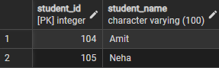

Step 3: Display all courses with or without enrolled students (RIGHT JOIN).

SELECT s.student_name, c.course_name

FROM students s

RIGHT JOIN enrollment e ON s.student_id = e.student_id

RIGHT JOIN courses c ON e.course_id = c.course_id;

Output

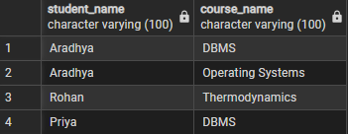

Step 4: Show students with department info using MULTIPLE JOINS or SELF JOIN.

SELECT s.student_name, d.dept_name

FROM Students s

LEFT JOIN Departments d

ON s.dept_id = d.dept_id

LEFT JOIN Enrollment e

ON s.student_id = e.student_id;

Output

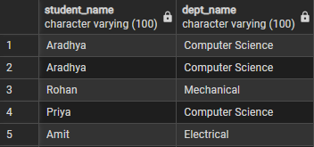

Step 5: Display all possible student-course combinations (CROSS JOIN).

SELECT s.student_name, c.course_name

FROM students s

CROSS JOIN courses c;

Output

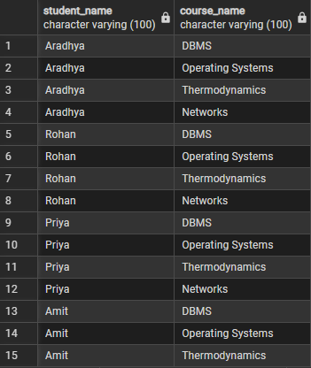

Learning Outcome
- Join Understanding: I learned how to use different types of SQL joins to retrieve related data from multiple tables.
- Practical Database Skills: I understood how real-world schemas such as Students, Courses, Enrollments, and Departments are related in a relational database.
- Data Analysis Ability: I learned how to identify matching and non-matching records using INNER JOIN, LEFT JOIN, and RIGHT JOIN.
- Advanced SQL Usage: I understood CROSS JOIN for generating all possible combinations.
- PostgreSQL Practice: I gained hands-on experience in writing and executing SQL queries in PostgreSQL / pgAdmin.

