1. PROJECT PROPOSAL
Project title: PharmaLink — An Online Pharmacy Marketplace

1.1 Background to the Problem

1.1.1 Problem Domain
Buying medicine in Bangladesh, and in Dhaka in particular, is still a walk-in activity. Most medicine is sold by small neighbourhood pharmacies that keep their stock in paper registers or simple spreadsheets. A customer cannot find out whether a medicine is in stock without going to the shop, cannot compare prices between shops, and has no record of what other buyers thought of a pharmacy. When a child develops a fever late at night, someone in the family goes from one shop to the next until they find the medicine, often paying whatever price is asked.
The pharmacy owner has the opposite problem. A small shop has no way to reach buyers outside its own street, usually notices that an item has run out only when a customer asks for it, and cannot easily tell which medicines earn it the most money. Large chains and existing delivery apps exist, but they mostly serve their own stock and do not give the ordinary licensed neighbourhood pharmacy a place to sell.
There is also a trust problem. Counterfeit and expired medicines are a known issue in the local market, and prescription-only medicines such as antibiotics are often sold without any prescription. A customer buying from an unknown seller has no easy way to check that the pharmacy is licensed by the Directorate General of Drug Administration (DGDA).

1.1.2 Proposed Solution: PharmaLink
PharmaLink is a software platform that sits between licensed pharmacies and the people who buy medicine from them. It does not own or stock any medicine itself. Pharmacies list what is actually on their shelves with price and stock; customers search across every approved pharmacy at once, order, pay and rate the pharmacy afterwards; and the company that runs the platform earns a commission on each completed sale, in the same way Foodpanda sits between restaurants and diners.
The system has four roles, all of which sign in through one shared login screen:
- Super Admin — the platform operator. Approves each new pharmacy after checking its DGDA licence number, suspends pharmacies with poor ratings, maintains the medicine category list, moderates reviews, sets each pharmacy's commission rate and reads platform-wide sales reports.
- Admin (Pharmacy Owner) — a pharmacy owner. Registers the shop, manages its medicines and stock, gets low-stock alerts, runs discount offers, verifies uploaded prescriptions and reads an earnings report that shows gross sales, platform commission and net earnings.
- Customer — a patient or family member. Searches and filters medicines by name, generic name, category, price, area and pharmacy, reads reviews, uses a cart, pays online by bKash, Nagad or Visa card or chooses cash on delivery, uploads a prescription when one is required, receives an invoice and rates the medicine after delivery.
- Delivery Man — a rider who carries orders from the pharmacy to the customer. Sees the orders assigned to them with the pickup and delivery address, updates each order's status as it moves (picked up, out for delivery, delivered), collects the payment for cash on delivery orders and keeps a history of completed deliveries.
Two features have been added to PharmaLink since its first version. The first is the Delivery Man role described above, so that an order is tracked all the way to the customer's door instead of stopping at Confirmed. The second is integrated payment: the customer can pay online through bKash, Nagad or a Visa card, or choose cash on delivery, and every order keeps its payment method and payment status (Pending, Paid or Failed) so that the pharmacy and the platform know which orders have actually been paid.
A first working version of PharmaLink was built as a C# Windows Forms desktop application over a Microsoft SQL Server database in the Object Oriented Programming 2 course. It covers 30 functional requirements across the three original roles. In this Software Engineering course the team will take the same product through a proper engineering process: gathering and documenting requirements, modelling and design, planned increments, testing and controlled delivery.

1.1.3 Target Group of Users
PharmaLink is aimed at the following groups:
Table 1.1: Target user groups of PharmaLink
User group | Who they are | What they need from PharmaLink
Customers (primary) | Urban patients and their families in Dhaka; working people with little time; parents of young children; elderly people and people with chronic conditions (diabetes, blood pressure) who buy the same medicine every month; carers buying for someone else. | Find a medicine quickly, compare price across shops, check that the shop is licensed, pay in a familiar way, get it delivered and reorder easily.
Pharmacy owners (primary) | Owners of small and medium licensed retail pharmacies who do not have their own website or app. | Reach more buyers without hiring staff, track stock and low-stock items, run offers and know exactly what they have earned after commission.
Platform operator (primary) | The company running PharmaLink, represented in the system by the Super Admin. | Keep the marketplace trustworthy, approve only licensed shops, control commission and monitor sales and service quality.
Delivery men (primary) | Riders, often young people working full or part time, who deliver orders on a bicycle or motorbike. | A clear list of assigned orders with addresses and phone numbers, a simple way to update status, and a record of cash collected and deliveries completed.
Secondary stakeholders | Doctors whose prescriptions are uploaded; the DGDA as the regulator; payment providers such as bKash, Nagad and Visa. | Prescriptions respected before dispensing; only licensed sellers on the platform; correct payment records.

1.1.4 Societal, Health, Safety, Legal and Cultural Issues
Medicine is not an ordinary product, so the project has to be considered beyond its technical features. Table 1.2 summarises each issue and how PharmaLink responds to it; the paragraphs below explain them.
Societal. Many people lose time and money going from shop to shop, and those without easy transport, such as elderly or disabled people, are affected the most. A single search across all approved pharmacies, with home delivery, reduces this. The platform also gives small neighbourhood pharmacies a fair channel to compete with large chains, which helps local businesses, and the Delivery Man role creates paid work for local riders. A possible negative effect is that people without a computer or internet access are left out; a mobile and web version is planned as future work for this reason.
Health. The main health risks are wrong medicine, expired medicine and misuse of prescription-only medicine such as antibiotics, whose overuse adds to antimicrobial resistance. Every medicine in PharmaLink carries a prescription-required flag. If the cart contains such a medicine the customer must upload a photo of the prescription, and the pharmacy must approve it before the order can be confirmed. Expiry dates are stored and must be in the future when a medicine is listed, and the details screen shows the generic name, strength and manufacturer so that the customer can check what they are buying.
Safety. Safety here covers both patient safety and the safety of personal data. Only pharmacies approved by the Super Admin after a DGDA licence check can sell, and badly rated pharmacies can be suspended. Passwords are stored only as salted PBKDF2 hashes, never as plain text. Every pharmacy-side query is filtered by the logged-in owner's pharmacy, so one pharmacy can never read another's sales or customer data. Prescription images are health data and are visible only to the customer and the pharmacy handling that order. Delivery men see only the orders assigned to them, with only the details needed to deliver them, and never see prescription images. Card details are entered on the payment provider's page and are not stored by PharmaLink, and an order is marked Paid only after the provider confirms the payment. Checkout runs inside one database transaction so that stock, order and payment records stay consistent.
Legal. Selling medicine in Bangladesh is regulated by the DGDA under the Drugs and Cosmetics Act 2023, which requires every retail pharmacy to hold a valid drug licence. PharmaLink stores each pharmacy's licence number under a unique constraint and keeps a new pharmacy in Pending status until it is approved. The platform acts as an intermediary, so responsibility for dispensing stays with the licensed pharmacy, and this must be made clear in the terms of use. Customer data (names, phone numbers, addresses and prescriptions) must be handled in line with national data protection and cyber security law, and reviews are hidden rather than deleted so that an audit trail is kept. The commission charged on each order is frozen on the order record, so a later change of rate cannot change what a pharmacy owed for past sales. Each online payment keeps the provider's transaction reference, and cash collected by a delivery man is recorded against the order, so every payment can be traced if there is a dispute.
Cultural. Mobile financial services such as bKash and Nagad are the most common way to pay online in Bangladesh, fewer people use cards, and many still prefer to see the goods before paying. PharmaLink therefore supports bKash, Nagad, Visa card and cash on delivery, with the delivery man collecting the cash at the door. People are used to buying from a pharmacy they know in their own area, so search can be filtered by area and pharmacy, and customers can read reviews before buying. Some health purchases are private or embarrassing to make in a crowded shop, and some customers, particularly women caring for family members, prefer ordering from home; home delivery helps here. Generic names are shown beside brand names because people often ask for a medicine by its brand.
Table 1.2: Summary of societal, health, safety, legal and cultural issues
Issue | Concern | How PharmaLink addresses it
Societal | Time and cost of searching shop to shop; small pharmacies cannot reach buyers | One search across all approved pharmacies; home delivery; paid work for local riders
Health | Wrong, expired or unprescribed medicine; antibiotic misuse | Prescription upload and pharmacist verification; expiry date checks; generic name shown
Safety | Unlicensed sellers; leaked passwords, card or health data | Licence-based approval; PBKDF2 hashing; per-pharmacy isolation; riders see only their orders; card data not stored
Legal | DGDA licensing; data protection; financial records | Unique licence numbers; Pending until approved; frozen commission; payment references and COD cash recorded
Cultural | Preference for cash and mobile money; trust in local shops; privacy | bKash, Nagad, Visa card and cash on delivery; area filter; reviews; home delivery

1.2 Selection of Process Model

1.2.1 Selected Process Model
The team has selected the Incremental Process Model for PharmaLink.

1.2.2 Explanation of the Incremental Model
In the incremental model the full set of requirements is identified at the start, and the product is then built and delivered in a series of increments. Each increment is a working, tested part of the system. The first increment delivers the core product, and every later increment adds new features on top of what has already been delivered, until the complete system exists. Each increment passes through the same five framework activities, and the increments overlap in time: while one increment is being constructed, the next can already be planned. After each delivery the users evaluate it, and their feedback goes into the plan for the next increment.
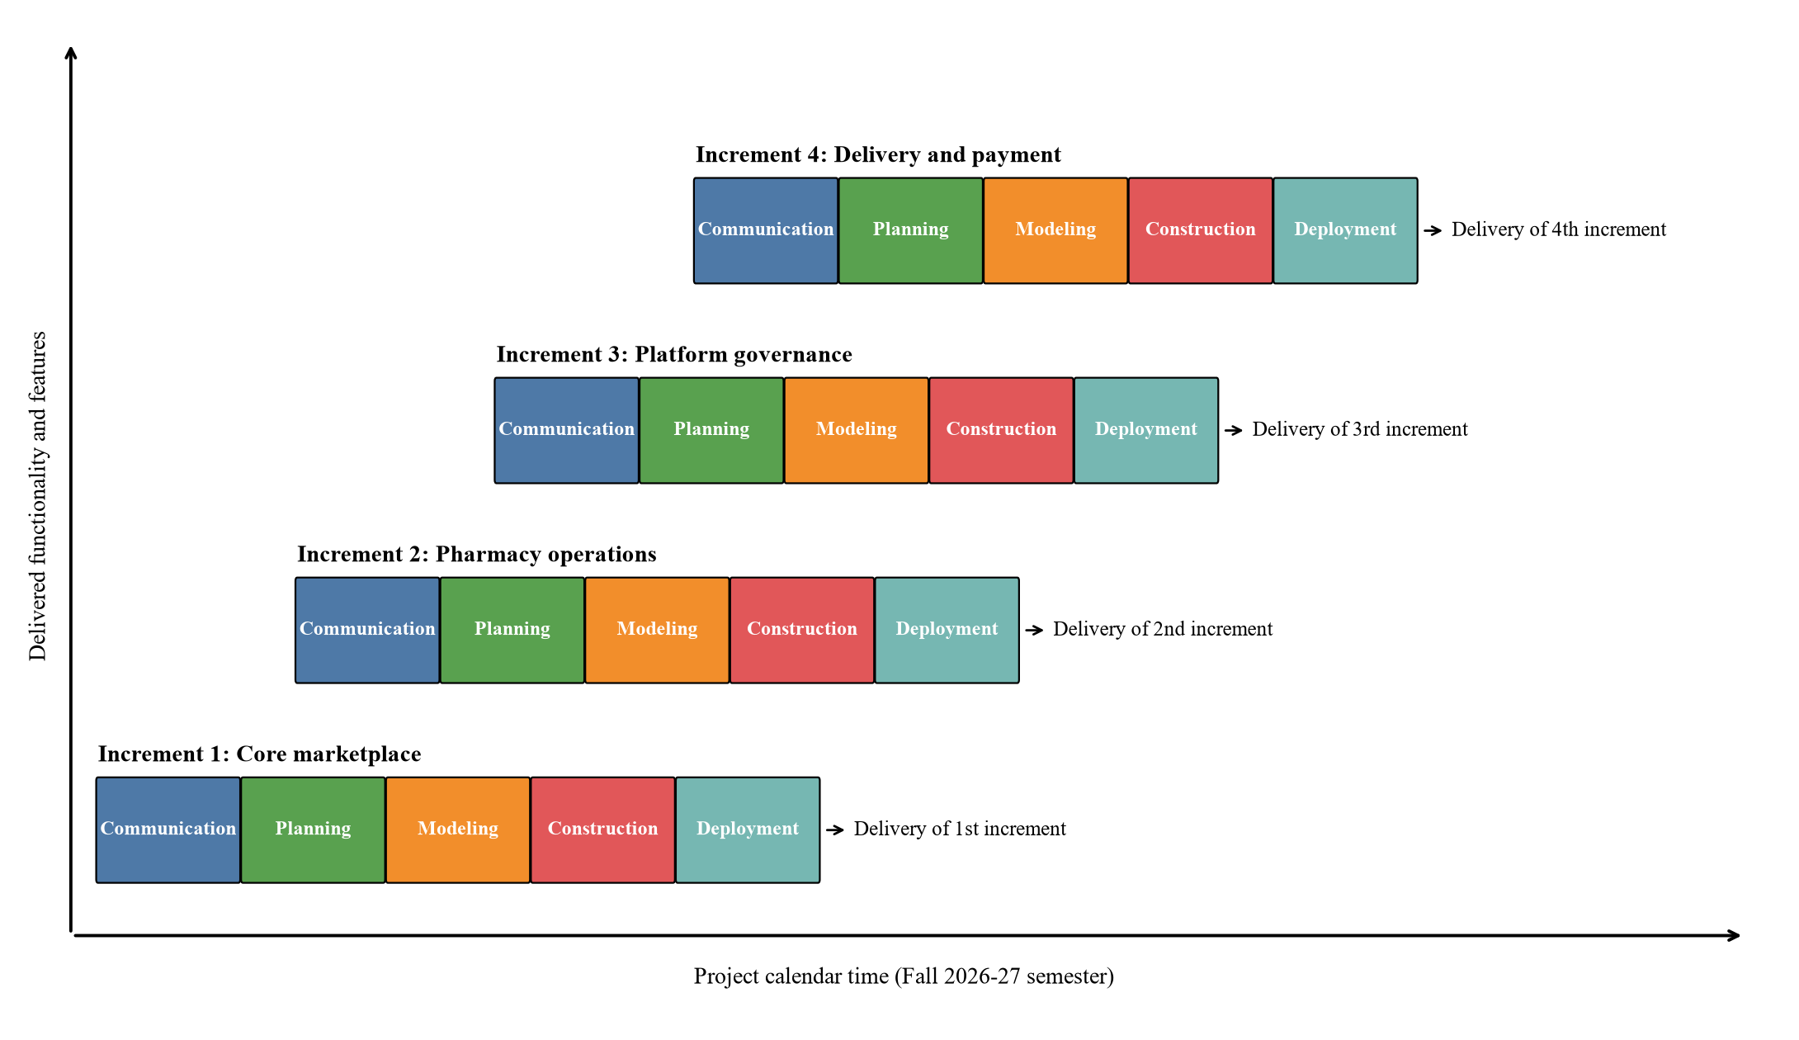
Figure 1.1: Incremental process model applied to PharmaLink
The five activities in each increment are carried out as follows for PharmaLink:
Table 1.3: Framework activities within each increment
Activity | What the team does in PharmaLink
Communication | Meet the course teacher (acting as client) and representative users; confirm and prioritise the requirements for this increment; agree acceptance criteria.
Planning | Estimate effort, assign tasks to the four team members, set the increment deadline and identify risks.
Modeling | Analysis and design: use case diagrams, activity diagrams, class diagrams, ER diagram and database schema, screen designs for the forms in this increment.
Construction | Code the forms and services in C# and the SQL Server tables and queries; unit, integration and regression testing against earlier increments.
Deployment | Deliver the working increment, demonstrate it, collect feedback and fix defects; feedback feeds the next increment's communication step.

The 30 original functional requirements of PharmaLink are divided into three increments by priority, and the two new features form a fourth increment. The core buying flow comes first because no other feature has value without it.
Table 1.4: Increment plan for PharmaLink
Increment | Features delivered | Requirements
1. Core marketplace | Shared login and sign-up, browse medicines from all approved pharmacies, search and filter, medicine details, cart, checkout with payment method, invoice, order history. | FR 1, 19–25, 27
2. Pharmacy operations | Pharmacy registration, medicine CRUD, stock dashboard with low-stock alerts, sales and earnings report, discount offers, read-only reviews, prescription upload and verification, owner profile, per-pharmacy data isolation. | FR 10–18, 26
3. Platform governance | Pharmacy approval and suspension, user management, platform sales and commission report, low-rated pharmacy report, category management, review moderation, per-pharmacy commission rate, customer ratings, today's offers, customer profile. | FR 2–9, 28–30
4. Delivery and payment | Delivery Man role and login, assigning orders to delivery men, delivery status updates visible to the customer and the pharmacy, cash collection for cash on delivery, delivery history; online payment through bKash, Nagad and Visa card with payment status and transaction reference. | New requirements

1.2.3 Why We Chose the Incremental Model
- Requirements are clear but large. The 30 functional requirements and the three user roles are already well understood from the earlier version of the project, so the full scope can be fixed at the start, which the incremental model assumes. What is not yet settled is the detail of each screen, and that can be refined increment by increment.
- The product splits naturally. The system divides cleanly into a customer part, a pharmacy part and a platform part. Each part can be built, tested and shown on its own, which matches the idea of an increment.
- Early working software. The core buying flow is delivered in the first increment, so a working product exists early in the semester instead of only at the end. If time runs short, the most important features are already finished.
- Feedback after every delivery. Each increment is demonstrated to the course teacher, and comments are applied in the next increment instead of after the whole system is complete.
- Lower risk and easier testing. Problems found in one increment, for example a database design mistake, are caught while the system is still small and cheap to change. Each increment is smaller and easier to test than the full system.
- Fits a small team and a fixed deadline. Our team has four students and a fixed semester. Increments line up with course milestones and let work be divided by module, so members can work in parallel.
- New features fit in as a new increment. The Delivery Man role and online payment were added after the first version was finished. In the incremental model this is expected: they become a new increment built on top of the working system, and the earlier increments are re-tested so that nothing that already worked is broken.
Other models were considered and rejected for the reasons below.
Table 1.5: Comparison with other process models
Model | Why it was not chosen for PharmaLink
Waterfall | Nothing works until the very end, and feedback from the teacher would come too late to change the design. A mistake in the database design would affect the whole system.
Prototyping | Useful when requirements are unclear. Our requirements are already clear, so building throwaway prototypes would waste time.
Spiral | Designed for large, high-risk projects with formal risk analysis in every cycle. That overhead is too heavy for a four-person semester project.
Agile (Scrum) | Needs a product owner who is always available, daily stand-ups and short sprints. As students with other courses we cannot keep that rhythm, and the course expects full documentation, which the incremental model keeps.

