
AMERICAN INTERNATIONAL UNIVERSITY–BANGLADESH (AIUB)
Dept. of Computer Science
Faculty of Science and Technology
CSC2210: OBJECT ORIENTED PROGRAMMING 2
Summer 2025–2026
Section: R
Project Report On
PharmaLink – An online pharmacy marketplace that connects patients with licensed neighbourhood pharmacies.
Supervised By
Dr. Md. Iftekharul Mobin
Submitted By:
Name | ID
1. Nafiul Islam | 21-45717-3
2. Md Arafat Rahman | 22-47910-2
3. Muhtasim Mahin | 23-53789-3
4. Shohidur Raza Sujon | 22-49449-3

CO2: Display and verify the mean of a real-life Project using the concepts of C# Graphical User Interface based environment with database integration to depict a desktop-based application.
Assessment  Criteria | Not Attended/  Incorrect (0) | Inadequate  (1–2) | Average  (3) | Good  (4) | Excellent  (5)
Evaluation  Criteria | Evaluation Definition |  |  |  | Total =
Requirement fulfillment | Properly demonstrate a real-life scenario-based project with proper functional requirement identification for the Object-Oriented Programming project development activities.
Validation | Ensuring the ability of students’ proper demonstration on validation forms in their system in terms of dealing with the data.
Verification | Identifying if the students can verify the system data along with proper functional requirements in terms of data flow.

CO3: Prepare and explain a real-life desktop application by synthesizing C# components and development tools with database integration.
Assessment  Criteria | Not Attended/  Incorrect (0) | Inadequate  (1–2) | Average  (3) | Good  (4) | Excellent  (5)
Evaluation  Criteria | Evaluation Definition |  |  |  | Total =
Organization of the application | Assessing whether the application is organized properly, with a complete report, a clear repository structure and an honest record of each member’s contribution.
Representation and Integration of Database | Assessing the representation of the database design, its normalization up to third normal form, and the integration of the tables through primary and foreign keys.
Graphical User Interface | Assessing whether the graphical user interface is consistent, user friendly and coherent, and whether every form is reachable and has a way back.

Date of Submission: ______________________

Table Of Contents
Topics | Page No.
1. Title | 4
2. Introduction | 4
3. Case Study | 4
3.1 Functional Requirements | 5
3.2 Traceability | 7
3.3 User Stories | 8
4. ER Diagram | 18
5. Normalization & Finalization | 20
6. Database Schema | 29
7. Database Query | 37
8. Transition Table | 60
9. Features and Facilities | 88
10. Conclusion | 90
10.1 Future Work | 91

1. Title
PharmaLink – An online pharmacy marketplace that connects patients with licensed neighbourhood pharmacies.

2. Introduction
In a city where a fever at eleven at night still means a rickshaw ride to whichever pharmacy is open, getting the right medicine quickly is a real problem and not a small one. PharmaLink is a desktop application, written in C# with Windows Forms over a Microsoft SQL Server database, that puts a software platform between the two sides of that problem. Licensed pharmacies list what is actually on their shelves, patients search across every listed pharmacy at once, and the company that runs the platform earns a commission on each completed sale.
The system is a three tier marketplace. The Super Admin is the platform operator, the Pharmacy Owner sells through the platform, and the Customer is the patient buying. All three are stored in one Users table, and a UserType column decides which dashboard opens after login. In the code and the database the Pharmacy Owner role is called Admin (UserType = 'Admin'); this report uses the name Pharmacy Owner throughout.
This report describes the finished system: the case study it was built from, the functional requirements and user stories for all three roles (including the requirements added during implementation), the entity relationship diagram, the normalization of every relationship up to third normal form, the resulting database schema with the script that creates it and the queries the application runs, the transitions between every form in the application, and the features the system provides.

3. Case Study
Anyone who has bought medicine at short notice in Dhaka knows the routine. A child spikes a fever at eleven at night, and someone goes out on a rickshaw to Mitford or the nearest para shop to find out whether the medicine is even in stock. If it is not, the search starts again at the next shop, with no way to compare prices and no way to confirm the strip is genuine. The pharmacy owner has the mirror problem. They keep stock in a paper register, do not know which item is running out until a customer asks, and cannot reach a buyer four streets away who has never heard of their shop.
PharmaLink is a Windows desktop application that puts a software platform between those two parties. It owns no medicine; it is the IT company in the middle, as Chaldal sits between grocers and households. Licensed pharmacies list what is on their shelves, patients search every listed pharmacy at once, and the platform takes a commission on each sale.
Three actors work inside the system and each wants something different. The Super Admin is the platform operator. They want a trustworthy marketplace, so they approve every new pharmacy against its DGDA drug licence number, suspend the ones customers rate badly, maintain the master category list, moderate abusive reviews and the reviews pharmacy owners report, warn a pharmacy whose service is slipping, and watch the commission earned. The Pharmacy Owner is someone such as the proprietor of Mitford Pharma. They want to sell more without hiring staff, so they list their medicines with price and stock, are warned when an item falls below its minimum level, verify prescriptions, confirm and deliver orders, run discount offers, and read an earnings report telling them what they are owed. The Customer is a patient such as a resident of Mirpur 10. They want the right medicine at a fair price delivered to their door, so they search, filter by category, price range, area, pharmacy and availability, read what other buyers said, pay by bKash, Nagad, card or cash on delivery, and rate each medicine they received once the order is delivered.
The entities are few and clear. A user is identified by a user id and carries a full name, a unique email, a salted password hash, a unique phone number, an address, a user type that decides which dashboard opens after login, and an account status. A pharmacy is identified by a pharmacy id and holds a shop name, a unique drug licence number, an area such as Mitford or Dhanmondi, an address, a contact number, a commission rate and an approval status. A medicine is identified by a medicine id and holds a brand name, a generic name, a manufacturer, a strength, a unit price, current stock, a minimum stock level, a prescription required flag and an expiry date.
The relationships are what make the system worth building. One user owns at most one pharmacy, which a UNIQUE constraint on Pharmacies.OwnerId enforces, and because the application writes the owner and the pharmacy together in one transaction, every pharmacy owner in practice has exactly one shop. One pharmacy lists many medicines, and one category classifies many medicines. One customer places many orders, and one order contains many medicines while one medicine appears in many orders, so that many to many relationship is resolved through the OrderItems junction table. One customer writes many reviews, and each review points back to the order line that proves the purchase was real.
Money flows in one direction and the commission comes out of the middle of it. The customer pays the full bill at checkout. The order stores the items total and the delivery charge and, beside them, the commission calculated on the items total from that pharmacy's own rate, eight percent for most shops and ten for a few. PharmaLink settles the remainder to the owner. Because the commission is frozen on the order row, changing a price or a pharmacy's rate next month cannot change what a pharmacy owes on last month's sales.

3.1 Functional Requirements
The requirements are numbered and grouped by role. Every one of them is answered by at least one form, listed in the traceability table in Section 3.2 and drawn in the transition table in Section 8, and every one except requirement 33, which only touches a settings file on the user's own computer, is backed by at least one statement in Section 7. Requirements 1 to 30 come from the original case study; requirements 31 to 37 were added while the system was being built.

Super Admin
No. | Requirement
1 | The Super Admin signs in through the same login form as every other user and is routed to the Super Admin dashboard when UserType = 'SuperAdmin'.
2 | The Super Admin views every pharmacy registration that is in Pending status, checks its DGDA licence number, and approves or rejects it. A rejected registration can still be approved later.
3 | The Super Admin suspends a pharmacy together with its owner's account, especially one whose average customer rating is poor, reinstates a suspended pharmacy, and deletes a pharmacy that has never taken an order.
4 | The Super Admin views a list of all Pharmacy Owners and Customers with a keyword search and filters for status and user type, and suspends or activates an account from it.
5 | The Super Admin views a platform-wide sales report showing, for each pharmacy, the number of orders, units sold, item sales and commission earned, filtered by date range, area and order status, and exports it as a CSV file.
6 | The Super Admin generates a low-rated pharmacy report listing every pharmacy whose average rating is below 2.5 from at least two visible reviews; both values can be changed on the report screen.
7 | The Super Admin adds, edits, deactivates and reactivates entries in the master medicine category list.
8 | The Super Admin hides abusive or fake reviews without deleting the underlying row, restores a hidden review, and handles reviews that pharmacy owners have reported, either by dismissing the report or by hiding the review.
9 | The Super Admin sets the commission rate of an individual pharmacy between 0 and 30 percent.

Pharmacy Owner
No. | Requirement
10 | The Pharmacy Owner registers a pharmacy with a shop name, DGDA licence number, area, shop address and contact number, and both the owner's account and the pharmacy stay Pending until the Super Admin approves them.
11 | The Pharmacy Owner creates, views, updates and delists (soft deletes) medicines belonging only to their own pharmacy, through a DataGridView, and can put a delisted medicine back on sale.
12 | The Pharmacy Owner views a stock screen showing units sold, units remaining, stock value, medicines expiring within 60 days and a low stock alert for every medicine where Stock < MinStock, and restocks a medicine from the alert.
13 | The Pharmacy Owner generates a sales and earnings report showing who bought what, on which date and time, at what unit price, with item sales, platform commission, net earnings and units sold, and exports it as a CSV file.
14 | The Pharmacy Owner creates percentage discount offers on their own medicines with a start date and an end date, and edits, pauses, resumes or deletes them.
15 | The Pharmacy Owner reads the ratings and reviews written on their own medicines but cannot edit or delete them; they can report an abusive review to the Super Admin with a short reason.
16 | The Pharmacy Owner approves a prescription image uploaded against an order that contains a prescription only medicine, or rejects it with a reason the customer can see.
17 | The Pharmacy Owner updates their shop profile, including the shop logo, and their own personal details and password.
18 | The system filters every Pharmacy Owner query by the logged in owner's PharmacyId, so that no pharmacy can read or change another pharmacy's data.

Customer
No. | Requirement
19 | The Customer signs up with a full name, unique email, unique mobile number, address and password, and signs in through the shared login form.
20 | The Customer browses medicines listed by every approved pharmacy on one screen.
21 | The Customer searches medicines by brand name, generic name or manufacturer.
22 | The Customer narrows the result set with five ComboBox filters: category, price range, area, pharmacy and availability.
23 | The Customer opens a medicine details screen showing the manufacturer, strength, category, expiry date, selling pharmacy, stock, prescription requirement, today's price and all visible reviews.
24 | The Customer adds a medicine to the cart, changes the quantity of a cart line and removes a cart line.
25 | The Customer checks out by entering a delivery address and choosing cash on delivery, bKash, Nagad or card (with the wallet number for bKash or Nagad), which generates a printable invoice.
26 | The Customer uploads a photograph of a doctor's prescription when the order contains a medicine whose RequiresRx flag is set, and uploads a new one from the order history if the prescription is missing or has been rejected.
27 | The Customer views a history of past orders, filtered by status, pharmacy and date range, with the invoice of each one.
28 | The Customer gives a rating from 1 to 5 with an optional comment of up to 500 characters, once per medicine per delivered order.
29 | The Customer views all discount offers that are active today with the discounted price already calculated.
30 | The Customer updates their own profile and changes their own password.

Added during implementation
No. | Role | Requirement
31 | All | An account is locked for 15 minutes after 5 wrong passwords in a row. An unknown email, a wrong password and a locked account all receive the same generic error message, so the login screen cannot be used to discover which emails are registered.
32 | Pharmacy Owner, Customer / Super Admin | A Pharmacy Owner or Customer who has forgotten their password sends a "Forgot password?" request with their email and registered mobile number. The Super Admin issues a temporary password from Manage Users, and the next login with it forces the user to choose a new password before any dashboard opens.
33 | All | "Remember my email" keeps the user's email address on this computer so it is filled in at the next launch. Only the email is stored, never the password.
34 | Super Admin / Pharmacy Owner | The Super Admin sends a written warning to a pharmacy. The owner sees it as a banner on their dashboard until they acknowledge it, and the Super Admin can see whether it has been read.
35 | Pharmacy Owner / Super Admin | The Pharmacy Owner reports an abusive review with a reason. The Super Admin sees reported reviews in their own queue and dismisses the report, hides the review, or later restores a hidden review.
36 | Pharmacy Owner / Customer | The Pharmacy Owner confirms a placed order (only once any prescription it needs is approved), marks a confirmed order delivered, or cancels an order that is not yet delivered. The Customer cancels their own order while it is still Placed. A cancellation puts the units back in stock.
37 | Customer | The Customer reorders a past order, which adds its available lines to the cart at today's prices and skips any line that can no longer be bought, naming the reason. The Customer can also save any invoice as a PDF file.

3.2 Traceability
No requirement is left without a screen, and only requirement 33 is left without a query. Query numbers refer to the queries in Section 7.3.
No. | Requirement (short) | Form(s) | Query
1 | One login, routed by role | LoginForm | 7.3.1
2 | Approve or reject a registration | SuperAdminDashboard, SuperAdminManageShopsForm | 7.3.11
3 | Suspend, reinstate or delete a pharmacy | SuperAdminManageShopsForm | 7.3.11
4 | Search and manage users | SuperAdminManageUsersForm | 7.3.16
5 | Platform sales and commission | SuperAdminSalesReportForm | 7.3.7
6 | Pharmacies rated below 2.5 | SuperAdminLowRatedShopsForm, SuperAdminDashboard | 7.3.10
7 | Master category list | ManageCategoriesForm | 7.3.16
8 | Moderate and restore reviews | ModerateReviewsForm | 7.3.16, 7.3.21
9 | Commission rate per pharmacy | SuperAdminManageShopsForm | 7.3.16
10 | Register a pharmacy | SignUpForm | 7.3.14
11 | Medicine CRUD | AdminMedicineForm, MedicineEditorForm | 7.3.15
12 | Stock and low stock alert | AdminInventoryForm, AdminDashboard | 7.3.8
13 | Sales and earnings report | AdminEarningsForm | 7.3.7
14 | Discount offers | DiscountOffersForm | 7.3.15
15 | Read and report reviews | AdminReviewsForm | 7.3.9, 7.3.21
16 | Verify prescriptions | VerifyPrescriptionForm | 7.3.18
17 | Shop profile, own details and password | PharmacyProfileForm, MyProfileForm | 7.3.18
18 | Data isolation by PharmacyId | AdminDashboard and every form it opens | 7.3.7, 7.3.8, 7.3.15
19 | Sign up and sign in | SignUpForm, LoginForm | 7.3.14, 7.3.1
20 | Browse every approved pharmacy | CustomerHomeForm | 7.3.2, 7.3.3
21 | Keyword search | CustomerHomeForm | 7.3.4
22 | Five ComboBox filters | CustomerHomeForm | 7.3.2, 7.3.3
23 | Medicine details and reviews | MedicineDetailsForm | 7.3.9
24 | Cart | CartForm | 7.3.5
25 | Checkout and invoice | CheckoutForm, InvoiceForm | 7.3.6
26 | Upload a prescription | CheckoutForm, UploadPrescriptionForm, OrderHistoryForm | 7.3.6, 7.3.18
27 | Order history and invoices | OrderHistoryForm, InvoiceForm | 7.3.17
28 | Rate a delivered medicine | OrderHistoryForm, GiveRatingForm | 7.3.17
29 | Today's offers | CustomerOffersForm | 7.3.12
30 | Own profile and password | MyProfileForm | 7.3.18
31 | Login lockout | LoginForm | 7.3.19
32 | Forgot password and forced change | ForgotPasswordForm, SuperAdminManageUsersForm, ChangePasswordRequiredForm | 7.3.19
33 | Remember my email | LoginForm | — (local settings file)
34 | Warning to a pharmacy | ModerateReviewsForm, AdminDashboard, SuperAdminManageShopsForm | 7.3.20
35 | Reported reviews | AdminReviewsForm, ModerateReviewsForm | 7.3.21
36 | Confirm, deliver and cancel orders | AdminDashboard, OrderHistoryForm | 7.3.17, 7.3.18
37 | Reorder and save invoice as PDF | OrderHistoryForm, CartForm, InvoiceForm | 7.3.17

3.3 User Stories
Each story is written in the form As a role, I can do something, so that business benefit, followed by the detail of the form, its inputs and buttons, what is validated and what happens in the database. The stories follow the order of the requirements they support.

Super Admin
1. As a Super Admin, I can sign in through the same login form as everyone else, so that the platform has one entry point and one place where access is decided.
There is no separate administrator login. The Super Admin types their email and password into LoginForm; the Log in button stays disabled until the email looks like an email and a password has been typed. The login query reads the account by email, together with the pharmacy row when the user owns one. The password is then checked in C# against the stored salt and hash: passwords are hashed with PBKDF2-HMAC-SHA256 over 100,000 iterations with a random salt for each user, and an older salted SHA-256 hash is still accepted and replaced by a PBKDF2 hash at the next successful login. Only after the lockout and the password have been checked does the code look at the account status: a Pending or Suspended account, or a pharmacy owner whose shop is Pending, Rejected or Suspended, is refused with a message saying why. When everything passes, the form reads UserType and opens the Super Admin dashboard; the same code opens the pharmacy dashboard or the customer home for the other two values. Every dashboard checks the account status again before it opens a screen, so an account suspended mid-session is signed out at the next click.
2. As a Super Admin, I can approve or reject a new pharmacy registration, so that only pharmacies with a valid drug licence can sell on the platform.
The Super Admin dashboard (SuperAdminDashboard) lists every Pending pharmacy with its owner, DGDA licence number, area, contact number and application date. Approve selected asks for confirmation, showing the licence number, and then sets Pharmacies.Status to 'Approved' and Users.Status to 'Active' in one transaction, after which the owner can log in and the medicines the shop lists become visible to customers. Reject selected sets the pharmacy to 'Rejected' and the owner's account to 'Suspended'. Nothing is deleted, so the licence number stays taken. The same approval is available on SuperAdminManageShopsForm, where a Status ComboBox filters the grid and Approve is enabled only for a Pending or Rejected row, so a rejected registration can still be approved later. Every status change checks the starting status inside its UPDATE, so a stale screen or a second Super Admin cannot approve a shop that has already changed.
3. As a Super Admin, I can suspend a pharmacy owner, so that a shop with repeated complaints stops receiving new orders.
On SuperAdminManageShopsForm the Super Admin selects an Approved pharmacy and clicks Suspend. A confirmation dialog shows the pharmacy name and its average rating. On Yes, two UPDATE statements run inside one transaction: Pharmacies.Status becomes 'Suspended' and the owner's Users.Status becomes 'Suspended'. The medicines themselves are left alone. Customers stop seeing the shop because every catalogue, offer and cart query returns only medicines of an Approved pharmacy, and the checkout checks the pharmacy status again before it takes an order. Reinstate, enabled only for a Suspended row, sets both rows back to Approved and Active, so the shop returns with exactly the medicines it had listed. Past orders are never deleted, so the sales history and the invoices customers already hold stay valid. Delete is enabled only for a pharmacy that has never taken an order; it removes that shop's offers, cart lines, medicines, the pharmacy row and the owner's account in one transaction. A shop with order history can only be suspended.
4. As a Super Admin, I can search the full user list, so that I can find an account when a customer or an owner contacts support.
SuperAdminManageUsersForm shows every Pharmacy Owner and Customer in one DataGridView, with the pharmacy name and its status filled in beside an owner's row through a LEFT JOIN on Pharmacies. A free text box searches name and email, a Status ComboBox filters to Pending, Active, Suspended or Reset requested, and a User type ComboBox filters to Admin or Customer. All filters are optional, and an empty box means no filter rather than no results. Suspend account and Activate account run AuthService.SetUserStatus, which keeps the account and the shop in step in one transaction: suspending an owner also suspends an Approved pharmacy, activating an owner reinstates a Suspended pharmacy, and activating an owner whose pharmacy is Pending or Rejected is refused, because that is a licence decision for Manage Pharmacies. The same screen handles forgotten passwords with Reset password, described in story 29.
5. As a Super Admin, I can view total revenue and commission per pharmacy, so that I know what the platform has earned and what it owes.
SuperAdminSalesReportForm takes a From and To date, an area and an order status through DateTimePicker and ComboBox controls; the status defaults to Confirmed + delivered, the orders that count as sales. Generate runs a query that joins Pharmacies, Orders and OrderItems, groups by pharmacy and returns the order count, units sold, item sales, commission, the amount settled to the shop, the average item price and the pharmacy's current rate. Order-level and line-level figures are aggregated separately, so the commission frozen on each order is counted once. Four tiles show gross item sales, platform commission, units sold and orders, and a bold PLATFORM TOTAL row is appended to the DataGridView. Export CSV writes the pharmacy rows, without the total row, to a file so they can be reconciled against bank settlements.
6. As a Super Admin, I can see which pharmacies are rated below 2.5, so that I can act on poor service before customers leave the platform.
SuperAdminLowRatedShopsForm runs a single query that joins Pharmacies, Users, Medicines and Reviews, leaves out hidden reviews, groups by pharmacy and applies HAVING AVG(Rating) < 2.5 AND COUNT(ReviewId) >= 2, so that one angry review cannot condemn a shop. The threshold and the minimum number of reviews are two numeric boxes that start at 2.5 and 2 and can be changed before pressing Run report. The grid shows the pharmacy, area, owner, owner phone, review count, average rating and status, with rows tinted red. Double clicking a row, or Open in Manage Pharmacies, opens that pharmacy in SuperAdminManageShopsForm with the record already selected. The same list, at 2.5 and 2, appears on the Super Admin dashboard.
7. As a Super Admin, I can maintain the master category list, so that every pharmacy classifies its medicines the same way.
ManageCategoriesForm is a DataGridView with an editor beside it and Add new, Save changes, Deactivate and Reactivate buttons. The category name is required, and a name that already exists is shown as a red error label under the field while the Super Admin types, instead of a database exception; a UNIQUE constraint on CategoryName still refuses a duplicate that slips through. There is no delete button: a category is deactivated by setting IsActive to 0, which removes it from every category dropdown while the medicines that already use it keep a valid foreign key. A checkbox shows deactivated categories so they can be reactivated.
8. As a Super Admin, I can hide an abusive review, so that the review section stays useful without destroying the audit trail.
ModerateReviewsForm defaults its rating filter to one and two star reviews, which is where abuse usually sits; the other choices are three stars and below, all ratings, and Reported by pharmacy. The grid shows the reviewer, medicine, pharmacy, stars, comment, date, the order id that proves the purchase, and whether the review is hidden or reported, with the pharmacy's reason. Hide review sets Reviews.IsHidden to 1 rather than deleting the row, so the review disappears from the customer screens and from every average rating calculation but remains available for audit; hiding a reported review also closes the report. Restore review sets IsHidden back to 0, and a checkbox includes hidden reviews in the list. Dismiss report, described in story 32, clears a report and leaves the review visible.
9. As a Super Admin, I can change one pharmacy's commission rate, so that I can offer a better rate to a high volume shop without touching anyone else.
The rate is a column on Pharmacies rather than a constant in the code, and it is edited from SuperAdminManageShopsForm for any pharmacy that is not Rejected. The value must be a number between 0 and 30; anything else shows a red error label and keeps Save rate disabled, and a CHECK constraint enforces the same range in the database. Changing it affects only orders placed from that moment on, because every order stores its own CommissionAmount at checkout time, so last month's settlement is never rewritten by today's decision.

Pharmacy Owner
10. As a Pharmacy Owner, I can register my pharmacy and wait for approval, so that customers can trust that every shop on the platform holds a real drug licence.
SignUpForm, with Register as set to Pharmacy Owner, asks for the shop name, DGDA licence number, area, shop address and shop contact number in addition to the personal fields, and its button reads Submit for approval. The contact number must be 11 digits starting with 01 or 02, and the area can be typed or picked from the areas already in use. Before saving, the form checks that the email, mobile number and licence number are not already registered. On save two rows are written inside one transaction: a Users row with UserType 'Admin' and Status 'Pending', and a Pharmacies row with Status 'Pending' linked to it. The licence number is protected by a UNIQUE constraint, so the same licence cannot be registered twice. Until the Super Admin approves the application the owner cannot log in and none of the shop's medicines are visible to customers.
11. As a Pharmacy Owner, I can add a new medicine, so that customers can find and buy it from my pharmacy.
AdminMedicineForm lists the owner's medicines with Add medicine, Update selected, Delete (delist), Put back on sale and Create offer buttons. Add medicine opens MedicineEditorForm as a modal dialog asking for brand name, generic name, category (ComboBox), manufacturer, strength, expiry date, unit price, units in stock, minimum stock, a prescription only checkbox and a description. The brand name, generic name and manufacturer cannot be empty, unit price must be greater than zero, stock and minimum stock must be whole numbers of zero or more, a new medicine's expiry date must be in the future, and the same brand and strength cannot be listed twice in one pharmacy; if any rule fails a red error label appears under the field and Save stays disabled. On Save a row is inserted into Medicines carrying the logged in owner's PharmacyId from the session, the database enforces the price, stock and duplicate rules again with CHECK and UNIQUE constraints, and the grid refreshes. Delete is a soft delete that sets IsActive to 0, so the medicine leaves the catalogue but every old order and invoice still resolves.
12. As a Pharmacy Owner, I can see which of my medicines are running out, so that I can restock before I lose a sale.
AdminInventoryForm opens with five summary tiles (medicines on sale, below minimum stock, units on the shelf, value of stock held, and medicines that expire within 60 days), a Low Stock Alert grid and the full inventory with units sold and units left. The alert grid runs a query filtered by WHERE PharmacyId = @PharmacyId AND Stock < MinStock and shows the shortfall in units, so the owner knows how much to order; its rows are painted red once each time the grid is bound. Selecting an alert row fills Units to add to stock with the shortfall, and Restock selected adds that number directly with UPDATE Medicines SET Stock = Stock + @Units, again scoped to the owner's PharmacyId. Open the medicine editor, or a double click on an inventory row, opens MedicineEditorForm with the stock field focused. The pharmacy dashboard shows the same alert, and double clicking a row there opens the editor too.
13. As a Pharmacy Owner, I can read my earnings report, so that I can check what PharmaLink owes me after commission.
AdminEarningsForm takes a From and To date and an optional medicine filter. It joins Orders, OrderItems, Medicines and Users so that every line shows the order number, date and time, customer name, medicine, strength, quantity, unit price, line total, payment method and status. Four tiles above the grid show item sales, platform commission, net earnings and units sold, counting only Confirmed and Delivered orders and leaving out the delivery charge. Commission is read from Orders.CommissionAmount, which was frozen at checkout time, so changing a medicine's price or the shop's rate today never rewrites last month's report. Export CSV saves the lines to a file.
14. As a Pharmacy Owner, I can create a discount offer, so that I can move stock during a slow season.
DiscountOffersForm lists the owner's existing offers with their state (Running, Scheduled, Expired or Paused) and lets them create a new one by choosing a medicine from a ComboBox, entering an offer title and a discount percentage, and picking a start and end date; a preview shows the price the customer will pay. The percentage must be greater than 0 and no more than 70, the end date cannot be earlier than the start date, and a new offer cannot end in the past; the first two rules are enforced again by CHECK constraints on the Offers table. If another offer on the same medicine overlaps those dates, the form warns that customers only ever get the higher discount. Selecting an offer loads it for Save changes, Pause offer, Resume offer or Delete offer. Once saved, the discounted price appears automatically on the customer's Offers screen for exactly the dates chosen.
15. As a Pharmacy Owner, I can read the reviews written about my medicines, so that I can understand what customers complain about.
AdminReviewsForm (Customer Reviews) is read only by design. It shows a DataGridView of reviewer name, medicine, strength, rating, comment, date, order number and whether the review has been reported, for this pharmacy's medicines only, with a rating filter and the average rating displayed above the grid. There is no Edit or Delete button anywhere on this form. If the owner believes a review is abusive they use the Report button, which flags the review for the Super Admin with a short reason rather than removing it; story 32 describes it.
16. As a Pharmacy Owner, I can verify a prescription before dispatch, so that I do not dispense a controlled medicine without a doctor's order.
When an order contains a medicine whose RequiresRx flag is set, its prescription appears in VerifyPrescriptionForm, filtered by default to Pending, with the customer, the doctor's name if given, the upload time, the uploaded image and the medicines on the order. Approve and Reject are enabled only for the order's current prescription while it is Pending and the order is still Placed, and the UPDATE checks the same conditions. Approve sets Prescriptions.VerifyStatus to 'Approved'. Reject asks for a short reason of up to 200 characters, which is stored in Prescriptions.RejectReason and shown to the customer. On the pharmacy dashboard, Confirm order stays disabled for a Placed order until its current prescription is Approved, a hint explains what the order is waiting for, and OrderService.Confirm refuses the change in its UPDATE as well.
17. As a Pharmacy Owner, I can update my shop profile and my password, so that customers always see my current address and my account stays secure.
PharmacyProfileForm (My Pharmacy Profile) edits the shop name, area, shop address, contact number and logo, and its UPDATE carries WHERE PharmacyId = @PharmacyId so an owner cannot edit another shop. The logo must be a JPG or PNG smaller than 2 MB and is copied into the application's own folder when the profile is saved. The licence number is displayed read only, because changing it would mean a new licence and a fresh approval, and the status, commission rate, average rating and registration date are shown but belong to the Super Admin. The password is changed in MyProfileForm (My Account), the same form customers use, which also edits the owner's name, mobile number and personal address; the password panel is described in story 27.

Customer
18. As a Customer, I can create an account, so that I can order medicine without visiting a pharmacy in person.
SignUpForm asks for account type, full name, email, mobile number, address, password and password confirmation. The email must match a basic address pattern and must not already exist, the mobile number must be 11 digits starting with 01 and must not already be registered, the password must be at least eight characters with at least one letter and one digit, and the two password boxes must match. A red label appears under a field once the user has typed in it or pressed Create account, never on a form that has not been touched, and nothing is saved while any field is invalid. On success a row is inserted into Users with UserType 'Customer' and Status 'Active', and the login form reopens with the new email already filled in. The UNIQUE constraints on email and phone stop a duplicate account even when two people register at the same moment.
19. As a Customer, I can search and filter medicines, so that I can find what I need at a price I can afford.
CustomerHomeForm carries a search TextBox and five ComboBox filters: category, price range, area, pharmacy and availability, which starts at In stock. The search runs 300 ms after the customer stops typing and matches the keyword against brand name, generic name and manufacturer with a LIKE query, so typing paracetamol finds Napa and Ace Plus even though neither brand contains that word. The filters are combined in a single query, the price range is compared with the price after today's discount, and only listed, unexpired medicines belonging to Approved pharmacies are returned. The result count and the number of active filters are shown in the status line under the grid, and Clear filters returns every filter to its default.
20. As a Customer, I can read reviews before I buy, so that I can avoid a pharmacy that sends damaged goods.
MedicineDetailsForm shows the manufacturer, strength, category, expiry date, selling pharmacy and area, stock, and whether a prescription is needed, followed by a grid of every visible review with the reviewer's name, star rating, comment and date, and the average rating. The reviews come from a join of Reviews and Users filtered by IsHidden = 0. If a discount offer is running today the original price is struck through and the discounted price is displayed beside it. The customer can add the medicine to the cart from this screen; if the medicine can no longer be bought, the screen says why and the button is disabled.
21. As a Customer, I can manage my cart, so that I can change my mind before paying.
CartForm lists each line with the medicine, strength, selling pharmacy, quantity, list price, discount, the price the customer pays, the line total and the stock, plus a summary panel showing items total, offer discount, delivery charge and the payable amount. A basket that spans two pharmacies is shown as two orders, each with its own delivery charge of Tk 60. The customer types a quantity and presses Update quantity: a quantity above the available stock is refused with a message, and zero removes the line. Remove line and Empty the cart ask for confirmation. Adding a medicine that is already in the cart increases the existing line instead of creating a duplicate, through a single MERGE statement, and the UNIQUE constraint on (CustomerId, MedicineId) guarantees it. A line that can no longer be bought is highlighted in red and Proceed to checkout stays disabled until it is fixed.
22. As a Customer, I can check out and receive an invoice, so that I have proof of what I paid.
CheckoutForm handles one pharmacy's part of the basket at a time, headed Order 1 of 2 when there are two. It pre-fills the delivery address from the profile and asks the customer to pick a payment method from cash on delivery, bKash, Nagad or card; choosing bKash or Nagad reveals a wallet number field that must be 11 digits starting with 01, and Confirm order stays disabled until every field is valid and any prescription the order needs is attached. Confirm runs one transaction that locks and re-checks that pharmacy's cart lines (the pharmacy is Approved, each medicine is listed, unexpired and in stock), inserts the Orders row with its items total, delivery charge and commission, inserts one OrderItems row per cart line at the discounted price shown on screen, records the prescription, decrements Medicines.Stock and deletes the customer's cart lines for that pharmacy. InvoiceForm then opens with a printable bill carrying the order number, date, payment method with the wallet number masked, the pharmacy's name, address and DGDA licence, the customer's delivery address, the line items, any offer savings and the grand total.
23. As a Customer, I can upload my prescription, so that I can buy an antibiotic that legally needs one.
If the order for a pharmacy contains a medicine with RequiresRx set, CheckoutForm shows a warning and an Upload my prescription button. It opens UploadPrescriptionForm, which asks for a photograph of the prescription and, optionally, the prescribing doctor's name. Only JPG and PNG files under 2 MB are accepted, and Attach stays disabled until a valid image is chosen. Cancel does not block the customer: it warns that the pharmacy cannot confirm the order without a prescription and then closes, but Confirm order stays disabled until an image is attached. On confirm the image is copied into the application's upload folder and a Prescriptions row with VerifyStatus 'Pending' is written inside the checkout transaction, and the order waits in the pharmacy's verification queue. If a prescription is missing or rejected while the order is still Placed, OrderHistoryForm enables Upload prescription (or Upload new prescription), which adds a new Prescriptions row; the rejected one is kept, and the newest row is the one that counts.
24. As a Customer, I can look back at my past orders, so that I can reorder the same medicine and show a bill if something is wrong.
OrderHistoryForm (My Orders) lists every order with its invoice number, date, selling pharmacy, number of lines, items total, delivery charge, total paid, payment method, status and prescription state, coloured by status. Two ComboBoxes filter by status and pharmacy, and From and To DateTimePickers set a date range that starts at the last six months. Selecting an order shows its lines underneath, and the buttons View invoice, Rate and review, Upload prescription, Cancel order and Reorder follow the selected order's state. View invoice reopens the printable bill. Because an order that spans two pharmacies was split at checkout, each pharmacy's delivery appears as its own row with its own invoice, which is what the customer actually received. Reorder and Cancel order are described in stories 35 and 34.
25. As a Customer, I can rate a medicine after delivery, so that other patients know whether the pharmacy is reliable.
Rate and review on OrderHistoryForm is enabled only for an order whose status is 'Delivered' and that still has at least one medicine without a review. It opens GiveRatingForm, where a ComboBox lists only the medicines on that order that have not been reviewed yet, five star buttons set the rating, and an optional comment box is limited to 500 characters; Submit review is enabled once a medicine and a rating are chosen. Submit inserts a row into Reviews carrying the customer id, medicine id and order id, but only when the query can prove the customer received that medicine on a delivered order, and the UNIQUE constraint on those three columns stops the same purchase being rated twice. The form stays open while other medicines on the order are still waiting for a review.
26. As a Customer, I can see today's offers, so that I can buy my regular medicine when it is cheapest.
CustomerOffersForm runs a query that returns only offers where today falls between StartDate and EndDate, the offer is not paused, the medicine is listed, unexpired and in stock, and the pharmacy is Approved. When a medicine has two running offers, only the higher discount is shown, which is the one the cart charges. The grid shows the offer title, medicine, strength, category, pharmacy, area, original price, discount percentage, the calculated price the customer will pay, the saving, the last valid date and the stock, filtered by category and area. Expired offers are filtered out by the query rather than by the form, so nothing stale can ever be displayed. Add to cart at this price puts the selected medicine straight into the cart.
27. As a Customer, I can change my password, so that my account stays secure.
MyProfileForm (My Account) has a Change my password panel asking for the current password, a new password and a confirmation. The new password must be at least eight characters with at least one letter and one digit, must differ from the current one, and the two new entries must match; Update password stays disabled until they do. The service reads the stored salt and hash, verifies the current password in memory against them (a legacy salted SHA-256 hash is still accepted), and then writes a new PBKDF2 hash under a fresh salt. That UPDATE also requires PasswordHash to be unchanged since it was read, so a password changed somewhere else in the meantime is never silently overwritten; a wrong current password or such a change produces a clear error and nothing is written. Plain text passwords are never stored or logged. The same form lets the customer edit their name, mobile number and delivery address; the email is read only because it is the login identifier.

Added during implementation
28. As a user of any role, I am protected by a login lockout, so that nobody can guess my password by trying again and again.
AuthService counts wrong passwords in Users.FailedLoginCount. On the fifth wrong password in a row (MaxFailedLogins = 5) a single UPDATE sets Users.LockoutUntil to fifteen minutes ahead (LockoutMinutes = 15) and resets the counter, and a locked account is refused before its password is even checked. A correct password clears the counter. An unknown email, a wrong password and a locked account all receive the same message on LoginForm, "Email or password is incorrect. After 5 wrong attempts in a row an account is locked for 15 minutes.", and an unknown email costs the same hashing work as a real one, so neither the wording nor the response time reveals whether an email is registered. Changing the password or receiving a temporary password from the Super Admin also lifts the lockout.
29. As a Pharmacy Owner or Customer, I can ask for my password to be reset, so that I can get back into my account when I have forgotten my password.
PharmaLink has no email or SMS service, so the reset goes through the Super Admin. The Forgot password? link on LoginForm opens ForgotPasswordForm, which asks for the email address and the registered mobile number. Send request runs one UPDATE that sets Users.PasswordResetRequestedAt only when both match an Active or Suspended Pharmacy Owner or Customer, and the reply is the same sentence whether or not anything matched, so the form cannot be used to discover accounts; the Super Admin account can never be reset this way. Waiting requests are counted on SuperAdminDashboard and sort to the top of SuperAdminManageUsersForm, which has a Reset requested column and filter. After phoning the user, the Super Admin clicks Reset password: a random ten character temporary password is generated, only its PBKDF2 hash is stored, Users.MustChangePassword is set to 1, the request and any lockout are cleared, and the password is shown once in a dialog with a Copy button. When the user signs in with it, ChangePasswordRequiredForm opens before any dashboard and asks for a new password that follows the usual rules and differs from the temporary one; cancelling it signs the user straight back out.
30. As a user of any role, I can ask the login screen to remember my email, so that I only have to type my password next time.
LoginForm has a Remember my email checkbox. When it is ticked and the login succeeds, Helpers/LoginPreferences.cs writes the email address, and nothing else, as one line in a text file in the user's local application data folder on this computer. A password is never stored, not even hashed. At the next launch the email is filled in, the box is ticked and the cursor waits in the password box. Signing in once with the box unticked deletes the file. Any problem reading or writing the file is ignored, because this convenience must never stop anyone signing in, and no database table is involved.
31. As a Super Admin, I can send a warning to a pharmacy, so that the owner hears about a pattern of complaints before I have to suspend the shop.
On ModerateReviewsForm, Warn pharmacy opens a prompt for the pharmacy behind the selected review. The text starts as a draft quoting the review's star rating and an excerpt of its comment, the Super Admin can rewrite it, and it must be between 10 and 500 characters before Send warning is enabled. After confirmation an UPDATE stores the text in Pharmacies.WarningMessage, sets WarnedAt to now and clears WarningAcknowledgedAt, so each pharmacy holds one current warning and a new one replaces the old. A warning changes no status and hides nothing. On AdminDashboard an unread warning appears as a banner above the order list until the owner presses I've read this, which records the time it was first read. SuperAdminManageShopsForm shows a Warning column reading Warned or Read with the date, with the full text as a tooltip, and Open pharmacy on the moderation screen jumps straight to that shop.
32. As a Pharmacy Owner, I can report an abusive review to the Super Admin, so that an unfair review is looked at without my being able to delete criticism myself.
On AdminReviewsForm, the owner selects a review and presses Report this review to the Super Admin. A prompt asks why, and the reason must be at least 5 and at most 200 characters. The UPDATE sets Reviews.IsReported to 1 and stores ReportReason and ReportedAt, but only for a review of this pharmacy's own medicines that is not already reported or hidden; the button then reads Already reported - waiting for the Super Admin, and the review stays visible to customers meanwhile. On ModerateReviewsForm the Reported by pharmacy filter lists reported reviews first with the pharmacy's reason. Dismiss report (keep the review visible) sets IsReported back to 0, Hide review sets IsHidden to 1 and closes the report, and Restore review makes a hidden review visible again.
33. As a Pharmacy Owner, I can confirm an order and mark it delivered, so that the customer and the platform always know where an order stands.
AdminDashboard lists the pharmacy's own orders with a status filter and a Prescription column. Confirm order is enabled only for a Placed order whose prescription is not needed or is Approved, and OrderService.Confirm applies the same rule in its UPDATE, reading the order's newest prescription. Mark delivered moves a Confirmed order to Delivered, which is what opens Rate and review for the customer. Cancel order, for an order that is not yet delivered or cancelled, runs one transaction that puts the ordered units back into Medicines.Stock and sets the order to Cancelled, with the order row locked so the same units cannot be restocked twice. Every statement carries the owner's PharmacyId, and View invoice opens the bill for the selected order.
34. As a Customer, I can cancel an order the pharmacy has not confirmed yet, so that I am not stuck with an order I placed by mistake.
On OrderHistoryForm, Cancel order is enabled only while the selected order is Placed. After confirmation, OrderService.CancelByCustomer runs one transaction that locks the order row, checks that it belongs to this customer and is still Placed, puts its units back into stock and sets the status to Cancelled. If the pharmacy confirmed the order a moment earlier, nothing changes and the customer is told so.
35. As a Customer, I can reorder a past order and save its invoice as a PDF, so that I can buy my regular medicines again in one step and keep a copy of every bill.
Reorder on OrderHistoryForm is enabled for a Confirmed, Delivered or Cancelled order. It reads the order's lines with the customer's id in the query and passes each one through CartService.AddOrIncrease, the same rule the Add to cart buttons use, so the cart prices everything at today's prices. A line whose medicine has been delisted, has expired, is out of stock or belongs to a pharmacy that is no longer Approved is skipped, and one summary names every skipped line with its reason before offering to open the cart. On InvoiceForm, Save as PDF asks for a file name and prints the same invoice to the Microsoft Print to PDF printer, then checks that the file was written; if that printer is not installed, the customer is told to use Print or Save as text file instead.

4. ER Diagram
The diagram uses Chen notation. Rectangles are entities, ellipses are attributes with the primary key underlined, diamonds are relationships, and 1, N and M give the cardinality.
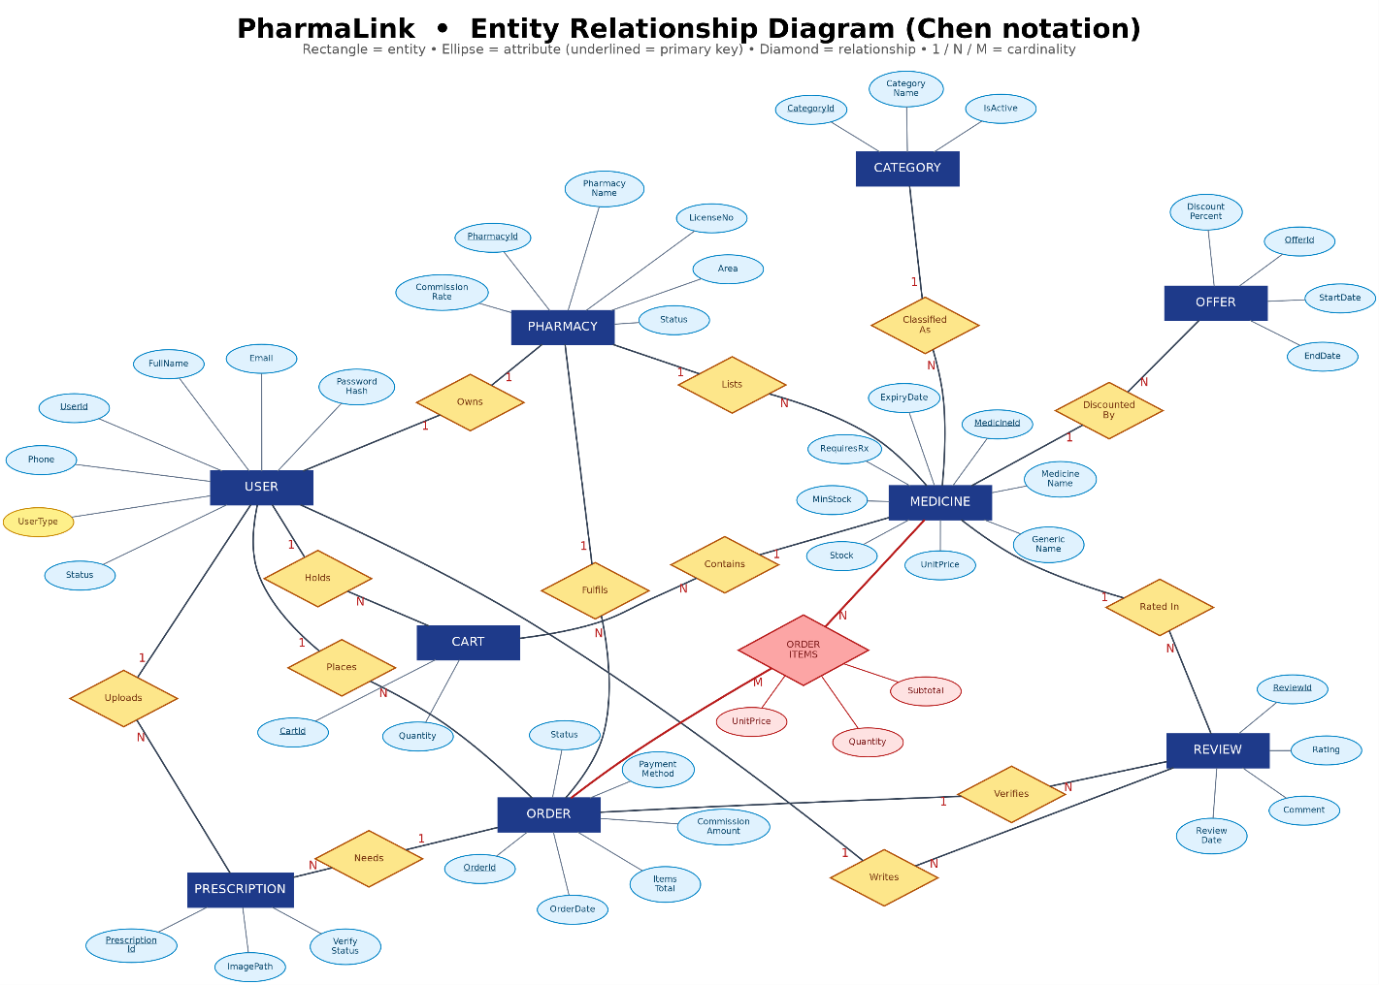
Figure 4.1 – Entity relationship diagram (Chen notation).
The diagram shows the attributes from the design phase. A few columns were added to the tables while the application was being built, and they are not drawn in Figure 4.1. Users gained FailedLoginCount, LockoutUntil, MustChangePassword and PasswordResetRequestedAt for the login lockout and the password reset that goes through the Super Admin. Pharmacies gained WarningMessage, WarnedAt and WarningAcknowledgedAt for the Super Admin's formal warning. Orders gained PaymentMobile, the bKash or Nagad wallet number. Reviews gained IsReported, ReportReason and ReportedAt so a Pharmacy Owner can report a review. Prescriptions gained RejectReason. Each of these columns describes only the row it belongs to, so none of them changes the relationships or the normalization in Section 5. All of them are listed in Section 6.1.
The script PharmaLinkDB_Setup.sql enforces the relationships and cardinalities below.
- Owns (Users 1 : 0..1 Pharmacies). Pharmacies.OwnerId is NOT NULL, is a foreign key to Users and is UNIQUE. So every pharmacy has exactly one owner, and a user owns at most one pharmacy. Customers and the Super Admin own none. The database cannot force a Pharmacy Owner to have a pharmacy, so the application handles that. Sign up inserts the Users row and the Pharmacies row in a single transaction (RegisterPharmacyOwner in Services/AuthService.cs), which means either both rows are saved or neither is. At login, an Admin account with no pharmacy on record is refused. In practice, every Pharmacy Owner has exactly one pharmacy.
- Lists (Pharmacies 1 : N Medicines). Medicines.PharmacyId is NOT NULL, so every medicine belongs to exactly one pharmacy. A pharmacy may list no medicines or many.
- Classified As (Categories 1 : N Medicines). Medicines.CategoryId is NOT NULL, so every medicine has exactly one category.
- Holds (Users 1 : N Cart). A customer has zero or more cart lines, and each line belongs to exactly one customer. UQ_Cart_Line allows only one line per customer per medicine.
- Contains (Medicines 1 : N Cart). Each cart line refers to exactly one medicine.
- Places (Users 1 : N Orders). Each order has exactly one customer.
- Fulfils (Pharmacies 1 : N Orders). Each order belongs to exactly one pharmacy. A basket with medicines from two pharmacies becomes two orders.
- Order Items (Orders M : N Medicines). The OrderItems junction table resolves this relationship. Each line points to one order and one medicine, UQ_OrderItems_Line allows only one line per medicine per order, and deleting an order deletes its lines (ON DELETE CASCADE). Checkout always creates an order from at least one cart line, but the database does not require a minimum number of lines.
- Writes (Users 1 : N Reviews). Each review has exactly one customer.
- Rated In (Medicines 1 : N Reviews). Each review rates exactly one medicine.
- Verifies (Orders 1 : N Reviews). Each review points to the order that proves the purchase. The composite foreign key FK_Reviews_OrderItem (OrderId, MedicineId) references OrderItems, so the medicine being reviewed must really be a line on that order. UQ_Reviews_OneEach allows only one review per customer, medicine and order.
- Discounted By (Medicines 1 : N Offers). Each offer discounts exactly one medicine.
- Needs (Orders 1 : N Prescriptions). An order has zero or more prescription rows. When a prescription is rejected and the customer uploads a new one, a new row is added. The row with the highest PrescriptionId is the current one. Deleting an order deletes its prescriptions (ON DELETE CASCADE).
- Uploads (Users 1 : N Prescriptions). Each prescription has exactly one uploading customer.
Every foreign key to a person references Users as a whole. The database therefore does not check the role. The application makes sure that only a Customer fills a cart, places orders, writes reviews and uploads prescriptions, and that only a Pharmacy Owner (UserType 'Admin') owns a pharmacy.

5. Normalization & Finalization
Every relationship on the ER diagram in Section 4 is normalized below. The unnormalized form (UNF) of a relationship is the combined set of attributes of the two entities it connects. Some attribute names exist on both sides, so they are given a qualifier here (for example UserAddress and PharmacyAddress) to keep them apart while they sit in the same relation. Section 5.1 explains how these names map to the SQL columns. Underlined attributes are primary keys and attributes marked (FK) are foreign keys. Braces { } mark a repeating group. The attributes are the design-phase attributes from Figure 4.1.
The same rules apply at every step:
- 1NF removes repeating groups, so every row holds one atomic value per attribute and the relation has a key.
- 2NF removes partial dependencies, where a non-key attribute depends on only part of a composite key. A relation whose key is a single attribute cannot have a partial dependency, so it is already in 2NF when it reaches 1NF.
- 3NF removes transitive dependencies, where a non-key attribute depends on the key only through another non-key attribute. On the "one" side of a one to many relationship, this is where the parent's attributes are split off.
Only relationships whose 1NF key is composite (Holds and Order Items) have real work to do at 2NF.
Owns: one to one relationship (Users 1 : 0..1 Pharmacies)
UNF: UserId, FullName, Email, PasswordHash, PasswordSalt, Phone, UserAddress, UserType, Status, CreatedAt, PharmacyId, PharmacyName, LicenseNo, Area, PharmacyAddress, ContactPhone, LogoPath, CommissionRate, PharmacyStatus, RegisteredAt.
1NF: UserId, FullName, Email, PasswordHash, PasswordSalt, Phone, UserAddress, UserType, Status, CreatedAt, PharmacyId, PharmacyName, LicenseNo, Area, PharmacyAddress, ContactPhone, LogoPath, CommissionRate, PharmacyStatus, RegisteredAt. A user owns at most one pharmacy, so there is no repeating group. Every value is already atomic, and UserId identifies each row.
2NF: Same as 1NF. The key UserId is a single attribute, so a partial dependency is impossible.
3NF:
- Users: UserId, FullName, Email, PasswordHash, PasswordSalt, Phone, UserAddress, UserType, Status, CreatedAt.
- Pharmacies: PharmacyId, PharmacyName, LicenseNo, Area, PharmacyAddress, ContactPhone, LogoPath, CommissionRate, PharmacyStatus, RegisteredAt, UserId(FK).
UserId determines PharmacyId, and PharmacyId in turn determines PharmacyName, LicenseNo and the other pharmacy attributes. They depend on the key only through a non-key attribute, which is a transitive dependency, so they move into their own relation. Without this split, every Customer and the Super Admin would carry empty pharmacy columns. The UserId foreign key is OwnerId in the final table. It is NOT NULL and UNIQUE, so a one to many foreign key becomes the 1 : 0..1 relationship shown in Section 4.
Lists: one to many relationship (Pharmacies 1 : N Medicines)
UNF: PharmacyId, PharmacyName, LicenseNo, Area, PharmacyAddress, ContactPhone, LogoPath, CommissionRate, PharmacyStatus, RegisteredAt, { MedicineId, MedicineName, GenericName, Manufacturer, Strength, UnitPrice, Stock, MinStock, RequiresRx, ExpiryDate, MedicineDescription, ImagePath, MedicineIsActive, CategoryId, CategoryName }.
1NF: MedicineId, MedicineName, GenericName, Manufacturer, Strength, UnitPrice, Stock, MinStock, RequiresRx, ExpiryDate, MedicineDescription, ImagePath, MedicineIsActive, CategoryId, CategoryName, PharmacyId, PharmacyName, LicenseNo, Area, PharmacyAddress, ContactPhone, LogoPath, CommissionRate, PharmacyStatus, RegisteredAt. Each medicine of the pharmacy gets its own row. A medicine belongs to only one pharmacy, so MedicineId alone identifies the row.
2NF: Same as 1NF. The key MedicineId is a single attribute.
3NF:
- Pharmacies: PharmacyId, PharmacyName, LicenseNo, Area, PharmacyAddress, ContactPhone, LogoPath, CommissionRate, PharmacyStatus, RegisteredAt.
- Medicines: MedicineId, MedicineName, GenericName, Manufacturer, Strength, UnitPrice, Stock, MinStock, RequiresRx, ExpiryDate, MedicineDescription, ImagePath, MedicineIsActive, CategoryId(FK), PharmacyId(FK).
- Categories: CategoryId, CategoryName.
This relationship has two transitive dependencies. MedicineId determines PharmacyId, which determines the pharmacy attributes. MedicineId also determines CategoryId, which determines CategoryName. Both chains are removed. Without the category split, renaming a category would mean updating every medicine row that carries it. The Categories relation here holds only the category attributes that appear in this UNF. The full Categories relation comes from Classified As.
Classified As: one to many relationship (Categories 1 : N Medicines)
UNF: CategoryId, CategoryName, CategoryDescription, IsActive, { MedicineId, MedicineName, GenericName, Manufacturer, Strength, UnitPrice, Stock, MinStock, RequiresRx, ExpiryDate, MedicineDescription, ImagePath, MedicineIsActive }.
1NF: MedicineId, MedicineName, GenericName, Manufacturer, Strength, UnitPrice, Stock, MinStock, RequiresRx, ExpiryDate, MedicineDescription, ImagePath, MedicineIsActive, CategoryId, CategoryName, CategoryDescription, IsActive.
2NF: Same as 1NF. The key MedicineId is a single attribute.
3NF:
- Categories: CategoryId, CategoryName, CategoryDescription, IsActive.
- Medicines: MedicineId, MedicineName, GenericName, Manufacturer, Strength, UnitPrice, Stock, MinStock, RequiresRx, ExpiryDate, MedicineDescription, ImagePath, MedicineIsActive, CategoryId(FK).
CategoryName, CategoryDescription and IsActive depend on MedicineId only through CategoryId, so they move to Categories.
Holds: one to many relationship (Users 1 : N Cart)
UNF: UserId, FullName, Email, Phone, UserType, Status, { CartId, MedicineId, MedicineName, UnitPrice, Quantity, AddedDate }.
1NF: UserId, MedicineId, CartId, FullName, Email, Phone, UserType, Status, MedicineName, UnitPrice, Quantity, AddedDate. Each cart line of the customer gets its own row. A customer has at most one line per medicine, so the pair (UserId, MedicineId) identifies the row. CartId is a surrogate that identifies the same row.
2NF:
- Users: UserId, FullName, Email, Phone, UserType, Status.
- Medicines: MedicineId, MedicineName, UnitPrice.
- Cart: CartId, Quantity, AddedDate, UserId(FK), MedicineId(FK).
The key is composite, so partial dependencies are possible, and there are two. FullName, Email, Phone, UserType and Status depend on UserId alone. MedicineName and UnitPrice depend on MedicineId alone. Both groups are removed. Quantity and AddedDate depend on the whole pair, because they describe that medicine in that customer's basket, so they stay. The pair (UserId, MedicineId) remains unique in Cart. That is UQ_Cart_Line, which turns "add the same medicine again" into an update of the quantity.
3NF: Same as 2NF. No non-key attribute of the three relations determines another.
Contains: one to many relationship (Medicines 1 : N Cart)
UNF: MedicineId, MedicineName, GenericName, UnitPrice, Stock, { CartId, Quantity, AddedDate }.
1NF: CartId, Quantity, AddedDate, MedicineId, MedicineName, GenericName, UnitPrice, Stock.
2NF: Same as 1NF. The key CartId is a single attribute.
3NF:
- Medicines: MedicineId, MedicineName, GenericName, UnitPrice, Stock.
- Cart: CartId, Quantity, AddedDate, MedicineId(FK).
MedicineName, GenericName, UnitPrice and Stock depend on CartId only through MedicineId, so they move back to the medicine relation. The cart line keeps only facts about the line itself.
Places: one to many relationship (Users 1 : N Orders)
UNF: UserId, FullName, Email, PasswordHash, PasswordSalt, Phone, UserAddress, UserType, Status, CreatedAt, { OrderId, OrderDate, ItemsTotal, DeliveryCharge, CommissionAmount, DeliveryAddress, PaymentMethod, OrderStatus }.
1NF: OrderId, OrderDate, ItemsTotal, DeliveryCharge, CommissionAmount, DeliveryAddress, PaymentMethod, OrderStatus, UserId, FullName, Email, PasswordHash, PasswordSalt, Phone, UserAddress, UserType, Status, CreatedAt.
2NF: Same as 1NF. The key OrderId is a single attribute.
3NF:
- Users: UserId, FullName, Email, PasswordHash, PasswordSalt, Phone, UserAddress, UserType, Status, CreatedAt.
- Orders: OrderId, OrderDate, ItemsTotal, DeliveryCharge, CommissionAmount, DeliveryAddress, PaymentMethod, OrderStatus, UserId(FK).
The customer attributes depend on OrderId only through UserId, so they are split off. DeliveryAddress stays on the order even though it usually matches UserAddress. It is copied at checkout and can be edited for that order, so it is a fact about the order, not a copy of the profile. TotalAmount is not in the list because it is not stored as an independent attribute. It is a computed PERSISTED column equal to ItemsTotal + DeliveryCharge, so the database engine derives it and it can never disagree with its two parts.
Fulfils: one to many relationship (Pharmacies 1 : N Orders)
UNF: PharmacyId, PharmacyName, LicenseNo, Area, CommissionRate, PharmacyStatus, { OrderId, OrderDate, ItemsTotal, DeliveryCharge, CommissionAmount, DeliveryAddress, PaymentMethod, OrderStatus }.
1NF: OrderId, OrderDate, ItemsTotal, DeliveryCharge, CommissionAmount, DeliveryAddress, PaymentMethod, OrderStatus, PharmacyId, PharmacyName, LicenseNo, Area, CommissionRate, PharmacyStatus.
2NF: Same as 1NF. The key OrderId is a single attribute.
3NF:
- Pharmacies: PharmacyId, PharmacyName, LicenseNo, Area, CommissionRate, PharmacyStatus.
- Orders: OrderId, OrderDate, ItemsTotal, DeliveryCharge, CommissionAmount, DeliveryAddress, PaymentMethod, OrderStatus, PharmacyId(FK).
A basket that holds medicines from two pharmacies produces two orders, one per pharmacy. That is why PharmacyId sits on the order header and not on the individual lines. CommissionAmount is not a transitive dependency on CommissionRate. It is the amount worked out at checkout and frozen on the order, so a later change to the pharmacy's rate cannot rewrite what was owed on an old sale.
Order Items: many to many relationship (Orders M : N Medicines)
UNF: OrderId, OrderDate, ItemsTotal, DeliveryCharge, CommissionAmount, DeliveryAddress, PaymentMethod, OrderStatus, { MedicineId, MedicineName, UnitPrice, Quantity, Subtotal }.
1NF: OrderId, MedicineId, OrderDate, ItemsTotal, DeliveryCharge, CommissionAmount, DeliveryAddress, PaymentMethod, OrderStatus, MedicineName, UnitPrice, Quantity, Subtotal.
2NF:
- Orders: OrderId, OrderDate, ItemsTotal, DeliveryCharge, CommissionAmount, DeliveryAddress, PaymentMethod, OrderStatus.
- Medicines: MedicineId, MedicineName.
- OrderItems: OrderId(FK), MedicineId(FK), Quantity, UnitPrice, Subtotal.
3NF: Same as 2NF.
This is the only many to many relationship in the model, and it is the one the assignment brief asks for. One order contains many medicines and one medicine appears in many orders, so in UNF the medicine details are a repeating group inside the order. 1NF removes the group by giving each medicine on an order its own row, and the key becomes the composite (OrderId, MedicineId). A composite key allows partial dependencies, and there are two. OrderDate, PaymentMethod and the other header attributes depend on OrderId alone. MedicineName depends on MedicineId alone. 2NF removes both by splitting the relation into three. The third relation is the OrderItems junction table.
Quantity, UnitPrice and Subtotal stay in OrderItems because they depend on the whole composite key. They record how much of that medicine was on that order, at the price charged on that day. UnitPrice here is the price at the time of purchase, not a copy of the medicine's current price, so it is not transitively dependent on MedicineId. Subtotal is determined by Quantity and UnitPrice. It is therefore not stored as an independent value: it is a computed PERSISTED column equal to Quantity * UnitPrice, which the engine derives, so it can never drift from its parts.
Writes: one to many relationship (Users 1 : N Reviews)
UNF: UserId, FullName, Email, Phone, UserType, Status, { ReviewId, Rating, Comment, ReviewDate, IsHidden }.
1NF: ReviewId, Rating, Comment, ReviewDate, IsHidden, UserId, FullName, Email, Phone, UserType, Status.
2NF: Same as 1NF. The key ReviewId is a single attribute.
3NF:
- Users: UserId, FullName, Email, Phone, UserType, Status.
- Reviews: ReviewId, Rating, Comment, ReviewDate, IsHidden, UserId(FK).
The customer attributes depend on ReviewId only through UserId, so they are split off.
Rated In: one to many relationship (Medicines 1 : N Reviews)
UNF: MedicineId, MedicineName, GenericName, UnitPrice, Stock, { ReviewId, Rating, Comment, ReviewDate, IsHidden }.
1NF: ReviewId, Rating, Comment, ReviewDate, IsHidden, MedicineId, MedicineName, GenericName, UnitPrice, Stock.
2NF: Same as 1NF. The key ReviewId is a single attribute.
3NF:
- Medicines: MedicineId, MedicineName, GenericName, UnitPrice, Stock.
- Reviews: ReviewId, Rating, Comment, ReviewDate, IsHidden, MedicineId(FK).
The medicine attributes depend on ReviewId only through MedicineId, so they are split off.
Verifies: one to many relationship (Orders 1 : N Reviews)
UNF: OrderId, OrderDate, ItemsTotal, OrderStatus, { ReviewId, Rating, Comment, ReviewDate }.
1NF: ReviewId, Rating, Comment, ReviewDate, OrderId, OrderDate, ItemsTotal, OrderStatus.
2NF: Same as 1NF. The key ReviewId is a single attribute.
3NF:
- Orders: OrderId, OrderDate, ItemsTotal, OrderStatus.
- Reviews: ReviewId, Rating, Comment, ReviewDate, OrderId(FK).
A review carries the order it came from as well as the customer and the medicine, and this third foreign key is what makes a review verifiable. In the final schema, OrderId and MedicineId together also form the composite foreign key FK_Reviews_OrderItem to OrderItems. That means a review can exist only for a medicine that really was a line on that order. The UNIQUE constraint UQ_Reviews_OneEach on (CustomerId, MedicineId, OrderId) stops the same purchase from being rated twice.
Discounted By: one to many relationship (Medicines 1 : N Offers)
UNF: MedicineId, MedicineName, GenericName, UnitPrice, Stock, { OfferId, OfferTitle, DiscountPercent, StartDate, EndDate, OfferIsActive }.
1NF: OfferId, OfferTitle, DiscountPercent, StartDate, EndDate, OfferIsActive, MedicineId, MedicineName, GenericName, UnitPrice, Stock.
2NF: Same as 1NF. The key OfferId is a single attribute.
3NF:
- Medicines: MedicineId, MedicineName, GenericName, UnitPrice, Stock.
- Offers: OfferId, OfferTitle, DiscountPercent, StartDate, EndDate, OfferIsActive, MedicineId(FK).
The medicine attributes depend on OfferId only through MedicineId, so they are split off. The discounted price is not stored. Queries calculate it from UnitPrice and DiscountPercent.
Needs: one to many relationship (Orders 1 : N Prescriptions)
UNF: OrderId, OrderDate, ItemsTotal, OrderStatus, { PrescriptionId, ImagePath, DoctorName, UploadedAt, VerifyStatus }.
1NF: PrescriptionId, ImagePath, DoctorName, UploadedAt, VerifyStatus, OrderId, OrderDate, ItemsTotal, OrderStatus.
2NF: Same as 1NF. The key PrescriptionId is a single attribute.
3NF:
- Orders: OrderId, OrderDate, ItemsTotal, OrderStatus.
- Prescriptions: PrescriptionId, ImagePath, DoctorName, UploadedAt, VerifyStatus, OrderId(FK).
The order attributes depend on PrescriptionId only through OrderId, so they are split off. One order can have several prescription rows because a rejected image can be replaced by a new upload. The row with the highest PrescriptionId is the current one.
Uploads: one to many relationship (Users 1 : N Prescriptions)
UNF: UserId, FullName, Phone, { PrescriptionId, ImagePath, DoctorName, UploadedAt, VerifyStatus }.
1NF: PrescriptionId, ImagePath, DoctorName, UploadedAt, VerifyStatus, UserId, FullName, Phone.
2NF: Same as 1NF. The key PrescriptionId is a single attribute.
3NF:
- Users: UserId, FullName, Phone.
- Prescriptions: PrescriptionId, ImagePath, DoctorName, UploadedAt, VerifyStatus, UserId(FK).
The customer attributes depend on PrescriptionId only through UserId, so they are split off.

5.1 Finalization
The table below lists every relation produced by the fourteen decompositions, in the order they were produced. The same entity appears in several relationships, so its relation is derived more than once. Every relation after the first for an entity is marked "(repeat of …)" with the number of the first one.
No. | Relation | From | Note
1 | Users: UserId, FullName, Email, PasswordHash, PasswordSalt, Phone, UserAddress, UserType, Status, CreatedAt | Owns | First Users relation
2 | Pharmacies: PharmacyId, PharmacyName, LicenseNo, Area, PharmacyAddress, ContactPhone, LogoPath, CommissionRate, PharmacyStatus, RegisteredAt, UserId(FK) | Owns | First Pharmacies relation
3 | Pharmacies: PharmacyId, PharmacyName, LicenseNo, Area, PharmacyAddress, ContactPhone, LogoPath, CommissionRate, PharmacyStatus, RegisteredAt | Lists | (repeat of 2)
4 | Medicines: MedicineId, MedicineName, GenericName, Manufacturer, Strength, UnitPrice, Stock, MinStock, RequiresRx, ExpiryDate, MedicineDescription, ImagePath, MedicineIsActive, CategoryId(FK), PharmacyId(FK) | Lists | First Medicines relation
5 | Categories: CategoryId, CategoryName | Lists | First Categories relation
6 | Categories: CategoryId, CategoryName, CategoryDescription, IsActive | Classified As | (repeat of 5, with CategoryDescription and IsActive added)
7 | Medicines: MedicineId, MedicineName, GenericName, Manufacturer, Strength, UnitPrice, Stock, MinStock, RequiresRx, ExpiryDate, MedicineDescription, ImagePath, MedicineIsActive, CategoryId(FK) | Classified As | (repeat of 4)
8 | Users: UserId, FullName, Email, Phone, UserType, Status | Holds | (repeat of 1)
9 | Medicines: MedicineId, MedicineName, UnitPrice | Holds | (repeat of 4)
10 | Cart: CartId, Quantity, AddedDate, UserId(FK), MedicineId(FK) | Holds | First Cart relation
11 | Medicines: MedicineId, MedicineName, GenericName, UnitPrice, Stock | Contains | (repeat of 4)
12 | Cart: CartId, Quantity, AddedDate, MedicineId(FK) | Contains | (repeat of 10)
13 | Users: UserId, FullName, Email, PasswordHash, PasswordSalt, Phone, UserAddress, UserType, Status, CreatedAt | Places | (repeat of 1)
14 | Orders: OrderId, OrderDate, ItemsTotal, DeliveryCharge, CommissionAmount, DeliveryAddress, PaymentMethod, OrderStatus, UserId(FK) | Places | First Orders relation
15 | Pharmacies: PharmacyId, PharmacyName, LicenseNo, Area, CommissionRate, PharmacyStatus | Fulfils | (repeat of 2)
16 | Orders: OrderId, OrderDate, ItemsTotal, DeliveryCharge, CommissionAmount, DeliveryAddress, PaymentMethod, OrderStatus, PharmacyId(FK) | Fulfils | (repeat of 14, with PharmacyId(FK) added)
17 | Orders: OrderId, OrderDate, ItemsTotal, DeliveryCharge, CommissionAmount, DeliveryAddress, PaymentMethod, OrderStatus | Order Items | (repeat of 14)
18 | Medicines: MedicineId, MedicineName | Order Items | (repeat of 4)
19 | OrderItems: OrderId(FK), MedicineId(FK), Quantity, UnitPrice, Subtotal | Order Items | First OrderItems relation
20 | Users: UserId, FullName, Email, Phone, UserType, Status | Writes | (repeat of 1)
21 | Reviews: ReviewId, Rating, Comment, ReviewDate, IsHidden, UserId(FK) | Writes | First Reviews relation
22 | Medicines: MedicineId, MedicineName, GenericName, UnitPrice, Stock | Rated In | (repeat of 4)
23 | Reviews: ReviewId, Rating, Comment, ReviewDate, IsHidden, MedicineId(FK) | Rated In | (repeat of 21, with MedicineId(FK) added)
24 | Orders: OrderId, OrderDate, ItemsTotal, OrderStatus | Verifies | (repeat of 14)
25 | Reviews: ReviewId, Rating, Comment, ReviewDate, OrderId(FK) | Verifies | (repeat of 21, with OrderId(FK) added)
26 | Medicines: MedicineId, MedicineName, GenericName, UnitPrice, Stock | Discounted By | (repeat of 4)
27 | Offers: OfferId, OfferTitle, DiscountPercent, StartDate, EndDate, OfferIsActive, MedicineId(FK) | Discounted By | First Offers relation
28 | Orders: OrderId, OrderDate, ItemsTotal, OrderStatus | Needs | (repeat of 14)
29 | Prescriptions: PrescriptionId, ImagePath, DoctorName, UploadedAt, VerifyStatus, OrderId(FK) | Needs | First Prescriptions relation
30 | Users: UserId, FullName, Phone | Uploads | (repeat of 1)
31 | Prescriptions: PrescriptionId, ImagePath, DoctorName, UploadedAt, VerifyStatus, UserId(FK) | Uploads | (repeat of 29, with UserId(FK) added)
When two versions of the same entity differ, they are merged. The final relation keeps the union of their attributes and all of their foreign keys. That is why Orders carries both UserId and PharmacyId, Reviews carries all three of its foreign keys, and Prescriptions carries two. Merging the repeats leaves ten relations.
Final relations
- Users: UserId, FullName, Email, PasswordHash, PasswordSalt, Phone, UserAddress, UserType, Status, CreatedAt.
- Categories: CategoryId, CategoryName, CategoryDescription, IsActive.
- Pharmacies: PharmacyId, PharmacyName, LicenseNo, Area, PharmacyAddress, ContactPhone, LogoPath, CommissionRate, PharmacyStatus, RegisteredAt, UserId(FK).
- Medicines: MedicineId, MedicineName, GenericName, Manufacturer, Strength, UnitPrice, Stock, MinStock, RequiresRx, ExpiryDate, MedicineDescription, ImagePath, MedicineIsActive, PharmacyId(FK), CategoryId(FK).
- Cart: CartId, Quantity, AddedDate, UserId(FK), MedicineId(FK).
- Orders: OrderId, OrderDate, ItemsTotal, DeliveryCharge, CommissionAmount, DeliveryAddress, PaymentMethod, OrderStatus, UserId(FK), PharmacyId(FK).
- OrderItems: OrderId(FK), MedicineId(FK), Quantity, UnitPrice, Subtotal.
- Reviews: ReviewId, Rating, Comment, ReviewDate, IsHidden, UserId(FK), MedicineId(FK), OrderId(FK).
- Offers: OfferId, OfferTitle, DiscountPercent, StartDate, EndDate, OfferIsActive, MedicineId(FK).
- Prescriptions: PrescriptionId, ImagePath, DoctorName, UploadedAt, VerifyStatus, OrderId(FK), UserId(FK).
These ten relations are the tables created by the script in Section 7. The following changes are made when they reach SQL Server.
- Foreign key names. The UserId foreign key is renamed after the role it plays. It becomes OwnerId in Pharmacies and CustomerId in Cart, Orders, Reviews and Prescriptions.
- Qualified names. The qualifiers used above to keep clashing names apart are dropped. CategoryDescription and MedicineDescription become Description. UserAddress and PharmacyAddress become Address. PharmacyStatus and OrderStatus become Status. MedicineIsActive and OfferIsActive become IsActive. Each is a plain column in its own table.
- Surrogate key for OrderItems. OrderItems gets a surrogate OrderItemId primary key, which is easier to use from C#. Its natural composite key (OrderId, MedicineId) is kept as the UNIQUE constraint UQ_OrderItems_Line, so the 2NF argument above still holds exactly. The same constraint is the target of the composite foreign key FK_Reviews_OrderItem.
- Alternate keys. UNIQUE constraints protect the alternate keys found during normalization or required by the rules: UQ_Cart_Line (CustomerId, MedicineId), UQ_Reviews_OneEach (CustomerId, MedicineId, OrderId), UQ_Pharmacies_Owner (OwnerId) and UQ_Pharmacies_License (LicenseNo), UQ_Users_Email and UQ_Users_Phone, and UQ_Categories_Name. Medicines also gets UQ_Medicines_PerShop (PharmacyId, MedicineName, Strength), so a pharmacy cannot list the same brand at the same strength twice. This constraint is a candidate key, not a new dependency, so Medicines stays in 3NF.
- Computed columns. TotalAmount (Orders) and Subtotal (OrderItems) are computed PERSISTED columns.
- Implementation columns. The implementation columns listed in Section 4 are added: FailedLoginCount, LockoutUntil, MustChangePassword and PasswordResetRequestedAt to Users; WarningMessage, WarnedAt and WarningAcknowledgedAt to Pharmacies; PaymentMobile to Orders; IsReported, ReportReason and ReportedAt to Reviews; RejectReason to Prescriptions. Each one depends only on the primary key of its own table, so all ten tables remain in third normal form.

6. Database Schema
The database is called PharmaLinkDB and has ten tables, all in third normal form. They are created by PharmaLinkDB_Setup.sql, which also loads the sample data. Section 7 gives the script. OrderItems is the junction table produced by the Order Items decomposition in Section 5. In the tables below, PK is a primary key, FK a foreign key, UNIQUE a unique constraint, CHECK a check constraint and DEFAULT a default constraint. Constraint names are given as they appear in the script.
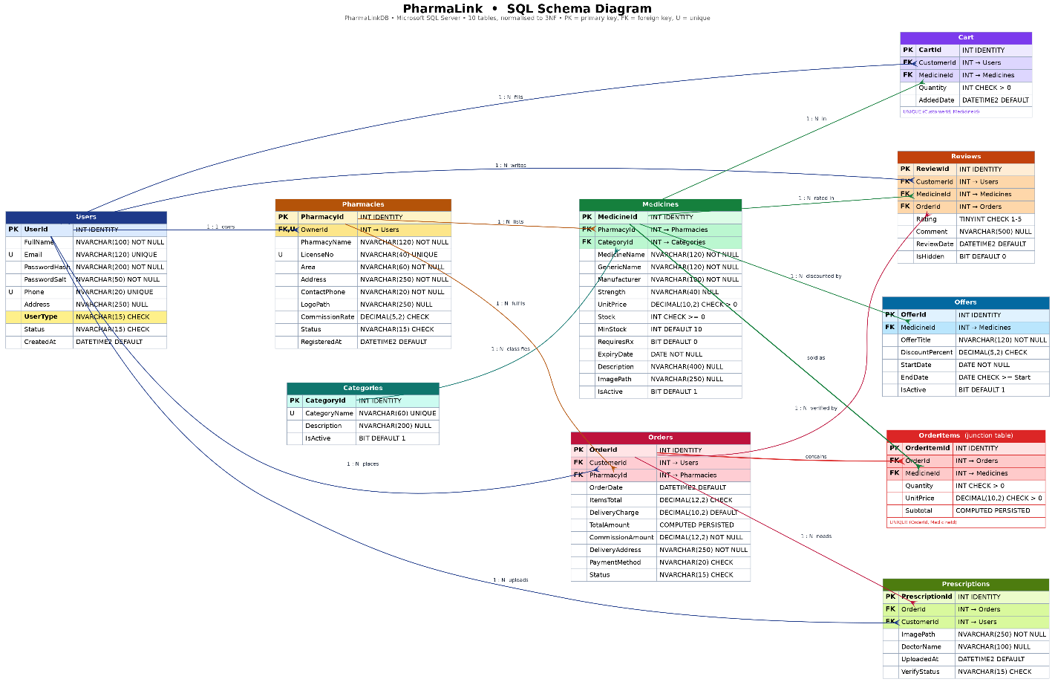
Figure 6.1 â€“ SQL schema diagram. The diagram was drawn at design time; Section 6.1 lists every column and constraint in the final script, including the columns added during implementation.

6.1 Table Descriptions

Users
This table stores everyone on the platform, whatever their role. The login query reads the UserType column, and that value decides which dashboard opens.
Column | Data type | Constraints | Description
UserId | INT IDENTITY(1,1) | NOT NULL, PRIMARY KEY (PK_Users) | Surrogate key for every person on the platform
FullName | NVARCHAR(100) | NOT NULL | Display name shown on dashboards, invoices and reviews
Email | NVARCHAR(120) | NOT NULL, UNIQUE (UQ_Users_Email), CHECK (CK_Users_Email: Email LIKE '%_@_%._%') | Login identifier; the CHECK enforces a basic address pattern
PasswordHash | NVARCHAR(200) | NOT NULL | Stored as "PBKDF2$100000$<base64 key>": PBKDF2-HMAC-SHA256 with 100,000 iterations and a 32-byte key, computed with the user's PasswordSalt (Helpers/PasswordHelper.cs). An older row may still hold a legacy salted SHA-256 hash. The application accepts it and re-hashes the password in the PBKDF2 format at the next successful login. The plain text password is never stored.
PasswordSalt | NVARCHAR(50) | NOT NULL | Random salt for each user (Base64), used when hashing
Phone | NVARCHAR(20) | NOT NULL, UNIQUE (UQ_Users_Phone) | Contact number; unique, so one number is one account
Address | NVARCHAR(250) | NULL | Default delivery address, filled in automatically at checkout
UserType | NVARCHAR(15) | NOT NULL, CHECK (CK_Users_Type: 'SuperAdmin', 'Admin', 'Customer') | Role: Super Admin, Pharmacy Owner ('Admin') or Customer; decides which dashboard opens
Status | NVARCHAR(15) | NOT NULL, DEFAULT 'Active' (DF_Users_Status), CHECK (CK_Users_Status: 'Pending', 'Active', 'Suspended') | Account state; a new Pharmacy Owner starts as 'Pending' until the Super Admin approves the pharmacy
CreatedAt | DATETIME2(0) | NOT NULL, DEFAULT SYSDATETIME() (DF_Users_CreatedAt) | Registration timestamp, shown as Member Since
FailedLoginCount | INT | NOT NULL, DEFAULT 0 (DF_Users_FailedLogins) | Number of wrong passwords in a row; reset by a successful login
LockoutUntil | DATETIME2(0) | NULL | After five wrong passwords in a row, set to fifteen minutes ahead; the account cannot log in until then
MustChangePassword | BIT | NOT NULL, DEFAULT 0 (DF_Users_MustChangePw) | 1 while the account uses a temporary password issued by the Super Admin; the next login must set a new password before any dashboard opens
PasswordResetRequestedAt | DATETIME2(0) | NULL | When the Forgot password form matched this account; NULL means no request is waiting for the Super Admin

Categories
This is the master list of medicine categories, maintained by the Super Admin. It is kept in its own table so a category name is stored once.
Column | Data type | Constraints | Description
CategoryId | INT IDENTITY(1,1) | NOT NULL, PRIMARY KEY (PK_Categories) | Surrogate key
CategoryName | NVARCHAR(60) | NOT NULL, UNIQUE (UQ_Categories_Name) | For example Antibiotic, Painkiller, Diabetes Care
Description | NVARCHAR(200) | NULL | Short explanation of the category
IsActive | BIT | NOT NULL, DEFAULT 1 (DF_Categories_IsActive) | Soft delete flag; a category that is in use is deactivated, never removed

Pharmacies
This table has one row per Pharmacy Owner. OwnerId is NOT NULL and UNIQUE, so each pharmacy has exactly one owner and no owner has two pharmacies.
Column | Data type | Constraints | Description
PharmacyId | INT IDENTITY(1,1) | NOT NULL, PRIMARY KEY (PK_Pharmacies) | Surrogate key; every Pharmacy Owner query filters on this value
OwnerId | INT | NOT NULL, FOREIGN KEY (FK_Pharmacies_Owner) to Users(UserId), UNIQUE (UQ_Pharmacies_Owner) | The owning user; UNIQUE gives the 1 : 0..1 Owns relationship
PharmacyName | NVARCHAR(120) | NOT NULL | Trading name, for example Mitford Pharma
LicenseNo | NVARCHAR(40) | NOT NULL, UNIQUE (UQ_Pharmacies_License) | DGDA drug licence number, checked by the Super Admin
Area | NVARCHAR(60) | NOT NULL | Locality used by the customer's Area filter
Address | NVARCHAR(250) | NOT NULL | Full postal address printed on the invoice
ContactPhone | NVARCHAR(20) | NOT NULL | Shop landline or mobile
LogoPath | NVARCHAR(250) | NULL | Relative path to the shop logo image
CommissionRate | DECIMAL(5,2) | NOT NULL, DEFAULT 8.00 (DF_Pharmacies_Comm), CHECK (CK_Pharmacies_Comm: 0 to 30) | Platform commission percentage for this pharmacy
Status | NVARCHAR(15) | NOT NULL, DEFAULT 'Pending' (DF_Pharmacies_Status), CHECK (CK_Pharmacies_Status: 'Pending', 'Approved', 'Suspended', 'Rejected') | Pending waits for the licence check; Approved is trading; Suspended is taken off the platform; Rejected is a refused registration, and the row is kept so the licence number stays taken. Customers only see medicines of an 'Approved' pharmacy
RegisteredAt | DATETIME2(0) | NOT NULL, DEFAULT SYSDATETIME() (DF_Pharmacies_Reg) | When the registration was submitted
WarningMessage | NVARCHAR(500) | NULL | The Super Admin's latest formal warning to the owner, one step short of suspension; NULL if the shop has never been warned
WarnedAt | DATETIME2(0) | NULL | When that warning was issued
WarningAcknowledgedAt | DATETIME2(0) | NULL | When the owner acknowledged the warning; the banner shows on the owner's dashboard while this is NULL

Medicines
These are the products for sale. When two pharmacies sell the same brand, each has its own row with its own price and stock.
Column | Data type | Constraints | Description
MedicineId | INT IDENTITY(1,1) | NOT NULL, PRIMARY KEY (PK_Medicines) | Surrogate key
PharmacyId | INT | NOT NULL, FOREIGN KEY (FK_Medicines_Pharmacy) to Pharmacies(PharmacyId) | The pharmacy that sells it; every Pharmacy Owner query filters on this column, so each owner sees only their own medicines
CategoryId | INT | NOT NULL, FOREIGN KEY (FK_Medicines_Category) to Categories(CategoryId) | Category of the medicine
MedicineName | NVARCHAR(120) | NOT NULL | Brand name, for example Napa
GenericName | NVARCHAR(120) | NOT NULL | Molecule name, for example Paracetamol; searchable
Manufacturer | NVARCHAR(100) | NOT NULL | For example Beximco, Square, Renata
Strength | NVARCHAR(40) | NULL | For example 500mg or 100ml
UnitPrice | DECIMAL(10,2) | NOT NULL, CHECK (CK_Medicines_Price: > 0) | Selling price per unit in taka
Stock | INT | NOT NULL, DEFAULT 0 (DF_Medicines_Stock), CHECK (CK_Medicines_Stock: >= 0) | Units currently on the shelf
MinStock | INT | NOT NULL, DEFAULT 10 (DF_Medicines_MinStock), CHECK (CK_Medicines_MinStock: >= 0) | Threshold that triggers the low stock alert
RequiresRx | BIT | NOT NULL, DEFAULT 0 (DF_Medicines_Rx) | 1 means a prescription image is needed for an order that contains this medicine
ExpiryDate | DATE | NOT NULL | Expiry date; expired stock is not offered to customers
Description | NVARCHAR(400) | NULL | Short description shown on the details form
ImagePath | NVARCHAR(250) | NULL | Relative path to the product image
IsActive | BIT | NOT NULL, DEFAULT 1 (DF_Medicines_IsActive) | 1 while the owner lists the item; the owner sets it to 0 to delist it. Suspending a pharmacy does not change this column. Customers stop seeing a suspended shop's medicines because catalogue queries also require Pharmacies.Status = 'Approved'
(PharmacyId, MedicineName, Strength) | – | UNIQUE (UQ_Medicines_PerShop) | One row per brand and strength per pharmacy

Cart
This is the customer's live basket. A UNIQUE constraint allows only one line per medicine, so adding the same medicine again updates the quantity.
Column | Data type | Constraints | Description
CartId | INT IDENTITY(1,1) | NOT NULL, PRIMARY KEY (PK_Cart) | Surrogate key
CustomerId | INT | NOT NULL, FOREIGN KEY (FK_Cart_Customer) to Users(UserId) | The customer who owns the basket
MedicineId | INT | NOT NULL, FOREIGN KEY (FK_Cart_Medicine) to Medicines(MedicineId) | The medicine in the basket
Quantity | INT | NOT NULL, CHECK (CK_Cart_Qty: > 0) | Units the customer intends to buy
AddedDate | DATETIME2(0) | NOT NULL, DEFAULT SYSDATETIME() (DF_Cart_AddedDate) | Records when the line was added; the application does not use it to expire baskets
(CustomerId, MedicineId) | – | UNIQUE (UQ_Cart_Line) | Stops duplicate lines for the same medicine

Orders
This table has one row per completed checkout. A basket that spans two pharmacies becomes two orders. ItemsTotal and CommissionAmount record what was actually charged and owed on the day, so a later price or commission change cannot rewrite an old invoice.
Column | Data type | Constraints | Description
OrderId | INT IDENTITY(1001,1) | NOT NULL, PRIMARY KEY (PK_Orders) | Invoice number shown to the customer; invoices start at 1001
CustomerId | INT | NOT NULL, FOREIGN KEY (FK_Orders_Customer) to Users(UserId) | The customer who placed the order
PharmacyId | INT | NOT NULL, FOREIGN KEY (FK_Orders_Pharmacy) to Pharmacies(PharmacyId) | The pharmacy that fulfils it; one order per pharmacy
OrderDate | DATETIME2(0) | NOT NULL, DEFAULT SYSDATETIME() (DF_Orders_Date) | Timestamp used by every date range report
ItemsTotal | DECIMAL(12,2) | NOT NULL, CHECK (CK_Orders_Items: >= 0) | Sum of the order's line items after any offer discount
DeliveryCharge | DECIMAL(10,2) | NOT NULL, DEFAULT 60.00 (DF_Orders_Delivery), CHECK (CK_Orders_Delivery: >= 0) | Charged to the customer; the platform takes no commission on it
TotalAmount | Computed | AS (ItemsTotal + DeliveryCharge) PERSISTED | The bill total, so it can never disagree with its parts
CommissionAmount | DECIMAL(12,2) | NOT NULL, CHECK (CK_Orders_Commission: >= 0) | ItemsTotal times the pharmacy's CommissionRate, frozen at checkout
DeliveryAddress | NVARCHAR(250) | NOT NULL | Copied from the profile but editable for each order
PaymentMethod | NVARCHAR(20) | NOT NULL, CHECK (CK_Orders_Payment: 'CashOnDelivery', 'bKash', 'Nagad', 'Card') | How the customer paid
PaymentMobile | NVARCHAR(20) | NULL | The bKash or Nagad wallet number used for payment; masked on the invoice
Status | NVARCHAR(15) | NOT NULL, DEFAULT 'Placed' (DF_Orders_Status), CHECK (CK_Orders_Status: 'Placed', 'Confirmed', 'Delivered', 'Cancelled') | Progress of the order

OrderItems
This is the mandatory junction table. It resolves the many to many relationship between Orders and Medicines.
Column | Data type | Constraints | Description
OrderItemId | INT IDENTITY(1,1) | NOT NULL, PRIMARY KEY (PK_OrderItems) | Surrogate key
OrderId | INT | NOT NULL, FOREIGN KEY (FK_OrderItems_Order) to Orders(OrderId) ON DELETE CASCADE | The parent order; its lines are deleted with it
MedicineId | INT | NOT NULL, FOREIGN KEY (FK_OrderItems_Medicine) to Medicines(MedicineId) | The medicine bought
Quantity | INT | NOT NULL, CHECK (CK_OrderItems_Qty: > 0) | Units of this medicine on this order
UnitPrice | DECIMAL(10,2) | NOT NULL, CHECK (CK_OrderItems_Price: > 0) | Price on the day of purchase, not today's price
Subtotal | Computed | AS (Quantity * UnitPrice) PERSISTED | Derived by SQL Server, so it can never drift
(OrderId, MedicineId) | – | UNIQUE (UQ_OrderItems_Line) | One line per medicine per order; also the target of FK_Reviews_OrderItem

Reviews
This table holds ratings and comments. Each review carries its OrderId, so the application can prove the reviewer actually bought the item.
Column | Data type | Constraints | Description
ReviewId | INT IDENTITY(1,1) | NOT NULL, PRIMARY KEY (PK_Reviews) | Surrogate key
CustomerId | INT | NOT NULL, FOREIGN KEY (FK_Reviews_Customer) to Users(UserId) | The customer who wrote it
MedicineId | INT | NOT NULL, FOREIGN KEY (FK_Reviews_Medicine) to Medicines(MedicineId) | The medicine being rated
OrderId | INT | NOT NULL, FOREIGN KEY (FK_Reviews_Order) to Orders(OrderId) | The order that proves the purchase; makes the review verified
Rating | TINYINT | NOT NULL, CHECK (CK_Reviews_Rating: BETWEEN 1 AND 5) | Star rating
Comment | NVARCHAR(500) | NULL | Written feedback
ReviewDate | DATETIME2(0) | NOT NULL, DEFAULT SYSDATETIME() (DF_Reviews_Date) | When the review was written
IsHidden | BIT | NOT NULL, DEFAULT 0 (DF_Reviews_Hidden) | Set to 1 by Super Admin moderation instead of deleting, so the record is kept
IsReported | BIT | NOT NULL, DEFAULT 0 (DF_Reviews_Reported) | Set to 1 when a Pharmacy Owner reports the review to the Super Admin; set back to 0 when the Super Admin hides the review or dismisses the report
ReportReason | NVARCHAR(200) | NULL | The owner's short reason, shown in the moderation queue
ReportedAt | DATETIME2(0) | NULL | When the review was reported
(CustomerId, MedicineId, OrderId) | – | UNIQUE (UQ_Reviews_OneEach) | One review per medicine per order
(OrderId, MedicineId) | – | FOREIGN KEY (FK_Reviews_OrderItem) to OrderItems(OrderId, MedicineId) | The reviewed medicine must really be a line on that order

Offers
Each offer is a percentage discount on one medicine, valid between two dates and created by the Pharmacy Owner. Queries calculate the discounted price, so the screens, the cart and the invoice always agree.
Column | Data type | Constraints | Description
OfferId | INT IDENTITY(1,1) | NOT NULL, PRIMARY KEY (PK_Offers) | Surrogate key
MedicineId | INT | NOT NULL, FOREIGN KEY (FK_Offers_Medicine) to Medicines(MedicineId) | The discounted medicine
OfferTitle | NVARCHAR(120) | NOT NULL | Shown on the customer's Offers screen
DiscountPercent | DECIMAL(5,2) | NOT NULL, CHECK (CK_Offers_Percent: > 0 AND <= 70) | Discount percentage
StartDate | DATE | NOT NULL | First day the offer applies
EndDate | DATE | NOT NULL, CHECK (CK_Offers_Dates: EndDate >= StartDate) | Last day the offer applies
IsActive | BIT | NOT NULL, DEFAULT 1 (DF_Offers_IsActive) | Lets the owner pause an offer without deleting it

Prescriptions
This table holds the prescription image that must be uploaded for an order containing a medicine with RequiresRx set. The Pharmacy Owner approves or rejects it before the order can be confirmed. A rejection records RejectReason, and the customer may then upload again, which adds a new row for the same order. An order can therefore have several rows, and the one with the highest PrescriptionId is the current prescription.
Column | Data type | Constraints | Description
PrescriptionId | INT IDENTITY(1,1) | NOT NULL, PRIMARY KEY (PK_Prescriptions) | Surrogate key; the highest value for an order is the current prescription
OrderId | INT | NOT NULL, FOREIGN KEY (FK_Prescriptions_Order) to Orders(OrderId) ON DELETE CASCADE | The order it belongs to; not unique, because a re-upload adds a row
CustomerId | INT | NOT NULL, FOREIGN KEY (FK_Prescriptions_Customer) to Users(UserId) | The customer who uploaded it
ImagePath | NVARCHAR(250) | NOT NULL | Relative path to the uploaded JPG or PNG
DoctorName | NVARCHAR(100) | NULL | Prescribing doctor, as typed by the customer
UploadedAt | DATETIME2(0) | NOT NULL, DEFAULT SYSDATETIME() (DF_Rx_Uploaded) | Upload timestamp
VerifyStatus | NVARCHAR(15) | NOT NULL, DEFAULT 'Pending' (DF_Rx_Status), CHECK (CK_Prescriptions_Status: 'Pending', 'Approved', 'Rejected') | The pharmacy's decision
RejectReason | NVARCHAR(200) | NULL | Why the pharmacy rejected the image, shown to the customer so they can upload a better one
Constraint and index totals. Counted from the script, the ten tables have:
- 10 primary keys, one per table;
- 16 foreign keys: 1 in Pharmacies, 2 in Medicines, 2 in Cart, 2 in Orders, 2 in OrderItems, 4 in Reviews (including the composite FK_Reviews_OrderItem), 1 in Offers and 2 in Prescriptions. Two of them are ON DELETE CASCADE (FK_OrderItems_Order and FK_Prescriptions_Order);
- 9 UNIQUE constraints: 2 in Users, 1 in Categories, 2 in Pharmacies, 1 in Medicines, 1 in Cart, 1 in OrderItems and 1 in Reviews;
- 20 CHECK constraints: 3 in Users, 2 in Pharmacies, 3 in Medicines, 1 in Cart, 5 in Orders, 2 in OrderItems, 1 in Reviews, 2 in Offers and 1 in Prescriptions;
- 22 DEFAULT constraints;
- 2 computed PERSISTED columns;
- 14 indexes created with CREATE INDEX.
SQL Server also builds an index for every PRIMARY KEY and UNIQUE constraint. For that reason, OrderItems(OrderId) and Cart(CustomerId) have no separate index: UQ_OrderItems_Line and UQ_Cart_Line already start with those columns.
Index | Table | Columns | Purpose
IX_Medicines_Pharmacy | Medicines | PharmacyId | Pharmacy Owner inventory screens, which filter by pharmacy, and joins to Pharmacies
IX_Medicines_Category | Medicines | CategoryId | Category filter on the customer catalogue
IX_Medicines_Name | Medicines | MedicineName | Search by brand name
IX_Medicines_Generic | Medicines | GenericName | Search by generic (molecule) name
IX_Orders_Customer | Orders | CustomerId | Customer's order history
IX_Orders_Pharmacy | Orders | PharmacyId | Pharmacy Owner order list and sales reports
IX_Orders_Date | Orders | OrderDate | Date range reports
IX_OrderItems_Medicine | OrderItems | MedicineId | Joins from a medicine to the order lines that sold it
IX_Reviews_Medicine | Reviews | MedicineId | Reviews and average rating of a medicine
IX_Reviews_Order | Reviews | OrderId | Finding the reviews that belong to an order
IX_Reviews_Customer | Reviews | CustomerId | A customer's own reviews
IX_Offers_Medicine | Offers | MedicineId | Offers for a medicine, joined into catalogue, cart and invoice prices
IX_Prescriptions_Order | Prescriptions | OrderId | The prescriptions of an order, including the current (highest PrescriptionId) one
IX_Pharmacies_Status | Pharmacies | Status | The 'Approved' filter on every customer query and the Super Admin's pending queue

7. Database Query
This chapter gives the database script, the sample data it loads and the queries behind every feature of the application. The complete script is PharmaLinkDB_Setup.sql in the repository root. Opened in SQL Server Management Studio and executed, it creates the database, all ten tables, 10 primary keys, 16 foreign keys, 9 UNIQUE constraints, 20 CHECK constraints, 14 supporting indexes and a full set of sample data. The setup script drops and recreates the tables, which deletes all data, so an older PharmaLinkDB that already holds data is brought up to the same schema with PharmaLinkDB_Upgrade.sql instead.

7.1 Database Script
The statements below are copied from PharmaLinkDB_Setup.sql. Only the explanatory comments and the DROP TABLE block at the top of the script are left out, and a few long constraint lines are wrapped so they fit on the page. The tables are created parents first, so every foreign key points at a table that already exists.
Database
IF NOT EXISTS (SELECT name FROM sys.databases WHERE name = 'PharmaLinkDB')
BEGIN
CREATE DATABASE PharmaLinkDB;
END
GO
USE PharmaLinkDB;
GO
Users table
CREATE TABLE Users (
UserId INT IDENTITY(1,1) NOT NULL,
FullName NVARCHAR(100) NOT NULL,
Email NVARCHAR(120) NOT NULL,
PasswordHash NVARCHAR(200) NOT NULL,
PasswordSalt NVARCHAR(50) NOT NULL,
Phone NVARCHAR(20) NOT NULL,
Address NVARCHAR(250) NULL,
UserType NVARCHAR(15) NOT NULL,
Status NVARCHAR(15) NOT NULL
CONSTRAINT DF_Users_Status DEFAULT ('Active'),
CreatedAt DATETIME2(0) NOT NULL
CONSTRAINT DF_Users_CreatedAt DEFAULT (SYSDATETIME()),
FailedLoginCount INT NOT NULL
CONSTRAINT DF_Users_FailedLogins DEFAULT (0),
LockoutUntil DATETIME2(0) NULL,
MustChangePassword BIT NOT NULL
CONSTRAINT DF_Users_MustChangePw DEFAULT (0),
PasswordResetRequestedAt DATETIME2(0) NULL,
CONSTRAINT PK_Users PRIMARY KEY (UserId),
CONSTRAINT UQ_Users_Email UNIQUE (Email),
CONSTRAINT UQ_Users_Phone UNIQUE (Phone),
CONSTRAINT CK_Users_Type CHECK (UserType IN ('SuperAdmin', 'Admin', 'Customer')),
CONSTRAINT CK_Users_Status CHECK (Status IN ('Pending', 'Active', 'Suspended')),
CONSTRAINT CK_Users_Email CHECK (Email LIKE '%_@_%._%')
);
GO
Categories table
CREATE TABLE Categories (
CategoryId INT IDENTITY(1,1) NOT NULL,
CategoryName NVARCHAR(60) NOT NULL,
Description NVARCHAR(200) NULL,
IsActive BIT NOT NULL
CONSTRAINT DF_Categories_IsActive DEFAULT (1),
CONSTRAINT PK_Categories PRIMARY KEY (CategoryId),
CONSTRAINT UQ_Categories_Name UNIQUE (CategoryName)
);
GO
Pharmacies table
CREATE TABLE Pharmacies (
PharmacyId INT IDENTITY(1,1) NOT NULL,
OwnerId INT NOT NULL,
PharmacyName NVARCHAR(120) NOT NULL,
LicenseNo NVARCHAR(40) NOT NULL,
Area NVARCHAR(60) NOT NULL,
Address NVARCHAR(250) NOT NULL,
ContactPhone NVARCHAR(20) NOT NULL,
LogoPath NVARCHAR(250) NULL,
CommissionRate DECIMAL(5,2) NOT NULL
CONSTRAINT DF_Pharmacies_Comm DEFAULT (8.00),
Status NVARCHAR(15) NOT NULL
CONSTRAINT DF_Pharmacies_Status DEFAULT ('Pending'),
RegisteredAt DATETIME2(0) NOT NULL
CONSTRAINT DF_Pharmacies_Reg DEFAULT (SYSDATETIME()),
WarningMessage NVARCHAR(500) NULL,
WarnedAt DATETIME2(0) NULL,
WarningAcknowledgedAt DATETIME2(0) NULL,
CONSTRAINT PK_Pharmacies PRIMARY KEY (PharmacyId),
CONSTRAINT UQ_Pharmacies_Owner UNIQUE (OwnerId),
CONSTRAINT UQ_Pharmacies_License UNIQUE (LicenseNo),
CONSTRAINT FK_Pharmacies_Owner FOREIGN KEY (OwnerId) REFERENCES Users(UserId),
CONSTRAINT CK_Pharmacies_Status CHECK (Status IN ('Pending', 'Approved',
'Suspended', 'Rejected')),
CONSTRAINT CK_Pharmacies_Comm CHECK (CommissionRate >= 0 AND CommissionRate <= 30)
);
GO
Medicines table
CREATE TABLE Medicines (
MedicineId INT IDENTITY(1,1) NOT NULL,
PharmacyId INT NOT NULL,
CategoryId INT NOT NULL,
MedicineName NVARCHAR(120) NOT NULL,
GenericName NVARCHAR(120) NOT NULL,
Manufacturer NVARCHAR(100) NOT NULL,
Strength NVARCHAR(40) NULL,
UnitPrice DECIMAL(10,2) NOT NULL,
Stock INT NOT NULL
CONSTRAINT DF_Medicines_Stock DEFAULT (0),
MinStock INT NOT NULL
CONSTRAINT DF_Medicines_MinStock DEFAULT (10),
RequiresRx BIT NOT NULL
CONSTRAINT DF_Medicines_Rx DEFAULT (0),
ExpiryDate DATE NOT NULL,
Description NVARCHAR(400) NULL,
ImagePath NVARCHAR(250) NULL,
IsActive BIT NOT NULL
CONSTRAINT DF_Medicines_IsActive DEFAULT (1),
CONSTRAINT PK_Medicines PRIMARY KEY (MedicineId),
CONSTRAINT FK_Medicines_Pharmacy FOREIGN KEY (PharmacyId)
REFERENCES Pharmacies(PharmacyId),
CONSTRAINT FK_Medicines_Category FOREIGN KEY (CategoryId)
REFERENCES Categories(CategoryId),
CONSTRAINT CK_Medicines_Price CHECK (UnitPrice > 0),
CONSTRAINT CK_Medicines_Stock CHECK (Stock >= 0),
CONSTRAINT CK_Medicines_MinStock CHECK (MinStock >= 0),
CONSTRAINT UQ_Medicines_PerShop UNIQUE (PharmacyId, MedicineName, Strength)
);
GO
Cart table
CREATE TABLE Cart (
CartId INT IDENTITY(1,1) NOT NULL,
CustomerId INT NOT NULL,
MedicineId INT NOT NULL,
Quantity INT NOT NULL,
AddedDate DATETIME2(0) NOT NULL
CONSTRAINT DF_Cart_AddedDate DEFAULT (SYSDATETIME()),
CONSTRAINT PK_Cart PRIMARY KEY (CartId),
CONSTRAINT FK_Cart_Customer FOREIGN KEY (CustomerId) REFERENCES Users(UserId),
CONSTRAINT FK_Cart_Medicine FOREIGN KEY (MedicineId) REFERENCES Medicines(MedicineId),
CONSTRAINT UQ_Cart_Line UNIQUE (CustomerId, MedicineId),
CONSTRAINT CK_Cart_Qty CHECK (Quantity > 0)
);
GO
Orders table
CREATE TABLE Orders (
OrderId INT IDENTITY(1001,1) NOT NULL, -- invoices start at 1001
CustomerId INT NOT NULL,
PharmacyId INT NOT NULL,
OrderDate DATETIME2(0) NOT NULL
CONSTRAINT DF_Orders_Date DEFAULT (SYSDATETIME()),
ItemsTotal DECIMAL(12,2) NOT NULL,
DeliveryCharge DECIMAL(10,2) NOT NULL
CONSTRAINT DF_Orders_Delivery DEFAULT (60.00),
TotalAmount AS (ItemsTotal + DeliveryCharge) PERSISTED,
CommissionAmount DECIMAL(12,2) NOT NULL,
DeliveryAddress NVARCHAR(250) NOT NULL,
PaymentMethod NVARCHAR(20) NOT NULL,
PaymentMobile NVARCHAR(20) NULL, -- bKash / Nagad wallet number
Status NVARCHAR(15) NOT NULL
CONSTRAINT DF_Orders_Status DEFAULT ('Placed'),
CONSTRAINT PK_Orders PRIMARY KEY (OrderId),
CONSTRAINT FK_Orders_Customer FOREIGN KEY (CustomerId) REFERENCES Users(UserId),
CONSTRAINT FK_Orders_Pharmacy FOREIGN KEY (PharmacyId) REFERENCES Pharmacies(PharmacyId),
CONSTRAINT CK_Orders_Items CHECK (ItemsTotal >= 0),
CONSTRAINT CK_Orders_Delivery CHECK (DeliveryCharge >= 0),
CONSTRAINT CK_Orders_Commission CHECK (CommissionAmount >= 0),
CONSTRAINT CK_Orders_Payment CHECK (PaymentMethod IN ('CashOnDelivery', 'bKash',
'Nagad', 'Card')),
CONSTRAINT CK_Orders_Status CHECK (Status IN ('Placed', 'Confirmed',
'Delivered', 'Cancelled'))
);
GO
OrderItems table
CREATE TABLE OrderItems (
OrderItemId INT IDENTITY(1,1) NOT NULL,
OrderId INT NOT NULL,
MedicineId INT NOT NULL,
Quantity INT NOT NULL,
UnitPrice DECIMAL(10,2) NOT NULL,
Subtotal AS (Quantity * UnitPrice) PERSISTED,
CONSTRAINT PK_OrderItems PRIMARY KEY (OrderItemId),
CONSTRAINT FK_OrderItems_Order FOREIGN KEY (OrderId) REFERENCES Orders(OrderId)
ON DELETE CASCADE,
CONSTRAINT FK_OrderItems_Medicine FOREIGN KEY (MedicineId)
REFERENCES Medicines(MedicineId),
CONSTRAINT UQ_OrderItems_Line UNIQUE (OrderId, MedicineId),
CONSTRAINT CK_OrderItems_Qty CHECK (Quantity > 0),
CONSTRAINT CK_OrderItems_Price CHECK (UnitPrice > 0)
);
GO
Reviews table
CREATE TABLE Reviews (
ReviewId INT IDENTITY(1,1) NOT NULL,
CustomerId INT NOT NULL,
MedicineId INT NOT NULL,
OrderId INT NOT NULL,
Rating TINYINT NOT NULL,
Comment NVARCHAR(500) NULL,
ReviewDate DATETIME2(0) NOT NULL
CONSTRAINT DF_Reviews_Date DEFAULT (SYSDATETIME()),
IsHidden BIT NOT NULL
CONSTRAINT DF_Reviews_Hidden DEFAULT (0),
IsReported BIT NOT NULL
CONSTRAINT DF_Reviews_Reported DEFAULT (0),
ReportReason NVARCHAR(200) NULL,
ReportedAt DATETIME2(0) NULL,
CONSTRAINT PK_Reviews PRIMARY KEY (ReviewId),
CONSTRAINT FK_Reviews_Customer FOREIGN KEY (CustomerId) REFERENCES Users(UserId),
CONSTRAINT FK_Reviews_Medicine FOREIGN KEY (MedicineId) REFERENCES Medicines(MedicineId),
CONSTRAINT FK_Reviews_Order FOREIGN KEY (OrderId) REFERENCES Orders(OrderId),
CONSTRAINT FK_Reviews_OrderItem FOREIGN KEY (OrderId, MedicineId)
REFERENCES OrderItems(OrderId, MedicineId),
CONSTRAINT UQ_Reviews_OneEach UNIQUE (CustomerId, MedicineId, OrderId),
CONSTRAINT CK_Reviews_Rating CHECK (Rating BETWEEN 1 AND 5)
);
GO
Offers table
CREATE TABLE Offers (
OfferId INT IDENTITY(1,1) NOT NULL,
MedicineId INT NOT NULL,
OfferTitle NVARCHAR(120) NOT NULL,
DiscountPercent DECIMAL(5,2) NOT NULL,
StartDate DATE NOT NULL,
EndDate DATE NOT NULL,
IsActive BIT NOT NULL
CONSTRAINT DF_Offers_IsActive DEFAULT (1),
CONSTRAINT PK_Offers PRIMARY KEY (OfferId),
CONSTRAINT FK_Offers_Medicine FOREIGN KEY (MedicineId) REFERENCES Medicines(MedicineId),
CONSTRAINT CK_Offers_Percent CHECK (DiscountPercent > 0 AND DiscountPercent <= 70),
CONSTRAINT CK_Offers_Dates CHECK (EndDate >= StartDate)
);
GO
Prescriptions table
CREATE TABLE Prescriptions (
PrescriptionId INT IDENTITY(1,1) NOT NULL,
OrderId INT NOT NULL,
CustomerId INT NOT NULL,
ImagePath NVARCHAR(250) NOT NULL,
DoctorName NVARCHAR(100) NULL,
UploadedAt DATETIME2(0) NOT NULL
CONSTRAINT DF_Rx_Uploaded DEFAULT (SYSDATETIME()),
VerifyStatus NVARCHAR(15) NOT NULL
CONSTRAINT DF_Rx_Status DEFAULT ('Pending'),
RejectReason NVARCHAR(200) NULL,
CONSTRAINT PK_Prescriptions PRIMARY KEY (PrescriptionId),
CONSTRAINT FK_Prescriptions_Order FOREIGN KEY (OrderId) REFERENCES Orders(OrderId)
ON DELETE CASCADE,
CONSTRAINT FK_Prescriptions_Customer FOREIGN KEY (CustomerId) REFERENCES Users(UserId),
CONSTRAINT CK_Prescriptions_Status CHECK (VerifyStatus IN ('Pending', 'Approved',
'Rejected'))
);
GO
Indexes
The script adds an index on each column the application filters or joins on most often. OrderItems(OrderId) and Cart(CustomerId) have no index of their own, because the UNIQUE constraints UQ_OrderItems_Line and UQ_Cart_Line already build an index that starts with those columns.
CREATE INDEX IX_Medicines_Pharmacy ON Medicines(PharmacyId);
CREATE INDEX IX_Medicines_Category ON Medicines(CategoryId);
CREATE INDEX IX_Medicines_Name ON Medicines(MedicineName);
CREATE INDEX IX_Medicines_Generic ON Medicines(GenericName);
CREATE INDEX IX_Orders_Customer ON Orders(CustomerId);
CREATE INDEX IX_Orders_Pharmacy ON Orders(PharmacyId);
CREATE INDEX IX_Orders_Date ON Orders(OrderDate);
CREATE INDEX IX_OrderItems_Medicine ON OrderItems(MedicineId);
CREATE INDEX IX_Reviews_Medicine ON Reviews(MedicineId);
CREATE INDEX IX_Reviews_Order ON Reviews(OrderId);
CREATE INDEX IX_Reviews_Customer ON Reviews(CustomerId);
CREATE INDEX IX_Offers_Medicine ON Offers(MedicineId);
CREATE INDEX IX_Prescriptions_Order ON Prescriptions(OrderId);
CREATE INDEX IX_Pharmacies_Status ON Pharmacies(Status);
GO

7.2 Sample Data
The script loads at least two rows into every table, so every query in 7.3 returns a meaningful result as soon as the script finishes. Order dates, offer dates, the prescription upload times and the warning time are written relative to SYSDATETIME(), so the dashboards and date-range reports always have recent data whenever the script is run. The complete INSERT section is STEP 5 of PharmaLinkDB_Setup.sql.
Table | Rows | What the rows contain
Users | 9 | One Super Admin, four pharmacy owners and four customers
Categories | 10 | Nine active categories (Antibiotic, Painkiller, Diabetes Care, Cardiac Care, Gastric & Antacid, Vitamins & Supplements, Skin Care, Baby Care, Devices & Equipment) and one inactive one, Herbal
Pharmacies | 4 | Three Approved shops and one Pending shop
Medicines | 24 | MedicineId 1-8 belong to Mitford Pharma, 9-15 to Dhanmondi Medico, 16-22 to Lazz Care Pharmacy and 23-24 to New Life Pharmacy (Pending, so customers never see them)
Cart | 2 | Two lines for Rahim Uddin from two different pharmacies
Orders | 7 | OrderId 1001-1007: four Delivered, one Placed, two Confirmed
OrderItems | 11 | The lines of those seven orders
Reviews | 7 | Three good reviews for Mitford Pharma and four poor-to-average reviews for Dhanmondi Medico
Offers | 4 | Three offers running today and one that has already ended
Prescriptions | 3 | Two Approved and one Pending
Every sample account can log in straight away. Its PasswordHash is the PBKDF2 value that Helpers/PasswordHelper.cs computes from the password and the stored salt.
UserId | Role | Name | Email | Password | Status
1 | Super Admin | PharmaLink Control | admin@pharmalink.com.bd | Admin@123 | Active
2 | Pharmacy Owner | Kamrul Hasan | kamrul@mitfordpharma.com | Pharma@123 | Active
3 | Pharmacy Owner | Shirin Sultana | shirin@dhanmondimedico.com | Pharma@123 | Active
4 | Pharmacy Owner | Tanvir Ahmed | tanvir@lazzcare.com | Pharma@123 | Active
5 | Pharmacy Owner | Imran Hossain | imran@newlifepharmacy.com | Pharma@123 | Pending (cannot log in until the Super Admin approves the shop)
6 | Customer | Rahim Uddin | rahim@gmail.com | Cust@123 | Active
7 | Customer | Nusrat Jahan | nusrat@gmail.com | Cust@123 | Active
8 | Customer | Tanjila Akter | tanjila@gmail.com | Cust@123 | Active
9 | Customer | Sabbir Ahmed | sabbir@gmail.com | Cust@123 | Active

PharmacyId | Pharmacy | Owner | Licence | Area | Commission | Status
1 | Mitford Pharma | Kamrul Hasan (2) | DGDA-DH-10021 | Mitford | 8.00% | Approved
2 | Dhanmondi Medico | Shirin Sultana (3) | DGDA-DH-10044 | Dhanmondi | 10.00% | Approved
3 | Lazz Care Pharmacy | Tanvir Ahmed (4) | DGDA-DH-10067 | Mirpur | 8.00% | Approved
4 | New Life Pharmacy | Imran Hossain (5) | DGDA-DH-10099 | Uttara | 8.00% | Pending
Several rows were added specifically for the demonstration:
- Order split. Orders 1006 (Mitford Pharma) and 1007 (Lazz Care Pharmacy) are the two halves of one basket that Rahim Uddin checked out from two pharmacies. His two live cart lines, Ace Plus from Mitford Pharma and Antacid Plus from Lazz Care Pharmacy, show the same split on the Cart screen before anyone adds an item.
- Prescription waiting. Order 1005 (Sabbir Ahmed, Lazz Care Pharmacy, 2 x Insulin 30/70) is still Placed. Its prescription, PrescriptionId 3, is Pending, so the order cannot be confirmed until the owner approves it. Orders 1001 (Azithrocin) and 1004 each have an Approved prescription on file.
- Low rated shop. Dhanmondi Medico has four visible reviews rated 2, 2, 1 and 3, an average of 2.00, so the "rated below 2.5" report returns it straight away. ReviewId 6 ("Worst shop in Dhanmondi, absolute cheats, do not order.", one star) is the abusive review for the moderation screen.
- Unread warning. Dhanmondi Medico also carries a Super Admin warning dated three days before the script runs. It has not been acknowledged, so the owner sees the banner at first login.
- Offers. 12% off Napa (MedicineId 1, Mitford Pharma), 15% off Losectil (MedicineId 12, Dhanmondi Medico) and 20% off Zinc-B (MedicineId 22, Lazz Care Pharmacy) are running today. The 10% Glucometer offer (MedicineId 13) ended 40 days ago, which shows that the query rather than the form filters out ended offers.
- Low stock. Azithrocin (18 in stock, minimum 40) and the Digital Thermometer (12 of 15) at Mitford Pharma, the Glucometer Kit (8 of 10) at Dhanmondi Medico, and Insulin 30/70 (22 of 25) and Moxacil (15 of 35) at Lazz Care Pharmacy are all below their minimum stock.

7.3 Feature Queries
Each query below runs behind a named form. All SQL lives in the service classes in Services/. Every @parameter is passed through SqlCommand.Parameters (directly or through DbHelper.P), and no user input is ever concatenated into a query string, which protects the system from SQL injection. Where a query below starts with a DECLARE block, the values are examples that are valid against the sample data in 7.2. The application itself never declares them; it supplies them as parameters. JOIN, GROUP BY, HAVING and the aggregates SUM, AVG and COUNT each appear more than once.

7.3.1 Login and role routing
Form: LoginForm. All three roles log in through AuthService.Login, and the UserType it returns decides which dashboard opens. The SQL looks the account up by email only. The password cannot be checked in the WHERE clause, because each user has their own random salt and the hash is PBKDF2-HMAC-SHA256 with 100,000 iterations. The database cannot compute that function, and the salt has to be read before the hash of the typed password can even be worked out. The C# code therefore takes four steps. First, if no row comes back, it still runs the same PBKDF2 work against a dummy salt, so the reply time does not reveal that the email is unknown. Second, if LockoutSeconds is above zero, it refuses the login before checking the password (see 7.3.19). Third, PasswordHelper.Verify compares the hashes with CryptographicOperations.FixedTimeEquals; a mismatch runs RecordFailedLogin. Fourth, after a correct password, it checks status. For a Pharmacy Owner (UserType Admin) it checks the pharmacy first: no pharmacy row, Rejected, Pending and Suspended each get their own message. Then it refuses a Pending or Suspended account. An unknown email, a wrong password and a locked account all get the same message: "Email or password is incorrect. After 5 wrong attempts in a row an account is locked for 15 minutes." That way the login screen cannot be used to find out which emails are registered. The LEFT JOIN supplies PharmacyId for a Pharmacy Owner. It is NULL for the Super Admin and for customers. The session stores it, and every later owner query filters on it.
-- Services/AuthService.cs (Login)
SELECT u.UserId, u.FullName, u.Email, u.PasswordHash, u.PasswordSalt,
u.Phone, u.Address, u.UserType, u.Status, u.CreatedAt,
u.FailedLoginCount, u.MustChangePassword,
CASE WHEN u.LockoutUntil > SYSDATETIME()
THEN DATEDIFF(SECOND, SYSDATETIME(), u.LockoutUntil) ELSE 0 END AS LockoutSeconds,
p.PharmacyId, p.PharmacyName, p.Status AS PharmacyStatus
FROM Users u
LEFT JOIN Pharmacies p ON p.OwnerId = u.UserId
WHERE u.Email = @Email;

7.3.2 Filter medicines by price range
Form: CustomerHomeForm. The customer catalogue uses one statement, MedicineService.SearchForCustomer, for the keyword box and all five ComboBox filters (category, price band, area, pharmacy, in stock only). A value of 0 or an empty string means "do not filter on this", so the customer can combine any subset of filters. The price band is compared against the price the customer pays after today's best offer, because that is the number the grid shows. @MinPrice is inclusive and @MaxPrice is exclusive, so neighbouring bands such as 0-100 and 100-500 never both list a Tk 100 item, and @MaxPrice = 0 means no upper limit. The join to Pharmacies lets the WHERE clause require ph.Status = 'Approved'. Suspending a shop does not change Medicines.IsActive, so this test is what hides a suspended or pending shop's stock without deleting a row. Expired stock (ExpiryDate today or earlier) is also excluded. The same statement serves 7.3.3 and 7.3.4.
-- Services/MedicineService.cs (SearchForCustomer)
DECLARE @Keyword NVARCHAR(60) = '', @CategoryId INT = 0,
@MinPrice DECIMAL(10,2) = 0, @MaxPrice DECIMAL(10,2) = 50, -- the "under Tk 50" band
@Area NVARCHAR(60) = '', @PharmacyId INT = 0, @InStock INT = 0;
SELECT m.MedicineId, m.MedicineName, m.GenericName, m.Strength, m.Manufacturer,
c.CategoryName, ph.PharmacyName, ph.Area, m.UnitPrice,
ISNULL(d.Pct, 0) AS DiscountPercent,
CAST(m.UnitPrice * (1 - ISNULL(d.Pct, 0) / 100.0) AS DECIMAL(10,2)) AS PriceYouPay,
m.Stock, m.RequiresRx, m.ExpiryDate
FROM Medicines m
INNER JOIN Categories c ON c.CategoryId = m.CategoryId
INNER JOIN Pharmacies ph ON ph.PharmacyId = m.PharmacyId
OUTER APPLY (SELECT MAX(o.DiscountPercent) AS Pct
FROM Offers o
WHERE o.MedicineId = m.MedicineId
AND o.IsActive = 1
AND CAST(GETDATE() AS DATE) BETWEEN o.StartDate AND o.EndDate) d
WHERE m.IsActive = 1
AND ph.Status = 'Approved'
AND m.ExpiryDate > CAST(GETDATE() AS DATE)
AND (@Keyword = '' OR m.MedicineName LIKE '%' + @Keyword + '%'
OR m.GenericName LIKE '%' + @Keyword + '%'
OR m.Manufacturer LIKE '%' + @Keyword + '%')
AND (@CategoryId = 0 OR m.CategoryId = @CategoryId)
AND CAST(m.UnitPrice * (1 - ISNULL(d.Pct, 0) / 100.0) AS DECIMAL(10,2)) >= @MinPrice
AND (@MaxPrice = 0 OR CAST(m.UnitPrice * (1 - ISNULL(d.Pct, 0) / 100.0)
AS DECIMAL(10,2)) < @MaxPrice)
AND (@Area = '' OR ph.Area = @Area)
AND (@PharmacyId = 0 OR ph.PharmacyId = @PharmacyId)
AND (@InStock = 0 OR m.Stock > 0)
ORDER BY m.MedicineName, PriceYouPay;

7.3.3 Filter by category and availability
Form: CustomerHomeForm. Category and availability are two more filters in the same SearchForCustomer statement shown in 7.3.2. There is no separate query. The Category ComboBox supplies @CategoryId, and the "In stock only" option sets @InStock = 1, which adds m.Stock > 0. The join to Categories brings in the category name, so the grid shows it without a second query. Only active categories are offered in the ComboBox. The example values below list in-stock painkillers from Approved pharmacies: Napa and Ace Plus (Mitford Pharma), Napa Extra (Dhanmondi Medico) and Napa (Lazz Care Pharmacy). The Pending New Life Pharmacy's Fast tablet is not listed.
-- Services/MedicineService.cs (SearchForCustomer, same statement as 7.3.2)
DECLARE @Keyword NVARCHAR(60) = '', @CategoryId INT = 2, -- Painkiller
@MinPrice DECIMAL(10,2) = 0, @MaxPrice DECIMAL(10,2) = 0,
@Area NVARCHAR(60) = '', @PharmacyId INT = 0, @InStock INT = 1;
-- the filter lines that do the work for this feature:
AND (@CategoryId = 0 OR m.CategoryId = @CategoryId)
AND (@InStock = 0 OR m.Stock > 0)

7.3.4 Keyword search
Forms: CustomerHomeForm (customer) and AdminMedicineForm (Pharmacy Owner). The customer's search box feeds @Keyword into the same SearchForCustomer statement, where it is matched against three columns: medicine name, generic name and manufacturer. A customer who types paracetamol may not know the brand is called Napa, and a customer who types Square wants everything that manufacturer makes. The Pharmacy Owner's own medicine list has a separate search, MedicineService.GetForPharmacy. It covers only medicine name and generic name, and it is always limited to the owner's own PharmacyId.
-- Services/MedicineService.cs (SearchForCustomer: customer keyword, three columns)
AND (@Keyword = '' OR m.MedicineName LIKE '%' + @Keyword + '%'
OR m.GenericName LIKE '%' + @Keyword + '%'
OR m.Manufacturer LIKE '%' + @Keyword + '%')
-- Services/MedicineService.cs (GetForPharmacy: the owner's own list, two columns)
SELECT m.MedicineId, m.MedicineName, m.GenericName, c.CategoryName, m.Manufacturer,
m.Strength, m.UnitPrice, m.Stock, m.MinStock, m.RequiresRx, m.ExpiryDate,
m.IsActive,
CASE WHEN m.Stock < m.MinStock THEN 'Low Stock' ELSE 'Healthy' END AS StockStatus
FROM Medicines m
INNER JOIN Categories c ON c.CategoryId = m.CategoryId
WHERE m.PharmacyId = @PharmacyId
AND (@IncludeDelisted = 1 OR m.IsActive = 1)
AND (@Keyword = '' OR m.MedicineName LIKE '%' + @Keyword + '%'
OR m.GenericName LIKE '%' + @Keyword + '%')
ORDER BY m.MedicineName;

7.3.5 Cart: add, remove and view with total
Forms: CustomerHomeForm, MedicineDetailsForm, CustomerOffersForm (Add to cart) and CartForm. Before it adds a line, CartService.AddOrIncrease checks in C# that the medicine is listed, its pharmacy is Approved, it has not expired, and the quantity already in the cart plus the new quantity does not exceed stock. MERGE then handles the add in one statement: if the line already exists the quantity increases, otherwise a new line is inserted. That is why the UNIQUE constraint on (CustomerId, MedicineId) is never violated. On the cart screen, setting a quantity of 0 removes the line, and a negative quantity is refused. Both cart SELECTs use today's best offer. The discounted unit price is rounded to two decimals first and only then multiplied by the quantity, the same rule checkout writes into OrderItems, so a line total in the cart equals the figure on the invoice. The second SELECT groups the basket by pharmacy, because a cart that spans two pharmacies becomes two orders, each with its own delivery charge. That charge is not written into the SQL: CartForm reads DeliveryCharge (60) from App.config and passes it in as @DeliveryCharge. The cart summary adds up ItemsTotal and BeforeDiscount from these grouped rows, so the items total, the discount and the payable amount always agree.
-- Services/CartService.cs
-- example: Rahim adds 20 x Napa 500mg
DECLARE @CustomerId INT = 6, @MedicineId INT = 1, @Quantity INT = 20,
@DeliveryCharge DECIMAL(10,2) = 60; -- from App.config
-- add an item (AddOrIncrease), or increase the quantity if the line already exists
MERGE Cart AS target
USING (SELECT @CustomerId AS CustomerId, @MedicineId AS MedicineId,
@Quantity AS Quantity) AS source
ON target.CustomerId = source.CustomerId
AND target.MedicineId = source.MedicineId
WHEN MATCHED THEN
UPDATE SET target.Quantity = target.Quantity + source.Quantity
WHEN NOT MATCHED THEN
INSERT (CustomerId, MedicineId, Quantity)
VALUES (source.CustomerId, source.MedicineId, source.Quantity);
-- change the quantity of one line (SetQuantity), or remove it (Remove)
UPDATE Cart SET Quantity = @Qty WHERE CustomerId = @Cust AND MedicineId = @Med;
DELETE FROM Cart WHERE CustomerId = @Cust AND MedicineId = @Med;
-- view the basket (GetLinesTable), with today's offer applied to each line
SELECT ct.CartId, ct.MedicineId, m.MedicineName, m.Strength,
ph.PharmacyId, ph.PharmacyName, ct.Quantity,
m.UnitPrice AS ListPrice,
ISNULL(d.Pct, 0) AS DiscountPercent,
CAST(ROUND(m.UnitPrice * (1 - ISNULL(d.Pct,0)/100.0), 2) AS DECIMAL(10,2))
AS PriceYouPay,
CAST(ct.Quantity * CAST(ROUND(m.UnitPrice * (1 - ISNULL(d.Pct,0)/100.0), 2)
AS DECIMAL(10,2)) AS DECIMAL(12,2)) AS LineTotal,
m.Stock, m.RequiresRx,
CASE WHEN m.IsActive = 1 AND ph.Status = 'Approved'
AND m.ExpiryDate > CAST(GETDATE() AS DATE) THEN 1 ELSE 0 END AS CanBuy
FROM Cart ct
INNER JOIN Medicines m ON m.MedicineId = ct.MedicineId
INNER JOIN Pharmacies ph ON ph.PharmacyId = m.PharmacyId
OUTER APPLY (SELECT MAX(o.DiscountPercent) AS Pct
FROM Offers o
WHERE o.MedicineId = m.MedicineId
AND o.IsActive = 1
AND CAST(GETDATE() AS DATE) BETWEEN o.StartDate AND o.EndDate) d
WHERE ct.CustomerId = @CustomerId
ORDER BY ph.PharmacyName, m.MedicineName;
-- basket summary per pharmacy (GetPharmacyGroups): how many orders checkout will create
SELECT ph.PharmacyId, ph.PharmacyName,
COUNT(*) AS Lines,
SUM(ct.Quantity) AS Units,
CAST(SUM(ct.Quantity * m.UnitPrice) AS DECIMAL(12,2)) AS BeforeDiscount,
CAST(SUM(ct.Quantity * CAST(ROUND(m.UnitPrice * (1 - ISNULL(d.Pct,0)/100.0), 2)
AS DECIMAL(10,2))) AS DECIMAL(12,2)) AS ItemsTotal,
@DeliveryCharge AS DeliveryCharge,
ph.CommissionRate
FROM Cart ct
INNER JOIN Medicines m ON m.MedicineId = ct.MedicineId
INNER JOIN Pharmacies ph ON ph.PharmacyId = m.PharmacyId
OUTER APPLY (SELECT MAX(o.DiscountPercent) AS Pct
FROM Offers o
WHERE o.MedicineId = m.MedicineId
AND o.IsActive = 1
AND CAST(GETDATE() AS DATE) BETWEEN o.StartDate AND o.EndDate) d
WHERE ct.CustomerId = @CustomerId
GROUP BY ph.PharmacyId, ph.PharmacyName, ph.CommissionRate
ORDER BY ph.PharmacyName;

7.3.6 Checkout: order, line items and stock in one transaction
Form: CheckoutForm. This is the most important query group in the system. OrderService.Checkout runs once for each pharmacy in the basket, which is why every statement carries @PharmacyId. A few steps happen in C# before any row is locked. A bKash or Nagad payment must include the wallet number (PaymentMobile); for Cash on Delivery and Card it is stored as NULL. Any prescription image is copied into the upload folder, so no file work happens while rows are locked. C# then opens a SqlTransaction at IsolationLevel.ReadCommitted and sends two commands on it. The first reads this pharmacy's cart lines WITH (UPDLOCK, HOLDLOCK) on Cart and WITH (UPDLOCK, ROWLOCK) on Medicines. The update locks are held until the transaction ends, so a second checkout for the same medicine waits and then sees the reduced stock, and a line added from another window cannot slip in unchecked. Under those locks, FindCheckoutProblem re-checks every line in C#. It refuses the order if the pharmacy is no longer Approved, the medicine has been delisted or has expired, the quantity is now more than the stock, or a prescription-only medicine has no image attached. The second command builds a snapshot of the lines in the table variable @Lines, rounding each unit price to two decimals. It throws error 50001 if the snapshot does not have the same number of lines that were locked and checked (the cart changed underneath), and error 50002 if a prescription-only line has no image. It then does the six writes that must succeed together: (1) the order header with PaymentMobile; (2) one OrderItems line per snapshot row, at the price the customer was shown; (3) the Prescriptions row, when the order needs one; (4) the stock reduction; (5) the clean-up of only this pharmacy's cart lines; and (6) the commission, frozen on the order header from ItemsTotal and today's rate. ItemsTotal is summed from the rounded snapshot, so it always equals SUM(OrderItems.Subtotal). @DeliveryCharge comes from App.config (60), not from a literal in the SQL. The batch has no BEGIN TRANSACTION of its own because the SqlTransaction owns it: any error, including the batch's own THROW, reaches the C# catch block, which calls tx.Rollback(), and a copied prescription image is deleted again if the transaction did not commit. Without the transaction, a failure halfway would leave an order with no items, a prescription-only order with no prescription, or stock sold twice.
-- Services/OrderService.cs (Checkout)
-- C#: conn.BeginTransaction(IsolationLevel.ReadCommitted); both commands run on that tx.
-- example values: Rahim (6) checks out their Mitford Pharma slice (Ace Plus x10)
DECLARE @CustomerId INT = 6, @PharmacyId INT = 1, @DeliveryCharge DECIMAL(10,2) = 60,
@DeliveryAddress NVARCHAR(250) = N'House 7, Road 3, Mirpur 10, Dhaka',
@PaymentMethod NVARCHAR(20) = 'bKash', @PaymentMobile NVARCHAR(20) = '01811000006',
@ImagePath NVARCHAR(250) = NULL, @DoctorName NVARCHAR(100) = NULL,
@CheckedLines INT = 1;
-- command 1: lock and re-check this pharmacy's cart lines (checked in C# afterwards)
SELECT m.MedicineId, m.MedicineName, ct.Quantity, m.Stock, m.IsActive, m.RequiresRx,
CASE WHEN m.ExpiryDate > CAST(GETDATE() AS DATE) THEN 0 ELSE 1 END AS IsExpired,
ph.Status AS PharmacyStatus
FROM Cart ct WITH (UPDLOCK, HOLDLOCK)
INNER JOIN Medicines m WITH (UPDLOCK, ROWLOCK) ON m.MedicineId = ct.MedicineId
INNER JOIN Pharmacies ph ON ph.PharmacyId = m.PharmacyId
WHERE ct.CustomerId = @CustomerId
AND m.PharmacyId = @PharmacyId;
-- command 2: snapshot, guards, then header, lines, prescription, stock, cart
DECLARE @Lines TABLE (MedicineId INT PRIMARY KEY, Quantity INT NOT NULL,
UnitPrice DECIMAL(10,2) NOT NULL);
INSERT INTO @Lines (MedicineId, Quantity, UnitPrice)
SELECT ct.MedicineId, ct.Quantity,
CAST(ROUND(m.UnitPrice * (1 - ISNULL(d.Pct,0)/100.0), 2) AS DECIMAL(10,2))
FROM Cart ct
INNER JOIN Medicines m ON m.MedicineId = ct.MedicineId
OUTER APPLY (SELECT MAX(o.DiscountPercent) AS Pct
FROM Offers o
WHERE o.MedicineId = m.MedicineId AND o.IsActive = 1
AND CAST(GETDATE() AS DATE) BETWEEN o.StartDate AND o.EndDate) d
WHERE ct.CustomerId = @CustomerId AND m.PharmacyId = @PharmacyId;
-- (the two THROW messages are shortened here; the full sentences are in the service)
IF (SELECT COUNT(*) FROM @Lines) <> @CheckedLines
THROW 50001, 'Your cart changed while the order was being placed. ...', 1;
IF @ImagePath IS NULL AND EXISTS (SELECT 1 FROM @Lines l
INNER JOIN Medicines m ON m.MedicineId = l.MedicineId
WHERE m.RequiresRx = 1)
THROW 50002, 'This order contains a prescription-only medicine. ...', 1;
DECLARE @Total DECIMAL(12,2) =
(SELECT CAST(SUM(Quantity * UnitPrice) AS DECIMAL(12,2)) FROM @Lines);
DECLARE @CommRate DECIMAL(5,2) =
(SELECT CommissionRate FROM Pharmacies WHERE PharmacyId = @PharmacyId);
INSERT INTO Orders (CustomerId, PharmacyId, ItemsTotal, DeliveryCharge, CommissionAmount,
DeliveryAddress, PaymentMethod, PaymentMobile, Status)
VALUES (@CustomerId, @PharmacyId, @Total, @DeliveryCharge,
CAST(ROUND(@Total * @CommRate / 100.0, 2) AS DECIMAL(12,2)),
@DeliveryAddress, @PaymentMethod, @PaymentMobile, 'Placed');
DECLARE @NewOrderId INT = CAST(SCOPE_IDENTITY() AS INT);
-- one line per cart row, at the discounted price the customer actually saw
INSERT INTO OrderItems (OrderId, MedicineId, Quantity, UnitPrice)
SELECT @NewOrderId, MedicineId, Quantity, UnitPrice FROM @Lines;
-- the prescription is part of the order, so it commits or rolls back with it
IF @ImagePath IS NOT NULL AND EXISTS (SELECT 1 FROM @Lines l
INNER JOIN Medicines m ON m.MedicineId = l.MedicineId
WHERE m.RequiresRx = 1)
INSERT INTO Prescriptions (OrderId, CustomerId, ImagePath, DoctorName)
VALUES (@NewOrderId, @CustomerId, @ImagePath, @DoctorName);
-- take the stock off the shelf
UPDATE m SET m.Stock = m.Stock - l.Quantity
FROM Medicines m INNER JOIN @Lines l ON l.MedicineId = m.MedicineId;
-- clear only this pharmacy's lines; the rest of the basket becomes the next order
DELETE ct
FROM Cart ct INNER JOIN @Lines l ON l.MedicineId = ct.MedicineId
WHERE ct.CustomerId = @CustomerId;
SELECT @NewOrderId;
-- C#: tx.Commit(); on any exception: tx.Rollback() and the copied image is deleted

7.3.7 Pharmacy earnings (JOIN + GROUP BY + SUM)
Forms: SuperAdminSalesReportForm and AdminEarningsForm. One revenue rule applies to every figure in ReportService, so no two screens can disagree. Only Confirmed and Delivered orders count as sales, because a Placed order may still be refused and a Cancelled one never happened. Gross sales are SUM(OrderItems.Subtotal), which leaves out the delivery charge. Commission is the frozen Orders.CommissionAmount stored at checkout, not a figure recalculated from today's rate, so changing a pharmacy's rate never rewrites past earnings. The Super Admin's Sales Report runs GetEarnings with @PharmacyId = 0 and a date range, an optional area and an optional status. An empty status means Confirmed plus Delivered; any other value reports just that status, for example Placed to see what is still waiting. Order-level figures (order count, commission) and line-level figures (units, gross sales, average item price) are added up in two separate derived tables. Joining OrderItems directly to Orders would repeat each order header once per line and inflate a SUM of CommissionAmount. GetEarnings also accepts a real PharmacyId, but the Pharmacy Owner's Earnings screen calls GetEarningsTotals. That method applies the same rule, always filtered on the owner's own PharmacyId, with an optional single medicine. When one medicine is chosen, each order's frozen commission is shared out across its lines in proportion Subtotal / ItemsTotal.
-- Services/ReportService.cs (GetEarnings: Super Admin Sales Report, @PharmacyId = 0)
SELECT ph.PharmacyId, ph.PharmacyName, ph.Area,
ord.TotalOrders, itm.UnitsSold, itm.GrossSales, ord.PlatformCommission,
CAST(itm.GrossSales - ord.PlatformCommission AS DECIMAL(12,2)) AS NetEarnings,
itm.AverageItemPrice, ph.CommissionRate
FROM Pharmacies ph
-- order level: the commission frozen on each order header, summed once
INNER JOIN (SELECT o.PharmacyId,
COUNT(*) AS TotalOrders,
CAST(SUM(o.CommissionAmount) AS DECIMAL(12,2))
AS PlatformCommission
FROM Orders o
WHERE o.OrderDate BETWEEN @FromDate AND @ToDate
AND ((@Status = '' AND o.Status IN ('Confirmed', 'Delivered'))
OR o.Status = @Status)
GROUP BY o.PharmacyId) ord ON ord.PharmacyId = ph.PharmacyId
-- line level: units and item sales (the delivery charge is not a sale)
INNER JOIN (SELECT o.PharmacyId,
SUM(oi.Quantity) AS UnitsSold,
CAST(SUM(oi.Subtotal) AS DECIMAL(12,2)) AS GrossSales,
CAST(AVG(oi.UnitPrice) AS DECIMAL(10,2)) AS AverageItemPrice
FROM Orders o
INNER JOIN OrderItems oi ON oi.OrderId = o.OrderId
WHERE o.OrderDate BETWEEN @FromDate AND @ToDate
AND ((@Status = '' AND o.Status IN ('Confirmed', 'Delivered'))
OR o.Status = @Status)
GROUP BY o.PharmacyId) itm ON itm.PharmacyId = ph.PharmacyId
WHERE (@PharmacyId = 0 OR ph.PharmacyId = @PharmacyId)
AND (@Area = '' OR ph.Area = @Area)
ORDER BY itm.GrossSales DESC;
-- Services/ReportService.cs (GetEarningsTotals: the owner's Earnings screen)
SELECT ISNULL(SUM(oi.Subtotal), 0) AS GrossSales,
ISNULL(SUM(oi.Quantity), 0) AS UnitsSold,
CASE WHEN @MedicineId = 0
THEN (SELECT ISNULL(SUM(o2.CommissionAmount), 0)
FROM Orders o2
WHERE o2.PharmacyId = @PharmacyId
AND o2.Status IN ('Confirmed', 'Delivered')
AND o2.OrderDate BETWEEN @FromDate AND @ToDate)
ELSE CAST(ISNULL(SUM(oi.Subtotal * o.CommissionAmount
/ NULLIF(o.ItemsTotal, 0)), 0) AS DECIMAL(12,2))
END AS Commission
FROM Orders o
INNER JOIN OrderItems oi ON oi.OrderId = o.OrderId
WHERE o.PharmacyId = @PharmacyId
AND o.Status IN ('Confirmed', 'Delivered')
AND o.OrderDate BETWEEN @FromDate AND @ToDate
AND (@MedicineId = 0 OR oi.MedicineId = @MedicineId);

7.3.8 Low stock alert
Forms: AdminInventoryForm and the low-stock grid on AdminDashboard. MedicineService.GetLowStock compares two columns of the same row. A fixed threshold would be wrong: ten glucometers is plenty, while ten strips of a painkiller is nothing, so each medicine carries its own MinStock. The shortfall column tells the owner how many units to reorder. The WHERE clause carries the owner's PharmacyId from the session, so the alert can never show another shop's stock. With the example value below, Lazz Care Pharmacy sees Moxacil (short by 20) and Insulin 30/70 (short by 3).
-- Services/MedicineService.cs (GetLowStock)
DECLARE @PharmacyId INT = 3; -- Lazz Care Pharmacy, from the session
SELECT m.MedicineId, m.MedicineName, m.Strength, c.CategoryName,
m.Stock, m.MinStock, (m.MinStock - m.Stock) AS ShortfallUnits
FROM Medicines m
INNER JOIN Categories c ON c.CategoryId = m.CategoryId
WHERE m.PharmacyId = @PharmacyId -- data isolation: own pharmacy only
AND m.Stock < m.MinStock
AND m.IsActive = 1
ORDER BY ShortfallUnits DESC;

7.3.9 Reviews for one medicine (JOIN)
Form: MedicineDetailsForm. A review stores only a CustomerId, so ReviewService.GetForMedicine joins to Users to show the reviewer's name. Hidden reviews are left out by the query rather than deleted, so Super Admin moderation takes effect at once on every customer screen while the row stays in the database for audit. The average shown beside the reviews also skips hidden rows. With the example value, Napa 500mg at Mitford Pharma shows Rahim Uddin's five-star review.
-- Services/ReviewService.cs (GetForMedicine)
DECLARE @MedicineId INT = 1; -- Napa 500mg, Mitford Pharma
SELECT r.ReviewId, u.FullName AS ReviewerName, r.Rating, r.Comment, r.ReviewDate
FROM Reviews r
INNER JOIN Users u ON u.UserId = r.CustomerId
INNER JOIN Medicines m ON m.MedicineId = r.MedicineId
WHERE r.MedicineId = @MedicineId
AND r.IsHidden = 0
ORDER BY r.ReviewDate DESC;
-- Services/ReviewService.cs (GetAverageForMedicine)
SELECT ISNULL(CAST(AVG(CAST(Rating AS DECIMAL(4,2))) AS DECIMAL(4,2)), 0)
FROM Reviews WHERE MedicineId = @Id AND IsHidden = 0;

7.3.10 Pharmacies rated below 2.5 (JOIN + GROUP BY + HAVING + AVG)
Forms: SuperAdminLowRatedShopsForm and the low-rated grid on SuperAdminDashboard. Ratings are stored against medicines, not pharmacies, so ReportService.GetLowRatedPharmacies joins four tables and groups back up to the pharmacy. HAVING is used instead of WHERE because the condition is on the aggregate itself. The second condition, a minimum number of reviews, is a fairness rule: one angry customer should not be enough to put a shop on the list. The dashboard calls the method with a threshold of 2.5 and a minimum of 2 reviews; the full report form lets the Super Admin change both. Hidden reviews are left out. With the sample data the query returns Dhanmondi Medico with 4 reviews and an average of 2.00.
-- Services/ReportService.cs (GetLowRatedPharmacies)
DECLARE @Threshold DECIMAL(4,2) = 2.5, @MinReviews INT = 2;
SELECT ph.PharmacyId, ph.PharmacyName, ph.Area,
u.FullName AS OwnerName, u.Phone AS OwnerPhone,
COUNT(r.ReviewId) AS TotalReviews,
CAST(AVG(CAST(r.Rating AS DECIMAL(4,2))) AS DECIMAL(4,2)) AS AverageRating,
ph.Status
FROM Pharmacies ph
INNER JOIN Users u ON u.UserId = ph.OwnerId
INNER JOIN Medicines m ON m.PharmacyId = ph.PharmacyId
INNER JOIN Reviews r ON r.MedicineId = m.MedicineId
WHERE r.IsHidden = 0
GROUP BY ph.PharmacyId, ph.PharmacyName, ph.Area, u.FullName, u.Phone, ph.Status
HAVING AVG(CAST(r.Rating AS DECIMAL(4,2))) < @Threshold
AND COUNT(r.ReviewId) >= @MinReviews
ORDER BY AverageRating ASC;

7.3.11 Approve, reject, suspend and reinstate a pharmacy
Forms: SuperAdminManageShopsForm (Approve, Suspend, Reinstate, Delete) and SuperAdminDashboard (Approve and Reject on the pending list). All four status changes go through one batch, PharmacyService.ChangeStatus, which runs as a single transaction under SET XACT_ABORT ON with TRY/CATCH. Each change is allowed only from certain starting statuses, and that check sits in the UPDATE itself, so a stale screen or a second Super Admin cannot, for example, suspend a shop that is still Pending. The batch locks the owner's Users row WITH (UPDLOCK, HOLDLOCK) before it updates Pharmacies. AuthService.SetUserStatus takes the same two tables in the same order, which prevents a deadlock when one Super Admin suspends the owner while another reinstates the shop. The owner's account is changed only if the pharmacy row actually changed. The four transitions are: Approve (Pending or Rejected to Approved, owner Active); Reject (Pending to Rejected, owner Suspended; the rows are kept so the licence number stays taken and the decision can be reversed with Approve); Suspend (Approved to Suspended, owner Suspended); and Reinstate (Suspended to Approved, owner Active). The Medicines table is never updated. Every customer query already requires ph.Status = 'Approved', so a suspended shop's items disappear by themselves, and reinstating it brings back exactly what the owner had listed. Delete is allowed only for a pharmacy with no orders; C# counts the orders first and refuses, suggesting Suspend instead, because deleting a shop that has traded would destroy invoices customers already hold. When deletion is allowed, a SqlTransaction removes the shop's offers, any cart lines for its medicines, its medicines, the pharmacy row, the owner's own cart lines and the owner's account, in that order.
-- Services/PharmacyService.cs (ChangeStatus; called by Approve, Reject, Suspend, Reinstate)
-- Approve(4): @FromStatus='Pending' @OtherFromStatus='Rejected' @ToStatus='Approved'
-- @OwnerStatus='Active' (New Life Pharmacy, owner Imran Hossain)
-- Reject: 'Pending' -> 'Rejected', owner 'Suspended'
-- Suspend: 'Approved' -> 'Suspended', owner 'Suspended'
-- Reinstate: 'Suspended' -> 'Approved', owner 'Active'
-- (when there is no second starting status, @OtherFromStatus repeats @FromStatus)
SET NOCOUNT ON;
SET XACT_ABORT ON;
DECLARE @Rows INT = 0;
BEGIN TRY
BEGIN TRANSACTION;
-- lock the owner's Users row BEFORE the Pharmacies row (same order as SetUserStatus)
DECLARE @OwnerId INT = (SELECT OwnerId FROM Pharmacies WHERE PharmacyId = @PharmacyId);
SELECT @OwnerId = u.UserId
FROM Users u WITH (UPDLOCK, HOLDLOCK)
WHERE u.UserId = @OwnerId;
UPDATE Pharmacies
SET Status = @ToStatus
WHERE PharmacyId = @PharmacyId
AND (Status = @FromStatus OR Status = @OtherFromStatus);
SET @Rows = @@ROWCOUNT;
IF @Rows = 1
UPDATE Users
SET Status = @OwnerStatus
WHERE UserId = @OwnerId;
COMMIT TRANSACTION;
END TRY
BEGIN CATCH
IF @@TRANCOUNT > 0 ROLLBACK TRANSACTION;
THROW;
END CATCH;
SELECT @Rows; -- 1 = changed, 0 = the shop was not in a state that allows this change
-- Services/PharmacyService.cs (Delete: only when this returns 0)
SELECT COUNT(*) FROM Orders WHERE PharmacyId = @Id;

7.3.12 Active offers today with the discounted price
Form: CustomerOffersForm. OfferService.GetActiveOffers lists only offers that can actually be used today. The offer must be switched on and today must fall between its start and end dates. The medicine must be listed (m.IsActive = 1), not expired and in stock, and its pharmacy must be Approved. A medicine can have two offers running at once, while the cart and checkout charge only the highest percentage (the MAX in 7.3.5 and 7.3.6). So this query ranks the offers for each medicine with ROW_NUMBER() and keeps one row per medicine: its best offer, with ties going to the older OfferId. The discount on this screen is therefore always the discount the cart charges. The discounted price is worked out in the query, not in C#. With the sample data the screen shows Zinc-B (20%), Losectil (15%) and Napa (12%); the ended Glucometer offer does not appear.
-- Services/OfferService.cs (GetActiveOffers)
DECLARE @CategoryId INT = 0, @Area NVARCHAR(60) = ''; -- no filter
SELECT OfferId, OfferTitle, MedicineName, Strength, CategoryName,
PharmacyName, Area, OriginalPrice, DiscountPercent, DiscountedPrice,
YouSave, EndDate, MedicineId, Stock
FROM (SELECT o.OfferId, o.OfferTitle, m.MedicineName, m.Strength, c.CategoryName,
ph.PharmacyName, ph.Area,
m.UnitPrice AS OriginalPrice,
o.DiscountPercent,
CAST(m.UnitPrice * (1 - o.DiscountPercent / 100.0) AS DECIMAL(10,2))
AS DiscountedPrice,
CAST(m.UnitPrice * (o.DiscountPercent / 100.0) AS DECIMAL(10,2)) AS YouSave,
o.EndDate, m.MedicineId, m.Stock,
ROW_NUMBER() OVER (PARTITION BY o.MedicineId
ORDER BY o.DiscountPercent DESC, o.OfferId ASC) AS OfferRank
FROM Offers o
INNER JOIN Medicines m ON m.MedicineId = o.MedicineId
INNER JOIN Categories c ON c.CategoryId = m.CategoryId
INNER JOIN Pharmacies ph ON ph.PharmacyId = m.PharmacyId
WHERE o.IsActive = 1
AND m.IsActive = 1
AND CAST(GETDATE() AS DATE) BETWEEN o.StartDate AND o.EndDate
AND m.ExpiryDate > CAST(GETDATE() AS DATE)
AND m.Stock > 0
AND ph.Status = 'Approved'
AND (@CategoryId = 0 OR m.CategoryId = @CategoryId)
AND (@Area = '' OR ph.Area = @Area)) best
WHERE OfferRank = 1
ORDER BY DiscountPercent DESC, MedicineName;

7.3.13 Revenue by area (JOIN + GROUP BY + HAVING + COUNT + SUM)
Form: none. ReportService.GetRevenueByArea is in the service layer, but a search of the code shows that no form calls it, so its result does not appear on any screen. The Super Admin dashboard tiles come from GetPlatformTotals instead. The query answers the question of which parts of the city are worth expanding into. It groups Confirmed and Delivered orders by pharmacy area. Revenue here is item sales without the delivery charge: each order's subtotals are added up first in a derived table, so the commission on the order header is not repeated once per line. HAVING then drops any area whose revenue is not above @MinRevenue. With a threshold of 100, the sample data returns Dhanmondi (1,940.00) and Mitford (324.00). Mirpur's only counted order, 1007, comes to 57.50, below the threshold, so HAVING drops that area. Order 1005 is still Placed and is not counted.
-- Services/ReportService.cs (GetRevenueByArea; available, not yet shown on a screen)
DECLARE @MinRevenue DECIMAL(12,2) = 100;
SELECT ph.Area,
COUNT(DISTINCT ph.PharmacyId) AS PharmaciesInArea,
COUNT(o.OrderId) AS Orders,
CAST(SUM(it.ItemSales) AS DECIMAL(12,2)) AS Revenue,
CAST(SUM(o.CommissionAmount) AS DECIMAL(12,2)) AS CommissionEarned
FROM Pharmacies ph
INNER JOIN Orders o ON o.PharmacyId = ph.PharmacyId
INNER JOIN (SELECT OrderId, SUM(Subtotal) AS ItemSales
FROM OrderItems
GROUP BY OrderId) it ON it.OrderId = o.OrderId
WHERE o.Status IN ('Confirmed', 'Delivered')
GROUP BY ph.Area
HAVING SUM(it.ItemSales) > @MinRevenue
ORDER BY Revenue DESC;

7.3.14 Sign up: register a customer or a pharmacy owner
Form: SignUpForm. Before inserting, the form calls EmailExists, PhoneExists and (for a Pharmacy Owner) LicenseExists, but only so it can show a friendly message. What actually prevents a duplicate account, including one created by two sign-ups racing each other, is the UNIQUE constraints on Email, Phone and LicenseNo. The password is never sent to the database: C# creates a random salt with PasswordHelper.CreateSalt and passes only the PBKDF2 hash and the salt. RegisterCustomer creates an Active customer who can shop straight away. RegisterPharmacyOwner writes the Users row and the Pharmacies row inside one SqlTransaction, both Pending, so there can never be an owner without a shop or a shop without an owner. Neither can be used until the Super Admin approves the shop (7.3.11). The example values below do not clash with any UNIQUE constraint in the sample data.
-- Services/AuthService.cs (EmailExists / PhoneExists / LicenseExists: friendly checks)
SELECT COUNT(*) FROM Users WHERE Email = @Email;
SELECT COUNT(*) FROM Users WHERE Phone = @Phone;
SELECT COUNT(*) FROM Pharmacies WHERE LicenseNo = @LicenseNo;
-- Services/AuthService.cs (RegisterCustomer): usable straight away
-- example: N'Farzana Rahman', 'farzana@gmail.com', '01811000010', N'Banani, Dhaka'
INSERT INTO Users (FullName, Email, PasswordHash, PasswordSalt, Phone, Address,
UserType, Status)
VALUES (@FullName, @Email, @Hash, @Salt, @Phone, @Address, 'Customer', 'Active');
SELECT CAST(SCOPE_IDENTITY() AS INT);
-- Services/AuthService.cs (RegisterPharmacyOwner): both rows in one SqlTransaction
-- example: N'Imtiaz Karim', 'imtiaz@popularpharma.com', '01710000011'
INSERT INTO Users (FullName, Email, PasswordHash, PasswordSalt, Phone, Address,
UserType, Status)
VALUES (@FullName, @Email, @Hash, @Salt, @Phone, @Address, 'Admin', 'Pending');
SELECT CAST(SCOPE_IDENTITY() AS INT);
-- example: N'Popular Pharmacy', 'DGDA-DH-10112', N'Panthapath',
-- N'House 9, Panthapath, Dhaka 1205', '02955000112'
INSERT INTO Pharmacies (OwnerId, PharmacyName, LicenseNo, Area, Address, ContactPhone,
LogoPath, Status)
VALUES (@OwnerId, @Name, @License, @Area, @Address, @Phone, @Logo, 'Pending');
-- C#: tx.Commit(); on any error tx.Rollback()

7.3.15 Medicine CRUD for the logged in pharmacy
Forms: AdminMedicineForm, MedicineEditorForm (the Add / Edit Medicine dialog) and DiscountOffersForm. Every statement carries the owner's PharmacyId, which comes from the session and never from the form. An owner therefore cannot create a medicine under another shop, and an UPDATE aimed at another pharmacy's row simply changes nothing. The UPDATE applies stock as a change rather than overwriting it: the dialog passes the stock it showed when it opened (@OriginalStock), and the database adds the difference to whatever is on the shelf now. Units sold while the dialog was open are therefore not "unsold", and the update is refused if the change would take stock below zero. OUTPUT returns the before and after stock so the form can tell the owner about sales that happened while they were editing. Delete is a soft delete (IsActive = 0), so OrderItems rows still point at a valid medicine and old invoices still resolve; Relist sets it back to 1. Before saving, C# calls NameExistsInPharmacy to give a friendly message; the real rule is UQ_Medicines_PerShop. Offers are also scoped to the owner: INSERT ... SELECT finds the medicine only if it belongs to this pharmacy, so an offer on another shop's medicine inserts no row. The same join guards pausing, editing and deleting an offer. The example values are valid for Mitford Pharma: it has no Maxpro 20mg yet, MedicineId 3 (Seclo) is its own medicine, and OfferId 1 (12% off Napa) is on its own medicine.
-- Services/MedicineService.cs
DECLARE @PharmacyId INT = 1, @Id INT = 3; -- Mitford Pharma, Seclo 20mg
-- CREATE (Insert) example: CategoryId 5, N'Maxpro', N'Esomeprazole', N'Renata Limited',
-- N'20mg', 8.00, 150, 40, 0, '2028-06-30'
INSERT INTO Medicines (PharmacyId, CategoryId, MedicineName, GenericName, Manufacturer,
Strength, UnitPrice, Stock, MinStock, RequiresRx, ExpiryDate,
Description, ImagePath)
VALUES (@PharmacyId, @CategoryId, @Name, @Generic, @Manufacturer,
@Strength, @UnitPrice, @Stock, @MinStock, @RequiresRx, @ExpiryDate,
@Description, @ImagePath);
SELECT CAST(SCOPE_IDENTITY() AS INT);
-- READ (the DataGridView): GetForPharmacy, shown in 7.3.4
-- UPDATE (Update): stock applied as a change, image kept unless a new one is given
UPDATE Medicines
SET CategoryId = @CategoryId, MedicineName = @Name, GenericName = @Generic,
Manufacturer = @Manufacturer, Strength = @Strength, UnitPrice = @UnitPrice,
Stock = Stock + (@NewStock - @OriginalStock), MinStock = @MinStock,
RequiresRx = @RequiresRx, ExpiryDate = @ExpiryDate, Description = @Description,
ImagePath = COALESCE(@ImagePath, ImagePath)
OUTPUT deleted.Stock AS StockBefore, inserted.Stock AS StockAfter
WHERE MedicineId = @Id AND PharmacyId = @PharmacyId
AND Stock + (@NewStock - @OriginalStock) >= 0;
-- DELETE (Delist): soft, so OrderItems rows stay valid; Relist sets IsActive = 1
UPDATE Medicines SET IsActive = 0 WHERE MedicineId = @Id AND PharmacyId = @PharmacyId;
-- Services/OfferService.cs (Create): an offer on one of my own medicines only
-- example: @MedicineId = 3, N'Gastric Care - 10% off Seclo', 10.00,
-- '2026-11-01', '2026-11-30'
INSERT INTO Offers (MedicineId, OfferTitle, DiscountPercent, StartDate, EndDate)
SELECT m.MedicineId, @Title, @Percent, @StartDate, @EndDate
FROM Medicines m
WHERE m.MedicineId = @MedicineId AND m.PharmacyId = @PharmacyId;
-- Services/OfferService.cs (SetActive): pause an offer, example @OfferId = 1, @Active = 0
UPDATE o SET o.IsActive = @Active
FROM Offers o INNER JOIN Medicines m ON m.MedicineId = o.MedicineId
WHERE o.OfferId = @OfferId AND m.PharmacyId = @PharmacyId;

7.3.16 Super Admin: user list, category CRUD and commission rate
Forms: SuperAdminManageUsersForm, ManageCategoriesForm, SuperAdminManageShopsForm and ModerateReviewsForm. AuthService.SearchUsers lists every Pharmacy Owner and customer. The Super Admin account is excluded, so it cannot be suspended or reset from this screen. A LEFT JOIN adds the shop name and shop status beside each owner. The keyword, status and user type filters treat an empty value as "no filter", and a "reset requests only" option narrows the list to accounts with a password reset waiting (7.3.19). Waiting requests sort to the top, oldest first. The Suspend / Activate button calls SetUserStatus. For a Pharmacy Owner, that method also suspends or reinstates the shop in the same transaction, and it refuses to activate an owner whose shop is Pending or Rejected, since that decision belongs to Approve. Categories are added, renamed and deactivated but never deleted from the form, because Medicines rows point at them; the service does have a Delete that runs only when no medicine uses the category, but ManageCategoriesForm does not call it. The commission rate is checked in C# (0 to 30) and again by CK_Pharmacies_Comm. A new rate affects only orders placed after the change, because each order froze its commission at checkout. The moderation queue lists reviews at or below a chosen rating and, with the "reported only" option, every review a Pharmacy Owner has reported whatever its rating. The full moderation statements are in 7.3.21. The example values are valid: Eye Care is a new category name, CategoryId 2 is Painkiller, and PharmacyId 1 is Mitford Pharma.
-- Services/AuthService.cs (SearchUsers)
DECLARE @Keyword NVARCHAR(60) = '', @Status NVARCHAR(15) = '', @UserType NVARCHAR(15) = '',
@ResetOnly INT = 0;
SELECT u.UserId, u.FullName, u.Email, u.Phone, u.UserType, u.Status,
ISNULL(p.PharmacyName, '-') AS PharmacyName,
ISNULL(p.Status, '-') AS PharmacyStatus,
u.CreatedAt, u.PasswordResetRequestedAt
FROM Users u
LEFT JOIN Pharmacies p ON p.OwnerId = u.UserId
WHERE u.UserType <> 'SuperAdmin'
AND (@Keyword = '' OR u.FullName LIKE '%' + @Keyword + '%'
OR u.Email LIKE '%' + @Keyword + '%')
AND (@Status = '' OR u.Status = @Status)
AND (@UserType = '' OR u.UserType = @UserType)
AND (@ResetOnly = 0 OR u.PasswordResetRequestedAt IS NOT NULL)
ORDER BY CASE WHEN u.PasswordResetRequestedAt IS NULL THEN 1 ELSE 0 END,
u.PasswordResetRequestedAt, u.UserType, u.FullName;
-- Services/CategoryService.cs (Add, Update, SetActive)
INSERT INTO Categories (CategoryName, Description)
VALUES (N'Eye Care', N'Eye drops, ointments and lens solutions');
SELECT CAST(SCOPE_IDENTITY() AS INT);
UPDATE Categories SET CategoryName = @Name, Description = @Description WHERE CategoryId = @Id;
-- example: @Id = 2, @Name = N'Painkiller',
-- @Description = N'Analgesic, antipyretic and anti-inflammatory medicines'
UPDATE Categories SET IsActive = @Active WHERE CategoryId = @Id; -- deactivate, never delete
-- Services/PharmacyService.cs (SetCommissionRate) example: @Rate = 9.50, @Id = 1
UPDATE Pharmacies SET CommissionRate = @Rate WHERE PharmacyId = @Id;
-- Services/ReviewService.cs (GetModerationQueue)
DECLARE @MaxRating INT = 2, @IncludeHidden INT = 0, @ReportedOnly INT = 0;
SELECT r.ReviewId, u.FullName AS Reviewer, m.MedicineName, ph.PharmacyName,
r.Rating, r.Comment, r.ReviewDate, r.OrderId, r.IsHidden,
r.IsReported, r.ReportReason, r.ReportedAt, m.PharmacyId
FROM Reviews r
INNER JOIN Users u ON u.UserId = r.CustomerId
INNER JOIN Medicines m ON m.MedicineId = r.MedicineId
INNER JOIN Pharmacies ph ON ph.PharmacyId = m.PharmacyId
WHERE (@ReportedOnly = 1 OR r.Rating <= @MaxRating)
AND (@ReportedOnly = 0 OR r.IsReported = 1)
AND (@IncludeHidden = 1 OR r.IsHidden = 0)
ORDER BY r.IsReported DESC, r.ReviewDate DESC;
-- Services/ReviewService.cs (SetHidden): hide the abusive review, never delete it
-- example: @Id = 6, @Hidden = 1
UPDATE Reviews
SET IsHidden = @Hidden,
IsReported = CASE WHEN @Hidden = 1 THEN 0 ELSE IsReported END
WHERE ReviewId = @Id;

7.3.17 Customer: place a review, read the order history and reorder
Forms: GiveRatingForm and OrderHistoryForm. The review INSERT is protected three ways. WHERE EXISTS proves the customer bought that medicine on that order and the order has been Delivered; otherwise no row is inserted and the form explains why. FK_Reviews_OrderItem requires (OrderId, MedicineId) to be a real order line. UQ_Reviews_OneEach stops the same purchase being reviewed twice, and C# turns that constraint error into "You have already reviewed this medicine on this order." The example values are valid: order 1001 is Rahim's Delivered order, it contains Vitamin C (MedicineId 6), and that line has not been reviewed yet. The order history query fills the customer's Orders grid. It includes the invoice total from the computed TotalAmount column, a CanReview flag for the Rate and Review button, and the prescription state read from the order's current prescription (7.3.18). Reorder reads the lines of one of the customer's own past orders, with no prices, since a reorder is charged at today's price. C# then calls AddOrIncrease (7.3.5) for each line, which re-checks that the medicine can still be bought and is in stock, and reports any line it skipped and why.
-- Services/ReviewService.cs (AddReview)
DECLARE @CustomerId INT = 6, @MedicineId INT = 6, @OrderId INT = 1001, @Rating TINYINT = 4,
@Comment NVARCHAR(500) = N'Sealed strips, delivered on time.';
INSERT INTO Reviews (CustomerId, MedicineId, OrderId, Rating, Comment)
SELECT @CustomerId, @MedicineId, @OrderId, @Rating, @Comment
WHERE EXISTS (SELECT 1
FROM OrderItems oi
INNER JOIN Orders o ON o.OrderId = oi.OrderId
WHERE oi.OrderId = @OrderId
AND oi.MedicineId = @MedicineId
AND o.CustomerId = @CustomerId
AND o.Status = 'Delivered');
-- Services/OrderService.cs (GetHistoryForCustomer)
SELECT o.OrderId, o.OrderDate, ph.PharmacyName,
(SELECT COUNT(*) FROM OrderItems oi WHERE oi.OrderId = o.OrderId) AS Items,
o.ItemsTotal, o.DeliveryCharge, o.TotalAmount, o.PaymentMethod, o.Status,
CASE WHEN NOT EXISTS (SELECT 1 FROM OrderItems xi
INNER JOIN Medicines xm ON xm.MedicineId = xi.MedicineId
WHERE xi.OrderId = o.OrderId AND xm.RequiresRx = 1)
THEN 'Not needed'
WHEN rx.VerifyStatus IS NULL THEN 'Missing'
ELSE rx.VerifyStatus END AS RxState,
rx.RejectReason,
CASE WHEN o.Status = 'Delivered'
AND EXISTS (SELECT 1 FROM OrderItems x
WHERE x.OrderId = o.OrderId
AND NOT EXISTS (SELECT 1 FROM Reviews r
WHERE r.OrderId = o.OrderId
AND r.MedicineId = x.MedicineId))
THEN 1 ELSE 0 END AS CanReview
FROM Orders o
INNER JOIN Pharmacies ph ON ph.PharmacyId = o.PharmacyId
OUTER APPLY (SELECT TOP 1 p.VerifyStatus, p.RejectReason
FROM Prescriptions p
WHERE p.OrderId = o.OrderId
ORDER BY p.PrescriptionId DESC) rx
WHERE o.CustomerId = @CustomerId
AND (@Status = '' OR o.Status = @Status)
AND (@PharmacyId = 0 OR o.PharmacyId = @PharmacyId)
AND o.OrderDate BETWEEN @FromDate AND @ToDate
ORDER BY o.OrderDate DESC;
-- Services/OrderService.cs (GetReorderLines): then C# calls AddOrIncrease per line
SELECT oi.MedicineId, m.MedicineName, m.Strength, oi.Quantity
FROM OrderItems oi
INNER JOIN Orders o ON o.OrderId = oi.OrderId
INNER JOIN Medicines m ON m.MedicineId = oi.MedicineId
WHERE oi.OrderId = @OrderId
AND o.CustomerId = @CustomerId
ORDER BY m.MedicineName;

7.3.18 Profile update, password change and prescription verification
Forms: MyProfileForm, OrderHistoryForm (re-upload a prescription), VerifyPrescriptionForm and AdminDashboard (Confirm). The profile UPDATE deliberately leaves out Email, because it is the login identifier. Password change (AuthService.ChangePassword) first reads the stored salt and hash. PasswordHelper.Verify then checks the current password in memory, for the same per-user salt reason as login. Only after that does C# create a fresh salt and a new PBKDF2 hash. The UPDATE's WHERE clause also requires PasswordHash = @OldStoredHash, the exact value just read. That is a concurrency guard: if the password was changed somewhere else in the meantime (for example the Super Admin issued a temporary password), no row is updated and the method returns false instead of overwriting that change. The same UPDATE resets FailedLoginCount, LockoutUntil and MustChangePassword. Prescriptions: an order may collect several Prescriptions rows over time, and only the current one, the row with the highest PrescriptionId, counts. The first prescription is written inside the checkout transaction (7.3.6). A re-upload from My Orders runs in its own transaction, locks the order row and is refused unless the order is the customer's, is still Placed, contains a prescription-only medicine, and has a current prescription that is missing or Rejected. A new upload is refused while a Pending (or Approved) prescription exists. The owner's decision updates a row only if it is the current prescription, it is still Pending, the order is still Placed and belongs to the owner's pharmacy. A rejection stores RejectReason (up to 200 characters) so the customer knows what to fix; an approval clears it. Finally, Confirm moves an order from Placed to Confirmed only if it belongs to the pharmacy and either has no RequiresRx item or has an Approved current prescription. The rule is in the UPDATE itself, not left to a disabled button. With the sample data, PrescriptionId 3 on order 1005 (Lazz Care Pharmacy) is the Pending one: a re-upload for order 1005 is refused, and Confirm changes nothing until the owner approves it.
-- Services/AuthService.cs (UpdateProfile) example: @UserId = 6
UPDATE Users
SET FullName = @FullName, Phone = @Phone, Address = @Address
WHERE UserId = @UserId;
-- Services/AuthService.cs (ChangePassword)
-- 1. read the salt and hash; C# runs PasswordHelper.Verify(current, salt, hash)
SELECT PasswordSalt, PasswordHash FROM Users WHERE UserId = @UserId;
-- 2. write the new hash under a new salt, only if the hash is still the one just read
UPDATE Users
SET PasswordHash = @NewHash, PasswordSalt = @NewSalt,
FailedLoginCount = 0, LockoutUntil = NULL,
MustChangePassword = 0
WHERE UserId = @UserId AND PasswordHash = @OldStoredHash;
-- Services/PrescriptionService.cs (Upload: re-upload on an existing order, abridged)
SET XACT_ABORT ON;
BEGIN TRY
BEGIN TRANSACTION;
DECLARE @Result INT = 0, @OrderStatus NVARCHAR(15), @Current NVARCHAR(15);
SELECT @OrderStatus = o.Status
FROM Orders o WITH (UPDLOCK, HOLDLOCK)
WHERE o.OrderId = @OrderId AND o.CustomerId = @CustomerId;
SELECT TOP 1 @Current = p.VerifyStatus
FROM Prescriptions p WHERE p.OrderId = @OrderId ORDER BY p.PrescriptionId DESC;
IF @OrderStatus IS NULL SET @Result = -1; -- not this customer's order
ELSE IF @OrderStatus <> 'Placed' SET @Result = -2; -- too late to change
ELSE IF NOT EXISTS (SELECT 1 FROM OrderItems oi
INNER JOIN Medicines m ON m.MedicineId = oi.MedicineId
WHERE oi.OrderId = @OrderId AND m.RequiresRx = 1)
SET @Result = -3; -- nothing on it needs one
ELSE IF @Current IN ('Pending', 'Approved')
SET @Result = -4; -- one is already waiting or accepted
ELSE
BEGIN
INSERT INTO Prescriptions (OrderId, CustomerId, ImagePath, DoctorName)
VALUES (@OrderId, @CustomerId, @ImagePath, @DoctorName);
SET @Result = 1;
END
COMMIT TRANSACTION;
SELECT @Result;
END TRY
BEGIN CATCH
IF XACT_STATE() <> 0 ROLLBACK TRANSACTION;
THROW;
END CATCH;
-- Services/PrescriptionService.cs (GetQueueForPharmacy) example: @PharmacyId = 3
SELECT p.PrescriptionId, p.OrderId, u.FullName AS Customer, p.DoctorName,
p.ImagePath, p.UploadedAt, p.VerifyStatus, p.RejectReason,
o.Status AS OrderStatus, o.TotalAmount,
CASE WHEN p.PrescriptionId = (SELECT MAX(x.PrescriptionId) FROM Prescriptions x
WHERE x.OrderId = p.OrderId)
THEN 1 ELSE 0 END AS IsCurrent
FROM Prescriptions p
INNER JOIN Orders o ON o.OrderId = p.OrderId
INNER JOIN Users u ON u.UserId = p.CustomerId
WHERE o.PharmacyId = @PharmacyId
AND (@VerifyStatus = '' OR p.VerifyStatus = @VerifyStatus)
ORDER BY CASE WHEN p.VerifyStatus = 'Pending' AND o.Status = 'Placed' THEN 0 ELSE 1 END,
p.UploadedAt;
-- Services/PrescriptionService.cs (SetVerifyStatus)
-- example: @Id = 3, @PharmacyId = 3, @Status = 'Approved', @Reason = NULL
UPDATE p
SET p.VerifyStatus = @Status,
p.RejectReason = @Reason
FROM Prescriptions p
INNER JOIN Orders o ON o.OrderId = p.OrderId
WHERE p.PrescriptionId = @Id
AND o.PharmacyId = @PharmacyId
AND o.Status = 'Placed'
AND p.VerifyStatus = 'Pending'
AND p.PrescriptionId = (SELECT MAX(x.PrescriptionId) FROM Prescriptions x
WHERE x.OrderId = p.OrderId);
-- Services/OrderService.cs (Confirm) example: @OrderId = 1005, @PharmacyId = 3
UPDATE o
SET o.Status = 'Confirmed'
FROM Orders o
WHERE o.OrderId = @OrderId
AND o.PharmacyId = @PharmacyId
AND o.Status = 'Placed'
AND ( NOT EXISTS (SELECT 1 FROM OrderItems xi
INNER JOIN Medicines xm ON xm.MedicineId = xi.MedicineId
WHERE xi.OrderId = o.OrderId AND xm.RequiresRx = 1)
OR (SELECT TOP 1 p.VerifyStatus FROM Prescriptions p
WHERE p.OrderId = o.OrderId ORDER BY p.PrescriptionId DESC) = 'Approved');

7.3.19 Login lockout, forgot password and forced password change
Forms: LoginForm, ForgotPasswordForm, SuperAdminManageUsersForm, SuperAdminDashboard and ChangePasswordRequiredForm. Lockout. AuthService defines MaxFailedLogins = 5 and LockoutMinutes = 15. After a wrong password, RecordFailedLogin adds one to FailedLoginCount in a single UPDATE, so two wrong attempts arriving at the same moment are both counted. On the fifth failure it sets LockoutUntil fifteen minutes ahead and resets the counter to zero, so the next lockout also needs five fresh failures. While the account is locked, Login refuses it before checking the password, with the same generic message (7.3.1). After a correct password, RecordSuccessfulLogin clears the counter and the lockout; if the stored hash is in an older format, it also replaces it with a PBKDF2 hash under a new salt, guarded by the old hash. Forgot password. PharmaLink has no email or SMS service, so resets go through the Super Admin. RequestPasswordReset runs exactly one parameterised UPDATE whatever was typed, and always returns the same reply ("If those details match an account, your request has been sent..."), so a match and a miss look identical and take the same time. It changes only an Active or Suspended Pharmacy Owner or customer whose Email and Phone both match; the Super Admin account is never reset this way. ISNULL keeps the original timestamp, so pressing Submit again cannot push an old request down the list. CountPendingPasswordResets feeds the count on the Super Admin dashboard. Temporary password. From Manage Users, the Super Admin phones the registered number and calls IssueTemporaryPassword. C# draws ten characters with the cryptographic RandomNumberGenerator from an alphabet that is easy to read aloud (no I, l, i, O, o, 0 or 1), redrawing until the result has at least one letter and one digit. It shows the password once and never stores it. One UPDATE writes the new hash and salt, sets MustChangePassword = 1, clears the reset request and lifts any lockout; its WHERE clause refuses the SuperAdmin row. Forced change. When Login returns a user with MustChangePassword set, LoginForm opens ChangePasswordRequiredForm before any dashboard. CompleteRequiredPasswordChange checks in C# that the new password is strong (at least 8 characters with a letter and a digit) and is not the temporary password. It then calls ChangePassword (7.3.18), whose UPDATE guarded by the old hash clears the flag.
-- Services/AuthService.cs (RecordFailedLogin) @Max = 5, @Minutes = 15
UPDATE Users
SET FailedLoginCount = CASE WHEN FailedLoginCount + 1 >= @Max
THEN 0 ELSE FailedLoginCount + 1 END,
LockoutUntil = CASE WHEN FailedLoginCount + 1 >= @Max
THEN DATEADD(MINUTE, @Minutes, SYSDATETIME())
ELSE LockoutUntil END
OUTPUT CASE WHEN inserted.LockoutUntil > SYSDATETIME() THEN 1 ELSE 0 END
WHERE UserId = @UserId;
-- Services/AuthService.cs (RecordSuccessfulLogin)
UPDATE Users
SET FailedLoginCount = 0,
LockoutUntil = NULL,
PasswordSalt = CASE WHEN @Upgrade = 1 AND PasswordHash = @OldHash
THEN @NewSalt ELSE PasswordSalt END,
PasswordHash = CASE WHEN @Upgrade = 1 AND PasswordHash = @OldHash
THEN @NewHash ELSE PasswordHash END
WHERE UserId = @UserId;
-- Services/AuthService.cs (RequestPasswordReset)
-- example: @Email = 'nusrat@gmail.com', @Phone = '01811000007'
UPDATE Users
SET PasswordResetRequestedAt = ISNULL(PasswordResetRequestedAt, SYSDATETIME())
WHERE Email = @Email
AND Phone = @Phone
AND UserType IN ('Admin', 'Customer')
AND Status IN ('Active', 'Suspended');
-- Services/AuthService.cs (CountPendingPasswordResets)
SELECT COUNT(*) FROM Users
WHERE PasswordResetRequestedAt IS NOT NULL AND UserType IN ('Admin', 'Customer');
-- Services/AuthService.cs (IssueTemporaryPassword) example: @UserId = 7
UPDATE Users
SET PasswordHash = @Hash,
PasswordSalt = @Salt,
MustChangePassword = 1,
PasswordResetRequestedAt = NULL,
FailedLoginCount = 0,
LockoutUntil = NULL
WHERE UserId = @UserId
AND UserType IN ('Admin', 'Customer');
-- Services/AuthService.cs (CompleteRequiredPasswordChange)
-- C#: Validator.IsStrongPassword(new) and new <> temporary, then ChangePassword (7.3.18)

7.3.20 Super Admin warning to a pharmacy
Forms: ModerateReviewsForm (Super Admin sends the warning), AdminDashboard (owner's banner) and SuperAdminManageShopsForm (warning column). A warning is a formal notice one step short of suspension. It changes no status and hides nothing, so it can be sent to a shop in any state. Each pharmacy holds at most one current warning, in three columns on Pharmacies. WarnPharmacy accepts 10 to 500 characters (checked in C#). It overwrites the message, restamps WarnedAt and clears WarningAcknowledgedAt, so a repeated warning shows again even if the owner had read the previous one. The owner's dashboard loads it with GetWarning. The C# property Pharmacy.HasUnreadWarning is true when WarnedAt is set, WarningAcknowledgedAt is not, and the message is not blank, and in that case the banner is shown. "I've read this" calls AcknowledgeWarning. Its WHERE clause carries the owner's own PharmacyId and WarningAcknowledgedAt IS NULL, so the first read time is kept and the Super Admin sees when the owner really read it. With the sample data, Dhanmondi Medico (PharmacyId 2) already has an unread warning.
-- Services/PharmacyService.cs (WarnPharmacy) example: @Id = 2
UPDATE Pharmacies
SET WarningMessage = @Message,
WarnedAt = SYSDATETIME(),
WarningAcknowledgedAt = NULL
WHERE PharmacyId = @Id;
-- Services/PharmacyService.cs (GetWarning): feeds Pharmacy.HasUnreadWarning in C#
SELECT PharmacyId, PharmacyName, WarningMessage, WarnedAt, WarningAcknowledgedAt
FROM Pharmacies
WHERE PharmacyId = @Id;
-- Services/PharmacyService.cs (AcknowledgeWarning) @Id = the owner's session PharmacyId
UPDATE Pharmacies
SET WarningAcknowledgedAt = SYSDATETIME()
WHERE PharmacyId = @Id
AND WarnedAt IS NOT NULL
AND WarningAcknowledgedAt IS NULL;
-- Services/PharmacyService.cs (Search, the warning column on Manage Pharmacies)
CASE WHEN p.WarnedAt IS NULL THEN ''
WHEN p.WarningAcknowledgedAt IS NULL
THEN 'Warned ' + FORMAT(p.WarnedAt, 'dd MMM yy', 'en-US')
ELSE 'Read ' + FORMAT(p.WarningAcknowledgedAt, 'dd MMM yy', 'en-US')
END AS WarningState

7.3.21 Reported reviews: report, dismiss, hide and restore
Forms: AdminReviewsForm (Pharmacy Owner reports) and ModerateReviewsForm (Super Admin decides). A Pharmacy Owner cannot hide or edit a review of their medicines. ReviewService.Report only flags it, setting IsReported with a reason and the time. The join to Medicines limits a report to reviews of the owner's own medicines, and IsReported = 0 stops the same review being reported again while a report is open. On the moderation screen, the "reported only" option (7.3.16) shows every reported review whatever its rating, with the owner's reason, and reported reviews always sort first. The Super Admin then does one of three things. Dismiss clears the report and leaves the review visible; it returns false if the review was no longer reported, meaning someone else already handled it. Hide sets IsHidden = 1 and also clears IsReported, because hiding answers the report; the reason and time are kept for the record. The hidden review disappears from customer screens and from every average rating. Restore sets IsHidden back to 0 and leaves IsReported as it is. No review is ever deleted. The example values are valid: ReviewId 6 is the one-star review of Calbo-D (MedicineId 15), which belongs to Dhanmondi Medico (PharmacyId 2).
-- Services/ReviewService.cs (Report)
-- example: @Id = 6, @PharmacyId = 2,
-- @Reason = N'Abusive language, no complaint about the order'
UPDATE r
SET r.IsReported = 1, r.ReportReason = @Reason, r.ReportedAt = SYSDATETIME()
FROM Reviews r INNER JOIN Medicines m ON m.MedicineId = r.MedicineId
WHERE r.ReviewId = @Id
AND m.PharmacyId = @PharmacyId
AND r.IsReported = 0
AND r.IsHidden = 0;
-- Services/ReviewService.cs (DismissReport): the review stays visible
UPDATE Reviews SET IsReported = 0 WHERE ReviewId = @Id AND IsReported = 1;
-- Services/ReviewService.cs (SetHidden): hide with @Hidden = 1, restore with @Hidden = 0
UPDATE Reviews
SET IsHidden = @Hidden,
IsReported = CASE WHEN @Hidden = 1 THEN 0 ELSE IsReported END
WHERE ReviewId = @Id;

8. Transition Table
This section lists the main screens of the application and every transition between them. LoginForm is the only entry point. After a successful login, one switch on the user's UserType opens one of three windows: SuperAdminDashboard, AdminDashboard or CustomerHomeForm. LoginForm hides while that window is open and comes back when it closes. Every other screen is a child form opened from its dashboard's sidebar or a button on it with ShowDialog, so all child screens are modal dialogs. The dashboard waits until the child closes and then refreshes its own data. Two forms, MyProfileForm and InvoiceForm, are shared by the Pharmacy Owner and the Customer, and each one shows only the signed-in user's data, read from UserSession.
The four diagrams below show the same navigation graphically. The tables that follow each one list every transition, including confirmation boxes and file dialogs that do not change the screen.
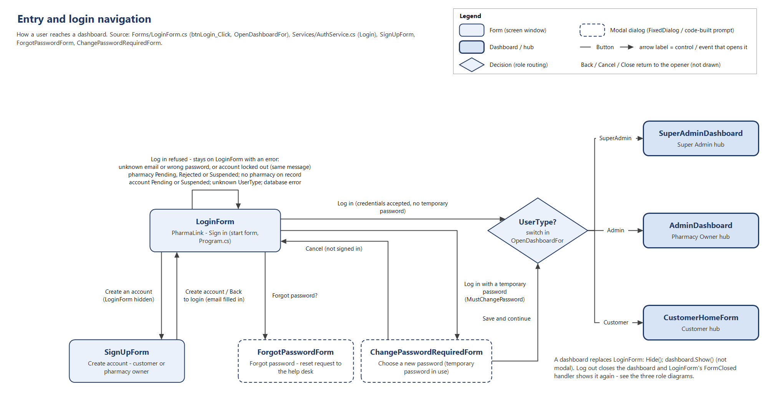
Figure 8.1 – Entry and role routing.
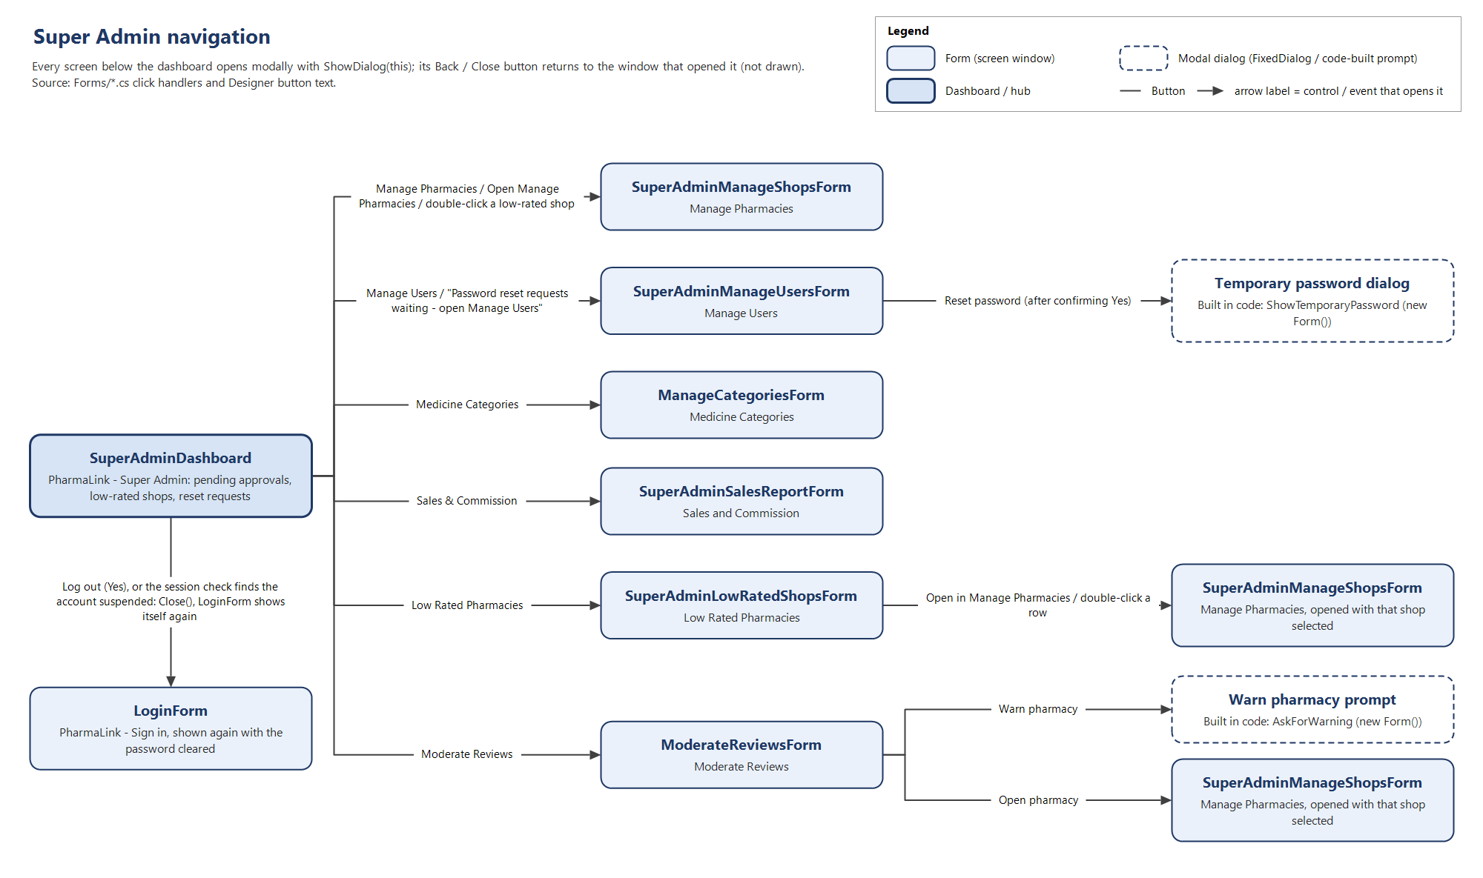
Figure 8.2 – Super Admin navigation.
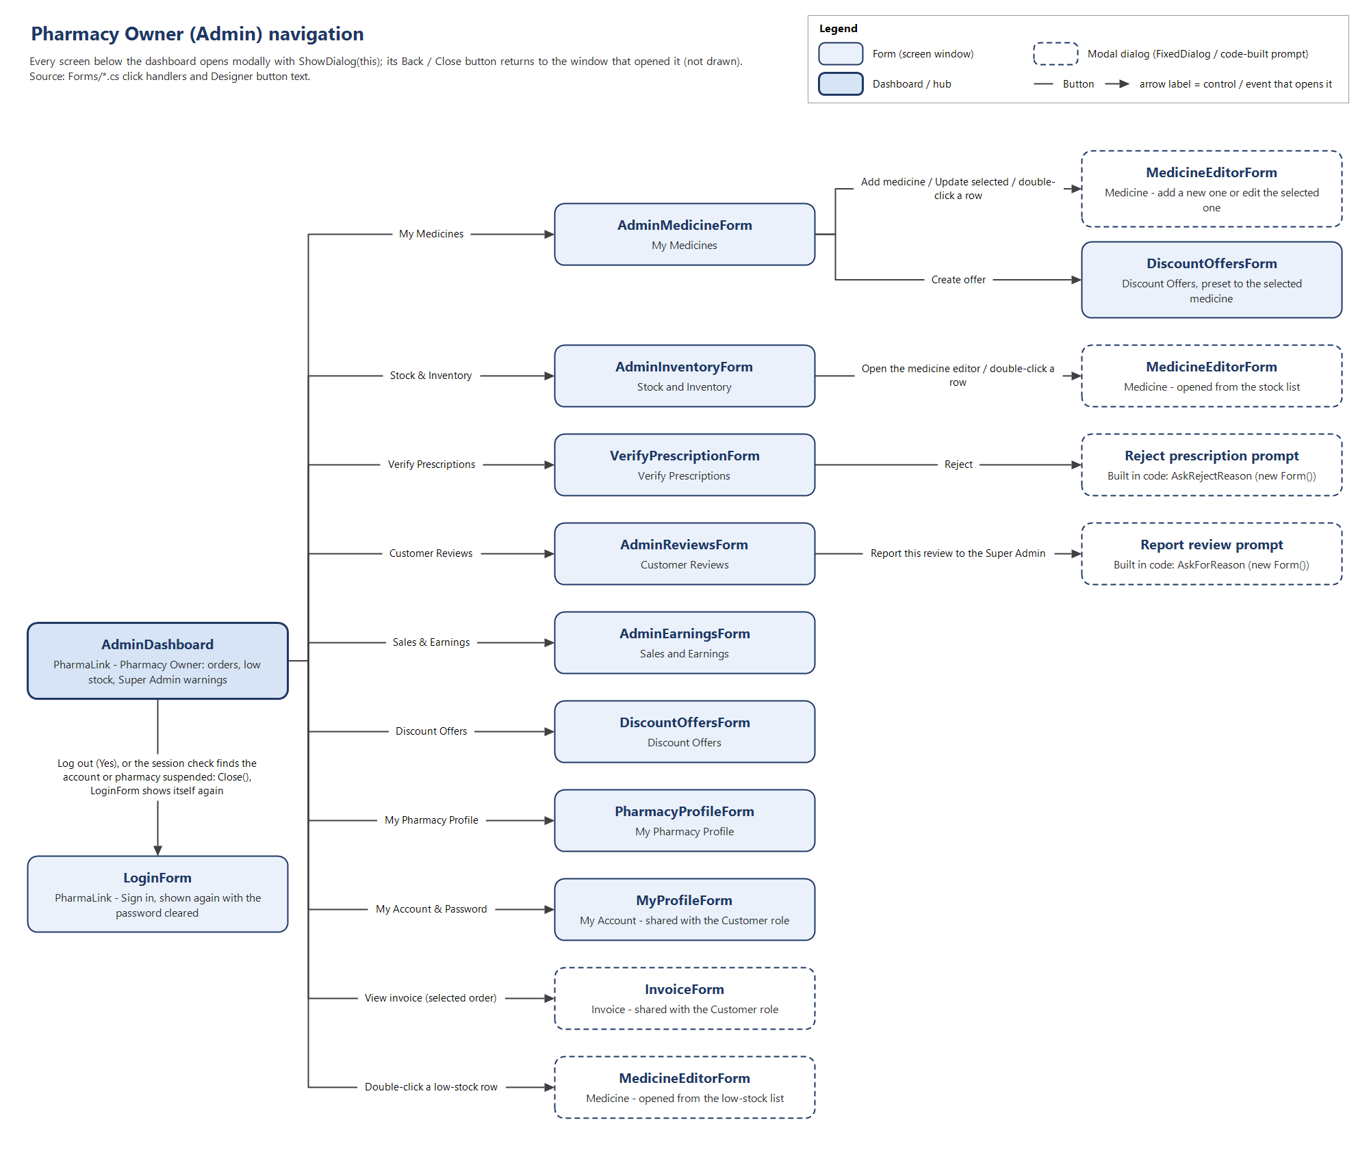
Figure 8.3 – Pharmacy Owner navigation.
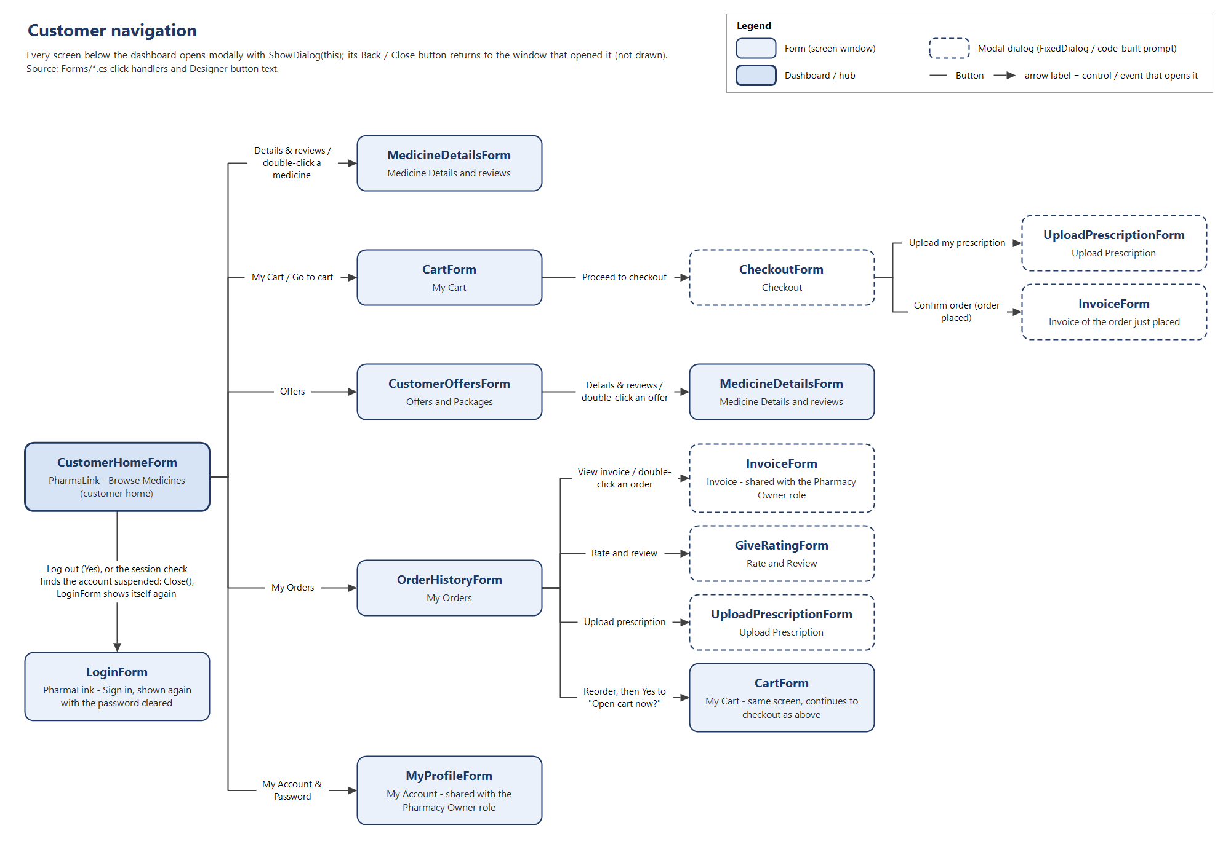
Figure 8.4 – Customer navigation.

8.1 Login, sign up and role routing
From form | Control / event | To form | Opens as
LoginForm | Create an account | SignUpForm | Modal dialog; LoginForm is hidden while it is open
SignUpForm | Back to login, or a successful Create account / Submit for approval | LoginForm | Dialog closes and LoginForm is shown again; a new Customer's email is already filled in
LoginForm | Forgot password? | ForgotPasswordForm | Modal dialog (the typed email is passed in)
ForgotPasswordForm | Send request or Cancel | LoginForm | Dialog closes
LoginForm | Log in, credentials correct but the account holds a temporary password (MustChangePassword) | ChangePasswordRequiredForm | Modal dialog, shown before any dashboard
ChangePasswordRequiredForm | Save and continue | Dashboard for the user's UserType | Dialog closes, then the dashboard opens as below
ChangePasswordRequiredForm | Cancel | LoginForm | UserSession is cleared and the message "Not signed in. Log in again with your temporary password to choose a new one." appears
LoginForm | Log in, UserType = SuperAdmin | SuperAdminDashboard | Main window; LoginForm hidden
LoginForm | Log in, UserType = Admin | AdminDashboard | Main window; LoginForm hidden
LoginForm | Log in, UserType = Customer | CustomerHomeForm | Main window; LoginForm hidden
LoginForm | Log in refused: unknown email, wrong password or an account locked after 5 failures (all three get the same message), a pharmacy that is Pending, Rejected or Suspended, or an account that is Pending or Suspended | LoginForm | Stays open with the reason under the Log in button
SuperAdminDashboard, AdminDashboard, CustomerHomeForm | Log out, then Yes on "Log out of PharmaLink?" | LoginForm | Dashboard closes; UserSession is cleared and LoginForm is shown again
SuperAdminDashboard, AdminDashboard, CustomerHomeForm | Any navigation click after the Super Admin has suspended the account or its pharmacy (session re-check) | LoginForm | "Signed out" message, then the dashboard closes
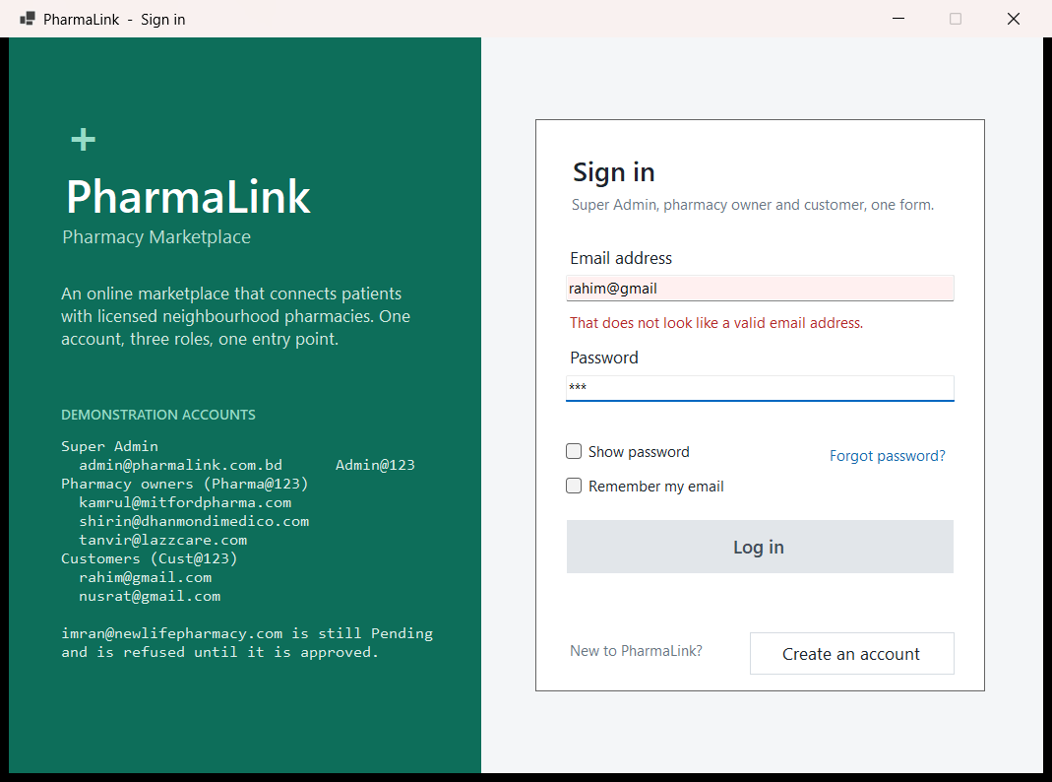
Figure 8.1.1 – Login (PharmaLink - Sign in) – The single entry point for all three roles, with the demonstration accounts listed on the left. The email "rahim@gmail" is refused with "That does not look like a valid email address.", so the Log in button stays greyed out even though a password has been typed. Below the password are Show password, Remember my email and Forgot password?.
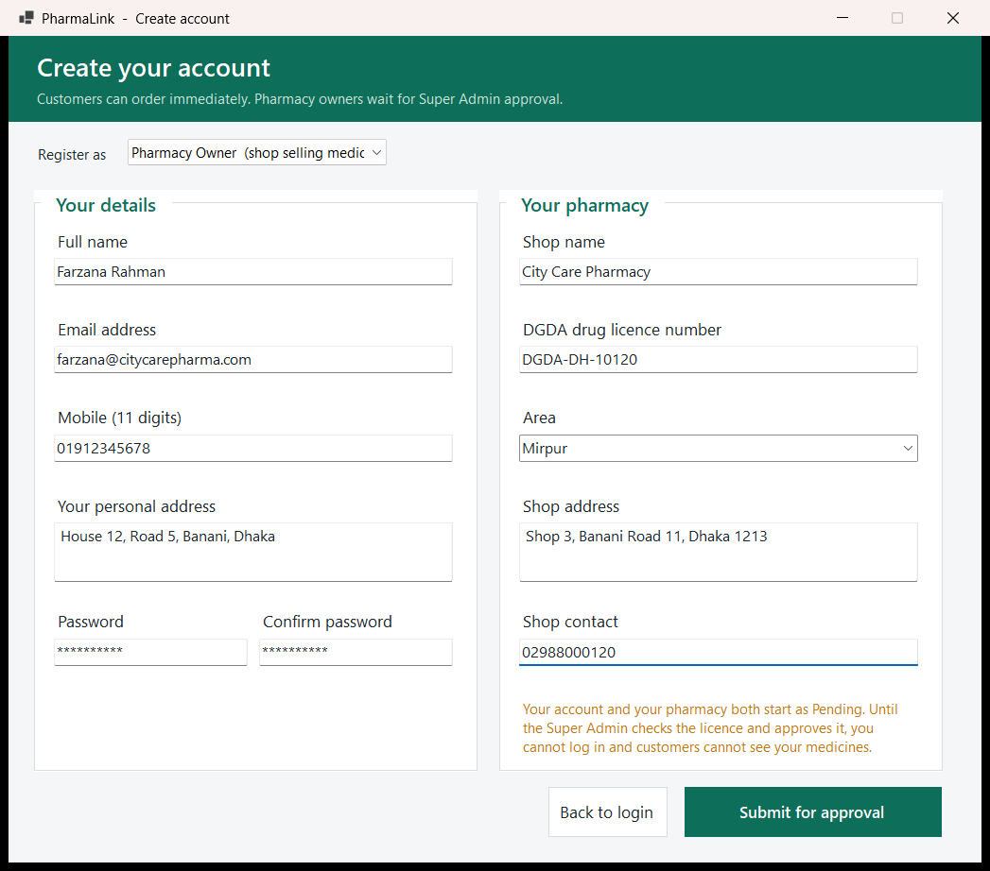
Figure 8.1.2 – Create account – Farzana Rahman registers City Care Pharmacy (licence DGDA-DH-10120, Mirpur) with Register as set to Pharmacy Owner, so the "Your pharmacy" panel is shown and the button reads Submit for approval. The note in orange explains that the account and the pharmacy both start as Pending until the Super Admin approves the licence.

8.2 Super Admin
From form | Control / event | To form | Opens as
SuperAdminDashboard | Manage Pharmacies (sidebar) or Open Manage Pharmacies | SuperAdminManageShopsForm | Modal dialog
SuperAdminDashboard | Double click a row in "Pharmacies rated below 2.5" | SuperAdminManageShopsForm (that pharmacy selected) | Modal dialog
SuperAdminDashboard | Manage Users (sidebar) | SuperAdminManageUsersForm | Modal dialog
SuperAdminDashboard | "Password reset requests waiting" button (shown only while requests exist) | SuperAdminManageUsersForm (opened on the reset requests) | Modal dialog
SuperAdminDashboard | Medicine Categories (sidebar) | ManageCategoriesForm | Modal dialog
SuperAdminDashboard | Sales & Commission (sidebar) | SuperAdminSalesReportForm | Modal dialog
SuperAdminDashboard | Low Rated Pharmacies (sidebar) | SuperAdminLowRatedShopsForm | Modal dialog
SuperAdminDashboard | Moderate Reviews (sidebar) | ModerateReviewsForm | Modal dialog
SuperAdminDashboard | Approve selected / Reject selected | Approve pharmacy / Reject registration confirmation | Message box; the dashboard stays and refreshes
SuperAdminManageShopsForm | Approve, Suspend, Reinstate, Delete | Matching confirmation box | Message box; the grid refreshes
SuperAdminManageUsersForm | Suspend account / Activate account | Change account status confirmation | Message box
SuperAdminManageUsersForm | Reset password, then Yes | Temporary password dialog (shows the password once, with a copy button) | Modal dialog
ManageCategoriesForm | Deactivate | Deactivate category confirmation | Message box
SuperAdminSalesReportForm | Export CSV | Save file dialog | Modal dialog
SuperAdminLowRatedShopsForm | Open in Manage Pharmacies, or double click a row | SuperAdminManageShopsForm (that pharmacy selected) | Modal dialog
SuperAdminLowRatedShopsForm | Export CSV | Save file dialog | Modal dialog
ModerateReviewsForm | Hide review | Hide review confirmation | Message box
ModerateReviewsForm | Warn pharmacy | "Warn pharmacy" prompt with an editable draft, then a confirmation | Modal dialog, then message box
ModerateReviewsForm | Open pharmacy | SuperAdminManageShopsForm (that pharmacy selected) | Modal dialog
Any Super Admin child form | Back | The form that opened it (SuperAdminDashboard, SuperAdminLowRatedShopsForm or ModerateReviewsForm) | Dialog closes and the parent refreshes
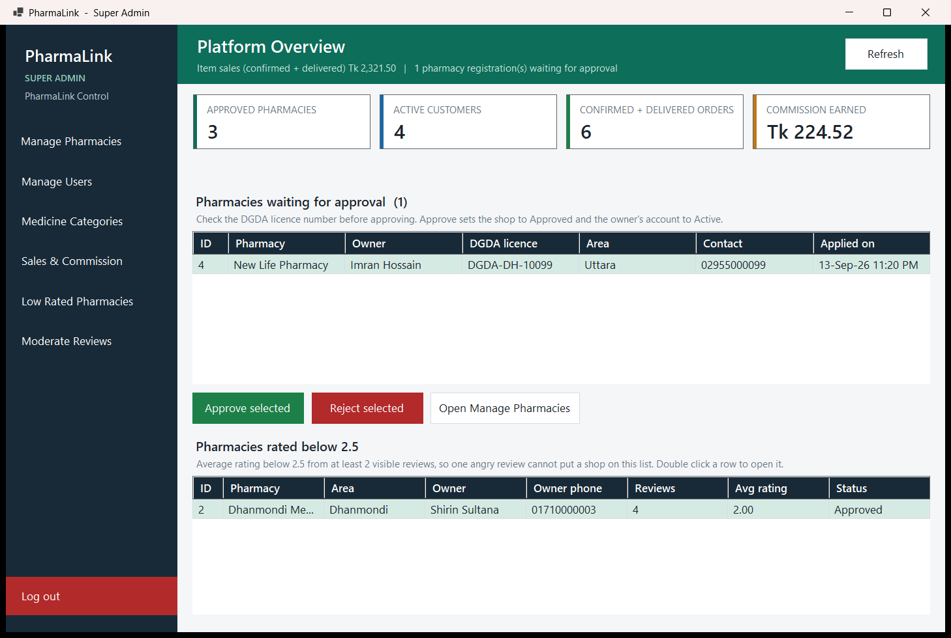
Figure 8.2.1 – Super Admin dashboard (Platform Overview) – Four tiles show 3 approved pharmacies, 4 active customers, 6 confirmed and delivered orders and Tk 224.52 commission earned. New Life Pharmacy (Imran Hossain, DGDA-DH-10099, Uttara) is waiting for approval, and Dhanmondi Medico appears in the low rated panel with an average of 2.00 from 4 reviews.
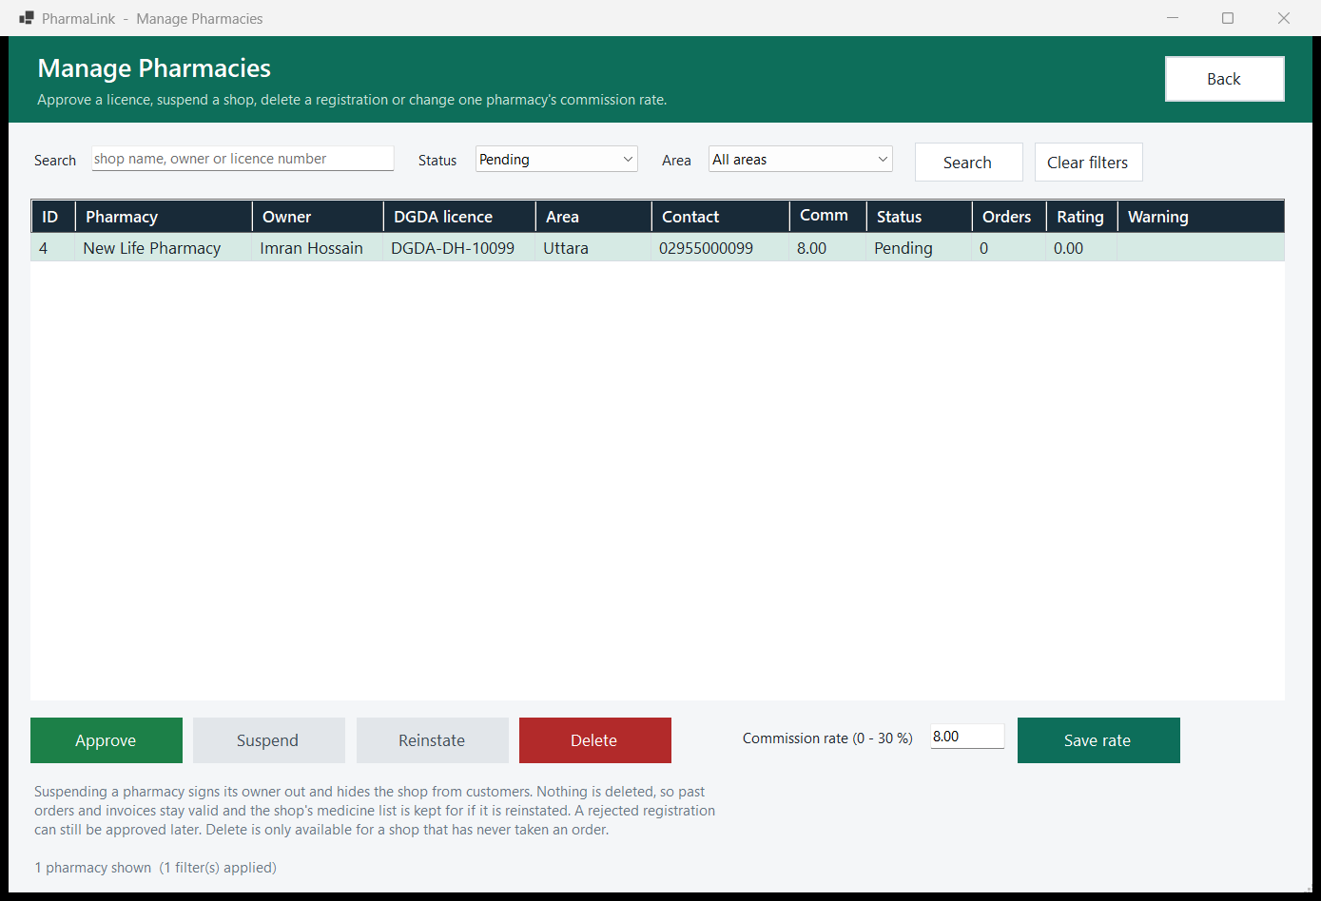
Figure 8.2.2 – Manage Pharmacies – With the Status filter set to Pending, only New Life Pharmacy is listed. Approve and Delete are available, but Suspend and Reinstate are greyed out because the shop is not yet Approved. The commission editor shows 8.00 next to Save rate.
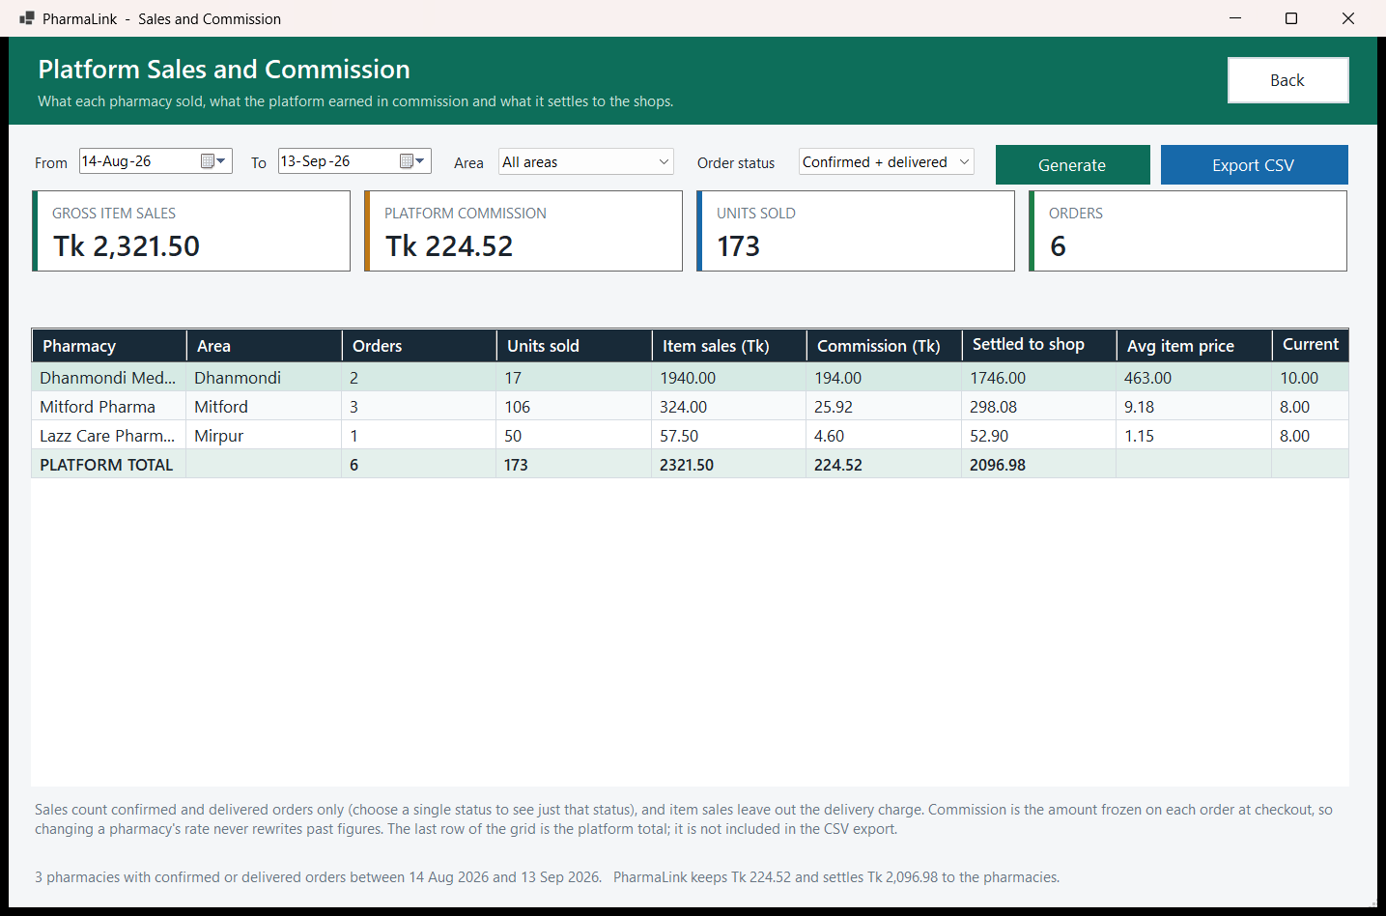
Figure 8.2.3 – Platform Sales and Commission – The report runs from 14 Aug to 13 Sep 2026 for confirmed and delivered orders. The tiles show gross item sales of Tk 2,321.50, platform commission of Tk 224.52, 173 units sold and 6 orders. The grid breaks these figures down for three pharmacies and ends in a bold PLATFORM TOTAL row, with Tk 2,096.98 settled to the shops.
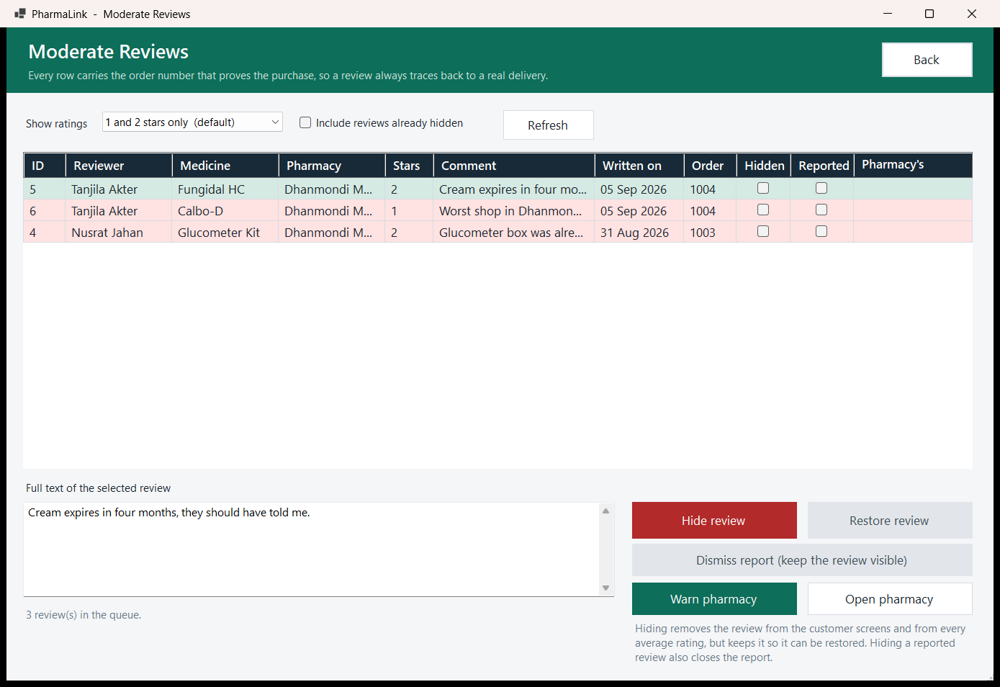
Figure 8.2.4 – Moderate Reviews – The default "1 and 2 stars only" filter lists three reviews of Dhanmondi Medico, each with the order number that proves the purchase. The selected review's full text appears below the grid, next to Hide review, Restore review, Dismiss report, Warn pharmacy and Open pharmacy.
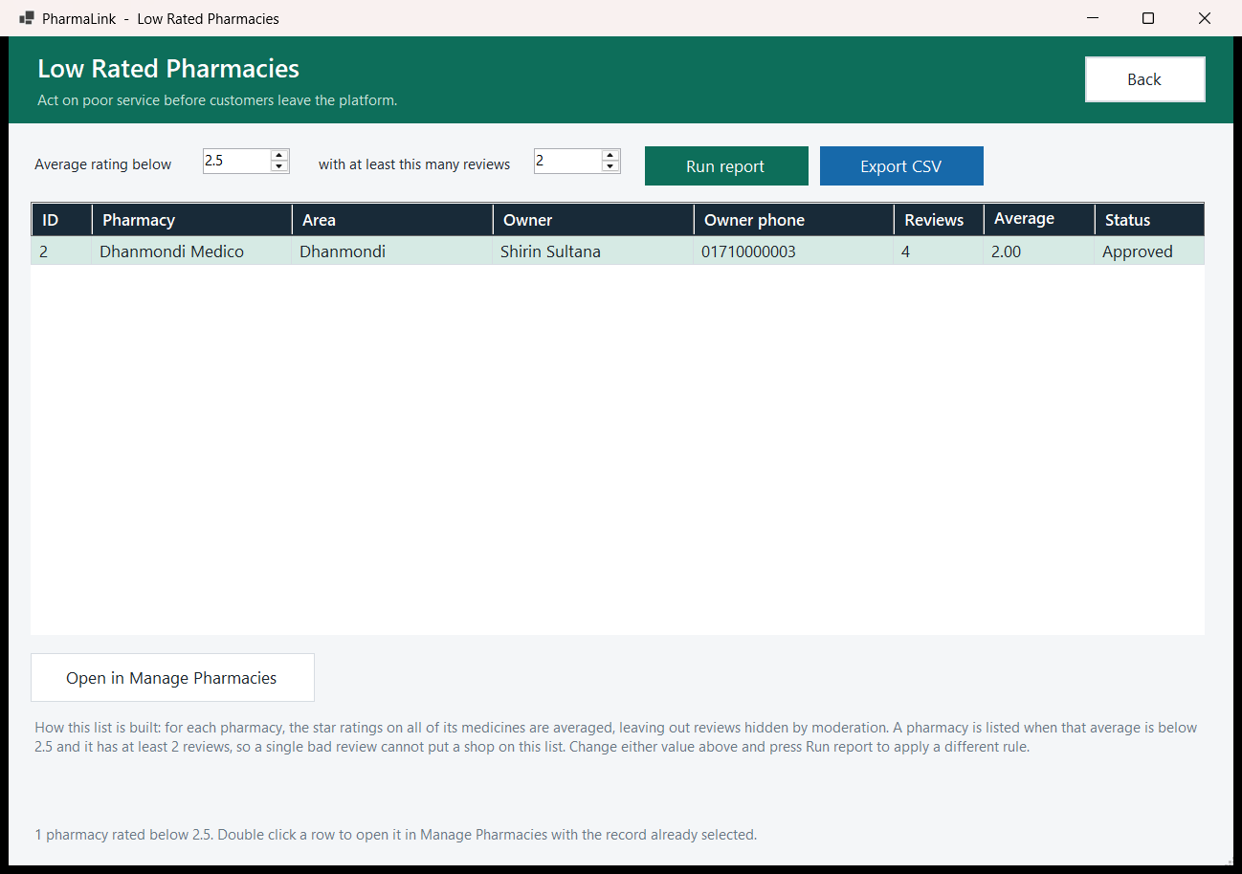
Figure 8.2.5 – Low Rated Pharmacies – With an average below 2.5 and at least 2 reviews, the report lists Dhanmondi Medico (4 reviews, average 2.00, Approved). Open in Manage Pharmacies and Export CSV act on the result.
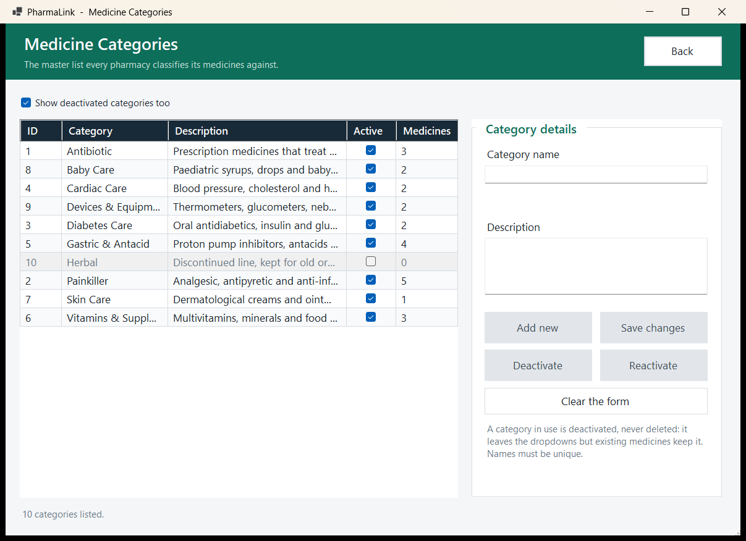
Figure 8.2.6 – Medicine Categories – With "Show deactivated categories too" ticked, ten categories are listed with their medicine counts. Herbal is greyed out because it has been deactivated. The note explains that a category in use is deactivated rather than deleted.

8.3 Pharmacy Owner
From form | Control / event | To form | Opens as
AdminDashboard | My Medicines (sidebar) | AdminMedicineForm | Modal dialog
AdminDashboard | Stock & Inventory (sidebar) | AdminInventoryForm | Modal dialog
AdminDashboard | Verify Prescriptions (sidebar) | VerifyPrescriptionForm | Modal dialog
AdminDashboard | Sales & Earnings (sidebar) | AdminEarningsForm | Modal dialog
AdminDashboard | Discount Offers (sidebar) | DiscountOffersForm | Modal dialog
AdminDashboard | Customer Reviews (sidebar) | AdminReviewsForm | Modal dialog
AdminDashboard | My Pharmacy Profile (sidebar) | PharmacyProfileForm | Modal dialog
AdminDashboard | My Account & Password (sidebar) | MyProfileForm (shared with the Customer) | Modal dialog
AdminDashboard | View invoice (selected order) | InvoiceForm (shared with the Customer) | Modal dialog
AdminDashboard | Double click a row in the low stock alert | MedicineEditorForm (edit mode) | Modal dialog
AdminDashboard | Confirm order / Mark delivered | AdminDashboard | Same window; the order list refreshes
AdminDashboard | Cancel order | Cancel order confirmation | Message box
AdminDashboard | I've read this (on the warning banner) | AdminDashboard | Same window; the banner is hidden
AdminMedicineForm | Add medicine | MedicineEditorForm (Add Medicine) | Modal dialog
AdminMedicineForm | Update selected, or double click a row | MedicineEditorForm (edit mode) | Modal dialog
AdminMedicineForm | Delete (delist) | Delist medicine confirmation | Message box
AdminMedicineForm | Create offer | DiscountOffersForm (the medicine preselected) | Modal dialog
AdminInventoryForm | Open the medicine editor, or double click an inventory row | MedicineEditorForm (edit mode) | Modal dialog
AdminInventoryForm | Restock selected | AdminInventoryForm | Same window; stock is added inline
AdminEarningsForm | Export CSV | Save file dialog | Modal dialog
DiscountOffersForm | Delete offer, or saving an offer that overlaps another | Delete offer / Overlapping offers confirmation | Message box
AdminReviewsForm | Report this review to the Super Admin | Reason prompt | Modal dialog
VerifyPrescriptionForm | Approve / Reject | Approve prescription confirmation / reason prompt | Message box / modal dialog
PharmacyProfileForm | Choose logo... | Open file dialog | Modal dialog
InvoiceForm | Print / Save as PDF / Save as text file | Print dialog / Save file dialog / Save file dialog | Modal dialog
Any Pharmacy Owner child form | Back, Cancel, Save or Close | The form that opened it | Dialog closes and the parent refreshes
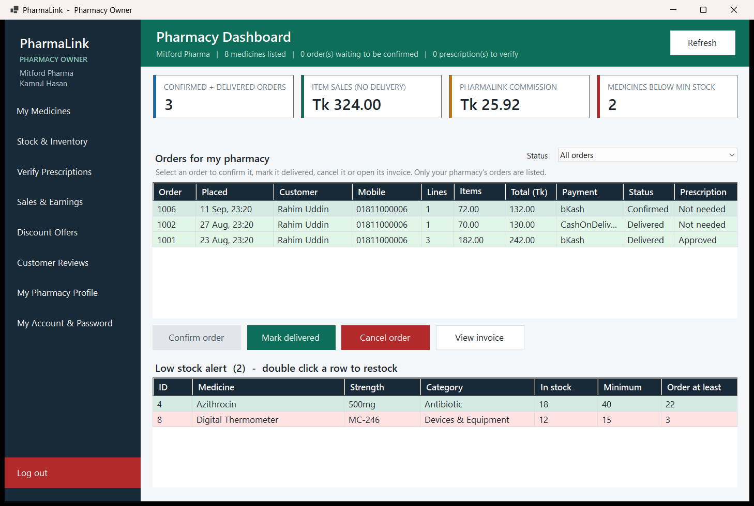
Figure 8.3.1 – Pharmacy Dashboard – Kamrul Hasan of Mitford Pharma sees 3 confirmed and delivered orders, Tk 324.00 item sales, Tk 25.92 PharmaLink commission and 2 medicines below minimum stock. The order queue sits above Confirm order, Mark delivered, Cancel order and View invoice. The low stock alert lists Azithrocin and Digital Thermometer with how many units to order.
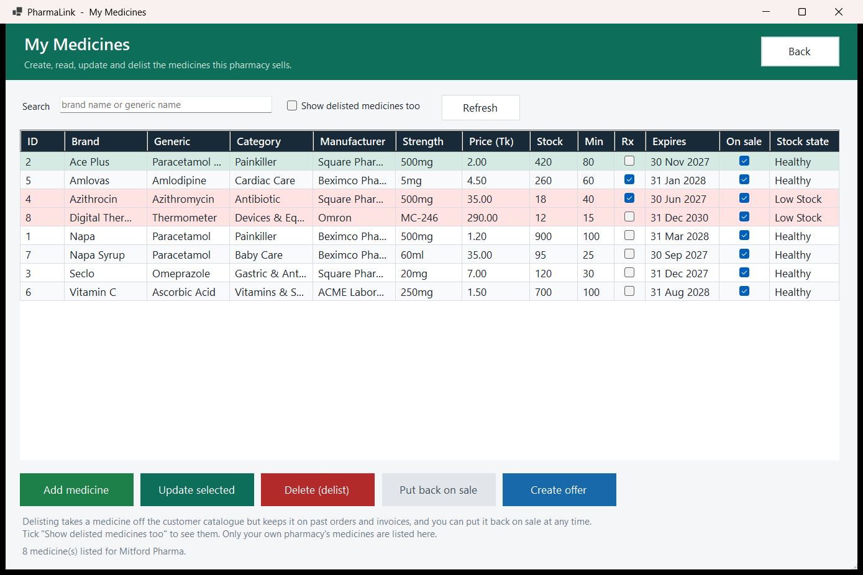
Figure 8.3.2 – My Medicines – Mitford Pharma's 8 medicines are shown with Rx, On sale and Stock state columns, and the two Low Stock rows are tinted red. The buttons are Add medicine, Update selected, Delete (delist), Put back on sale and Create offer. The note says delisting keeps a medicine on past orders and that only this pharmacy's medicines are listed.
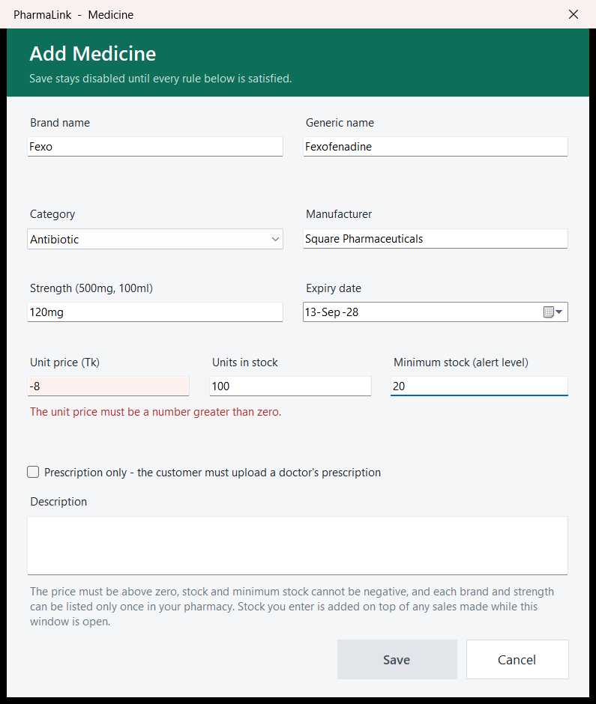
Figure 8.3.3 – Add Medicine (modal) – The unit price for Fexo is entered as -8, so the field is tinted red with the error "The unit price must be a number greater than zero." and Save is greyed out. The note below lists the rules for price, stock and unique brand and strength.
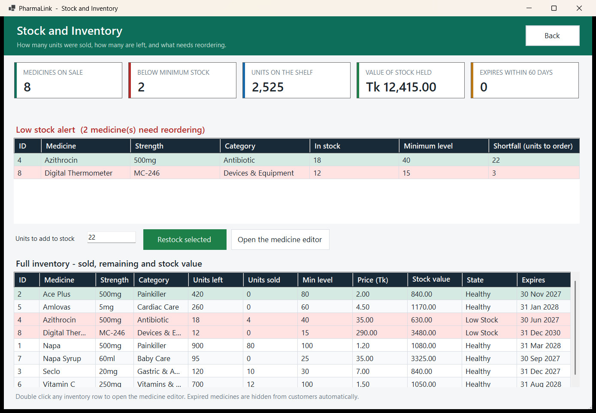
Figure 8.3.4 – Stock and Inventory – The tiles show 8 medicines on sale, 2 below minimum stock, 2,525 units on the shelf, Tk 12,415.00 of stock held and 0 expiring within 60 days. The low stock alert gives a shortfall of 22 units for Azithrocin and 3 for Digital Thermometer. Below it are the inline Restock selected control (22 units entered) and the full inventory grid.
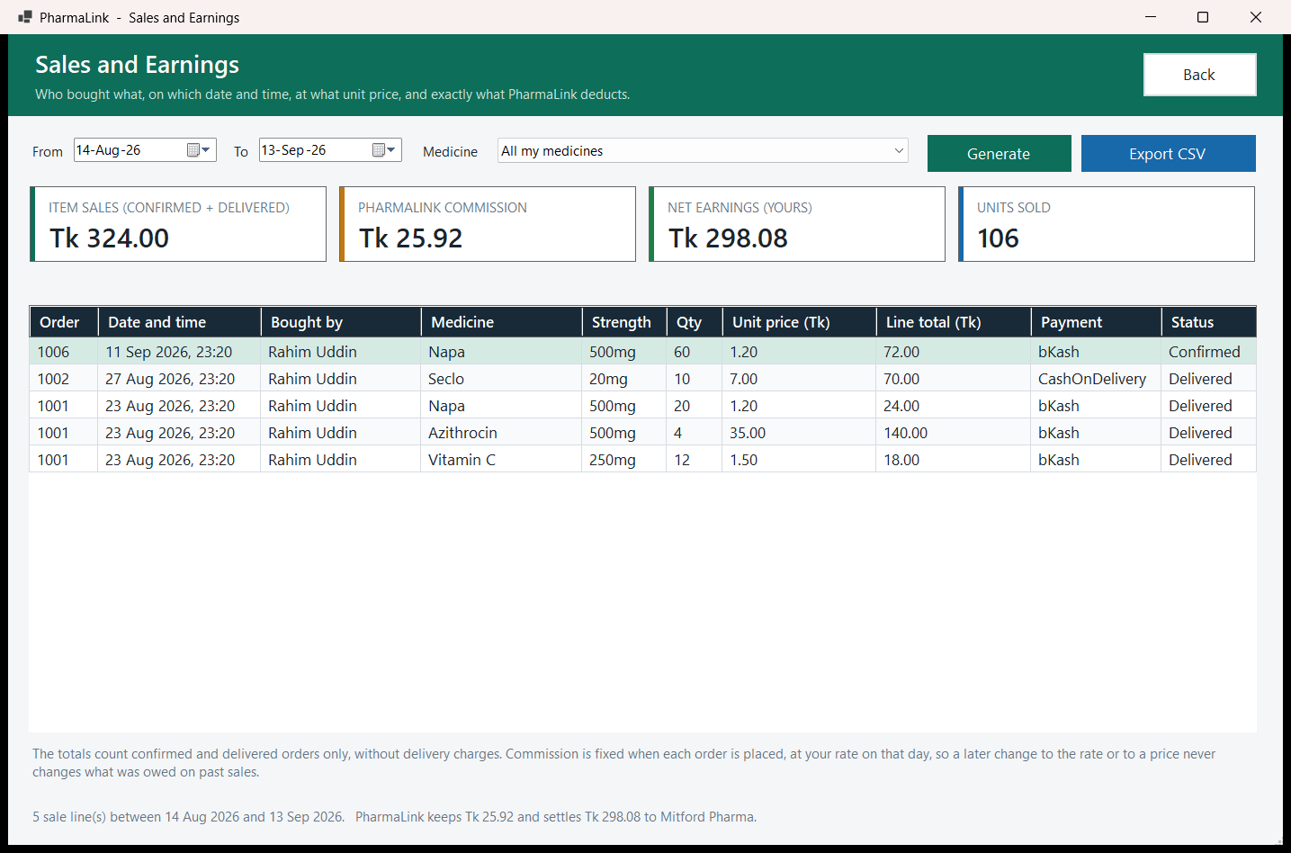
Figure 8.3.5 – Sales and Earnings – Between 14 Aug and 13 Sep 2026 Mitford Pharma had Tk 324.00 item sales, Tk 25.92 PharmaLink commission, Tk 298.08 net earnings and 106 units sold. The grid shows who bought each line, when, and at what unit price.
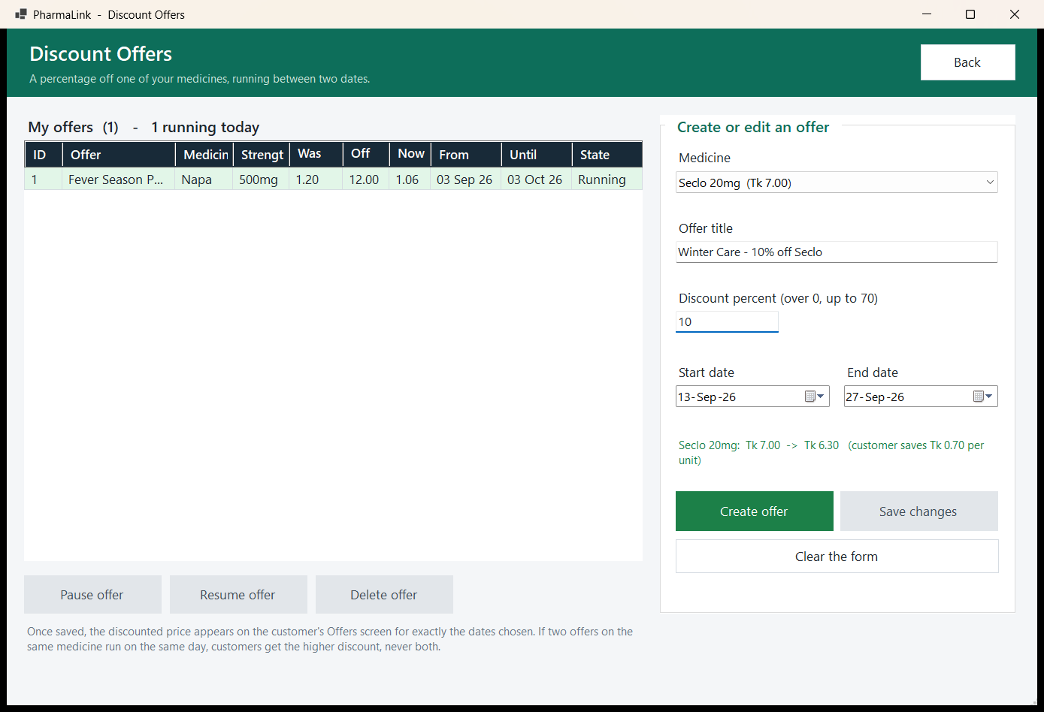
Figure 8.3.6 – Discount Offers – One offer is running: Fever Season Pack, 12% off Napa, from Tk 1.20 to Tk 1.06. The editor on the right is preparing "Winter Care - 10% off Seclo" for 13 to 27 Sep and previews the new price, Tk 7.00 -> Tk 6.30.
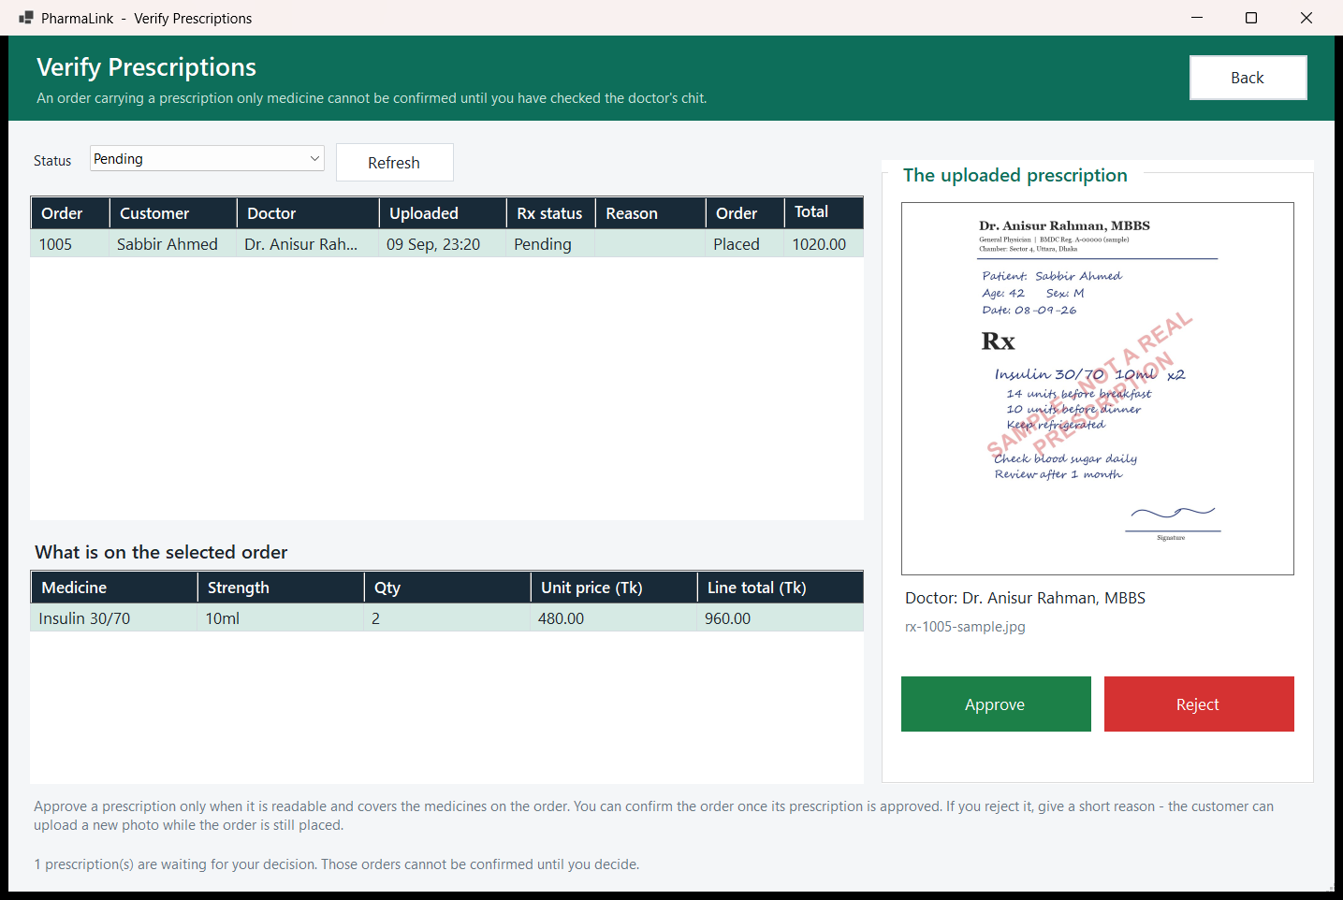
Figure 8.3.7 – Verify Prescriptions – Order 1005 from Sabbir Ahmed is Placed with a Pending prescription from Dr. Anisur Rahman for 2 x Insulin 30/70 10ml. The uploaded sample image is shown beside the Approve and Reject buttons.

8.4 Customer
From form | Control / event | To form | Opens as
CustomerHomeForm | Browse Medicines (sidebar), Search, or any filter change | CustomerHomeForm | Same window; the grid reloads
CustomerHomeForm | My Cart (sidebar) or Go to cart | CartForm | Modal dialog
CustomerHomeForm | Offers (sidebar) | CustomerOffersForm | Modal dialog
CustomerHomeForm | My Orders (sidebar) | OrderHistoryForm | Modal dialog
CustomerHomeForm | My Account & Password (sidebar) | MyProfileForm (shared with the Pharmacy Owner) | Modal dialog
CustomerHomeForm | Details & reviews, or double click a row | MedicineDetailsForm | Modal dialog
CustomerHomeForm | Add to cart | CustomerHomeForm | Same window; a status line confirms the addition
CustomerOffersForm | Details & reviews, or double click a row | MedicineDetailsForm | Modal dialog
CustomerOffersForm | Add to cart at this price | CustomerOffersForm | Same window
MedicineDetailsForm | Add to cart | MedicineDetailsForm | Same window; the cart is not opened
CartForm | Proceed to checkout | CheckoutForm | Modal dialog
CartForm | Remove line / Empty the cart | Confirmation | Message box
CheckoutForm | Upload my prescription (shown only when this pharmacy's part of the order contains a prescription only medicine) | UploadPrescriptionForm | Modal dialog
CheckoutForm | Confirm order, order placed | InvoiceForm | Modal dialog; when it closes, the checkout moves on to the next pharmacy ("Order 2 of 2") or closes
CheckoutForm | Confirm order, refused under lock (stock, price, prescription or pharmacy changed) | CheckoutForm | "Order not placed" message; the basket is reloaded
CheckoutForm | Cancel | Leave checkout confirmation, then CartForm | Message box, then the dialog closes
CartForm | CheckoutForm closes after the last pharmacy's order, leaving the cart empty | CustomerHomeForm (or OrderHistoryForm if the cart came from Reorder) | CartForm closes itself
OrderHistoryForm | View invoice, or double click an order | InvoiceForm | Modal dialog
OrderHistoryForm | Rate and review (enabled for a delivered order; otherwise it reads "Not delivered yet" or "Already reviewed") | GiveRatingForm | Modal dialog
OrderHistoryForm | Upload prescription (order still Placed, prescription missing or rejected) | UploadPrescriptionForm | Modal dialog
OrderHistoryForm | Cancel order (until the pharmacy confirms) | Cancel order confirmation | Message box; the list refreshes
OrderHistoryForm | Reorder, then Yes on "Open cart now?" | CartForm | Modal dialog
UploadPrescriptionForm | Choose a photograph of the prescription... | Open file dialog | Modal dialog
InvoiceForm | Print / Save as PDF / Save as text file | Print dialog / Save file dialog / Save file dialog | Modal dialog
Any Customer child form | Back, Cancel, Attach, Submit review or Close | The form that opened it | Dialog closes and the parent refreshes
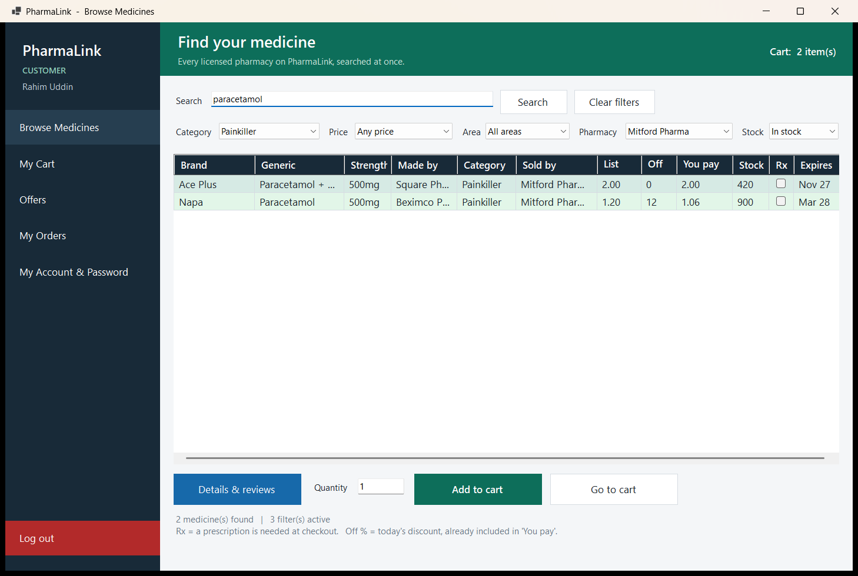
Figure 8.4.1 – Browse Medicines (Find your medicine) – Rahim Uddin searches "paracetamol" with the Category set to Painkiller, the Pharmacy to Mitford Pharma and Stock to In stock. Two medicines are found, and Napa shows a 12% discount, so the customer pays Tk 1.06. Prescription need is shown in the Rx column, and the header shows "Cart: 2 item(s)".
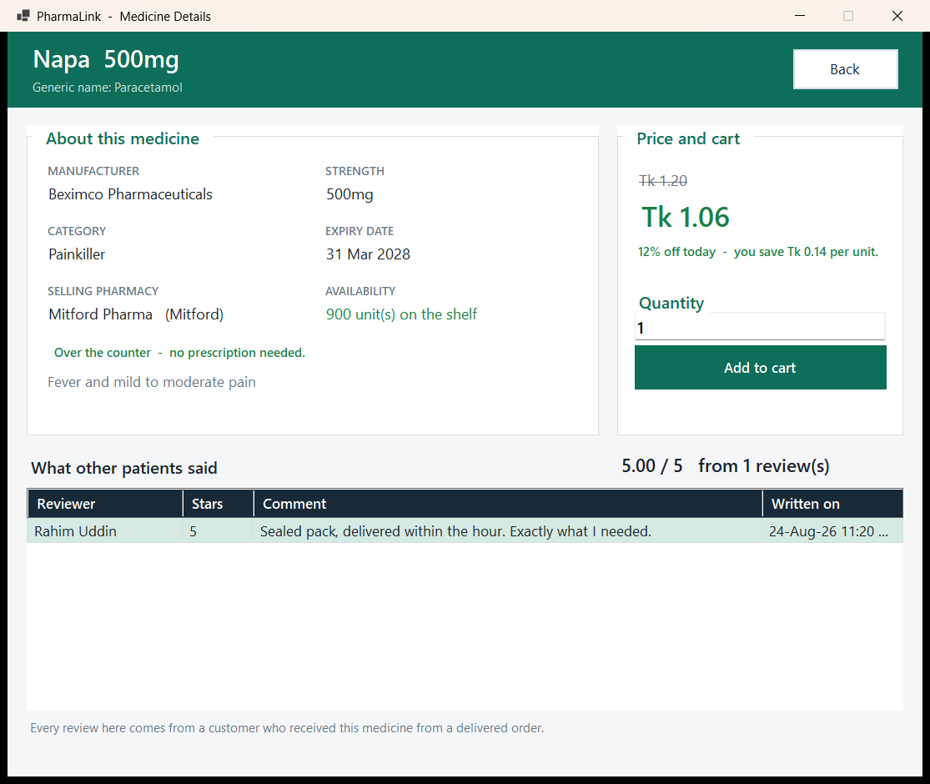
Figure 8.4.2 – Medicine Details – Napa 500mg from Beximco Pharmaceuticals, sold by Mitford Pharma with 900 units on the shelf and marked over the counter. The original Tk 1.20 is struck through beside Tk 1.06 (12% off today). The single review below gives 5.00 / 5.
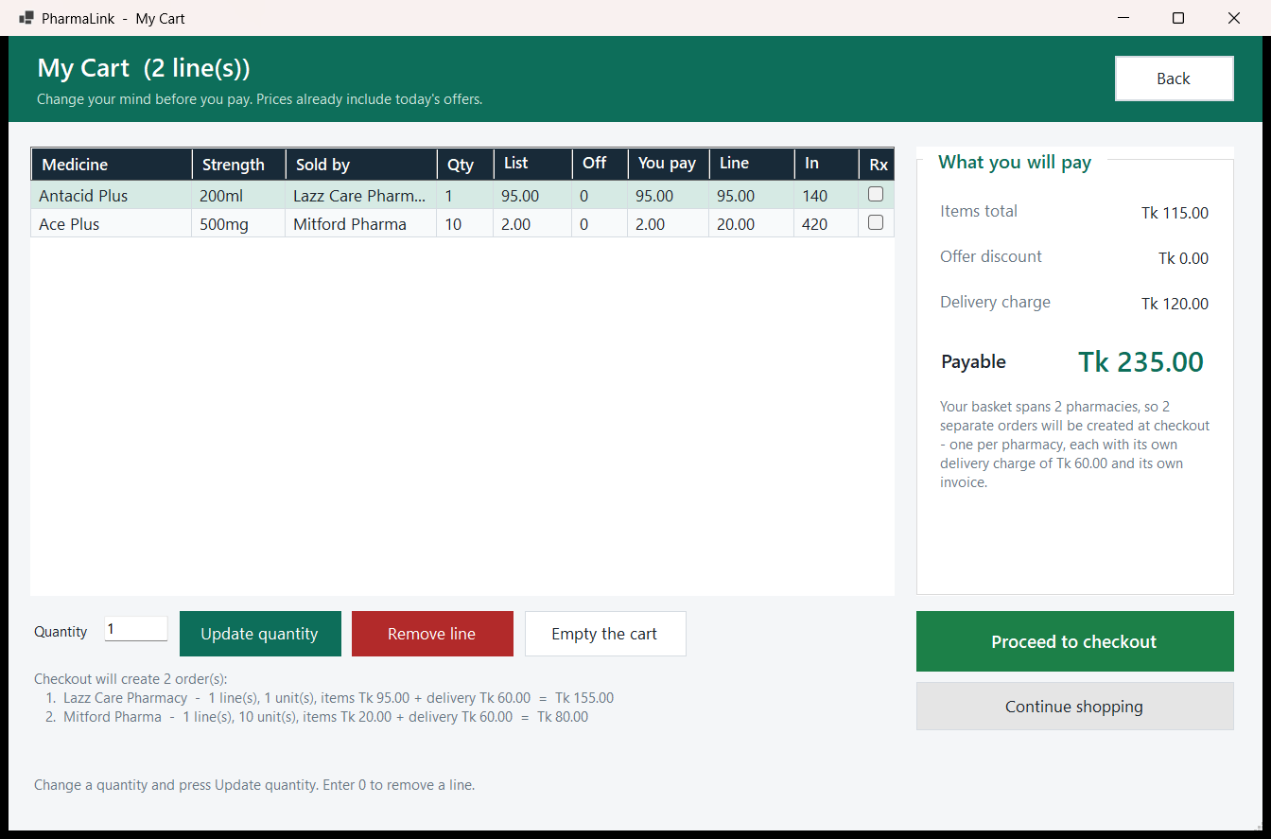
Figure 8.4.3 – My Cart – The cart holds two lines from two pharmacies, Antacid Plus from Lazz Care Pharmacy and 10 x Ace Plus from Mitford Pharma. The summary shows Tk 115.00 items, Tk 120.00 delivery and Tk 235.00 payable, and explains that checkout will create two separate orders with a Tk 60.00 delivery charge each. Quantity is changed in the text box with Update quantity.
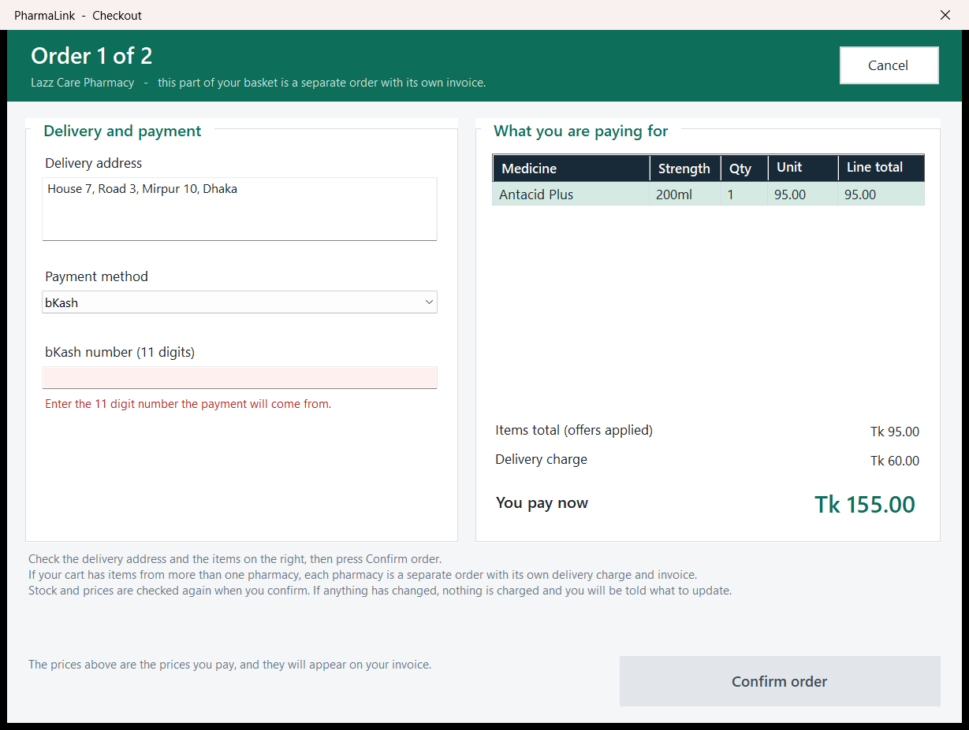
Figure 8.4.4 – Checkout (Order 1 of 2) – The Lazz Care Pharmacy part of the basket, for Tk 155.00. bKash is selected but no number has been entered, so the field shows "Enter the 11 digit number the payment will come from." and Confirm order is greyed out. The hint tells the customer to check the address and items, that each pharmacy is a separate order, and that stock and prices are checked again on confirm.
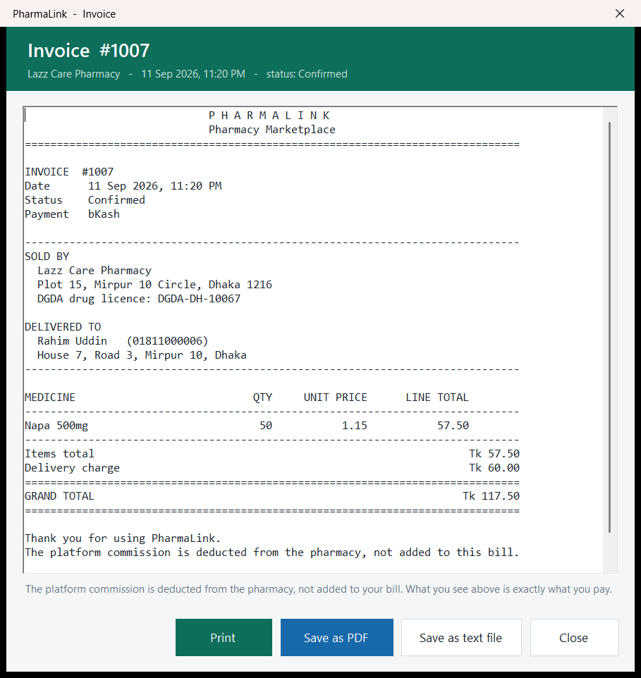
Figure 8.4.5 – Invoice #1007 – The bill from Lazz Care Pharmacy (licence DGDA-DH-10067) to Rahim Uddin is for 50 x Napa 500mg at Tk 1.15, plus Tk 60.00 delivery, a grand total of Tk 117.50. The footer states that the platform commission is deducted from the pharmacy, and the buttons are Print, Save as PDF, Save as text file and Close.
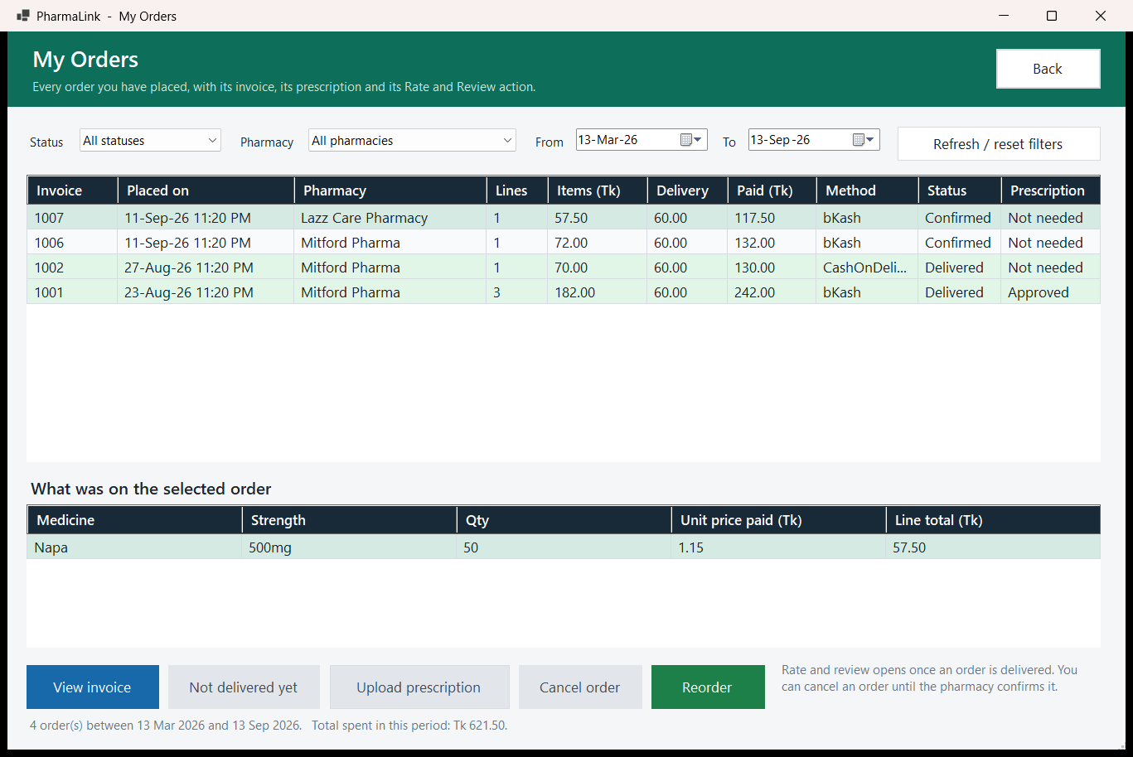
Figure 8.4.6 – My Orders – Four orders are listed, 1006 and 1007 Confirmed and 1002 and 1001 Delivered, for a total of Tk 621.50. The selected order 1007 is not delivered, so the rating button reads "Not delivered yet" and is disabled, next to View invoice, Upload prescription, Cancel order and Reorder.
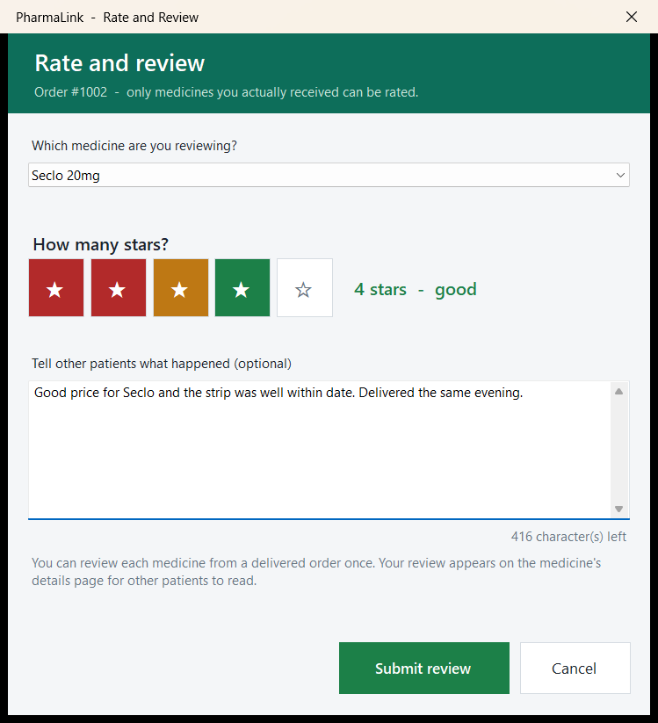
Figure 8.4.7 – Rate and Review (modal) – For order #1002 the customer picks Seclo 20mg, gives 4 stars ("good") and writes a comment, with 416 characters left. The note says each medicine from a delivered order can be reviewed once.
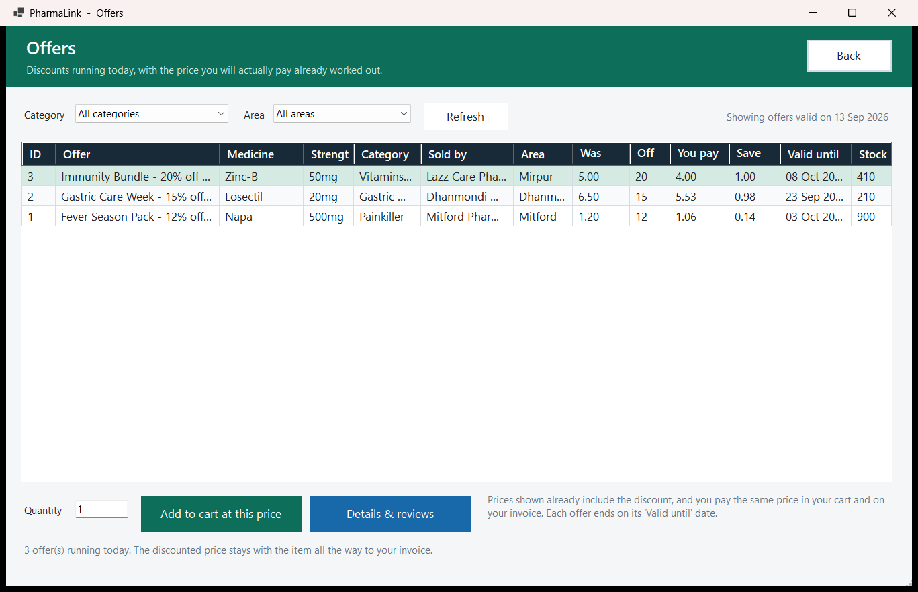
Figure 8.4.8 – Offers – Three offers valid on 13 Sep 2026 are shown: Immunity Bundle (Zinc-B, 20% off, Lazz Care), Gastric Care Week (Losectil, 15% off, Dhanmondi Medico) and Fever Season Pack (Napa, 12% off, Mitford Pharma). Each row shows the price already reduced, next to Add to cart at this price and Details & reviews.
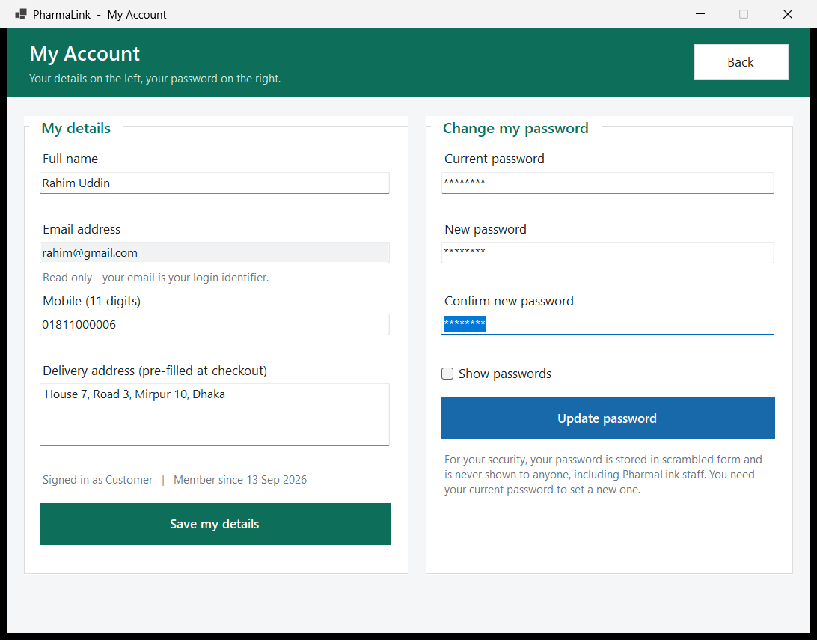
Figure 8.4.9 – My Account – Rahim Uddin's details are on the left, with the email read only because it is the login identifier. The password change is on the right, and its note says the password is stored in scrambled form and that the current password is needed to set a new one.

9. Features and Facilities
- One login for three roles: Every user signs in through the same LoginForm. The login query returns the UserType, which is stored in UserSession, and that one value decides whether SuperAdminDashboard, AdminDashboard or CustomerHomeForm opens. There is no separate administrator entry point to protect.
- Login lockout and a generic error: Five wrong passwords in a row lock an account for fifteen minutes. An unknown email, a wrong password and a locked account all get the same message and cost the same hashing time, so the login screen cannot be used to find out who is registered.
- Salted PBKDF2 password hashing: Passwords are hashed with PBKDF2-HMAC-SHA256, 100,000 iterations and a random salt per user, and are compared in constant time. An older account that still has a salted SHA-256 hash can still log in, and its hash is upgraded to PBKDF2 at that login. A password change checks the current password in memory, then writes the new hash with an UPDATE that only succeeds if the stored hash has not changed in the meantime.
- Help-desk password reset: PharmaLink has no email or SMS service, so ForgotPasswordForm sends a request that is matched on email and registered mobile number. The Super Admin sees the waiting requests on the dashboard and issues a random temporary password, shown once and stored only as a hash. At the next login ChangePasswordRequiredForm makes the user choose a new password before any dashboard opens.
- Remember my email: The login form can remember the email address, never the password, on that computer. Unticking the box and signing in once removes it.
- Licence checked pharmacy onboarding: A Pharmacy Owner who registers is held at Pending, together with their pharmacy, and cannot log in until the Super Admin has checked the DGDA drug licence number and approved it. Customers cannot see the medicines before approval either. A rejected registration is kept, not deleted, so it can still be approved later.
- Data isolation between pharmacies: Every Pharmacy Owner query filters on the PharmacyId taken from UserSession at login. The id is passed into each service method, for example OrderService.Confirm(orderId, pharmacyId) and MedicineService.Delist(medicineId, pharmacyId). A Pharmacy Owner can never read or change another pharmacy's medicines, orders or earnings, because the rule is in the query itself, not in which controls are shown.
- Suspension that takes effect at once: Suspending a pharmacy changes the Pharmacies and Users rows in one transaction and deletes nothing, so past orders and invoices stay valid. The dashboards re-check the account before opening any screen, so a suspended user is signed out at their next click.
- Search and five way filtering: Customers search by brand name, generic name or manufacturer, so a doctor's chit that says paracetamol finds Napa. Results are narrowed by category, price, area, pharmacy and stock through ComboBox controls instead of free text.
- Low stock alerts and inline restock: Each medicine has its own minimum stock level, so the alert compares two columns of the same row instead of a fixed threshold. Ten boxes of a glucometer is plenty; ten strips of a painkiller is nothing. The alert shows the shortfall in units, and the Pharmacy Owner can add stock straight from the alert or open the medicine editor.
- Soft delisting of medicines: Delete (delist) sets a medicine's IsActive flag to 0 instead of removing the row, so it leaves the customer catalogue but stays on past orders and invoices, and Put back on sale reverses it.
- Prescription control: An order containing a prescription only medicine cannot be placed without a photograph of the doctor's prescription, and the pharmacy cannot confirm the order until it has approved that image. A rejection carries a reason that the customer sees in My Orders. The customer can then upload a new photo while the order is still Placed.
- Time limited discount offers: A Pharmacy Owner sets a percentage discount, up to 70%, with a start and an end date, and can pause, resume or delete it. The discounted price is calculated inside the query, so the offers screen, the details screen, the cart and the invoice always show the same figure. When two offers overlap, the higher discount applies, never both.
- Transactional checkout: Checkout runs once per pharmacy inside one database transaction. It locks and re-checks the cart lines, stock, expiry and pharmacy status, inserts the order and its line items, inserts the prescription when one is needed, reduces stock and clears only that pharmacy's cart lines. If anything changed, nothing is written. A basket that spans two pharmacies becomes two orders, each with its own delivery charge and its own invoice.
- Order handling by the pharmacy: The Pharmacy Owner confirms, marks delivered or cancels orders from the dashboard queue. Cancelling returns the units to stock, and each action succeeds only if the order is still in the status the action expects.
- Customer cancel and reorder: A customer can cancel an order until the pharmacy confirms it. Reorder puts the items of a past order back in the cart at today's prices and skips, with a reason, anything that is delisted, expired, out of stock or from a pharmacy that is no longer approved.
- Verified reviews and moderation: A review points back to the delivered order it came from, so only a customer who actually received the medicine can rate it, and only once. The Super Admin can hide an abusive review and restore it later, but never delete it, so the rating history stays complete.
- Reported reviews and pharmacy warnings: A Pharmacy Owner cannot edit or delete a review of their shop, but can report it with a reason. Reported reviews appear under the "Reported by pharmacy" filter in Moderate Reviews, where the Super Admin can hide the review or dismiss the report. The Super Admin can also send the pharmacy a warning, which stays as a banner on the owner's dashboard until they press "I've read this".
- Commission frozen at the point of sale: The commission is calculated once at checkout from the pharmacy's own rate and stored on the order row. A later change to the rate or a price cannot rewrite what was owed on past sales, and the earnings and sales reports never have to be reconciled by hand.
- Reports with CSV export: The Super Admin's sales and commission report groups sales by pharmacy with a total row, and the low rated report uses HAVING with a minimum number of reviews so one angry review cannot list a shop. The Pharmacy Owner's earnings report shows every sale line. All three can be exported to CSV.
- Printable invoices: Every order has a bill that shows both addresses, the pharmacy licence number, the line items at the price charged and the grand total. It can be printed, saved as a PDF through Windows' Microsoft Print to PDF printer, or saved as a text file. Customers reopen invoices from My Orders, and the Pharmacy Owner opens them from the dashboard.

10. Conclusion
PharmaLink began as an ordinary observation about buying medicine late at night in Dhaka and ended as a working three tier marketplace. The group wrote a case study grounded in a real domain, a set of functional requirements and user stories for all three roles, a ten table database normalised to third normal form with a junction table for order line items, and a SQL script whose queries sit behind named features. The group then built the application on that design: a C# WinForms client on SQL Server with 30 forms, a service layer that holds every query, and a navigation structure in which every form can be reached and has a way back.
Thirty functional requirements came from the design phase. Seven more were added during implementation when testing exposed gaps: login lockout; forgot password with a temporary password and a forced change; remember my email; Super Admin warnings to pharmacies; reported reviews; confirming, delivering and cancelling orders; and reorder with saving an invoice as a PDF. That gives thirty-seven requirements in total. Keeping the requirements, the forms and the queries consistent with each other was the hardest part of the work. When the report says a Pharmacy Owner cannot see another pharmacy's data, that is backed by the PharmacyId filter in the queries. When it says a customer cannot review the same purchase twice, that is backed by a UNIQUE constraint in the schema.
What the group takes away is that the design decides how hard the coding is. Choosing a junction table early kept the checkout code simple. Storing the commission on the order row means the earnings report never has to be reconciled by hand. Keeping categories in their own table makes a rename one UPDATE instead of a hundred. Some problems appeared only once the system was running: two customers buying the last unit at the same moment, a pharmacy suspended while its owner was still signed in, and passwords that needed a slower hash than the design had planned. They were solved with row locks and re-checks inside the checkout transaction, a session check before every screen, and PBKDF2 hashing with a transparent upgrade.

10.1 Future Work
The system meets its requirements. The items below are not built and are real limitations or extensions of the current version.
- Delivery rider role with order tracking: Orders go straight from Confirmed to Delivered today. A fourth role for riders, with a status for "out for delivery" and live tracking, would let customers see where their medicine is.
- Email and SMS notifications: The application has no email or SMS service. Customers learn about status changes only by opening My Orders, and a forgotten password has to go through the Super Admin, who phones the user with a temporary password. An SMS or email gateway would allow status alerts and self-service password reset.
- Refill reminders: A reminder for patients on long term medication, based on the quantity and date of their last order.
- Real bKash payment gateway: Checkout records the bKash or Nagad number the customer types but does not take a payment. Integrating the payment gateway would confirm payment before the order is placed.
- Bangla language toggle: All screens are in English. A Bangla option for the customer screens would make the application usable for far more patients.

