CAMERA MODULE MARKET

MARKET REQUIREMENTS DOCUMENT

WPI TEAM

APRIL 25th, 2024

# **Table of Contents**

1. Business Case/Objectives .................................................................................... 2
2. Market/Industry Forecast .................................................................................... 2
3. Teradyne Market Position .................................................................................... 4
4. Market Drivers and Target Applications ............................................................ 4
5. Target Accounts and Key Requirements ............................................................ 7
6. Competitor Assessment .................................................................................... 19
7. Vision for Competitive Advantage ........................................................................ 30
8. System Target Costs and Prices ........................................................................ 33
9. Product Requirement ................................................................................................ 35
10. Limitations and Challenges .................................................................................... 37
11. Final Recommendations .................................................................................... 39
12. Appendix ............................................................................................................ 41
13. References ............................................................................................................ 49

# **BUSINESS CASE AND OBJECTIVE**

To determine whether entering the Compact Camera Module (CCM) Industry is worthwhile by exploring the dynamics of the industry, identifying the total available market (TAM) of the market segments, evaluating the performance and current offerings of major players, and analyzing target customer requirements. CCM market segments include mobile, computing, automotive, and other consumer devices.

## **MARKET/INDUSTRY FORECAST**

The 2023 Yole Market Report’s projections of the CCM industry’s unit volume and approximations of CCM testing system unit costs ($300,000 per unit), total number of system sites needed (6 sites), and test time per unit (120 seconds) indicates a TAM of $482.1M in 2026, $8.4M in 2027, and $5.4M in 2028. The average TAM from 2026-2028 is $165.3M. The assumptions included in the TAM calculations are Teradyne will not have a test system until 2026; Teradyne will capture each market segment (mobile, computing, automotive, and other consumer); and Teradyne will test 25% of CCMs (exception is automotive with 75%).

The following tables display the CCM TAM and the CCM unit volume. The TAM table shows that mobile CCMs – smartphones and feature phones – garner the highest valued TAM in 2026-2028 with a $320.4M TAM in 2026, almost ten times more than the second highest valued segment. This total is driven by mobile phones' abundant unit volume from 2023-2028. Assuming the mobile unit volume CAGR projections and testing costs are accurate, this segment is the most lucrative. The only drawback is that the mobile market’s unit volume CAGR could decline slightly.

The computing, automotive, and other consumer CCM segment’s TAM isn’t as large as the mobile segment, however, these markets still offer some opportunities. Computing CCMs – laptops, tablets, and computer mice – have a $36M TAM projection in 2026, automotive CCMs – passenger and LCV – have a $80.7M TAM projection in 2026, and other consumer CCMs - security cameras, drones, smartwatches, etc. – have a $45M projection in 2026. The unit volume CAGR for these three markets are projected to increase as well, with other consumer and automotive segments expected to grow >10%. These are very respectable numbers, and these segments could be strategic investments for new entrants given the rapid improvements in CCM capabilities.

*Table 1.1*

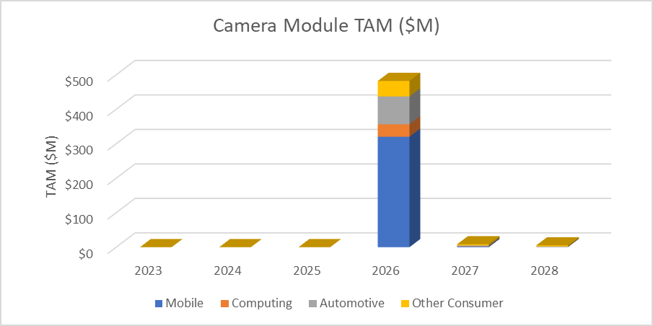*Figure 1.1*

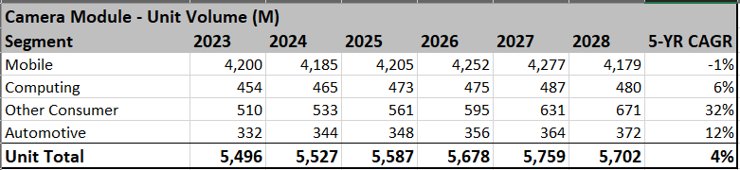

*Table 1.2*

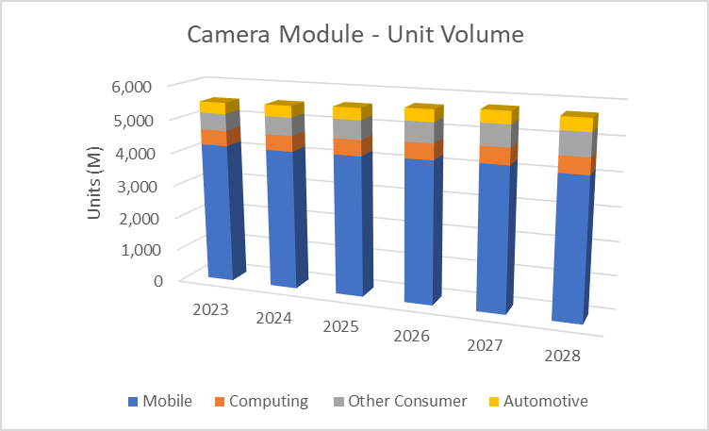

*Figure 1.2*

**TERADYNE MARKET POSITION**

Teradyne doesn’t currently participate in the camera module testing market. This document details the opportunities and current competition of the Camera Module Testing market. The analysis of potential opportunities and competitors currently participating in this market will be covered later in the document.

**MARKET DRIVERS**

In this section, we delve into the key factors impacting the demand for camera modules and in turn their need for testing, for different industries: Smartphone, Laptops and PCs, Automobile and Others. From the integration of cameras in smartphones and laptops to their application in automotive and medical devices, testing the camera modules has gained immense importance to ensure quality standards, functionality, reliability and compliance are met. By examining the evolving landscape of technological innovation, market trends, competition and consumer preferences, we would like to explain the forces shaping the future of the camera module market.

According to current research available on the camera module market and different industries, there are some evident reasons impacting the market trends. Understanding and exploring these reasons will help prepare better for the future evolution of the camera module market. The reasons below are some of the top-level factors to watch out for as they can cause either a positive or a negative impact on the market with their volatile and dynamic nature.

1. **Technological advancements:** Rapid changes in the technology are to be observed and followed by companies to change along with as it enhances product functionality, reliability and performance.
2. **Market saturation:** With time and increase in similar products, the market tends to reach a saturation point limiting growth opportunities. It becomes important to make sure that companies build competitive advantage.
3. **Economic factors:** Economic changes are uncontrollable and can cause fluctuations in consumer spending and business investment, hence needing the companies to brace for change.
4. **Regulatory environment:** It is of utmost importance for companies to ensure regulations and compliances are met and standards are maintained. This is also a macroeconomic factor to be monitored continuously to ensure its adherence.
5. **Consumer preferences:** Every market trend is highly impacted by consumer preferences and requires companies to closely monitor and analyze this data to ensure they enter the market with the most suitable product keeping the market trend dynamic.
6. **Competitive dynamics:** Intensified competition within the industries defines market trends to a certain extent. Understanding the competition can help a company place itself better in the market.

There is a global growth in the demand for camera modules in the camera market as mentioned in markets and markets and global info research report. Below is a summary of the top three key factors driving the demand of smartphones, laptops and PCs, automobile and others, which also explains the need for camera module testing in each of these industries.

1. **Smartphones**
   * **Increased Smartphone Adoption**: The proliferation of smartphones worldwide, driven by rising consumer demand for connectivity, advanced features, and mobile applications, has fueled the demand for camera module testing equipment. Smartphone manufacturers strive to deliver high-quality cameras to meet consumer expectations, driving the need for rigorous testing throughout the production process.
   * **Advancements in Camera Technology**: Continuous advancements in smartphone camera technology, including higher megapixel counts, multiple lenses, and innovative features such as optical image stabilization and computational photography, necessitate sophisticated testing equipment to ensure optimal performance and reliability.
   * **Market Competition**: Intense competition among smartphone manufacturers to differentiate their products based on camera quality and performance has led to increased investments in testing equipment to maintain competitive advantages and meet market demands.
2. **Laptops and PCs**
   * **Integration of Cameras**: The integration of cameras into laptops and PCs for video conferencing, online meetings, content creation, and multimedia applications has become ubiquitous, driving the demand for camera module testing equipment. Quality assurance and reliability testing are essential to ensure the functionality and performance of integrated cameras in these devices.
   * **Remote Work and Learning Trends**: The global shift towards remote work, online education, and virtual communication, especially accelerated by the COVID-19 pandemic, has heightened the importance of reliable camera functionality in laptops and PCs. As demand for these devices’ surges, so does the need for robust testing solutions to meet quality standards and user expectations.
   * **Innovation and Customization**: OEMs and ODMs in the laptop and PC market continuously innovate to deliver new features, form factors, and user experiences. This drive for innovation necessitates comprehensive testing of camera modules to address diverse use cases, environmental conditions, and performance requirements.
3. **Automotive**
   * **Rise of Advanced Driver Assistance Systems (ADAS)**: The increasing integration of camera based ADAS technologies in modern vehicles for features such as lane departure warning, automatic emergency braking, and adaptive cruise control has propelled the demand for camera module testing equipment in the automotive sector. Ensuring the accuracy, reliability, and compliance of camera systems is critical for vehicle safety and regulatory compliance.
   * **Autonomous Driving Development**: The development and testing of autonomous vehicles rely heavily on camera sensor data for perception, navigation, and environmental awareness. Testing equipment plays a vital role in verifying the functionality, accuracy, and robustness of camera modules in diverse driving conditions and scenarios.
   * **Stringent Quality Standards**: Automotive manufacturers and suppliers must adhere to stringent quality standards and regulatory requirements to ensure the safety and performance of vehicle components, including camera modules. Testing equipment helps validate compliance with industry standards and specifications, mitigating risks and liabilities.
4. **Others**
   * **Consumer Electronics**: Beyond smartphones, laptops, and PCs, camera modules are increasingly integrated into a wide range of consumer electronics products, including tablets, wearables (e.g.: Fitness trackers, Smartwatches), home appliances (e.g. Smart thermostats, Smart lighting systems, Smart security cameras Smart refrigerators Smart washing machines, Smart ovens.) and IoT devices (e.g.: Industrial robots, Environmental monitoring devices, Predictive maintenance sensors, Remote patient monitoring devices, Wearable health trackers, Smart medication dispensers, Soil moisture sensors, Weather monitoring stations, Crop monitoring drones). The proliferation of these drives demand for camera module testing equipment to maintain quality and reliability standards.
   * **Industrial and Medical Applications**: Camera modules find applications in industrial inspection, medical imaging, security surveillance, and augmented reality/virtual reality (AR/VR) systems, among others. Testing equipment tailored to these specific applications is essential to ensure precision, accuracy, and consistency in performance.

**TARGET ACCOUNTS AND KEY REQUIREMENTS**

According to extensive market research and predictive modeling, the worldwide camera modules market, which was valued at USD 43.3 billion in 2023, is expected to grow to USD 68.5 billion by 2028, registering a compound annual growth rate (CAGR) of 9.6%. Significant factors driving this growth include the growing demand for smartphones and consumer electronics equipped with cameras, the rising adoption of augmented reality (AR) and virtual reality (VR) technologies, increased integration of cameras in automotive systems for driver assistance, and technological advancements in 3D and thermal camera technologies that are creating new opportunities for applications.

The figure below illustrates the top seven market players in the camera module industry based on revenue share, according to market research data from 2022. Further analysis has been conducted on four of these players, and the findings are presented here. We have also included the company OmniVision based on the information obtained from a direct interview source.

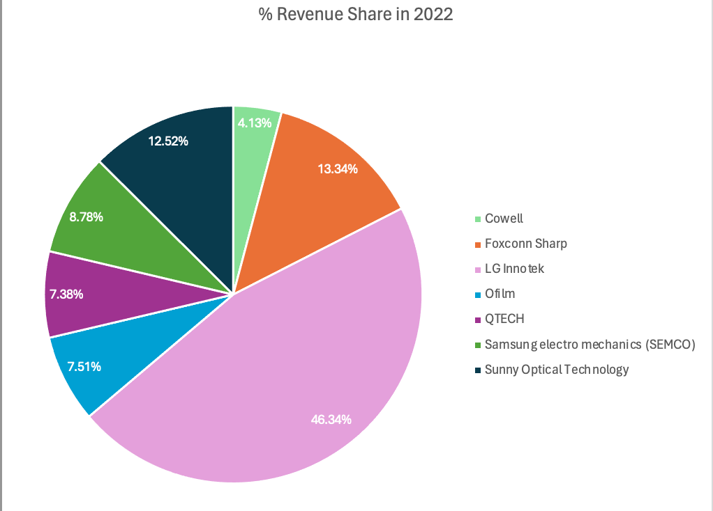

*Figure 4.1*

1. **Target account Customer -LG INNOTEK**

**1.1 Company Overview**

LG Innotek is a subsidiary of LG Group specializing in the development and manufacturing of advanced electronic components and materials. Founded in 1970 and headquartered in Seoul, South Korea. LG Innotek has established itself as a leading provider of innovative solutions in various industries by developing key materials and components for the mobile, display, semiconductor, automobile, and IoT industries.

**1.2 Financial Overview**

According to the Yole report, the Korean company LG Innotek holds a 35% market share, outperforming its competitors due to its strategic expansion into various applications. The company released their first camera module in 2005 and last year in 2023 it sold 240 million mobile camera modules with an annual sales revenue of $2.5 billion. LG Innotek is planning to diversify its business portfolio, which is currently focused on camera modules for mobile devices, by growing its sales of automotive components to $3.8 billion within five years.

From the financial reports of the company, we can deduce that the profitability growth has decreased for the company from 2022 to 2023. However, the increase in total equity indicates that the company's financial position strengthened over the period.

*Figure 4.2*

The company has experienced increase in sales from 2022 to 2023, but it faced challenges in maintaining profitability and operating income. The decline in operating income can be attributed to factors like rising costs or operational inefficiencies.

*Figure 4.3*

**1.3 Product Overview**

The company's product portfolio encompasses a wide range of components such as camera modules, optical devices, wireless communication modules, and automotive electronics. Their advanced camera technology is tailored for smart devices such as smartphones, IoT devices, AR/VR headsets, and vehicles, featuring high-quality camera modules and 3D sensing capabilities.

**1.4 Strategic Overview:**

In 2023, LG Innotek announced a 1.3 trillion investment in its Hai Phong production facility in Vietnam to enhance camera module production. With plans for the new facility to be operational by the latter half of 2024 and commence mass production by 2025, the aim is clear: to meet the growing demand, particularly from major clients like Apple's iPhone. LG Innotek's market share is particularly high in high-end models such as ToF (time of Flight) and folded zoom modules.

According to assessments from S&P Global, market analysts, and LG Innotek's own evaluations, the global market for automotive camera modules is expected to grow at an average annual rate of 7%, reaching $10.03 billion by 2030 from $6.44 billion in 2023, driven by advancements in self-driving technologies. LG Innotek is expanding its camera module technology into the automotive sector and other areas. It plans to enhance its autonomous sensing solutions by leveraging its advanced camera module technology to offer Automotive camera modules, LiDAR, and Radars. In Feb 2024, LG Innotek announced to successfully develop a high-performance heating camera module for autonomous vehicles, using ultra-precision optical design and technology. The module is designed to prevent frost and snow from obstructing the camera lens. This is essential for safe and reliable driving in harsh weather conditions. Set for production in 2027, this innovative module is anticipated to boost LG Innotek's presence in the autonomous vehicle camera market by delivering unique value to customers.

In 2024 it has partnered with Taiwanese company AOE Optronics Co. Inc, a global leader in optical lens development focusing on automotive camera module lenses, to collaborate on developing camera module lenses. LG Innotek will leverage its expertise in optical system design, automated manufacturing processes, and quality control systems, while AOE will contribute its proprietary material development, moulding, and precision optical lens manufacturing technology. Through this strategic partnership, LG Innotek aims to enhance its product competitiveness and expand its presence in new markets such as autonomous driving and extended reality (XR). This investment also strengthens LG Innotek's supply chain management by securing a stable supply of camera module lenses, a critical component for its products.

1. **Target account Customer – SUNNY OPTICAL TECHNOLOGY(GROUP) COMPANY LIMITED 舜宇光學科技（集團）有限公司**

## **2.1 Company Overview**:

Sunny Optical Technology is primarily engaged in three major industries: mobile phone business, automotive onboard business, and XR (extended reality) metaverse industry. The company owns its production lines, including in-house equipment testing processes.

Sunny Optical's operations are divided into optical components, optoelectronic products, and optical instruments, which are applied in fields such as mobile phones, automobiles, VR/AR, and robotics. Among them, the optical components division includes products like automotive lenses, automotive LiDAR optical components, VR spatial positioning lenses, mobile phone lenses, digital camera aspherical glass lenses, and other optical parts. The optoelectronic products division offers automotive modules, VR folded optics ("Pancake") modules, VR vision modules, mobile camera modules, and other optoelectronic modules. The optical instruments division's products comprise smart inspection devices and microscopes, among others.

### 2.2 Financial Overview:

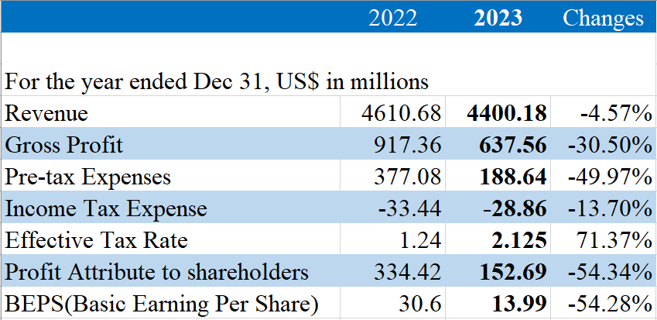

*Table 4.1*

On March 20, Sunny Optical Technology announced its annual financial results up to December 31, 2023. The data reveals that in 2023, Sunny Optical's revenue reached roughly $4.40 billion, marking a 4.57% decline from the previous year. The company's gross profit saw a substantial reduction of 30.50% to approximately $637.56 million. Pre-tax expenses were nearly halved, decreasing by 49.97% to $188.64 million. Income tax expenses decreased by 13.70% to $28.86 million. Notably, the effective tax rate increased significantly by 71.37% to 2.125%. Profits attributable to shareholders took a downturn, with a sharp decline of 54.34% to $152.69 million. Additionally, the basic earnings per share (BEPS) contracted 54.28%, arriving at 13.99. These figures reflect a challenging fiscal year for the company.

Despite Sunny Optical Technology's active efforts in recent years to transition and advance its automotive business, over 66% of the company's revenue still stems from the smartphone sector. As a part of the smartphone supply chain, it is challenging for the company to operate independently of the market's beta, or systemic risk. In the past year, the weak smartphone market in 2023 has directly affected the company's performance.

Examining the business specifics, in 2023, the revenue from Sunny Optical Technology's optoelectronic products amounted to $ 2.98 billion, marking a year-on-year decline of 7.4%. This downturn is primarily attributed to the continuous trend towards the downsizing and downgrading in smartphone cameras, as well as fierce competition within the industry, which resulted in a decrease in the average selling price of smartphone camera modules.

In addition, the Company's consolidated gross margin has shown an overall trend of decreasing over the years, from 23.3% in 2021, to 19.9% in 2022, and then carrying 14.5% in 2023.

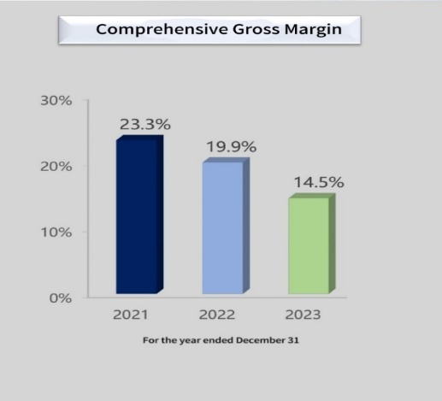

*Figure 4.4*

### Revenue Distribution by Product Application from 2021 to 2023:

Data obtained from Sunny Optical Technology's 2023 annual performance report, it indicates:

1. Mobile phones and related products continue to dominate most of the revenue market.

2. Automotive-related products have shown a growth trend in revenue.

3. Other products have demonstrated a stable development trend.

Overall, as the smartphone business (phone lenses + camera modules) is the core of Sunny Optical Technology's operations, the company's performance and stock price are heavily dependent on the cyclical performance of the smartphone sector. The decline in revenue from this business in 2023 has put considerable pressure on the company's performance.

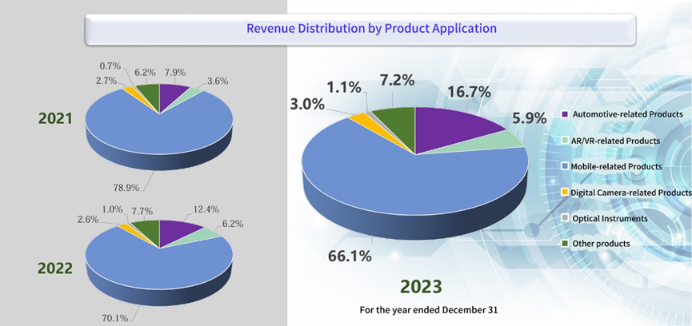

*Figure 4.5*

### 2.3 Business Units/ Products offered overview:

From the perspective of main product revenue, automotive-related products, digital camera-related products, other lenses, and optical instruments have seen growth, while mobile-related products, AR/VR-related products, other aspherical and flat products, and other products have experienced a decline in revenue. Among these, mobile-related products, automotive-related products, and AR/VR-related products are the top three revenue contributors, accounting for 66%, 17%, and 6% of total revenue, respectively.

**1. Camera Module Market:**

In the camera module segment for mobile phones, Sunny Optical noted that the demand in the smartphone market began to show signs of recovery in the second half of 2023. The market demand for camera modules saw some improvement, with the group's annual shipment volume of camera modules in 2023 increasing by approximately 9.8% to about 567,482,000 units. However, given the complex market environment and increasing cost pressures and competition, the profitability of the camera module business faced significant challenges.

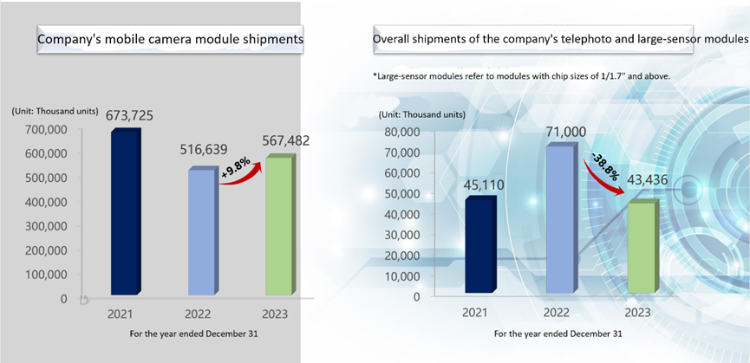

*Figure 4.6*

**2. Global Automotive Camera Market:**

Starting from the past two years, Sunny Optical Technology has placed increasing importance on the development of emerging businesses such as automotive and VR. Among them, the revenue from the automotive business in 2023 was $73 million, a year-on-year increase of 28.61%, with its proportion in total revenue up by 4.3 percentage points to 16.7%, making it the second-largest source of revenue after smartphones. In the automotive lens business, the group's shipments in 2023 increased by approximately 15.1% to about 90,812,000 units, maintaining the leading global market share and further widening the gap with the second-ranked global competitor.

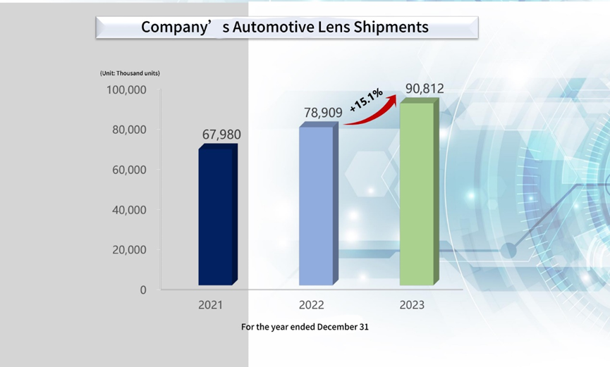

*Figure 4.7*

**3. XR/VR Market:**

In the VR/AR domain, Sunny Optical is intensifying its research in the industry. They stated that in XR (Extended Reality), which is in a continuous growth phase with more opportunities and demands. Additionally, in practice, Sunny Optical Technology Company completed the development of a vision module adapted for the next-generation mainstream platform of a well-known platform manufacturer and served as the main recommended solution for that platform's reference design. Meanwhile, a series of innovative miniaturization packaging technologies were developed, applicable to the full range of VR/AR vision modules.

**2.4 Strategic Overview:**

For the outlook of 2024, the management of Sunny Optical Technology points out that the global economy will still face challenges such as insufficient consumer demand, supply chain restructuring, and intensified market competition, indicating persisting uncertainties. However, emerging technologies such as new energy and AI provide new growth points for the economy. The trend towards intelligence poses new demands on the optoelectronic industry, bringing development opportunities. In the future, the company will adhere to its core optoelectronics business and advance work in three areas:

1. Explore new potential in the smartphone-related business and strive to improve operational quality.
2. Build competitiveness in the automotive, extended reality (XR), and robot vision-related businesses, with an emphasis on elevating market position.
3. Strengthen management in capital investments, enhance the efficiency of input-output, and focus on optimizing operational benefits.

**3) Target account Customer—Q Tech**

**3.1 Company overview:**

Q Technology is a leading technology company headquartered in China and is a global leader in the manufacturing of high-end camera modules and fingerprint recognition modules for smart mobile terminals. Established in 2012, the company quickly became one of the world's leading suppliers of smartphone camera modules and fingerprint recognition modules.

**3.2 Financial Overview:**

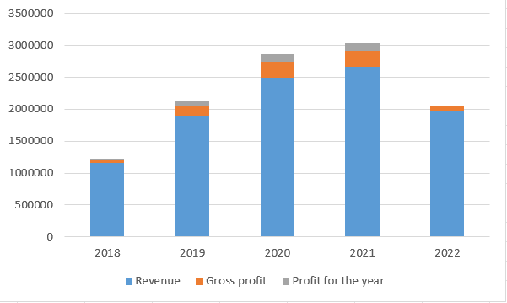

*Figure 4.8*

This data set provides a comprehensive overview of the financial performance of Q tech Company for the years 2018 to 2022, including revenue, gross profit, and annual profit trends.

From 2018 to 2021, the company experienced steady revenue growth, increasing from $1,162.17 million to $2,666.09 million. However, in 2022, there was a significant decline in revenue to $1,965.60 million. This decrease may be attributed to a reduction in product demand, as indicated.

The gross profit of the company saw rapid growth from 2018 to 2020, rising from $50.44 million to $252.94 million. In 2021, the gross profit remained relatively stable at $251.71 million. In 2022, there was a sharp decline in gross profit to $77.33 million, likely influenced by the decrease in product demand.

Annual profit showed steady growth from 2018 to 2020, increasing from $20.57 million to $120.02 million. In 2021, the annual profit continued to grow to $123.26 million. Nonetheless, in 2022, the annual profit decreased significantly to $15.30 million due to the decline in product demand.

Despite the company's strong revenue and profit growth from 2018 to 2021, the decrease in revenue and profit in 2022 highlights challenges. The decline in financial performance appears to be primarily driven by a reduction in product demand. To address this decline, the company may need to reassess its product offerings, marketing strategies, and overall market positioning to adapt to changing demand dynamics.

**3.3 Product Overview:**

Q Technology's main business includes smartphone camera modules, automotive camera modules, 3D sensing modules, and related optical components. Currently, Q Technology's products cover a wide range of camera modules from 2 million pixels to 108 million pixels, including ultra-thin camera modules, dual/multi-camera modules, Optical Image Stabilization (OIS) camera modules, 3D camera modules, automotive camera modules, smart home camera modules, capacitive fingerprint recognition modules, and optical in-display fingerprint recognition modules.

Shipment Report:

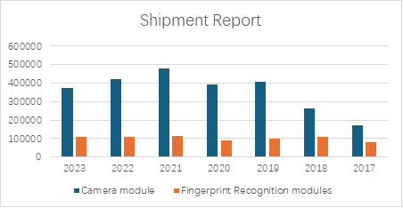

*Figure 4.9*

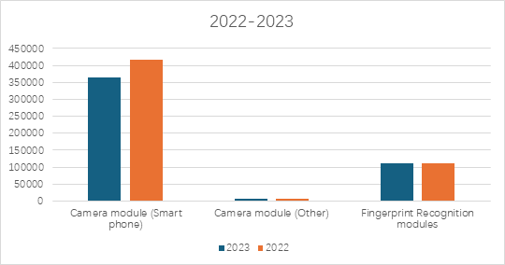

*Figure 5.0*

**3.4 Strategic Overview:**

1. Q Technology's main products are mid-to-high-end camera modules, which have strong specificity, leading to potential testing requirements in the uniqueness of the lenses. These requirements include: the imaging effect of high-pixel camera modules, lens response and collaboration in multi-camera modules, optical image stabilization effects, and the imaging effect of 3D camera modules.
2. The shipment volume indicates that Q Technology's main products are highly concentrated in mobile phone camera modules, while research on automotive camera modules and XR camera modules is still in the early stages, which may necessitate related testing equipment.
3. Fingerprint recognition modules also involve camera modules, which can serve as an alternative testing product. It is important to note that they differ significantly from general camera modules, especially in terms of size, optical design, and image processing algorithms, which have been specially optimized to meet the unique requirements of fingerprint recognition.
4. **Target Account Customer- Samsung Electro Mechanics (SEMCO)**

**4.1 Company Overview:**

Samsung Electro-Mechanics is a versatile manufacturer of various parts from mechanical parts to high-tech electronic parts. Founded in 1973, Samsung Electro-Mechanics has grown into a world-class company that develops and produces major electronic components. They are leaders in camera module line up for Automotive Driving Assistance System and Autonomous driving.

**4.2 Financial Overview:**

In 2023, the company held a 10% revenue share in the camera module market with 360 million units of automobile camera modules sold.

In terms of revenue, in the fourth quarter of 2023, the Optics & Communication Solution Unit had an increase of 36% compared to the previous year, reaching $644 million. Samsung Electro-Mechanics attributed this growth to expanding supply to both domestic and international clients, particularly in high-definition folded zoom technology and high-pixel automotive camera modules. They aim to further grow their business by offering more unique products, like advanced camera modules for IT and dependable automotive camera modules.

**4.3 Product Overview:**

The company is equipped with all major core technologies for designing and manufacturing top-tier camera modules and they produce them for both mobile devices and automobiles. They excel in high precision design and mass production technologies for the lens, actuator, and Printed Circuit Board (PCB), which are integral components of the camera module. With advanced technologies such as high-resolution slim lens technology, high-performance miniaturized actuator technology, optimized curved PCB design, and module integration, they deliver high-end camera modules with diverse features and functionalities.

.

**4.4 Strategic Overview:**

A Korean report claims that Tesla’s 80% supply of Camera module is from SEMCO. Currently, they are progressing into developments of automotive camera modules equipped with water repellent and heating functions. The heating function prevents condensation buildup on the camera lens or other components caused by temperature variations, which could otherwise degrade image quality. By maintaining a consistent temperature within the camera module, it ensures reliable operation and high-quality imaging, even in challenging weather conditions. The new camera module will be Samsung’s 4.0 version with 5 million pixels, which shows five times clearer images than the previous 3.0 generation. These cameras will power Tesla EVs’ self-driving sensor suite and likely other features like Sentry Mode, Dashcam and more.

1. **Target Account Customer- OmniVision Technologies (OVT)**

**5.1 Company Overview:**

OmniVision Technologies is a company that specializes in the design and production of advanced digital imaging solutions. It has become a leading provider of CMOS image sensor technologies for various applications, including mobile phones, automotive, surveillance, and medical imaging. Omnivision’s ‘Camera Cube Chip’ integrates image sensors, processor and lenses in a miniature wafer level camera module.

OmniVision has a strong focus on research and development, investing in cutting-edge technologies to stay ahead of market trends and customer needs. They collaborate with industry partners to introduce new technologies and improve the performance and capabilities of their sensors. Their client information is not available.

**5.2 Business Units/ Products offered overview:**

1. Wide range to support various application needs for the camera module market
2. High-resolution image sensors
3. Sensors with features like high dynamic range (HDR), high-speed capture, and low power consumption
4. Customized sensor solutions
5. Technical support and software development kits (SDKs)

* **Testing Information:**

1. **Testing Focus:** Camera module testing without lens.
2. **Current Testing Equipment:** Amulas tester.
3. **Testing Type:** System level testing.
4. **Test Time:** 40-60 seconds per test
5. **Test Sites**: 32 sites with synchronization testing

**5.3 Strategic Overview:**

1. An increase in test site count from existing 32 to 192-256.
2. Need for asynchronous testing to enhance flexibility and efficiency in test operations.
3. Lower the COT.

**Takeaway for Teradyne’s actions:**

1. Improving operational efficiency: Automating the testing process can streamline operations, reduce manual errors, and increase productivity.
2. Our testing solutions can help identify design or manufacturing flaws that may be contributing to rising costs. By pinpointing these issues early in the development process, we can assist in reducing rework, minimizing waste, and ultimately lowering production costs.
3. We recognize that the constant enhancements in camera resolutions are driving significant growth in the global camera module market. Teradyne can provide scalable testing solutions that align with market dynamics and offer the flexibility to adapt to ongoing innovations and changes in the industry.

**COMPETITOR ANALYSIS**

Entering a new market requires analyzing multiple major aspects, one of which is the competitor analysis. Delving deep into the products and services offered and the financials of competitors in the camera module testing market helps gain more insights for us to align our offerings in this market. To help gain competitive advantage and build on Teradyne’s capabilities for the camera module testing market, we have analyzed five competitors who are market leaders specializing in various industries and products. Below is a snapshot of the reasons why we chose these competitors, and the following is a detailed analyses of the competitors’ offerings, financials and product details (replicated from websites to provide exact product details).

*Figure 5.1*

1. **Company: Trioptics**

Trioptics, founded in December 1991 is a subsidiary company of Jenoptik AG, headquartered in Wedel, Germany with many other locations in Europe, Asia and the USA. Trioptics develops and produces the widest range of optical measurement and manufacturing systems. They enable the development, quality control and production of lenses, lens systems and camera modules. Trioptics is a leading name in the field of optical measurement as they have been creating standards and not just fulfilling them. They cater to the Automotive, VR & AR and Optics Manufacturing markets. The parent company Jenoptik, a public company listed on the Frankfurt Stock Exchange, recorded a revenue of 981 million euros (approx. $1 billion USD in today’s conversion) in the fiscal year 2022. They have shown a steady growth over the years except in 2020 and 2021 considering the pandemic years but bounced back with 23% growth in 2022. Trioptics no longer has their standalone financial statements since the Jenoptik takeover in 2021. Trioptics recorded a revenue of 61.5 million euros (approx. $66.5 million USD in today’s conversion) in 2020 before the acquisition.

|  |  |  |  |  |
| --- | --- | --- | --- | --- |
| **Product** | **Purpose** | **Description** | **Features** | **Image** |
| CamTest Smart | The most versatile measuring system | CamTest Smart is an end-of-line test system that enables comprehensive testing of camera modules. With the help of focusing collimators, a test chart and an integrating sphere integrated in only one device, the End-of-Line test can be realized. | Testing of all essential image quality characteristics of camera modules in just one system.  Flexibility regarding different camera types.  Flexible low to mid volume production and R&D.  Fully automated process.  Measures MTF, LSF, Optical Center, Distortion, Color Rendering and much more. |  |
| CamTest TempControl | Camera module temperature tests | CamTest TempControl determines the image quality of optical sensor systems under the influence of temperature. The instrument simulates the real temperature conditions in a climatic chamber. | * Highly accurate measurement in a temperature range between -40°C and +120°C * Individually configurable and automated measurement routines * Comprehensive analyses of camera behavior to identify product optimizations. |  |
| CamTest Focus | Determination of best focus plane | The collimator virtually projects the target onto the sample. By using focusable collimators, any object distance of 1m to infinity can be generated. This makes it possible to measure the position and tilt of the best focus plane. | * The setup provides a field of view of +/-90° * Variable object distance from finite to infinite in just one measurement setup * Measurement of various parameters such as: MTF, SFR, through-focus MTF, image plane tilt, boresight shift, roll angle. |  |
| CamTest Chart | Easy measurement of distortion | The CamTest Chart system projects a test target from finite or infinite object distance to the camera module under test. For an infinite test setup, a specially designed relay optic is used. With the help of a suitable optical structure, cameras with a highly distorted optical system can also be calibrated. | * Measurement of camera lens geometric distortion (LGD), TV distortion, camera boresight and optical center, camera EFL and FOV. * From the distortion measurement the distortion coefficients (Seidel coefficients) are obtained used for the calibration of the camera module under test * Especially relevant for ADAS (Advanced Driver Assistance Systems) * The relay optic is available as an upgrade | CamTest Chart |
| CamTest Spectral | Determination of sensor parameters | The CamTest Spectral comes with an integrating sphere in finite object distance. The integrating sphere serves as a light source in order to obtain the diffuse light required for the measurements | * Measurements of camera modules with up to 160° field of view * The sphere allows a light uniformity of more than 95 % * The setup is particularly well-suited for measuring parameters such as defective pixels, FPN, color rendering, OECF, relative illumination and dynamic range. | CamTest Spectral |
| CamTest MTF | One-shot MTF measurement | To test camera modules with larger object distances, a structure with fixed collimators, which are preset for infinite or finite object distances, is suitable. In this case, the field of view depends on the actual object distance. | * With this set-up, the MTF can be quickly and easily determined * Furthermore, also Line Spread Function, SFR and ESF can be measured * This method is especially suitable for a final quality check in high volume camera production. | CamTest MTF |
| CamTest ColMot 2.0 | Optical target projectors for the performance test of electronic camera modules | The CamTest ColMot system is a series of industry-leading optical target projectors providing virtual test targets for the performance test of electronic camera modules or objective lenses. The main application is the test for camera image quality, lens alignment and focus precision. | * Compact design for dense field of view (FOV) coverage * Infinite conjugate testing for very wide FOV cameras * For measurement of MTF/ SFR, through-focus MTF/ SFR, image plane tilt, camera boresight, focus setting and roll angle * High speed and high positioning repeatability. |  |
| CamTest ColMot 6.0 | New optical target projectors for high-speed camera testing | The new CamTest ColMot 6.0 is characterized by a very long product lifetime, high speed for fast measurement and short cycle times. It is very user-friendly and has improved maintainability with an integrated cycle counter, temperature sensor and internal data storage of collimator-specific data. | * Extended product lifetime * The most compact design for dense field of view (FOV) coverage * Highest speed for fast measurements and short cycle times * High positioning repeatability and accuracy. |  |
| CamTest LWIR collimators | Long-wavelength infrared collimators for the production of thermal imaging cameras | The first edition of CamTest LWIR collimators enables automated mass production of thermal imaging cameras. For manufacturers of thermal imaging, thermographic or infrared cameras used in the military and in the surveillance of buildings, industrial plants or people. | * Making the invisible visible with the LWIR collimators in infrared technology * Wavelength range: 7 -12 μm * "Effective focal length (EFL): 50 mm, 200 mm or 500 mm" (“Active Alignment, Assembly and Testing of Camera Modules - H P Instruments”) * 5-axis Controller manages and monitors the lighting, the shutter and the fan. |  |
| CamTest R&D | High-precision image quality test | The CamTest R&D is a high-precision measurement device for testing a variety of image quality parameters of camera modules. The computer-controlled test target distance can be freely selected from finite distances to infinity using a focusing collimator. | * Available for various wavelength ranges (VIS, NIR and LWIR) * Can be used for many types of camera modules * Ideal solution for comprehensive measurement tasks in the R&D environment * Wide off-axis angle range of up to +/- 110°. | CamTest R&D |
| CamTest Software |  | The software is particularly user-friendly. The user is automatically guided through the measurement process. The output of the values can be done as pass/fail output. Measurement certificates are generated directly from the software in order to ensure complete traceability. | * The CamTest software supports the following measurement parameters and their analysis * Image quality features * Optomechanical properties: sensor position (tilt, rotation, defocusing) * Other optical parameters: distortion, relative illumination, focal length * Color characteristics: chromatic aberrations * Lens light reflection. |  |

1. **Company: Automation Engineering Inc. (AEi)**

AEi, established in 1990, is a leading supplier of automation tools and controls, along with active alignment camera module assembly and test systems and machines. AEi was recognized as the leader of automotive camera active alignment market and was acquired by ASM Pacific Technology Ltd, a leading global supplier of hardware and software solutions for the semiconductors and electronics’ manufacturing on February 1st, 2022. AEi is based out of Tewksbury, MA and believes in delivering value propositions like Performance, Accuracy, Reliability and Flexibility. ASMPT recorded a revenue of $2.47 billion USD for the year 2022 which was a 11.8% decrease compared to 2021 and a net profit of $3.34 million USD.

|  |  |  |  |  |
| --- | --- | --- | --- | --- |
| **Product** | **Purpose** | **Description** | **Features** | **Image** |
| Compact Post-Cure Test Equipment | The solution to test 100% of the production | "ASMPT’s innovative Post Cure Test (PCT) System ensures 100% of manufactured cameras meet the highest industry standards." (“PCT - ASMPT AEi”)  Our new PCT systems are already bringing process control to the mass-production lines of our Tier 1 customers, performing critical testing of breakthrough products to bring ADAS technology to market. | The PCT is the perfect partner for our CMAT systems that are responsible for the major share of all ADAS cameras produced in the market.  Combining the PCT with our CMAT, as illustrated, produces an exceptional correlation of optical results enabling a Closed Loop continuous feedback. This delivers extraordinary process control right at the critical stage of camera assembly. |  |

ASMPT’s test equipment provides the following benefits:

##### **Modular Tests allowing choice & remarkable economic value**

* Image Quality Test (IQT) – Measures optical performance of assembled cameras with the most comprehensive set of tests against the operational thermal range of the final product.
* "Intrinsic Parameter Calibration (IPC) – Calibrates intrinsic parameters (IP) for cameras up to 120 Degree HFOV against the most prominent industry standards" (“PCT - ASMPT AEi”)

##### **Our design, software and technology all drive value for our customers**

* Smallest footprint in the industry while delivering a cycle time of < 10 seconds
* PCT FlexTest software suite allows the customization of tests configurations.
* Changeover time between products < 10 minutes, options to run products with zero changeover time.
* The IPC module contains no moving parts to guarantee industry leading MTBF.
* Designed for lean 24/7 production.

##### **Our tests and design leads to significant process control**

* Accurate MTF results using individually calibrated high-performance collimators.
* Accurate EFL measurements are ensured by illumination matching operational environment color temperature.
* IPC calibration quality – checked by scheduled inline validation testing without interruption of the production line.

**Economic Value**

* 99% yield achievement optimizing the economics of the production line. Scrap costs money.
* Maximizing throughput. Minimizing unit costs.
* One system optimizes productivity and minimizes unit costs.
* Tailored testing optimizes productivity and ensures products are produced right first time.
* Maximizing your ROI.

1. **Company: DXOMARK**

DXOMARK started in 2008 as the Image Quality Evaluation Team at DxO Labs but split from DxO Labs in 2017. Since the separation, DXOMARK is an independent company that has rapidly grown, defining their focus on testing and optimizing digital imaging devices. Over 1 billion cameras and smartphones have benefited from DXOMARK’s expertise. The camera team at DXOMARK are testing and tuning new smartphone and standalone cameras in coordination with camera and smartphone makers. DXOMARK has 10 years of experience in the smartphone camera industry offering services from concept to tuning and refining standards for final production. DXOMARK has a variety of different products that can be pieced together based on what the camera needs tested. This is not an automated process and focuses on personalization based on company needs.

|  |  |  |  |  |
| --- | --- | --- | --- | --- |
| **Software** | **Purpose** | **Description** | **Features** | **Image** |
| Analyzer Software GUI | Software to test image quality | This software contains a comprehensive set of image quality measurement capabilities related to sensor, lens, and ISP evaluation. Metrics are compliant with most image quality standards. | Modules:  Optics  Photo  HDR  Autofocus  Stabilization  Timing  Video  Features:  User friendly  Measurement waiting list  Automatic detection and cropping  Easy export  Comprehensive and intuitive. |  |
| **Set Up Equipment** | Purpose | **Description** | **Features** | **Image** |
| MTF Evaluation Bench | Measurement setup | Generates sun-like flare images in a lab setup. Compact, automated, and ways to move table-top setup incorporates a bright light source and color temperature. It has a manual rotation and two axes to measure flares from all angles with precision of 2 arcmin. | Features:  Source rotation -130 to +130 degrees  Camera rotation of 0 to 360 degrees |  |
| **Example Tests** | Purpose | **Description** | **Features** | **Image** |
| DXOMARK Chart | Tests multiple objective metrics on image quality |  | Metrics:  Detailed preservation  Noise  Resolution  Exposure  Perceptual analysis  Features:  Size: 1300 x 890 x 18mm  Material: PVC |  |
| HDR Noise Chart | Mitigates veiling glare and ghosting | The chart is made of black metallic plate designed to mitigate glare and ghosting. It contains 28 neutral density patches and 5 polarizers for exposure adjustment. Contains markers that use Analyzer software to autonomously obtain all objective metrics | Metrics:  Opto-Electric Conversion Function  Dynamic and Tonal Range  Tone Curve  Noise and SNR  Noise grain size  ISO speed rating  Dark signal  Features:  Size: 315x315x23.5mm  Material: aluminum |  |
| Dead Leaves Chart | Evaluates textures preservation and noise | Features standard dead leaves pattern for assessing texture preservation as well as 12 grey patches for assessing visual noise to help characterize device’s noise vs texture tradeoff. | Metrics:  Photo and video texture preservation  Texture and edge acutance  Ringing  Visual noise  Photo and video stabilization  Features:  Size: 785x603x3mm  Material: White Dibond |  |
| Color Checker | Tests color amplitude and intensity | Color is an integral part of photo and video quality. Use this chart to evaluate white balance amplitude and intensity and color rendering amplitude and intensity. | Metrics:  White balance  Color fidelity  Color rendering  Color sensitivity  Exposure  Noise  Auto-exposure convergence  ISO speed rating  White balance stability  Features:  Size: 785x603x7mm  Material: PVC |  |
| Realistic Mannequins | Facilitate image quality evaluation | Test scenes using mannequins are identical, making resulting measurements repeatable and reliable. Saves testing time for lab operators; tests and measures spectral response of each head. | Metrics:  Exposure  Noise  Face detail preservation  Perceptual analysis  Features:  Size: 895x445x1290mm  Materials: polyurethane foam, skin-like pigmentation, silicon, real hair. |  |

1. **Company: Hioki**

Hioki E.E. Corporation has been at the forefront of the electrical manufacturing industry since 1935, providing electrical testing and measurement instruments. Hioki’s experience has established global partnerships across various test and measurement industries. Hioki supports applications ranging from research and design to maintenance and service with four different products: automatic test equipment, data recording equipment, electronic measuring instruments, and field measuring instruments. Hioki is in a similar position to Teradyne, as the camera module testing industry is a growing market and they are investigating if it is an opportunity they should look to enter.

|  |  |  |  |  |
| --- | --- | --- | --- | --- |
| **Product** | **Purpose** | **Description** | **Features** | **Image** |
| In-Circuit Tester FA1220 | Conduct functional tests of individual electronic circuit board components or while mounted on PCB’s | Embeddable PCB measuring component providing extensive function testing capabilities to complement existing automatic testing equipment. (“IN-CIRCUIT TESTER FA1220 | Hioki”) | Consolidated single desktop tower  Extensive function testing  Macro-testing function to increase test efficiency  Electrolytic capacitor and IC reverse insertion detection  Four-terminal low-resistance measurement  Size: 200mm x 323 mm x 298mm |  |
| Short- Open Tester FA1221 | Multichannel short/open tester that can be embedded in existing test equipment | Multichannel short/open 4-wire test equipment for populated board testing. Small form factor allows units to be embedded into existing systems helping to reduce installation time and costs. | Consolidated single desktop tower  Specifically designed for short/open testing  Four-terminal low-resistance measurement  Size: 200mm x 323 mm x 298mm |  |

1. **Company: Core Optics**

Core Optics has been excelling in CCM technology since 2002, especially in the smartphone and automotive market. Headquartered in North Carolina, USA, Core Optics offers an integrated system designed for the entire mobile camera module lifecycle production, including testing of these camera modules. Their business units comprise of Automotive camera testing, 3D Tof Testing, Mobile Camera Testing and Smart Phone Testing. As of March 2024, The Coretec Group, Inc. Has acquired 100% of the membership interests of Core Optics LLC and its subsidiaries. The products from Core Optics are as follows:

|  |  |  |  |  |
| --- | --- | --- | --- | --- |
| **Product** | **Purpose** | **Description** | **Features** | **Image** |
| Co.CMT - F400S and Co.CMT - F500S | Full Auto Solution |  | * One Picker Full Auto Inline Handler * Good/Reject Sorting with Trays * No vibration effect to Tester with Handler isolated * Adapted to all the is Media Machines * Inline Conveyor   Software:   * Image Recognition for Pick & Place * Reject sorting with Tray Map * Alarming to OP when issued |  |

**VISION FOR COMPETITIVE ADVANTAGE**

Teradyne could carve out a significant niche in the camera module testing industry by tailoring solutions to the specific needs of manufacturers, market trends especially within the rapidly evolving automotive sector. The competitive advantage strategies should be:

1. **Next-Generation Camera Module Testing & Technological Innovations:** Investing in the capability to test next-generation camera modules, including those used in ADAS and autonomous vehicles, will be crucial. This includes testing for 3D sensing, LiDAR, Active Alignment and sensor fusion between DMS and OMS in one camera module are becoming standard in automotive sector. With mobile CCM connections transitioning to board-to-board and Zero Insertion Force (ZIF) connectors, Teradyne's testing solutions should accommodate these advanced connection types, especially reduction in connection pitch from 0.5mm to 0.35mm indicates a trend towards miniaturization. Teradyne's equipment must therefore be precise enough to handle smaller, more densely packed components. For budget smartphones, where cameras and LEDs are bundled on a single flexible circuit, Teradyne's testers should be versatile enough to test these integrated modules effectively.
2. **Customized Testing Solution:** Developing testing technologies that are customized to individual manufacturer needs can differentiate Teradyne from competitors who may have more generic offerings. This approach ensures closer alignment with customer development cycles and provides a competitive edge while preparing to enter the market. The OEMs of camera module manufacturers and testers do not reveal much about their capabilities and requirements. Almost all the testing solutions are built focusing on the specific customer needs.
3. **Automated, Robust and Efficient Testing with Advanced Circuit Design Technology:** The aim should be to offer robust testing systems that can deliver high-speed, efficient, and reliable test results. This means integrating systems capable of rapid data generation and self-testing functionalities to ensure product quality and yield with minimum failures. Currently many testers are developing automated testing solutions reducing human involvement. And to do that Teradyne must possess advanced electrical circuit design technology, on par with ongoing semiconductor systems, and high-speed signal processing circuit design capabilities. These strengths will empower her to develop integrated products compatible with the latest high-speed camera sensors.
4. **Strategic Partnerships:** Teradyne should start building strategic relationships with camera module OEMs and other components OEMs who require specialized testing services. This includes anticipating and preparing testing solutions for customers who have unique requirements and not all suppliers will be able to meet the customer requirements, especially she should not be able switched to other testers immediately and switching to other suppliers reveals her know how. Building strategic alliances with the OEMs in the total value chain will insulate against any future threats.
5. **Developing Market Penetration Strategy with an Entry Timeline:** Right now, the Camera module market for cell phone is matured/saturated, automotive is expanding and computing devices are volatile/unpredictable. It's prudent for Teradyne to establish a foothold in a single, carefully selected market, such as the expanding automotive sector, which aligns with global trends towards automation and electrification. By doing so, Teradyne can concentrate resources effectively, mitigate risk, and build a strong brand reputation before diversifying into other market segments. Establishing a clear entry timeline is imperative for Teradyne to capitalize on market opportunities at their peak.
6. **Software & AI Integration with Flexibility**: Modern camera modules, especially those integrated into smartphones, security systems, autonomous or high-end vehicles increasingly incorporate AI for functionalities like face detection and ADAS. This integration demands sophisticated software that can process and analyze images in real-time, requiring algorithms capable of learning and adapting to diverse conditions and subjects. Teradyne’s testing solutions must address the reliability and performance of both hardware and software components. Moreover, different customers have different types of software requirements. Teradyne software in testing system should be customized, user-friendly, and handled with less technical manpower. Most importantly she should craft software solutions for precise and rapid camera module inspection/testing in various domains, like image processing software, embedded software, and application program software. Additionally, she should excel in creating user-centered and intuitive GUIs (graphic user interfaces) to enhance user interaction and satisfaction.
7. **Identifying Right Customer**: Teradyne should prioritize to make testing solution for those who produce camera modules and outsource their testing needs from other suppliers due to not having in-house testing capabilities - "Camera Module Manufacturers with Outsourced Testing". This means that they focus on the manufacturing aspect of camera modules and rely on external partners for specialized testing and quality assurance. There are a lot of camera module manufacturers who are equally OEMs and testers. Ultimately, when Teradyne enters the market, identifying OEMs looking for testing suppliers will be a strategic move for Teradyne.
8. **Asynchronization Test**: This means to perform tests on multiple camera modules or components simultaneously but not necessarily starting and ending at the same time which means each test can run independently and is not required to wait for others to complete before it begins. This kind of testing can increase overall testing throughput and efficiency. Teradyne should invest heavily on how to handle multiple test sequences at once by employing software with advanced scheduling algorithms, multi-threaded processing capabilities, sufficient memory and storage to handle simultaneous data processing from several sources.
9. **Increasing Test Site Counts with Modern Mechanical design technology**: For a mass scale OEMs, having a test system with more sites means they can test more modules in parallel, significantly reducing the CCM test wait times and speeding up the entire production process involving less resources. This approach should be evolved through incorporating state-of-the-art design methodologies, including 3D CAD, dynamic analysis, and animation action analysis, to create optimal CCM testers and assembly systems characterized by low cost, compact size, and high units per hour (UPH) efficiency.
10. **Taking Advantage of the Automotive Sector:** According to Sony, the next generation Autonomous vehicle (level 3) will have up to 18 cameras per vehicle. Right now, Tesla’s model Y has 9 cameras including 5MP resolution with front cameras. There will be multiple ADAS forward cameras, e-mirror replacement, driver monitoring and thermal imaging. The European and other governments have already authorized the deployment of digital rear-view systems. The white house has announced considerable investments in EV infrastructure, which includes the development and deployment of a national network of 500,000 EV chargers. Safety regulation and increasing demand for car automation encourage and force car OEMs to integrate more and more imaging technologies. Light vehicle shipments have recovered since the pandemic and gradually increasing at a CAGR of 2.4%. Mobile phone and consumer camera modules have lower profits except automotive camera modules. That is why Teradyne should take advantage of these market characteristics ASAP.
11. **Low COT and Right Balances:** Cost of the test is one of the crucial aspects for Teradyne’s future testing solution but may not be the same for all market segments. As of today, most cell phone camera module testers are in South Asia because low COT is their best competitive advantage. On the other hand, testers located in Europe and North America have testing solutions more for electronics, automotive, healthcare, and consumer products. As a new entrant it will be hard for Teradyne to make testing solutions which boasts low COT competing with South Asian competitors whereas almost all North American/European testers do not have customers who are cell phone OEMs. They focus more on precision, reliability, accuracy and building long-lasting partnerships. While making future testing solution Teradyne should focus on which factors to emphasize as COT will shape her testing qualities for different market segments and finding the right balance for each segment will dictate her overall strategy. Precision requirements are severe in automotive applications, while the mass production scale and high-quality image are well sought in mobile phone OEMs.

**SYSTEM TARGET COSTS AND PRICES**

Based on our research, we assumed that all the camera modules of Auto industry will be tested and considering this we have prepared this COT table:

|  |  |  |  |  |  |  |  |
| --- | --- | --- | --- | --- | --- | --- | --- |
|  | Test Flow | SLT | SLT | SLT | SLT | SLT | SLT |
| Device | Camera Module | Camera Module | Camera Module | Camera Module | Camera Module | Camera Module |
| **Year** |  | 2025 | 2026 | 2027 | 2028 | 2029 | 2030 |
| **Full Unit Base Cost (ea.)** | **$** | $300,000 | $300,000 | $300,000 | $300,000 | $300,000 | $300,000 |
| **# Sites per Unit** | **ea.** | 20 | 60 | 40 | 80 | 100 | 120 |
| **Per Site Price** | **$** | 15,000 | 7,500 | 5000 | 3750 | 3000 | 2500 |
| **Single Site Test Time** | **sec** | 60 | 60 | 60 | 60 | 60 | 60 |
| **Overall Cost/Bin1 Device** | | ¢ 5 | ¢ 2 | ¢ 2 | ¢ 1 | ¢ 1 | ¢ 1 |

*Table 7.1*

In the above Cot model, we assumed that each test time is 60 sec although this will change in future and overall costs are considered in cents. Sites per unit are also assumed to increase over the years and most importantly the per site price will reduce gradually. The Full unit cost is an estimated cost we assumed for all the years.

However, here's a concise table summarizing the resolution categories, their average price per megapixel, and the technological components involved in mobile phone camera modules.

|  |  |  |  |  |
| --- | --- | --- | --- | --- |
| **Ser** | **Resolution** | **Price per Mp** | **Total Price** | **Components Cost Breakdown** |
| 1 | 1-3Mp | ¢ 64 | $1.2 | Profit CCM: ¢ 15  Assembly CCM: ¢ 06  Substrate & others: ¢ 26  Lens: ¢ 26  Actuator (AF & OIS): ¢ 00In the above Cot  Image sensor: ¢ 55 |
| 2 | 5-8Mp | ¢ 38 | $2.5 | Profit CCM: ¢ 29  Assembly CCM: ¢ 15  Substrate & others: ¢ .46  Lens: ¢ 46  Actuator (AF & OIS): ¢ 0  Image sensor: $1.07 |
| 3 | 10-13Mp | ¢ 52 | $6 | Profit CCM: ¢ 77  Assembly CCM: ¢ 36  Substrate & others: ¢ 95  Lens: $1.01  Actuator (AF & OIS): ¢ 48  Image sensor: $2.38 |
| 4 | 16-30Mp | ¢ 30 | $7 | Profit CCM: ¢ 90  Assembly CCM: ¢ 48  Substrate & others: $0.90  Lens: $1.03  Actuator (AF & OIS): ¢ 62  Image sensor: $2.96 |
| 5 | 32-48Mp | ¢ 31 | $12.5 | Profit CCM: $1.60  Assembly CCM: $0.86  Substrate & others: $0.98  Lens: $1.72  Actuator (AF & OIS): $1.11  Image sensor: $6.02 |
| 6 | 50Mp+ | ¢ 43 | $21.8 | Profit CCM: $3.03  Assembly CCM: $1.52  Substrate & others: $1.30  Lens: $2.92  Actuator (AF & OIS): $2.06  Image sensor: $10.83 |

*Table 7.2*

**PRODUCT REQUIREMENTS**

|  |  |
| --- | --- |
| **Marketing Requirement Statement** | **Engineering Response** |
| **ESTIMATED COST OF TESTING** | |
| The camera testing module process is recommended to be done using compact machine capable of running an end-to-end test in one go. The testing machine is aimed at having fewer parts hence the need of aiding peripherals for checking and counterchecking of outcomes.    Teradyne’ Camera Module testing machine is to be highly scalable to accommodate different camera testing modules aimed for both mid and high-end products.    The cost of testing would vary based on the target account specification and standards to be met per batch of camera modules. |  |
| **DEVICE SPECIFICATIONS** | |
| End-of -Line test capacity aided by focusing collimators and a test chart. Capable of measuring.  MTF and LSF  LSF and Optical Center  Distortion and color rendering.    Ability to accommodate testing of mid-to-high-end camera modules.  High pixel camera.  Lens response.  Multi-camera modules  Optical Image standardization  3D camera modules    Low power consumption, low COT. Asynchronous testing coiled with flexibility and efficiency in test operations.    Test time < 60 seconds per unit, customized sensor solutions with high dynamic range (HDR)and a test site count > 200. |  |
| **ECOSYSTEM** | |
| Proper regulation of temperature for machine efficiency. Capable of regulating image quality under the influence of temperature and can carry out such simulation. Capable of.  Accurately measure temperature in set range deemed for quality. E.g. -30oC to +200oC.  Automated measuring routines.  Analysis of camera behavior and identify product optimization.    Incorporate a focus plane in the testing ecosystem with a collimator to virtually project the target onto the sample. The set is to have –  An appropriate and adjustable field of view, e.g. +/-90o.  A variable object distance could be from finite to infinite set to a desired number of measurements. |  |
| **SOFTWARE** | |
| Develop or buy software to test image quality, authenticity against sensors, lenses, and ISP evaluations.  Set or comply with target account image quality standards.  The software to compare to or outdo others by being:  Comprehensive and intuitive  User friendly  Enabling automatic and guided detection and cropping. |  |
| **PERIFERALS AND INTEGRATION** | |
| ColMot 6.0 or a customization of the same to aid in high seed camera testing, supplementing the other devices in the ecosystem.  Infrared collimator for production of thermal imaging cameras, would complement the ecosystem’s focus plane which projects the target to the sample. |  |
| **INSTRUCTION MANUALS** | |
| Be put in logical order and easy to follow for both experts and new users.    Interpreting in most common languages for easy understanding.    To be accompanied with illustrative pictures and demos of the products and components. |  |
| **TEST SCORES** | |
| Set an evaluation bench flexible to accommodate all camera modules. Incorporate bright light source and color temperature for precision test targets to 2 or required arcmin.    The evaluation bench allows appropriate source rotation like -130 to 130 degrees with a camera rotation of 0 to 360 degrees.    The test score aims at the highest industry standards by partnering with PCT for scoring ADAS cameras – high chance of producing exceptional correlation of optical result that enables a Closed Loop continuous feedback. |  |

**LIMITATIONS AND CHALLENGES**

1. **Limited data for accurate predictions**

A major limitation at present in this project was the limited data availability. Data in terms of customers, competitors, prices of products, test time and testing process was limited due to unavailability of confidential data on the internet and lack of time/scope to interview customer companies personally/virtually. With more data in every section, these analyses and predictions can be enhanced for more accuracy and reliability to make any decision. Below is the list of sections where data was limited, barring which more accurate predictions can be made.

1. **Equipment and Site Count Data Gaps**

Most of the customers' equipment capabilities and site count data are inconsistent and it is hard to make a prediction. A comprehensive market survey to gather data on the range of testing equipment prices and site counts utilized in current testing solutions could inform Teradyne’s market entry strategy and equipment development.

1. **Customer Voice (VOC) In-Depth Insights**

Due to limitations with customer visits and engagement we could not gather both qualitative and quantitative information directly from potential or current customers to understand their needs and requirements better. Direct engagement with potential customers through interviews, surveys or third parties would provide invaluable insights into specific needs and preferences, guiding tailored testing solutions.

1. **Comprehensive Competitive Analysis**

We could not visit or meet with any competitor who is now operating in the camera module industry and from online data it is really challenging to compare the potential competitors in various aspects. Detailed analysis of competitors’ offerings, pricing strategies, and market positioning can identify gaps and opportunities for differentiation in Teradyne's service offerings.

1. **Technology Evolution and Adoption Rates**

We did not get any solid information on how the technologies are evaluated in different market segments, what the ongoing adoption rates are and how clearly, they will shape up. Assessing how rapidly new camera technologies are being adopted in future with a timeline will be crucial for ensuring that Teradyne’s testing solutions remain relevant and capable of handling future innovations.

1. **Supply Chain Dynamics**

From our research hardly, we got any information regarding the supply chain dynamics, what are the key challenges, pitfalls and how competitors/customers are facing them. Understanding the supply chain, including critical component availability and lead times, will be essential to ensure Teradyne can meet demand and scale effectively.

1. **Intellectual Property Landscape**

From our research we could hardly get any information regarding innovation's evolution going on in the market and the ongoing patent war between customers/competitions. A thorough IP review will ensure Teradyne’s solutions do not infringe on existing patents and will identify opportunities for Teradyne to protect its own innovations in future.

1. **Market Entry Timing**

We have very limited data and base on that we just made a predictive timeline for Teradyne to enter into the market. However, Timing market entry is critical as it will dictate the future business in this sector; thus, further research is needed to predict when certain technologies will mature and when market conditions will be most favorable for her to enter with the development of testing solutions.

1. **Testing Solution Integration with Manufacturing Processes**

Due to lack of technical knowledge, we could not gather enough data and comprehend how Teradyne's future solution can be integrated with the production process of customers. Exploring how a future testing solution can be integrated into customers' upcoming manufacturing processes may pose a challenge and will require careful planning and potentially customized solutions.

1. **CCM Testing Volume Estimation Challenges**

From our research we could predict the volume of CCM will be shipped globally in future but how much from them will be tested according to the ongoing industry practice is difficult to predict. Further research is needed to estimate testing volumes across different market segments, considering variations in OEM testing protocols, failure rates, regulatory demands, and camera module complexities.

1. **Regulatory Standards Compliance Requirement**

Due to short research timing and lack of knowledge we could not investigate further the global regulatory landscape and how it ensures testing parameters in all market segments. To ensure that testing solutions meet all required standards for each targeted market segment, particularly for automotive applications, Teradyne needs thorough analysis for any entry plan.

1. **Cost of Test Model Refinement**

In this respect we hardly got any information, especially for the automotive sector as no customers reveal it to keep their internal information secret. To guide investment and pricing strategies, further refinement of the cost of test (CoT), incorporating more granular cost drivers and operational considerations.

1. **Profitability and Return on Investment Projections**

We did not make any detailed analysis of how much profit margin Teradyne should plan and predict from the potential market segment after going to business. Establishing more precise models and analysis is needed to forecast profitability and ROI for Teradyne's testing solutions across different market segments. Teradyne can use their contacts in the market to gain more data, to understand price and cost details, and to decide their strategic actions.

1. **Capital Requirements**

Through our research we did not make any estimation of capital, resource and manpower Teradyne will be required to enter the market in future but to make a more accurate prediction this estimation is crucial to understand the cost benefit analysis. This analysis is the final piece of puzzle Teradyne needs to make the decision.

**FINAL RECOMMENDATIONS**

There are gaps to be filled in the Camera Module Industry and Teradyne can take advantage of these gaps to possibly realize an acceptable return on investment. The industry is not only occupied by technically capable prospective competitors whose market share is significantly high in almost all segments but also characterized by continuous evolution. Considering all the factors our final recommendations are as follows:

1. Strategically enter the Automotive Camera Module Testing market by 2028. Position Teradyne as a trusted, specialized provider of testing solutions, initially targeting customers with manufacturing facilities in North America. Plan for subsequent expansion to serve European automotive clients, aligning with their high standards and safety regulations. This focus is chosen due to the automotive sector's escalating demands for meticulous testing to ensure safety, reliability and quality which is non-negotiable in this industry. The market offers a considerable total addressable market (TAM) estimated at $75M, indicating substantial revenue potential. Plus, this sector's growth towards increased automation, government support, customer demand and electrification represent a significant growth opportunity, aligning with Teradyne’s technological strengths. Further, this market is rising compared to mobile CCM, providing an opportunity for Teradyne to establish a strong market presence with innovative testing solutions tailored for high-resolution sensors, ADAS components, and fully autonomous vehicle systems, where profit margin is relatively high.
2. Prioritize investment in R&D of sensor testing technology, with a special focus on autonomous vehicles and technologies critical for the future of transportation sectors. Autonomous vehicles are expected to rely heavily on advanced sensor arrays for navigation and safety, a market niche Teradyne can serve with its expertise in high stakes testing environments. This should include developing testing capabilities that can simulate and evaluate complex scenarios, ensuring reliability and regulatory compliance for autonomous vehicles. More and early research and knowledge on this development can give a head start to Teradyne in the fast growing industry.
3. Conduct and make effort for aggressive market research to find out and enter partnerships/collaborations/acquisitions with potential customers/testers who are new entrants and focuses on making final product. By aligning with companies at the forefront of manufacturing innovations in camera modules and related technologies, Teradyne can create comprehensive testing solutions that serve as an integral part of the production lifecycle, from concept to finished product. That will also help Teradyne to build testing solutions in camera module assembly, actuators, connectors, sensors and other similar components.

**APPENDIX**

**Regression model results for rate of impact of each factor in their respective industry’s market trends.**

**Regression Code for Market Drivers**

1.PHONE:

import numpy as np  
from sklearn.linear_model import LinearRegression  
  
*# Given data*  
years = np.array([2021, 2022, 2023]).reshape(-1, 1) *# Years for which data is available*  
advancements = np.array([35, 40, 45]) *# Advancements in Camera Technology*  
adoption = np.array([40, 45, 30]) *# Increased Smartphone Adoption*  
competition = np.array([50, 60, 40]) *# Market Competition*  
  
*# Create and fit linear regression models for each factor*  
advancements_model = LinearRegression().fit(years, advancements)  
adoption_model = LinearRegression().fit(years, adoption)  
competition_model = LinearRegression().fit(years, competition)  
  
*# Predict values for future years*  
future_years = np.array([2024, 2025, 2026, 2027, 2028]).reshape(-1, 1)  
advancements_pred = advancements_model.predict(future_years)  
adoption_pred = adoption_model.predict(future_years)  
competition_pred = competition_model.predict(future_years)  
  
*# Display predicted values*  
print("Predicted Percentage Values for Advancements in Camera Technology:")  
for year, value in zip(future_years.flatten(), advancements_pred):  
 print(f"{year}: {value:.2f}%")  
  
print("\nPredicted Percentage Values for Increased Smartphone Adoption:")  
for year, value in zip(future_years.flatten(), adoption_pred):  
 print(f"{year}: {value:.2f}%")  
  
print("\nPredicted Percentage Values for Market Competition:")  
for year, value in zip(future_years.flatten(), competition_pred):  
 print(f"{year}: {value:.2f}%")

Answer Outcome:

C:\Users\Administrator\anaconda3\envs\pythonProject1\python.exe C:\Users\Joseph\PycharmProjects\pythonProject4\main.py

Predicted Percentage Values for Advancements in Camera Technology:

2024: 50.00%

2025: 55.00%

2026: 60.00%

2027: 65.00%

2028: 70.00%

Predicted Percentage Values for Increased Smartphone Adoption:

2024: 28.33%

2025: 23.33%

2026: 18.33%

2027: 13.33%

2028: 8.33%

Predicted Percentage Values for Market Competition:

2024: 40.00%

2025: 35.00%

2026: 30.00%

2027: 25.00%

2028: 20.00%

Process finished with exit code 0

2. Laptop and PC’s:

import numpy as np  
from sklearn.linear_model import LinearRegression  
  
*# Given data*  
years = np.array([2021, 2022, 2023]).reshape(-1, 1) *# Years for which data is available*  
integration = np.array([50, 45, 40]) *# Integration of Cameras*  
remote = np.array([40, 30, 35]) *# Remote Work and Learning Trends*  
innovation = np.array([60, 50, 70]) *# Innovation and Customization*  
  
*# Create and fit linear regression models for each factor*  
integration_model = LinearRegression().fit(years, integration)  
remote_model = LinearRegression().fit(years, remote)  
innovation_model = LinearRegression().fit(years, innovation)  
  
*# Predict values for future years*  
future_years = np.array([2024, 2025, 2026, 2027, 2028]).reshape(-1, 1)  
integration_pred = integration_model.predict(future_years)  
remote_pred = remote_model.predict(future_years)  
innovation_pred = innovation_model.predict(future_years)  
  
*# Display predicted values*  
print("Predicted Percentage Values for Integration of Cameras:")  
for year, value in zip(future_years.flatten(), integration_pred):  
 print(f"{year}: {value:.2f}%")  
  
print("\nPredicted Percentage Values for Remote Work and Learning Trends:")  
for year, value in zip(future_years.flatten(), remote_pred):  
 print(f"{year}: {value:.2f}%")  
  
print("\nPredicted Percentage Values for Innovation and Customization:")  
for year, value in zip(future_years.flatten(), innovation_pred):  
 print(f"{year}: {value:.2f}%")

OUTCOME:

C:\Users\Administrator\anaconda3\envs\pythonProject1\python.exe C:\Users\Joseph\PycharmProjects\pythonProject4\main.py

Predicted Percentage Values for Integration of Cameras:

2024: 35.00%

2025: 30.00%

2026: 25.00%

2027: 20.00%

2028: 15.00%

Predicted Percentage Values for Remote Work and Learning Trends:

2024: 30.00%

2025: 27.50%

2026: 25.00%

2027: 22.50%

2028: 20.00%

Predicted Percentage Values for Innovation and Customization:

2024: 70.00%

2025: 75.00%

2026: 80.00%

2027: 85.00%

2028: 90.00%

Process finished with exit code 0

3. Automotive:

import numpy as np  
from sklearn.linear_model import LinearRegression  
  
*# Given data*  
years = np.array([2021, 2022, 2023]).reshape(-1, 1) *# Years for which data is available*  
adas = np.array([60, 70,65]) *# Rise of Advanced Driver Assistance Systems (ADAS)*  
autonomous = np.array([70, 65, 55]) *# Autonomous Driving Development*  
quality = np.array([45, 50, 40]) *# Stringent Quality Standards*  
  
*# Create and fit linear regression models for each factor*  
adas_model = LinearRegression().fit(years, adas)  
autonomous_model = LinearRegression().fit(years, autonomous)  
quality_model = LinearRegression().fit(years, quality)  
  
*# Predict values for future years*  
future_years = np.array([2024, 2025, 2026, 2027, 2028]).reshape(-1, 1)  
adas_pred = adas_model.predict(future_years)  
autonomous_pred = autonomous_model.predict(future_years)  
quality_pred = quality_model.predict(future_years)  
  
*# Display predicted values*  
print("Predicted Percentage Values for Rise of Advanced Driver Assistance Systems (ADAS):")  
for year, value in zip(future_years.flatten(), adas_pred):  
 print(f"{year}: {value:.2f}%")  
  
print("\nPredicted Percentage Values for Autonomous Driving Development:")  
for year, value in zip(future_years.flatten(), autonomous_pred):  
 print(f"{year}: {value:.2f}%")  
  
print("\nPredicted Percentage Values for Stringent Quality Standards:")  
for year, value in zip(future_years.flatten(), quality_pred):  
 print(f"{year}: {value:.2f}%")

Outcome:

C:\Users\Administrator\anaconda3\envs\pythonProject1\python.exe C:\Users\Joseph\PycharmProjects\pythonProject4\main.py

Predicted Percentage Values for Rise of Advanced Driver Assistance Systems (ADAS):

2024: 70.00%

2025: 72.50%

2026: 75.00%

2027: 77.50%

2028: 80.00%

Predicted Percentage Values for Autonomous Driving Development:

2024: 48.33%

2025: 40.83%

2026: 33.33%

2027: 25.83%

2028: 18.33%

Predicted Percentage Values for Stringent Quality Standards:

2024: 40.00%

2025: 37.50%

2026: 35.00%

2027: 32.50%

2028: 30.00%

Process finished with exit code 0

OTHERS:

import numpy as np  
from sklearn.linear_model import LinearRegression  
  
*# Given data*  
years = np.array([2021, 2022, 2023]).reshape(-1, 1) *# Years for which data is available*  
consumer_electronics = np.array([45, 50, 55]) *# Consumer Electronics*  
industrial = np.array([40, 35, 45]) *# Industrial Applications*  
medical = np.array([50, 55, 52]) *# Medical Applications*  
  
*# Create and fit linear regression models for each factor*  
consumer_electronics_model = LinearRegression().fit(years, consumer_electronics)  
industrial_model = LinearRegression().fit(years, industrial)  
medical_model = LinearRegression().fit(years, medical)  
  
*# Predict values for future years*  
future_years = np.array([2024, 2025, 2026, 2027, 2028]).reshape(-1, 1)  
consumer_electronics_pred = consumer_electronics_model.predict(future_years)  
industrial_pred = industrial_model.predict(future_years)  
medical_pred = medical_model.predict(future_years)  
  
*# Display predicted values*  
print("Predicted Percentage Values for Consumer Electronics:")  
for year, value in zip(future_years.flatten(), consumer_electronics_pred):  
 print(f"{year}: {value:.2f}%")  
  
print("\nPredicted Percentage Values for Industrial Applications:")  
for year, value in zip(future_years.flatten(), industrial_pred):  
 print(f"{year}: {value:.2f}%")  
  
print("\nPredicted Percentage Values for Medical Applications:")  
for year, value in zip(future_years.flatten(), medical_pred):  
 print(f"{year}: {value:.2f}%")

OUTCOME:

C:\Users\Administrator\anaconda3\envs\pythonProject1\python.exe C:\Users\Joseph\PycharmProjects\pythonProject4\main.py

Predicted Percentage Values for Consumer Electronics:

2024: 60.00%

2025: 65.00%

2026: 70.00%

2027: 75.00%

2028: 80.00%

Predicted Percentage Values for Industrial Applications:

2024: 45.00%

2025: 47.50%

2026: 50.00%

2027: 52.50%

2028: 55.00%

Predicted Percentage Values for Medical Applications:

2024: 54.33%

2025: 55.33%

2026: 56.33%

2027: 57.33%

2028: 58.33%

Process finished with exit code 0

**REFERENCES**

1. [Top Camera Modules Companies | Camera Modules Industry Players (marketsandmarkets.com)](https://www.marketsandmarkets.com/ResearchInsight/camera-module-market.asp)
2. [Global Camera Module Testing Equipment Market 2024 by Manufacturers, Regions, Type and Application, Forecast to 2030--GlobalInfoResearch](https://www.globalinforesearch.com/reports/1761804/camera-module-testing-equipment)
3. [Camera Module Testing Equipment Market Size, Growth, Forecast 2023–2030 | by Jarredmertz | Medium](https://medium.com/@jarredmertz2772/camera-module-testing-equipment-market-size-growth-forecast-2023-2030-cf14a2b72d78)
4. [Camera Modules Market Size, Share, Industry Report, Revenue Trends and Growth Drivers (marketsandmarkets.com)](https://www.marketsandmarkets.com/Market-Reports/camera-module-market-134910924.html)

**Customer and Competitor analysis**

1. [**https://www.lginnotek.com/solution/autoDrive.do**](https://www.lginnotek.com/solution/autoDrive.do)
2. [**https://www.globenewswire.com/news-release/2024/02/01/2822222/28124/en/Global-Camera-Modules-Market-Set-to-Reach-68-5-Billion-by-2028-Leading-Players-are-LG-Innotek-OFILM-Group-Co-and-Sunny-Optical-Technology.html**](https://www.globenewswire.com/news-release/2024/02/01/2822222/28124/en/Global-Camera-Modules-Market-Set-to-Reach-68-5-Billion-by-2028-Leading-Players-are-LG-Innotek-OFILM-Group-Co-and-Sunny-Optical-Technology.html)
3. <https://www.prnewswire.com/news-releases/lg-innotek-launches-a-drive-to-preoccupy-the-autonomous-vehicle-camera-market-with-the-development-of-high-performance-heating-camera-modules-302069770.html>
4. <https://www.kedglobal.com/camera-modules/newsView/ked202106070009>
5. <https://www.patentlyapple.com/2023/06/lg-innotek-to-invest-close-to-us1-billion-in-new-camera-module-plant-in-vietnam-for-iphone-cameras-including-folded-zoom-mod.html>
6. <https://appleinsider.com/articles/21/08/12/foxconn-to-take-on-iphone-camera-component-assembly>
7. chrome-extension://efaidnbmnnnibpcajpcglclefindmkaj/https://doc.irasia.com/listco/hk/sunnyoptical/cpresent/cpre240320.pdf
8. <https://www.eet-china.com/mp/a300167.html>
9. Trioptics Product Range - <https://trioptics.com/us/products/camtest-camera-modules-testing/>
10. Jenoptik Financial Statements - <https://www.jenoptik.us/investors/geschaeftsbericht-2022>
11. Trioptics Financial Statements - <https://deeptech.dealroom.co/companies/trioptics_gmbh_optische_instrumente>
12. Trioptics website - <https://trioptics.com/>
13. ASMPT AEi website - <https://aei.semi.asmpt.com/2022/02/03/asmpt-completes-acquisition-of-automation-engineering-inc-aei/>
14. ASMPT Financial Statements - <https://www.asmpt.com/en/investors/financials-results/>
15. ASMPT AEi Product information - <https://aei.semi.asmpt.com/pct/>
16. DXOMARK testing- <https://www.dxomark.com/how-we-test/>
17. DXOMARK Smartphone Testing- <https://corp.dxomark.com/smartphone-camera/>
18. Hioki- <https://www.hioki.com/our-business>
19. Hioki Camera Module Industry- <https://www.hioki.com/us-en/learning/applications/detail/id_113495>

**Vision for competitive advantage**

1. <https://www.hbkworld.com/en/solutions/applications/virtual-testing>
2. <https://corp.dxomark.com/camera-module-testing/>
3. <https://www.whitehouse.gov/briefing-room/statements-releases/2023/04/17/fact-sheet-biden-harris-administration-announces-new-private-and-public-sector-investments-for-affordable-electric-vehicles/>
4. <https://ieeexplore.ieee.org/document/4763509>
5. <https://citeseerx.ist.psu.edu/document?repid=rep1&type=pdf&doi=516c6a6302dd3ceb13093c38b0b494b4bad672fb>