

North South University

School of Business & Economics

Investment Theory (FIN637)

Section: 01

PROJECT ON

“Risk-return Properties of Selected Mutual Funds and Portfolio compared to that of the Market”

Submitted To

Dr. Arifur Rahman, PhD

Associate Professor

Department of Accounting and Finance

North South University

Name | ID
ARAFAT AHMED | 2016224060
NISHAT TASNIM SIMU | 2016091660
TASFIA MALIK | 2016215690
ISHTIAQUE HOSSAIN KHAN AKASH | 2016588660
NATASHA MAYEEN | 1925170660
AFROJA KHATUN | 1925407660

LETTER OF TRANSMITTAL

May 20, 2021

Dr. Arifur Rahman, PhD
Associate Professor
School of Business and Economics
MBA Program
North South University
Subject: Submission of Project Paper.

Dear Sir,
We are pleased to submit you this report on “Risk-return Properties of Selected Mutual Funds and Portfolio compared to that of the Market” which you have asked us to prepare as a part of a requirement of MBA Program for our FIN 637 (Investment Theory) course. We would like to convey that this report was extremely beneficial for us to accumulate some knowledge about Investment Theory. In presenting this project, we have tried our level best to include all the relevant information and the explanation to make the report informative and comprehensive. Besides, we have tried our best to follow the guidelines that have been provided, in every aspects of planning and preparing our paper. Working for this report has been an interesting and informative experience for us. We have learned many unidentified facts, which I believe will be supportive of our life and professional careers in the future. We have immensely enjoyed working on this report.

Finally, I would like to thank for your valuable guidance and advice for preparing this report and giving us this wonderful opportunity to work on this project.
Sincerely,

Arafat Ahmed
Nishat Tasnim Shimu
Tasfia Malik
Ishtiaque Hosaain Khan Akash
Natasha Mayeen
Afroza Khatun

TABLE OF CONTENTS

- Executive Summery …………………………………………………4

- Introduction ………………………………………………………… 5

- Objectives……………………………………………………………..5

- Methodology………………………………….....................................6

- Portfolio construction ………………………….................................6

- Analysis……………………………………………………………….7

- Limitation……………………………………………………………..8

- Conclusion…………………………………………………………….9

Task: Risk-return Properties of Selected Mutual Funds and Our Portfolio

Executive Summary:

In this report, we have constructed a portfolio, which is consisted of 20 randomly selected stocks listed in the Dhaka Stock Exchange (DSE). Besides, we have also chosen three mutual funds in order to perform an investment analysis. The dataset we have used to do the analysis is provided from Thomson Reuters Eikon of last 60 months. Here, we used DSEX INDEX BROAD as a proxy of market return for better comparison with the average market return. We have calculated market capitalization, risk free rate, equal weighted return and value weighted return of 20 stocks, return of the mutual funds, Sharpe ratio, Skewness, Kurtosis and Regression analysis to measure the relationship between our portfolio with market and mutual funds with Market. Finally, we have commented on the risk-return properties of the selected mutual funds and our chosen portfolio relative to each other and to the market portfolio as DSEX.

Introduction:

A portfolio is a grouping of financial assets such as stocks, bonds, commodities, currencies and cash equivalents, as well as their fund counterparts, including mutual, exchange-traded and closed funds. Modern portfolio theory (MPT) is a theory on how risk-averse investors can construct portfolios to optimize or maximize expected return based on a given level of market risk, emphasizing that risk is an inherent part of higher reward. Portfolio construction is a process of selecting the optimum combination of securities in order to earn maximum returns from tolerating minimum risk. It is a difficult task for any investor to select stocks to add to his portfolio that may yield him a good return as well as greater diversification of his risk. There are different types of methods that investors might use in order to measure the risk-return properties of the securities, as there is a positive relationship between expected return and risk. As a result, investors need to be extremely careful about their assets’ risk-return behaviors. That is why, after calculating value weighted portfolio and equal weighted portfolio, Sharpe ratio, Skewness, Kurtosis we tried to find out the best return portfolio for any investor. Also through Regression analysis, we measured market risk as well as the Beta, which indicates the portfolio sensitivity to market movement.

Objectives:

The main purposes of the report are portfolio formation and the analysis of the risk-return properties of various assets. The other objectives are –

  - To study the risk and return of the individual stock.

  - To study the risk-return properties of mutual funds.

  - To calculate the portfolio risk and return.

  - To study the volatility of the portfolio and the mutual funds in respect to their excess return.

  - To recommend our clients the best investment opportunity.

Methodology:

We have mainly used secondary sources in order to collect data. The dataset we have used to do the analysis is collected from Thomson Reuters Eikon. Additional data are collected from Dhaka Stock Exchange website, online portals, investment theory books etc. This report consisted of data of 60 months from April 2016 to March 2021. All the return index that we used are month end values. As a risk-free rate, we have taken Bangladesh Bank Rate in order to calculate risk premium. Once the data are collected, among different stocks, we have selected 3 mutual funds and 20 stocks. By keeping the concept of diversification, we have tried to select our stocks from variety of sectors from oil industry to bank and financial institutions. After we are done with the formation of the portfolio consisted of 20 stocks, we have calculated risk and return of the portfolio. We have also calculated risk and return of the 3 chosen mutual funds. With the use of MS Excel software, we have analyzed the data. In this report we have used both value weight and equal weight techniques to do the risk-return calculations. Sharpe ratio is a measure of excess portfolio return over the risk-free rate relative to its standard deviation. Skewness essentially measures the symmetry of the distribution. Kurtosis is used as a measure of financial risk. Finally, regression has compared DSEX return to value weighted index-price weighted index of 20 random stocks, and three different mutual funds return. For regression analysis we used 95% confidence interval.

Portfolio Construction:

As already mentioned above, we have randomly chosen 20 individual stocks in order to construct a portfolio. Here, we have tried to select stocks from various industries so that we can achieve better diversification of risk. We have also assumed that it is rational to take value weight to calculate portfolio return. Our portfolio contains at least banks, insurance company, financial institution, Cement Industry, pharmaceuticals, Telecommunication industry, Tobacco industry, cosmetics producers, Iron industry, Chemical Industry, Textile industry and power industry.

Mutual Funds:

We were required to choose 3 mutual funds for the report and based on their 5-year past performance data, we have calculated their expected return and risk. Besides, with the help of Sharpe ratio we have analyzed their volatility to excess return.

DSEX
The broad market considered for the assignment was the Bangladesh DSE Broad or the Dhaka Stock Exchange. It gives investors an overview of the entire stock market in Bangladesh regarding their performances each trading day. DSEX closing prices for each of the 60 days were collected and using those values, the average return and the standard deviation were calculated. The DSEX data was used to calculate a regression for the 20 stocks value weighted and equal weighted portfolio and three other mutual funds portfolio. This give us the Beta and Correlation Coefficient values.

RISK FREE RATE
The BS monthly weighted average call money rates were collected for the 60 months and an average was calculated. The BS monthly weighted average call money rates (annualized percent rate) were collected for 60 months and converted to get the risk free rate per months with the given formula;
“(1 + monthly rate per annum/100)^(1/12)) – 1)*100"
This average value was the risk-free rate that was used in the calculations.

Average risk free rate 31.1641%

AVERAGE RETURN AND STANDARD DEVIATION AND VARIANCE

Data was collected for 60 months from April 2016 to March 2021. For the portfolio, the data consisted of the Total Return Index of the stocks in the portfolio for the 60 months. An average return was calculated for the portfolio in each of the 60 dates and all those average returns were used to find a final average return for the portfolio consisting of 20 stocks for the course of 60 months. Both the return of equal weighted and value weighted calculated. The standard deviation of the portfolios was found out by finding the standard deviation of the 60 average returns found for each of the 60 months for all the portfolios including DSEX.
Type | Equal Weighted Return | Value Weighted Return | PRIME FIN.FIRST MUT.FUND Return | EBL FIRST MUTUAL FUND Return | IFIC BK.1ST MUTUAL FUND Return | DSEX Return
Type | 20 Stocks Portfolio | 20 Stocks Portfolio
Mean | 0.6808266% | 0.7904377% | 1.5665547% | 0.8891898% | 0.7752221% | 0.3890125%
SD | 4.5618425% | 4.5206348% | 10.5658848% | 9.7890201% | 8.2690599% | 4.3381327%
Variance | 0.002081041 | 0.002043614 | 0.011163792 | 0.009582491 | 0.006837735 | 0.00188194

Table 1: Mean, Standard Deviation, and Variance of the equal weighted 20 stocks portfolio, value weighted 20 stocks portfolio, other three mutual funds and DSEX stocks each
The Portfolio of Prime Finance First Mutual Fund (Bank) has the highest average return (1.5665547%) amongst all portfolios whereas DSEX return has the lowest average return. However, the value weighted return of 20 stocks portfolio is higher in comparison to the equal weighted return of 20 stocks portfolio.

The Standard Deviation represents the total risk associated with the portfolio. Among the 20 stocks equal weighted and value weighted return, three mutual funds return and DSEX return, The prime finance mutual funds has the highest SD and DSEX index portfolio has the lowest SD as the market risk is diversified.

That means prime finance first mutual fund is giving highest return with more associated risk, which proves the attractiveness with more risk and more volatility.

On the contrary, DSEX (market) return is providing least return, which indicates that the market bears least risk and least volatility.

The Value Weighted return of 20 stocks Portfolio seems to have the lowest standard deviation among all of them (4.5206348%) after DSEX indicating that the portfolio has the lowest risk among all of them and could be the safest investment.
A stock's historical variance measures the difference between the stock's returns for different periods and its average return. A stock with a lower variance typically generates returns that are closer to its average. A stock with a higher variance can generate returns that are much higher or lower than expected, which increases uncertainty and increases the risk of losing money.

Similarly, the return of prime finance first mutual fund has the highest variance among all other mutual funds return, 20 stocks random portfolios and DSEX. That is why, this stock tends to be good for aggressive investors who are less risk-averse. In addition to that, DSEX return has the lowest variance tend to be good for conservative investors who have less risk tolerance.

Sharpe Ratio:
Sharpe ratio is the measure of risk-adjusted return of a financial portfolio. A portfolio with a higher Sharpe ratio is considered superior relative to its peers. The measure was named after William F Sharpe, a Nobel laureate and professor of finance, emeritus at Stanford University.
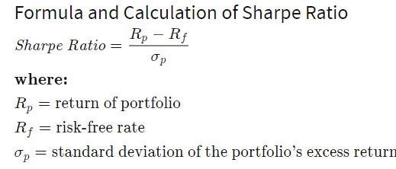

Type of Ratio | Equal Weighted Return  20 Stocks Portfolio | Value Weighted Return  20 Stocks Portfolio | PRIME FIN.FIRST MUT.FUND Return | EBL FIRST MUTUAL FUND Return | IFIC BK.1ST MUTUAL FUND Return | DSEX Return
Sharpe Ratio | -6.682228891 | -6.718893746 | -2.801237028 | -3.092741921 | -3.675010335 | -7.094086764

Here the Prime Finance First Mutual Fund Return has the highest Sharpe ratio among all other returns. That means the greatest risk premium per unit of risk taken, and thus, it has the better investment. It also indicates that investing this portfolio bears substantially more risk than rest, which may explain investors’ higher returns, but which also means they have a higher chance of eventually sustaining losses.
Lastly, DSEX return has the lowest Sharpe ratio among all other portfolios and mutual funds. This clearly signifies that this return have comparatively poor performance after adjusting for risk.

Skewness:
Skewness measures the asymmetry of a distribution. If the curve is shifted to the left or to right then, it is said to be skewed. Skewness essentially measures the relative size of the two tails. Positive skewness occurs, when the tail of the curve move from left to right. Negative skewness occurs when the tail moves from right to left.

 | Equal Weighted Return | Value Weighted Return | PRIME FIN.FIRST MUT.FUND Return | EBL FIRST MUTUAL FUND Return | IFIC BK.1ST MUTUAL FUND Return | DSEX Return
Skewness | 0.271297386 | 0.626304825 | 0.75816525 | 0.446011796 | 0.18029025 | 0.553011495
Kurtosis | 1.333996558 | 2.656201917 | 1.243746205 | 1.020283675 | 2.400218362 | 1.132863145

The entire above portfolio are positively skewed, which overestimates the risk. Between the six portfolios Value weighted return of 20 stocks Prime First mutual Fund return and DSEX return are moderately skewed (as the value is between 0.5 to 1) That means, there are moderate chances of frequent small losses and extreme gain. Though the Skewness is not less than -1 and not more than +1 so the extreme cases are not likely to happen. It is not very high or very low volatile.
On the other hand, skewness of equal weighted average of 20stocks, EBL first Mutual fund and IFIC 1st Mutual fund is less than 0.5. This means these portfolios are approximately symmetrical.

Kurtosis:
Kurtosis is a measure of the combined sizes of the two tails. It measures the amount of probability in the tails. The value is often compared to the kurtosis of the normal distribution, which is equal to 3. If the kurtosis is greater than 3, then the dataset has heavier tails than a normal distribution (more in the tails). If the kurtosis is less than 3, then the dataset has lighter tails than a normal distribution (less in the tails).

Here, As Kurtosis values all the portfolios are positive and are less than 3. This represents platykurtic kurtosis. It may indicates flatter curves which means it creates less outliers or extreme surprises than normal curve but it is more stable than the leptokurtic curve. It has less chance of having extremely large return or extremely small return. For that, reason most of the cautious investors may, therefore, avoid investing in leptokurtic markets and concentrate on investments that deliver platykurtic returns.

Regression Analysis of Portfolios
(Equal-Weight 20 stocks Portfolio vs. DSEX)

Running a regression between excess returns of Equal Weight (EW) Portfolio of 20 stocks and DSEX, we have obtained following outputs: -
Regression Statistics
Multiple R | 0.893567
R Square | 0.798462
Adjusted R Square | 0.794926
Standard Error | 0.020836
Observations | 59

Coefficient of determination (R-square) says that 79.8% of the variation of the portfolio excess return can be explained by variation in DSEX excess returns. Standard error of the regression or standard deviation of residuals - a measure of anomaly the average relationship between the portfolio and the index due to firm-specific factors - stood at 2.084%

ANOVA
 | df | SS | MS | F | Significance F
Regression | 1 | 0.098036 | 0.098036 | 225.8244 | 1.75E-21
Residual | 57 | 0.024745 | 0.000434
Total | 58 | 0.122781

The ANOVA (Analysis of Variance) table above splits the sum of squares into explained variation i.e. regression and unexplained variation i.e. residual. Sum of Squares of Regression (SSR) which is 0.098036, indicates the portion of variation of the dependable variables (portfolio excess return) explained by independent variables (DSEX). This is the systematic risk component. In contrast, the variance of the unexplained portion of the portfolio excess return is depicted by Mean Squares of Residual (0.000434). It is the portion, which is independent of the DSEX excess return. This is the firm specific risk component.

 | Coefficients | Standard Error | t Stat | P-value
Intercept | 0.003153 | 0.002723 | 1.157691 | 0.251818
DSEX | 0.939646 | 0.062529 | 15.02745 | 1.75E-21

Summarizing the above output, we get Security Characteristic Line (SCL):
Expected Excess Return of EW Portfolio-20 stocks Ŷ = 0.003153 + 0.939646x
Here, the equation describes the linear dependence of EW 20 stocks portfolio’s excess return on changes in the state of broader market as represented by the excess returns of DSEX index portfolio. The regression estimates give us the SCL with intercept αp (0.0032) of the EW 20 stocks portfolio and slope βp (0.939646).
For the intercept, t-value (1.157691) is low & p-value (0.251818) is significantly higher than 0.05, indicating intercept value is insignificant and can be zero.
t-value (15.02745) for beta coefficient is high & p-value (1.75E-21) is significantly lower than 0.05. This indicates that beta coefficient is significant.
The beta estimate of 0.939646 tells us that the excess return of 20 stocks equal-weight portfolio is moderately sensitive to market movement and tracks the market in same direction.
Following diagram shows the scatter plot and SCL of excess return or risk premium (RP) of EW 20 stocks portfolio and DSEX: -
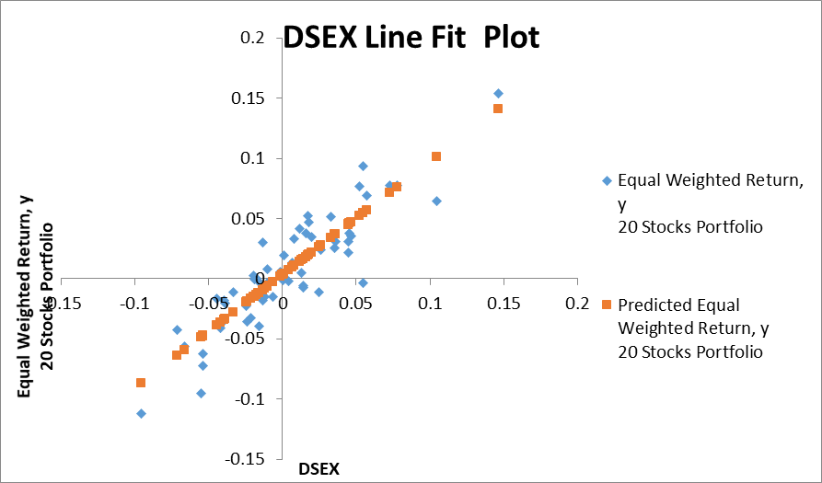

(Value-Weighted Portfolio vs. DSEX)
Running a regression between excess returns of Value-Weighted (VW) Portfolio of 20 stocks and DSEX, we have obtained following outputs: -

SUMMARY OUTPUT
Regression Statistics
Multiple R | 0.867114
R Square | 0.751887
Adjusted R Square | 0.747535
Standard Error | 0.022909
Observations | 59

Coefficient of determination (R-squared) says that around 75.19% of the variation of the portfolio excess return can be explained by variation in DSEX excess returns. Standard error of the regression or standard deviation of residuals - a measure of anomaly in the average relationship between the portfolio and the index due to firm-specific factors - stood at 2.3%.
ANOVA
 | df | SS | MS | F | Significance F
Regression | 1 | 0.090657 | 0.090657 | 172.7344 | 6.74706E-19
Residual | 57 | 0.029916 | 0.000525
Total | 58 | 0.120573

The ANOVA (Analysis of Variance) table above splits the sum of squares into explained variation i.e. regression and unexplained variation i.e. residual. Sum of Squares of Regression (SSR) which is 9.1%, indicates the portion of variation of the dependable variables (portfolio excess return) explained by independent variables (DSEX). This is the systematic risk component. In contrast, the variance of the unexplained portion of the portfolio excess return is depicted by Mean Squares of Residual (.00053). It is the portion which is independent of the DSEX excess return. This is the firm specific risk component.

 | Coefficients | Standard Error | t Stat | P-value
Intercept | 0.004389 | 0.002995 | 1.465779 | 0.148204
DSEX | 0.903593 | 0.068752 | 13.14285 | 6.75E-19

Summarizing the above output, we get Security Characteristic Line (SCL):
Expected Excess Return of value weight Portfolio of 20 stocks, Ŷ = 0.004389 + 0.903593x
Here, the equation describes the linear dependence of value weighted 20 stocks portfolio’s excess return on changes in the state of economy as represented by the excess returns of DSEX index portfolio. The regression estimates give us the SCL with intercept αp (.0044) of the VW 20 stocks portfolio and slope βp (0.903593).
For the intercept, t-value (1.465779) is pretty low & p-Value (0.148204) is higher than 0.05. So, intercept value is not significant & there is high probability that intercept value is insignificant or zero.
Running the similar hypothesis test for beta estimate which is 0.903593 with standard error of 0.068, we obtain large value of t-statistics (13.14) and p-value (6.75E-19) is significantly smaller than 0.05 here. This indicates coefficient value is significant.
The beta estimate of 0.903593 tells us that the excess return of 20 stocks value weighted portfolio is moderately sensitive to market movement. Value-weighted 20 stocks portfolio tracks the market in same direction
Following diagram shows the scatter plot and SCL of excess return or risk premium (RP) of 20 stocks value weighted portfolio and DSEX:
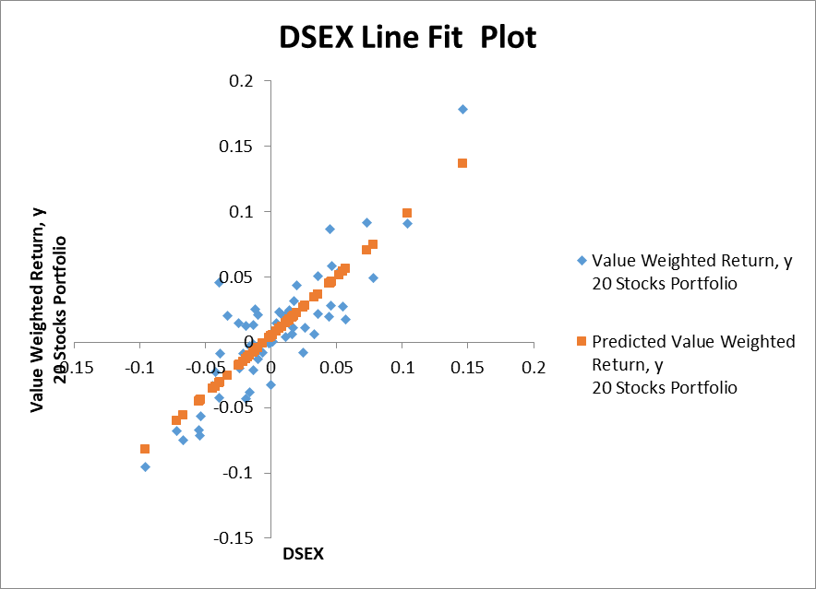

In summary, the regression above showed that the value weighted portfolio showed positive correlation and slightly less sensitivity to market than the equal weighted portfolio of 20 stocks.

Regression Analysis of Portfolio
(Prime Bank Mutual Fund vs. DSEX)
Running a regression between Prime Fin First Mutual Fund and DSEX, we have obtained following outputs: -

SUMMARY OUTPUT
Regression Statistics
Multiple R | 0.492746
R Square | 0.242799
Adjusted R Square | 0.229515
Standard Error | 0.093541
Observations | 59
Coefficient of determination (R Square) says that only 24.28% of the variation of the Mutual Fund excess return can be explained by DSEX excess returns. Standard error of the regression or standard deviation of residuals - a measure of anomaly the average relationship between the portfolio and the index due to firm-specific factors - stood at 9.35%
ANOVA
 | df | SS | MS | F | Significance F
Regression | 1 | 0.159923 | 0.159923 | 18.27723 | 7.3522E-05
Residual | 57 | 0.498741 | 0.00875
Total | 58 | 0.658664

The ANOVA (Analysis of Variance) table above splits the sum of squares into explained variation i.e. regression and unexplained variation i.e. residual. Sum of Squares of Regression (SSR) which is 0.159923, indicates the portion of variation of the dependable variables (Mutual Fund excess return) explained by independent variables (DSEX). This is the systematic risk component. In contrast, the variance of the unexplained portion of the portfolio excess return is depicted by Mean Squares of Residual (0.00875). It is the portion which is independent of the DSEX excess return. This is the firm-specific risk component.

 | Coefficients | Standard Error | t Stat | P-value
Intercept | 0.010997 | 0.012227 | 0.89941 | 0.372219
DSEX | 1.200125 | 0.280719 | 4.275188 | 7.35E-05

Summarizing the above output, we get Security Characteristic Line (SCL):
Expected Excess Return of Mutual Funds, Ŷ = 0.010997 + 1.200125x Excess Return -DSEX
Here, the equation describes the linear dependence of Prime Fin First Mutual Fund’s excess return on changes in the state of broader market as represented by the excess returns of DSEX index portfolio. The regression estimates give us the SCL with intercept αp (0.011) of the Prime Fin First Mutual Funds and slope βp (1.20).
As t-stat is pretty low or p-value is higher than 0.05, we can safely say that intercept value is not significant. Standard error of the alpha estimate is 0.012227.
The value of t-stat is quite large for the beta coefficient (4.275188) and p-value (7.35E-05) is significantly lower than 0.05. This indicates low probabilities that beta coefficient value is zero. So, beta coefficient is significant.
Running the similar hypothesis test for beta estimate which is 1.20 with standard error of 0.28. The beta estimate of 1.20 tells us that the excess return of Mutual Fund is highly sensitive to market movement and tracks the market in the same direction.
Following diagram shows the scatter plot and SCL of excess return or risk premium (RP) of Mutual Funds and DSEX: -
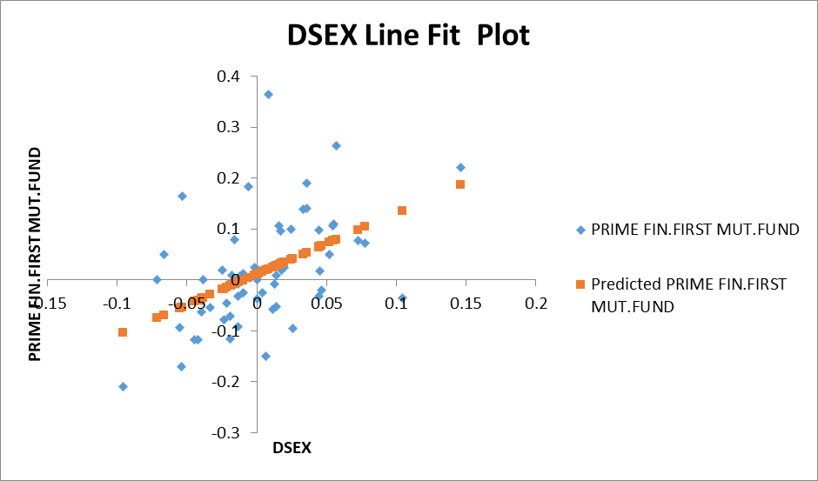

(EBL First Mutual Fund vs. DSEX)
Running a regression between Prime Fin First Mutual Fund and DSEX, we have obtained following outputs: -
SUMMARY OUTPUT
Regression Statistics
Multiple R | 0.54133
R Square | 0.293038
Adjusted R Square | 0.280635
Standard Error | 0.083739
Observations | 59

Coefficient of determination (R Square) says that only 29.3% of the variation of the Mutual Fund excess return can be explained by DSEX excess returns. Standard error of the regression or standard deviation of residuals - a measure of anomaly the average relationship between the portfolio and the index due to firm-specific factors - stood at 8.4%

ANOVA
 | df | SS | MS | F | Significance F
Regression | 1 | 0.165674 | 0.165674 | 23.62664 | 9.55332E-06
Residual | 57 | 0.399693 | 0.007012
Total | 58 | 0.565367

The ANOVA (Analysis of Variance) table above splits the sum of squares into explained variation i.e. regression and unexplained variation i.e. residual. Sum of Squares of Regression (SSR) which is 0.165674, indicates the portion of variation of the dependable variables (Mutual Fund excess return) explained by independent variables (DSEX). This is the systematic risk component. In contrast, the variance of the unexplained portion of the portfolio excess return is depicted by Mean Squares of Residual (0.007012). It is the portion which is independent of the DSEX excess return. This is the firm-specific risk component.

 | Coefficients | Standard Error | t Stat | P-value
Intercept | 0.00414 | 0.010946 | 0.37824 | 0.706657
DSEX | 1.221513 | 0.251303 | 4.860724 | 9.55E-06

Summarizing the above output, we get Security Characteristic Line (SCL):
Expected Excess Return of Mutual Funds, Ŷ = 0.00414 + 1.2215135x Excess Return -DSEX
Here, the equation describes the linear dependence of EBL First Mutual Fund’s excess return on changes in the state of economy as represented by the excess returns of DSEX index portfolio. The regression estimates give us the SCL with intercept αp (0.004) of the EBL First Mutual Funds and slope βp (1.22).
As t-stat is pretty low or p-value is higher than 0.05, we can safely say that intercept value is not significant. Standard error of the alpha estimate is 0.010946.
The value of t-stat is quite large for the beta coefficient (4.860724) and p-value (9.55E-06) is significantly lower than 0.05. This indicates low probabilities that beta coefficient value is zero. So, beta coefficient is significant.
Running the similar hypothesis test for beta estimate which is 1.22 with standard error of 0.25. The beta estimate of 1.22 tells us that the excess return of Mutual Fund is highly sensitive to market movement and tracks the market in the same direction.
Following diagram shows the scatter plot and SCL of excess return or risk premium (RP) of Mutual Funds and DSEX: -

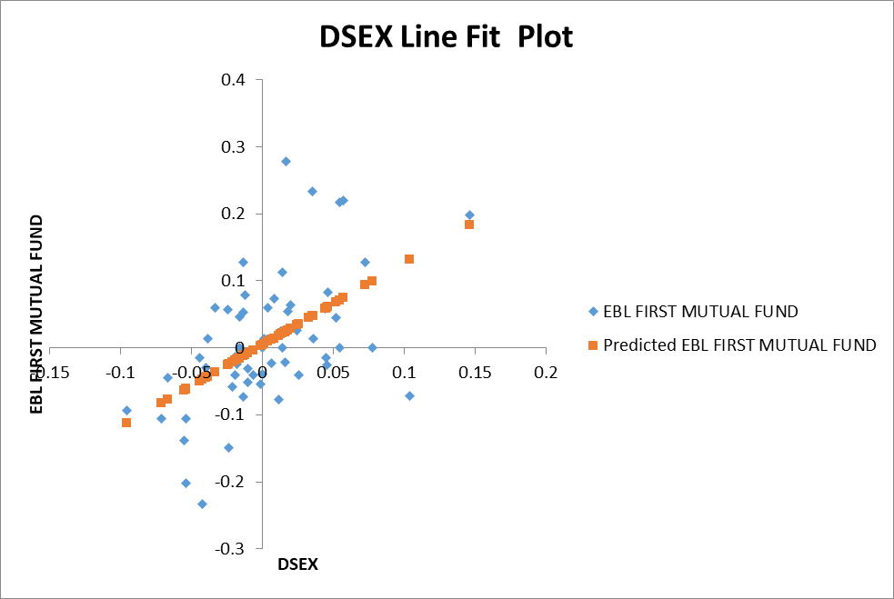

(IFIC Bank First Mutual Fund vs. DSEX)
Running a regression between Prime Fin First Mutual Fund and DSEX, we have obtained following outputs: -

SUMMARY OUTPUT
Regression Statistics
Multiple R | 0.447144
R Square | 0.199938
Adjusted R Square | 0.185901
Standard Error | 0.07525
Observations | 59

Coefficient of determination (R Square) says that only about 20% of the variation of the Mutual Fund excess return can be explained by DSEX excess returns. Standard error of the regression or standard deviation of residuals - a measure of anomaly the average relationship between the portfolio and the index due to firm-specific factors - stood at 7.5%

ANOVA
 | df | SS | MS | F | Significance F
Regression | 1 | 0.08066 | 0.08066 | 14.24444 | 0.000384559
Residual | 57 | 0.322766 | 0.005663
Total | 58 | 0.403426

The ANOVA (Analysis of Variance) table above splits the sum of squares into explained variation i.e. regression and unexplained variation i.e. residual. Sum of Squares of Regression (SSR) which is 0.08066, indicates the portion of variation of the dependable variables (Mutual Fund excess return) explained by independent variables (DSEX). This is the systematic risk component. In contrast, the variance of the unexplained portion of the portfolio excess return is depicted by Mean Squares of Residual (0.005663). It is the portion, which is independent of the DSEX excess return. This is the firm-specific risk component.

 | Coefficients | Standard Error | t Stat | P-value
Intercept | 0.004437 | 0.009836 | 0.451057 | 0.65366
DSEX | 0.852316 | 0.225828 | 3.77418 | 0.000385

Summarizing the above output, we get Security Characteristic Line (SCL):
Expected Excess Return of Mutual Funds, Ŷ = 0.004437 + 0.852316x
Here, the equation describes the linear dependence of Prime Fin First Mutual Fund’s excess return on changes in the state of economy as represented by the excess returns of DSEX index portfolio. The regression estimates give us the SCL with intercept αp (0.004) of the Prime Fin First Mutual Funds and slope βp (0.85).
As t-stat is pretty low or p-value is higher than 0.05, we can safely say that intercept value is not significant. Standard error of the alpha estimate is 0.009836.
The value of t-stat is quite large for the beta coefficient (3.77418) and p-value (0.000385) is lower than 0.05. This indicates low probabilities that beta coefficient value is zero. So, beta coefficient is significant.
Running the similar hypothesis test for beta estimate, which is 0.85 with standard error of 0.22. The beta estimate of 0.85 tells us that the excess return of Mutual Fund is moderately sensitive to market movement and tracks the market in the same direction.
Following diagram shows the scatter plot and SCL of excess return or risk premium (RP) of Mutual Funds and DSEX: -

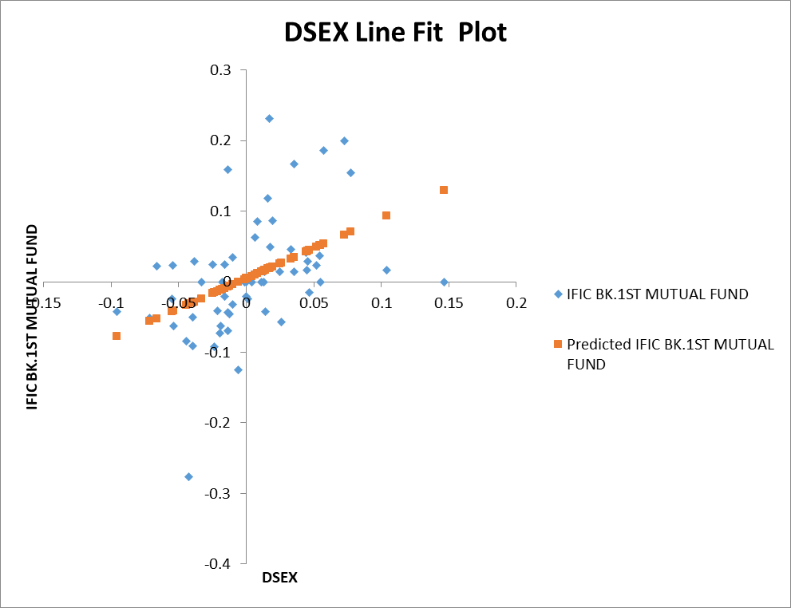

Reference:
Source: https://insights.factorresearch.com/research-skewness-as-a-factor/
Source: https://www.youtube.com/watch?v=I9-7Eh6K38E&t=316s
Source: https://cleartax.in/g/terms/platykurtic

