

# Course Title: Microprocessor interfacing and embedded system (3 Cr)

**Team project**

**Semester**:

**Group: 8**

**Section:**

**Names, Student IDs and emails:**

Implement the given encryption table using microcontroller. Use single pole, double throw switch to configure the inputs for high and low conditions. Use LEDs to represent the corresponding output statuses.

|  |  |  |  |  |  |  |  |  |
| --- | --- | --- | --- | --- | --- | --- | --- | --- |
| **Input** | | | | **Output** | | | | |
| **I3** | **I2** | **I1** | **I0** | **O3** | **O2** | **O2** | **O1** |
| **0** | **0** | **0** | **0** | **0** | **1** | **0** | **0** |
| **1** | **0** | **0** | **0** | **1** | **1** | **0** | **1** |
| **0** | **1** | **0** | **0** | **0** | **0** | **1** | **0** |
| **1** | **1** | **0** | **0** | **1** | **1** | **0** | **0** |
| **0** | **0** | **1** | **0** | **1** | **0** | **1** | **1** |
| **1** | **0** | **1** | **0** | **1** | **0** | **1** | **0** |
| **0** | **1** | **1** | **0** | **1** | **0** | **0** | **1** |
| **1** | **1** | **1** | **0** | **0** | **0** | **0** | **0** |
| **0** | **0** | **0** | **1** | **0** | **1** | **0** | **1** |
| **1** | **0** | **0** | **1** | **0** | **0** | **1** | **1** |
| **0** | **1** | **0** | **1** | **1** | **0** | **1** | **0** |
| **1** | **1** | **0** | **1** | **1** | **1** | **1** | **1** |
| **0** | **0** | **1** | **1** | **0** | **1** | **0** | **0** |
| **1** | **0** | **1** | **1** | **1** | **0** | **0** | **0** |
| **0** | **1** | **1** | **1** | **1** | **1** | **1** | **0** |
| **1** | **1** | **1** | **1** | **0** | **1** | **0** | **0** |

Hints for deriving the logic expression:

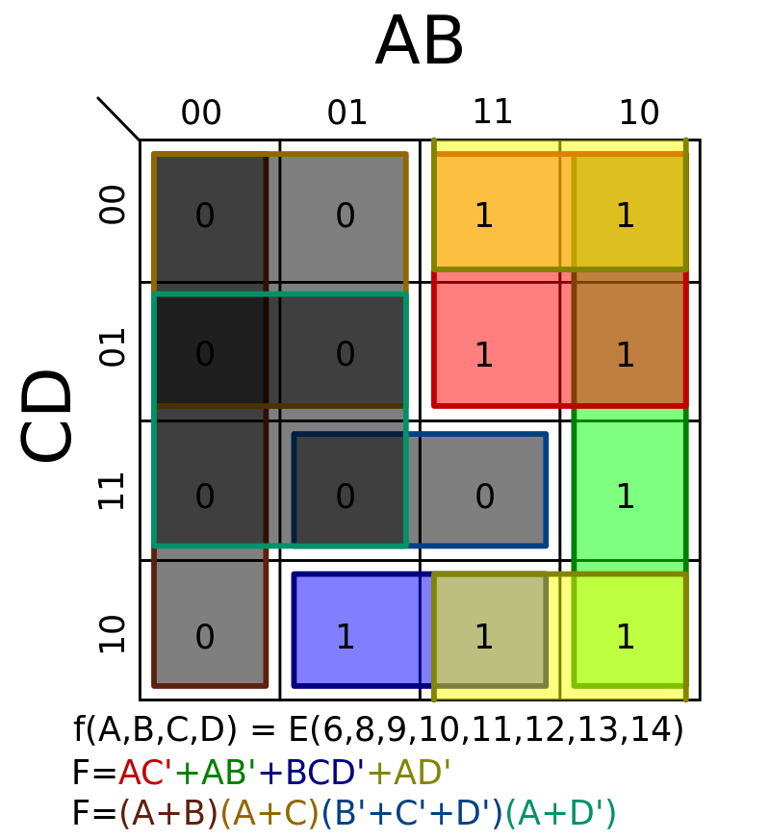

Example microcontroller: (Arduino UNO)

