UGANDA MARTYRS UNIVERSITY

MOBILE COMPUTING AND NETWORKS- FINAL ASSESMENT

DESIGN PROPOSAL

WANYANA JESCA 2021-B072-23544

SSEVVUME ARAFAT 2021-B072-22053

**Introduction:**

In today's digital age, the world of books has undergone a transformative shift, with readers increasingly turning to mobile applications for their book discovery needs. We are thrilled to introduce our innovative mobile application, eBooks, designed to revolutionize the way readers explore, discover, and engage with books. The purpose of eBooks is to provide an unparalleled book discovery experience, catering to the diverse interests and preferences of avid readers. With a vast catalog of books, personalized recommendations, and an array of user-friendly features, eBooks aims to be the ultimate companion for book lovers seeking their next captivating read. In an era where time is precious and attention spans are fleeting, finding the perfect book can be a daunting task. eBooks aims to alleviate this challenge by offering a seamless and intuitive platform that empowers readers to embark on literary adventures effortlessly. Whether you're a fan of mystery, romance, science fiction, or any genre under the sun, eBooks has something for everyone.

**Project Scope:**

*Objective:*

The objective of the eBooks application project is to develop a mobile application that revolutionizes the book discovery experience for readers. The application aims to provide a user-friendly platform for exploring, discovering, and engaging with a diverse range of books across various genres.

*Features and Functionalities:*

The eBooks application will include the following core features and functionalities:

User registration and authentication for personalized experiences.

Comprehensive book catalog with a wide selection of titles from different genres.

Advanced search functionality to facilitate easy book discovery by title, author, genre, or keywords.

Personalized book recommendations based on user preferences, reading history, and ratings.

Detailed book information, including synopsis, author background, ratings, and user reviews.

Ability to create and manage a personal Wishlist for saving books of interest.

Bookmarking feature to save progress within books and resume reading from the last page.

The eBooks application will include the following core features and functionalities:

Comprehensive book catalog with a wide selection of titles from different genres.

Advanced search functionality to facilitate easy book discovery by title, author, genre, or keywords.

Personalized book recommendations based on user preferences, reading history, and ratings.

*Constraints and Assumptions:*

The application will require a stable internet connection for real-time data retrieval and updates.

The application will be developed using industry-standard development frameworks and tools.

*Deliverables:*

The expected deliverables of the project include:

Fully functional and tested mobile application for Android platforms.

**User requirements**

*Personalized Book Recommendations:*

Users expect the application to provide personalized book recommendations based on their reading preferences, interests, and browsing history.

The recommendations should be accurate, diverse, and continuously updated to introduce users to new books and authors.

*Easy Book Discovery:* Users want a user-friendly interface that allows them to easily explore and discover books across different genres, authors, and themes.

The application should provide intuitive search functionality with filters and sorting options to help users find specific books or browse based on their interests.

*Seamless Online Bookstore Integration:*

Users expect the application to seamlessly integrate with online bookstores, allowing them to view real-time book availability, pricing, and direct purchasing options.

The integration should provide a smooth transition from book discovery to purchase without redirecting users to external websites or applications.

*User Profile:*

Users desire the ability to create and manage personal profiles within the application, including preferences, reading history, and saved books.

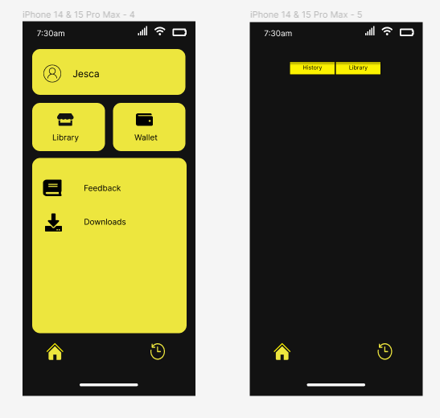

*Offline Reading Support (if applicable):*

If the application supports offline reading of e-books, users may request the ability to download books for offline access.

The offline reading feature should be seamless, easy to use, and support synchronization of reading progress when the user goes online.

*Privacy and Data Security:*

Users expect the application to prioritize their privacy and protect their personal information.

The application should adhere to privacy regulations, clearly communicate its data handling practices, and provide options for managing and controlling user data.

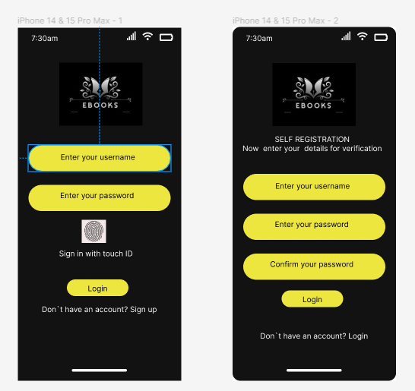

*Below are the challenges or limitations encountered during the implementation;*

*Unstable network:* An unstable network significantly impacted the development process in Android Studio. It restricted the ability to access online resources, code snippets, and libraries that are essential for building our project. Additionally, an unstable network disrupted the connection between Android Studio and external devices especially when it came to my hand set, making it difficult to test and debug our application effectively.

*Testing on different devices and versions*: Developing the Android platform involved dealing with a wide range of devices and operating system versions. This fragmentation posed challenges in ensuring compatibility and a consistent user experience across various devices. Testing our application on multiple devices and operating system versions was crucial, and this was time-consuming and complex to acquire and manage the necessary devices for testing our application.

*Designing user interface:* Designing an intuitive and visually appealing user interface (UI) was crucial for the success of an Android application. However, the design process was disrupted by limited and unstable network access. This limitation challenged us to access design resources, generate design assets, or collaborate effectively on the UI design. Consequently, it hindered the iteration and refinement of the UI to meet the desired outcomes.

*Code errors and debugging:* During Android Studio development, encountering errors and bugs was common. These issues prevented the smooth execution of our application on devices, impeding progress and productivity. Debugging and troubleshooting code problems was time-consuming,

*Time constraints:* Developing an Android Studio project required a lot of time and effort. In our case, inadequate time availability as a group posed a challenge. Coordinating schedules, finding time for collaborative work, and ensuring progress within given deadlines was difficult. These time constraints impacted the overall project timeline and affect the quality of the final application.

*Limited skills and expertise:* The skills and expertise of the development team played a crucial role in the success of an Android Studio project. Since we had a limited range of skills and expertise impacted the quality and functionality of the application. Due to the lack of familiarity with certain tools, libraries, or UI design techniques, we had to compromise on certain design choices or exclude desired features from the application.

Pushing the work to the cloud also present challenges due to the network

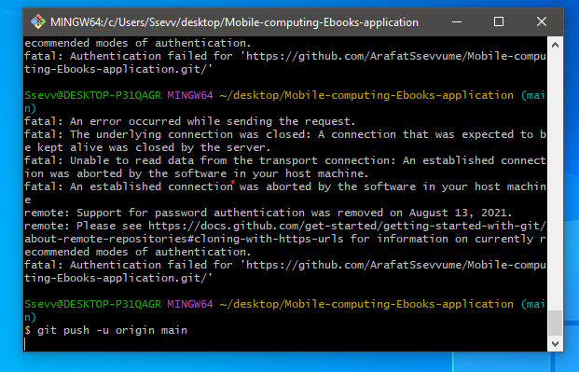

*To overcome these challenges, consider the following strategies:*

*Stabilizing the network connection:* Taking measures to ensure that there is a stable network connection, such as using a reliable internet service provider or setting up a local development environment that does not heavily rely on online resources.

*Expanding device testing:* Prioritized testing on a diverse range of Android devices and versions to ensure compatibility. Exploring options like cloud-based testing services or virtual devices to access a broader range of testing environments.

*Adapt UI design process:* when the limited network access hampered the UI design process, we considered alternative methods such as offline design tools or creating mockups and prototypes in advance. Collaboration tools and version control systems helped us to work together effectively despite physical or network limitations.

*Effective debugging practices:* Familiarized ourselves with debugging tools and techniques specific to Android Studio. Leverage available resources, such as official documentation, online forums, or debugging tutorials, to enhance your debugging skills and streamline the resolution of code errors.

*Time management and planning:* Allocated and dedicated time for the project and established a clear timeline with achievable milestones. Regularly communicated and coordinated with a group member to ensure progress and address any scheduling conflicts or time constraints.

Skill development and collaboration: Identified areas where skill gaps existed and explored opportunities for learning and development. Encourage collaboration and knowledge sharing among team members to leverage individual strengths and collectively overcoming the limitations.

*below are the lessons learned;*

*Importance of project documentation:* The write-up or proposal plays a crucial role in providing a clear understanding of the project requirements and objectives. It highlights the desired outcome and guides the development process.

*Significance of user interface designs:* User interface designs are essential right from the beginning of the project. They help in understanding the needs and preferences of the target audience, enabling the creation of an intuitive and engaging application.

*Learning new codes and their impact:* The project provided an opportunity to learn new codes and understand how they function within the system. This learning experience enhanced the team's skills and knowledge, enabling them to implement new features and functionalities effectively.

*Prioritizing security:* Ensuring security throughout the development process is crucial to protect sensitive information and prevent unauthorized access. Future iterations of the project should continue prioritizing security measures to safeguard user data and maintain user trust.

*Importance of communication:* Open and transparent communication within the development team is vital for project success. It facilitates effective collaboration, knowledge sharing, and problem-solving. Maintaining regular communication channels and fostering a culture of open feedback can lead to better outcomes.

*discuss potential improvements for future iterations of the project.*

*User research and feedback*: Conducting user research and gathering feedback from the target audience can provide valuable insights into their pain points, usability issues, and feature requests. Incorporating user feedback into future iterations can help improve the application's overall user experience and meet user expectations more effectively.

*Usability testing:* Implementing usability testing during the development process can help identify any usability issues or bottlenecks early on. This iterative testing approach allows for refinements and improvements to the user interface, interaction flows, and overall usability of the application.

*Continuous learning and skill development*: Encourage team members to continue learning and expanding their skills in areas that are relevant to the project. This could involve attending workshops, training sessions, or exploring online resources to stay updated with the latest technologies, frameworks, and best practices.

*Agile development methodologies:* Consider adopting agile development methodologies, such as Scrum or Kanban, for future iterations. These methodologies promote iterative development, close collaboration, and flexibility, allowing for quicker feedback cycles and better adaptability to changing requirements.

*Quality assurance and testing*: Implement a robust quality assurance process, including thorough testing on various devices and operating system versions. This can help identify and address potential issues, bugs, and compatibility problems early in the development cycle, resulting in a more stable and reliable application.

.