A Mini Project Seminar On

**Classification of Arrythmia using SVM with PCA**

Submitted in partial fulfillment of the requirements for the award of the

**Bachelor Of Technology**

in

**Department of Computer Science and Engineering (Artificial**

**Intelligence and Machine Learning)**

**By**

**Mohammed Arafath 21241A6646**

**Boga Sandeep 21241A6614**

**Tappatla Sujit 21241A6660**

Under the Esteemed guidance of

**Mr P.Aditya Sharma**

**Assistant Professor**



**Department of Computer Science and Engineering**

**(Artificial Intelligence and Machine Learning)**

**GOKARAJU RANGARAJU INSTITUTE OF ENGINEERING AND**

**TECHNOLOGY**

# (Approved by AICTE, Autonomous under JNTUH, Hyderabad) Bachupally, Kukatpally, Hyderabad-500090



**GOKARAJU RANGARAJU INSITUTE OF ENGINEERING AND TECHNOLOGY**

**(Autonomous)**

**Hyderabad-5000090**

**CERTIFICATE**

This is to certify that the mini project entitled **“Classification of Arrhythmia using SVM with PCA”** has been submitted by **Mohammed Arafath (21241A6646), Boga Sandeep (21241A6614) and Tappatla Sujt (21241A6660)** in partial fulfillment of the requirements for the award of the degree of BACHELOR OF TECHNOLOGY in Computer Science and Engineering (Artificial Intelligence and Machine Learning) for the academic year 2023-2024.

**External Examiner**

**ACKNOWLEDGEMENT**

There are many people who helped us directly and indirectly to complete our project successfully. We would like to take this opportunity to thank one and all. First, we would like to express our deep gratitude towards our internal guide **Mr P.Aditya Sharma**, Assistant Professor/Associate Professor/Professor, Department of Computer Science and Engineering (Artificial Intelligence and Machine Learning) for his support in the completion of our dissertation. We are thankful to mini project coordinator **Mr. B. Rajasekhar**, Assistant Professor, for his valuable suggestions and comments during this project period.

We wish to express our sincere thanks to **Dr. G. Karuna**, Head of the Department, and to our principal **Dr. J. PRAVEEN**, for providing the facilities to complete the dissertation. We would like to thank all our faculty and friends for their help and constructive criticism during the project period. Finally, we are very much indebted to our parents for their moral support and encouragement to achieve goals.

**Mohammed Arafath (21241A6646)**

**Boga Sandeep (21241A6614)**

**Tappatla Sujit (21241A6660)**

# DECLARATION

We hereby declare that the mini project titled **“Classification of Arrythmia using SVM with PCA”** is the work done during the period from 6th February 2024 to 29th June 2024 and is submitted in the partial fulfillment of the requirements for the award of degree of Bachelor of Technology in Computer Science and Engineering (Artificial Intelligence and Machine Learning) from Gokaraju Rangaraju Institute of Engineering and Technology (Autonomous under Jawaharlal Nehru Technology University, Hyderabad). The results embodied in this project have not been submitted to any other University or Institution for the award of any degree or diploma.

**Mohammed Arafath (21241A6646)**

**Boga Sandeep (21241A6614)**

**Tappatla Sujit (21241A6660)**

## ABSTRACT

This study mainly focuses on the classification of arrhythmia which is based on electrocardiogram (ECG) data by using Support Vector Machines (SVM) in addition with Principal Component Analysis (PCA). ECG data which contains critical information about the electrical activity of the heart, are analyzed to identify arrhythmias, potentially life-threatening irregular heartbeats. The high-dimensional nature of ECG signals necessitates the use of dimensionality reduction techniques, such as PCA, to enhance the computational efficiency and accuracy of the SVM classifier. PCA is employed to extract the most significant features from the ECG data, reducing noise and preserving essential information. Subsequently this features are fed into the SVM a robust supervised learning algorithm known for its efficacy in binary and multi-class classification problems. The proposed method demonstrates promising results, with improved classification accuracy and reduced computational complexity, making it a viable approach for real-time arrhythmia detection and diagnosis in clinical settings.

**LIST OF FIGURES**

|  |  |  |
| --- | --- | --- |
| **Figure No Figure Name** | | **Page No**  **4**  **8**  **21**  **23**  **28**  **30**  **32**  **35** |
| 1.1.1 1.4  3.2.1  3.2.2  3.5.1  3.5.2  3.5.3  3.5.4 | Model Structure Diagram  Architecture Diagram  Module Connectivity Diagram  Architecture Diagram  Class Diagram  Sequence Diagram  Use Case Diagram  Activity Diagram  **LIST OF TABLES**  **Table No Table Name Page no**    2.1 Literature Survey 14  4.1.1 Types of Arrythmia 36  4.2.1Experiement Results 52 |
|

**LIST OF ACRONYMS**

**Acronym Full Form**

|  |  |
| --- | --- |
| SVM  PCA  ECG | Support Vector Machine  Principal Component Analysis  Electro Cardiogram |

**TABLE OF CONTENTS**

|  |  |  |  |
| --- | --- | --- | --- |
| **Chapter No.** | **Chapter Name** | **Page No.** | |
|  | Certificate |  | i |
|  | Acknowledgement |  | ii |
|  | Declaration |  | iv |
|  | Abstract |  | V |
|  | List of Figures |  | vi |
|  | List of Tables |  | vii |
|  | List of Acronyms |  | viii |
| **1** | **Introduction** |  |  |
|  | 1.1Classification of Arrythmia using SVM with PCA |  | 1 |
|  | 1.2 Objective of the Project |  | 2 |
|  | 1.3 Methodology |  | 3 |
|  | 1.4 Architecture diagram |  | 5 |
|  | 1.5 Organization of the Report |  | 7 |
| **2** | **Literature Survey** |  |  |
|  | 2.1 Summary of Existing Approaches |  | 8 |
|  |
| **3** | **Proposed Method** |  |  |
|  | 3.1 Problem Statement & Objectives of the Project |  | 19 |
|  | 3.2 Architecture Diagram |  | 21 |
|  | 3.3 Modules and its Description |  | 31 |
|  | 3.4 Requirements Engineering |  | 33 |
|  | 3.5 Analysis and Design through UML |  | 35 |
| **4** | **Results and Discussions** |  |  |
|  | 4.1 Description about Dataset |  | 38 |
|  | 4.2 Detailed Explanation |  | 39 |
|  | 4.3 Significance of the Proposed Method with its Advantages | | 41 |
| **5**  **6**  **7** | **Conclusion and Future Enhancements**  **Appendices**  **References** |  | 43  44  52 |

|  |  |  |
| --- | --- | --- |
|  |  |  |
|  |  |  |
|  |  |  |
|  |  |  |
|  |  |  |
|  |  |  |  |

## CHAPTER 1 INTRODUCTION

## Arrythmia Classification using SVM with PCA

Palpitation is a broad term that can be a simple case of skipped heartbeat to a complex case of life-threatening arrhythmias that include atrial fibrillation and ventricular tachycardia. The present identification and categorization of arrhythmias is very essential for successful therapeutic management. Since improper functioning of the heart that comes with arrhythmias may cause very bad outcomes, it is very vital to diagnose it early and accurately. The time domain study of electrical activity from the heart muscle is known as ECG, which is the evaluative method used by clinicians to diagnose arrhythmias. Nevertheless manual analysis of thereby dissected ECG data is laborious as well as vulnerable to human error which underlines the necessity for precise infused and automated allocations.

There are certain challenges in relation to the ECG signals which include; ECG signals contain more complexity and variability in contrast to the large numbers of features which make it cumbersome for computer to classify the arrhythmia. ECG signals are extremely complex with large number of data points and its readings can be affected by various factors such as noise, patient movement, and electrode placement among others. To overcome these obstacles, better sophisticated signal processing and artificial intelligence computation methods are used for the better identification of arrhythmia. Among these techniques, Support Vector Machines (SVM) have gained popularity specially because of their ability to efficiently handle the classification problems, in particular when beset with noise or when the classes are overlapping. This form of classification is expected since SVM’s strength lies in its ability to construct the best hyperplane that separates various classes and the binary classes in question include normal and abnormal heart rhythms.

However, directly applying the SVM to calculate the ECG suffers from the high dimensionality of the data and causes overfitting and much more computational load. In this case, Principal Component Analysis provides a solution through the notion of reducing the data from a large number of dimensions to a much lower number of imensions but at the same time retains the most important information of the data being analyzed. PCA involves the reduction of the given high-dimensional data with many variables and replaces them with a new set of variables known as principal components, which are linear combinations of the original variables and are mutually uncorrelated, and they represent the directions of high variance in the data set. Therefore, the PCA analysis is effectively conducted before the SVM model to select the features of the ECG signals with most discriminative characteristics to remove noise and enhance the classifier performance.

LBM: By combining both PCA and SVM for classification of the arrhythmia data, the diagnostic capability is enhanced, and therefore, more reliable. Moreover, the proposed Dimensionality Reduction by PCA improved the performance of SVM to a level that it became possible to work on large data-sets. This combined approach not only enhances the performance of the algorithm in terms of recognition of different types of arrhythmias but also decreases the time needed to achieve the result, making this algorithm relevant for clinical practice. Thus, this methodology has explicit possibilities of enhancing the diagnosis of erythematous-squamous diseases and guiding the patients in improving the quality of their lives and personal healthcare organizations.

This is due to the fact that arrhythmia, a condition of irregular heartbeat can present itself in various forms including minor skipped beats up to and including life threatening conditions like atrial fibrillation and ventricular tachycardia. Thus, the ability to detect and classify arrhythmias is very important in cases where medical interventional and management is to be implemented. Due to the danger posed by untreated arrhythmias, early detection of the condition is crucial and should involve the use of any technology that will determine their presence with high accuracy. Any alteration in rhythm and rate of the heart is detected through ECG, a technique that employs electrodes to produce electrical recordings from the patient. However, to manually examine the ECG data takes much time and it is easily affected by the interpreter’s subjectivity and inaccuracy and hence the importance of employing accurate and efficient diagnostic techniques.

Hence, the complexity and the non-stationarities that are associated with ECG signals remain one of the major difficulties in the arrhythmia classification. ECG signals have a stringent dimension since they include multiple leads and can be affected by several external effects such as noise, patient movements, and location of electrodes. In order to overcome these problems different sophisticated signal processing and an intelligent pattern recognition via machine learning methods are used to improve the detections of arrhythmias. Of these techniques, Support Vector Machines have shown to be more acceptable due to the high level of resilience they exhibit in times of noisy or overlapping dataset classification. SVM performs exceptionally well due to its ability to classify data into relevant categories by drawing a hyperplane that best separates these categories; this makes it appropriate for use in this study as an attempt is made to distinguish between normal and abnormal heart rhythms.

However, direct use of SVM on ECG data might cause overfitting and add complexity due to its high-dimensionality data. To have a measure of control over this aspect of big data analysis, Principal Component Analysis (PCA) is an effective solution that can help to reduce the number of dimensions of the data that are being analyzed, but it retains the most important aspects. PCA maps the original high dimension data into a new lower dimension space with fewer dimensions known as principal components, which are the directions that hold maximum variability in the data. Before the SVM, the most important ECG signals which contain valuable information for classification are derived through PCA process, removing high order noises and also accelerating the classification process.

Joint use of PCA and SVM for arrhythmia classification is more beneficial than using PCA alone because SVM enhances the advantages of PCA, making it more effective in classification and diagnosis of a condition. In the same way that PCA improves the feasibility of handling large amounts of data by reducing the size of data to a manageable number of dimensions such that large data sets affects the performance of SVM and as a result data pre-processing becomes feasible. This combined strategy does not only increases the level of accuracy with respect to the diagnosis of the arrhythmia but also lowers the memory complexity needed for the process thereby being ideal for real time use in clinical practice. Therefore, there continues to be a clear opportunity to drive progress in the further improvement of automated diagnosis of the arrhythmias in order to provide the patients with better prognosis and support the enhancing of clinicians’ work.

As mentioned earlier, the modeling procedure of using PCA and SVM for arrhythmia classification also follows some critical steps. First of all, ECG data should be preprocessed and filtered, because there are noises and artifacts that can disturb, and make difficult, the analysis of the real heart beats rhythms. Process of data preparation involves the refining of the data – such techniques as the filtering and normalization are often applied at this stage. After cleaning of the data, the PCA is used on the data set to identify the main directions that explain the spread of ECG signals. The above components are used as the features of the SVM classifier into which information about various types of arrhythmias is fed to for classification.

Among the methods used in classification, kernel function in SVM is one of the most significant determinants of classification outcome. Some of the kernels which exist include Linear kernel which is quite good for simple cases in machine learning, Polynomial kernel which works well when data is repetitive, and the RBF kernel which is appropriate when the data has a large variance. The best parameters for the SVM include the regularization parameter and additional parameters depending on the selected kernel type, all of which should be tuned to obtain the highest classification accuracy. There is customarily cross-validation steps included in this optimization process with the aim of choosing the right model parameters and for avoidance of overfitting.

When working with the SVM on the arrhythmia classification system which implements PCA, the following measures should be taken Quality assessment methodologies applied in this particular case deal with accuracy, precision, the recall rate, and the F-Measure ( F1). Besides that, the use of the receiver operating characteristic (ROC) curve and the area under the curve (AUC) evaluate the classifier’s capacity to discriminative between two or more classes. Even more, the performances of the system are validated through cross-validation with newly developed database and tested with other previous methods and with other prevalent learning models. These evaluations help in making ensure that the developed system, in addition to being accurate in its predictions, is also valid across the various patient domains and scenarios within the clinical setup.

In conclusion, it can be stated that using the features selected by PCA and the support vector machine classifier is an effective way of achieving good results in classification of arrhythmia based on ECG data. This particular method overcomes the difficulties often encountered when working with high-dimensional data and noise in ECG signals through applying PCA for dimensionality reduction and utilizing the classification capacity of SVM. The resulting system is equipped for attaining the precise results of the Arrhythmia detection which are crucial for proper patient’s management. The future work could therefore aim at improvement of these methods, investigation of the deep learning methodologies, and inclusion of various other physiological parameters in order to simplify the differentiation of new and complex types of Arrhythmia by these automated classification techniques.

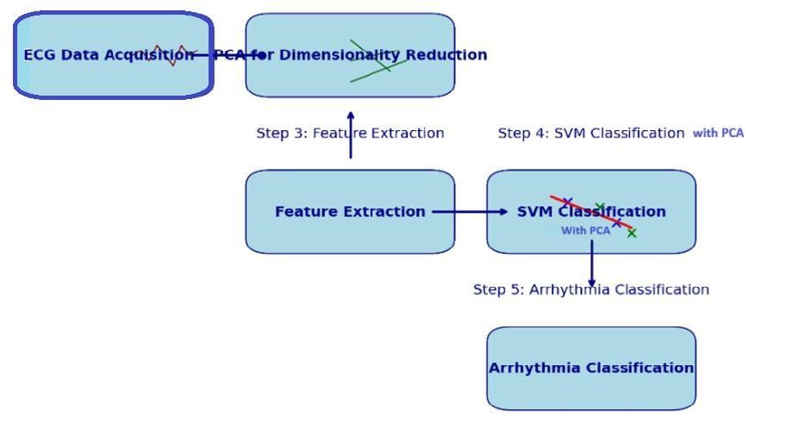

Figure 1.1.1:Model Structure Diagram

**1.2 Objective of the project:**

The main aim of our project is to detect whether a person is experiencing arrhythmia and, if so, to classify it into one of 16 specific types based on electrocardiogram (ECG) data that we are having using a combination of Support Vector Machines (SVM) and Principal Component Analysis (PCA). This system aims to

1.Enhance Diagnostic Accuracy: To improve the precision and reliability of arrhythmia detection to assist clinicians in making timely and accurate diagnoses, thereby reducing the risk of misdiagnosis and improving patient outcomes.

2.Reduce Computational Complexity: To utilize PCA to reduce the dimensionality of high-volume ECG data, retaining essential features while minimizing noise, to enhance the computational efficiency of the SVM classifier.

3.Automate ECG Analysis: Develop an automated process that can analyze ECG signals in real-time, facilitating continuous monitoring and rapid identification of arrhythmias without the need for constant human oversight.

4.Classify Arrhythmia Types: Accurately classify detected arrhythmias into one of 16 specific types, providing detailed diagnostic information that is crucial for determining the appropriate treatment and management strategies.

5.Create a Robust and Generalizable Model: Ensure the classification model is robust across different datasets and patient population, maintaining high performance and reliability in diverse clinical environments.

6.Provide a Basis for Future Research: Establish a foundational system that can be further refined and expanded upon, potentially incorporating advanced techniques such as deep learning and integrating additional physiological data for comprehensive cardiovascular monitoring.

**1.3 Methodology**

To achieve the objective of detecting and classifying arrhythmias based on ecg data, we adopt a systematic methodology integrating support vector machines (SVM) with principal component analysis (PCA). the process involves the following key steps:

**1. Data collection and preprocessing:**

**Data Collection:** Gather a comprehensive dataset which contains the ecg recordings from multiple subjects, ensuring it includes both normal and arrhythmic heartbeats. the dataset should encompass all 16 types of arrhythmias targeted for classification. sources to this data may include public databases like mit-bih arrhythmia database or uc irvine machine learning repository which provide annotated ecg record.

**Preprocessing:** cleaning the raw ecg data to remove noise. this step includes filtering techniques to eliminate baseline wander, power line interference, and other signal distortions. additionally, segment the ecg signals into individual heartbeats or segments for further analysis. techniques such as wavelet transforms or bandpass filters may be employed to enhance signal quality.

**2. Feature extraction using PCA:**

**Dimensionality reduction:**apply pca to the preprocessed ecg data to reduce its dimensionality. pca transforms the original high-dimensional ecg signals into a smaller set of principal components that capture the most significant variations in the data. this step involves computing the covariance matrix of the data, performing eigenvalue decomposition, and selecting the top principal components based on explained variance.

**Feature selection:** select a subset of the principal components that retain the essential characteristics of the ecg signals while discarding the less informative components. this step ensures the svm classifier receives the most relevant features, enhancing its performance and reducing computational complexity. the selection of principal components is typically guided by a threshold on the cumulative explained variance, such as 95%

**3.Training the svm classifier:**

**Algorithm selection:** use the svm algorithm, known for its robustness in handling classification tasks, especially in the presence of noise and overlapping classes. choose an appropriate kernel function (e.g., linear, polynomial, or radial basis function) based on the nature of the ecg data. the rbf kernel is often preferred for its ability to handle non-linear relationships.

**Model training:** train the svm classifier using the principal components extracted from the training dataset. optimize the hyperparameters of the svm, such as the regularization parameter (c) and kernel-specific parameters (e.g., gamma for rbf kernel), through techniques like grid search with cross-validation to prevent overfitting and enhance generalization. this step involves splitting the data into training and validation sets, training multiple models with different parameter settings, and selecting the model with the best performance on the validation set.

**4. Model evaluation and validation:**

* **performance metrics:** evaluate the trained svm classifier using a set of performance metrics, including accuracy, precision, recall, f1-score, and the area under the receiver operating characteristic (roc) curve (auc). these metrics provide a comprehensive assessment of the model's ability to detect and classify arrhythmias. confusion matrices can also be used to visualize the classification performance for each type of arrhythmia.
* **validation:** test the model on an independent validation dataset to ensure its robustness and generalizability. compare the results with those obtained from traditional methods and other machine learning techniques to validate the effectiveness of the proposed approach. additionally, use techniques such as k-fold cross-validation to further ensure the reliability of the model.

**5. implementation for real-time analysis:**

**1.system integration:** develop a real-time system that integrates the trained svm classifier with pca into a pipeline capable of continuously monitoring and analyzing ecg signals ensure the system can process incoming data in real-time, providing immediate feedback on the presence and type of arrhythmia. this involves developing software that can interface with ecg monitoring devices, preprocess the data on-the-fly, apply pca transformation, and classify the signals using the svm model.

**2.clinical testing:** conduct clinical testing to evaluate the system's performance in real-world scenarios. collaborate with healthcare professionals to refine the system based on practical insights and feedback, ensuring it meets clinical standards and requirements. this step includes pilot studies, user training, and iterative refinement based on observed performance and user feedback by following this methodology, we aim to develop a robust and efficient system capable of accurately detecting and classifying arrhythmias into one of 16 types based on ecg data. this approach leverages the strengths of svm and pca to enhance diagnostic accuracy, reduce computational complexity, and provide reliable, real-time arrhythmia detection and classification.

**1.4 Architecture daigram:**

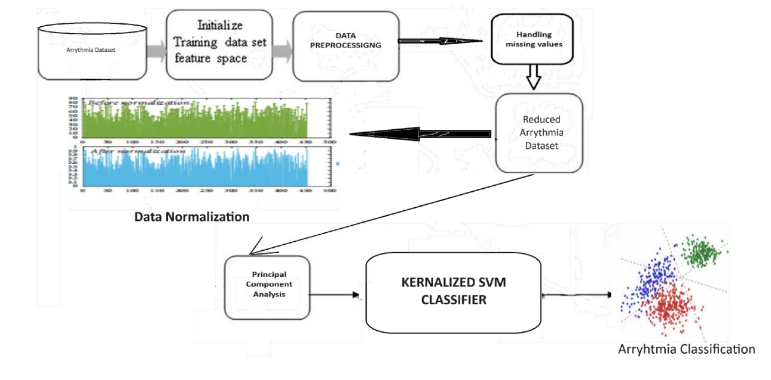

## Figure 2. Architecture diagram

Here’s a brief description of the architecture diagram for arrhythmia classification using Support Vector Machine (SVM) with Principal Component Analysis (PCA)

1. Data Collection:

Input Data: The process begins with collecting ECG (Electrocardiogram) data, which contains signals that represent the electrical activity of the heart.

1. Data Preprocessing:

Noise Removal: Raw ECG data is often noisy. Filtering techniques are applied to remove noise and artifacts.

Segmentation: The continuous ECG signal is divided into segments / heartbeats.

1. Feature Extraction:

Raw Features: Extract features from the ECG segments, such as time-domain features (e.g RR interval) and frequency-domain features (e.g power spectral density).

1. Dimensionality Reduction:

Principal Component Analysis (PCA): PCA is applied to the extracted features to reduce the dimensionality while retaining most of the variance in the data. This helps in reducing computational complexity and avoiding overfitting.

1. Training and Classification:

Support Vector Machine (SVM): The reduced feature set from PCA is fedded into the SVM classifier. SVM is the supervised learning model that finds a optimal hyperplane for classifying the data into different arrhythmia classes.

* Training Phase: SVM is trained using labelled data to learn the decision boundaries.
* Testing Phase: The trained SVM model is used to classify new, unseen ECG data.

6. Post-Processing:

- Decision Making: The output from the SVM classifier indicates the type of arrhythmia. Post-processing steps may include aggregating results from multiple segments to make a final decision.

7. Output:

- Classification Result: The final output is the classification of the ECG segment into different types of arrhythmia (e.g., normal, atrial fibrillation, ventricular tachycardia).

The architecture for arrhythmia classification using SVM with PCA involves several key steps:

1. Data collection and preprocessing to clean and segment the ECG signals.
2. Feature extraction to derive meaningful features from the ECG data.
3. Dimensionality reduction using PCA to streamline the feature set.
4. Training an SVM classifier to distinguish between different arrhythmia types.
5. Post-processing to refine the classification results.
6. Outputting the final classification of arrhythmia types.

This approach combines the power of PCA for efficient feature representation and SVM for robust classification, making it effective for arrhythmia detection and classification tasks.

**1.5 Organization of the Report**

The report that we have created is divided into the following Chapters.They are:

**Chapter 1: Introduction**

In the first chapter, there is a brief introduction to the project was provided. Along with the proper objective and methodology documentation was provided. An architecture diagram conveying the steps followed in the weapon detection.

**Chapter 2: Literature Survey**

In this chapter, there 10 existing approaches are discussed along with the literature review and summary of the drawbacks of the existing approaches.

**Chapter 3: Proposed Method**

In this chapter, the problem statement and objective of the project is described and then followed by the details of the architecture diagram, modules and its description. This chapter also involves hardware and software requirements, functional and non-functional requirements of the project. Additionally, for better visualization of the proposed method Class Diagrams, Sequence Diagrams, Use case Diagrams and Activity Diagram are also provided.

**Chapter 4: Results and Discussion**

In this chapter, description about the dataset used for the working of the project is followed by detailed explanation of experimental results and significance of proposed method is provided.

**Chapter 5: Conclusion and Future Enhancement**

In this chapter, the summary of project highlighting objectives, importance, approach that is adapted is followed by the results and future enhancement is provided in detail.

**Chapter 6: Appendices**

This chapter consists of sample code of the proposed method.

**CHAPTER 2**

**LITERARTURE SURVEY**

**2.1 Summary of Existing Approaches**

**1. Cardiac arrhythmia classification using svm, knn and naive bayes algorithms:**

Our study focuses on classifying Cardiac Arrhythmia into 16 types using SVM, KNN, and Naïve Bayes algorithms. We utilized the UCI Arrhythmia dataset and reduced features through selection techniques. Notably, we achieved accuracy improvements: 9.9% for SVM, 3.3% for KNN, and a significant 24.2% for Naïve Bayes with relevant features. Our multiclass classification, considering relevant features, showcased SVM (71.4% accuracy) and Naïve Bayes (70.3% accuracy) outperforming KNN (62.6% accuracy) post-feature selection.

**2.Multiclass Classification of Cardiac Arrhythmia Using Improved Feature Selection and SVM Invariants:**

This method utilizes a dataset comprising labeled ECG data covering various arrhythmia types for multiclass classification. The accuracy achieved depends on the effectiveness of feature selection techniques and the robustness of SVM invariants. Accuracy metrics specific to multiclass classification, such as F1-score or confusion matrices, would be reported to evaluate the model's performance. The dataset's diversity and quality play a crucial role in achieving high accuracy. SVM invariants help enhance classification accuracy by imposing constraints on the SVM model, improving its ability to differentiate between different arrhythmia classes.

**3.Arrhythmia Classification based on Multi-domain feature extraction:**

This approach utilizes a dataset containing ECG recordings with annotations for different arrhythmia types. Accuracy metrics such as accuracy, sensitivity, and specificity would be reported based on the model's performance. The accuracy achieved depends on the effectiveness of feature extraction from multiple domains and the robustness of the classification algorithm used. The dataset's diversity and quality are critical for capturing subtle variations in the ECG signals across different arrhythmia classes. While multidomain feature extraction enhances classification accuracy, it also increases computational complexity.

**4.Cardiac arrhythmias classification using photoplethysmography database:**

This approach relies on data from a photoplethysmography (PPG) database, which measures changes in blood volume and provides insights into cardiovascular activity. The dataset used includes PPG signals that may exhibit patterns indicative of various cardiac arrhythmias. Accuracy metrics specific to PPG-based classification, such as sensitivity and specificity for arrhythmia detection, would be reported. However, accuracy assessment may also involve validation against ECG-based classifications to ensure reliability. The advantage lies in PPG's non-invasiveness and potential for real-time monitoring, but its limitations in detecting certain arrhythmia types should be considered.

**5.Arrhythmia classification using SVM with selected features:**

This method employs Support Vector Machines (SVM) for arrhythmia classification using a dataset comprising labeled ECG recordings. Accuracy metrics such as classification accuracy, sensitivity, and specificity would be reported to evaluate the model's performance. The accuracy achieved depends on the quality of feature selection and the effectiveness of SVM in classification. The dataset's diversity and size play a crucial role in achieving high accuracy, along with careful feature selection to ensure informative features are retained. The advantage lies in reduced computational complexity and improved generalization, but appropriate feature selection is essential for accurate classification.

**6.ECG arrhythmia classification based on logistic model tree:**

This approach typically uses a dataset containing labeled ECG recordings with various arrhythmia patterns. The accuracy achieved would vary based on the dataset's diversity and size, as well as the quality of model training and tuning. Accuracy metrics such as sensitivity, specificity, and overall classification accuracy would be reported based on the model's performance. The logistic model tree aims for high accuracy in classifying arrhythmias while providing interpretability. However, overfitting can occur if the model becomes too complex. Regularization techniques and cross-validation are commonly used to address this issue and ensure accurate generalization.

**7.A Study on Arrhythmia via ECG Signal Classification Using the Convolutional Neural Network**

Cardiovascular diseases (CVDs) are a major cause of death globally. Currently, diagnosing these diseases involves analyzing Electrocardiogram (ECG) data, which can be resource-intensive due to the need for expert analysis. To address this, machine learning-based methods for ECG analysis have gained popularity. However, existing methods often require manual feature recognition, complex models, and lengthy training.

This paper introduces a 12-layer deep one-dimensional convolutional neural network designed to classify five micro-classes of heartbeat types using the MIT-BIH Arrhythmia database. The model incorporates a wavelet self-adaptive threshold denoising technique, outperforming other methods such as BP neural networks and random forests in accuracy, sensitivity, robustness, and noise resistance. This efficient classification saves medical resources, making it beneficial for clinical applications.

**8.A review on deep learning methods for ECG arrhythmia classification**

This paper reviews recent advances in Deep Learning (DL) applied to Electrocardiogram (ECG) signal classification for healthcare. It covers methods like Convolutional Neural Networks (CNN), Deep Belief Networks (DBN), Recurrent Neural Networks (RNN), Long Short-Term Memory (LSTM), and Gated Recurrent Unit (GRU). Among 75 studies from 2017-2018, CNN emerges as the most utilized technique for feature extraction in 52% of cases. DL methods achieve high accuracy in classifying Atrial Fibrillation (AF) (100%), Supraventricular Ectopic Beats (SVEB) (99.8%), and Ventricular Ectopic Beats (VEB) (99.7%) using GRU/LSTM, CNN, and LSTM, respectively.

**9. Analysis and classification of cardiac arrhythmia based on general sparsed neural network of ECG signals**

In this paper, we focus on efficiently classifying arrhythmia using a General Sparsed Neural Network (GSNN), a robust and reliable technique. We utilize the MIT-BIH dataset to select different classes of ECG beats, and signal-to-noise ratio analysis aids in filtering the ECG signals. Our GSNN extracts ECG signal features, which are then processed by a neural network for final classification. MATLAB software is employed for evaluation.

Our aim is to design an efficient neural network and implement reliable techniques for accurate arrhythmia classification. We achieved an impressive accuracy rate of 98%, the highest reported. This GSNN approach significantly enhances arrhythmia detection compared to other methods, promising improved prediction and classification efficiency.

**10.Arrhythmia classification detection based on multiple electrocardiograms databases**

Cardiovascular diseases top the list of global mortality causes, prompting a vital need for effective heart disease detection methods like Electrocardiogram (ECG). However, the challenge lies in limited ECG samples and imbalanced data distribution across existing databases, making neural network training difficult. This paper delves into three meticulously labeled ECG databases, standardizes sampling rates, proposes a selfprocessing technique for heartbeats, and amalgamates them into a comprehensive ECG arrhythmia classification database named Hercules-3. Splitting it into 80% training and 20% testing sets, we developed a 16-classification fully connected neural network on Hercules-3, achieving a remarkable 98.67% accuracy rate. Our method surpasses others by enhancing recall, accuracy, and F1-score by at least 6%, 4%, and 7%, respectively.

**11.Classification of Electrocardiogram Signals for Arrhythmia Detection Using Convolutional Neural Network**

Detecting cardiovascular diseases promptly is crucial to reducing mortality rates, but diagnosing cardiac arrhythmia early is challenging. Analyzing ECG data manually with a Holter monitor is difficult, leading researchers to explore Convolutional Neural Networks (CNNs) for automated ECG signal identification. This study presents a 9-layer CNN model that categorizes ECG signals based on ANSI and AAMI standards using the MITBIH arrhythmia dataset. The model achieved exceptional performance, with a sensitivity of 99.0% and a positive predictivity of 99.2% for VEB detection, as well as 99.0% sensitivity and 99.2% positive predictivity for SVEB detection, resulting in an overall accuracy of 99.68%.

**12.Analysis and classification of heart diseases using heartbeat features and machine**:

This study introduces a machine learning-based ECG (Electrocardiogram) classification method utilizing various ECG features. An ECG signal measures the heart's electrical activity. Our approach is implemented using MLlib and Scala on the Apache Spark framework, known for scalable machine learning capabilities. The main challenge in ECG classification lies in handling signal irregularities crucial for patient status detection. Thus, we propose an efficient classification method achieving high accuracy.

Each heartbeat comprises distinct action impulse waveforms from specialized cardiac tissues, posing classification challenges due to waveform variations among individuals, described by specific features. These features serve as inputs for the machine learning algorithm. Leveraging Spark-Scala simplifies algorithm usage, especially for large datasets. Our evaluation used a dataset with 205,146 records, employing various classification algorithms like Decision Trees, Random Forests, and Gradient-Boosted Trees (GDB).

We assessed our method on MIT-BIH Arrhythmia and MIT-BIH Supraventricular Arrhythmia databases, achieving 96.75% accuracy with GDB Tree and 97.98% with Random Forest for binary classification. For multi-class classification, Random Forest achieved 98.03% accuracy, while Gradient Boosting Tree supported binary classification only.

**Table 1:Summary of Existing Approaches:**

|  |  |  |  |  |  |
| --- | --- | --- | --- | --- | --- |
| **REFERENCE NO** | **AUTHOR** | **TITLE** | **METHODOLOGY** | **YEAR OF PUBLIACTION** | **ACUURACY** |
| [1] | Raghavendra M Devadas | **Cardiac**  **arrhythm**  **ia classificat ion using svm, knn and naive bayes**  **algorithm**  **s** | **Dataset:** UCI Arrhythmia dataset. **Feature Selection:** Technique to reduce irrelevant features, enhancing model performance. **Algorithms:** SVM, KNN, Naïve Bayes. |  | 71.4% |
| [2] | Anam Mustaqeem,Syed Muhammad Anwar and Muahammad Majid" | **Multiclass**  **Classification of Cardiac Arrhythmia Using Improved Feature Selection and SVM**  **Invariants** | **Dataset Source**: UCI Machine Learning Data Repository.  **OAO (One-Against-One)**:  Binary classifiers for each pair of |  | 92.07% |
| [3] | Danyang Yuan,Youxi Wang,Dianyin Cui and Lu Cao | **Arrhytmi a**  **Classifica tion based on Multi domain feature extraction** | **2.Multi-domain Feature Extraction:** We've come up with a new approach that combines KICA for nonlinear features and DWT for frequency domain features, giving us a more comprehensive set of features |  | 73% |
| [4] | Qasem Qananwah,Marwa Ababneh and Ahmad Dagamseh | **Cardiac arrhythm**  **ias classificat ion using photoplet hysmogra phy database** | Employed signal-  processing techniques for noise elimination and artifact removal in PPG signals.  Extracted 41 PPG features for classification of cardiac arrhythmias. |  | 98.4% |
| [5] | Narendra Kohli and Nishchal K.Verma | **Arrhythm**  **ia classificat ion using SVM with**  **selected features** | **SVM Methods**: One Against One  (OAO), One Against All (OAA),  Fuzzy Decision Function (FDF), Decision Directed Acyclic Graph (DDAG). |  | 83.7% |
| [6] | V.Mahesh,A.kandaswamy,C.Vimal,B.Sathish | **ECG**  **arrhythm**  **ia classificat ion based on logistic**  **model**  **tree** | **Classifier**: Logistic Model Tree(LMT) to classify 11 arrhythmia types based on the extracted features |  | 98% |
| [7] | Mengze Wu,Yongdu Lu,Wenli Yang,Shen Yuong Wong | **A**  **Study**  **on Arrhythm ia via**  **ECG**  **Signal**  **Classifica tion Using the Convoluti onal Neural**  **Network** | A 12-layer deep one-dimensional convolutional neural network (1D CNN) is used.  Wavelet self-adaptive threshold denoising method is applied. The model classifies five microclasses of heartbeat types using the MIT-BIH Arrhythmia database. |  | 97.4% |
| [8] | Zahra Ebrahimi,Mohammad Loni,Maoud Dneshtalab,Arash Gharehbaghi | **Areview on deep**  **learning methods for ECG**  **arrhythm**  **ia classificat io** | **ModelImplementation**: Applying DL models (CNN, DBN, RNN, LSTM, GRU). |  | 99.8% |
| [9] | ]Sanjay Tanaji Sanamdikar,Satish Tukaram Hamde,Vinayak Ganpat Asutkar | Analysis and  classificati  on of  cardiac arrhythmia  based on general sparsed neural network of  ECG  signals | **Signal Processing**: Signal-tonoise ratio (SNR) was calculated to filter the ECG signals.  **Feature Extraction**: A  General Sparsed Neural Network (GSNN) was used to extract features from the ECG signals.  **Classification**: The extracted features were processed by the neural network to classify the arrhythmias. |  | 98% |
| [10] | Men Qi,Hongxiang Shao,Nianfeng Shi,Guoqiang Wang Yifei Lv, | **Arrhythm**  **ia classificat ion**  **detection based on multiple electrocar diograms database** | A fully connected neural network designed for 16-class ECG arrhythmia classification. |  | **98.67**  **%** |
| [11] | Muhammad Aleem Raza, Muhammad Anwar, Kashif Nisar, Ag. Asri Ag. Ibrahim,  Usman Ahmed Raza, Sadiq Ali Khan, Fahad, | **Classifica tion of Electroca rdiogram Signals for**  **Arrhythm**  **ia**  **Detection**  **Using Convoluti onal Neural**  **Network** | 9-layer CNN for ECG signal classification into 5 ANSI/AAMI categories |  | **99.68**  **%** |
| [12] | Fajr Ibrahem Alarsan,mamoon Younes | **Survey on**  **arrhythm**  **ia classificat ion of**  **ECG**  **signals** | Machine learning-based ECG classification using MLlib and Scala on Apache Spark |  | **98.03**  **%** |

## CHAPTER 3

## PROPOSED METHOD

**3.1 Problem Statement and Objectives**

Here the Problem Statement and the objective of the project are discussed in this section.

**3.1.1 Problem Statement**

The significance of a proposed work in the classification of arrhythmia using SVM with PCA lies in its potential impact on healthcare and medical diagnostics.

Arrhythmias are complex cardiac conditions that require accurate diagnosis for proper treatment. Using advanced machine learning techniques like SVM with PCA can lead to improved accuracy in classifying arrhythmias, thus aiding in better diagnosis and patient management.

Accurate classification of arrhythmias can help in the early detection of potential cardiac abnormalities. Early detection often translates to early intervention and prevention of adverse cardiac events, thereby improving patient outcomes and reducing healthcare costs.

By automating the arrhythmia classification process, the proposed system can help in optimizing resource utilization in healthcare settings. It can reduce the time and effort required for manual ECG analysis, allowing healthcare professionals to focus more on critical tasks.

Once developed, the system can be easily scaled and deployed across different healthcare facilities. This scalability ensures that more patients can benefit from accurate arrhythmia classification regardless of their geographical location or access to specialized medical expertise.

The project contributes to the field of medical research and development by exploring the application of advanced machine learning algorithms in healthcare.

Ultimately, the significance of the proposed work lies in its potential to enhance patientcentric care. Accurate classification of arrhythmias leads to tailored treatment plans, improved quality of life for patients, and overall advancements in cardiac healthcare.

**3.1.2 Objectives of the Project**

* To use Electrocardiogram (ECG) for our model.It is the most preferred tool used by clinical practitioners to capture heartbeat. ECG is renowned to be costeffective, easy to use .
* To Increase the Model Efficiency.
* To make this model Robustness to noise.
* To make this model to handle large Datasets.That is to make the model Scalability.
* To classify the 16 types efficiently.

**3.2 Detailed Explanation of Architecture Diagram:**



**Arrhythmia Dataset:** This is the foundational component of your project, consisting of a comprehensive collection of electrocardiogram (ECG) data representing various arrhythmia patterns. The dataset likely includes annotated recordings of heart rhythms, encompassing normal sinus rhythms as well as abnormal patterns indicative of different arrhythmia types such as atrial fibrillation, ventricular tachycardia, or atrioventricular block.

**Initialize Training Dataset Feature Space:** The initialization of the training dataset feature space involves selecting and defining the relevant features (variables) that will be used to train the classification model. These features could include time-domain features (e.g., RR interval, QT interval), frequency-domain features (e.g., power spectral density), and morphology-based features (e.g., P wave amplitude, QRS complex duration). The careful selection of features is crucial as it directly impacts the model's ability to accurately classify arrhythmias.

**Data Preprocessing:** In the data preprocessing stage, several crucial tasks are performed to ensure the quality and integrity of the training dataset. This includes handling missing values through imputation techniques such as mean imputation or predictive modeling, addressing outliers that could skew the model's learning process, and normalizing feature values to a standardized scale to prevent bias in the model's training.

**Handling Values:** This step focuses on handling categorical variables and addressing any class imbalances within the dataset. Categorical variables may be encoded using techniques like one-hot encoding or label encoding to make them compatible with machine learning algorithms. Class imbalance, where certain arrhythmia types may be underrepresented compared to others, is mitigated through techniques such as oversampling, undersampling, or using algorithms designed to handle imbalanced data, ensuring fair representation during model training.

**Reduced Arrhythmia Dataset:** Dimensionality reduction techniques are applied to the preprocessed dataset to create a Reduced Arrhythmia Dataset. These techniques, such as Principal Component Analysis (PCA), linear discriminant analysis (LDA), or feature selection algorithms like Recursive Feature Elimination (RFE), aim to reduce the number of features while retaining as much relevant information as possible. This reduction not only improves computational efficiency but also helps in avoiding overfitting and improving model generalization.

**Principal Component Analysis (PCA):** This is a widely used dimensionality reduction technique which transforms the dataset into a set of orthogonal components, each representing a linear combination of the original features. These components, known as principal components, capture the maximum variance in the data. By retaining a subset of these principal components that contribute significantly to the variance, PCA effectively reduces the dataset's dimensionality while preserving essential information for accurate classification.

**Kernelized SVM (Support Vector Machine):** The final stage involves utilizing a Kernelized Support Vector Machine (SVM) for arrhythmia classification. SVMs are powerful supervised learning algorithms capable of handling both linear and non-linear classification tasks. The "kernel trick" is employed to transform the data into a higher-dimensional space where nonlinear relationships can be effectively captured through hyperplanes. This allows the SVM to create a decision boundary that maximally separates different arrhythmia classes, leading to accurate classification results.

In summary, the architecture encompasses a systematic workflow starting from raw ECG data, progressing through preprocessing, feature selection, dimensionality reduction, and culminating in the utilization of advanced machine learning techniques like Kernelized SVM for robust and accurate arrhythmia classification. Each step is designed to optimize data quality, enhance computational efficiency, and improve the model's ability to effectively identify and classify various arrhythmia patterns.

**3.2.1 MODULE CONNECTIVITY DIAGRAM**

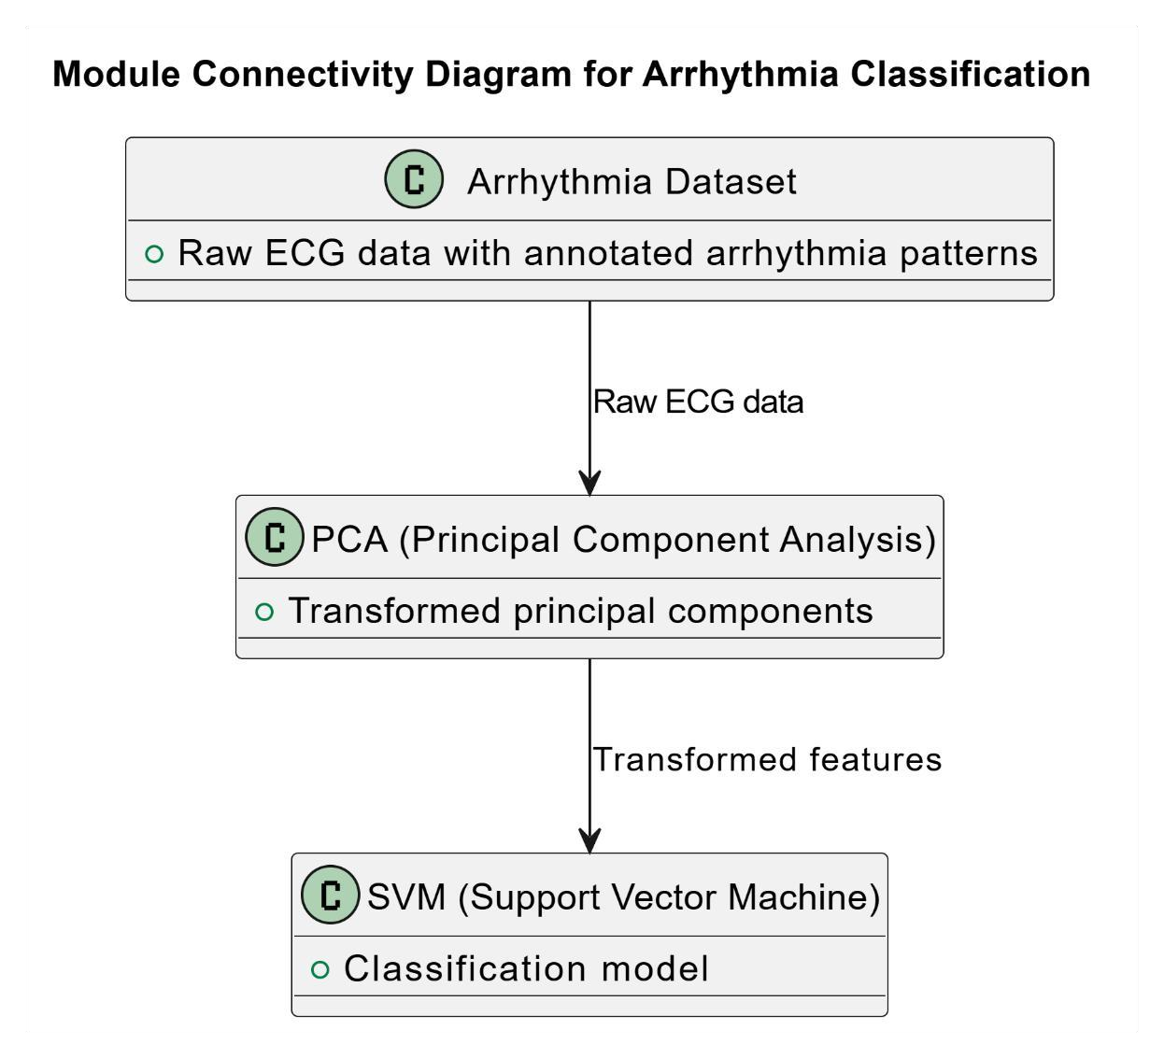

**3.3 Modules and its Description:**

**Arrhythmia Dataset Module:**

* + - **Description:** This module represents the initial dataset containing raw ECG data with annotated arrhythmia patterns. It serves as the starting point for the arrhythmia classification process.
    - **Connectivity:** The Arrhythmia Dataset module provides input data to both the PCA module and the SVM module.

**PCA (Principal Component Analysis) Module:**

* + - **Description:** The PCA module performs dimensionality reduction on the input dataset, transforming it into a set of principal components that capture the most significant features while reducing dimensionality.
    - **Connectivity:**
      * Receives input data from the Arrhythmia Dataset module.
      * Provides the transformed principal components as input to the SVM module.

**SVM (Support Vector Machine) Module:**

* + - * **Description:** The SVM module utilizes the transformed features from PCA to build and train a Support Vector Machine model for arrhythmia classification. SVM is effective in creating an optimal hyperplane to separate different arrhythmia classes. **Connectivity:**
      * Receives input from the PCA module (transformed features).
      * Outputs the classification model, which can then be used for arrhythmia classification tasks.

The Arrhythmia Dataset Module provides the initial dataset to both the PCA Module and the SVM Module. The PCA Module performs dimensionality reduction and passes the transformed features to the SVM Module, where the actual classification model is built

and trained. This modular approach ensures a systematic flow of data and processing

steps, leading to accurate arrhythmia classification using SVM with PCA.

## CONNNECTIVITY

1. **Arrhythmia Dataset Module to PCA Module Connectivity:**
   * + - The Arrhythmia Dataset Module serves as the source of raw ECG data containing arrhythmia patterns.
       - This module directly connects to the PCA Module, providing the initial dataset as input for dimensionality reduction.
       - The connectivity ensures that the PCA Module receives the necessary data to perform its transformational tasks, extracting essential features while reducing dimensionality.
2. **Arrhythmia Dataset Module to SVM Module Connectivity:**
   * + - Similar to the connectivity with the PCA Module, the Arrhythmia Dataset Module also connects to the SVM Module. o This connection ensures that the SVM Module has access to the original dataset, which may be needed for validation or testing purposes alongside the transformed features.
       - While the PCA Module focuses on feature extraction and dimensionality reduction, the direct connection to the SVM Module allows for a streamlined process of data flow and analysis.
3. **PCA Module to SVM Module Connectivity:**
   * + - The PCA Module serves as an intermediary step between the Arrhythmia Dataset Module and the SVM Module.
       - After performing dimensionality reduction and feature extraction, the PCA

Module passes on the transformed principal components to the SVM Module. o This connectivity is crucial as it allows the SVM Module to receive optimized input data, enhancing its ability to build an accurate classification model based on the reduced feature space.

Overall, the connectivity between these modules ensures a coherent and efficient workflow in the arrhythmia classification system. The data flows seamlessly from the initial dataset through dimensionality reduction in the PCA Module to the final classification stage in the SVM Module. Each module plays a distinct yet interconnected role, contributing to the overall accuracy and effectiveness of arrhythmia classification using SVM with PCA.

* 1. **Requirements Engineering**
     1. **Functional and Non-Functional Requirements:**

**3.4.1.1 Functional Requirements:**

1. **Data Ingestion:**

o The system must be able to import ECG data from various formats (e.g., CSV, XML, HDF5).

The system must support the ingestion of labeled arrhythmia datasets for training purposes.

1. **Data Preprocessing:**
   * + - * The system must normalize the ECG data to ensure consistency. o The system must handle missing values by using appropriate imputation methods.
         * The system must remove or handle outliers in the ECG data.
2. **Feature Extraction:**

o The system must extract relevant features from the ECG data, including time-domain and frequency-domain features.

1. **Dimensionality Reduction:**
   * + - * The system must apply Principal Component Analysis (PCA) to reduce the dimensionality of the feature set.
         * The system should retain the principal components that capture the majority of the variance in the data.
2. **Model Training:**

o The system must train a Support Vector Machine (SVM) classifier using the reduced feature set obtained from PCA. o The system must allow for parameter tuning of the SVM classifier to optimize performance.

1. **Model Validation:**
   * + - * The system must validate the trained SVM model using techniques such as cross-validation.
         * The system must evaluate model performance using metrics like accuracy, precision, recall, and F1-score.
2. **Arrhythmia Classification:**
   * + - * The system must classify new ECG data into different arrhythmia types based on the trained SVM model.
         * The system must provide classification results with confidence scores.
3. **User Interface:**
   * + - * The system must provide a user-friendly interface for inputting new ECG data.
         * The system must display classification results in an interpretable format.
         * The system must allow users to visualize ECG data and the corresponding classification results.
4. **Reporting and Analysis:**

o The system must generate detailed reports of classification results, including performance metrics and identified arrhythmia types. o The system should provide tools for analyzing classification outcomes and identifying potential areas for improvement.

1. **Integration:**
   * + - * The system must integrate with existing healthcare information systems to allow for seamless data exchange.
         * The system should support API endpoints for programmatic access to classification functionalities.

**3.4.1.2 Non-Functional Requirements:**

1. **Performance:**

The system must process and classify ECG data in real-time or near realtime to be useful in clinical settings.

The system must handle large volumes of ECG data efficiently without significant delays.

2. **Scalability:**

o The system must be scalable to handle an increasing amount of ECG data and concurrent users. o The system architecture should support distributed computing to enhance scalability.

3. **Reliability:**

The system must be reliable and available with minimal downtime.

The system must ensure data integrity and consistency throughout the processing pipeline.

4. **Security:**

o The system must implement robust security measures to protect patient data, including encryption and access control. o The system must comply with relevant healthcare regulations (e.g., HIPAA) regarding data privacy and security.

5. **Usability:**

The system must be intuitive and easy to use for healthcare professionals with varying levels of technical expertise.

The user interface should be clear and provide helpful prompts and guidance for users.

6. **Maintainability:**

The system must be designed for easy maintenance and updates.

The codebase should be modular and well-documented to facilitate ongoing development and troubleshooting.

7. **Interoperability:**

The system must be able to integrate and operate with other medical devices and healthcare information systems.

The system should use standard data formats and communication protocols to ensure compatibility.

8. **Accuracy:**

The system must maintain high accuracy in arrhythmia classification to be clinically useful.

Continuous monitoring and improvement mechanisms should be in place to enhance accuracy over time.

9. **Flexibility:**

o The system should be flexible enough to incorporate new algorithms and techniques as advancements in machine learning and medical research emerge.

The system should allow for customization based on specific healthcare facility requirements.

10. **Documentation:**

The system must have comprehensive documentation for users, including manuals and online help resources.

Developers must have access to detailed technical documentation to facilitate development and integration.

By meeting these functional and non-functional requirements, your arrhythmia classification system will be well-positioned to provide accurate, efficient, and reliable support for healthcare professionals in diagnosing and managing cardiac conditions

**3.5 Analysis and Design through UML**

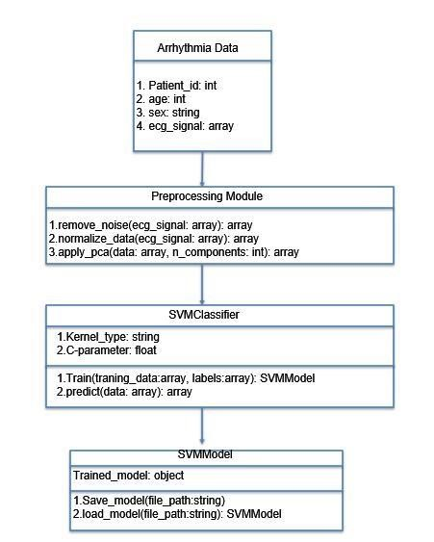

## FIGURE 3.5.1 CLASS DIAGRAM

**1. ArrhythmiaData:**

* **Description:** Represents the data structure containing all relevant information about each patient.
* **Attributes:**
  + patientID: Unique identifier for the patient.
  + age: Age of the patient.
  + sex:Sex of the patient (e.g., Male, Female).
  + ecgSignal: Raw ECG signal data for the patient.
* **Methods:** o getPatientInfo(): Retrieves basic information about the patient. o getECGSignal(): Returns the raw ECG signal data for further processing.

1. **PreprocessingModule:**
   * **Description:** Responsible for preprocessing the ECG signal data, including noise removal, normalization, and applying PCA for dimensionality reduction.
   * **Attributes:** None (purely functional class).
   * **Methods:**
     + removeNoise(ecgSignal): Applies noise removal algorithms to the ECG signal data.normalizeSignal(ecgSignal): Normalizes the ECG signal to a standard scale.applyPCA(ecgSignal): Performs Principal Component Analysis (PCA) to reduce the dimensionality of the ECG signal data. o preprocessData(ecgSignal): Executes the full preprocessing pipeline (noise removal, normalization, and PCA) on the ECG signal data.
2. **SVMClassifier:**
   * **Description:** Represents the Support Vector Machine classifier, which includes methods for training the model on labeled data and making predictions.
   * **Attributes:** o svmModel: Instance of the trained SVM model.
   * **Methods:**
     + trainModel(trainingData, labels): Trains the SVM model using the provided training data and corresponding labels. o predict(ecgSignal): Makes predictions based on the input ECG signal data using the trained SVM model. o evaluateModel(testData, testLabels): Evaluates the trained SVM model using test data and returns performance metrics.
3. **SVMModel:**
   * **Description:** Encapsulates the trained SVM model and provides methods for saving and loading the model from files.
   * **Attributes:** o modelPath: Path to the saved SVM model file.
   * **Methods:**

saveModel(filePath): Saves the trained SVM model to the specified file path. o loadModel(filePath): Loads the SVM model from the specified file path. o getModel(): Returns the current SVM model instance.

**Connectivity Description:**

* + **ArrhythmiaData to PreprocessingModule:**
    - **Description:** The ArrhythmiaData class provides the raw ECG signal data to the PreprocessingModule for initial data preparation steps. This connection ensures that the preprocessing methods have access to the necessary data.
    - **Purpose:** To transform raw ECG data into a preprocessed format that is suitable for SVM training and prediction.
  + **PreprocessingModule to SVMClassifier:**
    - **Description:** The PreprocessingModule processes the ECG signal data and passes the cleaned and reduced data to the SVMClassifier. This
    - processed data is used for training the SVM model and for making predictions.
    - **Purpose:** To ensure that the SVMClassifier operates on high-quality, dimensionally-reduced data, enhancing model accuracy and performance.
  + **SVMClassifier to SVMModel:**
    - **Description:** The SVMClassifier uses the SVMModel class to save the trained SVM model to a file or to load an existing model for making predictions. This interaction allows for model persistence and reuse.
    - **Purpose:** To facilitate the saving and loading of the SVM model, enabling the classifier to be used across different sessions without retraining.

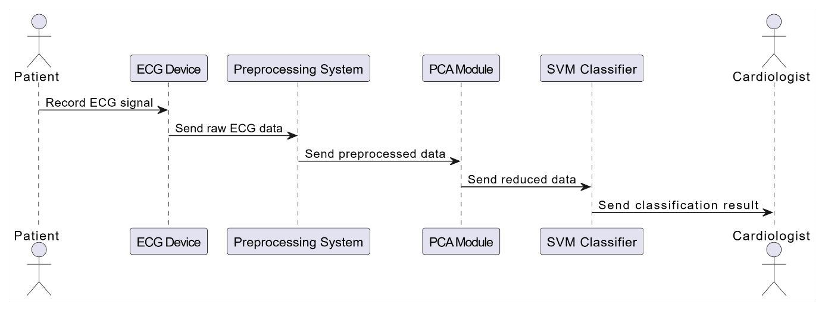

## FIGURE 3.5.2 SEQUENCE DIAGRAM

**ECG Signal Acquisition:**

**Step 1.1:** The patient uses an ECG Device to record heartbeat data. This device could be a wearable ECG monitor or a medical-grade ECG machine.

**Step 1.2:** The ECG Device collects the raw ECG signals from the patient. These signals are typically in the form of electrical impulses that represent the heart's activity over a period of time.

**Preprocessing of ECG Data:**

**Step 2.1:** The ECG Device sends the raw ECG data to the Preprocessing System. This transmission could occur via wired or wireless communication methods, depending on the setup.

**Step 2.2:** The Preprocessing System receives the raw ECG data. This system is responsible for preparing the data for further analysis.

**Step 2.3:** The Preprocessing System filters out noise from the raw ECG signals. Noise can originate from various sources such as patient movement, electrical interference, or baseline wander.

**Step 2.4:** The system normalizes the ECG data, ensuring that all signals are on a comparable scale. Normalization is crucial for accurate analysis.

**Step 2.5:** The system handles missing values in the ECG data. Missing data can occur due to temporary signal loss or other interruptions. The system may use techniques like interpolation or imputation to fill in these gaps.

**PCA for Dimensionality Reduction:**

**Step 3.1:** The preprocessed ECG data is sent to the PCA Module. PCA (Principal Component Analysis) is a statistical technique used to reduce the dimensionality of large datasets while preserving as much variability as possible.

**Step 3.2:** The PCA Module performs dimensionality reduction on the preprocessed data. By identifying the principal components (the directions of maximum variance), PCA transforms the data into a lower-dimensional space.

· **SVM Classification:**

**Step 4.1:** The reduced data from the PCA Module is sent to the SVM Classifier. An SVM (Support Vector Machine) is a supervised learning model that analyzes data for classification and regression analysis.

**Step 4.2:** The SVM Classifier processes the reduced data. Using the trained SVM model, it classifies the data into one of the predefined types of arrhythmia. In this case, the classifier is designed to differentiate between 16 types of arrhythmia.

· **Result Notification:**

**Step 5.1:** The classification result from the SVM Classifier is sent to the Cardiologist. This step ensures that the medical professional receives the classification outcome for further interpretation and action.

**Step 5.2:** The Cardiologist reviews the classification result. Based on the result, the cardiologist can make informed decisions regarding diagnosis, treatment, and management of the patient's condition.

**FIGURE 3.5.3 USE CASE DIAGRAM USE CASE DIAGRAM 1:**

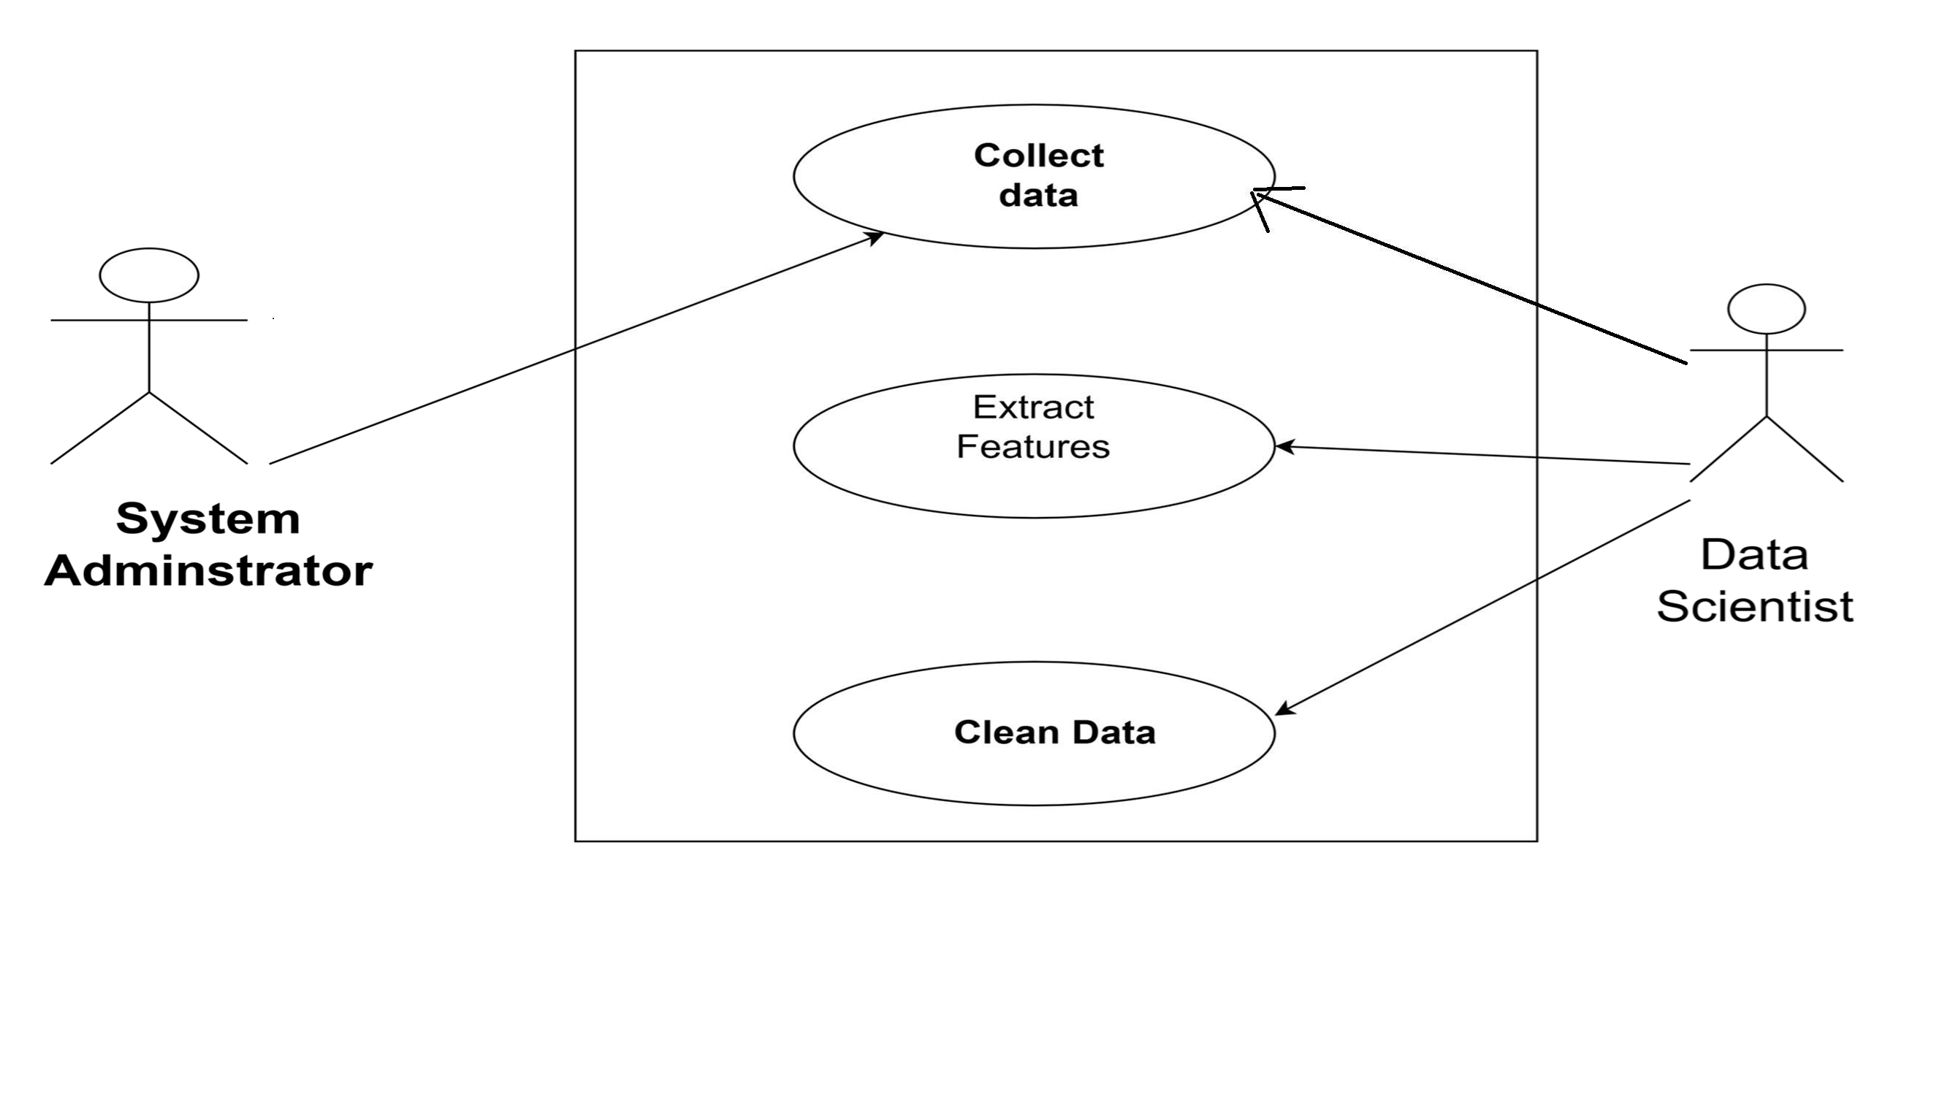

Actors:

* System Administrator: Manages the raw ECG data.
* Data Scientist: Performs data preprocessing and feature extraction.

Use Cases:

* Collect Raw Data: The System Administrator collects the raw ECG data from various sources.
* Clean Data: The Data Scientist cleans the raw data by handling missing values, normalizing the data, and removing outliers.
* Extract Features: The Data Scientist extracts relevant features from the cleaned ECG data.

**USE DIAGRAM 2**

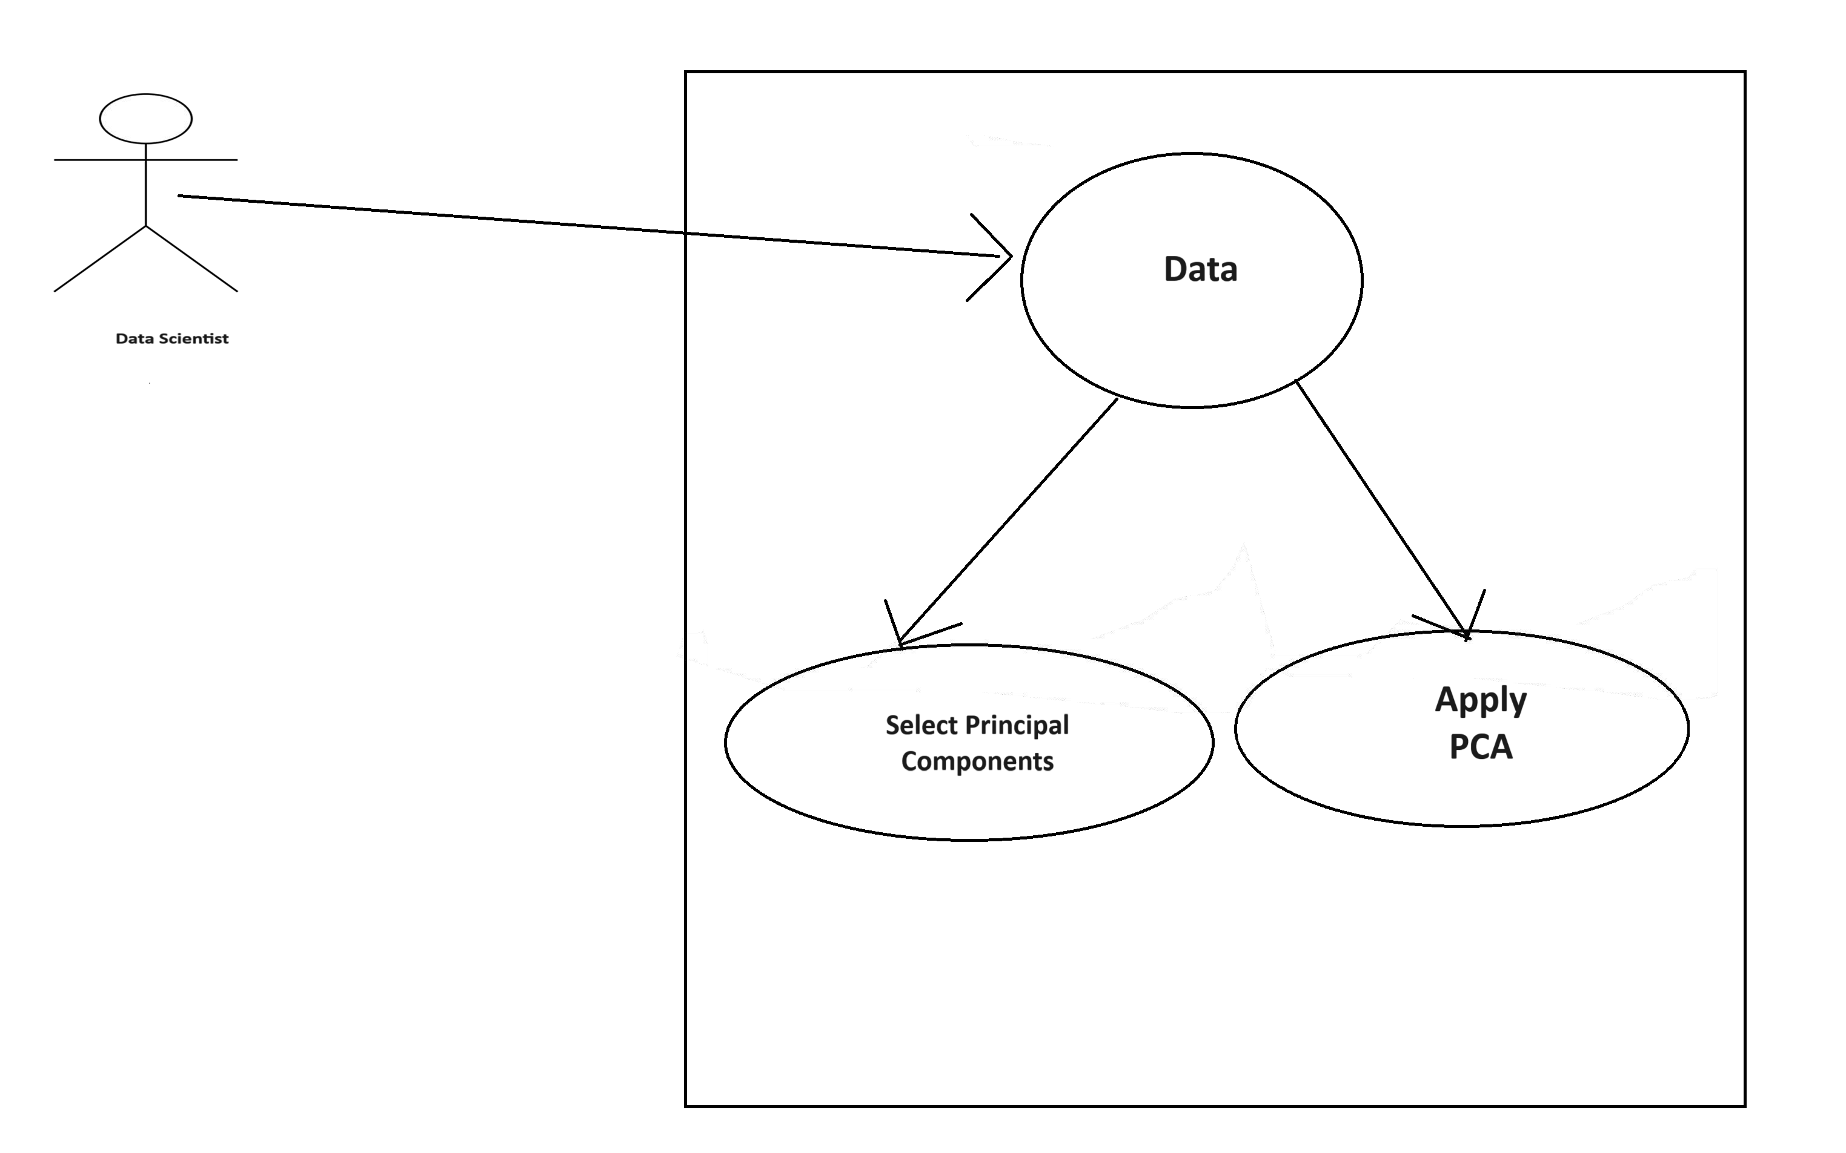

Actors:

* Data Scientist: Performs dimensionality reduction.

Use Cases:

* Apply PCA: The Data Scientist applies Principal Component Analysis to reduce the dimensionality of the extracted features.
* Select Principal Components: The Data Scientist selects the optimal number of principal components that explain a significant portion of the variance.

**USE CASE DIAGRAM 3:**

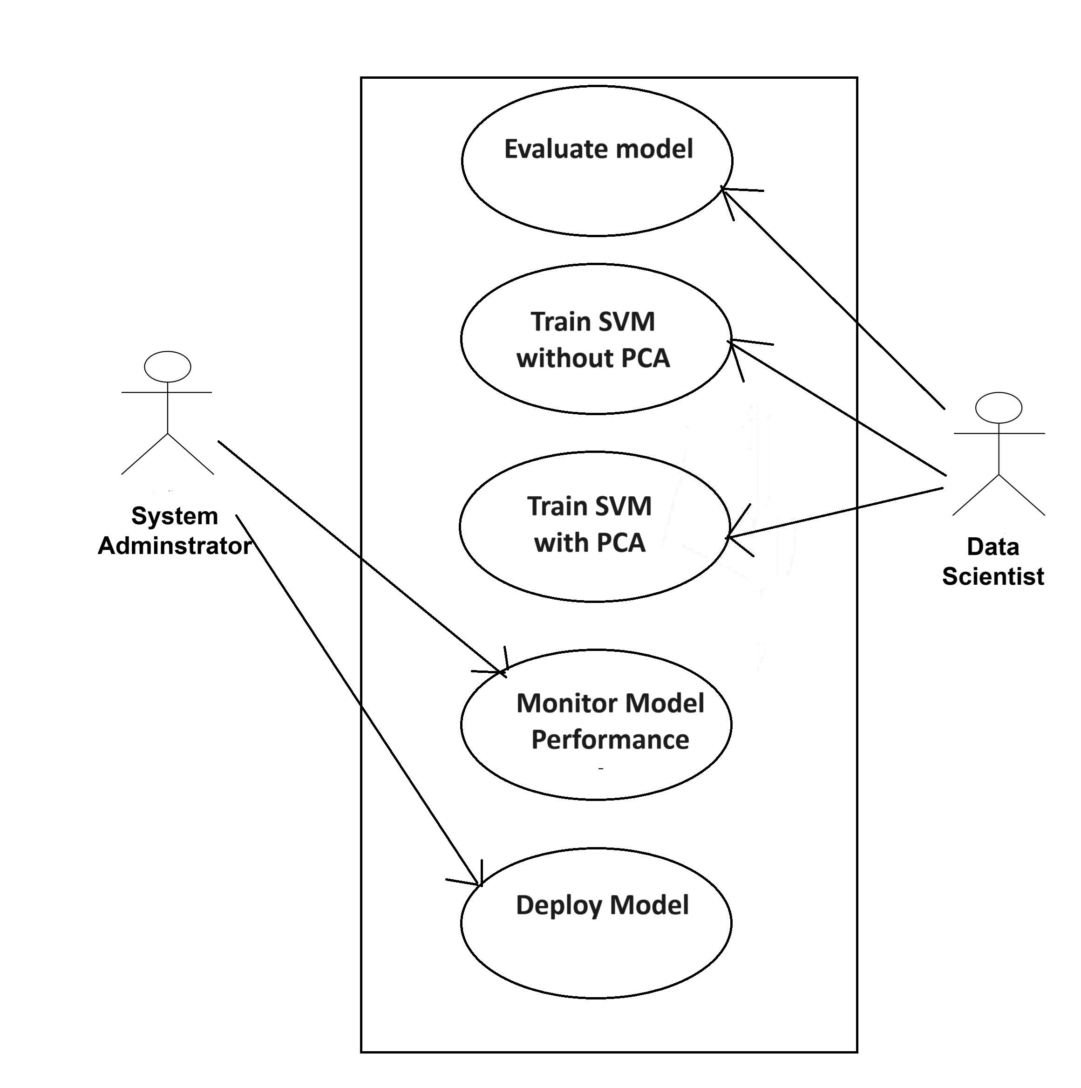

Actors:

* Data Scientist: Trains and evaluates the classification model.
* System Administrator: Oversees the model deployment and maintenance.

Use Cases:

* Train SVM Model: The Data Scientist trains the Support Vector Machine model using the reduced feature set from PCA.
* Evaluate Model: The Data Scientist evaluates the model's performance using metrics like accuracy, precision, recall, and F1-score.
* Deploy Model: The System Administrator deploys the trained model for real-time classification.
* Monitor Model Performance: The System Administrator monitors the model's performance and updates it with new data for continuous improvement.

**3.5.4 Activity Diagram**

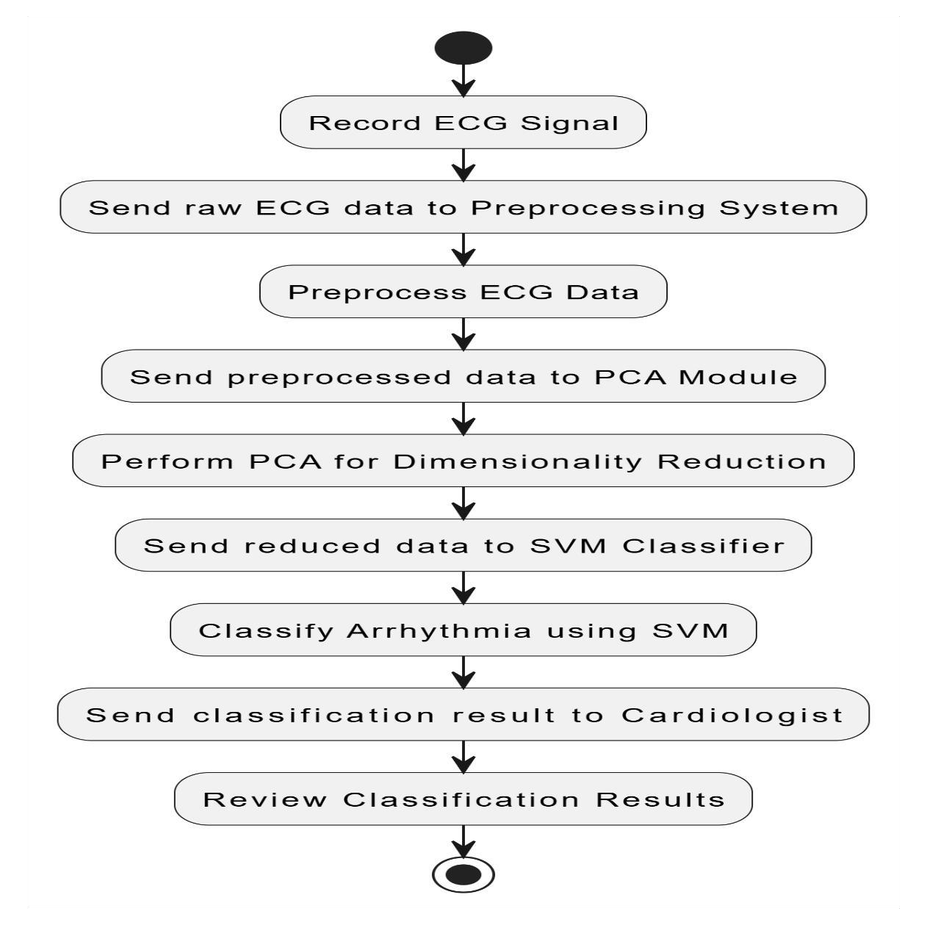

**Record ECG Signal**

The patient uses an ECG device to record their heartbeat data.

**Send raw ECG data to Preprocessing System**

The raw ECG data is transmitted from the ECG device to the preprocessing system.

**Preprocess ECG Data**

The preprocessing system filters noise, normalizes the data, and handles any missing values to prepare the data for further analysis.

**Send preprocessed data to PCA Module**

The preprocessed ECG data is sent to the PCA module for dimensionality reduction.

**Perform PCA for Dimensionality Reduction**

The PCA module performs Principal Component Analysis to reduce the dimensionality of the ECG data, making it more manageable and enhancing the performance of the SVM classifier.

**Send reduced data to SVM Classifier**

The data with reduced dimensionality is sent to the SVM classifier for classification.

**Classify Arrhythmia using SVM**

The SVM classifier uses the reduced data to classify the ECG signals into one of 16 types of arrhythmia based on the patterns learned during training.

Send classification result to Cardiologist

The classification result is sent to the cardiologist for review.

**Review Classification Results**

The cardiologist reviews the classification results to diagnose the patient's condition and determine the appropriate course of action.

**CHAPTER 4**

**RESULTS AND DISCUSSION**

**4.1 Description about the dataset:**

The Dataset used in this project is taken from UCI machine learning Repository.So firstly we will take the ECG data from the database.We perform Data Preprocessing Techniques like Handling Missing values.We generate the Final dataset Splitting The Dataset.Firstly modeling is done with SVM.And At last we will be using PCA(Principle Component Analysis) to reduce the dimension of our sampled dataset to get best feature to find better accuracy.

And finally we apply SVM with PCA.And we compare the acuuracy of the both the models.

**4.1.1 Types Of Arrythmia:**

|  |  |
| --- | --- |
| **Class code** | **Class** |
| **01** | Normal |
| **02** | Ischemic changes(Coronary Artery Disease) |
| **03** | Old Anterior Myocardial Infarction |
| **04** | Old Inferior Myocardial Infarction |
| **05** | Sinus tachycardy |
| **06** | Sinus bradycardy |
| **07** | Ventricular Premature Contraction (PVC) |
| **08** | Supraventricular Premature Contraction |
| **09** | Left bundle branch block |
| **10** | Right bundle branch block |
| **11** | degree AtrioVentricular block |
| **12** | Degree AV Block |
| **13** | degree AV block |
| **14** | Left ventricule hypertrophy |
| **15** | Atrial Fibrillation or Flutter |
| **16** | Others |

**4.2 Detailed explanation about the Experiement Results:**

**RESULT:**

**The Train Accuracy that we obtained is 0.995290 among all the models.**

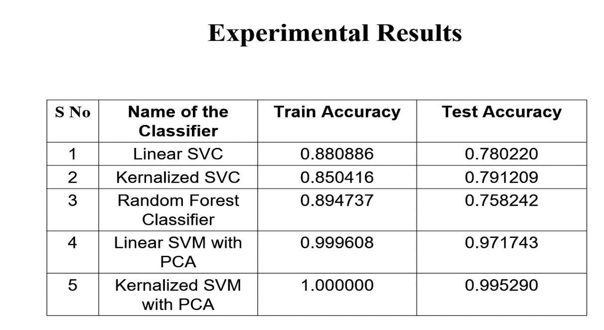

## 4.2.1 Experiement Results

**4.3 Significance of Proposed Method:**

Certainly! Here's an elaboration on the significance of the proposed work in the classification of arrhythmia using SVM with PCA, highlighting its potential impact on healthcare:

**Improved Diagnosis Accuracy:**

Arrhythmias, or irregular heartbeats, present a significant diagnostic challenge due to their complexity and variability. Accurate diagnosis is critical for determining the appropriate treatment and management strategies for patients with cardiac conditions. The integration of advanced machine learning techniques like Support Vector Machines (SVM) combined with Principal Component Analysis (PCA) can significantly enhance the accuracy of arrhythmia classification. SVM is a robust supervised learning algorithm known for its effectiveness in classification tasks, while PCA aids in dimensionality reduction, ensuring that the most relevant features are used for analysis. By leveraging these techniques, the proposed system can more accurately distinguish between different types of arrhythmias, leading to more reliable diagnoses. This improved accuracy is crucial for ensuring that patients receive the correct treatment, thereby improving their overall health outcomes.

**Early Detection and Prevention:**

The ability to accurately classify arrhythmias is not only vital for diagnosis but also for early detection of potential cardiac abnormalities. Early detection is key in preventing severe cardiac events, as it allows for timely intervention. With the proposed system, healthcare providers can identify arrhythmias at an earlier stage, even before symptoms become pronounced. This early detection enables preventive measures to be taken, potentially averting adverse cardiac events such as heart attacks or strokes. By catching these conditions early, the system can contribute to better patient outcomes and potentially save lives. Furthermore, early intervention can reduce long-term healthcare costs by preventing the progression of cardiac diseases and reducing the need for more extensive treatments down the line.

**Decision Support for Healthcare Professionals:**

The proposed arrhythmia classification system can serve as a powerful decision support tool for cardiologists and other healthcare professionals. Interpreting ECG data can be complex and time-consuming, requiring specialized expertise. The system can assist healthcare providers by automatically analyzing ECG data and highlighting potential arrhythmias, thereby streamlining the diagnostic process. This assistance can help

clinicians make more informed and timely decisions regarding patient care. Moreover, it can reduce the cognitive load on healthcare professionals, allowing them to focus on more critical aspects of patient management and treatment planning. The system's ability to provide consistent and accurate analyses can also enhance the quality of care provided, ensuring that all patients receive high-standard, evidence-based care.

**Efficient Use of Resources:**

Automating the arrhythmia classification process with SVM and PCA can lead to significant resource optimization in healthcare settings. Manual analysis of ECG data is labor-intensive and time-consuming, often requiring skilled personnel. By automating this process, the proposed system can free up valuable time and resources for healthcare professionals. This efficiency allows for better allocation of medical staff to other critical tasks, improving overall workflow and productivity in healthcare facilities. Additionally, automation can help in managing larger volumes of ECG data more effectively, making it feasible to screen and monitor more patients within the same timeframe. This increased efficiency can also contribute to cost savings, as it reduces the need for extensive manual labor and allows for better utilization of existing resources.

**Scalability and Accessibility:**

One of the significant advantages of the proposed system is its scalability. Once developed, the system can be deployed across various healthcare facilities, from small clinics to large hospitals, without the need for extensive customization. This scalability ensures that the benefits of accurate arrhythmia classification are accessible to a broader patient population. Additionally, the system can be integrated into telemedicine platforms, providing remote areas with access to advanced diagnostic tools. This accessibility is particularly important in regions with limited access to specialized medical expertise. By democratizing access to high-quality arrhythmia classification, the system can help bridge the gap in healthcare disparities and ensure that more patients receive timely and accurate diagnoses, regardless of their geographical location.

In summary, the proposed work in arrhythmia classification using SVM with PCA holds significant promise for improving healthcare outcomes. It enhances diagnostic accuracy, facilitates early detection and prevention, supports clinical decision-making, optimizes resource use, and ensures scalability and accessibility. These benefits collectively contribute to better patient care, more efficient healthcare delivery, and ultimately, improved public health.

## Chapter 5

## Conclusion and Future enhancements

**5.1 CONCLUSION**

The general purpose of this work is to identify the 16 forms of the Arrhythmia disease using the SVM(i.e:Support vectot machines) with PCA(Principal Component Analysis) approach. Classification of Arrhythmias is an essential area of concern in the field of cardiology as the same is useful for the diagnosis as well as the treatment of heart related rhythmical diseases. By applying SVM as one of the effective machine learning methods to reduce the dimensionality of data using the PCA method the goal is to achieve better results in classification and their faster accomplishment.

**Processes:**

**1. Data Collection**

* Source: Obtain a dataset that includes various features extracted from ECG signals. A commonly used dataset for this task is the MIT-BIH Arrhythmia Database.
* Preprocessing: Clean the data by handling missing values, normalizing the data, and removing any outliers.

**2. Feature Extraction**

* Signal Processing: Extract relevant features from the ECG signals. This can include time-domain features, frequency-domain features, and morphological features.
* Feature Selection: Identify and select the most informative features that contribute to the classification task.

**3. Dimensionality Reduction with PCA**

* Principal Component Analysis (PCA): Apply PCA to the extracted features to reduce the dimensionality of the dataset. PCA helps in transforming the data into a lowerdimensional space while retaining most of the variance in the data.
* Variance Explained: Determine the number of principal components to retain by explaining a significant portion of the variance (e.g., 95%).
* Projection: Project the original features onto the principal components to obtain a reduced feature set.

**4. Model Training**

* Support Vector Machine (SVM): Train an SVM classifier on the reduced feature set obtained from PCA.
* Kernel Selection: Choose an appropriate kernel (e.g., linear, RBF) based on the characteristics of the data.
* Hyperparameter Tuning: Use techniques such as grid search or cross-validation to optimize the hyperparameters of the SVM model.

**5. Model Evaluation**

* Cross-Validation: Evaluate the model using k-fold cross-validation to ensure its generalizability and to avoid overfitting.
* Performance Metrics: Assess the performance of the classifier using metrics such as accuracy, precision, recall, F1-score, and confusion matrix.

**6. Model Testing**

-Test Set Evaluation: Test the trained SVM model on an independent test set to evaluate its performance on unseen data.

- Analysis: Analyze the results and compare the performance with other existing methods or baseline models.

**7. Results Interpretation and Reporting**

* Visualization: Visualize the results using plots such as ROC curves, precisionrecall curves, and confusion matrices.
* Interpretation: Interpret the results to understand the effectiveness of the SVM classifier with PCA in classifying the 16 types of arrhythmia.
* Reporting: Document the findings, methodologies, and conclusions in a comprehensive report.

**5.2 Future Enhancements**

Potential Future Enhancements in the Classification of Arrhythmia using SVM with PCA

Incorporate CNNs or RNNs alongside SVM with PCA for Capturing Intricate ECG

Patterns

Convolutional Neural Networks (CNNs) and Recurrent Neural Networks (RNNs) are powerful deep learning models capable of capturing complex patterns and temporal dependencies in ECG signals. By incorporating CNNs or RNNs with SVM and PCA, we can leverage their strengths in feature extraction and sequence modeling. CNNs are effective in identifying local patterns and features in the ECG data, while RNNs can handle the temporal dynamics and dependencies, providing a more comprehensive analysis of the ECG signals. This hybrid approach could improve the accuracy and robustness of arrhythmia classification.

Explore Random Forests or Gradient Boosting to Combine Predictions for Improved Accuracy

Random Forests and Gradient Boosting are ensemble learning techniques that combine the predictions of multiple models to enhance accuracy and reduce overfitting. By exploring these methods, we can create a more robust classifier by leveraging the strengths of various algorithms, including SVM. Random Forests use a multitude of decision trees, while Gradient Boosting builds sequential models to correct errors from previous ones. Integrating these with SVM and PCA could result in a more reliable and precise arrhythmia classification system.

Develop Mechanisms for Model Updates Based on New Data for Continuous

Improvement

Continuous improvement of the model is crucial for maintaining its relevance and accuracy. Developing mechanisms for model updates involves implementing automated pipelines that retrain the model periodically using new incoming data. This approach ensures that the classifier remains up-to-date with the latest patterns and trends in arrhythmia data, thereby improving its performance over time. Techniques such as online learning or incremental learning can be employed to facilitate these updates without the need for complete retraining from scratch.

Enhance Model Interpretability to Provide Insights into Prediction Rationale

Model interpretability is essential for gaining insights into the decision-making process of the classifier, especially in the medical field. Enhancing model interpretability involves developing methods to explain the rationale behind the predictions made by the SVM model. Techniques such as SHAP (SHapley Additive exPlanations) or LIME (Local Interpretable Model-agnostic Explanations) can be used to provide explanations for individual predictions, helping clinicians understand why a certain arrhythmia type was classified. This transparency is crucial for building trust in the model's predictions.

Implement Real-Time Monitoring with Alert Systems for Prompt Anomaly Detection

Real-time monitoring of ECG signals with integrated alert systems can significantly improve patient care by providing immediate detection of anomalies. Implementing such systems involves designing a pipeline that continuously processes ECG data, applies the trained classifier, and triggers alerts when abnormal patterns indicative of arrhythmia are detected. This setup ensures prompt medical intervention, potentially preventing serious health complications. Real-time systems require efficient data processing and robust model performance to handle continuous data streams.

Extend the System to Handle Multiple Arrhythmia Types Beyond Binary Classification

The current project focuses on classifying 16 types of arrhythmia, but there is potential to extend the system to handle a broader range of arrhythmia types, including rare or newly identified ones. This extension involves collecting more diverse ECG data and retraining the model to distinguish between multiple classes effectively. Techniques such as multiclass SVM or hierarchical classification can be employed to manage the complexity of multiple arrhythmia types, ensuring comprehensive diagnostic capabilities.

By implementing these future enhancements, the arrhythmia classification system can be significantly improved in terms of accuracy, robustness, and applicability in real-world clinical settings.

## CHAPTER 6

APPENDICES

6.1 Sample Code

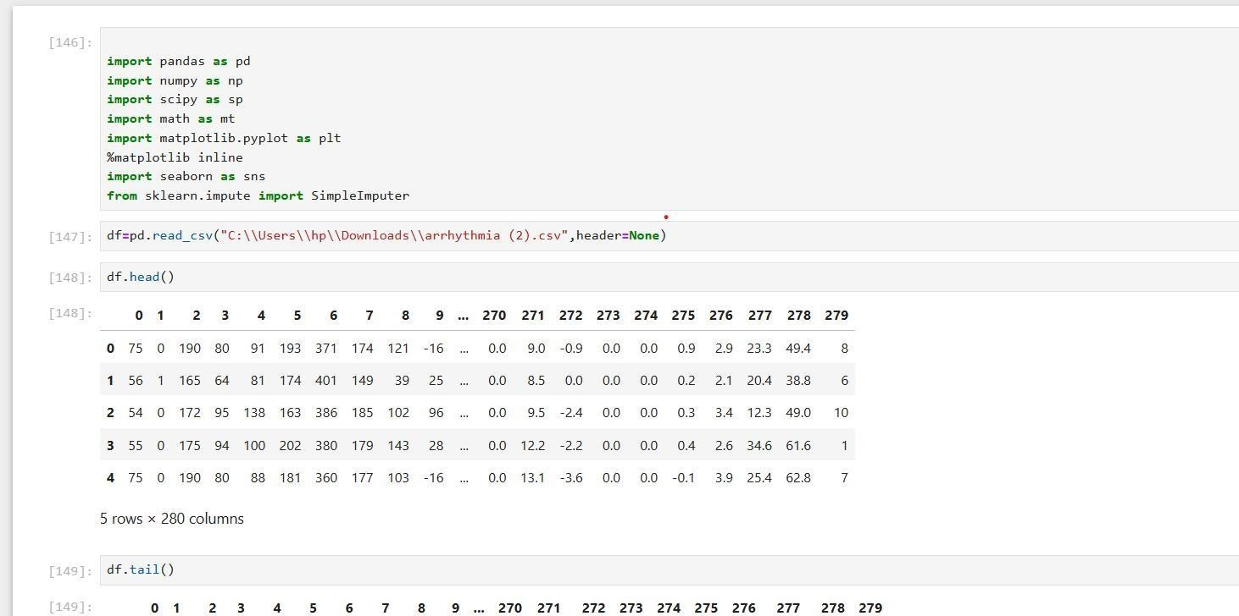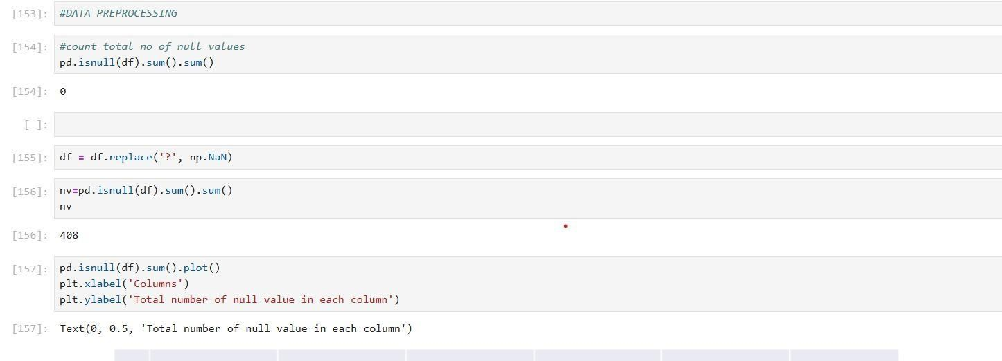

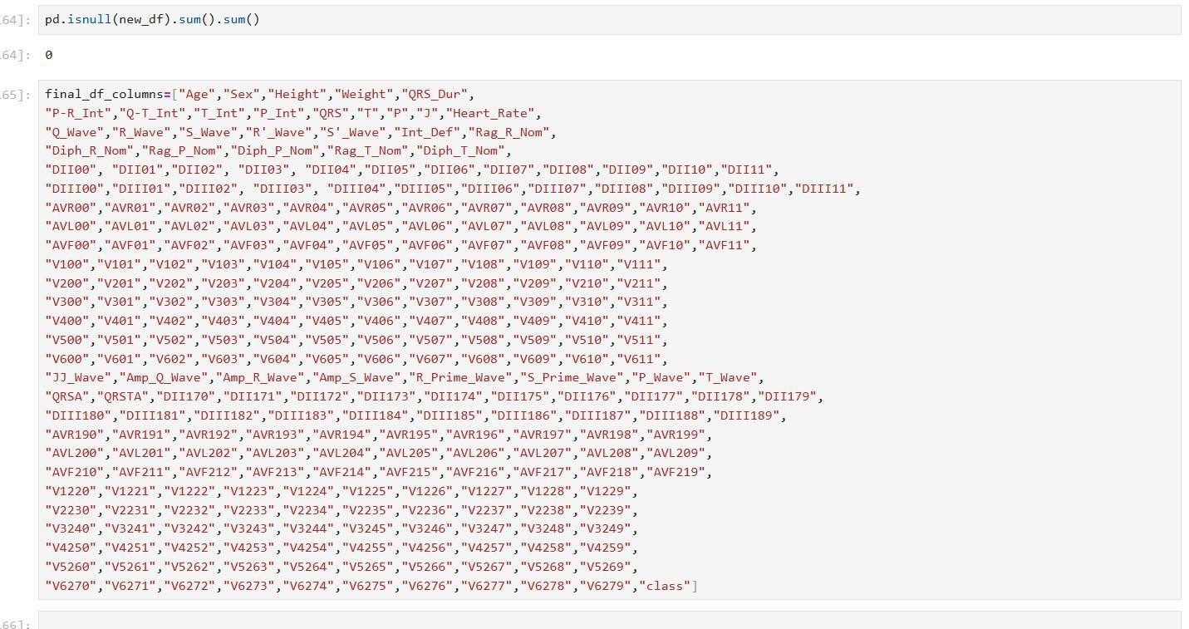

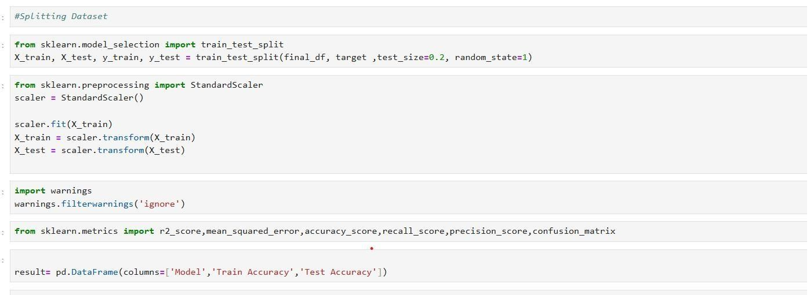

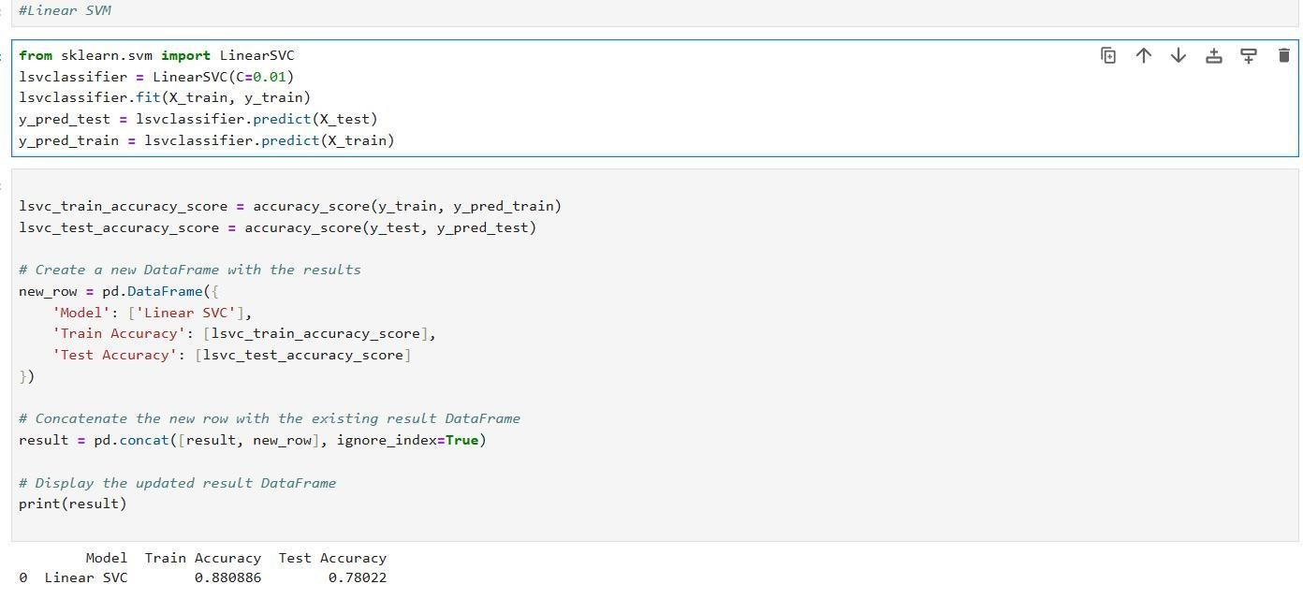

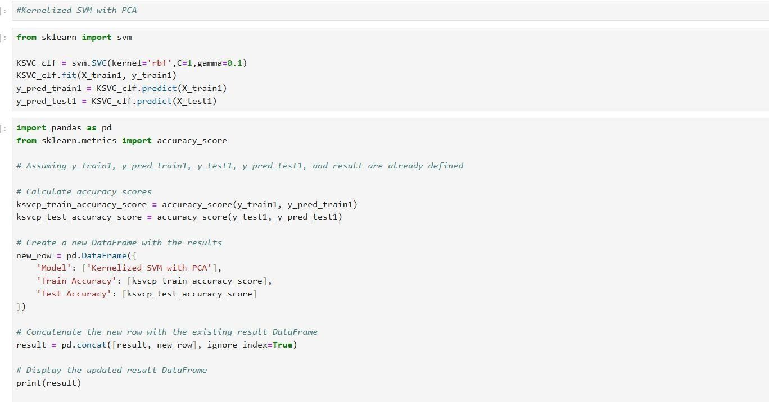

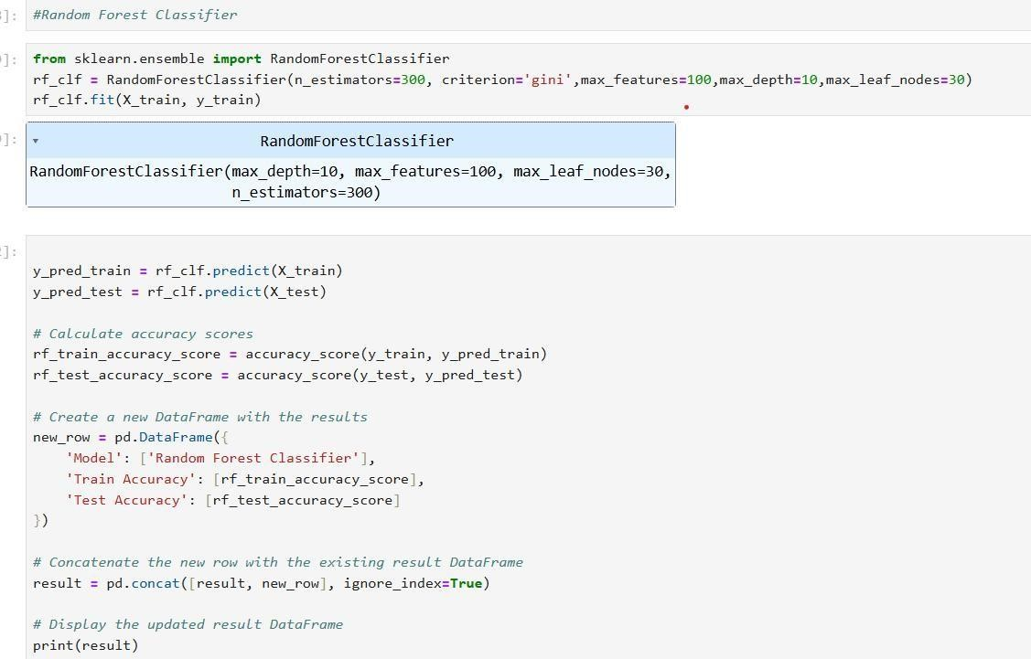

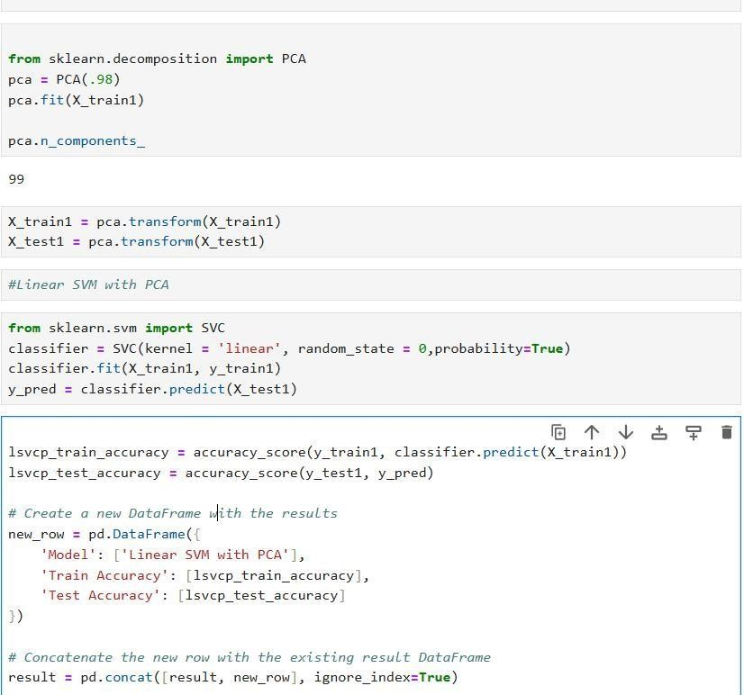

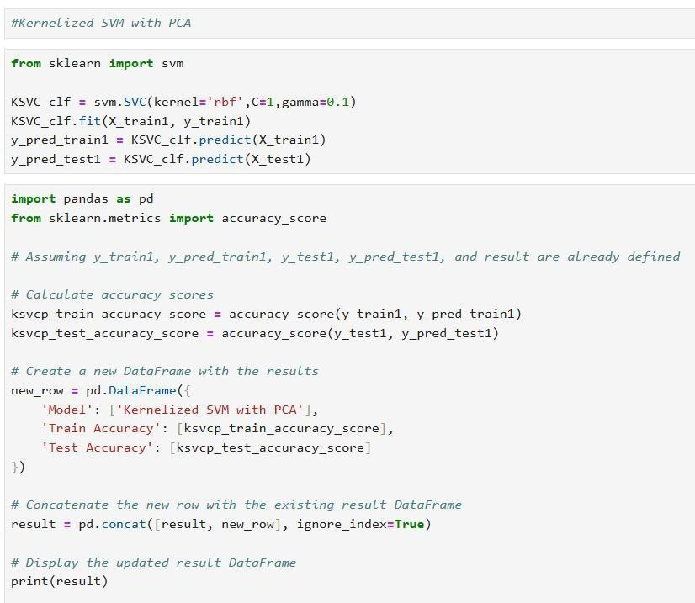

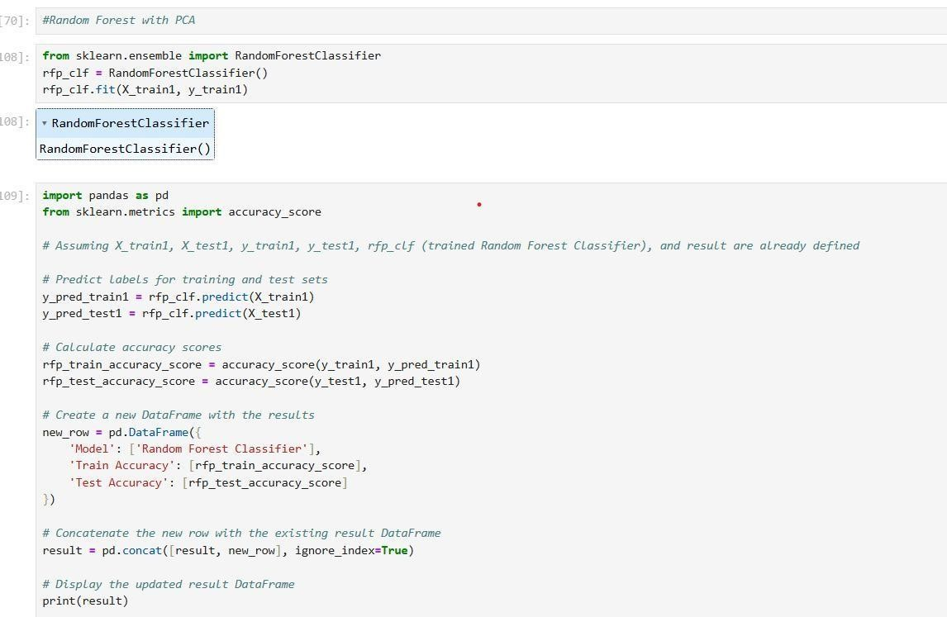

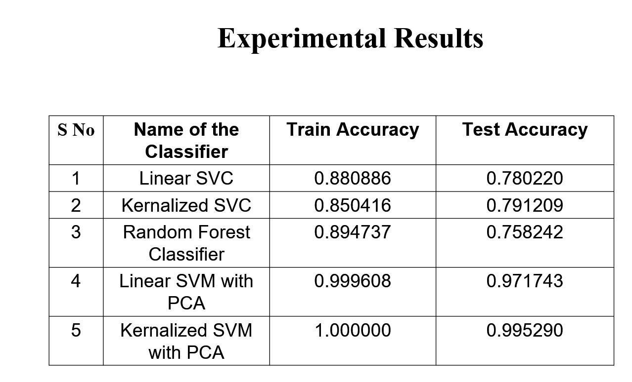

**REFERENCES**

[1] Raghavendra M Devadas**,“Cardiac arrhythmia classification using svm, knn and naive bayes algorithms”** International Research Journal of Engineering and Technology,volume:08 Issue:05 |May 2021 https://www.irjet.net/archives/V8/i5/IRJETV8I5721.pdf

[2].Anam Mustaqeem,Syed Muhammad Anwar and Muahammad Majid"**Multiclass**

**Classification of Cardiac Arrhythmia Using Improved Feature Selection and SVM**

**Invariants "** in , Open Access Vol 2018, pp. 7310496 , 2023

https://www.researchgate.net/publication/323581202_Multiclass_Classification_of_Cardi

ac_Arrhythmia_Using_Improved_Feature_Selection_and_SVM_Invariants

[3]. Danyang Yuan,Youxi Wang,Dianyin Cui and Lu Cao**“Arrhythmia Classification Based on Multi-Domain Feature Extraction for an ECG Recognition System”**,

Tianjin Polytechnic University,Volume-16,issue-09,20th Oct 2016 **https://doi.org/10.3390/s16101744**

[4]. Qasem Qananwah,Marwa Ababneh and Ahmad Dagamseh,”**Cardiac arrhythmias classification using photoplethysmography database"** in open access, Vol 2018, pp.

7310496 , 2023 https://www.ncbi.nlm.nih.gov/pmc/articles/PMC10858029/

[5]. Narendra Kohli and Nishchal K.Verma,**"Arrythmia classification using SVM with selected features”** in , International Journal of Engineering Science and Technology Vol

3 No(8), pp. 2141-2820 , 2211

https://www.ajol.info/index.php/ijest/article/view/80168

[6]. V.Mahesh,A.kandaswamy,C.Vimal,B.Sathish**,“ECG arrhythmia classification based on logistic model tree”,** Department of Information Technology, PSG College of

Technology, Coimbatore, India,Vol 02,9th Jun 2009 https://www.scirp.org/html/794.html

[7].Mengze Wu,Yongdu Lu,Wenli Yang,Shen Yuong Wong **“A Study on**

**Arrhythmia via ECG Signal Classification Using the Convolutional** Department of

**Neural Network"**

|  |  |
| --- | --- |
| Information Engineering, Wuhan University of Technology, Wuhan, China, Volume 14 | |
| 2020 |  |

https://www.frontiersin.org/articles/10.3389/fncom.2020.564015/full

[8].Zahra Ebrahimi,Mohammad Loni,Maoud Dneshtalab,Arash Gharehbaghi, **“A review on deep learning methods for ECG arrhythmia classification”** Department of Innovation, Design and Technology, Mälardalen University, 72123 Västerås, Sweden https://doi.org/10.1016/j.eswax.2020.100033

[9].Sanjay Tanaji Sanamdikar,Satish Tukaram Hamde,Vinayak Ganpat Asutkar,” **Analysis and classification of cardiac arrhythmia based on general sparsed neural network of ECG signals”** Volume 2,published:18 June 2020

https://link.springer.com/article/10.1007/s42452-020-3058-8

[10].Men Qi,Hongxiang Shao,Nianfeng Shi,Guoqiang Wang Yifei Lv, **“Arrhythmia classification detection based on multiple electrocardiograms databases”** Vol.10 , Article No .154, pp. 1-19 Published :September 27,2023.

https://doi.org/10.1371/journal.pone.0290995

1. Muhammad Aleem Raza, Muhammad Anwar, Kashif Nisar, Ag. Asri Ag. Ibrahim,

Usman Ahmed Raza, Sadiq Ali Khan, Fahad, **“Classification of Electrocardiogram**

**Signals for Arrhythmia Detection Using Convolutional Neural Network”,** Vol.2 , Article No .172, pp. 1-21**.**published 26 December 2023

https://doi.org/10.32604/cmc.2023.032275

1. Fajr Ibrahem Alarsan,mamoon Younes, **“Analysis and classification of heartdiseases using heartbeat features and machine learning algorithms”** . Volume 20 Published 31 August 2019 https://journalofbigdata.springeropen.com/articles/10.1186/s40537-019-0244-x