Mistborn: The Last Empire

Become the mistress of the mists!

# High Concept

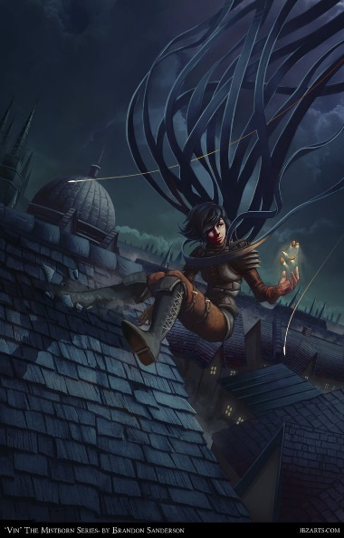 You are Vin, a young urchin with the rare ability to control all of the 7 known powers of Allomancy. Join Kelsier and his troop of honorable thieves as they incite a house war, kindle a revolution, and attempt to bring down the immortal Lord Ruler.

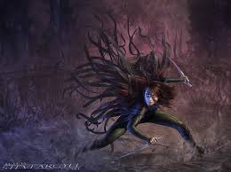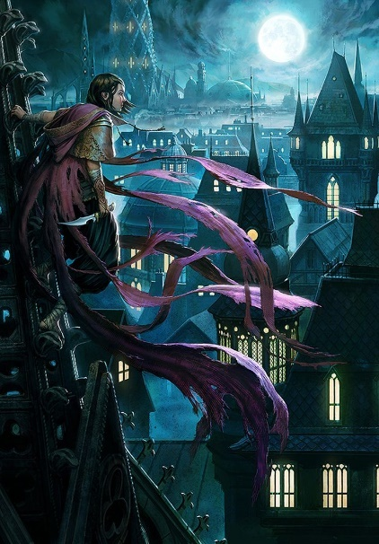

# Features

* The point of view will be third person so that players can have an accurate idea of their surroundings at all times.
* The game will take place in Luthadel, the capital city of the Last Empire. The days are filled with ash and the nights with mist. The keeps of the ruling nobles, built like cathedrals, dot the city, with Kredik Shaw, the Lord Ruler’s palace, standing tall in the center. These huge structures will give the player lots of verticality.
* The player will have 12 abilities (Allomantic skills) at their disposal: enhanced senses and strength, remotely pushing and pulling on metal, enhancing and dampening people’s emotions, and 6 others that will be revealed throughout the story.
* Abilities will be managed by their own mana meter, with some abilities burning up faster than others, making players use each ability strategically.
* By pushing and pulling on anything metallic, players will be able to manipulate the game world, throwing items in all directions, turning pennies into lethal bullets, and soaring throughout the vertically impressive city by pushing and pulling against fixed metal objects.
* Players will participate in a complex and entertaining story about learning to trust, hope and fighting when everything seems hopeless.
* Missions will be given where players are given a goal (assassinations, robberies and rescuing the suppressed lower class, and sabotaging a target’s goals) and will be allowed to accomplish that goal in any way they see fit.
* Progression consists of leveling up Vin’s abilities by increasing stats and unlocking new sub-skills. She will train with Kelsier’s crew members, each a master in a specific Allomantic skill.

# Player Motivation

The major player motivation will be to complete the story, which has twists and turns all over. However, another major draw will be to perfect their skill with the abilities given to them. PvP combat similar to GTA V Online will also be enticing to players.

# Genre

This game is an action-adventure title, with a strong emphasis on stealth.

# License

This game will be an adaptation of the brilliant novel written by American Author Brandon Sanderson. Sanderson has received 13 awards and numerous nominations for his writing, and was handpicked to finish Robert Jordan’s epic Wheel of Time series. A favorite among his many novels, *Mistborn* is the first in a trilogy that Erik Kain, wrote in his Forbes article “’Mistborn’ Review: A Fantasy Masterpiece”, was “crafted with such bloody precision, it's nearly impossible to put the books down”. Furthermore, DMG Entertainment has purchased the movie rights for Sanderson’s novel and announced the screen writer on February 27, 2017[1]. This gives the powerful impression of a safe investment.

# Target Audience

‘Mistborn’ will be targeted to two major groups of players: Those who play for narrative, and those who enjoy stealth combat. As mentioned above, the story has already proven to be solid material, boasting a significant fan base. The combat would be geared more toward stealth, like Arcane Studios’ *Dishonored*, except players will be significantly better equipped for melee combat. This broadens the target audience, drawing in both players that would like to get in and out unseen, and players that would rather go in ‘guns a-blazing’ and cause mass mayhem.

# Competition

‘Mistborn’’s closest competitors will be other action games with stealth mechanics, namely the *Dishonored* series and the Ubisoft’s *Assassin’s Creed* series. This game, however, will allow for more open scenarios. Tanking enemies is a completely viable strategy, something that is hard to pull of in either aforementioned series. Furthermore, while *Dishonored* and *Assassin’s Creed* both give the player plenty of tools, ‘Mistborn’ will allow players to weaponize the surrounding environment, opening up countless possibilities.

# Unique Selling Points

* Players will be able to bound across a world boasting copious verticality.
* Each power will have to be monitored, as use depletes individual reserves, adding another layer of strategy.
* Money players use to buy gear and certain upgrades doubles as ammunition in fights.
* Players will be able to gauge NPC interactions and influence their emotions, such as enraging an argument into a fight, or calming an unaware enemy to relax his guard. This is a layer of strategy never before seen.
* The game is an adaptation of an already well-established series, which has two sequel trilogies planned and is part of a larger universe of equally excellent novels. Upon success, the IP has several directions in which to grow.

# Target Hardware

PS4, Xbox One and PC. Maybe Switch.

# Design Goals

* **Engaging, Exciting Story:** The game will adapt an already acclaimed story and bring it to an even larger audience. With twists, turns, and foreshadowing you will only see on subsequent playthroughs, the story is gold. Furthermore, it is a heartwarming tale about finding hope when all seems hopeless.
* **Open-Ended, Strategic Combat:** Players will be given a location and a target, and allowed to complete the objective anyway they choose. This greatly broadens the target audience, inviting both the careful and the reckless. Players will be given tools for locating enemies, hiding themselves, melee and ranged combat, manipulating NPC interactions and, most promisingly, the ability to manipulate the entire environment.
* **Deep Gameplay:** While gameplay will be simple to pick up, combat will be complex enough that players will lose themselves setting up the perfect trap for a target, or learning how to manipulate objects in amazing new ways.
* **Humorous, Real Characters:** Players come back to games for two reasons: The amazing gameplay and to relive adventures with beloved characters. ‘Mistborn’ is chock full of characters that are loveable and hilarious, yet each with his or her own foibles and prejudices. Players will find themselves in these characters, and that is what will bring them back for replay.
* **PVP Combat:** Players will be given the option to enter a multiplayer mode where they will be able to tackle missions as a player-created avatar, while other players will be scouring the mists looking for their own targets.

# Synopsis

The game takes place on the planet Scadrial, where volcanoes called the Ashmounts constantly belch out ash, staining the earth brown and the sky red. 1000 years ago, the Hero of Ages destroyed a dark force called the Deepness and became the Lord Ruler, the immortal tyrant. The Lord Ruler bestowed upon his allies the ability to ingest certain metals and ‘burn’ those metals in order to use powerful abilities. These powers became known as Allomancy. Allomantic abilities are passed on genetically, and the offspring of the Lord Ruler’s allies became the noble class, while all others became the lower caste, the skaa, and were treated as little more than slaves. Fast forward 1,000 years and a charismatic thief named Kelsier has escaped the inescapable prison, the Pits of Hathsin, and has discovered that as the illegal illegitimate son of a noble, he has inherited the increasingly rare ability to use all of the Allomantic abilities. He is a Mistborn. While rounding up his old crack team for one last heist, he discovers Vin, an untrusting young woman, and discovers she too is Mistborn, though she doesn’t know it. He saves her from her abusive gang leader, and together with his crack team, they orchestrate a daring plan to incite chaos among the Noble houses, fuel a rebellion among the Skaa, and dethrone the tyrannical Lord Ruler once and for all.

1. *Tartaglione, Nancy (January 27, 2016).*[*"DMG Entertainment Taps F Scott Frazier To Adapt 'Mistborn: The Final Empire'"*](https://deadline.com/2017/01/dmg-f-scott-frazier-adapting-mistborn-the-final-empire-brandon-sanderson-1201895621/)*.*[*Deadline.com*](https://en.wikipedia.org/wiki/Deadline.com)*.*