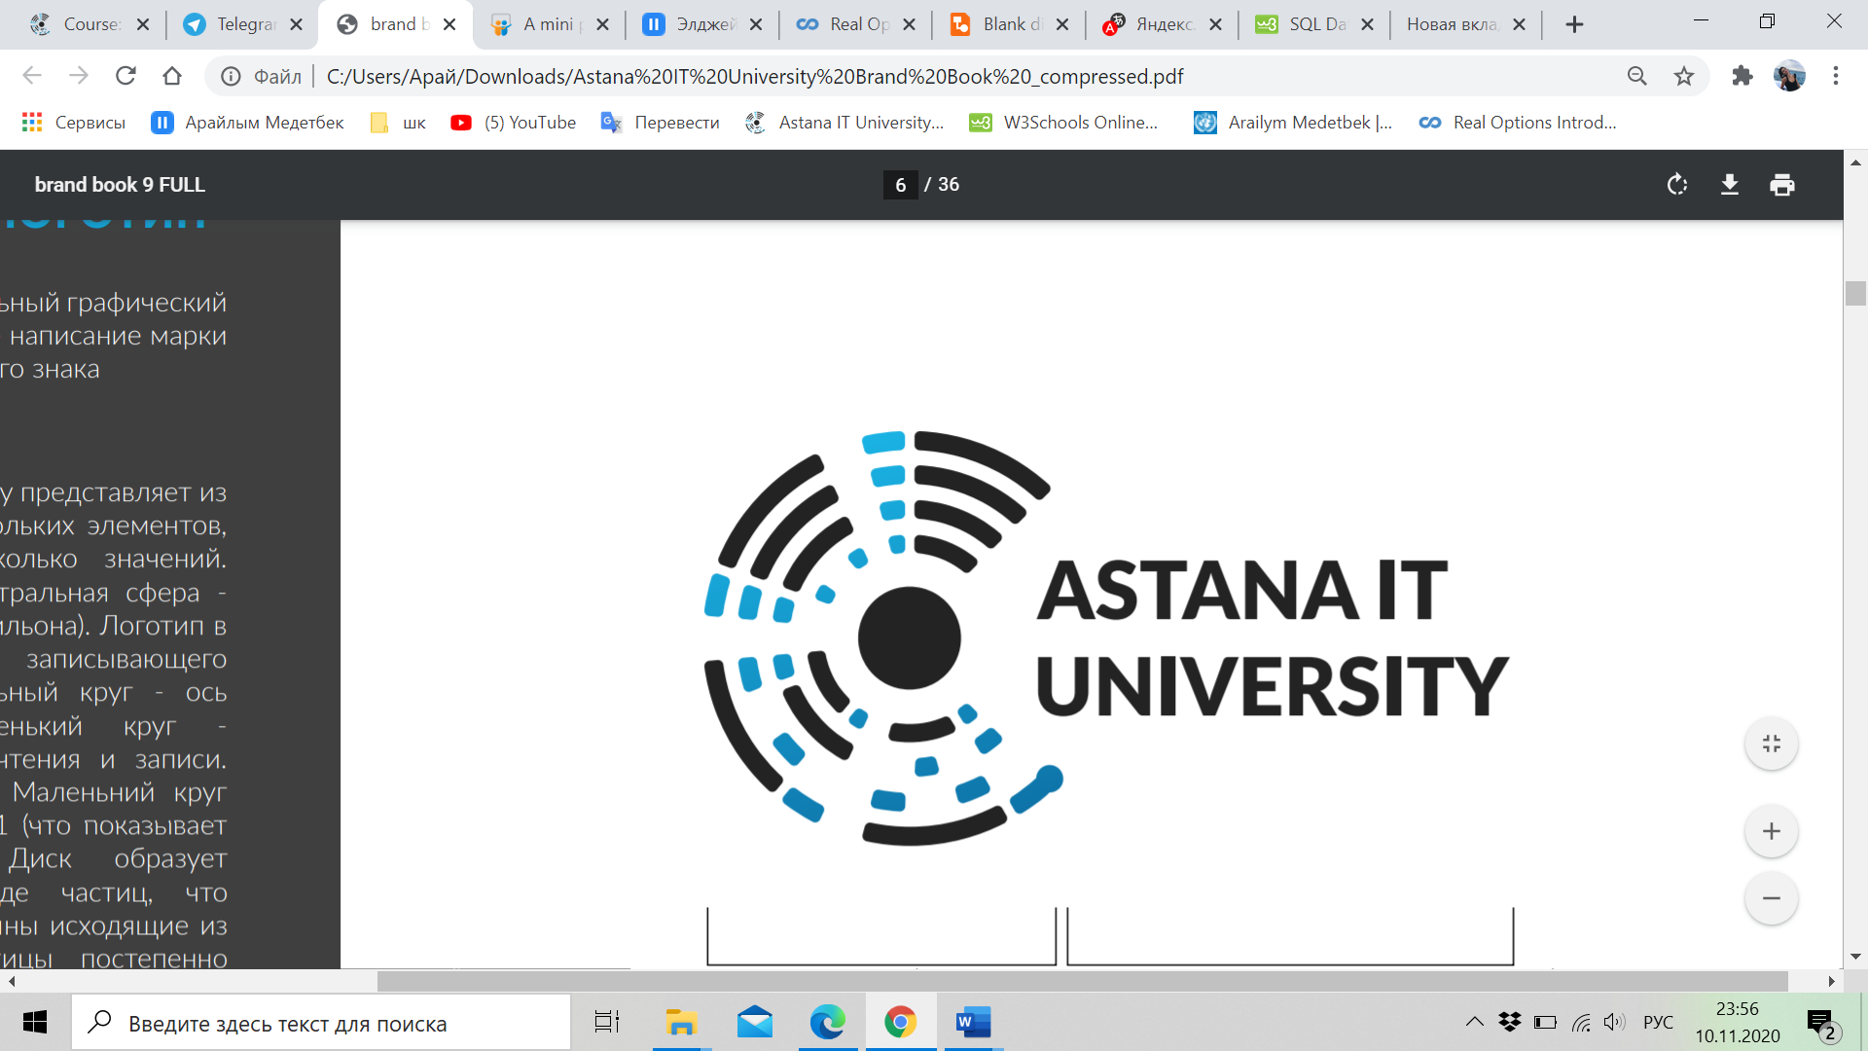

Nur-Sultan, Kazakhstan

IT Management 2021

WEB Technologies

**The scoring of football goals**



**Group name:** ITM 2005

**Students:** Medetbek Arailym, Izglikov Abylaikhan, Kalkaman Bakytzhan, Nurakhunov Kurban, Kaskin Daniyal

**Teacher:** Salkenov Aldiyar

**Table of contents**

|  |  |  |
| --- | --- | --- |
| Content | | Page Number |
| #1 | Introduction | 3 |
| #2 | Overview | 4 |
| #3 | Project goals and team interests | 5 |
| #4 | Phases: | 5 |
| #5 | Content structure | 6 |
| #6 | Summary | 13 |
| #7 | Reference | 14 |

Introduction

Football is a group of competitive sports in which players kick a ball to score a goal in various ways. Moreover, it can be surely considered that this type of the sport one of the most popular, because according to the website Topendsports.com the number of football fans is equal to 3.5 billion people, which is really big numbers.

The rules of football simple and everyone can understand it easily. There are 2 teams are playing against each other, each team should consist of 11 members: goalkeeper, defenders, midfielders, and forwards. The game consists of 2 periods and each period’s length is equal to 45 minutes. Furthermore, it should be mentioned that this sport is available to everyone, who wants to act in.

Overview

* **About your team** – The team number 1.
  + **Members and their roles**1.Medetbek Arailym- 204013, responsible to the documentation part of the project, Java-script code araika2402@gmail.com  
    2.Kalkaman Bakytzhan- 204036, responsible for Java-script code  
    3.Nurakhunov Kurban- 204069, responsible for Java-script code  
    4.Izgilikov Abilaykhan – 204108, responsible for HTML/CSS code Aboizg@mail.ru   
    5.Kaslin Daniyal – 204053, responsible for HTML/CSS code,
  + **Communication strategy**   
    1. Created special chat in the platform “Telegram” to share with the information, which is connected to the project.  
    2. Meetings in the platform “Microsoft Teams” everyday in the purpose of identifying the completed work.  
    3. The meetings after lessons to discuss some points, such as design or problem with code – everyday.
* **Motivation**   
  The topicality of the project can be evaluated in the high level, because the considering sport is really fascinating and well-known among people. They can easily count possible score of any football match.
* **High-level project scope**   
  The created project should be considered as brand-new website, due to it was created from white page.
* **Target audience/market**   
  As the main audience is regarding the fans of the sport, which is called football. Furthermore, the young people in the purpose to make them more

Project goals and team interests

Project goals:

* To create the website, which shows possible combinations of given score
* Represent the group members
* Increase the interest of the youth to the sport by attractive design of the site.

Team interests

* Understand HTML tags, CSS and JavaScript by creating the website
* Understanding the launching of the website via a local server
* Establish a solid understanding of website design principles
* Improve team working skills by collaborating with different members of the group
* Improve the communication skills by working as teem and collecting information from different sources

Phases:

Phase 1- The creature of the website design in the program Photoshop

Phase 2- Basic website by applying the HTML

Phase 3- The adding styles to the website by applying CSS and animation by Bootstrap

Phase 4- The creating of algorithms by using the JavaScript.

Phase 5- Uploading the website to the local server

Phase 6- The documentation part of the project

Phase 7- Pre-test of the created website before distribution

Phase 8- Distribution of the website among audience and utilization

Content structure

**Site map**

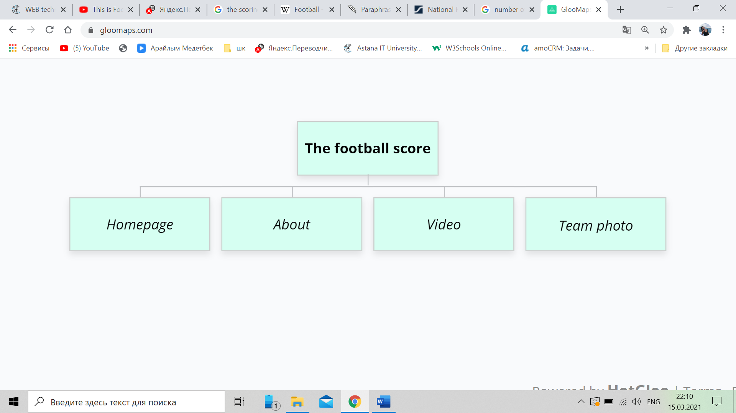

As it can be mentioned from the supplied illustration, there will be 4 main parts of the website, such as Home page and about page, video, and team photo. Moreover, there will be footer, which give opportunity for users to communicate with the owners of the website.

**Content types**

* 1. Photos of the team members
  2. Video
  3. Photo of the team

**Design**

**Used photos:**

**Used colours:**

The main colors, which are used in the website are white, black and blue. These colors are classic colors, which can be considered as user-friendly.

**Functionality:**

The presented website gives opportunity to the user to apply different functions and it makes the website fascinating. First of all, we can notice the navbar, which gives opportunity to move from one page to another. Then, we ca notice the text area, which is used to entering the names of players of each team. In this part user must write names players by enter. Moreover, there are 2 inputs with type number, where the scores of teams can be written. The website will identify the winner of the match and if you open the console, it will give opportunity to see the combinatorica of the possible scores by the players. Then, it can be easily noticed that in the footer it was given information about the owners of the website. If we consider the second webpage, about, this page will give information about the responsibilities of team members in the creating of this website. Moreover, there is a chance to see the team photo and video by server.

**Hosting**

The website was uploaded to the GitHub. Moreover, we can use the website in the local host by the framework, which is called “express”

**Accessibility**

All used colors and fonts are chosen specially, in this way that it can be easily read and there will not be any discomfort to the users of the website. In this purpose it was used as much as possible pleasant colors to the eyes of human like blue, green, white and black.

**Deadline**

* Phase 1- 14.03.2021
* Phase 2- 15.03.2021
* Phase 3- 16.03.2021
* Phase 4- 17.03.2021
* Phase 5- 17.03.2021
* Phase 6- 18.03.2021

Summary ??

In conclusion, it can be summarized that our group can achieve to its goal, because we have created the website of the football score counter, which can automatically identify the winner of the match. In the pre-test phase, all the expectation has been met. It means that the website works in the correct way and performs all tasks, which is required.

In general, all group members can achieve to their goals, taking into account that the project has competed in 1 week. The first thing, which was completed by members of our group is working as one “organism”, finding compromise and listen each other. Surely, at the start there were some issues, due to everyone has got his own idea and point of view, but in the process, we can find one common language. As the second thing, which we have covered is applying our theoretical knowledge in the HTML, CSS and JS languages in the practice, by creating the website of football score counter.

References:

1. GitHub
2. Google fonts
3. gloomaps.com