Nick Basile

08/17/2023

CS-330-X6138

Project Reflection

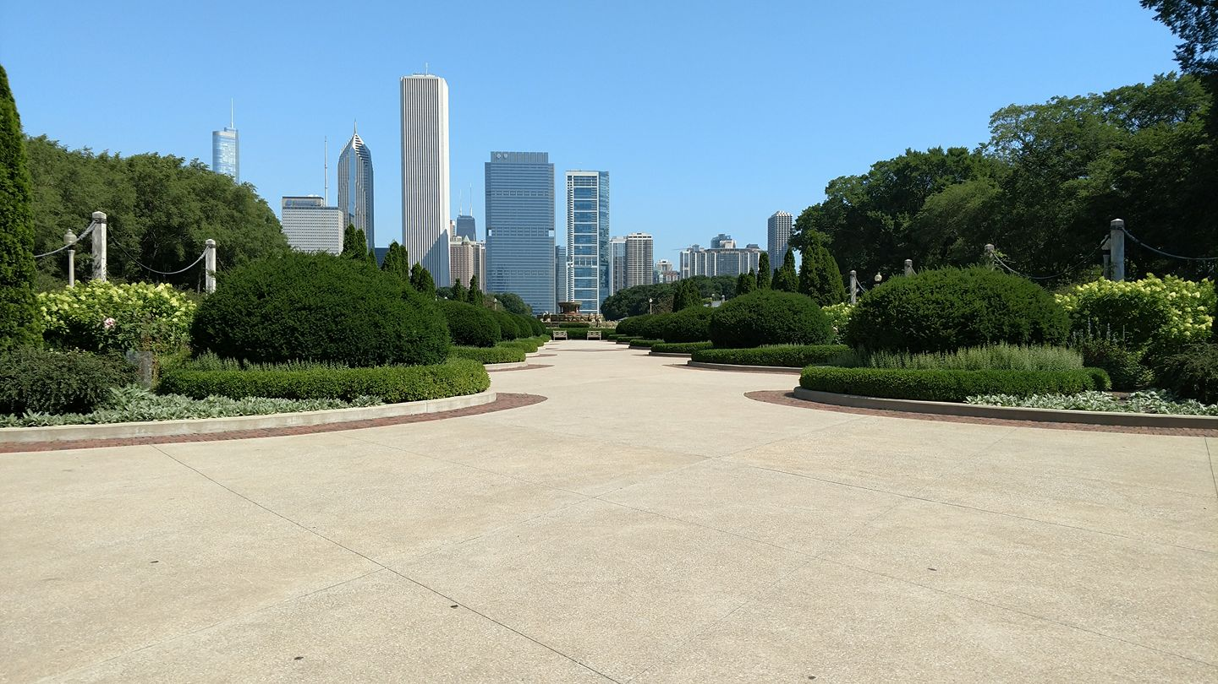

For this Final Project, I chose the above image from my Chicago vacation a few years ago. I have chose this image specifically because it contains several objects in here of various shapes and sizes. The buildings are large and mostly rectangular, the trees and the bushes are both circular as well as elongated rectangles. The tower with the cap, also was chosen and included due to the pyramid cap on the top. I also chose to include the circular bushes, as they are another shape aside from the plane for the sky, the cube (elongated) for the towers, and the pyramid for the cap of one of the large towers. The ground was textured with a cement mesh, and the sky background was textured with an actual background picture of Chicago.

Navigating around the scene can be done by the WASD keys for basic movement, as well as Q+E for verticality. Increasing the camera movement speed can be performed with the mouse wheel scroll up, and decreasing done the opposite with scrolling down. The O and P keys allow translating the scene between orthographic and perspective views, respectively. I set the camera to appear directly in front of the scene, so that the straight on view is somewhat similar to the picture provided in this document.

The custom functions in this program that I used to make it more modular would be the re-use of the tower mesh’s to generate several towers of the same type, as well as multiple bushes. By using the same vertices and then translating and rotating them into place, several buildings can be made out of existing vertices without addition need for more. In addition to this, you can also change textures on those duplicates when creating the objects.