**PIZZA SALES SQL QUERY**

1. **KPI’s**
2. **Total Revenue**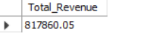
3. **Average Order Value**

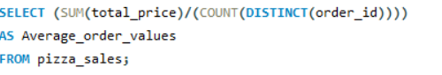



1. **Total Pizza Sold**



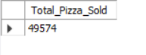

1. **Total Orders**



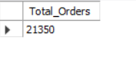

1. **Average Pizza Per Order**

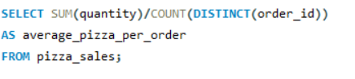

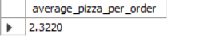

1. **DAILY TREND FOR TOTAL ORDERS**

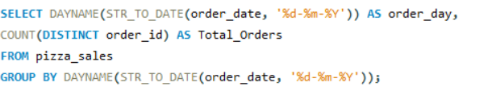

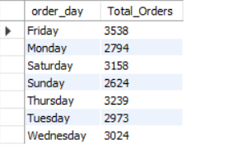

1. **HOURLY TREND FOR TOTAL ORDERS**

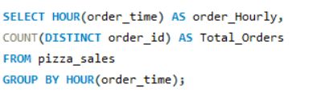

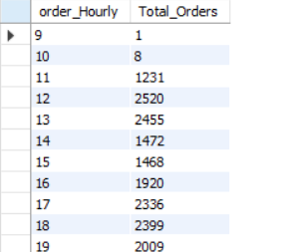

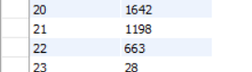

1. **% OF SALES BY PIZZA CATEGORY-**

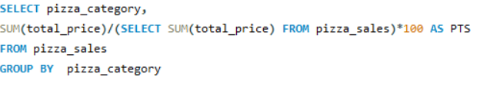

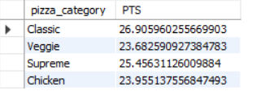

1. **% OF SALES BY PIZZA SIZE-**

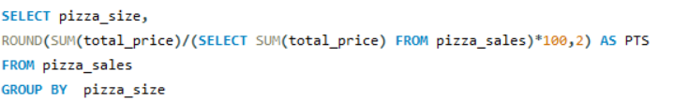

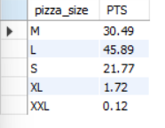

1. **TOTAL PIZZAS SOLD BY PIZZA CATEGORY-**

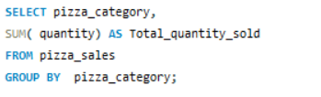

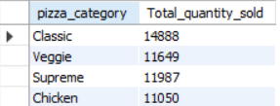

1. **TOP 5 BEST SELLERS BY TOTAL PIZZAS SOLD-**

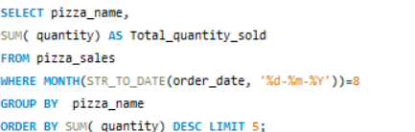

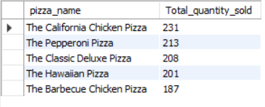

1. **BOTTOM 5 BEST SELLERS BY TOTAL PIZZAS SOLD-**

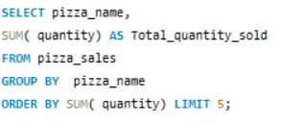

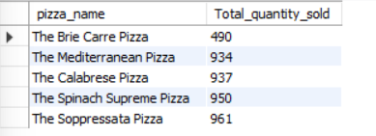

**NOTE-**

If you are applying the month, quarter, week filter to the above queries you can use where clause. Follow some of below example

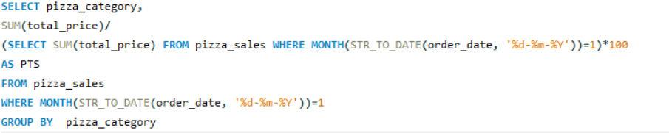

Here,

***MONTH(STR_TO_DATE(order_date, '%d-%m-%Y'))=1***

Indicates that output for the month of January has been called

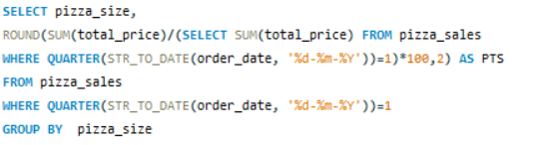.

Here,

***WHERE QUARTER(STR_TO_DATE(order_date, '%d-%m-%Y'))=1***

Indicates that output for first quarter has been called.