**React OTP Authentication Tester**

This is a simple React application for testing OTP (One-Time Password) authentication using Firebase Authentication. It allows users to sign up and verify their phone numbers via SMS.

**Tools used:**

React.js

Visual Studio code

Firebase

**Initialisation:**

After downloading the files from the repository these commands have to run on terminal to make the code properly:

npm install react-phone-input-2 –save

npm install react-hot-toast

npm install react-icons

npm install firebase

npm install react

then”npm start” in the my app folder to get started

How it works:

* Upon opening the app on the browser , you are going to see this screen which prompts for you to enter a phone number. 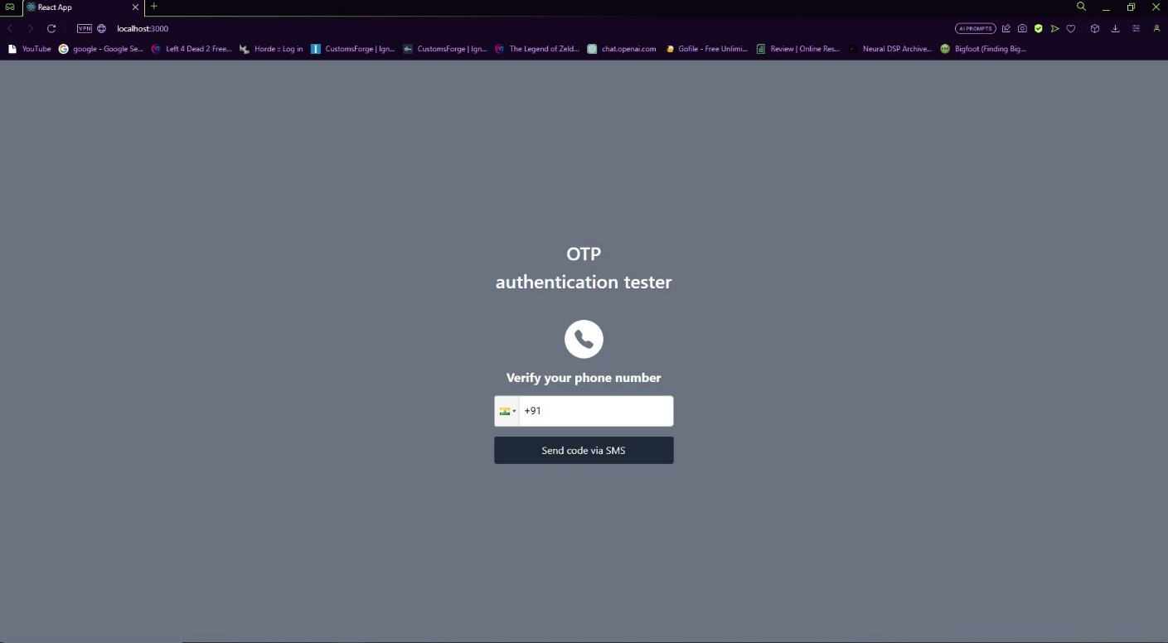
* If the entered number is invalid or it has received too many OTPs the below screen will show a pop-up showing an error. This error was shown using toast.

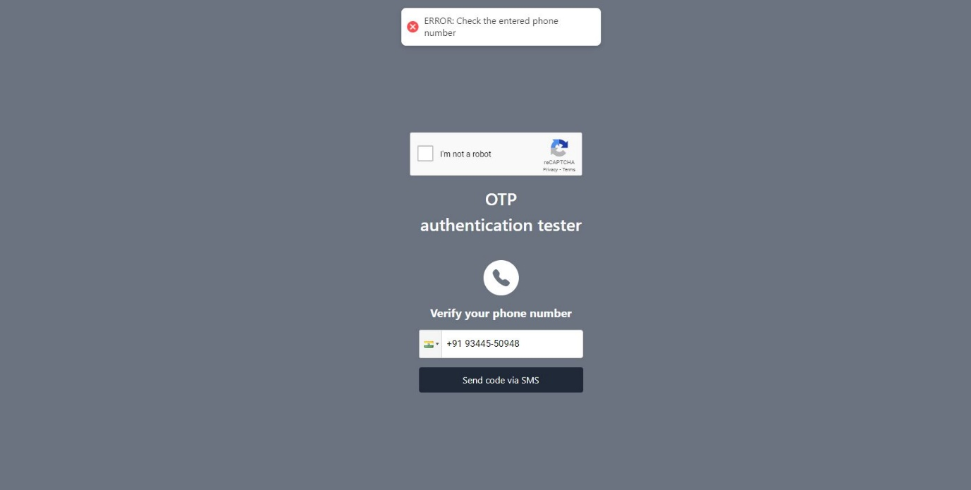

* If the phone number correct, you will proceed to this next screen, and receive and OTP on the entered number. Pressing the resend OTP button will take you back to the previous screen

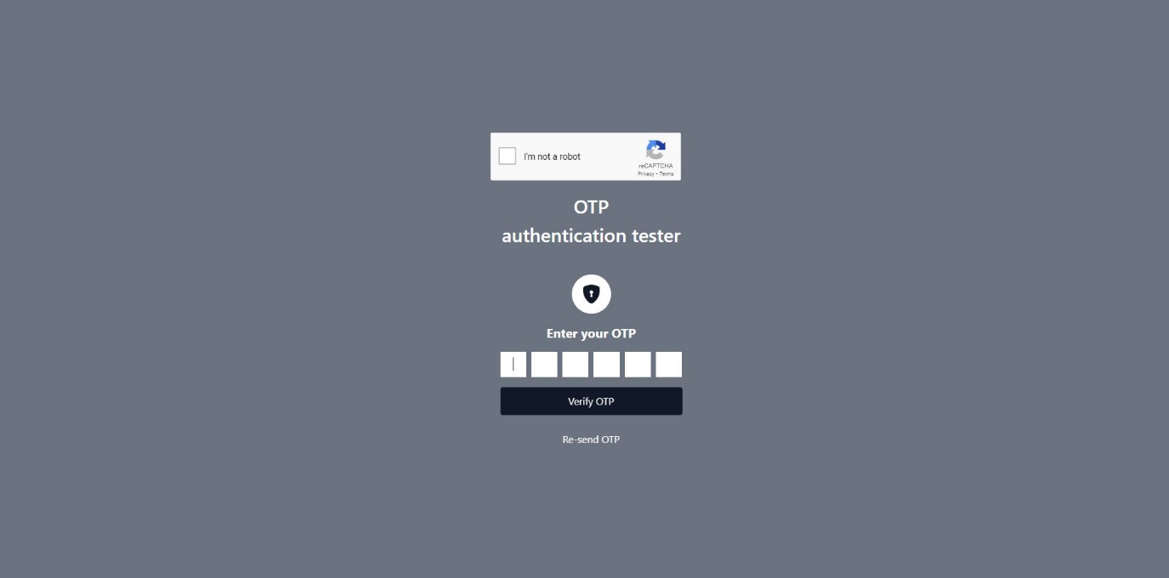

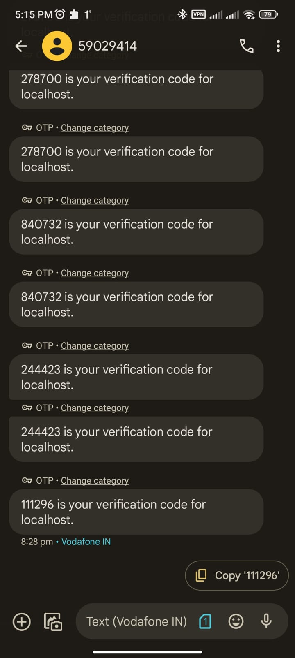

* If a wrong OTP is entered, the following screen will show, and the right OTP will show the screen beside it:

