** PROJECT REPORT TEMPLATE**

**1 INTRODUCTION**

* 1. Overview

Designing a Resume using Canva

* 1. Purpose

We created a Resume for physical education teacher

1. **PROBLEM DEFINITION & DESIGN THINKING**
   1. Empathy Map

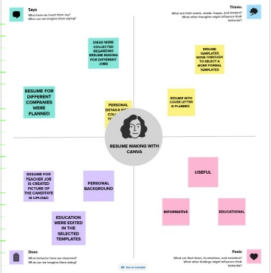

* 1. Ideation & Brainstroming

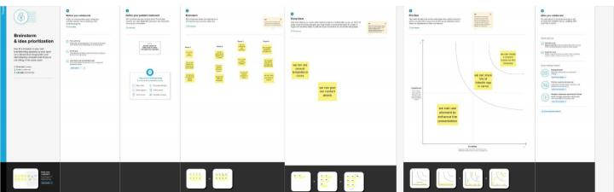

1. **RESULT**

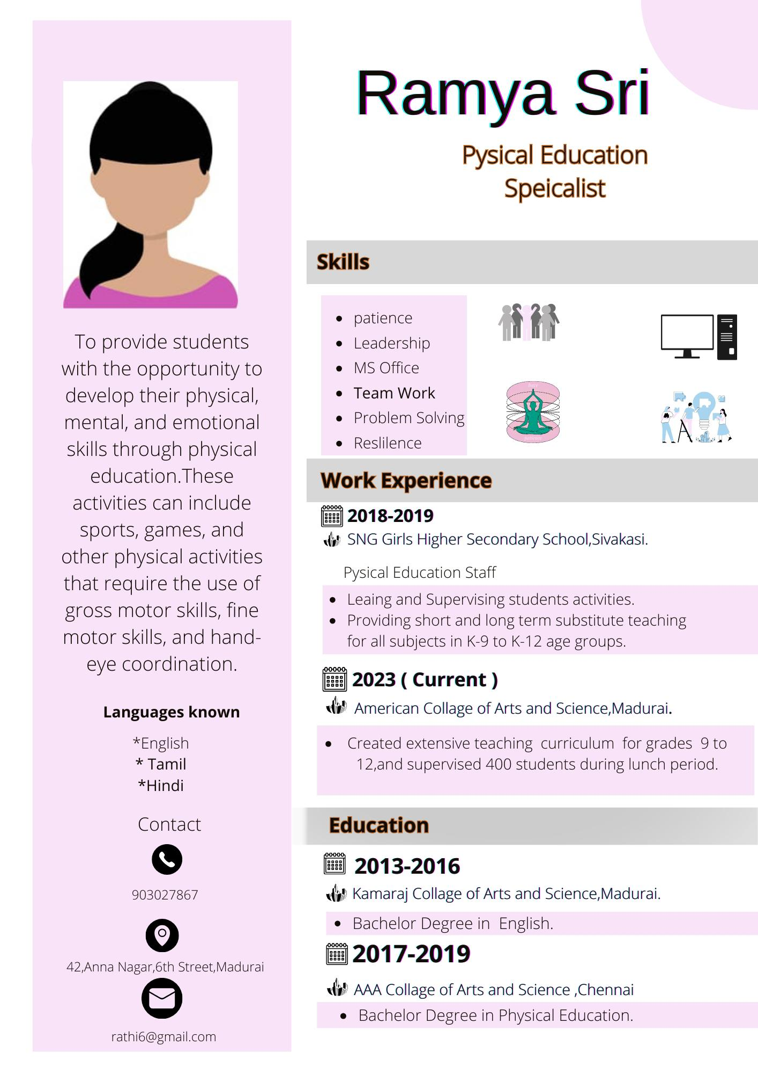

1. **ADVANTAGES AND DISADVANTAGES**

It is useful to create Resume for all job profiles

The disadvantage of creating Resume in canva is it’s certain features are Limited because of pro version

1. **APPLICATIONS**

It was helpful to create Resume easily

1. **CONCLUSION**

Canva is helpful app to create and edit content. It enhances our creative skills