**DOCUMENTATION OF THE PROJECT PLAN**

Aram Abbasi

Shiva Pandey

Similä Samuel

Oulu University of Applied Sciences

**DOCUMENTATION ON PROJECT PLAN**

**WEB BASED MATHEMATICS TOOL**

**INTRODUCTION**

This is a project plan document that demonstrates purpose, scope, objectives, project phases and their schedule of the project works. This documentation also provides the detailed information on planned activities as well as the work time estimates for each activity during each phases of the project development. The main purpose of this project work is to apply the skills and knowledges that has been taught during the lectures on developer basic skills. In addition, to provide an overview of the project management plan.

This is a group assignment that has been assigned in order to evaluate the student performance on developer basic skills. We belong to group number 10. The members of this group are Aram Abbasi, Shiva Pandey and Similä Samuel. Github repository address for our project is https://github.com/Aram777/DevBasicSkills2017-10.

The main objective of this project is to design and implement a web based mathematic tools. There will be six different mathematics functionalities for the user to interact with this web-based tools such as number system conversions, number system outputs, combinatorics, truth tables, random values and chess knight moves.

Necessary tools that has been used during the project will be Microsoft project, Visual Studio Code, GitHub, Microsoft Visio and myBalsamiq.

**PROJECT PHASES**

A project includes several phases to be accomplished. After the discussion in our group we have listed the following phases including activities to be done during each phase. The table below shows the list of projects phases and work time estimates for each activity during each phase**.**



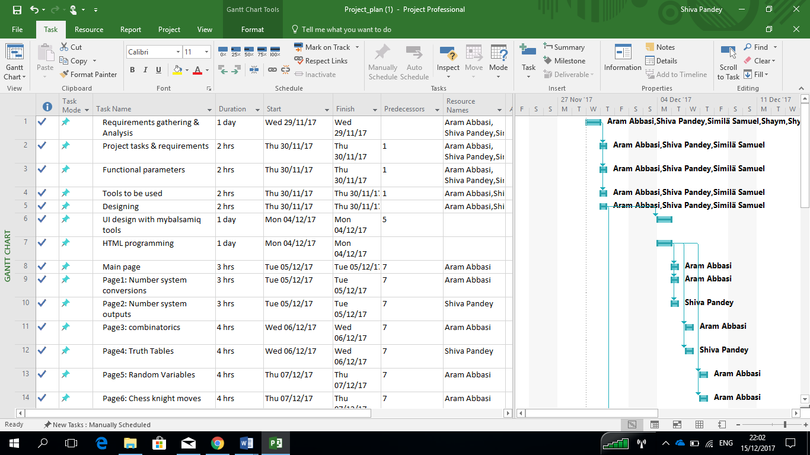

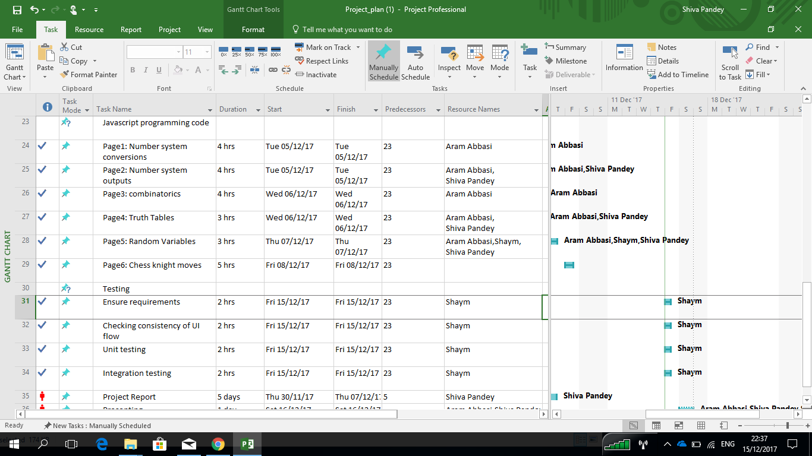

**CONCLUSION**

On the basis of the schedule mentioned on the Table 1, we will try to complete the project on the estimated period of time. Shared ideas, skills and knowledges within the group will be demonstrated well. All the assets and tasks done to implement a project will be shared in the GitHub public repository. Each asset will be updated in a regular basis.