<*Online shopping project*>

Functional Specifications

Version: <*1.00* >

<March 25, 2018>

**Prepared by:**

***Aram Abbasi***

***Shiva Pandey***

**Shyam Raja Bhetuwal**

**Sunny Shil**

**Zhanna Kresteva**

Revision Chart

This chart contains a history of this document’s revisions. The entries below are provided solely for illustration purposes.

| Version | Primary Author(s) | Description of Version | Date Completed |
| --- | --- | --- | --- |
| *Draft* | Aram Abbasi  Shiva Pandey  Shyam Raja Bhetuwal  Sunny shil  Zhanna Kresteva | Initial draft created for distribution and review comments | 21.03.2018 |
| *Final* | Shiva Pandey | First complete draft, which is placed under change control | 25.03.2016 |
|  |  |  |  |

Contents

1. Introduction 5

1.1 Project Overview 5

1.2 Problem Statement 5

1.3 Reference/ Source Documents 5

1.4 Goals 6

2. System Architecture 7

2.1 System Architecture Diagram 7

3. Use Case Model 8

3.1 List of Actors 8

3.2 List of Use Cases 8

3.3 Use Case Diagram 9

3.4 User Interface 16

3.5 Data Dictionary 16

4. Glossary 17

5. Appendices 18

List of Figures.

Figure 1 System Architecture 7

Figure 2 System Level Use Case Diagram 9

# Introduction

## Project Overview

Online shopping system is an extremely important e-commerce web-application to be able to respond to the client's needs and desires in the most effective and timely manner. This online shopping project is launched to design a commercial website that can help to improve the business and make it worldwide.

The main objective of this project is to fix the limitations and problems related to paper-based processes of shopping. It manages and tracks all the details of shopping, delivery, products, payments, customer and internet.

## Problem Statement

The purpose of this web-based application is to systematize and facilitate the entire process of shopping over the internet. It is designed to maximize access to improve the continuity and efficiency of the services to the end user.

## Reference/ Source Documents

Following are the source documents that have been consulted during the analysis phase.

a. system requirements specifications analysis document

b. use case design

c. use case model

d. user interface design

## Goals

The main goal of the project is to build an online shopping web-based application to increase the sales by implementing a new technology of web pages design. It is also aimed at targeting a lot of customers and company to their location. Through this system it is expected to advertise and send procure to customer by sending email.

# System Architecture

.

## System Architecture Diagram

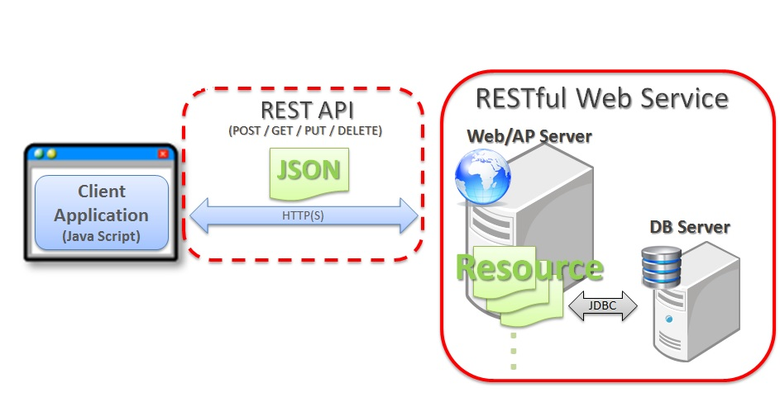

Figure 1 System Architecture

# Use Case Model

## List of Actors

Admin: This person performs all the system activities

Visitor: This person can see the products and make a user account

Registered user: This person can select product(s) and pay for it send feedbacks.

## List of Use Cases

Following are the lists of use cases:

Log-in: Allow user to provide account information and start purchasing.

View items: Allow visitor and customer to see products and their specifications.

Add items to cart: Allow customer to add (or remove) one or more products to shopping cart.

Instant pay: Allow customer select payment method and accept payment.

Feedback: Allow customer to rate products and send feedback to admin.

Registering user: Allow visitor to be a customer by making an account in the system.

Track orders: Allows admin to tack all orders and customer to track his(her) orders.

Add item: Allow admin to add a new item to system or edit the specifications of the products.

Reporting: Allow admin to make a sale report with the graph.

## Use Case Diagram

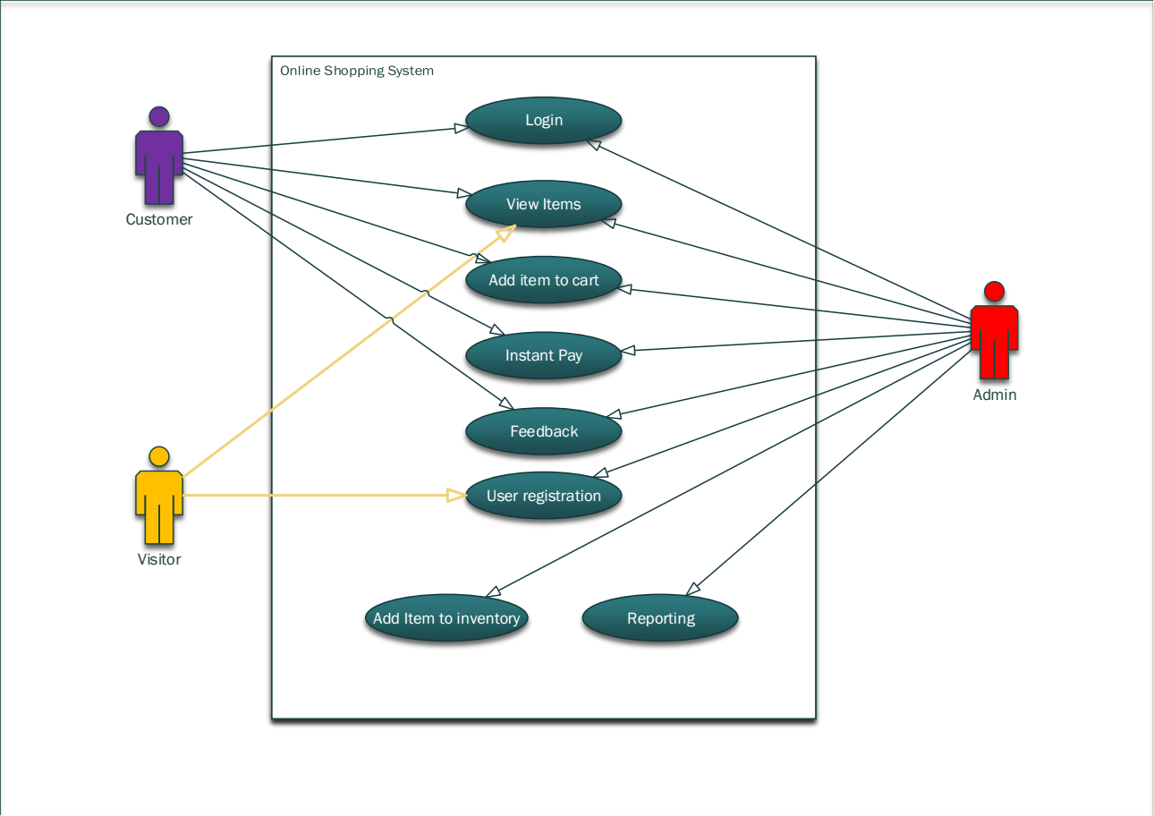

Figure 2. System Level Use Case Diagram

3.4 Use cases description

Following are the use case and their description used in our system. The UML sequence diagram of all the use case are listed in Appendix 1.

Use case Login

Name: Login

Actors: Customers.

Purpose: Login to system by the email and password.

Description: A customer provides his email and password to login.

Cross Reference: Customer must register himself first then he can login to system.

Pre-Conditions: Should have internet access.

Successful Post-Conditions: System ready to use.

Failure Post-Conditions: Email and password must be valid.

Table 1: Typical course of events for use case log-in.

|  |  |  |  |
| --- | --- | --- | --- |
| **Typical Course of Events** | | | |
| **Actor Action** | | **System Response** | |
| 1 | Customer browse the main page and click login button. | 2 | Login page displayed. |
| 3 | Customer provides email address and password | 4 | System compares the entered data with saved data in data base |
| 5 | Customer start using systems. |  |  |

**Use Case View Items**

Name: View Items.

Actors: Customers, visitors, Admin.

Purpose: Finding the toys by searching and flirting the list of products.

Description: A customer can see the list of products and can add them to the cart.

Cross Reference: Customer must login first.

Pre-Conditions: --

Successful Post-Conditions: Customer find the best one and add it to the cart.

Failure Post-Conditions:

Table 2. Typical course of events for use case view items.

|  |  |  |  |
| --- | --- | --- | --- |
| **Typical Course of Events** | | | |
| **Actor Action** | | **System Response** | |
| 1 | Browse view items page |  | Display the lists of products |
| 2 | Customer select a product by searching and filtering the products in search tab. | 3 | System represent a new products list after user specified the search criteria. |
| 4 | Customer continue shopping. |  |  |

**Use Case Add items to cart**

Name: Add items to cart.

Actors: Customers, Admin.

Purpose: adding desired item to the shopping cart.

Description: A customer can add one or more products to the cart.

Cross Reference: Customer must login first.

Pre-Conditions: --

Successful Post-Conditions: Customer is ready to checkout.

Failure Post-Conditions: Defined quantity is not available.

Table 3. Typical course of events for use case add items to cart.

|  |  |  |  |
| --- | --- | --- | --- |
| **Typical Course of Events** | | | |
| **Actor Action** | | **System Response** | |
| 1 | This action begins when user press adds to cart | 2 | System shows the item description and a place to write the number of product |
| 3 | Customer define the quantity | 4 | System check the entered quantity by the stock inventory. |
| 5 | Customer is ready for instant pay. |  |  |

**Use Case Instant pay**

Name: Instant Pay.

Actors: Customers.

Purpose: paying for the selected items.

Description: A customer can select payment method (PayPal, credit card) then he can confirm the payment.

Cross Reference: Customer must add item to the shopping cart first.

Pre-Conditions: customers must have the items in the shopping cart.

Successful Post-Conditions: Customer is able to take the order.

Failure Post-Conditions: Not enough credit or balance.

Table 4. Typical course of events for use case instant pay.

|  |  |  |  |
| --- | --- | --- | --- |
| **Typical Course of Events** | | | |
| **Actor Action** | | **System Response** | |
| 1 | This action begins when the customer clicked at the pay it now button. | 2 | System represents the list of payment method |
| 3 | Customer choose one of the payment method and click confirm | 4 | System send a request to the payment source and show the result to the customer. |
| 5 | Customer can continue shopping. |  |  |

**Use Case Feed Back**

Name: Feedback.

Actors: Customers, Admin.

Purpose: Rating the products and give some feedback to admin.

Description: A customer can rate the products by stars and also he is able to write somethings to admin and Admin is able to answer.

Cross reference: Customer must login first.

Pre-Conditions: customer must login to the system.

Successful Post-Conditions: Customer save his opinion.

Failure Post-Conditions:

Table 5. Typical course of events for use case feedback

|  |  |  |  |
| --- | --- | --- | --- |
| **Typical Course of Events** | | | |
| **Actor Action** | | **System Response** | |
| 1 | This action starts when a customer clicked at feedback button | 2 | System shows the purchase history and a place to rate and to write somethings |
| 3 | Customer rate the products by starts or he writes a note | 4 | System save it and shows it in next time to all customers. |
| 5 | Customer can continue shopping. |  |  |

**Use Case User registration**

Name: User registration.

Actors: visitor, Admin.

Purpose: Creating a new account for the visitor.

Description: A visitor starts registration with his email address, delivery address, phone number, name and password.

Cross Reference:

Pre-Conditions: --

Successful Post-Conditions: Visitor become a customer.

Failure Post-Conditions: email address is not valid or unique or the password is not strong enough.

Table 6. Typical course of events for use case user registration

|  |  |  |  |
| --- | --- | --- | --- |
| **Typical Course of Events** | | | |
| **Actor Action** | | **System Response** | |
| 1 | This action starts when a visitor clicked at the register button | 2 | System shows the registration form to the visitor |
| 3 | Visitors fill all mandatory fields and click at the register button. | 4 | System check the entered data and also password policy and return a message to visitor. |
| 5 | Visitor become customer and able to login. |  |  |

**Use Case Adding items to inventory**

Name: Adding Items to the inventory.

Actors: Admin.

Purpose: add a new item to the inventory.

Description: Admin can add a new product to the inventory.

Cross Reference: Admin must login first.

Pre-Conditions: --

Successful Post-Conditions: System have a new product.

Failure Post-Conditions:

Table 7. Typical course of events for use case adding items to inventory.

|  |  |  |  |
| --- | --- | --- | --- |
| **Typical Course of Events** | | | |
| **Actor Action** | | **System Response** | |
| 1 | This action starts when Admin clicked at the add product button | 2 | System shows the new product for to the admin |
| 3 | Admin fills all mandatory fields and click at the add button. | 4 | System check the entered data and make a new record in database. |
| 5 | Admin will back to the product list. |  |  |

**Use Case Reporting**

Name: Reporting.

Actors: Admin.

Purpose: Getting a report with customized criteria.

Description: Admin defines criteria for sale report and takes some data by the report.

Cross Reference: Admin must login first.

Pre-Conditions: --

Successful Post-Conditions:

Failure Post-Conditions:

Table 8. Typical course of events for use case reporting

|  |  |  |  |
| --- | --- | --- | --- |
| **Typical Course of Events** | | | |
| **Actor Action** | | **System Response** | |
| 1 | This action starts when Admin clicked at the report button | 2 | System shows the report form to the Admin |
| 3 | Admin define the report criteria and press show report. | 4 | System prepare a report by the entered data for admin. |
|  |  |  |  |

## User Interface

This section may be used to provide screenshots of the application to give an idea of how the GUI will appear.

## Data Dictionary

This section may be used to provide the details of interface elements that are present on the screenshots.

|  |  |  |  |  |
| --- | --- | --- | --- | --- |
| Element Name | Type | Validation | Mandatory | Remarks |
|  |  |  |  |  |

# Glossary

A glossary or model dictionary lists and defines all the terms that require clarification in order to improve communication and reduce the risk of misunderstanding.

Record domain or business terms, rules, concepts, etc. in the glossary

|  |  |
| --- | --- |
|  | Comments |
| *DS* | *DS stands for Directing Staff, a class instructor* |
| *Div* | *Stands for a Division with fixed strength and organization* |
| *Package* | *….* |
|  |  |

# Appendices

Figure: Use case login

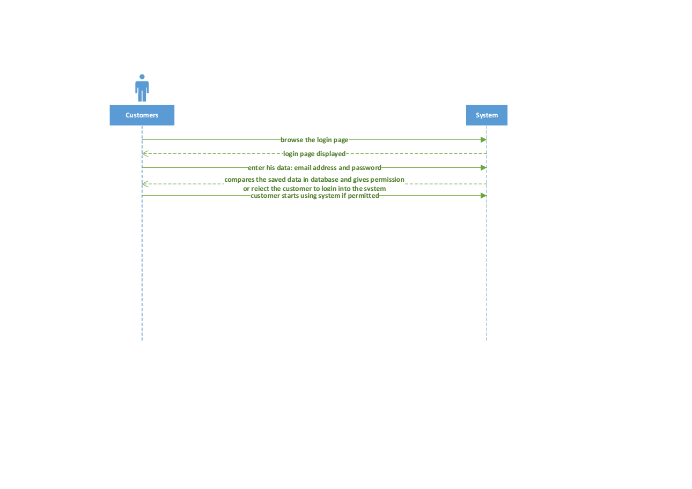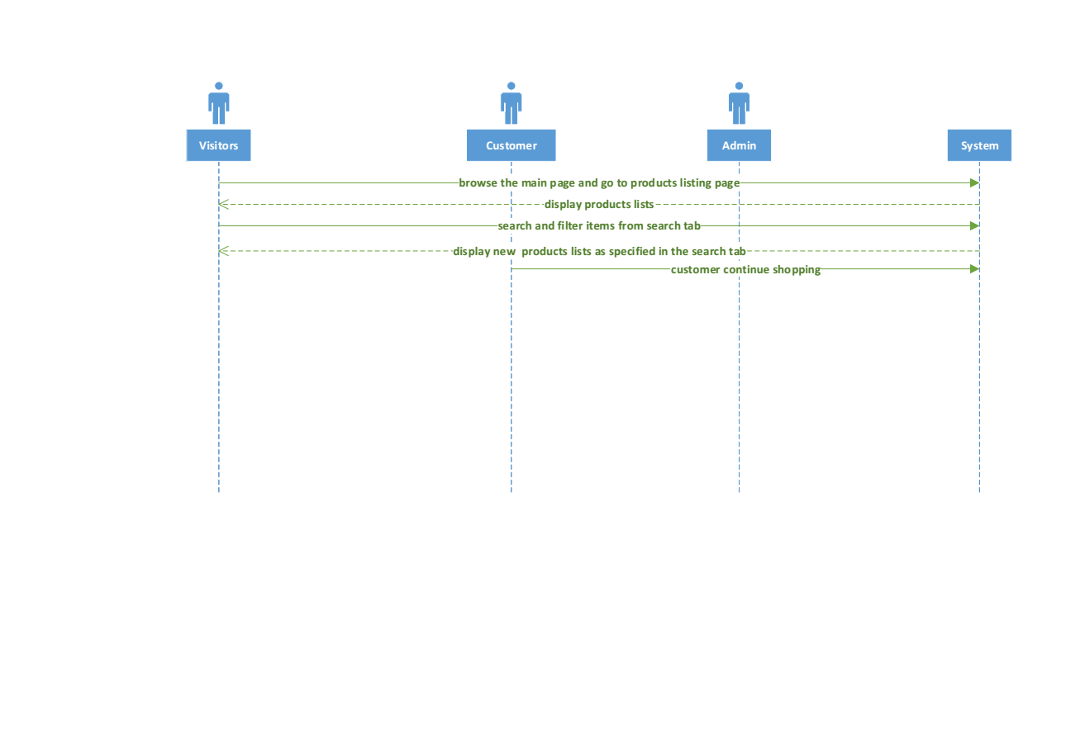

Figure: use case view items.

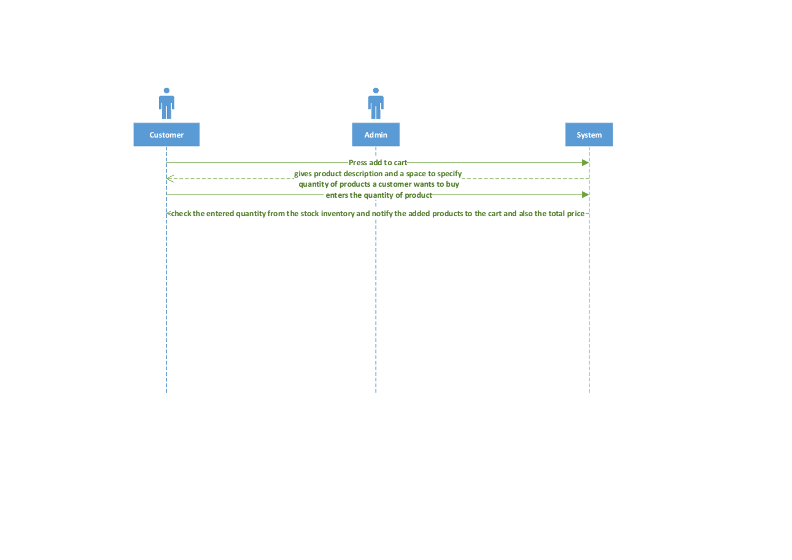

Figure: Add items to cart.

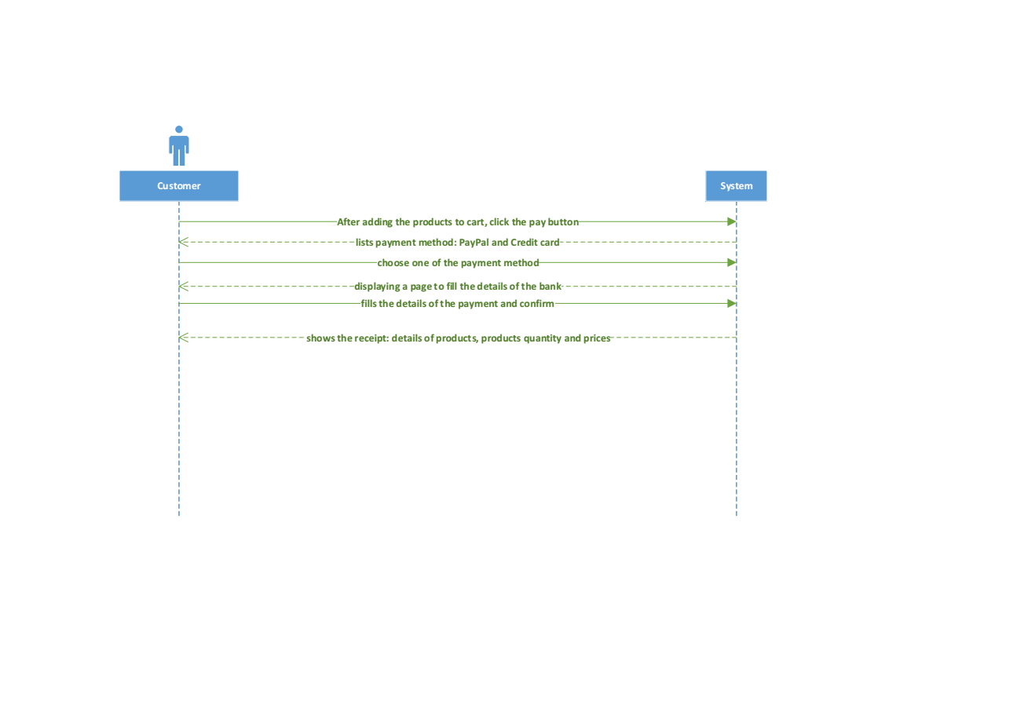

Figure: use case instant pay.

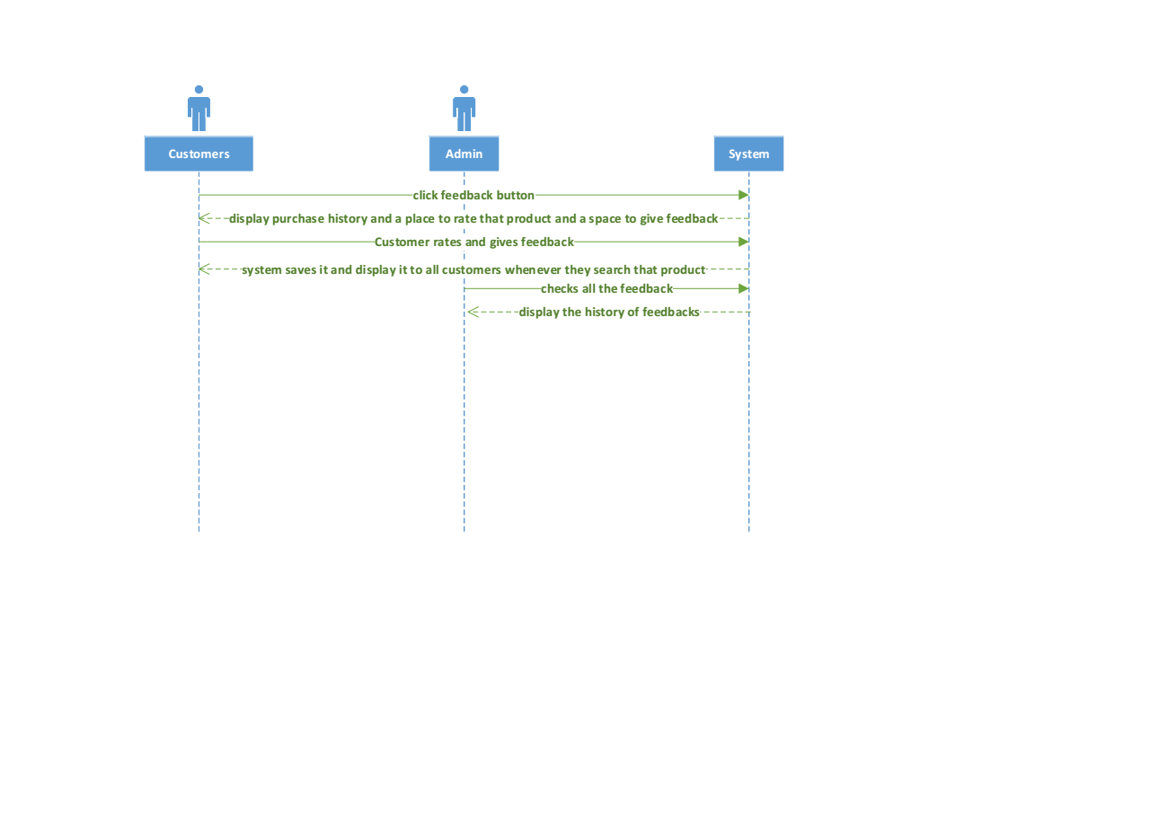

Figure: use case feedback.

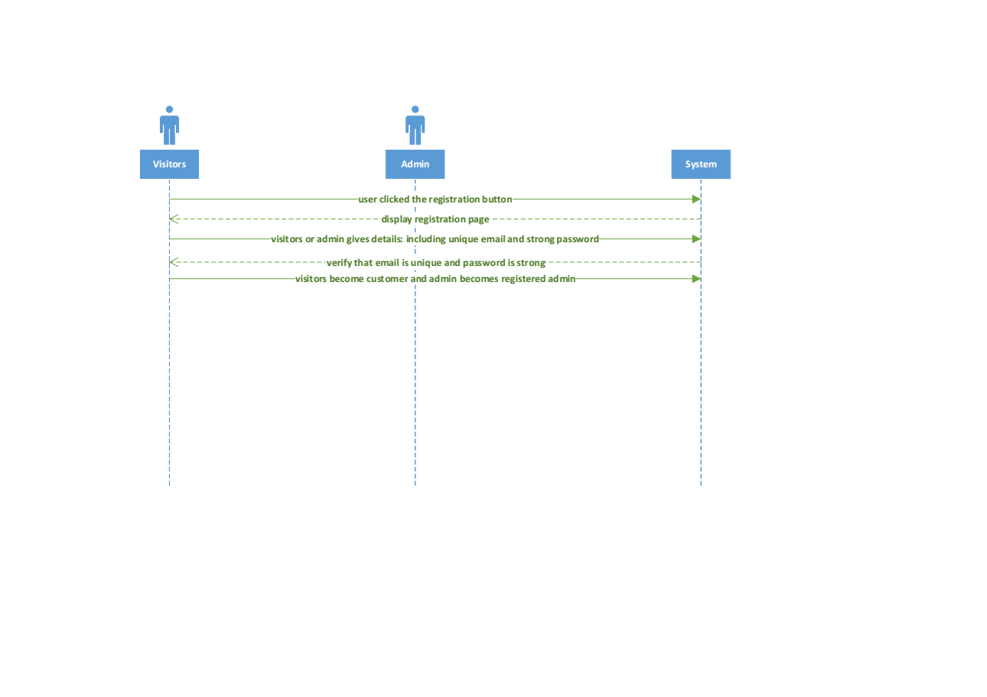

Figure: use case user registration.

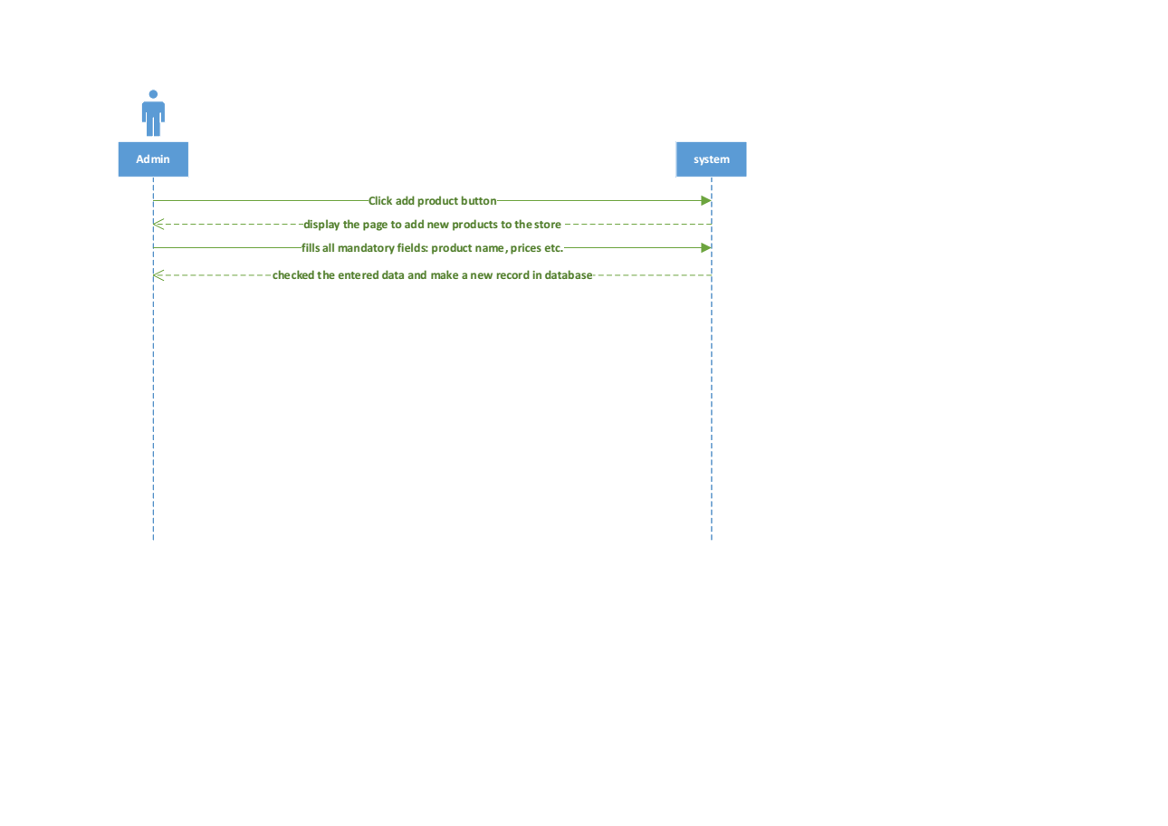

Figure: use case add items to inventory.

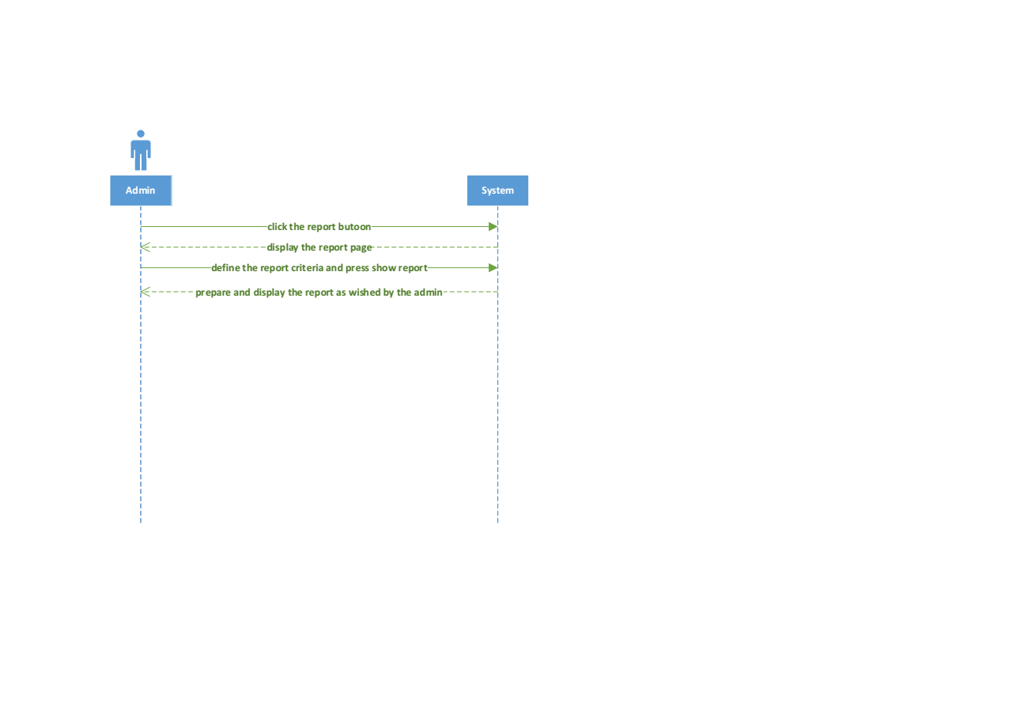

Figure: use case reporting.