Documentation for the Investment Banking Underwriting Market Risk Assessment RAG System

Overview: The Investment Banking Underwriting Market Risk Assessment System is an AI-driven application that evaluates the risk involved in the underwriting processes of investment banking. It leverages advanced text embedding technologies, a vector database for efficient information retrieval, and AI-powered inference to provide risk assessments and ensure compliance with regulatory standards.
Dataset: The system utilizes the dataset named Investment_Banking_Underwriting_Market_Risk_Assessment_Corrected_Dataset.csv. This dataset includes details such as Issuance ID, Type of Issuance, Issuance Size, Currency, and various risk scores like Market Risk Score, Counterparty Risk Score, and Liquidity Risk Score, along with Regulatory Compliance Flags.
Key Components:
- Sentence Transformer Embeddings:
  - Utilizes the sentence-transformers/all-MiniLM-L6-v2 model to generate embeddings for each issuance detail, facilitating semantic searches within the vector database.
- Qdrant Vector Database:
  - Manages embeddings and allows for efficient similarity searches to find the most relevant issuance profiles based on the query.
- Claude AI Inference:
  - Integrates with the Claude API to synthesize responses based on the context of relevant issuance profiles, addressing queries related to underwriting risks and compliance.
- FastAPI Framework:
  - The system is accessible via a FastAPI application, allowing real-time querying and integration with investment banking systems.
Functional Flow:
- Data Loading and Formatting:
  - Loads data from the CSV file into a pandas DataFrame. Each row is processed into a structured text format that outlines key details of the issuance.
- Embedding and Vector Storage:
  - Each issuance profile is embedded and stored in the Qdrant vector database, enabling efficient query processing and retrieval.
- Document Retrieval:
  - For incoming queries, the system computes embeddings and performs semantic searches in the vector database to retrieve the top relevant issuance profiles.
- LLM :
  - The retrieved profiles serve as context for the Claude model, which processes the query to generate a coherent and informed response.
- API Interaction:
  - Users interact with the system via HTTP requests to the FastAPI application, submitting queries and receiving AI-generated responses.
Regulatory Compliance: The system is designed to comply with financial regulations relevant to investment banking, ensuring that all underwriting processes meet the necessary compliance standards.

Architecture diagram of your Retrieval-Augmented Generation (RAG) system:
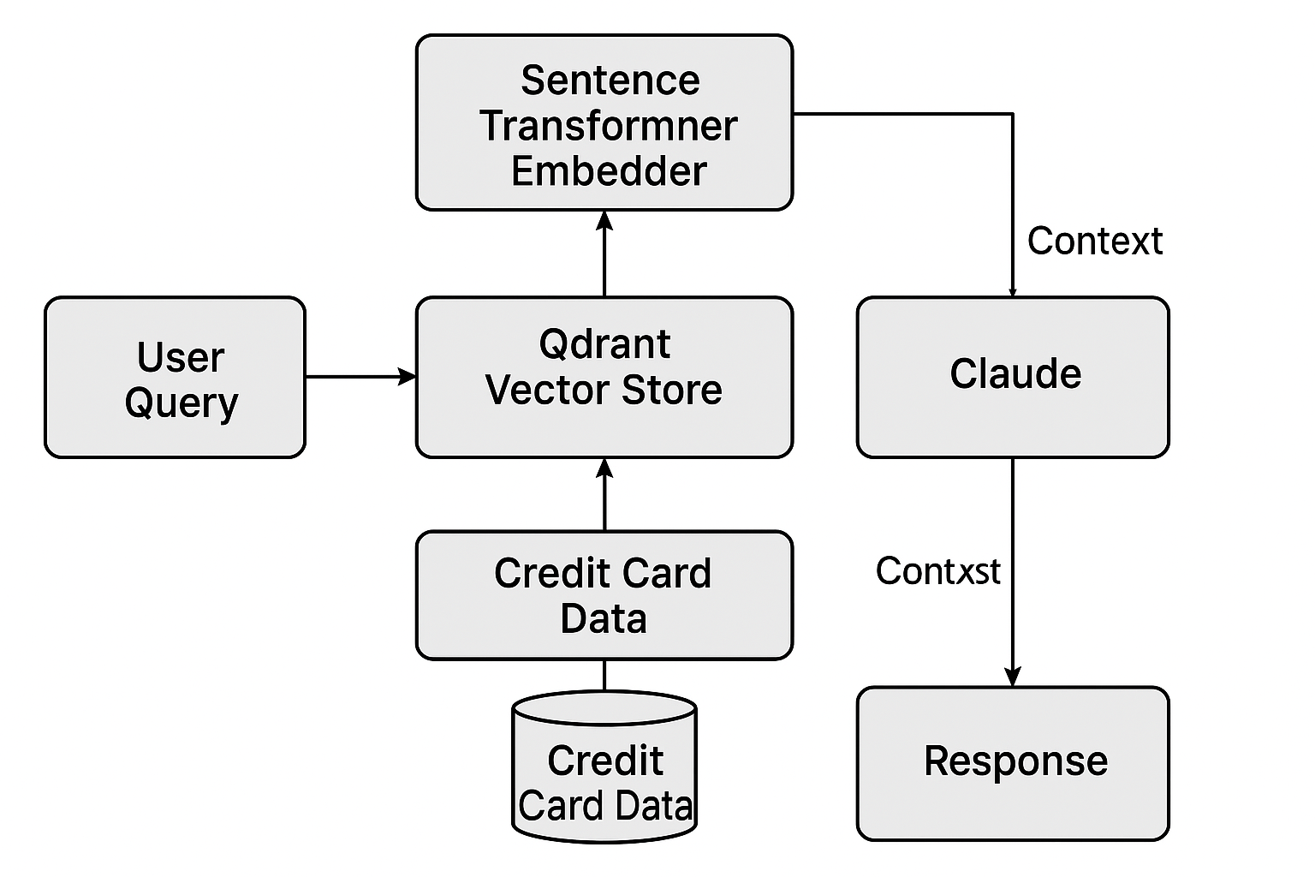

Final Summary Table:
Component | Description
Data Source | Investment_Banking_Underwriting_Market_Risk_Assessment_Corrected_Dataset.csv - Contains detailed issuance information for risk assessment.
Embedding Model | Sentence Transformer (sentence-transformers/all-MiniLM-L6-v2) - Converts issuance data into embeddings for semantic search.
Vector Database | Qdrant - Manages embeddings and metadata, enabling efficient retrieval of issuance profiles based on query embeddings.
AI Inference Engine | Claude API - Generates responses based on issuance profile contexts and user queries, ensuring informed risk assessments and compliance insights.
API Framework | FastAPI - Provides a web interface for querying the system in real-time, facilitating integration with investment banking systems.
Regulatory Standards | Ensures compliance with various financial regulations applicable to investment banking underwriting processes.

