RAG Documentation: Retail Banking – Branch Credit Risk & Compliance Tool

Overview: The Retail Banking: Branch Credit Risk & Compliance Tool is an AI-driven application designed to evaluate the risk and compliance of individual retail customers applying for personal loans or mortgages. It leverages a combination of semantic search through Qdrant vector databases, sentence embedding technologies, and Claude-based AI inference to provide risk assessments and compliance checks in real-time.
Dataset: The system uses a dataset named corrected_simulated_credit_data.csv, which contains simulated credit information for hypothetical customers. This data includes fields such as CustomerID, Age, Employment Status, Annual Income, Credit Score, Debt-to-Income Ratio (DTI), Loan Amount, Loan Purpose, Loan Duration, Repayment History, Compliance Flag, and Risk Level.
Key Components:
- Sentence Transformer Embeddings:
  - Utilizes the sentence-transformers/all-MiniLM-L6-v2 model to generate embeddings for each customer profile. These embeddings represent the textual data in a high-dimensional space, facilitating semantic search capabilities.
- Qdrant Vector Database:
  - Manages the embeddings and allows efficient similarity searches. Documents (customer profiles) are stored with their embeddings and additional metadata in a Qdrant collection named credit_docs.
- Claude AI Inference:
  - Powered by the Claude API, the system generates answers to specific compliance and risk-related queries by synthesizing information from contextually relevant customer profiles.
Functional Flow:
- Data Loading and Preparation:
  - The data from the CSV file is read into a pandas DataFrame. Each row is processed into a structured text format that describes the customer’s financial profile.
- Embedding and Vector Storage:
  - Each customer profile text is embedded using the Sentence Transformer and stored in the Qdrant vector database along with its original text for easy retrieval.
- Semantic Search:
  - When a query is received, the system computes its embedding and performs a semantic search to find the top relevant customer profiles based on cosine similarity of embeddings.
- AI Inference:
  - The Claude model receives the query and the context of top relevant customer profiles. It processes this information to provide a coherent, informed response regarding the customer’s compliance and risk status.
- API Integration:
  - The entire system is encapsulated within a FastAPI application, making it accessible via HTTP requests. This setup allows for easy integration with other systems and real-time query handling.
Regulatory and Compliance Context: The system is designed to adhere to several key banking regulations and standards:
- Basel III: Influences the risk models used by banks by defining necessary capital and liquidity requirements.
- Fair Lending Laws (e.g., Equal Credit Opportunity Act in the U.S.): Ensures that all credit decisions are made without discrimination.
- Truth in Lending Act (TILA): Mandates that all lenders disclose the terms of credit, fees, and the annual percentage rate (APR) transparently.
- Consumer Financial Protection Bureau (CFPB) Guidelines: Provides oversight on consumer protection measures and ensures the fair treatment of borrowers.
Usage: The system can be queried via a web interface where users input compliance or risk-related questions. The backend processes this input, retrieves relevant customer profiles, and uses Claude AI to generate appropriate responses. The output includes the query, the context used (top customer profiles), and the AI-generated answer.

Architecture diagram of your Retrieval-Augmented Generation (RAG) system:
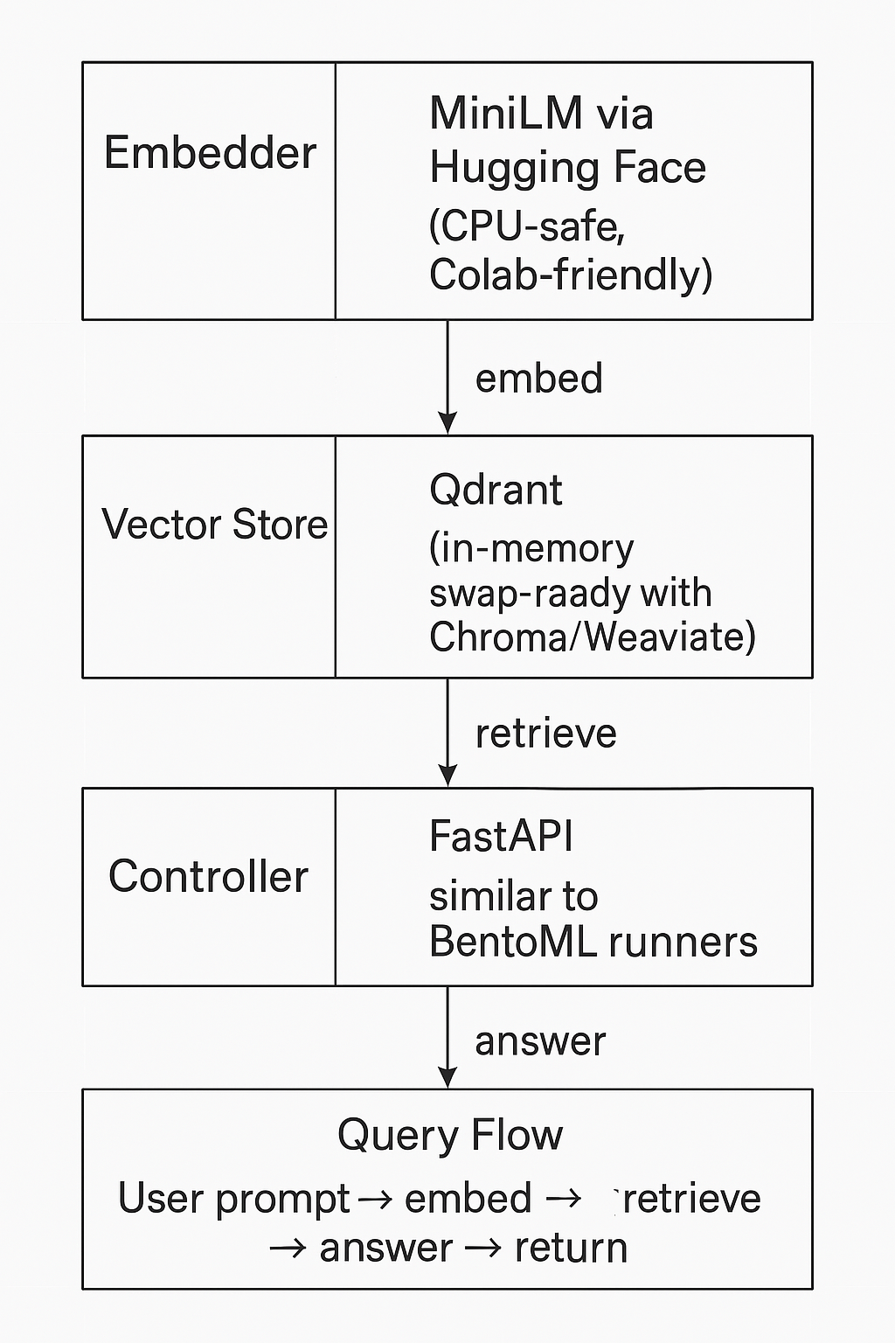

FINAL SUMMARY:
LAYER | IMPLEMENTATION
EMBEDDER | MiniLM via Hugging Face (CPU-safe, Colab-friendly)
VECTOR STORE | Qdrant (in-memory, swap-ready with Chroma/Weaviate)
LLM | Claude 3.5 Haiku via Anthropiс API
CONTROLLER | FastAPI, similar to BentoML runners
QUERY FLOW | User prompt → embed → retrieve → answer → return

