Documentation for the Credit Card – Credit Line Management & Compliance System RAG

Overview: The Credit Card – Credit Line Management & Compliance System is an AI-driven tool designed to analyze and respond to queries about credit card management and compliance. It utilizes advanced text embedding, vector storage for fast retrieval, and AI-powered inference to provide insights and ensure adherence to regulatory standards.
Dataset: The system uses the dataset named credit_card_data.csv, which includes detailed credit card account information such as Cardholder ID, Account Number, Credit Limit, Available Credit, Total Spent This Month, Minimum Payment, Payment Status, Interest Rate, Fees Charged, Recent Large Transactions, Risk Score, Compliance Issues, Last Payment Date, and Next Payment Due Date.
Key Components:
- Sentence Transformer Embeddings:
  - Uses the sentence-transformers/all-MiniLM-L6-v2 model to generate embeddings for each account profile, facilitating semantic search within the vector database.
- Qdrant Vector Database:
  - Stores embeddings and additional metadata, enabling efficient similarity searches and retrieval of the most relevant account profiles in response to queries.
- Claude AI Inference:
  - Integrates with the Claude API to provide intelligent responses based on the context of relevant account profiles, helping address queries related to compliance and risk management.
- FastAPI Framework:
  - The system is accessible via a FastAPI application, allowing real-time querying and integration with other banking systems.
Functional Flow:
- Data Loading and Formatting:
  - Data from the CSV file is loaded into a pandas DataFrame, where each row is processed into a descriptive text format outlining key account details.
- Embedding and Vector Storage:
  - Each account profile is embedded and stored in the Qdrant vector database, which is set up to handle queries efficiently.
- Document Retrieval:
  - For incoming queries, the system calculates embeddings and uses them to perform semantic searches in the vector database, retrieving the top relevant account profiles.
- LLM :
  - The retrieved account profiles serve as context for the Claude model, which processes the query to generate a coherent and contextually informed response.
- API Interaction:
  - Users can interact with the system via HTTP requests to the FastAPI application, where they can submit queries and receive AI-generated responses.
Regulatory Compliance: The system is designed to comply with various financial regulations, including:
- Basel III: Influences internal risk models and credit policies.
- Consumer Financial Protection Bureau (CFPB) Guidelines: Ensures fair treatment of consumers and oversight of financial practices.
- Fair Credit Reporting Act (FCRA): Governs the collection and use of consumer credit information

Architecture diagram of your Retrieval-Augmented Generation (RAG) system:
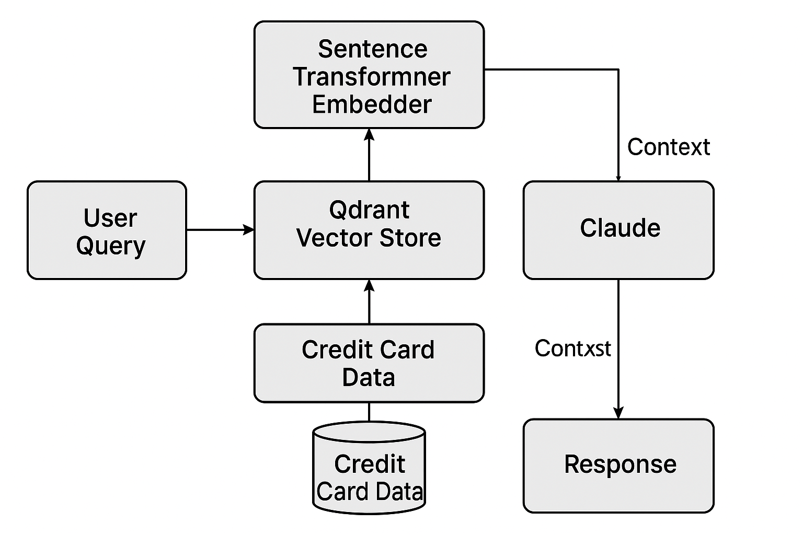
Final Summary Table:
Component | Description
Data Source | credit_card_data.csv - Contains detailed account information for credit card management.
Embedding Model | Sentence Transformer (sentence-transformers/all-MiniLM-L6-v2) - Converts account data into embeddings for semantic search.
Vector Database | Qdrant - Manages embeddings and metadata, allowing for efficient retrieval based on query embeddings.
LLM | Claude API - Generates responses based on account profile contexts and user queries, ensuring compliance and risk management insights.
API Framework | FastAPI - Provides a web interface for querying the system in real-time, facilitating integration with banking systems.
Regulatory Standards | - Basel III  - Consumer Financial Protection Bureau (CFPB) Guidelines  - Fair Credit Reporting Act (FCRA)

