**KALINGA INSTITUTE OF INDUSTRIAL TECHNOLOGY**



**PROJECT REPORT ON**

**WEATHER LIVE ANDROID APP**

**Name** : Arambh Jha

**Branch** : Master of Computer Applications

**Roll No** : 1739009

**Semester** : 3rd

**Contents**

**SNo Contents Page No.**

**1 Introduction 1**

**2 Requirements 2**

**3 Number of activities 3**

**4 Use Case Diagram 4**

**5 Data Flow Diagram 4**

**6 Working 6**

**7 Class Diagram 7**

**8 Conclusion 9**

**9 References 10**

**Introduction**

“WeatherLive” is an android weather application which provides the current weather information of the given location. The location can be either custom defined or the current location can be detected.

There are a variety of weather mobile apps in Google Play. Those apps have great features and functionalities to satisfy users. However, only a few of them have friendly user interface, which means that a lot of them might be difficult to be navigated even though they provide enough functionalities. It is not convenient for new users. Therefore, I would like to do improvements on weather mobile apps.

**The objectives** include:

The mobile app allows people to check out the weather in multiple cities worldwide. The weather data is dynamic, which means that users can see the weather anytime. The mobile app not only show the weather, condition and temperature, but it also uses various icons to represent the weather accordingly. It will be easy to read and use. Besides, the mobile app will have friendly user interfaces. Users can find the information they want in a short time and limited clicks. It is easy to be navigated.

1

**Requirements**

Client:

Operating System – Android

Version - Android Version 4.4+ ( KitKat)

GPS – Yes

Internet Connectivity – Yes

RAM – 1 GB

Developer:

Operating System – Any

IDE – Android Studio / Eclipse

Internet Connectivity - Yes

GPS – Yes

RAM – 4 GB

*Above specifications are mentioned for smooth running of the application

2

**Number of Activities**

The application is mainly divided into four modules:

1. Splash Screen : This is basically the welcome screen of the application. It’s the first screen that comes into play when the user launches this application.
2. Custom Location UI : This is the screen right after the splash screen. In here the user has two options, he can input any desired location(city, state and country) or he can track his current location, which takes us to another module.
3. Current Location UI : When the user selects the “Live” option, he is redirected to this activity. Here the system tracks the user’s current location(city and country) using his cellphone’s inbuilt GPS.
4. Weather Report Screen : This is the final screen. Here the weather report for the entered location is displayed and the user can view the temperature is C or F units.

3

**Use Case Diagram**

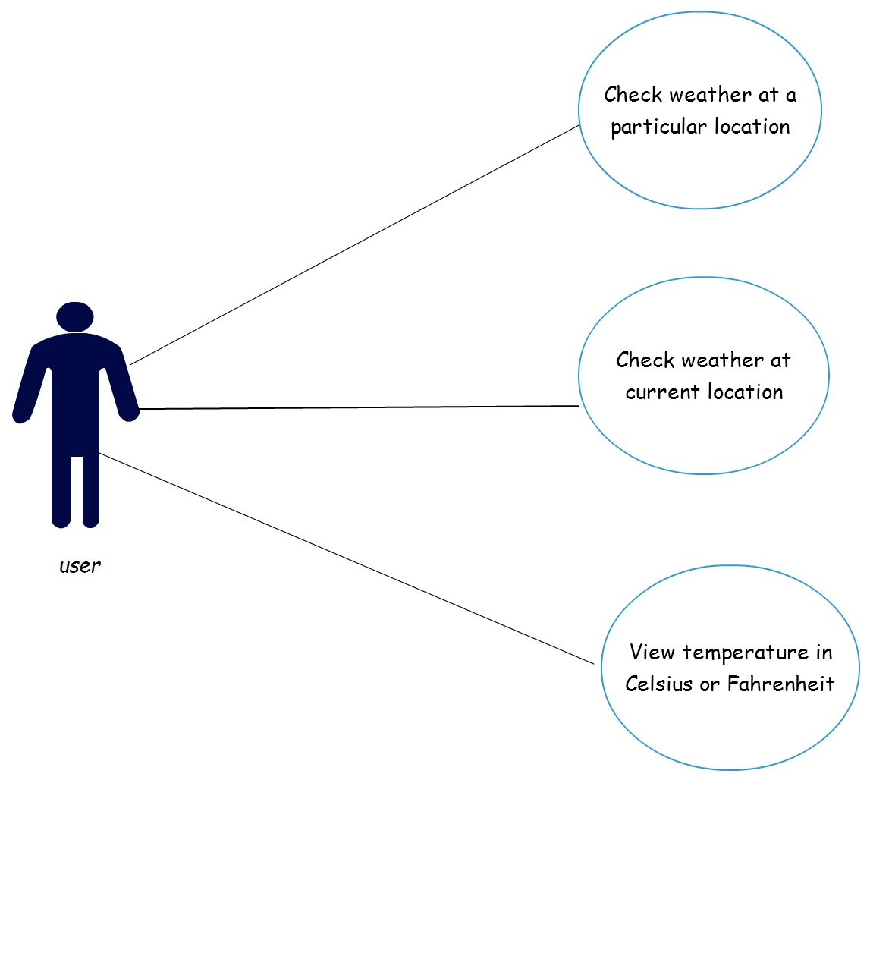

**Data Flow Diagram**

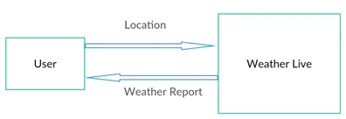

**Level 0**

4

**Level 1**

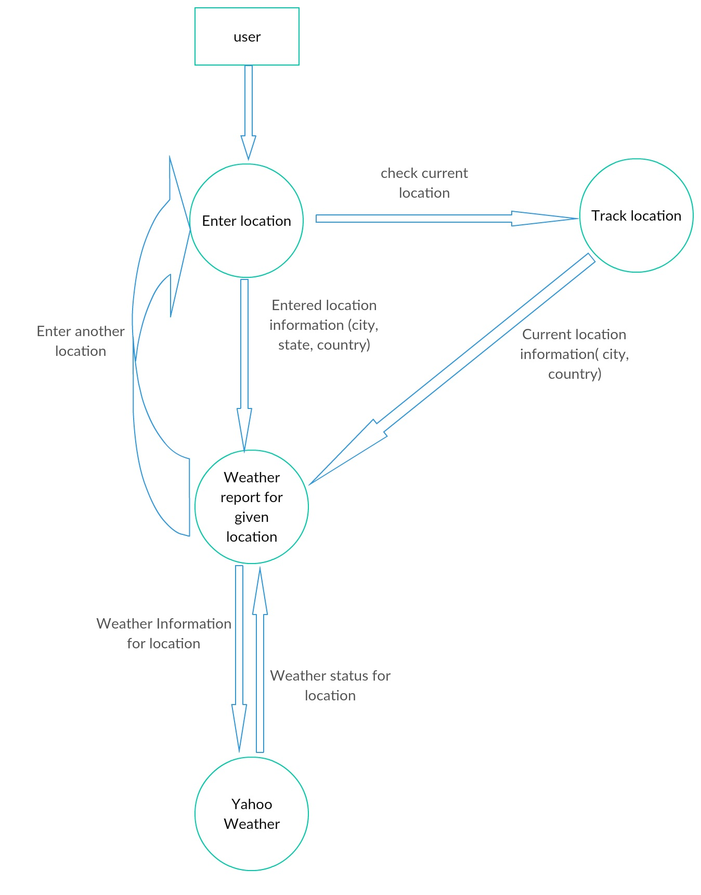

5

**Working**

Following is a brief description of how this application works.

The user must be connected to the internet and must have his GPS on for this application to work. The user should also allow permission for internet access and GPS access to this application.

When the user opens the application, the first screen is the Splashscreen. It is basically a welcome screen in the android application. After that the use is redirected to the second screen where he or she has to enter the location details, i.e, City, State, Country in respective order. There is no autofill so the user has to make sure of the correct spelling. He can also choose an option to detect his current location by clicking the Live button or can proceed to check weather for given location.

In the location activity, the application will request location access from the user which the user must provide so that the application can work. It uses the Geocoding process to detect user’s location using his latitude and longitude and gives his City and Country and passes this data onto the final page where the weather is shown.

In this final activity, the entered locations are concatenated together as one String argument and are passed on to the Yahoo Server as Yahoo Query Language(YQL). This fetches the data from the server in JSON format and is passed back to the application where there are separate classes for handling this returned JSON data and thus the final result, i.e, the entered location’s Temperature, Condition and Location are shown and a respective figure according to the condition is shown.

This is how this “WeatherLive” application works.

6

**Class Diagram**

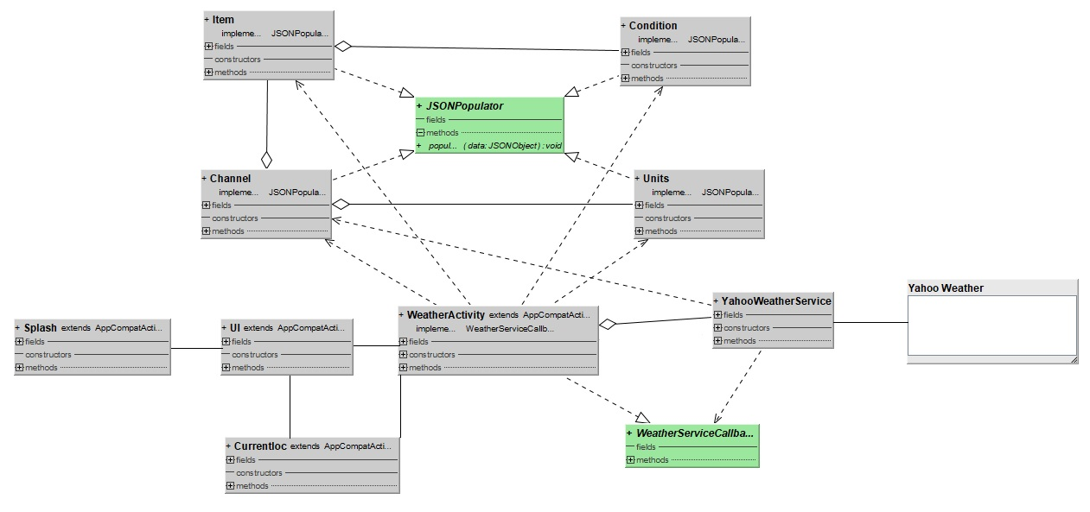

7

**Class Diagram**(elaborated)

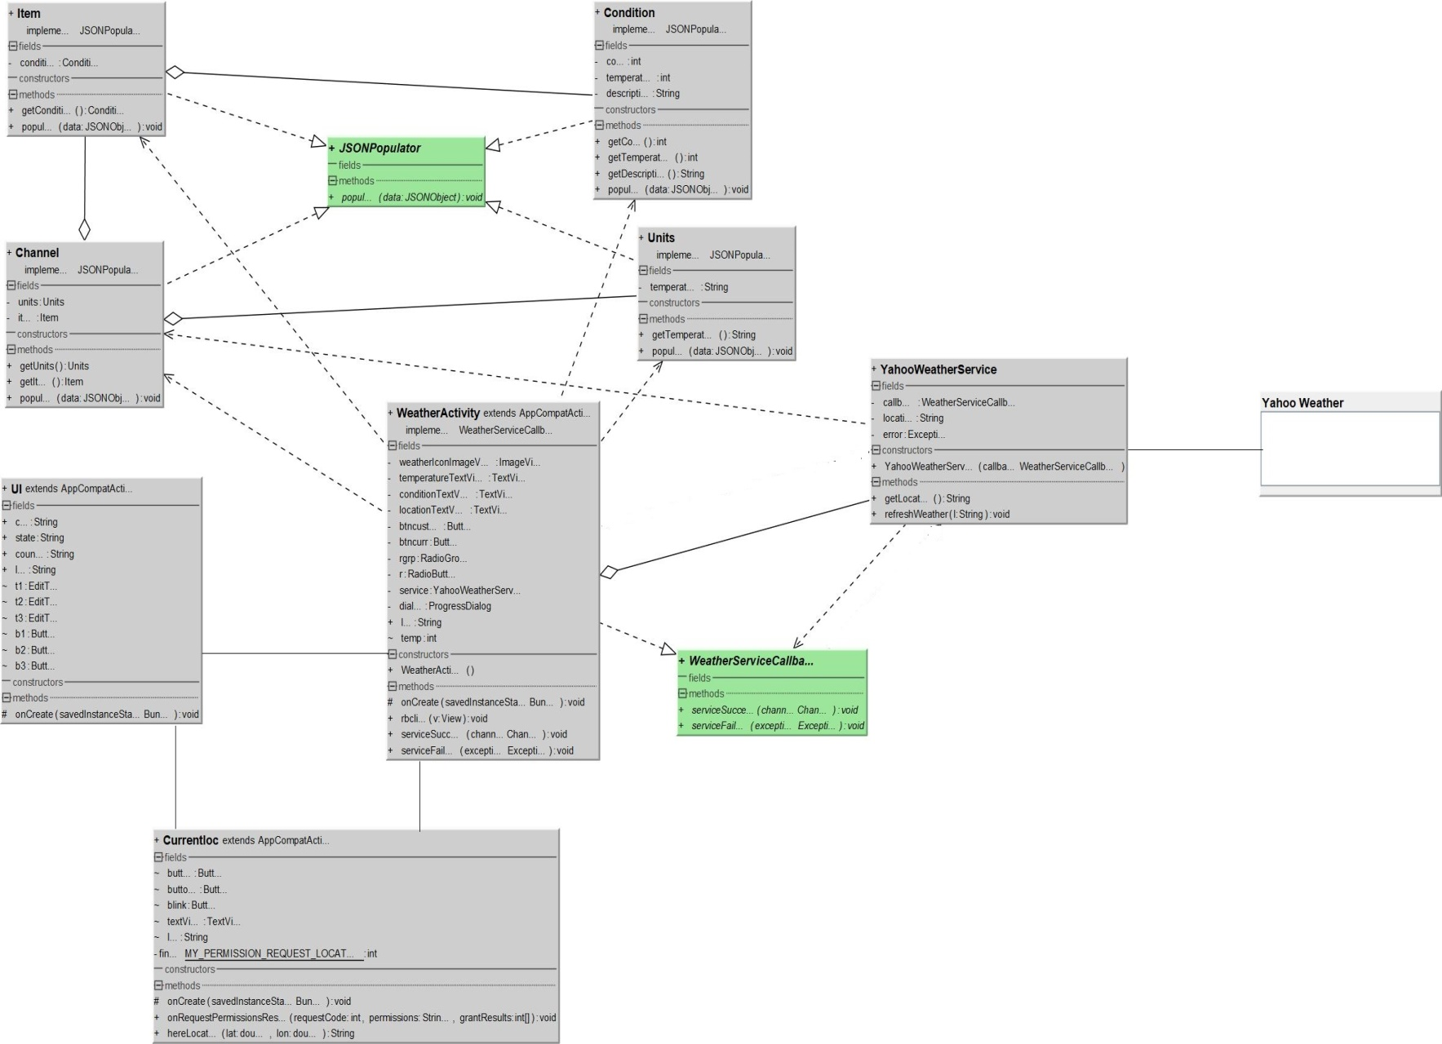

8

**Conclusion**

So at last I want to conclude that this application WeatherLive is free and gives the exact weather information for the entered location information and is very accurate. The user can enter any number of locations worldwide and can even check his current location.

Limitations :

* The user has to enter the city, state and country on his own. Spelling mistakes are not corrected.
* There is no Autofill in the text boxes.
* Search history is not saved.
* Weather conditions aren’t updated on their own.

Future Scope :

* AutoFill of locations will be implemented using services like Google Places, eliminating the chances of incorrect input.
* Location search history of user will be saved.
* More weather informations and forecast will be added.

9

**References**

* YouTube <https://www.youtube.com/channel/UCur8jimXQNPWemqLCxZK4oA>
* Google <https://docs.google.com/document/u/0/>
* Github <https://github.com/DigitalPhantom>
* Creatly [https://creately.com/app/#](https://creately.com/app/)

10