Identification of MicroRNA-29 Noncoding RNA Targetome in Keratinocytes
Supplementary

This document contains supplementary tables and figures supporting the analyses presented in the main report.

2026
Arame Raoofi Arani
STUDENT ID NUMBER: 14327327
School of Biological Science

Supplementary Materials Lists
Supplementary Table S1. Candidate miR-29-associated genes used for correlation analysis. Supplementary Table S2. CLIP-based identification of candidate miR-29-associated noncoding RNAs (ncRNAs) in interfollicular keratinocytes.
Supplementary Figure S1. Interaction networks of miR-29a, miR-29b, and miR-29c with their associated target genes.

Supplementary Figure S1. Interaction networks of miR-29a, miR-29b, and miR-29c with their associated target genes.
Table S1. Candidate miR-29-associated genes used for correlation analysis. Genes were selected based on reported association with miR-29 from HMDD and literature sources and grouped into functional categories, including extracellular matrix remodeling, cell adhesion, growth factor signaling, inflammation, cell survival, and epigenetic regulation. These genes were used to assess relationships between candidate lncRNAs and miR-29-associated pathways in keratinocyte RNA-seq datasets.
Gene | Functional Category | Source
ADAM12 | ECM remodeling | HMDD
LOX | ECM remodeling | HMDD
COL1A1 | ECM remodeling | Literature
FN1 | ECM remodeling | HMDD
COL5A1 | ECM remodeling | HMDD
FBN1 | ECM remodeling | HMDD
MMP2 | ECM remodeling | HMDD
SPARC | ECM remodeling | HMDD
LAMA2 | ECM remodeling | HMDD
WNT4 | Growth factor signaling | HMDD
PDGFRB | Growth factor signaling | HMDD
VEGFA | Growth factor signaling | Literature
SMAD3 | Growth factor signaling | HMDD
TGFB1 | Growth factor signaling | Literature
TGFB2 | Growth factor signaling | HMDD
LAMC2 | Cell adhesion | HMDD
DSC2 | Cell adhesion | Literature
DSG2 | Cell adhesion | Literature
ITGB1 | Cell adhesion | Literature
ITGA6 | Cell adhesion | HMDD
MCL1 | Cell survival | HMDD
BCL2 | Cell survival | HMDD
CASP8 | Cell survival | HMDD
TNFAIP3 | Inflammation | HMDD
REL | Inflammation | HMDD
AHR | Inflammation | HMDD
HDAC9 | Epigenetic regulation | HMDD
HDAC4 | Epigenetic regulation | HMDD
DNMT3A | Epigenetic regulation | HMDD
TET2 | Epigenetic regulation | HMDD
SMARCC1 | Epigenetic regulation | HMDD

Table S2. CLIP-based identification of candidate miR-29-associated noncoding RNAs (ncRNAs) in interfollicular keratinocytes. Enriched ncRNA transcripts identified from AGO-associated CLIP-seq data are shown. For each candidate, the gene name, Ensembl gene ID, normalized expression level (baseMean), and log2 fold change (CLIP vs input) are provided. All listed transcripts passed filtering criteria including expression threshold and enrichment (log2FC > 1), and were retained as candidate ncRNAs within the miR-29-associated targetome.
Gene Name | Ensembl Gene ID | Expression (log2) | log2FoldChange (CLIP vs input)
H19 | ENSG00000130600 | 5.20 | 6.18
RP11-834C11.4 | ENSG00000250742 | 13.70 | 4.10
LINC00511 | ENSG00000227036 | 4.14 | 2.10
AC005154.6 | ENSG00000196295 | 4.61 | 1.86
SNHG7 | ENSG00000233016 | 5.61 | 1.72

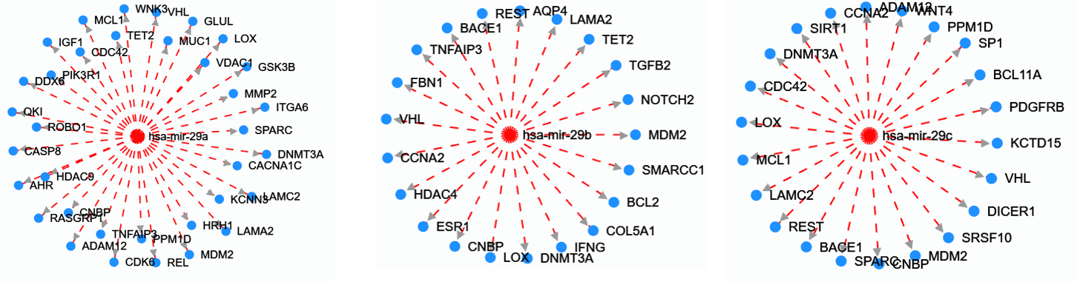
Figure S1. Interaction networks of miR-29a, miR-29b, and miR-29c with their associated target genes. Each network illustrates experimentally validated miR-29–target gene interactions, including genes involved in extracellular matrix remodeling, cell adhesion, growth factor signaling, inflammation, apoptosis, and epigenetic regulation. Nodes represent target genes, and edges indicate regulatory interactions.

