Project Report

ATM Machine Software

# Contents

1. Acknowledgements
2. Synopsis
3. User Guide
4. Developer’s Guide
5. Acknowledgements.

LUKMON ABDULHALEEM OLUWAPELUMI

OLATUDE ABDULGANIY ARAMIDE

ASEMOTA TIMOTHY OSAYAMEN

ASEMOTA AISOSA MICHEAL

AYOOLA OLUWAKANYINSOLAMI BOLUWATIFE

BALOGUN MUHAMMED ORELUWA

1. Synopsis.

ATM in full meaning Automated Teller Machine uses software application for performing banking operations. Banking process has become easier and customers are now able to save time for checking balance, withdraw money from any location, deposit money, and transfer is made possible using ATM machines.

We designed an ATM banking system project for understanding operations that are involved in ATM software

1. User Guide.

**User Guide**

**ADMIN MODULE:**

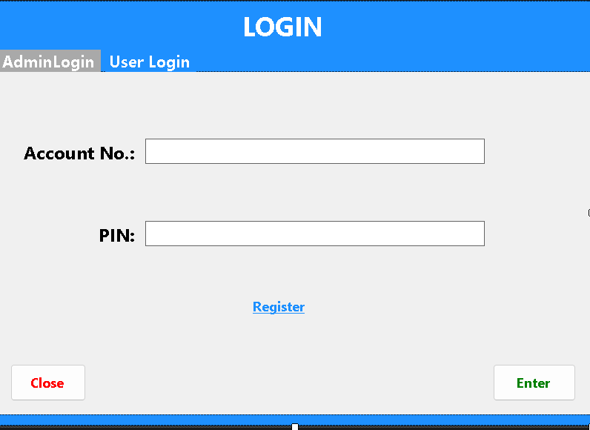

The first page you see is the login page you enter your details if you don’t have one you can click on register below to get your account created.

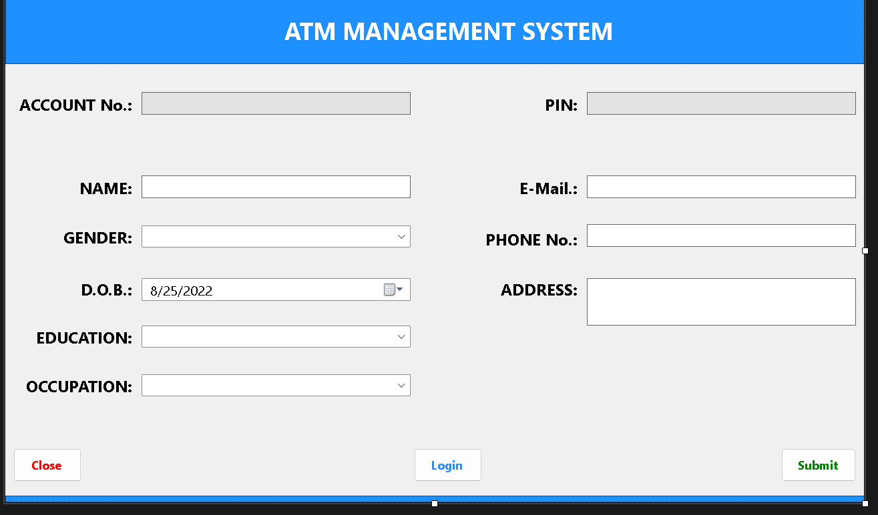

And you are taken to the menu page where there are six options:

* Balance Enquiry
* Change PIN
* Transfer Money
* Withdrawal
* Deposit
* Reports

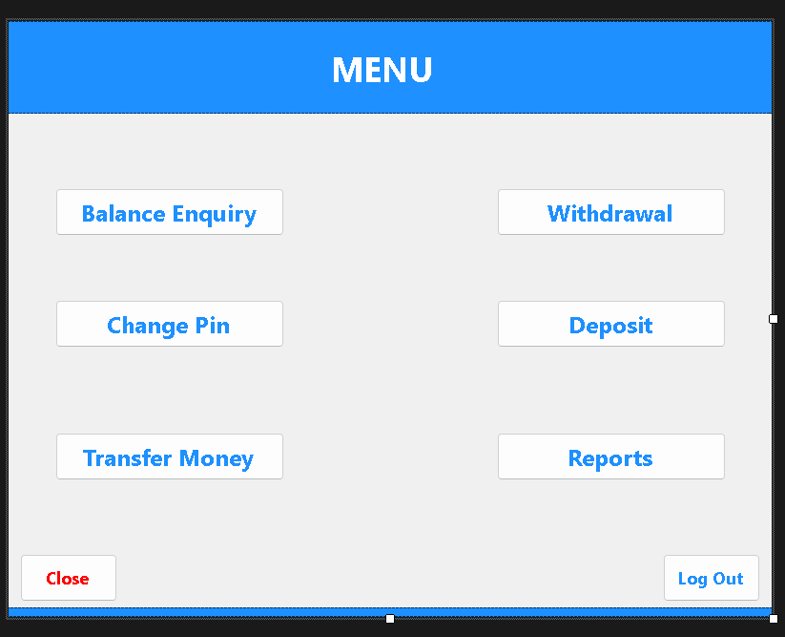

If you click on balance enquiry you are taken to page that displays your balance.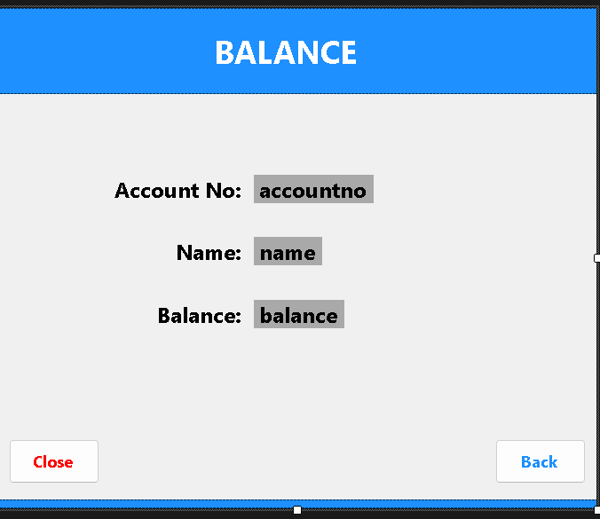

When you click on the change PIN you taken to page where you are asked to input your PIN and the new PIN you what to change it to twice for confirmation.

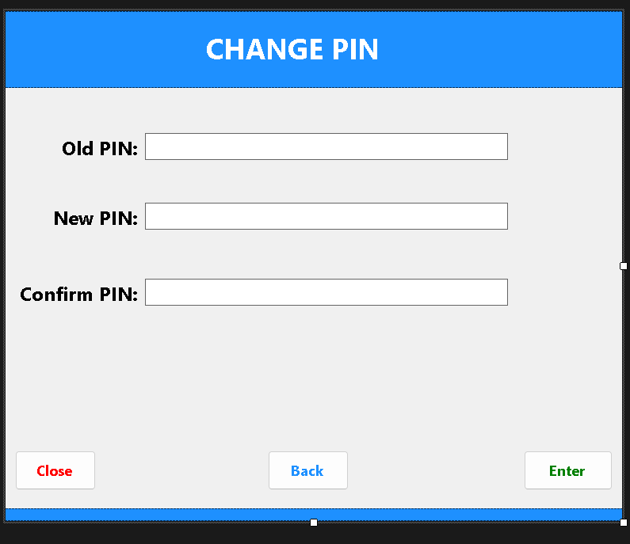

When you click on the transfer money option you are asked to input your account, the recipient account, and amount to be transferred. 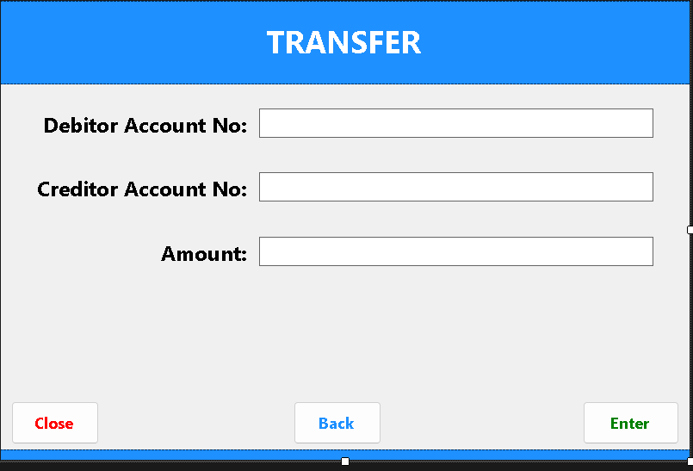

When you click on withdrawal you asked to input the amount to withdraw. 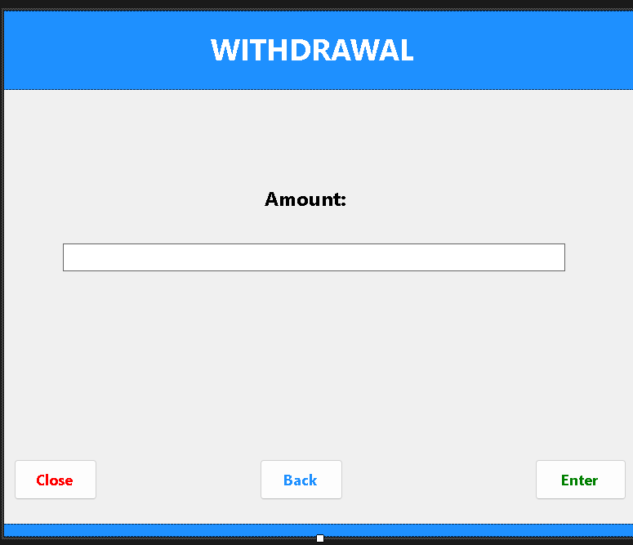

When you click on deposit you asked to input the amount to deposited. 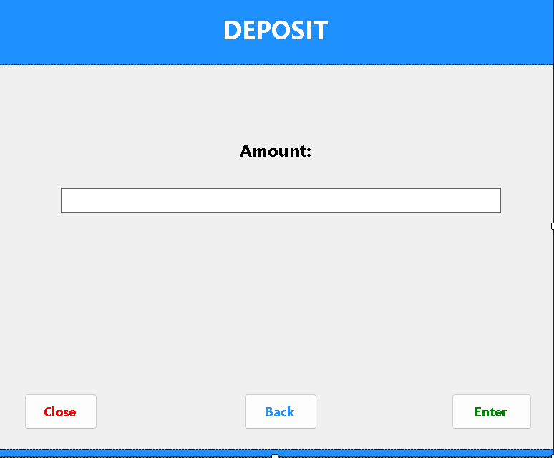

When you click on reports you are to input a date which is used to generate the transaction that took place on that date.

**USER MODULE:** 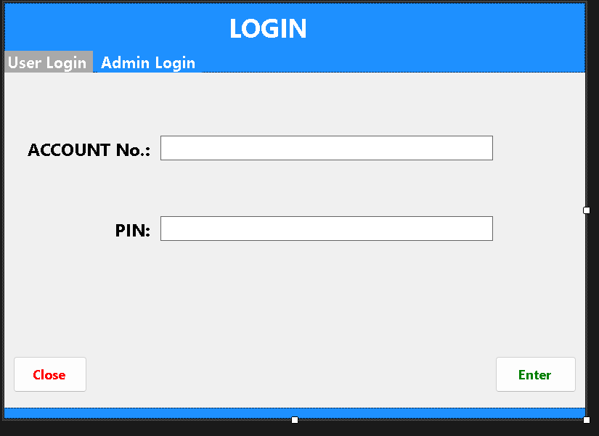

The first page you see is the login page you enter your details and you are taken to the menu page where there five options:

* Balance Enquiry
* Change PIN
* Transfer Money
* Withdrawal
* Deposit

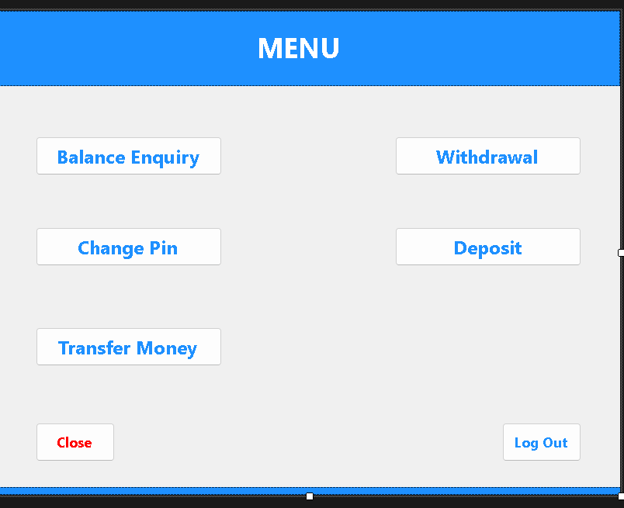

If you click on balance enquiry you are taken to page that displays your balance. 

When you click on the change PIN you taken to page where you are asked to input your PIN and the new PIN you what to change it to twice for confirmation.



When you click on the transfer money option you are asked to input your account, the recipient account, and amount to be transferred. 

When you click on withdrawal you asked to input the amount to withdraw.



When you click on deposit you asked to input the amount to deposited. 

1. Developers Guide.

The Source Code was written with Visual Studio 2022 and MSSQL was used for the database