¹Ihor Miroshnychenko
PhD, Associate Professor of the Department of Technologies Management
¹Taras Shevchenko National University of Kyiv, Ukraine

Revolutionizing Content Creation: Unveiling the Power of Quarto in Modern Education and Multidisciplinary Applications

Abstract. This article explores the transformative potential of Quarto, an innovative content creation platform, in modern education and multidisciplinary applications. By integrating with R, Python, and Julia programming languages, Quarto facilitates the development of dynamic documents, scientific articles, websites, and books, revolutionizing content creation across various domains [1, 2]. This article delves into the advantages of leveraging Quarto’s capabilities, providing an immersive and interactive experience, enabling educators, researchers, and authors to craft content that transcends the boundaries of traditional static materials.
Keywords: Quarto, modern education, R programming, Python, interactive content, presentations, book writing, website development.

In today’s fast-paced digital landscape, the synthesis of technology with content creation has become an imperative element in modern education and various professional fields. Quarto, a versatile content creation platform, paired with R, Python, and Julia programming languages, offers an innovative and immersive approach to crafting dynamic documents, scientific articles, websites, and books.
One of Quarto’s prominent features is its integration with data-driven programming languages. This integration allows for the creation of dynamic and interactive documents, empowering researchers, educators, and authors to embed code, visualizations, and interactive elements within their content. Educators can develop compelling teaching materials, researchers can present data-driven findings, and authors can create books enriched with interactive elements, thus engaging their audience in new and profound ways.
Quarto Markdown files (.qmd) and Jupyter Notebook files (.ipynb) are fundamental to the Quarto system, providing a foundation for combining text, code, data analysis, and interactivity within a single document.
The Quarto content generation pipeline involves several stages to create dynamic, interactive, and data-rich documents. While there are numerous processes that work internally in Quarto, an overview of the basic content creation pipeline is shown in Figure 1.
Here is an outline of the typical process when rendering a .qmd file in Quarto:
- Content Creation in .qmd Files: Authors create content in Quarto Markdown (.qmd) files, which consist of a combination of Markdown text for narrative content and code blocks from languages like R, Python, Julia, etc., for data analysis and visualizations.
- Execution of Code Blocks using Jupyter: Quarto utilizes Jupyter/knitr for code execution. The code blocks within the .qmd file are executed by Jupyter, generating results and output that includes textual, visual, or computational elements.
- Conversion to Plain Markdown: The combination of code, executed output, and Markdown text from the .qmd file is then converted to plain Markdown, capturing the results and outputs of the executed code blocks. This stage typically involves processing the dynamic content into a static representation.
- Pandoc Processing: The resulting plain Markdown generated from the previous step is passed through Pandoc [3]. Pandoc is a universal document converter that takes input in various formats, including Markdown, and can output to a variety of formats, such as HTML, PDF, or others. In this step, Pandoc converts the plain Markdown into the desired final output format, applying styles, layouts, and configurations specified in the Quarto settings.

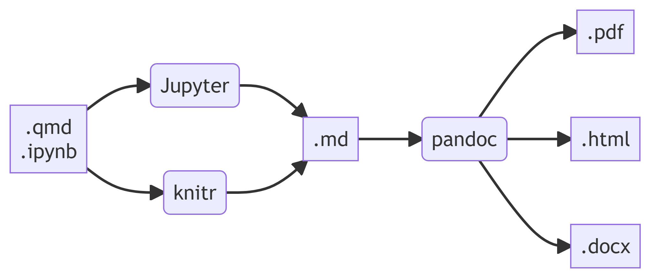
Figure 1 – Quarto content generation pipeline
This multi-stage process involves the dynamic execution of code within Quarto, followed by a conversion to a static representation in Markdown, and finally the transformation into the desired output format by Pandoc.

References:
- McKinney, Wes. 2022. Python for Data Analysis: Data Wrangling with Pandas, NumPy, and Jupyter. O’Reilly Media. https://wesmckinney.com/book.
- Wickham, Hadley, and Garrett Grolemund. 2023. R for Data Science: Import, Tidy, Transform, Visualize, and Model Data. O’Reilly Media. https://r4ds.had.co.nz.
- “Pandoc a Universal Document Converter”, 2022. URL: https://pandoc.org.

