from collections import deque

def bfs(graph, start_vertex):

    visited = set()

    queue = deque([start_vertex])

    while queue:

        vertex = queue.popleft()

        if vertex not in visited:

            visited.add(vertex)

            print(vertex, end=" ")

            for neighbor in graph[vertex]:

                queue.append(neighbor)

graph = {

    'A': ['B', 'C'],

    'B': ['A', 'D', 'E'],

    'C': ['A', 'F'],

    'D': ['B'],

    'E': ['B', 'F'],

    'F': ['C', 'E'],

}

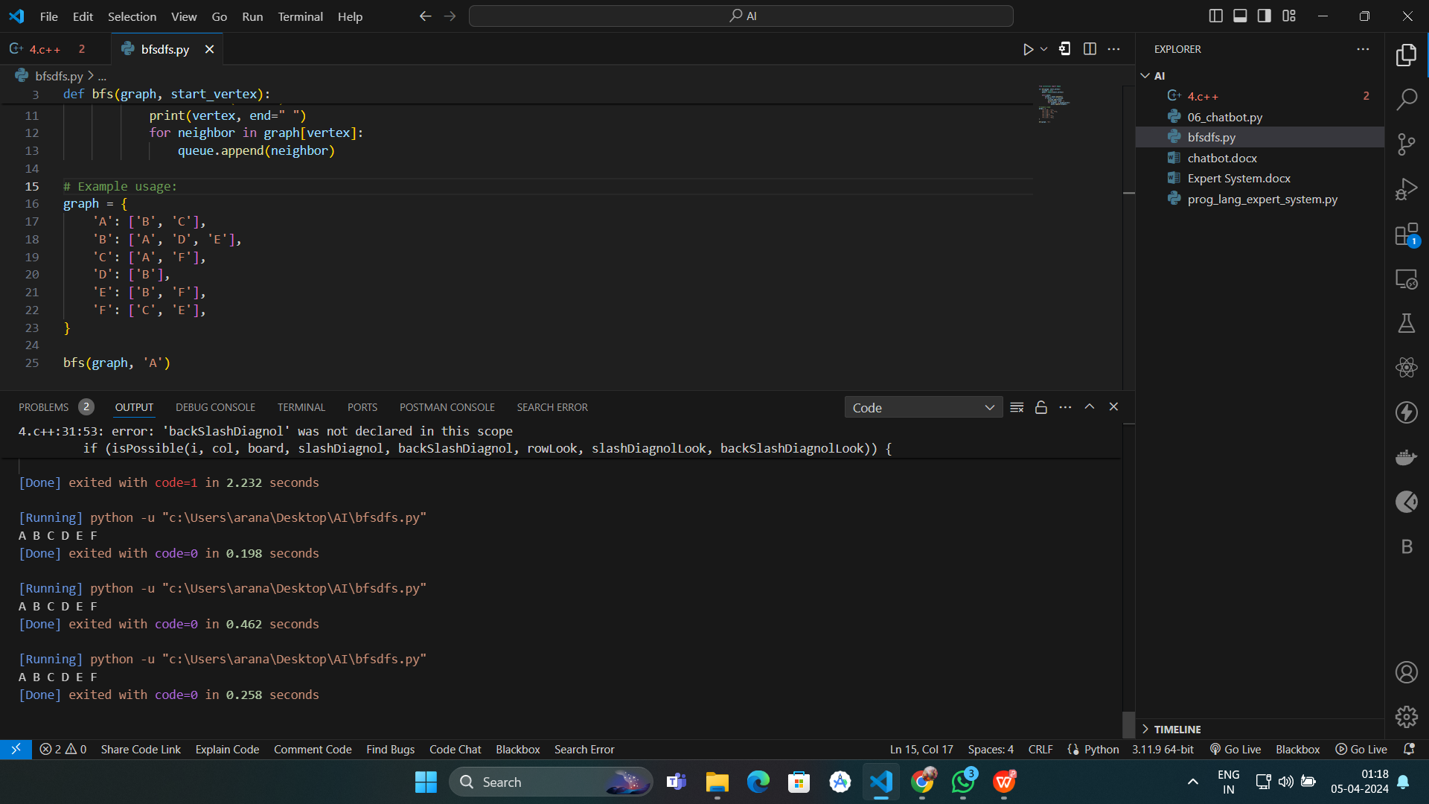bfs(graph, 'A')