FINAL MACHINE LEARNING PROJECT REPORT
Customer Retail Data Analysis
Using Machine Learning Models
──────────────────────

Project by
V. Arankan

1. Introduction
Machine Learning is a branch of Artificial Intelligence that enables computers to learn from data and make predictions. In this project, different Machine Learning algorithms are implemented using a customer retail dataset. The project focuses on preprocessing data, training models, evaluating performance, and comparing algorithms.

2. Project Objective
The main objective of this project is to implement and compare multiple Machine Learning classification algorithms using a customer retail dataset.

The objectives include:
- Data preprocessing
- Handling missing values
- Encoding categorical data
- Data visualization
- Model training and prediction
- Model evaluation
- Performance comparison

3. Dataset Description
The dataset used in this project is a customer retail dataset containing sales transaction information.

Features Used
- Quantity
- UnitPrice
- Country

Other Dataset Columns
- InvoiceNo
- StockCode
- Description
- InvoiceDate
- CustomerID
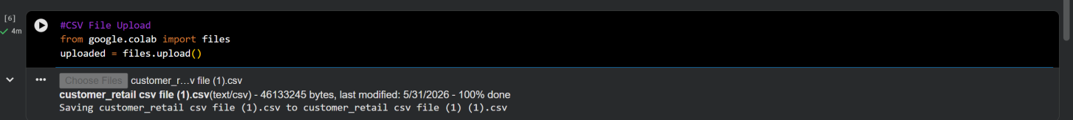
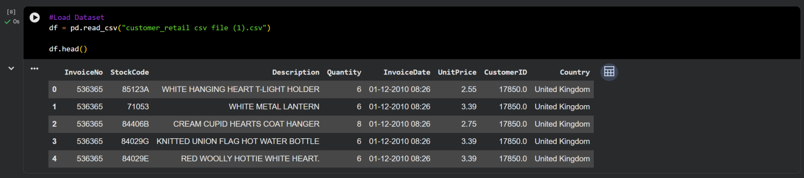

4. Tools and Technologies Used
- Python
- Google Colab
- Pandas
- NumPy
- Matplotlib
- Scikit-learn

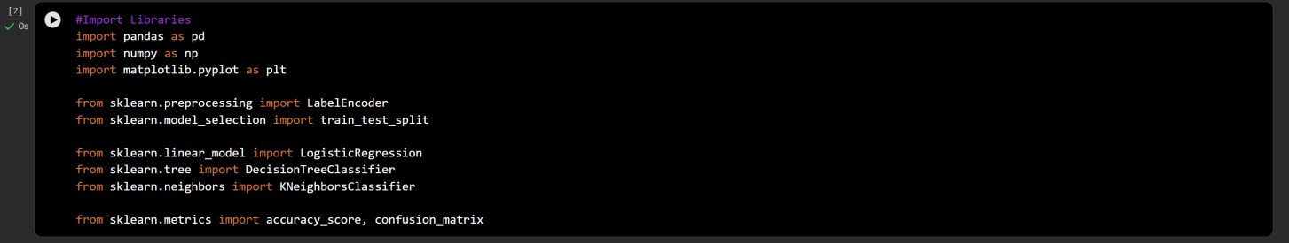

5. Data Preprocessing
Data preprocessing is an important step in Machine Learning. The following preprocessing techniques were applied:

5.1 Handling Missing Values
Missing values were removed using the dropna() function.

5.2 Encoding Categorical Data
The Country column contained text values. LabelEncoder was used to convert text into numerical values.
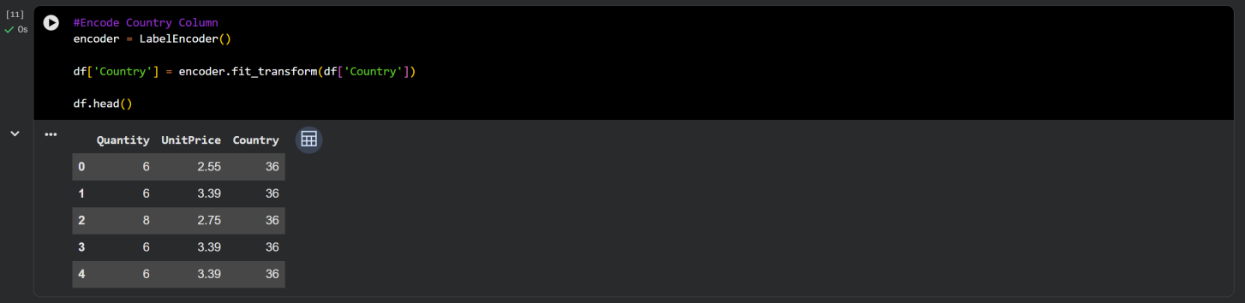

5.3 Feature Selection
The following features were selected:
- Quantity
- UnitPrice
- Country

5.4 Target Creation
A target column was created:
- Quantity > 10 → 1
- Quantity <= 10 → 0
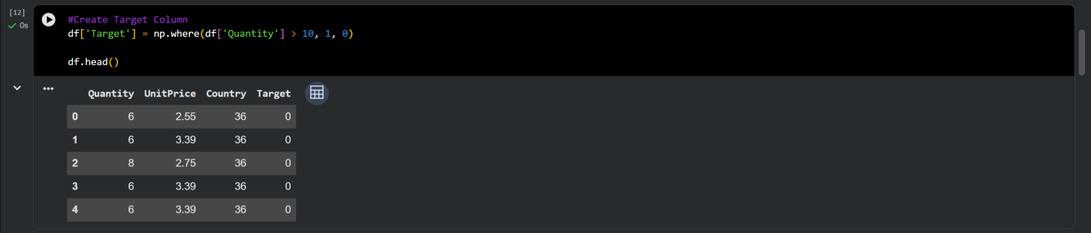

6. Data Visualization
Visualization helps understand the dataset distribution. The graphs were generated using Matplotlib.

Visualizations Included:
- Customer Distribution Graph
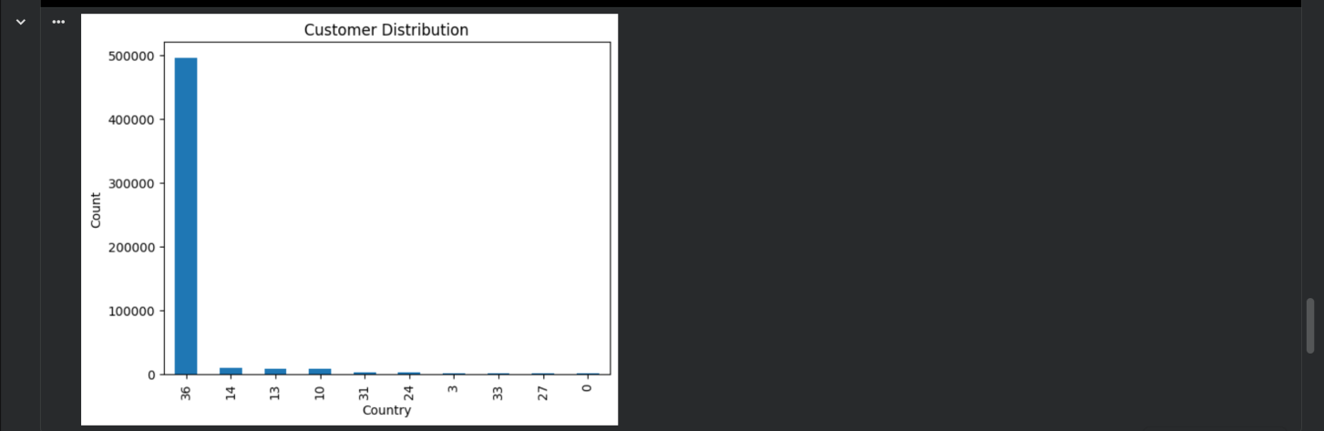

- Model Accuracy Comparison Graph
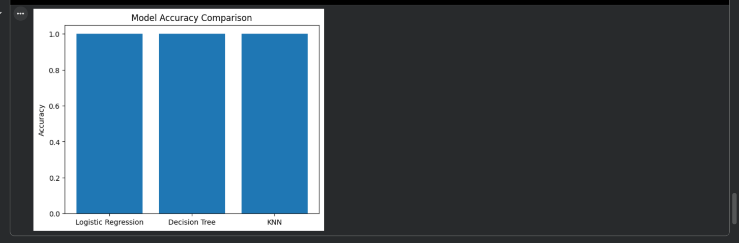

7. Machine Learning Models Used

7.1 Logistic Regression
Logistic Regression is a supervised learning classification algorithm used for binary classification problems.

7.2 Decision Tree Classifier
Decision Tree is a tree-based Machine Learning algorithm used for classification and prediction.

7.3 K-Nearest Neighbors (KNN)
KNN classifies data points based on the nearest neighboring data samples.

8. Model Training and Testing
The dataset was divided into:
- 80% Training Data
- 20% Testing Data

The train_test_split() function was used for splitting the dataset.

9. Evaluation Metrics
The following evaluation metrics were used:

Accuracy Score
Accuracy measures how correctly the model predicts the output.

Confusion Matrix
Confusion Matrix shows the classification performance of the model.

10. Results
After training all models, the accuracy scores were compared.

Model | Accuracy
Logistic Regression | 1.0
Decision Tree | 1.0
KNN | 0.9999907733756528

Logistic Regression Accuracy
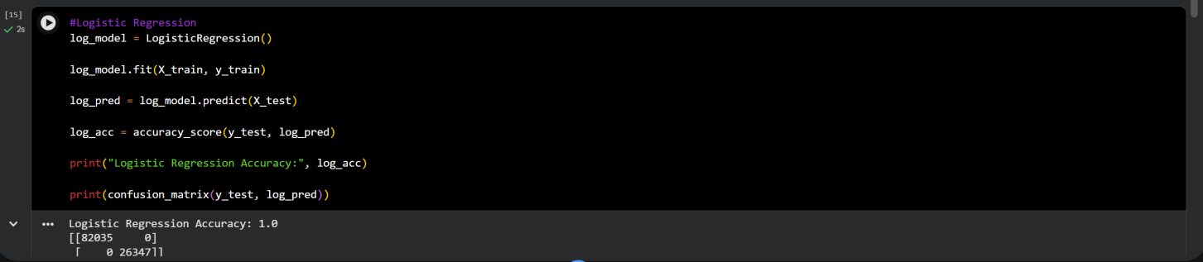

Decision Tree Accuracy
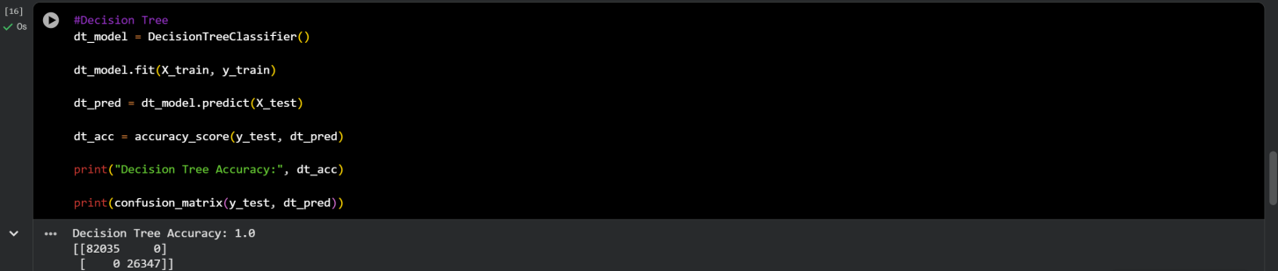

KNN Accuracy
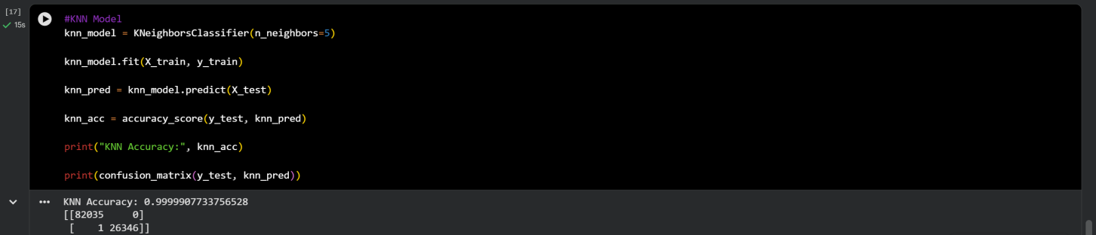

11. Conclusion
This project successfully implemented multiple Machine Learning models using a customer retail dataset. Data preprocessing, visualization, model training, prediction, and evaluation were completed successfully.

The project helped in understanding:
- Supervised learning
- Classification algorithms
- Data preprocessing
- Model evaluation
- Performance comparison

Different algorithms produced different accuracy results, demonstrating the importance of selecting suitable models for Machine Learning tasks.

12. References
- Scikit-learn Documentation
- Google Colab
- Python Documentation
- Pandas Documentation

