INTE 22303 : Artificial Intelligence (24/25)
Assignment 2 – Google ADK
Flood, Landslide and Disaster Recovery Assistant
Student Number: ____________________
ADK project: flood_disaster_assistant (Agent Config YAML, loaded in ADK Web / Web Builder). All factual values come from the supplied data pack (effective date 2026-08-19, data status SUPPLIED-RECORD). The data pack is not a live feed.

Section B - Business-process flow diagram
The flowchart shows how one user message moves through the assistant. Every path ends with one of the four allowed outcomes: an explanation of the returned records, one focused question, a not-found / error result, or a refusal.
Key process rules:
- Immediate danger (trapped person, serious injury, collapsed structure, rising water inside an occupied building, active landslide; rule DR-R001) is handled first: no question is asked before the safety warning and guidance SG-005 are given.
- Each area has two recorded incidents and two listed relief points, so when the incident type or assistance type cannot be worked out from the user's words, the assistant asks one focused question listing only the recorded options. It never picks one for the user.
- The question ends the turn. When the user replies, the root coordinator hands the conversation back to the pipeline, the intake loop re-reads the whole conversation and the workflow continues.
- Unsupported areas or incident types produce a NOT_FOUND result. No replacement area, incident, shelter, guidance or source is invented.

Figure 1. Business-process flow of the Flood, Landslide and Disaster Recovery Assistant
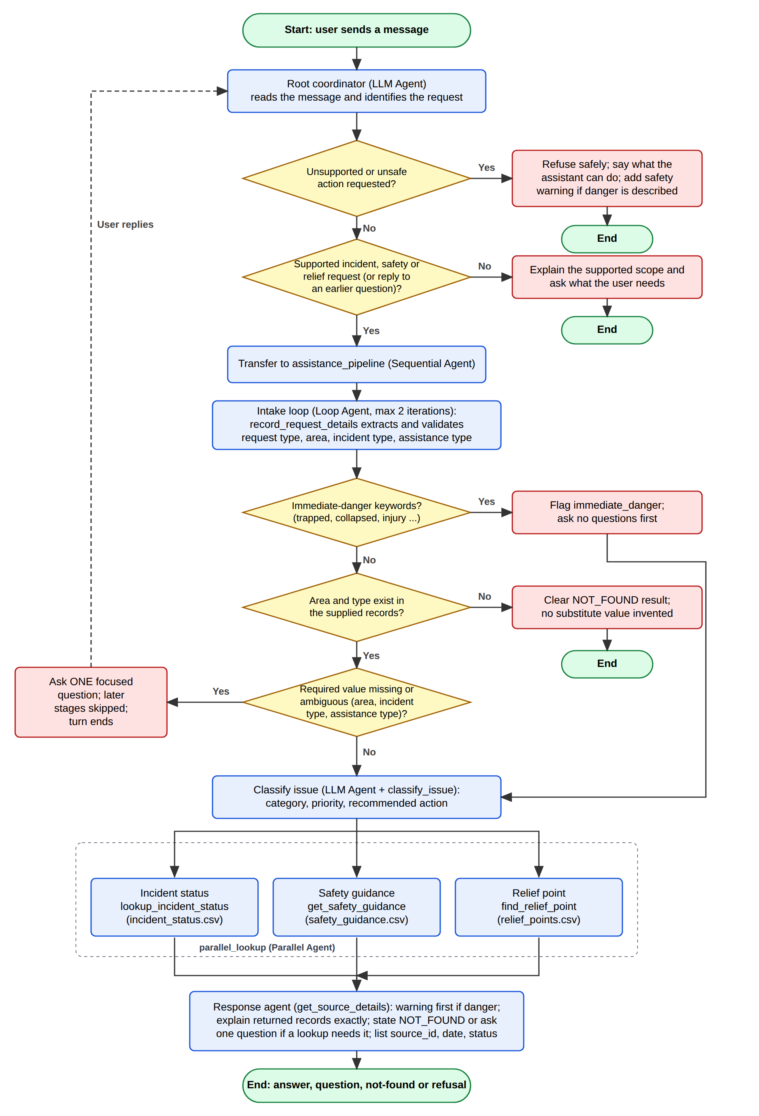

Section C - Tool design
All six Function tools are in flood_disaster_assistant/tools.py and are registered in the owning agent's YAML as flood_disaster_assistant.tools.<name>. Every tool reads only the data_pack files. Area and type comparisons are case-insensitive, and the supplied spelling is returned. Every returned record keeps its source_id, effective_date and data_status.

C1. record_request_details
Field | Definition
Tool | record_request_details
Purpose | Intake validation for the bounded Loop step. Works out what the user is asking for and whether exactly one more value is needed before any lookup runs.
Inputs | request_type (incident_status | safety_guidance | relief_point | incident_and_relief | problem_report)  area (string, "" if not given)  incident_type (string, "" if not given)  assistance_type (string, "" if not given)  problem_description (user's words, "" if none)  tool_context (injected by ADK; gives access to session state and actions)
Processing | - Clears values left over from the previous turn.  - Unknown request_type: returns RETRY and does not stop the loop, so the loop runs once more. On the 2nd attempt it returns NEEDS_INPUT instead.  - problem_description matches a DR-R001 immediate-danger keyword: returns COMPLETE with immediate_danger = true and asks nothing.  - Area given but not Colombo/Ratnapura/Kegalle: returns NOT_FOUND.  - Area missing (every request except safety_guidance): returns NEEDS_INPUT for area.  - Incident type: taken from the explicit value or from description keywords (issue_rules.csv). An unsupported type returns NOT_FOUND. If none is given and the area has more than one recorded incident, returns NEEDS_INPUT with the recorded types for that area.  - Assistance type (relief requests): matched on assistance_type, a small synonym list (shelter, relief centre, supplies, first aid, information) or the services column. If more than one listed type matches, returns NEEDS_INPUT with those types.  - Writes every value to session state. On any final status it sets actions.escalate = true, which ends intake_loop.
Outputs | intake_status: COMPLETE | NEEDS_INPUT | NOT_FOUND | RETRY  request_type, area, incident_type, assistance_type, problem_description, immediate_danger  missing_field + question (NEEDS_INPUT, always exactly one question)  not_found_reason (NOT_FOUND)

C2. classify_issue
Field | Definition
Tool | classify_issue
Purpose | Classifies the reported problem using the deterministic rules in issue_rules.csv (source DR-005).
Inputs | problem_description (string)  incident_type (string, recorded at intake)  request_type (string, recorded at intake)  tool_context (injected)
Processing | - Checks each rule's pipe-separated keywords against the description, ignoring case. Rules are checked in file order, so immediate_danger comes first, then landslide, flood, blocked_route and relief_request.  - If no keyword matches, uses the rule whose category equals the recorded incident_type.  - If still no match and the request is a relief request, uses DR-R005 (relief_request).  - Stores the result in state["classification"].
Outputs | status FOUND: rule_id, category, priority, recommended_action, matched_keywords, match_basis, other_matched_categories, source_id, effective_date, data_status  status NOT_FOUND with a message when no rule applies

C3. lookup_incident_status
Field | Definition
Tool | lookup_incident_status
Purpose | Returns the recorded incident for an area and incident type from incident_status.csv (source DR-001).
Inputs | area (string)  incident_type (string: flood | landslide | blocked_route, or equivalent wording)
Processing | - Unsupported area: NOT_FOUND, with the list of supported areas.  - No incident_type and more than one recorded incident: NEEDS_CLARIFICATION, with the recorded types (the tool never picks one).  - Normalises the type (for example "road blocked" becomes blocked_route) and filters the rows. No row: NOT_FOUND, with the types recorded for that area.
Outputs | status FOUND + incident {incident_id, area, incident_type, status, priority, summary, recorded_update, source_id, effective_date, data_status}  or NEEDS_CLARIFICATION / NOT_FOUND

C4. get_safety_guidance
Field | Definition
Tool | get_safety_guidance
Purpose | Returns the recorded safety guidance for the classified incident type and priority from safety_guidance.csv (source DR-002).
Inputs | incident_type (classification category: flood | landslide | blocked_route | immediate_danger | relief_request)  priority (normal | high | urgent | critical)
Processing | - Filters rows by incident_type. None: NOT_FOUND.  - Returns the row that also matches the priority exactly.  - If no row matches the priority, returns all rows recorded for that type, with a note.
Outputs | status FOUND + guidance [{guidance_id, incident_type, priority, guidance, avoid, escalation_note, source_id, effective_date, data_status}] (+ note)  or NOT_FOUND

C5. find_relief_point
Field | Definition
Tool | find_relief_point
Purpose | Returns the listed shelter, relief centre or assistance point for an area and assistance type from relief_points.csv (source DR-003).
Inputs | area (string)  assistance_type (string, e.g. temporary_shelter, relief_supplies, "shelter", "food", "first aid")
Processing | - Unsupported area: NOT_FOUND.  - Matches the assistance type exactly, then through the synonym list, then against the services column.  - No match: NOT_FOUND, with the types listed for that area.  - More than one match: NEEDS_CLARIFICATION, with those types (never guesses).
Outputs | status FOUND + relief_point {relief_id, area, assistance_type, name, location_description, services, recorded_status, source_id, effective_date, data_status}  or NEEDS_CLARIFICATION / NOT_FOUND

C6. get_source_details
Field | Definition
Tool | get_source_details
Purpose | Explains the source IDs cited in an answer, using source_register.md.
Inputs | source_ids (comma-separated string, e.g. "DR-001,DR-002")
Processing | - Parses the source register table.  - Returns the register row for each requested ID. Unknown IDs are listed as not_found, never invented.  - Adds the register note that the effective date is a dataset version, not a guarantee of current conditions.
Outputs | sources [{source_id, record_group, description, effective_date, data_status}]  not_found [ids]  note

Section D - Agent design
All LLM agents use gemini-3.5-flash-lite (available on the Gemini API free tier, 15 requests per minute). Specialist agents inside workflows have disallow_transfer_to_parent and disallow_transfer_to_peers set, so they cannot hand the conversation away. Stages after intake use the before-agent callback flood_disaster_assistant.callbacks.workflow_gate. It skips the stage without calling the model when intake is not COMPLETE, or when a parallel branch was not requested, and it writes "SKIPPED: <reason>" to that branch's output key.

D1. disaster_recovery_coordinator
Field | Definition
Agent | disaster_recovery_coordinator (root, LLM Agent)
Instructions | Greets the user and routes each message. It first checks for unsupported or unsafe actions and refuses them without transferring, even when the message mentions a flood or shelter. Immediate-danger descriptions and every supported request (incident status, classification, safety guidance, relief point, incident + relief together, or a reply to an earlier question) are transferred to assistance_pipeline.  Refuses unsupported or unsafe actions: dispatching rescue, emergency or medical help; reserving a shelter; arranging transport; payments; official complaints; promising evacuation, rescue, reopening or outcomes; guaranteeing safety; claiming live systems.  Never invents values. Never asks for NIC numbers, passwords, OTPs or payment details.  Side effects: none (no data written).
Tools it owns | None (built-in transfer_to_agent only). Sub-agent: assistance_pipeline.
Expected output | A transfer to assistance_pipeline, a brief scope explanation, or a safe refusal (with the safety warning when danger is described).

D2. intake_agent
Field | Definition
Agent | intake_agent (LLM Agent, child of intake_loop)
Instructions | Reads the whole conversation and calls record_request_details once, passing only values the user actually gave.  COMPLETE: replies "Request details recorded."  NEEDS_INPUT: replies with exactly the one returned question (follow-up behaviour).  NOT_FOUND: states the returned reason and the supported scope, without suggesting a replacement.  RETRY: corrects the arguments and calls the tool once more.  Side effects: writes the request fields and intake_status to session state; escalates to end the loop.
Tools it owns | record_request_details
Expected output | One line: confirmation, one focused question, or a not-found message.

D3. issue_classifier_agent
Field | Definition
Agent | issue_classifier_agent (LLM Agent)
Instructions | Calls classify_issue with the recorded request_type, problem_description and incident_type from state.  Replies with one line: "Classification: <category> | priority <priority> | rule <rule_id> | source <source_id>". Adds no advice.  Skipped by workflow_gate when intake is not COMPLETE.  Side effects: writes state classification and classification_summary.
Tools it owns | classify_issue
Expected output | Classification line (output_key classification_summary).

D4. incident_lookup_agent
Field | Definition
Agent | incident_lookup_agent (LLM Agent, parallel branch)
Instructions | Calls lookup_incident_status with the area and incident_type from state, and copies the returned values exactly.  Skipped when there is no area or incident type, or when incident information was not requested.
Tools it owns | lookup_incident_status
Expected output | Incident record, NOT_FOUND or NEEDS_CLARIFICATION (output_key incident_result).

D5. safety_guidance_agent
Field | Definition
Agent | safety_guidance_agent (LLM Agent, parallel branch)
Instructions | Calls get_safety_guidance with the classification category and priority, and copies the guidance, avoid and escalation_note fields exactly.  Skipped when intake is not COMPLETE.
Tools it owns | get_safety_guidance
Expected output | Guidance record(s) or NOT_FOUND (output_key guidance_result).

D6. relief_lookup_agent
Field | Definition
Agent | relief_lookup_agent (LLM Agent, parallel branch)
Instructions | Calls find_relief_point with the area and assistance_type from state, and copies the returned values exactly.  Skipped when relief information was not requested.
Tools it owns | find_relief_point
Expected output | Relief point, NOT_FOUND or NEEDS_CLARIFICATION (output_key relief_result).

D7. response_agent
Field | Definition
Agent | response_agent (LLM Agent)
Instructions | Collects the source_ids in the recorded results and calls get_source_details.  If immediate_danger is true, starts with the immediate safety warning and says the records are not emergency dispatch.  Explains each result that was not skipped, using only the returned values. States NOT_FOUND results clearly. Asks one focused question for a NEEDS_CLARIFICATION result.  Ends with a Sources line (source_id, record group, effective_date, data_status) and the dataset-version note.  Never adds contact numbers, locations, deadlines, reopening times, promises or safety guarantees.
Tools it owns | get_source_details
Expected output | Final user-facing answer grounded in the supplied records.

Section E - Workflow design

E1. Sequential workflow
Field | Definition
Workflow | assistance_pipeline (SequentialAgent)
Responsibility | Runs the stages that depend on earlier results, in a fixed order: intake -> classification -> lookups -> response. Classification needs the validated request, the lookups need the area, types and classification, and the response needs every lookup result.
Information it needs | The user conversation, passed on by the root coordinator. Stages then share session state: request_type, area, incident_type, assistance_type, problem_description, immediate_danger, intake_status, classification, incident_result, guidance_result, relief_result.
Children | 1. intake_loop (LoopAgent)  2. issue_classifier_agent (LlmAgent)  3. parallel_lookup (ParallelAgent)  4. response_agent (LlmAgent)

E2. Parallel workflow
Field | Definition
Workflow | parallel_lookup (ParallelAgent)
Responsibility | Runs the incident-status, safety-guidance and relief-point lookups at the same time. They do not depend on each other; each reads the same recorded state and writes its own output key, so the branches never overwrite each other. Branches the user did not request are skipped by workflow_gate.
Information it needs | area, incident_type and assistance_type from intake; classification (category and priority) from issue_classifier_agent.
Children | incident_lookup_agent -> incident_result  safety_guidance_agent -> guidance_result  relief_lookup_agent -> relief_result

E3. Loop workflow
Field | Definition
Workflow | intake_loop (LoopAgent)
Responsibility | A bounded missing-information and retry step. Validates the request details before any lookup. It exits (escalate) as soon as record_request_details returns COMPLETE, NEEDS_INPUT (one focused question is given to the user) or NOT_FOUND. When the tool returns RETRY (invalid request type), it runs once more so intake_agent can correct its arguments. After the user answers the question, the next turn re-enters the loop with the new value and the workflow continues.
Information it needs | The full conversation (earlier question and the user's reply), plus the data pack's supported areas, recorded incident types and listed assistance types.
Children | intake_agent (LlmAgent, tool record_request_details)
Maximum repetitions | max_iterations: 2 (one attempt plus one retry). The tool also converts a second RETRY into NEEDS_INPUT, so the loop can never repeat without a result.

Section F - Web Builder implementation and evidence
Run with: adk web (from the project folder), select flood_disaster_assistant. Use a new session for each test and wait about one minute between tests: a full request uses about 11 model calls and the free tier allows 15 per minute. The expected results below are the values in the supplied records. After running each test, paste the observed result and screenshot into the red placeholders.

F1. Agent and tool configuration
Field | Definition
Test scenario | Agent and tool configuration
Prompt or configuration action | Open ADK Web Builder and load flood_disaster_assistant. Expand the agent tree and the tools of each LLM agent.
Expected result | All four agent types are present: LLM (disaster_recovery_coordinator and 7 specialists), Sequential (assistance_pipeline), Parallel (parallel_lookup), Loop (intake_loop, max_iterations 2). Six Function tools are registered: record_request_details, classify_issue, lookup_incident_status, get_safety_guidance, find_relief_point, get_source_details.
Actual result | [To complete: paste the value observed in ADK Web]
Required screenshot proof | Web Builder graph/configuration showing the LLM, Sequential, Parallel, and Loop agents, plus the registered tools
Screenshot | [To complete: Insert screenshot: Web Builder graph/configuration showing the LLM, Sequential, Parallel, and Loop agents, plus the registered tools]

F2. Sequential workflow
Field | Definition
Test scenario | Sequential workflow
Prompt or configuration action | Prompt: "What is the recorded landslide status in Kegalle?"
Expected result | Events run in order: disaster_recovery_coordinator (transfer) -> intake_agent (record_request_details: COMPLETE, area Kegalle, incident_type landslide) -> issue_classifier_agent (DR-R002, landslide, critical) -> parallel_lookup -> response_agent. Answer: INC-005, restricted_area, critical, "Slope movement recorded with local access restrictions", recorded 2026-08-19T16:30; guidance SG-003; sources DR-001, DR-002, DR-005, effective 2026-08-19, SUPPLIED-RECORD. relief_lookup_agent is skipped.
Actual result | [To complete: paste the value observed in ADK Web]
Required screenshot proof | Workflow graph and Events trace showing ordered execution
Screenshot | [To complete: Insert screenshot: Workflow graph and Events trace showing ordered execution]

F3. Parallel workflow
Field | Definition
Test scenario | Parallel workflow
Prompt or configuration action | Prompt: "Show me the flood status in Ratnapura and where I can get relief supplies there."
Expected result | parallel_lookup runs incident_lookup_agent, safety_guidance_agent and relief_lookup_agent as separate branches, and all results are returned: INC-003 (flood, warning_recorded, critical, "River-level rise and household access disruption recorded"); guidance SG-001 (flood, high, the priority from rule DR-R003); RP-004 Ratnapura Relief Supplies Point, South district service zone, drinking water | dry food | hygiene supplies, listed. Sources DR-001, DR-002, DR-003, DR-005.
Actual result | [To complete: paste the value observed in ADK Web]
Required screenshot proof | Workflow graph and Events trace showing both branches
Screenshot | [To complete: Insert screenshot: Workflow graph and Events trace showing both branches]

F4. Loop workflow
Field | Definition
Test scenario | Loop workflow
Prompt or configuration action | Turn 1: "What is the incident status in Colombo?" Turn 2: "Flood"
Expected result | Turn 1: intake_loop calls record_request_details, which returns NEEDS_INPUT and escalates. The assistant asks one question: "Which incident type are you asking about in Colombo: blocked_route or flood?" Later stages are skipped. Turn 2: the loop runs again, returns COMPLETE and continues: INC-001, monitoring, high, "Localized surface flooding recorded near low-lying access roads", guidance SG-001, sources DR-001, DR-002, DR-005.
Actual result | [To complete: paste the value observed in ADK Web]
Required screenshot proof | Workflow graph and Events trace showing the bounded follow-up
Screenshot | [To complete: Insert screenshot: Workflow graph and Events trace showing the bounded follow-up]

F5. Unsupported or unavailable request
Field | Definition
Test scenario | Unsupported or unavailable request
Prompt or configuration action | Prompt A: "Please send a rescue boat and reserve a shelter place for my family." Prompt B: "Where is the nearest shelter in Galle?"
Expected result | A: the root coordinator refuses to dispatch or reserve, without promising any outcome, and says it can show recorded incident status, guidance and listed relief points. B: intake returns NOT_FOUND: "No supplied records exist for area 'Galle'. Supported areas are Colombo, Ratnapura, Kegalle." No shelter, location or contact number is invented.
Actual result | [To complete: paste the value observed in ADK Web]
Required screenshot proof | Events trace showing the safe result
Screenshot | [To complete: Insert screenshot: Events trace showing the safe result]

Additional check: immediate danger
Prompt: "Our house flooded and the water rising inside, my grandmother is trapped upstairs in Ratnapura." Expected: the response starts with the immediate safety warning (move away from danger and contact the relevant local emergency service or authority; the records are not emergency dispatch). It then gives SG-005 and the recorded Ratnapura flood incident INC-003, and asks no question before the warning.

