PREDICTIVE PROBLEM SET 2
729_ARANYA PRADHAN
2026-02-05
#1 Problem to demonstrate that the population regression line is fixed, but least square regression line varies
set.seed(123)
n <- 50
# Step 1: Population line
x_range <- seq(5, 10, length.out = 100)
y_pop <- 2 + 3 * x_range
plot(x_range, y_pop, type = "l", col = "red", lwd = 2, ylim = c(10, 40),
xlab = "x", ylab = "y", main = "Population vs. Sample Regression Lines")
# Step 2-4: Generate 5 sample lines
colors <- c("blue", "green", "orange", "purple", "brown")
for (i in 1:5) {
x <- runif(n, 5, 10)
epsilon <- rnorm(n, 0, 4)
y <- 2 + 3 * x + epsilon
model <- lm(y ~ x)
abline(model, col = colors[i], lty = 2)
}
legend("topleft", legend = c("Population Line", paste("Sample", 1:5)),
col = c("red", colors), lty = c(1, rep(2, 5)), cex = 0.8)
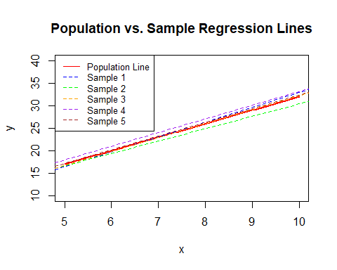 Interpretation: The red line is the “truth”. Because each sample has different random noise ($ϵ$), the estimated slopes and intercepts vary slightly around the true population values.
#2 Problem to demonstrate that βˆ0 and βˆ minimises RSS
set.seed(123)
n <- 50
# Step 1: Generate data
x <- runif(n, 5, 10)
x_centered <- x - mean(x)
epsilon <- rnorm(n, 0, 1)
y <- 2 + 3 * x_centered + epsilon
# Step 2: OLS Estimates
fit <- lm(y ~ x_centered)
beta0_hat <- coef(fit)[1]
beta1_hat <- coef(fit)[2]
# Step 3: Grid search for RSS
b0_grid <- seq(beta0_hat - 1, beta0_hat + 1, length.out = 100)
b1_grid <- seq(beta1_hat - 1, beta1_hat + 1, length.out = 100)
rss_func <- function(b0, b1) {
sum((y - b0 - b1 * x_centered)^2)
}
# Compute RSS for combinations
rss_results <- outer(b0_grid, b1_grid, Vectorize(rss_func))
# Find minimum
min_idx <- which(rss_results == min(rss_results), arr.ind = TRUE)
cat("Minimum RSS found at: Beta0 =", b0_grid[min_idx[1]], ", Beta1 =", b1_grid[min_idx[2]], "\n")
## Minimum RSS found at: Beta0 = 2.046088 , Beta1 = 3.08645
cat("OLS Estimates: Beta0 =", beta0_hat, ", Beta1 =", beta1_hat, "\n")
## OLS Estimates: Beta0 = 2.056189 , Beta1 = 3.076349
#3. Unbiasedness of Least Squares Estimators
set.seed(123)
n <- 50
R <- 1000
beta0_true <- 2
beta1_true <- 3
estimates <- replicate(R, {
x <- runif(n, 0, 1)
eps <- rnorm(n, 0, 1)
y <- beta0_true + beta1_true * x + eps
coef(lm(y ~ x))
})
# Average of estimates
avg_estimates <- rowMeans(estimates)
print(avg_estimates)
## (Intercept) x
## 2.013053 2.982112
Comment: The average ${\hat{β}}_{0}$ and $\hat{β}$ should be very close to 2 and 3 respectively, confirming that the estimators are unbiased.
#4.Comparing Simple Linear Regressions (Boston Data)
library(MASS)
data("Boston")
# Predictors: crim, nox, black, lstat
predictors <- c("crim", "nox", "black", "lstat")
results <- list()
# (a) Run four separate regressions
for (p in predictors) {
formula_str <- as.formula(paste("medv ~", p))
results[[p]] <- lm(formula_str, data = Boston)
}
# (b) & (c) Present output and evaluate
summary_table <- data.frame(
Predictor = predictors,
Estimate = sapply(results, function(m) coef(m)[2]),
R_Squared = sapply(results, function(m) summary(m)$r.squared),
P_Value = sapply(results, function(m) summary(m)$coefficients[2, 4])
)
print(summary_table)
## Predictor Estimate R_Squared P_Value
## crim.crim crim -0.41519028 0.1507805 1.173987e-19
## nox.nox nox -33.91605501 0.1826030 7.065042e-24
## black.black black 0.03359306 0.1111961 1.318113e-14
## lstat.lstat lstat -0.95004935 0.5441463 5.081103e-88
Analysis Best Fit: Look for the highest R-squared value. Usually, lstat (lower status percentage) explains the most variance in medv in this dataset.Usefulness: All four predictors typically show significant p-values ($<0.05$), meaning they are useful individual predictors, though their impact varies (e.g., nox has a negative relationship with price).

