CONCLAVE: Agentic AI Without a Language Model —
Ensemble Machine Learning as the Cognitive Core for
Connectivity-Denied Autonomous Systems
Aranya Mahmud
Every widely used agentic AI framework places a language model at the centre of the sense–decide–act loop. That choice imports two dependencies that are untenable in the environments where autonomy matters most: a network path to a remote model, or enough local compute to host one. During a flood, a cyclone, or an earthquake — precisely when an autonomous responder is most valuable — cellular and backhaul infrastructure is among the first casualties, and the field hardware that survives is battery-powered and memory-constrained. We ask whether the language model is actually load-bearing for the class of agentic tasks these deployments require, and find that it often is not. We present CONCLAVE, a framework in which a heterogeneous machine-learning ensemble replaces the language model as the cognitive core, supplying action selection, open-vocabulary tool routing, calibrated abstention, and an explicit uncertainty decomposition that a single model cannot provide. On the Berkeley Function Calling Leaderboard, CONCLAVE’s ranking ensemble selects the correct tool with 90.8% top-1 accuracy on the user-contributed multi-tool split, 78.9% when every test tool was unseen during training, in 4.0 ms per decision from a 631 KB model. On the HumAID crisis-triage benchmark it reaches 74.3% weighted F1 against 76.0% for the RoBERTa baseline the dataset authors report on the same combined split — a 1.8-point gap — while exceeding every classical baseline they report, from a 36 MB artefact rather than a 125M-parameter transformer. In a sequential flood-response simulation, CONCLAVE is statistically indistinguishable from an oracle cloud agent under full connectivity (Δ = 0.6, 95% CI [−0.7, 1.9]) and significantly better once outages begin, converting a −127 mean return into +34 when 73% of steps are offline. We also report a negative result: ensemble disagreement, while an excellent detector of covariate shift (AUROC up to 0.955), does not outperform random allocation when used to direct a scarce human oversight budget in a sequential task. CONCLAVE is released under Apache-2.0.
Department of Computer Science and Engineering, Daffodil International University, Dhaka, Bangladesh. E-mail: aranyamahmud29@gmail.com
Code, data-preparation scripts, and all result artefacts are available at https://github.com/<user>/conclave.
Index Terms— Agentic AI, ensemble learning, edge computing, offline autonomy, disaster response, uncertainty quantification, tool use.

Introduction
The contemporary AI agent is defined by its cognitive core. Frameworks such as LangGraph, CrewAI, AutoGen, and the various vendor agent SDKs differ in orchestration, memory, and tooling, but agree on one point: a large language model performs the reasoning, and everything else is scaffolding. This consensus has proven productive for open-ended, text-mediated work.
It is a poor fit for a distinct and important class of deployments. Consider a flood-warning and response system in a riverine district. It ingests gauge readings and radio traffic; it must decide when to broadcast a warning, when to begin evacuation, when to commit scarce boats, and when to defer to a human coordinator. The decisions recur with little variation, the input is largely structured, and the consequences are severe. Crucially, the system’s value peaks exactly when the cellular network has failed. A cloud-backed agent in that moment is not degraded; it is absent.
The field has recognised the resource half of this problem. A recent survey of adaptive agentic AI for mobile and embedded devices [1] catalogues elastic inference, test-time adaptation, and cloud–edge offloading — but frames the entire design space around “foundation models as the cognitive core,” so every technique is a way of compressing the language model. NVIDIA’s position paper [2] pushes further, arguing that because agentic invocations are “a small number of specialised tasks performed repetitively and with little variation,” small language models are sufficient and 10–30× cheaper. Empirical follow-up is sobering: TinyLLM’s evaluation of sub-3B models on function calling reports a best overall accuracy of 65.74% [3], and even a quantised 0.5B model needs roughly half a gigabyte of weights.
We take the NVIDIA argument one step further than its authors do. If the task is genuinely specialised, repetitive, and low-variance, the question is not how small the language model can be — it is whether a language model is required at all. Natural language is a means of specifying the task, not necessarily of executing it. Once the tool set is registered and the decision space is enumerated, the residual problem is classification, ranking, and sequential control under uncertainty: the problem classical machine learning was built for, and solves in kilobytes and microseconds.
This paper makes that case concretely.

Contributions
- A framework. CONCLAVE realises the full agentic loop — perception, action selection, open-vocabulary tool routing, symbolic planning over tool preconditions, case-based episodic memory, and hard safety constraints — with a heterogeneous ML ensemble in place of a language model. It has no network dependency, requires no GPU, and serialises to under 250 KB for the disaster agent.
- Uncertainty as control flow. Because the core is a committee, total predictive uncertainty decomposes into aleatoric and epistemic parts at no additional cost. CONCLAVE routes on this decomposition: act, gather more evidence, abstain, or escalate. We calibrate the thresholds by selective prediction rather than hand-tuning them.
- Bounded worst-case decision latency. A decision is a fixed number of estimator evaluations and a bounded-depth planning search. There is no analogue of an unbounded generation loop, so p99 latency is a measurable constant — a property that matters for certifying safety-critical autonomy.
- Evaluation across four axes, on public benchmarks: tool routing and abstention (BFCL v3), crisis perception (HumAID), sequential control under connectivity loss, and resource cost under emulated edge profiles.
- An honest negative result. We show where the approach’s central intuition fails: instantaneous ensemble disagreement is a poor allocator of scarce human oversight in sequential tasks, losing to random allocation. We analyse why and identify the correction.

Related Work

LLM-centred agent frameworks
The dominant frameworks all assume a language model performs reasoning, tool selection, and planning. Their limitations under resource constraint are well-documented and have prompted an active compression literature, but the architectural assumption is rarely questioned. Work on LLM planning competence [4] independently suggests that autoregressive models are weak planners absent an external verifier, which further undercuts the case for placing one at the centre of a control loop.

Small language models at the edge
The SLM-agent line [2, 3] shares our diagnosis — that agentic workloads are narrow and repetitive — but not our conclusion. TinyLLM [3] is our closest point of comparison: it evaluates TinyAgent, TinyLlama, Qwen, and xLAM on BFCL with SFT, PEFT, RL, and DPO optimisation, reaching 65.74% overall and 55.62% multi-turn accuracy. We note carefully that BFCL’s headline metric includes argument-level AST matching, so our tool-selection numbers are not directly comparable; we make the comparison only on cost, where the gap is several orders of magnitude, and on the routing sub-task, which we measure separately.

Agentic AI for disaster management
Disaster Copilot [5] proposes a multi-agent orchestrator for disaster response and explicitly raises resource-limited operation, but it is a vision paper: no implementation, and on-device orchestration is a design goal rather than a measured result. Deployed AIoT flood systems typically use a fixed model pipeline with no agency — no tool selection, no abstention, no planning. CONCLAVE occupies the space between: real autonomy, actually offline.

Ensembles and uncertainty
That ensembles improve accuracy and produce useful uncertainty estimates is long established [6, 7]. The mutual-information decomposition we use originates in Bayesian active learning [9], and selective prediction has its own literature [10]. Our contribution is not these components but their composition: using them as the control substrate of an autonomous agent, and evaluating whether that composition survives contact with agentic benchmarks.

The CONCLAVE Framework

Overview
An CONCLAVE tick is:
$$\text{observe}→\text{featurise}→\underset{\text{committee}}{\underset{⏟}{\text{ensemble posterior}}}→\underset{\text{k-NN}}{\underset{⏟}{\text{episodic prior}}}→\text{gate}→\text{constraints}→\text{act}$$
Every stage is a bounded amount of arithmetic and none touches the network.

Observations and budgeted features
An Observation carries numeric features (gauge readings, resource counts) and optional free text (a radio transcript, an SMS field report). Text is featurised by the hashing trick with TF–IDF reweighting, so the featuriser has no stored vocabulary and its footprint is fixed at construction. This is the single most consequential engineering choice for microcontroller-class targets: a conventional fitted vocabulary on HumAID occupies roughly 98 MB, whereas the hashed featuriser is constant-size and tunable by one parameter, which we sweep in Section V-B.

The ensemble brain
The core is a soft-voting committee of deliberately heterogeneous members — a boosted tree model, a bagged forest, and a linear model, plus a generative naive-Bayes member for text. Homogeneity is the failure mode to avoid: a random forest’s trees share an inductive bias, so their disagreement collapses off-distribution exactly when the agent most needs a warning. Mixing model families keeps the disagreement signal alive.
Two defaults are set from measurement rather than convention. First, n_jobs=1: an agent decides about one observation at a time over a handful of candidate actions, and joblib’s thread-pool construction costs roughly 20× more than the prediction itself at that batch size (90 ms versus 4 ms in our measurements). Parallelism is a throughput optimisation and a latency pessimisation; edge agents want the latter. Second, shallow forests: depth-10, 60-estimator forests lose well under a point of accuracy against unbounded 200-tree forests while cutting the serialised model roughly 9×.

Uncertainty decomposition as control flow
For member posteriors $\{p_{m}\}_{m=1}^{M}$ over K actions with mean $\overset{‾}{p}$, we compute
H[p]⏟total=1Mm​H[pm]⏟aleatoric+H[p]−1Mm​H[pm]⏟epistemic,
each normalised by $\text{log}K$. The distinction is operationally meaningful. High aleatoric uncertainty means the members agree the situation is genuinely ambiguous; more sensing will not help, so the agent should abstain. High epistemic uncertainty means the members disagree — the agent is outside its competence, and should gather evidence or escalate. A single model cannot separate these without expensive sampling; a committee gets it for free.
Gate thresholds are calibrated, not chosen: we select the largest coverage whose accuracy on accepted decisions meets a target precision, which is standard selective prediction and keeps the framework honest.

Open-vocabulary tool routing
Rather than classifying into a fixed action label set, the router scores (request, tool-specification) pairs with a ranking ensemble over lexical-overlap, TF–IDF-similarity, and schema-structure features. Because it scores pairs, a tool registered after training is scored by the same features as any other — the agent gains capabilities without retraining, which is the property that makes LLM routers attractive in the first place. Specification vectors are static and cached at registration, so routing costs one query vectorisation plus a few sparse dot products.

Planning, memory, and constraints
A cost-optimal forward search over tool preconditions and effects, with an admissible set-cover heuristic and a hard depth bound, handles action ordering; termination is guaranteed by construction. Episodic memory is a capacity-bounded k-NN store over past (observation, action, reward) cases that contributes a prior over actions — the ensemble agent’s counterpart to in-context learning, at kilobytes and microseconds. Finally, a constraint layer sits above the learned policy: no statistical model may authorise an irreversible act on its own, and a violated constraint converts the action into a recorded escalation.

Experimental Setup
All experiments run on a 2-core x86_64 Linux container with 3.82 GB RAM — itself close to a Raspberry Pi profile — with seeds fixed at 42 and full provenance recorded in every result artefact. Software: scikit-learn 1.7.2 [12], LightGBM 4.7.0 [13], NumPy 2.2.6.
Benchmarks and what each isolates.
Benchmark | Size | Capability isolated
BFCL v3 | 1,700 functions | tool routing, abstention
HumAID | 76,484 tweets | crisis perception
Flood-response sim | 40-step episodes | sequential control
Edge profiles | 5 boards | resource cost
We note one discarded dataset, because the reason generalises. A widely-used Bangladesh flood-prediction dataset gives 99.6% accuracy under a standard ensemble — but a depth-1 decision stump on rainfall alone scores 98.4%, and 92% of rows are positive. Its “Flood?” label is essentially a rainfall threshold, so any model recovers it and the benchmark measures nothing. We report this because such labels are common in applied disaster-ML papers and are rarely audited.

Results

Tool routing and abstention
Tool routing on BFCL v3. Latency is per single decision, not amortised over a batch.
Split | n | Lexical | CONCLAVE | ms/dec.
multiple | 60 | 90.0% | 98.3% | 4.72
live_multiple | 316 | 79.4% | 90.8% | 3.99
live_multiple (unseen tools) | 346 | 56.7% | 78.9% | 4.35
Abstention (irrelevance) | 2,628 | --- | 84.3% acc / 0.921 AUC | 0.11
Table II and Fig. 1 report the results. The ranking ensemble reaches 90.8% top-1 accuracy on the user-contributed multi-tool split at 3.99 ms per decision (p99 7.09 ms) from a 631 KB model. The lexical-similarity control isolates how much comes from learning: 11.4 points on the standard split, and 22.2 points on the unseen-tool split, where the router still reaches 78.9% on tools absent from training. Abstention — deciding no tool applies — reaches 0.921 AUC at 0.11 ms.
For context, TinyLLM [3] reports 65.74% overall BFCL accuracy for optimised sub-3B models. We stress that this is a different metric, including argument-level matching, and we do not claim to beat it. The defensible comparison is cost: three orders of magnitude in model size, and milliseconds against the hundreds of milliseconds to seconds an SLM needs per generation on ARM hardware.
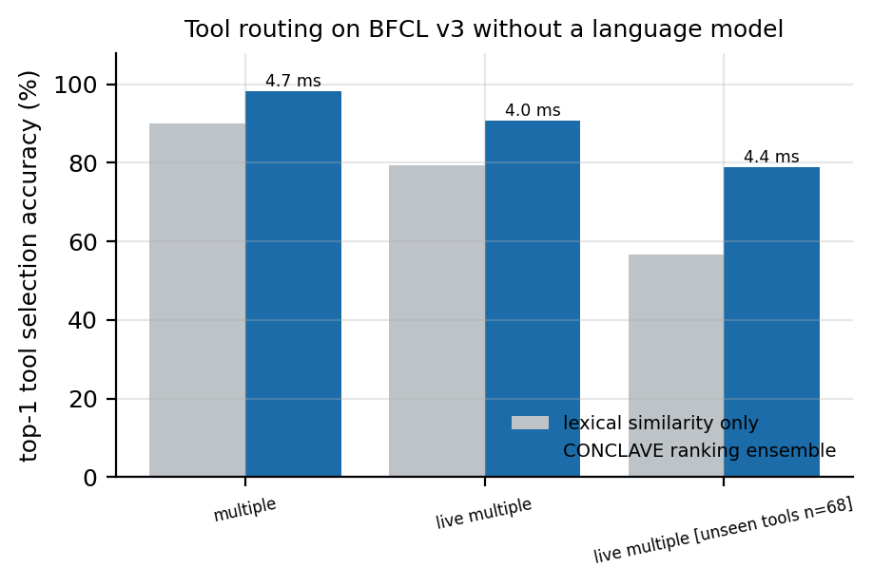
Tool routing on BFCL v3. Learning contributes 11–22 points over lexical matching, with the largest gain where tools were unseen in training.

Crisis perception
HumAID triage, combined 10-class split. Baselines are as reported by the dataset authors , Table 7, row ``All''. The feature budget is CONCLAVE's deployment knob.
Model | Weighted F1 | Size | ms/dec.
Reported by the dataset authors
RoBERTa | 0.760 | ~500 MB | ---
BERT / DistilBERT / XLM-R | 0.758 | 250--500 MB | ---
FastText | 0.744 | --- | ---
SVM | 0.731 | --- | ---
Random Forest | 0.707 | --- | ---
This work
CONCLAVE 2^16 features | 0.743 | 36.4 MB | 4.94
CONCLAVE 2^14 features | 0.726 | 10.1 MB | 1.82
CONCLAVE 2^12 features | 0.713 | 2.6 MB | 1.27
Table III and Fig. 2 give the accuracy–footprint frontier on the authors’ combined split. CONCLAVE lands 1.8 weighted-F1 points behind RoBERTa using a 14× smaller artefact, and matches FastText (0.743 vs 0.744) while clearly exceeding the authors’ SVM (0.731) and random forest (0.707). Even the 2.6 MB configuration (0.713) edges past their random forest — at a size where a transformer is simply not an option. We do not claim to match RoBERTa; we claim the trade is favourable when the alternative is no agent at all.
One caution for readers comparing against this dataset: Table 7 of [15] also contains a column average of 0.781, computed across per-event and event-type rows. It is not the combined-dataset result and should not be used as the baseline for work evaluated on the combined split, as we initially did before checking the source table.
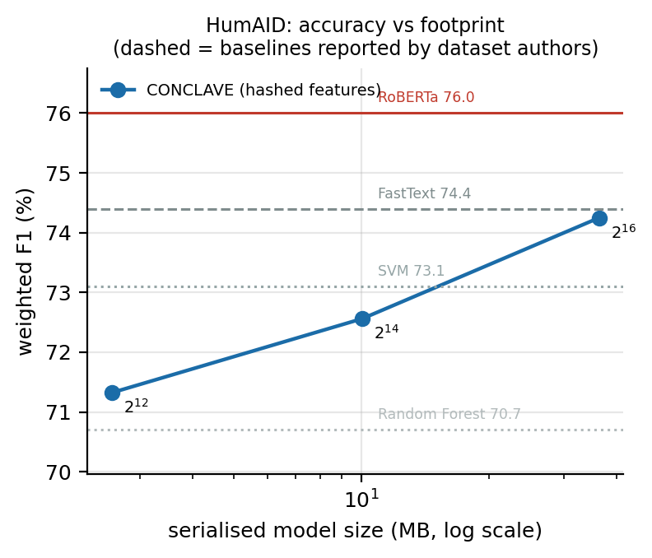
Accuracy against deployment footprint on HumAID. Each point is a hashed-feature budget.

Sequential control under connectivity loss
This is the experiment the work exists for, and it is deliberately stacked against us. The cloud baseline runs an oracle policy with access to the simulator’s latent risk — no real language model would do this well. CONCLAVE sees only noisy sensors and a text field report, and was trained by behaviour cloning on that same expert, so it is strictly weaker in capability. Any advantage therefore comes from availability alone.
Mean episode return under connectivity loss, 120 episodes per cell. Paired bootstrap over identical episode seeds.
Offline | CONCLAVE | Cloud oracle | Δ | 95% CI
0.0% | 36.5 | 35.8 | +0.6 | [-0.7, 1.9]
35.3% | 33.9 | -34.2 | +68.1 | [57.6, 78.9]
53.0% | 34.3 | -77.7 | +112.0 | [100.6, 123.6]
62.3% | 34.8 | -99.3 | +134.2 | [122.9, 145.8]
68.6% | 34.9 | -113.2 | +148.1 | [136.2, 160.3]
73.1% | 33.5 | -127.3 | +160.8 | [148.5, 173.0]
Table IV and Fig. 3 show the result. Under full connectivity the two are statistically indistinguishable (Δ = 0.6, CI [−0.7, 1.9]), which confirms behaviour cloning recovered the expert and validates the comparison as fair. From the first outage regime onward, CONCLAVE is significantly better, and the gap widens monotonically. In casualty terms, the oracle agent’s mean rises from 53.7 to 276.9 as connectivity degrades, while CONCLAVE stays between 41.9 and 50.0. A last-action cache recovers roughly half the loss but no more: stale actions in a fast-moving flood are only marginally better than none. Static threshold rules — the real-world incumbent — are unaffected by outages, as expected, but are far worse than either agent throughout.
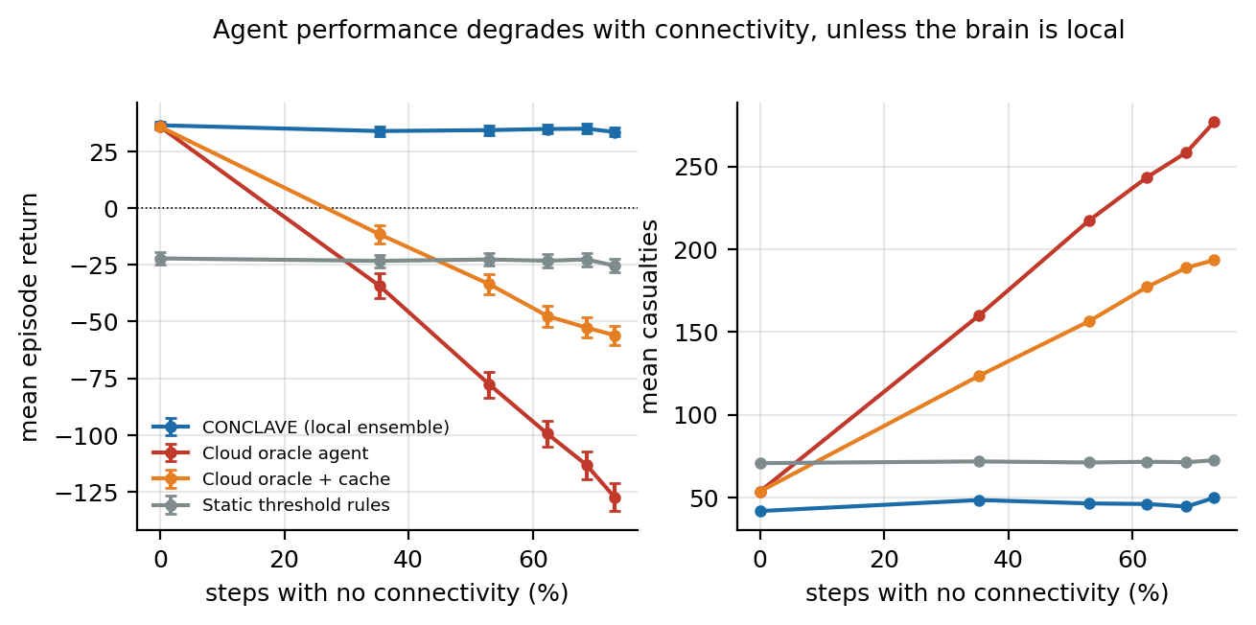
Return and casualties against measured offline fraction. The cloud agent has an oracle policy; its collapse is availability, not capability.

Resource cost
Decision cost under emulated edge profiles. Measured values were obtained with the board's core count and an enforced RAM ceiling; on-device columns are estimates scaled by relative single-core throughput.
 | Measured (host) | Estimated on-device
Board | mean | p99 | mean | energy
Host (2-core x86) | 2.47 ms | 3.07 ms | 2.47 ms | 37.1 mJ
Jetson Nano | 2.46 ms | 3.23 ms | 9.47 ms | 94.7 mJ
Raspberry Pi 4B | 2.44 ms | 3.64 ms | 8.72 ms | 55.8 mJ
Raspberry Pi 3B+ | 2.43 ms | 2.87 ms | 14.27 ms | 71.4 mJ
Pi Zero 2 W | 2.49 ms | 3.37 ms | 22.59 ms | 56.5 mJ
Each cell is the lowest-median batch of five independent batches of 120 decisions. Interference from other processes can only make a timing slower, so a single batch is an upper bound contaminated by whatever else the machine was doing; taking the quietest batch is the least-contaminated estimate. We also record the ratio of worst to best batch median (at most 1.19 here) so that contamination stays visible rather than being averaged away. Without this, we measured p99 figures that varied by 2.5× between runs on the same code.
We separate measurement from modelling, because conflating them is how resource claims fail review. Measured: single-decision latency with the target’s core count and an enforced RLIMIT_AS ceiling, peak resident memory, and serialised size. Estimated, and labelled as such: on-device latency scaled by relative single-core throughput, and energy as latency × TDP.
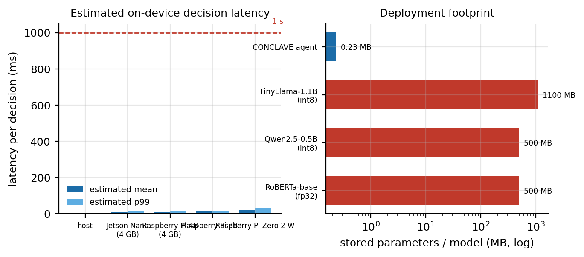
Left: estimated per-decision latency across emulated boards, with the 1 s mark shown for scale. Right: deployment footprint against the smallest agent-capable language models, on a log axis.
The complete disaster agent — featuriser and ensemble — serialises to 232 KB, roughly 2100× smaller than a quantised 0.5B SLM’s weights. Fig. 4 puts that alongside the smallest language models the agentic literature considers. Estimated decision latency is about 23 ms mean and 31 ms at the 99th percentile even on a Pi Zero 2 W. We report one caveat plainly: peak resident memory is 217 MB, which is dominated by the Python runtime and scientific stack, not the agent. On a 512 MB board that fits, but a C or MicroPython deployment would remove most of it, and we have not built one.

Does the uncertainty signal earn its place?
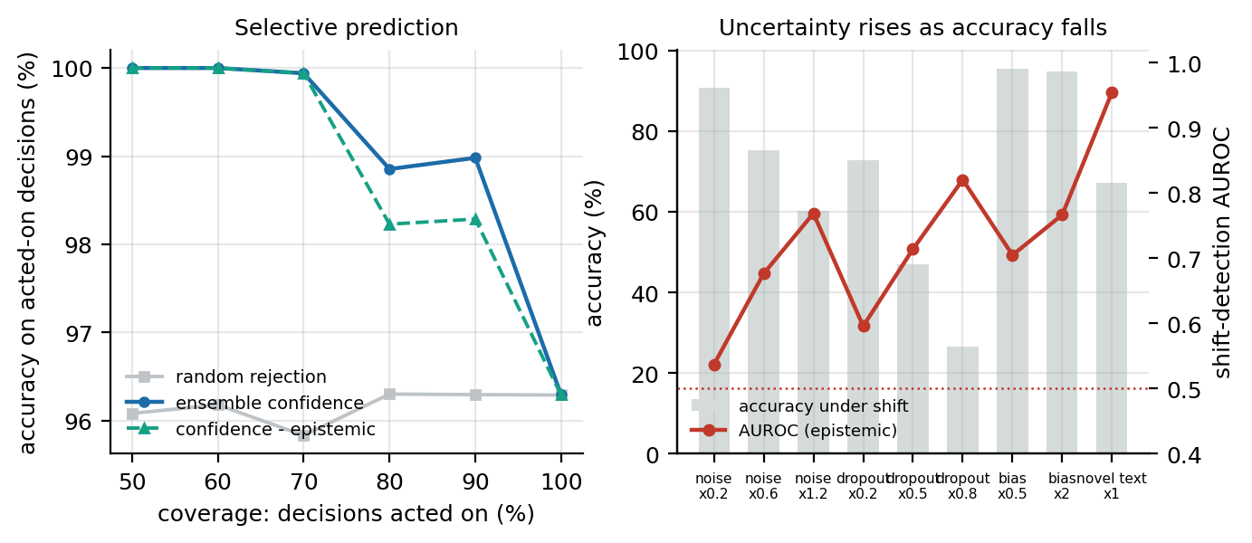
Left: selective prediction. Right: uncertainty tracks accuracy degradation across covariate shifts.
Selective prediction works. Accuracy on acted-on decisions rises from 96.3% at full coverage to 100% at 50% coverage, while random rejection stays flat at ~96% (AURC 0.946).
Shift detection works. Across sensor noise, dropout, bias, and an unfamiliar report vocabulary, uncertainty rises monotonically as accuracy falls — AUROC 0.955 for novel text (accuracy $96.3\%→67.2\%$) and 0.820 for 80% sensor dropout (accuracy $→26.6\%$). We note an initial probe that shifted flood severity gave AUROC ≈ 0.50; that was a flaw in the probe, not the signal, because the controller keeps observations in-distribution under severity change. We report it because the distinction — shifting latent dynamics is not shifting covariates — is easy to get wrong.
The decomposition does not beat plain confidence. On both selective prediction and shift detection, max-posterior confidence matches or slightly exceeds the epistemic term (e.g. 0.960 vs 0.955 AUROC on novel text). The theoretical appeal of separating aleatoric from epistemic uncertainty did not translate into measured advantage on these tasks.
And uncertainty-triggered oversight fails outright. Under 60% sensor dropout, with a budget of 10 human interventions per episode, random allocation lifts mean return from −14.7 to +2.9, while epistemic-triggered allocation reaches only −11.1 and confidence-triggered −10.3. Random wins. The diagnosis: instantaneous uncertainty is high in clusters, so uncertainty-triggered escalations bunch together early in an episode, whereas random allocation spreads oversight across the horizon. In a sequential task, when a decision matters is at least as important as how uncertain it is, and an instantaneous signal is blind to that. The correction is a value-of-information criterion that weights uncertainty by the consequence of error at that step; we have not implemented it, and we flag it as the most promising direction for follow-up work.

Discussion

When to use which core
Our results do not show that ensemble agents are better than language-model agents. They show the two occupy different regimes. A language model remains necessary when the action space is open-ended, when the task specification arrives in unconstrained natural language and changes between invocations, or when the agent must compose genuinely novel plans. An ensemble core is preferable when the tool set is enumerable, the observations are largely structured, the decision recurs, the deployment is connectivity-denied or power-constrained, or worst-case latency must be certified. Disaster response sits squarely in the second regime, as do industrial monitoring, agricultural control, and remote clinical triage.

The cost of the language model was mostly not reasoning
A striking implication of Section V-B and Table II is how much of an agentic pipeline turns out not to need language modelling. Tool routing is ranking; abstention is binary classification; triage is multi-class classification; sequential control is policy learning. The language model in a conventional stack is doing work that is, for these tasks, largely representational — and a hashing featuriser plus a committee of small models recovers most of that representation at a fraction of the cost.

Limitations and Threats to Validity
We state these plainly.
No physical hardware. We do not own a Raspberry Pi or Jetson board. Core counts and RAM ceilings were genuinely enforced, but on-device latency and energy are model-based estimates using literature-derived throughput ratios. They should be treated as projections until measured on real boards.
The sequential environment is a simulation. Its dynamics are hand-specified, and the expert controller that CONCLAVE clones is a heuristic rather than an optimal policy. The availability result — that a local brain keeps working when the network does not — is robust to these details, but absolute returns are not meaningful outside the simulator.
Argument filling is out of scope. CONCLAVE routes to a tool and abstains when none applies; it does not extract typed arguments from free text, which BFCL’s headline metric requires. Structured argument extraction with classical methods is a real gap.
The comparison to SLMs is on cost, not capability. We did not run an SLM baseline ourselves; we cite published numbers on a related but different metric. A head-to-head evaluation on identical metrics and identical hardware is the obvious next study.
Text handling is lexical. Hashed n-grams have no compositional semantics. Negation, sarcasm, and paraphrase will hurt CONCLAVE more than a transformer, which likely accounts for much of the HumAID gap.
Peak memory is dominated by the runtime. The agent is 232 KB; the Python process is 217 MB. A genuinely microcontroller-class deployment needs a reimplementation we have not attempted.

Conclusion
Agentic AI has converged on a single architectural assumption — that a language model belongs at the centre of the loop — and that assumption excludes exactly the deployments where autonomy has the highest stakes: the flood district with no cell tower, the remote clinic on a solar panel. We built CONCLAVE to test whether the assumption is load-bearing, and find that for bounded, recurring, sensor-driven decision loops it largely is not. A heterogeneous ensemble routes tools at 90.8% top-1 accuracy in 4 ms from 631 KB, triages crisis reports within 1.8 F1 points of a transformer at 1/14 the size, and holds its performance flat while an oracle cloud agent collapses as connectivity fails. It also has real limits, including one place where our central intuition about uncertainty did not survive measurement.
The broader point is that “agentic” names a control architecture, not a model class. Recovering that distinction makes autonomy available to a large class of systems currently priced out of it.

Reproducibility
All code, seeds, result artefacts, and figure-generation scripts are released under Apache-2.0. Every result in this paper is regenerated by five scripts in experiments/; each writes a JSON artefact recording platform, seed, and commit. The full suite runs in under 30 minutes on the 2-core container described in Section IV.

References
- Authors of arXiv:2510.00078, “Adaptive and resource-efficient agentic AI systems for mobile and embedded devices: A survey,” arXiv preprint arXiv:2510.00078, 2025.
- P. Belcak, G. Heinrich, S. Diao, Y. Fu, X. Dong, S. Muralidharan, Y. C. Lin, and P. Molchanov, “Small language models are the future of agentic AI,” arXiv preprint arXiv:2506.02153, 2025, nVIDIA Research.
- M. A. Haque, F. Rahman, K. D. Gupta, K. Shujaee, and R. George, “TinyLLM: Evaluation and optimization of small language models for agentic tasks on edge devices,” arXiv preprint arXiv:2511.22138, 2025.
- K. Valmeekam, M. Marquez, and S. Kambhampati, “Can large language models really improve by self-critiquing their own plans?” arXiv preprint arXiv:2310.08118, 2023.
- B. Li, J. Ma, K. Yin, Y. Xiao, C.-W. Hsu, and A. Mostafavi, “Disaster management in the era of agentic AI systems: A vision for collective human-machine intelligence for augmented resilience,” arXiv preprint arXiv:2510.16034, 2025.
- T. G. Dietterich, “Ensemble methods in machine learning,” Multiple Classifier Systems, LNCS 1857, pp. 1–15, 2000.
- L. Breiman, “Random forests,” Machine Learning, vol. 45, no. 1, pp. 5–32, 2001.
- B. Lakshminarayanan, A. Pritzel, and C. Blundell, “Simple and scalable predictive uncertainty estimation using deep ensembles,” in Advances in Neural Information Processing Systems (NeurIPS), 2017.
- N. Houlsby, F. Huszár, Z. Ghahramani, and M. Lengyel, “Bayesian active learning for classification and preference learning,” arXiv preprint arXiv:1112.5745, 2011.
- R. El-Yaniv and Y. Wiener, “On the foundations of noise-free selective classification,” Journal of Machine Learning Research, vol. 11, pp. 1605–1641, 2010.
- Y. Geifman and R. El-Yaniv, “Selective classification for deep neural networks,” in Advances in Neural Information Processing Systems (NeurIPS), 2017.
- F. Pedregosa et al., “Scikit-learn: Machine learning in Python,” Journal of Machine Learning Research, vol. 12, pp. 2825–2830, 2011.
- G. Ke, Q. Meng, T. Finley, T. Wang, W. Chen, W. Ma, Q. Ye, and T.-Y. Liu, “LightGBM: A highly efficient gradient boosting decision tree,” in Advances in Neural Information Processing Systems (NeurIPS), 2017.
- S. G. Patil, F. Yan, H. Mao, and J. E. Gonzalez, “Berkeley function calling leaderboard,” https://gorilla.cs.berkeley.edu/leaderboard.html, 2024.
- F. Alam, U. Qazi, M. Imran, and F. Ofli, “HumAID: Human-annotated disaster incidents data from twitter with deep learning benchmarks,” in Proceedings of the International AAAI Conference on Web and Social Media (ICWSM), vol. 15, 2021, pp. 933–942.

