Visual Design and Functional Testing

Live Class User Sign Up and Login
STC1: Students Test Cases (STC) for Live Class Login Interfaces
STC1.1 Sign Up
Input: Enter roll number: 166101007, User Name/ Name: Ujjwal Biswas, Password: ubiswas, Reenter Password: ubiswas, Upload Image
Expected Output: Sign-Up Successful
STC1.2 Sign-In
Input: Enter roll number: 166101007, Password: ubiswas, Scan QR Code (X=6, Y=6), Login Button press
Expected Output: Open Students Dash
STC1.3 Cross Check the user data base table for the both cases and the seating position of the student in the class room (such as X=6, Y=6)
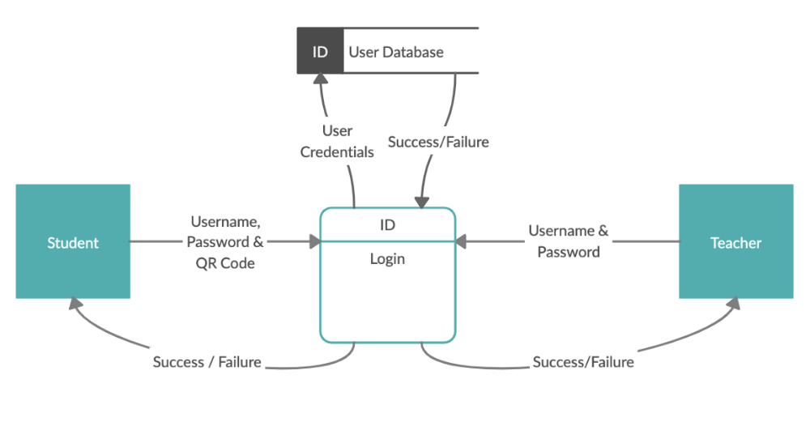
TTC1: Teacher Test Cases (STC) for Login Interfaces
TTC1.1: Sign In
Input: Enter User Name: IITG100, Password: 100, login button presses
Expected Output: Window for entering the classroom dimension
TTC1.2: Open Teacher Dash
Input: Enter teacher credentials and then row number: 21, Column Number 18, and Generate button press, and then tap on visualization
Expected Output: Open Teacher Dash
TTC1.3 Cross check the user data base table for the both cases

Live Classroom slide synchronization and sharing
TTC2: Teacher Test Cases (STC) for slide synchronization and sharing Interface
TTC2.1: Upload new PPT as PDF
Input: PPT on HCI-Evaluation as PDF
Expected output: The file (HCI-Evaluation) should appear on teacher dash
TTC2.2: Open existing PPT as PDF
Input: tap on open PDF
Expected output: The file (HCI-Evaluation) slides across the teacher and student devices
TTC2.3 Changing slide number
Input: teacher swipes left or right, in order to change the page
Expected output: slides changes across the teacher and student devices
TTC2.4 Cross Check the slide data base table for all cases
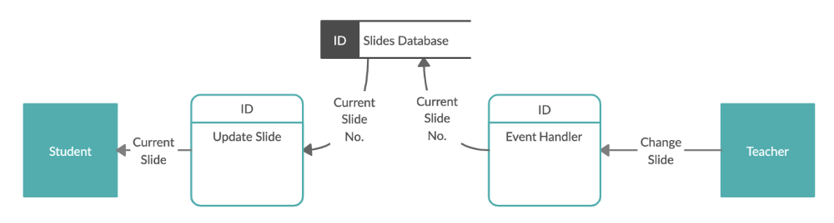
STC2: Students Test Cases (STC) for slide synchronization and accessing Interfaces
STC2.1 Get access of slide
Input: Students login credentials, button press on classroom
Expected output: The file (HCI-Evaluation) slides appears on student devices
STC2.2 Cross check the same in slide data base table

Live Query synchronization and posting
STC3: Students Test Cases (STC) for Live Query synchronization and posting Interfaces
STC3.1 Student query dashboard
Input: Students login credentials, button press on classroom, and tap on Query Panel
Expected output: Display students query panel
STC3.2 Post a query
Input: type a query (what do you mean by “meet user requirement”?) and button press on post
Expected output: Query will appear on students and teacher query panel
STC3.3 Query response
Input: type an answer or button press on like for the query and button press on post
Expected output: Query answer will appear on students and teacher query panel and display number of likes count the query should be displayed in a sorted order (highest likes query will appear on top of the panel)
STC3.4 Cross Check the query data base table for all the cases (here check no. of touch count, text length, and device shake frequency and average pressure on the events)
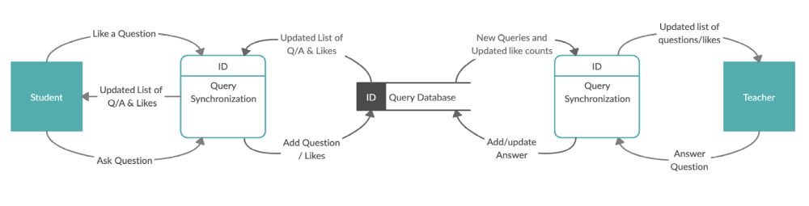
TTC3: Teacher Test Cases (TTC) for Live Query synchronization and posting Interfaces
TTC3.1 Teacher query dashboard
Input: Button press on classroom, and tap on Query Panel
Expected output: Display teachers query panel
TTC3.2 Post a query
Input: Type a query (what is the meaning of the statement “meet user requirement”?) and button press on post
Expected output: Query will appear on students and teacher query panel
TTC3.3 Query response
Input: Type an answer and button press on post or button press on like for liking the query
Expected output: Query answer will appear on students and teacher query panel including number of likes count
TTC3.4 Cross Check the query data base table for all the cases

Live Quiz synchronization and posting
TTC4: Teacher Test Cases (STC) for Live Quiz synchronization and posting Interfaces
TTC4.1 View question
Input: Button press EXAMINATION button on teacher dash, tap on view question
Expected output: Get quiz questionnaire (Set 1 or Set 2)
TTC4.2 Add question
Input: Button press EXAMINATION button on teacher dash, tap on Add question, type question, options and correct answer then press submit
Expected output: Get quiz questionnaire (Set 1 or Set 2)
TTC4.3 Cross check the Quiz data base table for all the activity
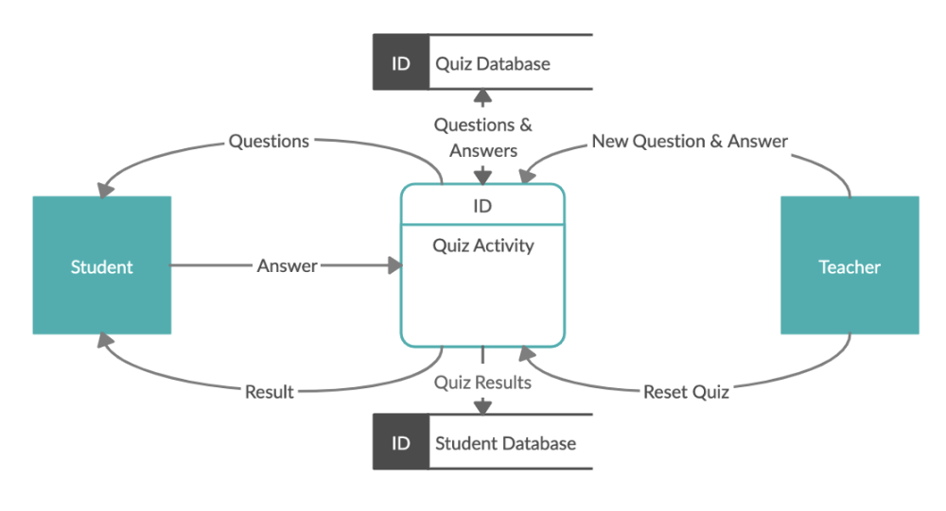
STC4: Students Test Cases (STC) for Live Quiz Interfaces
STC4.1 Get quiz question
Input: Button press on Quiz from student dash
Expected output: Get quiz questionnaire (Set 1 or Set 2)
STC4.2 Answer quiz question
Input: Selection of correct option (answer) from quiz panel
Expected output: able to submit answer for question
STC4.3 Revisit the question
Input: Button press on Previous or Next
Expected output: Display previous or next question
STC4.3 Get quiz result
Input: Button press on submit or get result
Expected output: able to get results as out of 5 you got 4
STC4.4 Cross check the activity in Quiz data base table

Live Class Note Taking Interface for Students
STC5: Students Test Cases (STC) for Live Class Note Taking Interface for Students Interfaces
STC5.1 View a note
Input: Button press on class notes from student dash
Expected output: Get list of notes saved
STC5.2 Save a note
Input: type class note, and press save button
Expected output: Note will be saved
STC5.3 Cross Check the data base table (here check no. of touch count, text length, and device shake frequency and average pressure on the events)

Live Class Attendance Taking Interface
TTC6: Teacher Test Cases (STC) for Live Class Attendance Taking Interfaces
TTC6.1: Get attendance
Input: Press on GET ATTENDANCE and then START ATTENDACE button
Expected output: Get Attendance is enabled message
TTC6.2 Stop attendance
Input: Press on GET ATTENDANCE and then STOP ATTENDACE button
Expected output: Get Attendance is DISABLED message
TTC6.3 Cross Check the Attendance data base table
STC6: Students Test Cases (STC) for Live Class Attendance Taking Interfaces
STC6.1 Give attendance
Input: Press on ATTENDANCE and then RECORD ATTENDACE button
Expected output: Attendance is recorded and attendance is DISABLE message
STC6.3 Cross check the Attendance data base table

Live Class Visualization Interface for Teacher
TTC7: Teacher Test Cases (STC) for Live Class Visualization Interfaces
TTC7.1: View the students over all class status
Input: Press on VISUALIZATIO button
Expected output: Grid view of the whole class based on login time class dimension input (21x18) output should be of 7x9 grids with highlighted color
TTC7.2: View the student image and state
Input: Press on VISUALIZATIO button, then tap on critical grid element highlighted in red
Expected output: 2\3 grid view including student image and state highlighted using colored bounding box.
TTC7.3: View the student details as pop-up
Input: Tap on student image
Expected output: Students details pop-up stays for 20 seconds message with student’s id and states
TTC7.4 Cross Check the student State and seating position in the data base table
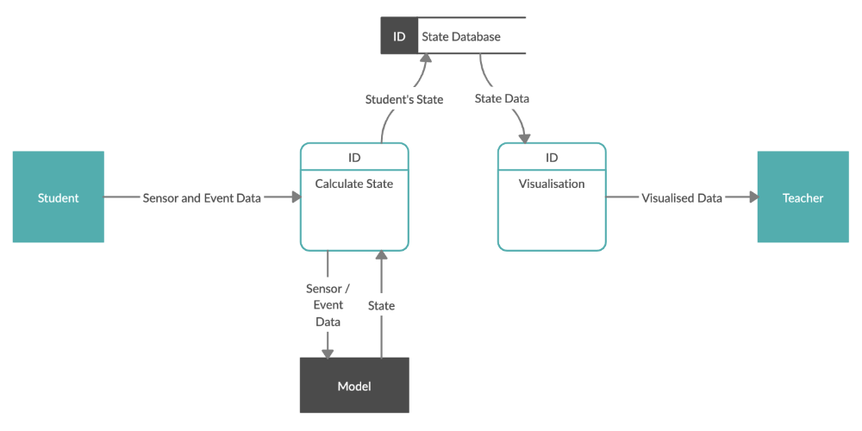

Live Class Alert Generation Interface
TTC8: Teacher Test Cases (STC) for Live Class Alert Generation Interfaces
TTC8.1 View Login time (start of the class) notification
Input: Enter User Name: IITG100, Password: 100, login button presses, and type class dimension (roes=21 and columns=18) and press generate button
Expected output: Get login time notification such as more than 50% students performed below average in last Quiz.
TTC8.2 During Lecture Alert
Input: automated not required any input from teacher side
Expected output: Get real time smart phone vibration/beep/pop-up message
TTC8.3: End of the class notification
Input: Exit button press on teacher dash
Expected output: Get real time feedback for that class (such as students grade dropped significantly)
TTC8.4: Cross check the Teacher Alert data base table for all the activities
STC8: Students Test Cases (STC) for Live Alert Interfaces
STC8.1 View Login time (start of the class) notification
Input: Enter User Name: Ujjwal, Password: ubiswas, scan QR code for seat number and login button presses
Expected output: Get login time notification such as you are excessively absent from class, please try to improve it.
STC8.2 During Lecture Alert
Input: automated not required any input from students’ side
Expected output: Get real time smart phone vibration/beep/pop-up message/flickering screen based on state
STC3.3 End of the class notification
Input: Exit button press on student dash
Expected output: Get real time feedback for that class (such as your grade dropped significantly be careful)
STC4.4 Cross check the activity in Students Alert data base table

Need Data Dictionary consists of the following information −
- Name of the tables in the database
- Constraints of a table i.e. keys, relationships, etc.
- Columns of the tables that related to each other
- Purpose of the table
- Accessed information of the table
- Updated information of the table (i.e., when it will be updated to cross check the entry)

