PROYECT 1

Domain Driven Design: Banking

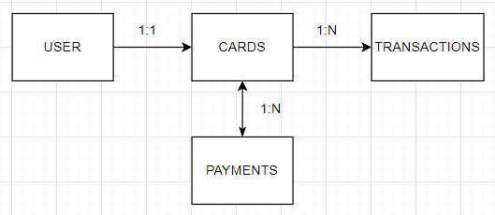

Description of the DDD (Domain driven design)

A DDD is a software development approach that focuses on designing software that reflects a business domain. It emphasizes understanding the business needs and using a common language between business stakeholders and developers.

Within a bank there are users who can have only a card with are able to make as transactions as payments. To pay the with credit card it is used a payment but cannot exceed the credit limit that is measure with a credit usage.

Business Rules:

1. Every user has only one card.
2. A card can be used to do multiple transactions.
3. A card can have multiple payments.
4. Every time a movement is made with the cards, it will be reflected on your card balance after the transaction is made.
5. As we will be doing payments, it would be necessary to access some data of the cards like card number, expiration date, NIP, CVV and CLABE.
6. To create a new user ID, we will need to have all the following information from each client, RFC, CURP, name, birth date, address, phone, email, and password.
7. The following information is required to do a transaction: ID, reference, concept, amount, and transaction date.
8. And for the payments, the information we need is ID of the payment, card ID, amount, concept, and date.
9. Payments cannot exceed the credit limit, which will be measured by subtracting the credit limit minus the total of the credit usage.
10. If the transaction exceeds the current available credit, it will not be executed and a *‘Max limit reached’* message will pop up.
11. After every transaction or payment is made, the balance of the card will be updated and the new amount will be displayed.

Entity Relationship Diagram:

An ER diagram is a graphical representation that shows the relationship with the entities in a database, it shows us how the entities relate with each other. We can represent these relationships by lines that represents how these entities are related to each other. Its main function is to help us design how to model the data and their relationships between tables and to communicate complex data models in a clear and more understandable way.

In the ER we used peewee compatible data type so it can be stored on our database.

