Zingy

Bachelor of Science in Information Technology  
College of Computing Technology

Abstract

The purpose of our project is to explore which factors influence Irish university students’ eating behaviours and to then develop a tailored application to help better these eating habits.

The aim of our research is to investigate and identify the present status of the diet amongst university students. After having gathered our research, our goal is to collect ideas and recommendations in order to facilitate the diet of students. Development of an effective and tailored application aiming to improve a healthier option of eating behaviours in university students is our goal.

Based on our research, it is evident that universities within Ireland do not cater for the dietary habits of students to the extent in which it would be impactful. In conclusion, this opens a niche in the market for an application like Zingy.

Acknowledgements

We would like to express our sincere appreciation and deepest gratitude for our Supervisor Graham Glanville for the encouragement, help and guidance, without which, this work would be possible. For all the support and strengthen words given to us, in this way all long in persisting to complete this project.

We are truly grateful.

We would like to express our thanks also, to all the lectures in the College of Computing Technology, Department of IT for their support during this Project, advices and valuable comments.

To David Bitar and Andreas Schlangen, Project Manager at Keywords International for all the initial support, in the early stages of this project even when the first idea was dropped by the group, they gave us full support and understanding.

To our family and friends for their unceasing encouragement, support, love and being always by our side.

Table of Contents

|  |  |
| --- | --- |
| **INTRODUCTION** |  |
| 1.1 Introduction | pg. 6 |
| **LITERATURE REVIEW** |  |
| 2.1 Overview of Background | pg. 6 |
| 2.2 Research Focus | pg. 8 |
| 2.3 Research Problem | pg. 9 |
| 2.4 Research Question | pg. 10 |
| 2.5 Research Aim | pg. 10 |
| 2.6 Research Methodology | pg. 11 |
| 2.7 Data Collection | pg. 12 |
| 2.8 Data Analysis | pg. 14 |
| **SYSTEM ANALYSIS** |  |
| 3.1 System Analysis | pg. 14 |
| 3.2 Database Analysis | pg. 20 |
| 3.3 Developing Languages | pg. 24 |
| **SYSTEM DESIGN & IMPLEMENTATION** |  |
| 4.1 System Design | pg. 26 |
| 4.2 Wireframes | pg. 27 |
| 4.3 Logo Design | pg. 33 |
| 4.4 Development & Implementation | pg. 33 |
| 4.5 Implementation of Database | pg. 36 |
| **TESTING & EVALUATION** |  |
| 5.1 Testing the Database | pg. 36 |
| 5.2 Hosting | pg. 39 |
| **REFERENCES** | pg. 40 |
| **GROUP WORK ANALYSIS** | pg. 42 |

**1.1 INTRODUCTION**

The purpose of our project is to explore which factors influence Irish university students’ eating behaviours and to then develop a tailored application to help better these eating habits. Development of an effective and tailored application aiming to improve a healthier option of eating behaviours in university students is our goal.

**2.1 OVERVIEW OF BACKGROUND**

The aim of our research is to investigate and identify the present status of the diet amongst university students. During the transition from secondary school to university, students need to adapt to a new environment. Students will have lived at home while attending secondary school, so more than likely, their parents will have prepared a balanced and nutritional dinner for them each night. Their parents will have also been responsible for maintaining the grocery shopping and purchasing healthy food for a balanced diet. Of course each student would have helped prepare meals at home from time to time, but the majority of students would have never had the responsibility of preparing an entire meal from start to finish. This entails deciding upon healthy ingredients to cater for a well-balanced meal, and followed by the next stage of cooking the meal. When a student transitions to college, their environment is much different. Some students may still live at home with their parents, while others may rent student accommodation. Either way, this student is now a full time student with a part time job. A students hours can vary entirely from week to week between attending lectures, studying, doing assignments, working shifts, and maintaining the social aspect of college too. When students fail to adapt their dietary habits adequately this can have negative consequences on their health. Negative consequences are, but not limited to:

1. Poor Brain Function: The human brain relies on glucose to function properly. Glucose is derived from carbohydrates and other nutrients such as healthy fats and antioxidants. According to a study published "The Journal of the Federation of American Societies for Experimental Biology" in Dec. 2009, fatty foods can have an immediate negative impact on the brain’s ability function. This study was conducted on a number of rats. During the study, these rats were fed a high-fat diet and those who were fed a high-fat diet tested significantly lower in cognitive abilities after eating the fatty fare compared to the rats who were fed a lower-fat diet. In correlation to students attending university, eating a restrictive diet or even skipping meals can have similar effects, including poor memory and poor concentration abilities.
2. Poor Exercise Capabilities: As students ourselves, we can be guilty of eating too much some days and eating too little other days. As a result of eating too much or too little, this can cause lethargy, fatigue and other effects that hinder physical activity. Referring to "The Journal of the Federation of American Societies for Experimental Biology" in the previous bullet point, after the rats had eaten high-fat food, the study ran 35-percent less distance than the rats who were fed lower-fat food. According to the National Eating Disorders Association, people who diet often experience poor muscle strength, endurance, oxygen utilization and coordination. Exercise is often incorporated into a university student's life, with the majority of universities having a gym available to students on campus. Exercising is recommended for a healthy brain. Exercising and healthy eating habits go hand in hand, but the general belief of the average student is that exercising and dieting goes hand in hand. Dieting can also cause physical weakness and fainting, particularly if one over-exerts oneself through exercise.
3. Poor Sleep: It is a fair observation that students attending university get very little sleep, between studying full time, working part time, all while trying maintain a social life. We know this very well ourselves. Saying that, there have been many times we each have gone to bed hungry simply for being too tired to cook, while there have also been times where we each have overate. According to MayoClinic.com sleep specialist Dr. Timothy Morgenthaler, going to bed hungry and overeating can detract from one’s sleep. In return, poor sleep can then cause or worsen other short-term effects of an unhealthy diet, such as weight gain and reduced brain and exercise capabilities.
4. Mood Instability: Brain chemicals, such as serotonin and dopamine, promote positive moods. These brain chemicals rely on food and nutrients for proper function. The average student is slightly oblivious as to how their diet is affecting them in more ways than one. To keep up with academics, everyday activities, and to maintain grades it is essential for a student’s brain to be properly functioning. Calories and carbohydrates promote serotonin, so therefore skimping on calories or carbohydrates can cause depressive moods.

As students ourselves we are aware of our own diets, and we are also aware of the diet and behaviours of other students surrounding us over the past few years. For example, students having certain ingredients in their fridge but not knowing what recipes to make with these ingredients, so ordering takeaway appears to be the easiest option for them. A corresponding issue is that the student is spending a needless amount money for only one meal, while also proposing a poor and toxic diet for themselves in return.

**2.2 RESEARCH FOCUS**

The aim of our research is to investigate and identify the present status of the diet amongst university students. After having gathered our research, our goal is to collect ideas and recommendations in order to facilitate the diet of students. This research will be aimed in helping our application develop possible steps that college students can take to cater nutritional values, within preference. Relationships between nutrition and brain function have been the focus of much of our external research.

**2.3 RESEARCH PROBLEM**

There is a possibility that we may encounter certain problems while carrying out our research.

1. **Obtaining research:** As a group, we might all have different opinions regarding where and how we will obtain our research. Will we obtain our research over secondary data such as existing research and statistics, or primary data such as researching students within our own college? We will need to come together as a group and thoroughly discuss what each of us think is the best option suited for our project idea, before we come to an ultimate decision.
2. **Carrying out research:** If we decide to use existing research, we will all need to decide upon obtaining research within college students in general or do we stay locally within Ireland. Equally, if we decide to research students within our college, we will all need to decide how we will carry out this research – should we hand out surveys, gather a focus group to discuss more in depth with students, how many students, and so on.
3. **Application type:** We have three options for developing this application. Firstly, we have an option of developing a web application. A web application is a client - server software application in which the client (or user) runs in a web browser. Secondly, we have an option of developing a mobile application. A mobile application is an application software designed to run specifically on a mobile device. If we decide to develop a mobile application, we will then need to discuss about developing the application for iPhone users, Android users, or both. Thirdly, our final option is to design and develop both a web application and a mobile application.

**2.4 RESEARCH QUESTION**

At the end of carrying out our research, there are certain topics and questions we will need answered before we move forward with the design and development process of our application. Questions include, but are not limited to:

1. How are universities in Ireland contributing to accommodate the diet of their students?
2. Are universities in Ireland aware of the dietary habits of their students?
3. Furthermore, are universities in Ireland positively engaging with students regarding their dietary habits and needs?
4. Is there a niche in the market for an application to assist student diets?
5. Is there a need for a mobile application to assist with healthy recipe guidance for students studying in Higher Education?

**2.5 RESEARCH AIM**

The aim of our research is to make a final decision regarding the uncertainties we have of our application during the design process, and of course before the development process.

1. We aim to collect ideas and recommendations in order to facilitate the diet of students.
2. We want to know how universities are positively contributing to accommodate the diet of their students.
3. We want more of an insight into the diets of students.
4. Importantly, we aim to work effectively as a team!

With our intended research, we will use these results to help our application develop possible steps that college students can take to cater nutritional values, within preference. To best accommodate the diet of students we plan to develop an application with overall efficiency by providing appropriate recipes according to ingredients in the user’s fridge. We plan to have a nutritional notice for students to make themselves aware of what meals contain a higher nutritional value over other meals. A main aim in the design process will be how self-sufficient this is for students. Self-efficacy would impact the student’s diet, which in turn would hopefully eat out less, and to also stabilise the student financially. Self-efficacy would play an important role in predicting nutrition behaviour among college students. When we build our app we will test a number of students to research this.

**2.6 RESEARCH METHODOLOGY**

There are a few methodologies available to us for data collection. In this instance we will probably be combining methodologies. Our research will be interpretive.

1. Surveying: There are different types of surveys. We have the option to choose from a written questionnaire or individual interviews. Written questionnaires contain the risk of leaving some open-ended questions as a result of asking such specific questions. While individual interviews contain the risk of asking broad open-ended questions. If we chose this option, we will need to decide which type of survey would be more suitable for our project.
2. Group discussion: Seeing as we are college students ourselves, we have the option of gathering a group of other college students for a group discussion. We can speak with them over a period of time to cover a set of topics. A group discussion is much more personal form of research rather than handing out questionnaires. In a group discussion, we as a group can speak directly with college students and also have the opportunity of asking any follow-up questions that may arise. A group discussion can be time consuming, but much more valuable to our project.
3. Statistics: Research and statistics already exist which cover certain topics of our project. We have an option of gathering and sorting through existing research. If we sourced enough research, provided it is there to begin with, those articles could answer a lot of our unanswered questions. If the quantity and quality of research meeting our criteria exists, there may not be a need to practice another research methodology.

**2.7 DATA COLLECTION**

We decided to keep our research local to best tailor our application for Irish students. We researched multiple universities around Ireland to see if or how the nutrition of students were being catered for. Below are a list of our findings.

1. Dublin City University (DCU): DCU have a nutritional step by step guide on nutrition for students. This step by step guide includes top tips for healthy eating. The guideline also contains a student menu catering for specific students whom fall under different categories. It caters specifically for students on a budget, there is a menu catering for the ‘busy student’, and there are also nutrition tips catering for students sitting exams. DCU also has a healthcare professional on campus.
2. Trinity College Dublin: Trinity have nutrition tips for their students, but on a much smaller scale. Simply put, their ‘tips’ only display a detailed food pyramid. Trinity believe eating healthily on campus is a combination of knowledge and choice. However, the staff at catering services are well-informed about healthy eating and make every effort to provide healthy choices at all venues and at all times. Under their Mental Health Management on their website, they have a section dedicated to students suffering from eating disorders. ‘Proyouth’ aims to promote healthy eating habits and prevent eating disorders in college students around Ireland – however when we clicked on the link Proyouth is no longer available for students in Ireland. Due to the lack of update, we would not consider this as currently catering for students’ dietary habits.
3. Dublin Institute of Technology (DIT): Nothing available for students’ dietary habits.
4. University College Cork (UCC): After thoroughly browsing through their website, we noticed that there was only one single page on healthy eating. This page contained a suggested service that the college recommends to students. This service will bring dinner to the student from Mondays through Thursdays for a set price.
5. University of Limerick: Have a set meal plan for their students for a fixed price.

**2.8 DATA ANALYSIS**

Based on our research, it is evident that universities within Ireland do not cater for the dietary habits of students to the extent in which it would be impactful. The university we were most impressed by was Dublin City University. We were most impressed by DCU because this college contained a nutritional step by step guideline for healthy eating. What was most impressive, however, was this nutritional guideline catered for each individual student. It catered for an athletic student, a student who is always on the go, and it also catered for every student sitting their end of term exams.

Trinity College would be second in regards to informational, however we didn’t think it was half as impressive as DCU’s approach. Trinity believe eating healthily on campus is a combination of knowledge and choice independently, however are not providing information for the students’ knowledge, equally not leaving room for much choice. This is where our application will offer both knowledge and choice for students.

While UCC suggested a beneficial service to their students, we saw a problem arise with this. This service has delivery from Monday through Thursday only. This limits students’ choice, as there are three more days left in the week to prepare their own meals. Again, this is where our application will offer both knowledge and choice for students.

In conclusion, the vast majority did not positively contributing to accommodate the diet of their students.

**3.1 SYSTEM ANALYSIS**

Programming Methodology:  
Pair programming is the methodology of working in pairs, where there is one person coding and the second person review and checks if the code is alright. Is the almost the same job of a pilot and the co-pilot, where the co-pilot is there for an eventual situation. The second person in this case is there to prevent a mistake or to give a different solution/idea for the first programmer. Pair programming is better for being implemented for some reasons.

This project is easier to be maintained because it doesn’t depend by one person only. In case of one person travelling, being sick or unavailable, the other one can assume the responsibility and do the work. If the person get any trouble can just make a call, or send an email with some questions to the other person and do the work.

Working in pair makes the job flows much faster than the usual, individual. One person can help the other with their difficulties and gives a hand when necessary. When working alone, it can’t be done so easily, because sometimes the person who can give a hand, ins not so close, or does not reply the email or call, that was sent asking for advices for quickly and it makes the developer wait and waste time for something that can easily be done when working in pairs.

As the group are personal friends as well, when working in pairs can be done as well because, one can push another to work faster or harder without getting any personal troubles. This is part of this methodology, once when you’re working in pairs, pressuring the other person is part of the work to get the objective as the promised.

The pair programming methodology theoretically is, two programmers working together, but we adapted it. When someone updated the code, this person had to let the other know. Then, the second person could review the part updated.

Diagrams:  
We have developed two diagrams, to explain our system and its logic.

One an Entity Relational Diagram. These diagrams explain basically the database and how the tables relate to another.

We believe that these diagrams could give us a significant understanding of our system and how it would work, before we start coding or even when we are coding and some functional question appeared to us.

An Entity Diagram resumes all the database and clarify its relations. Analysing it and understanding it, is essential to the programmers to know how the back-end of the system works. Without it, everything would be more complicated to be known

All the attributes that every table have, and all the points of relations between them.

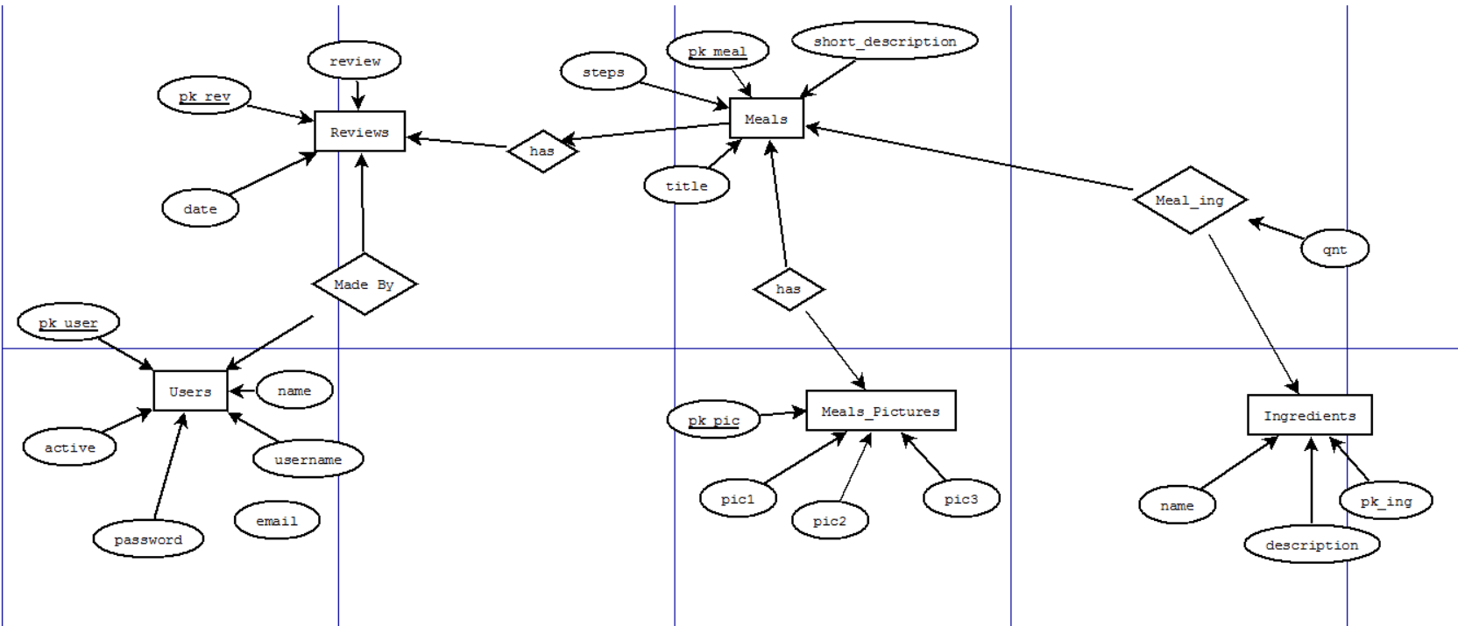

In the database we have 6 tables, Users, Reviews, Meals, Ingredients, Meals_Pictures and Meals_Ing.

Reviews is the table that will be responsible to keep all the reviews data. All the reviews will be done by users only. That’s the reason that Reviews and Users are connected.

An user not logged in the system won’t be able to write a reviews or insert a receipt in the system.

Users table will be responsible to keep all the data of the systems user in the database.

Ingredients table has the information of all the ingredients itself. Name and description of them.

Meals table, receives all the recipes, and how they are made, all the instruction. This table is connected to Ingredients table by the table Meal_ing that is a relation that connects them.

This relation contains an attribute ‘qnt’ that represents the quantity of the specific ingredient that the recipe requires.

Meals table relates to Reviews table that is the review that every meal registered in the system can receive.

Sequence Diagram

After the Entity Diagram, understanding the base of the system, is necessary how it works and the stages that it takes until the process between the user and the system get completed.

The Sequence Diagram has this function. To help the programmers to comprehend the stages separately of each piece of the system.

The sequence diagrams explain the communication of the 3 parts of the entire System. The User, System that represents the web service or mobile app ad the communication that the web/mobile app has with the database when necessary.

Seeing this, we understood that was necessary to create two scenarios here.

One when the user want just to look for a recipe. This is a simple search in the System, where the web series will look in the database and will give an answer. If the ingredients set by the user, all together, them make one of the recipes registered in the database or not

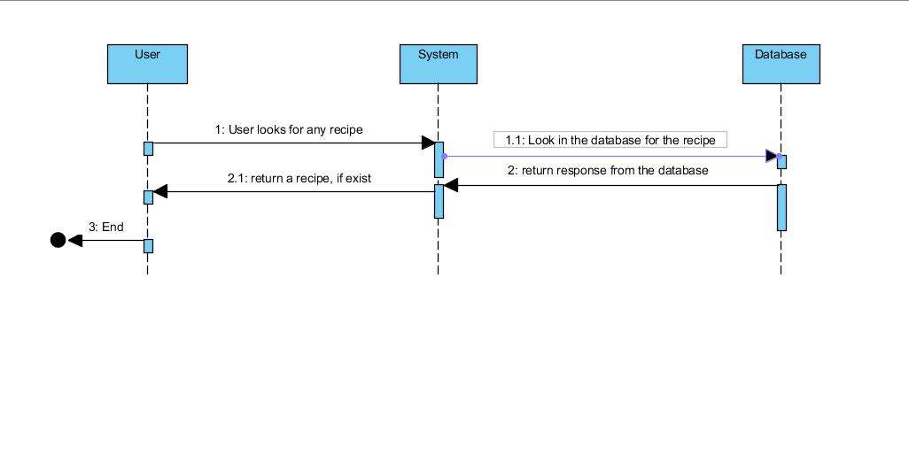

The second scenario represent when the user, after a research in the system, doesn’t find a recipe or the recipe return doesn’t match with what the user want and he want to add a we recipe to the system.

Our system allows only registered users to create and store new recipes in the system.

Then this diagram show all the messages between all the parts of the program how the step to add a new recipe are being done.

Without a login, the user is not able to do a comment or to insert a new recipe in the system. So, in the diagram blow represent this scenario.

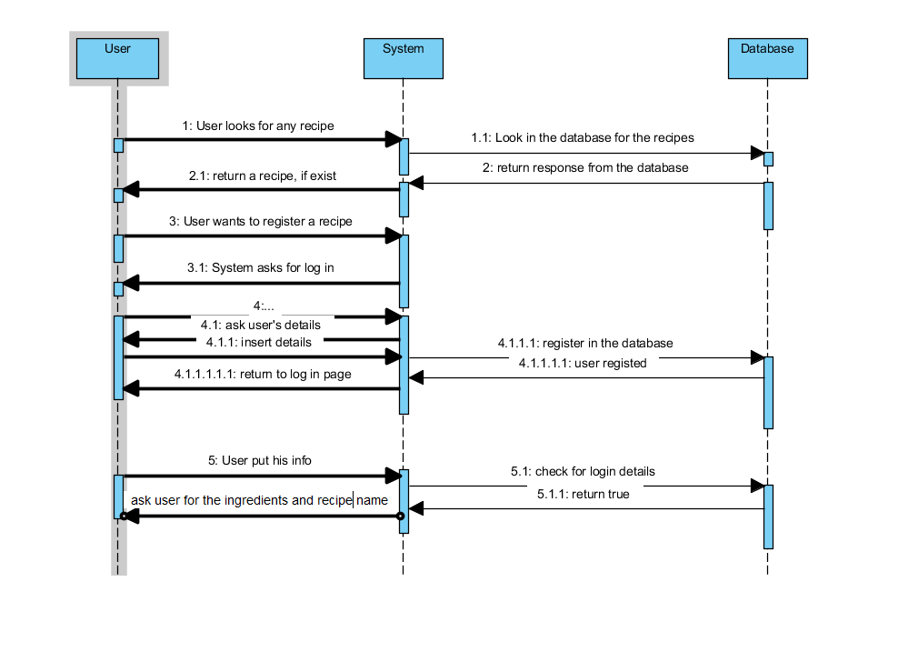

**3.2 DATABASE ANALYSIS**

Initial core idea:

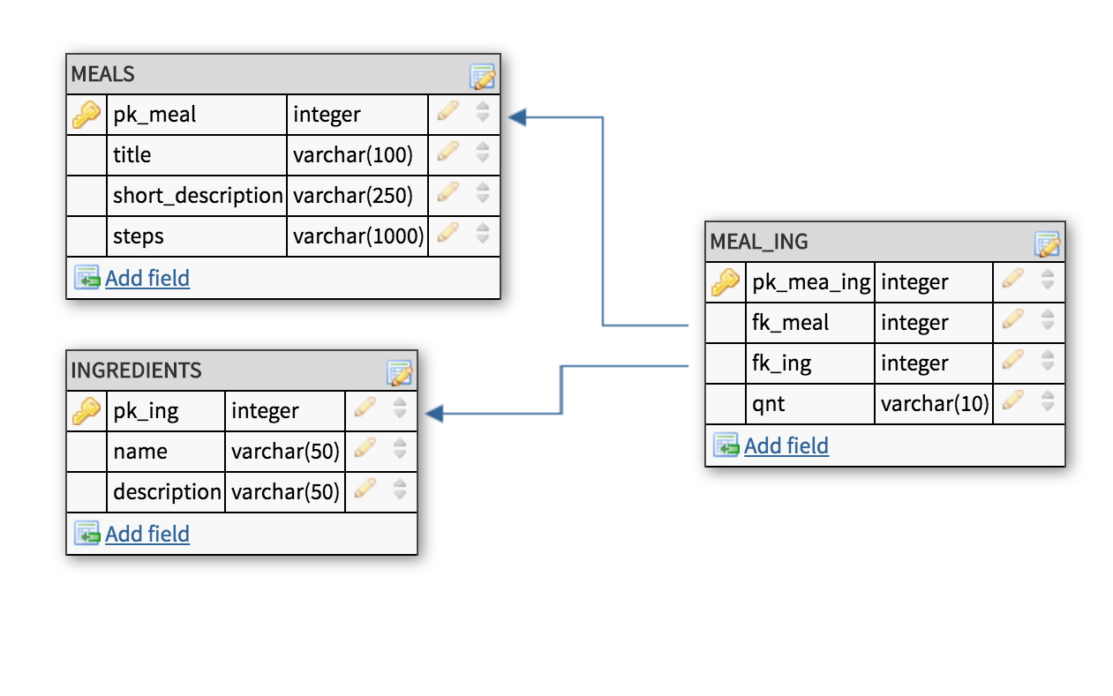

Initial idea containing the core functions of the system.

Main table **MEALS** with title, a short description and the steps on how to prepare the meal that will be entered by the user.

Entry examples:

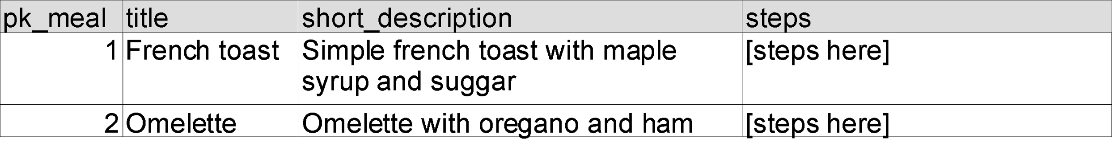

Table **INGREDIENTS** responsible to hold the full list of possible ingredients that can be used to build a meal. Note description field is not mandatory.

Entry examples:

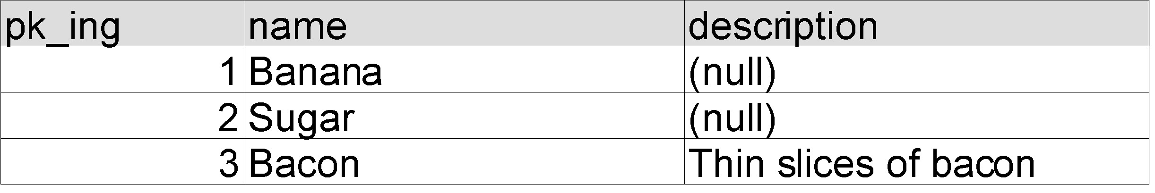

Table **MEAL_ING** is the main table responsible to link the meal to its ingredients. It has one two foreign keys, one linking to the **MEALS** table and other to the **INGREDIENTS.**

The application will be very graphical. Apart from showing to the user description and steps on how to prepare the meal, a new table (**MEAL_PICTURES**) was added only for that.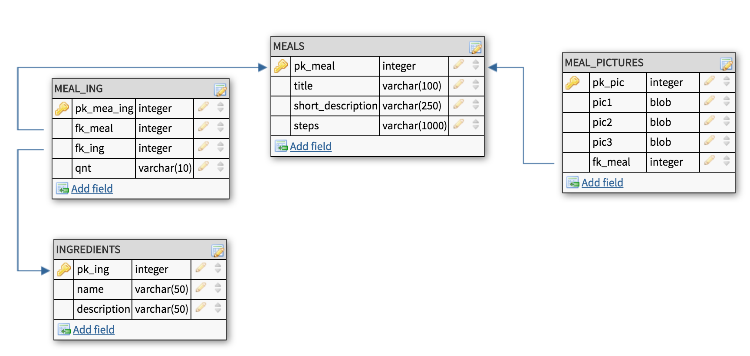

Three fields for the pictures, one for the main presentation and other two optional.

No pictures **for the steps** at this stage, as we think users would find too much time consuming adding steps manually and adding pictures.

Until now we worked with the main tables of our system.

We start now to add tables for user login and reviews. We believe whoever accesses our application, and makes a constant use of it, would like to see a review system for the recipes shared.

Reviews are important as users that look for reviews want external option from others to decide it whether a product (or something that is being advertised) can be trusted or not. People tend to turn sceptical if the page is promising something wonderful but at the end it was something completely the opposite. Let's imagine a user submitting a recipe saying it is healthy and low calories but the sum of the calories of all ingredients, turn the meal into a huge calorie-bomb. Or going even further, if an user that does not have much knowledge in cooking decides to share something but putting wrong instructions, a review system would take care of that, serving as a warning to others that something is not right with that recipe.

After adding these two last tables, this is how the design of the database looks like:

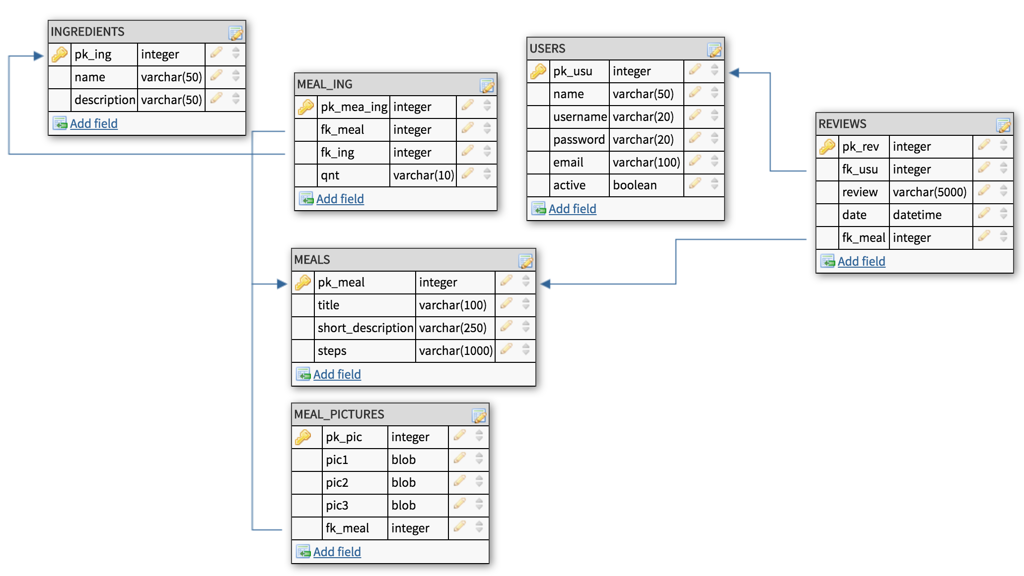

Finally, the data dictionary of the database:

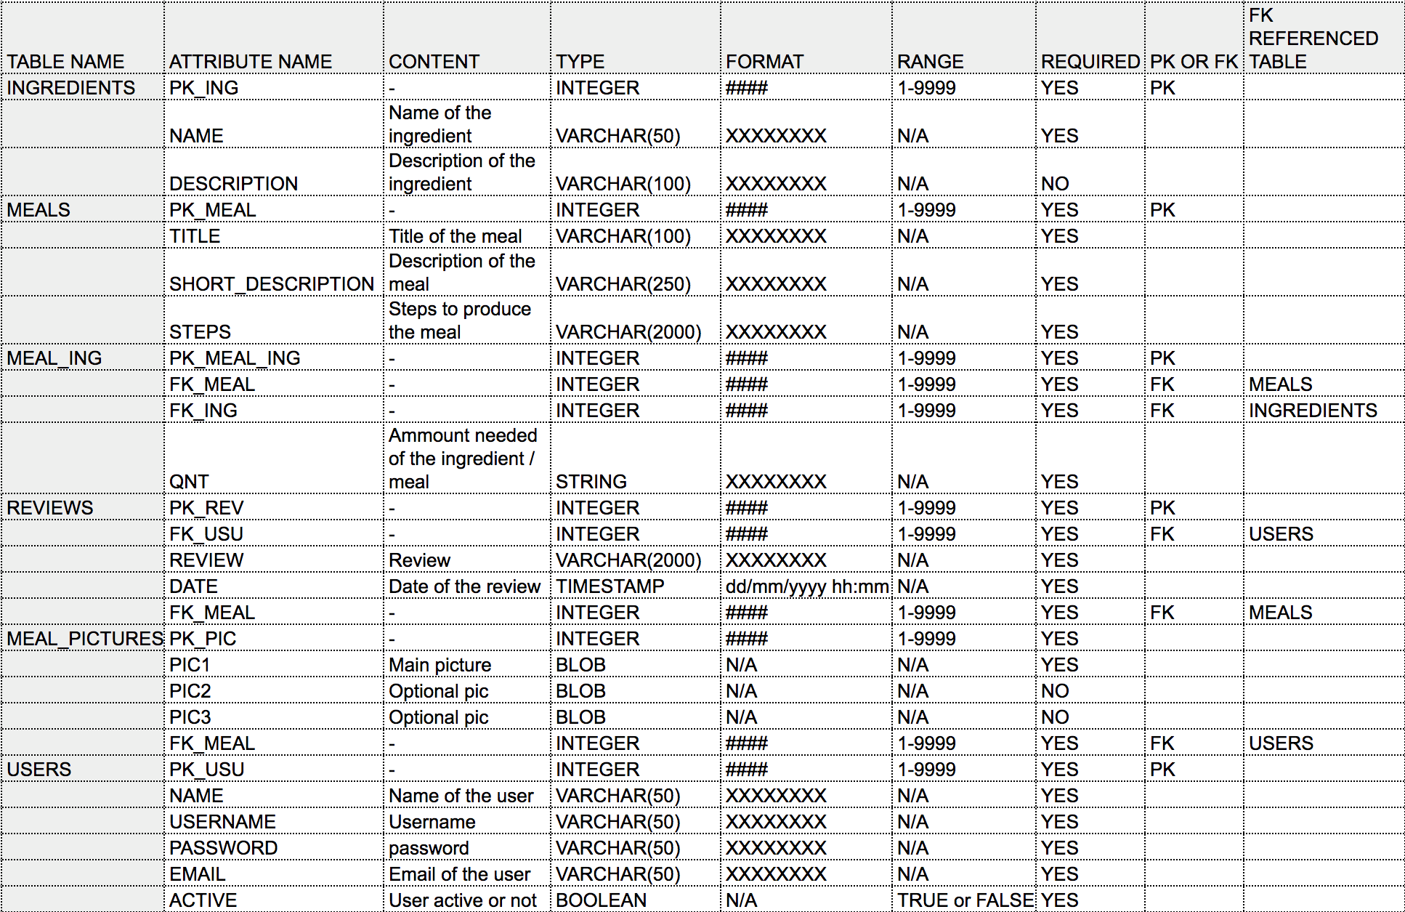

**3.3 DEVELOPING LANGUAGES**

The initial idea for the development of the application was to develop a native application focusing on android mobile and tablets. Application would be hosted on App Store (Google) or possibly hosted on a website.   
  
A list of pros and cons and risks were raised for this proposal:

Pros:

* Native applications work faster on mobile devices as they work with the device's built-in features.
* Apps hosted on App Stores have to get the approval of the store, assuring the user the application is safe and won't cause harm to their device
* Apps hosted on App Stores are easier to find as most stores organize apps by categories.

Cons:

* Maintenance costs are higher, especially if app supports various platforms.
* In our case, members of the group are not familiar with technologies that could be involved in developing such application nor the SDKs needed.

After the research, and analysis of the pros and cons, we concluded it would be too risky to spend time in a development plan we are not familiar with. An alternative framework such as JQuery Mobile was decided to be the best option for us and would attend our necessities.

“jQuery Mobile is a HTML5-based user interface system designed to make responsive websites and web applications that are accessible on all smartphones, tablets and desktop devices.”

-https://jquerymobile.com/-

jQuery makes the job easier as it gives templates and open sources to developers to create webpages ad apps quickly and efficiently.

Another advantage is that once that you are developing in JQuery mobile, it makes your application be available for all kind of devices, after configured. You don’t need to make two different application.

JQuery is free and there are loads of books and tutorials in the web to gives us a hand when necessary. The language facilitate our work without make us lose any quality.

MySQL is a free platform, very simple and is not complicated to be used and maintained. MySQL was created to be an open source and able to compete with huge companies as Oracle and SQL. This platform is easy to use, scalable, fast and it fit for us, because it totally free, as we don’t any expectations to get paid for this now.

MySQL is one of the most used databases is the world, because it secures all the data stored. It makes the system secure and reliable. MySQL guarantee the restore in case the system fails, using a backup.

MySQL doesn’t require too much experience with databases and it is simple to learn. With few SQL statements, we can build a good database and interactive. But that doents mean, that our database is not efficient, because it is free or because MySQL is very simple open source database.

MySQL is scalable, the default size is 4GB, but some fonts say that the maximum size is 8GB.*

https://www.novell.com/documentation/nw65/web_mysql_nw/data/aj5bj52.html

MySQL prevent memory leaks, that’s mean that all data is secure in the database. You can access the contents of the database only if you can pass through the authentication.

MySQL provides SSH and SSL pro make sure that the user can have a safe connection and can access the databases with no risk of been hacked by any strangers.

All those advantages counted for our decision for use this database.

**4.1 SYSTEM DESIGN**

We chose the name Zingy for our application. To keep the name relatable to our application idea, we decided upon adjectives to describe food. Initially we liked Crunchy, but then when we saw Zingy we agreed that Zingy was much catchier! Especially for our target audience. Our wireframes below illustrate our design strategy.

**4.2 WIREFRAMES**

During the first stages of the development, wireframes were created to illustrate our ideas on how the application would look like. To present these wireframes in a more structured manner for clarity of the reader, I have placed each screen on separate pages below.

**Initial Login Screen**The wireframe below shows the design foundation for the login screen. This page will be the initial page presented to the user once they have clicked into the application. There are four options available. There is an option to allow existing users to login into the application. After successful login user is redirected to the main page. There are alternative options also, such as, an option to log in as a Guest, to create a new user account, and to retrieve a lost password.

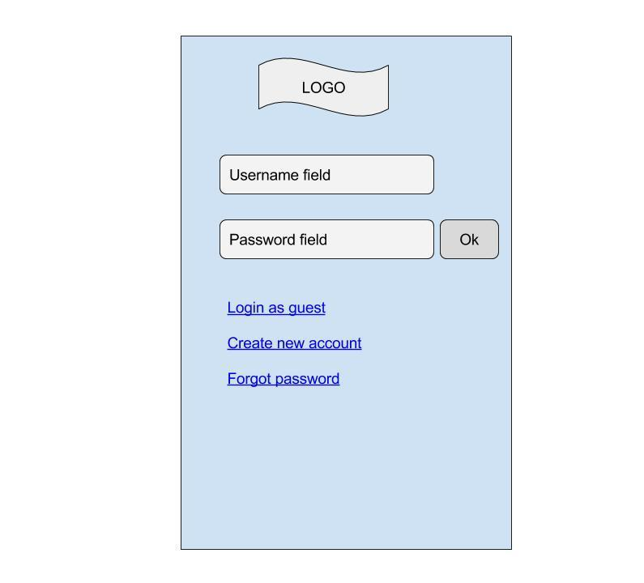

**Create a New Account Screen**

The wireframe below shows the design foundation for creating a new user account page. The new user screen has a form. This form asks for basic information to be collected from the user, such as, username, password and security question. The security question will be presented if a user forgets their current password. This is how they will recover their lost password.

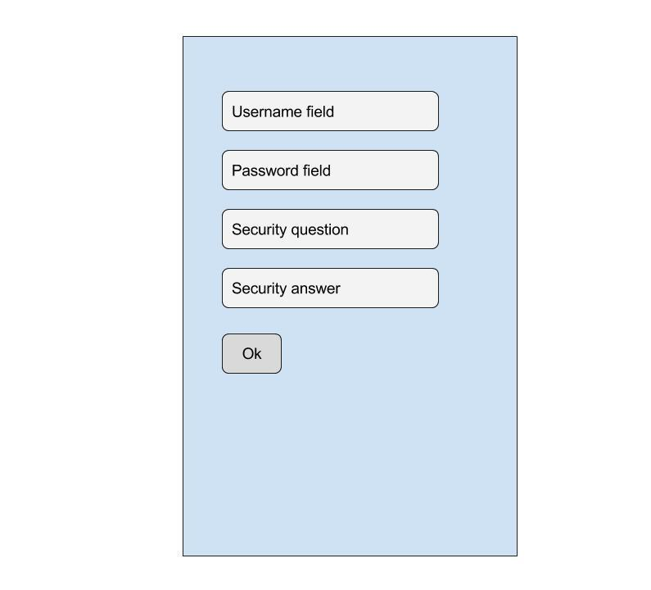

**Main Screen**

The wireframe below shows the design foundation for the main screen. This page will be presented once an existing user has logged in, or when a new user logs in as a Guest user. The main screen will contain search fields for the ingredients input. After entering in an ingredient, the user can tap on the *plus sign* to add another ingredient. Once finished, the user can then tap on *Search* when done. Tapping the *Search* button, the application will then access the database and gather all matching results, based solely on information provided.

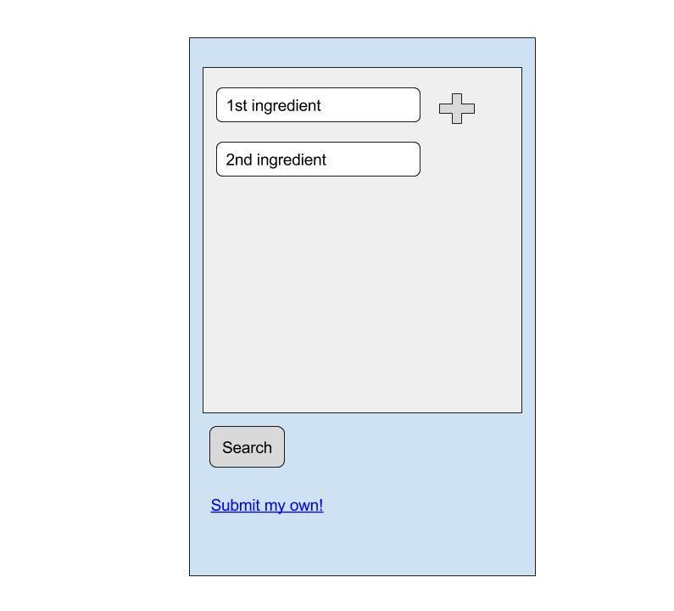

**Recipe Results Screen**

The wireframe below shows the design foundation for the recipe results screen. This page will be presented after a user has logged in, and entered the ingredients available to them. This results screen will present to the user all recipes that matched the data provided. The recipe list will contain a main picture of the meal, title and a brief description.

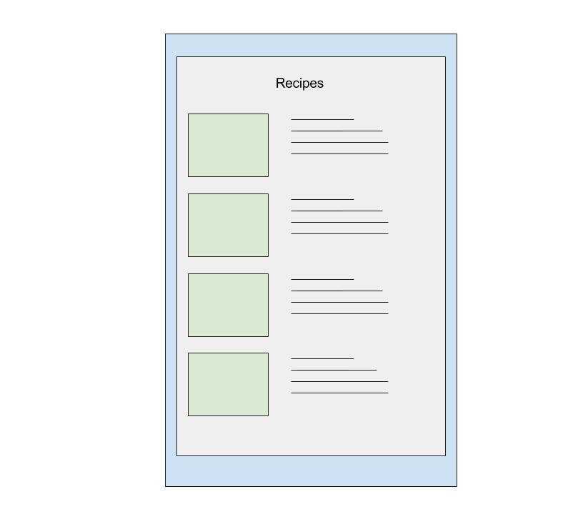

**Recipe Results Screen (Detailed)**The wireframe below shows the design foundation for the recipe results screen in more detail. This page will be presented after a user has logged in, entered the ingredients available to them, and has now chosen a meal that they would like to cook. The screen will show the name of the meal, a large main picture, the same previous short description, and a step-by-step guideline outlining how the user can prepare the meal. Other functionalities can also be implemented, such as, a rating system and a review system.

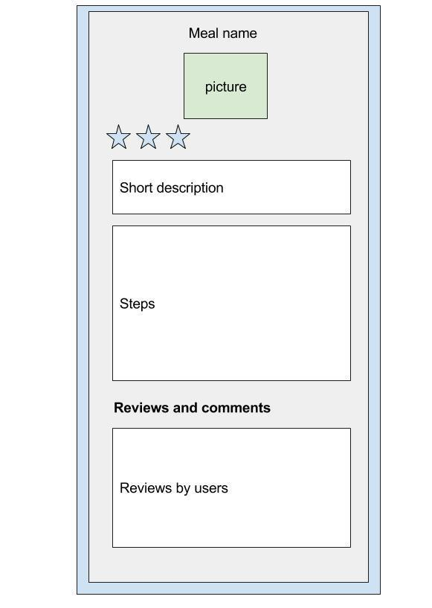

**Forgot Password Screen**

The wireframe below shows the design foundation for the forgot password page. The user will be asked to enter their current username, and the answer to their security question. This is how they will recover their lost password.

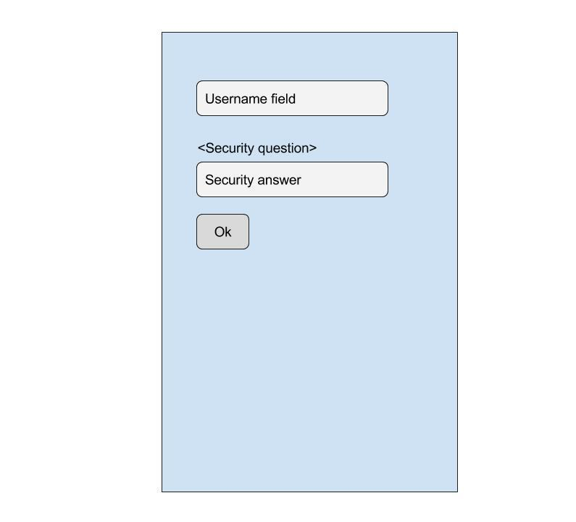

**4.3 LOGO DESIGN**

Since we kept the application name relatable to our idea, we wanted to do the very same for our logo. We kept in mind that we are creating this application for mobile users. For any given mobile application, it’s the logo icon people see on their screen. Our aim was a good distinctive, yet simple, logo. We chose an apple because it is appropriate to our application and it is practical, yet simple. Fruit conveys an intended message. Out of all fruit, why decide upon an apple? Well, an apple a day keeps the doctor away!

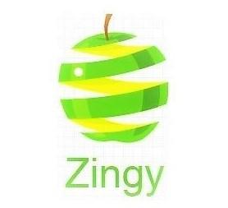

**4.4 DEVELOPMENT AND IMPLEMENTATION**

With the Github account created, team could work remotely, sharing code and having a control of different versions. Member Douglas responsible for the Front-end while Matheus was responsible for the Back-end of the application.

We have used Google Drive as well to store all docs, images (for the web service), and web app files. Google Drive in one of the most safes web platforms on the actual days, and we believe we could suit us perfectly. Google Drive is easy and handy to be used, once you can sync it with all your devices, then if any of the colleague upload any doc, you can access it anytime, anywhere.

Layout and website responsive test made with devices owned by the members of the group and also with online tools, such as MobileTest, which simulates a range of mobile devices and tables in order to ensure layout works according to developers expectations.

Since the initial ideas of the wireframes, a few things changed.

On the **login screen** we now have the logo created. Fields mentioned in the wireframes remain the same, just changing slightly the position of the button.

**New user** now asks for **email address** instead if security question. We believe this is be the best way to register new users, as it avoid one single user to create several accounts and would ease the process of password recover.

**Main screen** and **results screen** detailing the search remain with same fields. Final screen just with the mail had the star-rating system removed as it would be an extra feature that could be added later in the future. Concerns that it would take too much time to implement were raised.

Final version of the prototype:

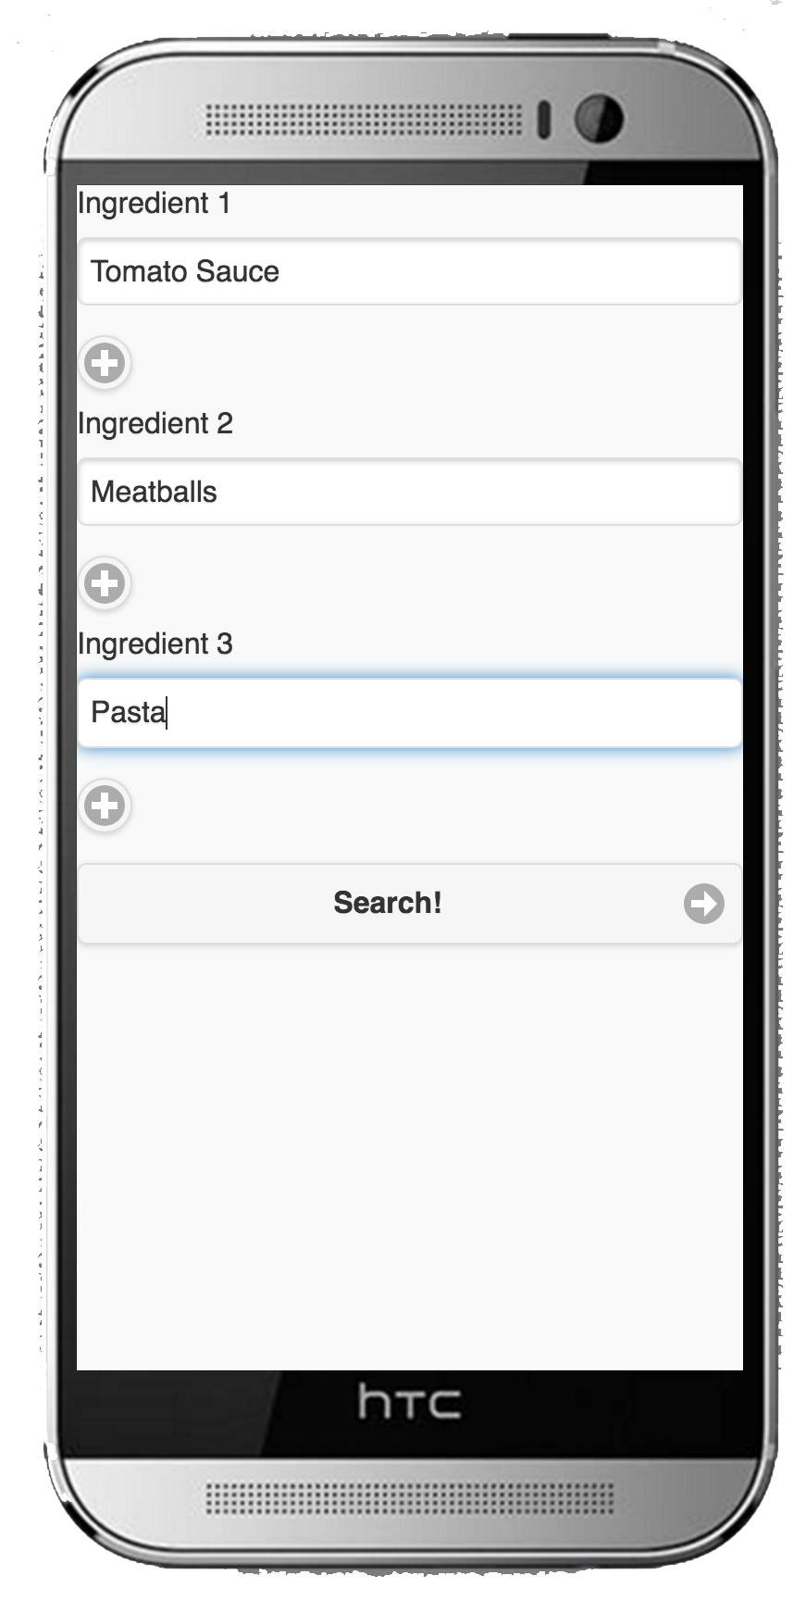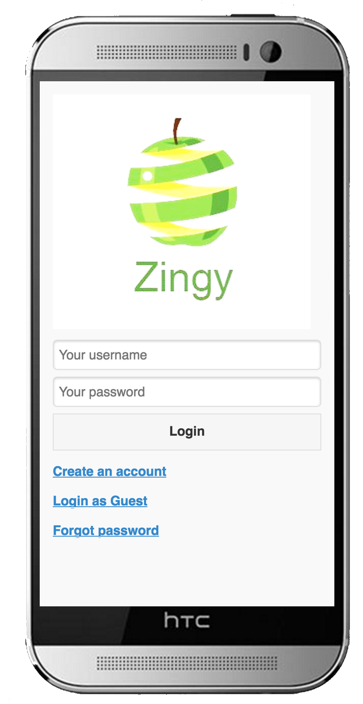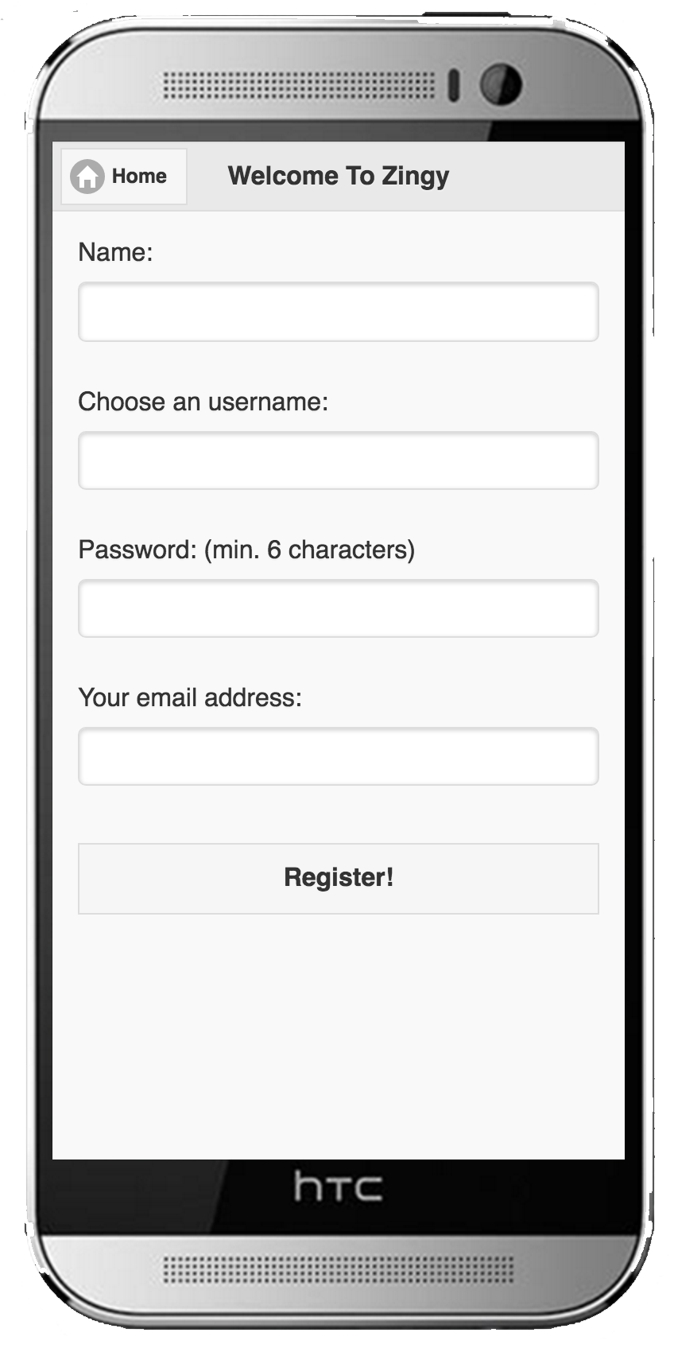

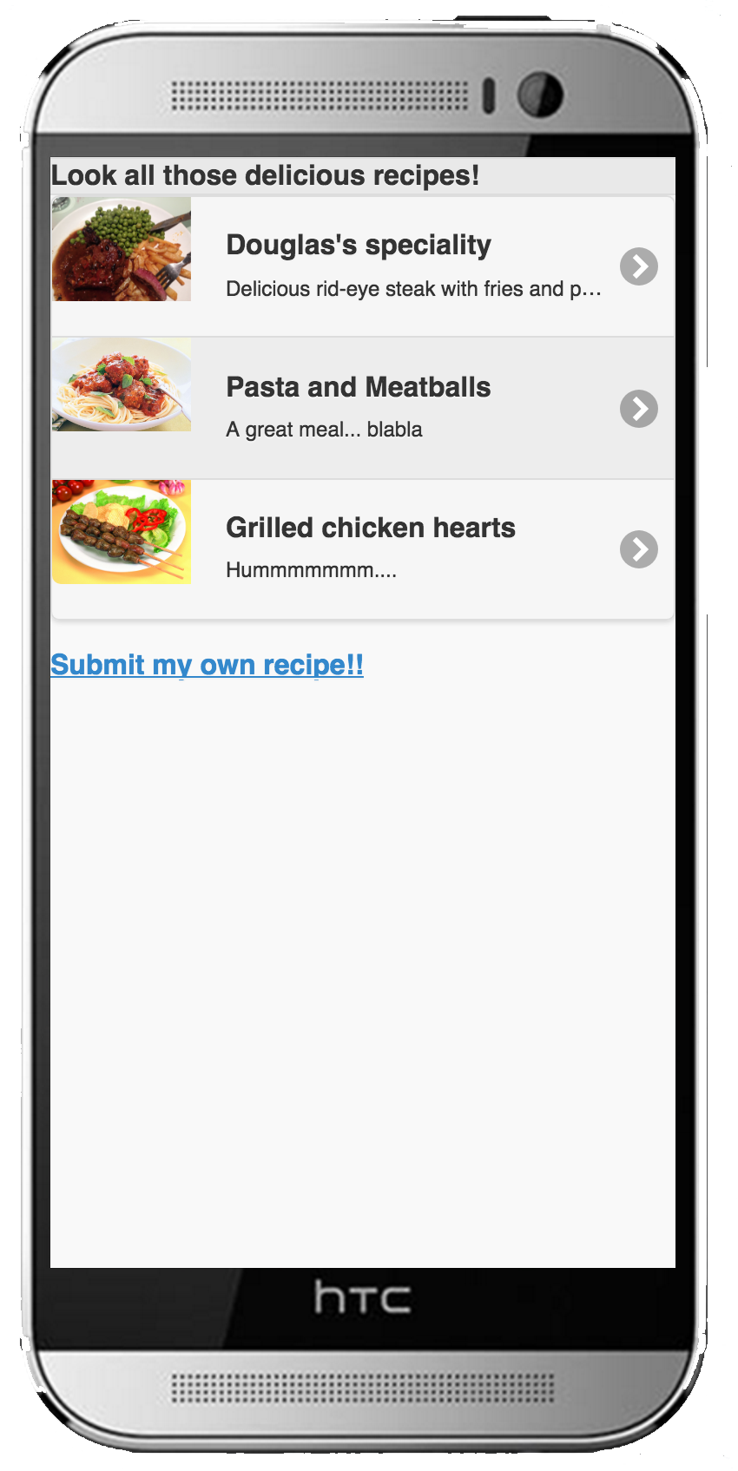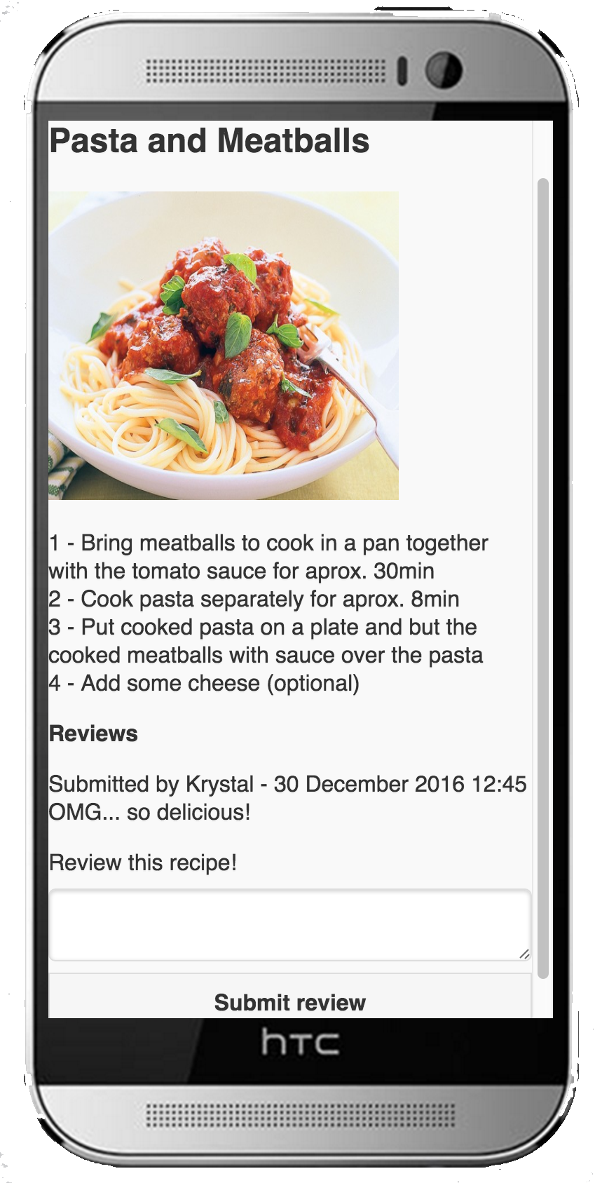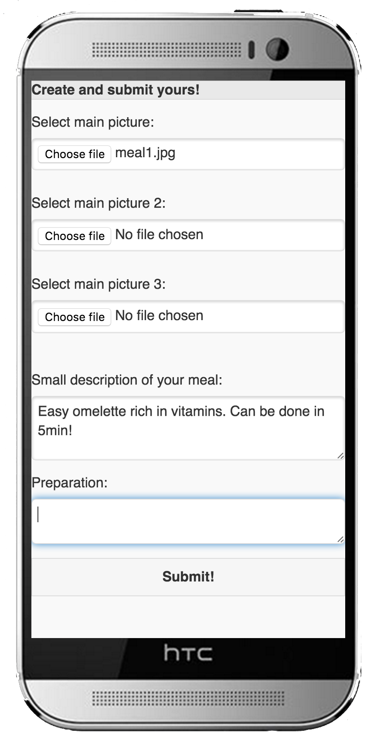

**4.5 IMPLEMENTATION OF DATABASE**

As specified previously, we worked with MySQL database, using mainly XAMPP application as a manager for the PHP and MySQL services. MySQL database accessed via browser using PHPMyAdmin.

**5.1 TESTING THE DATABASE**

To test the database, some data was added to simulate queries from the user.

Table **MEALS** was filled with two entries.

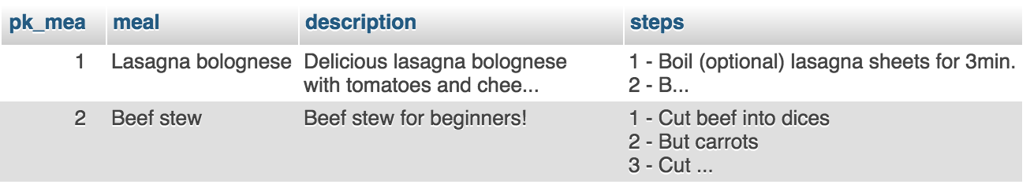

These will be the testing meals we are going to work with.

Some ingredients were also added to the **INGREDIENTS** table. Many items here are random data, but also the ingredients for our two first meals are being added to be linked with the **MEAL_ING** table.

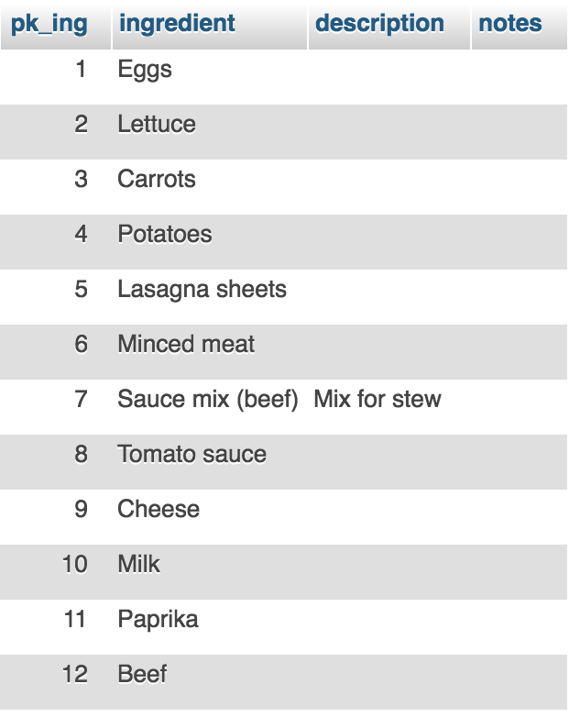

After having a good amount of ingredients in our table, we carefully link the meals with the ingredients. Note this is for testing purposes, as when the user uses the application, the link will be done by code.

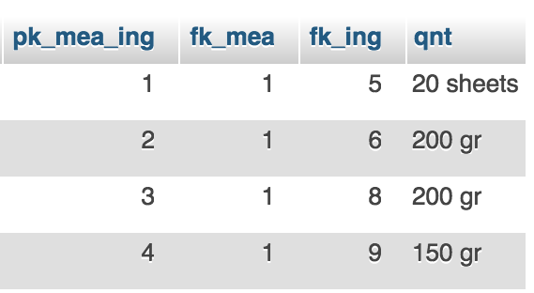

Note we are linking here the item Lasagna bolognese (with primary key of value **1**) on table **MEALS** and the ingredients from **INGREDIENTS** to this table. This table also has a field with states the quantity that will be needed.

To test if our database is working correctly, we execute a query to return the name of the meal, the description and the steps needed based on four ingredients provided.

For this test we are going to provide the ingredients below:

* Cheese
* Minced meat
* Tomato Sauce
* Lasagna sheets

Beginning of the test:

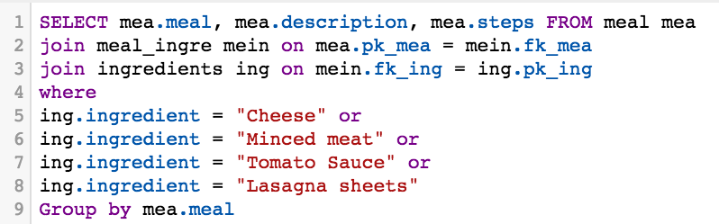

Result of our query:

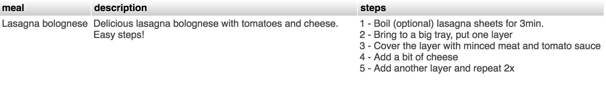

Test successfully returns the meal related to the items we provided.

**5.2 HOSTING**

In the first stage of our project we were hosting our web service in the 000webhost.com. For some unknown reasons the hosting provider stopped giving support to JQuery Mobile applications, forcing us to move our application to another provider.

We found another provider on the link www.x10hosting.com. This provider gave us the same result that we had in the first hosting service.

This web service provides some features that suits us like, the maintenance of the database by phpAdmin. We used to use this service by our own, we created personal works with databases.

They have their own cloud service, forum and support team. What makes this company better to us, because we can have a help if needed. Another point is, that the company has 10 years of business, what makes it trustful

**6.1 REFERENCES**

* Jan Sheehan. (2015) *Live Strong’s website*. Available at: · <http://www.livestrong.com/article/497063-research-on-healthy-eating-habits-student-learning/> (Accessed: 21 November 2016).
* PMC Public Health (2014) *PMC Public Health’s website*. Available at: <https://www.ncbi.nlm.nih.gov/pmc/articles/PMC3905922/> (Accessed: 21 November 2016).
* Sameer Deshpande , Michael D. Basil & Debra Z. Basil. (2009) *Health Marketing Quarterly’s website*. Available at: <http://www.tandfonline.com/doi/pdf/10.1080/07359680802619834> (Accessed: 29 November 2016).
* August McLaughlin. *SFGate’s website*. Available at: <http://healthyeating.sfgate.com/short-term-effects-bad-eating-habits-2579.html> (Accessed: 5 December 2016).
* [Priya Viswanathan](https://www.lifewire.com/priya-viswanathan-2373021) (2017), *Lifewire website.* Available at:  
  <https://www.lifewire.com/pros-and-cons-of-native-apps-and-mobile-web-apps-2373173> (Accessed: 21 March 2017).
* [Matt Rhodes](http://www.freshminds.net/author/matt/) (2009), *Freshminds website.* Available at:  
  <http://www.freshminds.net/2009/03/why-do-people-write-reviews/>(Accessed: 15 Aprill 2017).

● Sonali. (2017) Advantages of PHP Programming. Availavle at:<https://www.eukhost.com/blog/webhosting/advantages-of-php-programming/> (Accessed: 15 January 2017).

● Kelly Waters. (2017) What is Agile?(10 Key Principles of Agile). Available at: [www.allaboutagile.com/what-is-agile-10-key-principles/](http://www.allaboutagile.com/what-is-agile-10-key-principles/) (Accessed: 01 April 2017).

● Donald Bell.(2004) The Sequence Diagram). Available at:<https://www.ibm.com/developerworks/rational/library/3101.html> (Accessed: 15 April 2017).

● Creative Blog Style. (2013) Five reasons To Use JQuery Mobile. Available at:<http://www.creativebloq.com/jquery/five-reasons-use-jquery-mobile-4135691> (Accessed at: 25 March 2017).

**7.1 GROUP WORK ANALYSIS**

|  |  |
| --- | --- |
| **WORK** | **BY WHOM** |
| Abstract | Krystal |
| Acknowledgments | Matheus |
| 1.1 Introduction | Krystal, Douglas |
| 2.1 Overview of Background | Krystal |
| 2.2 Research Focus | Krystal |
| 2.3 Research Problem | Krystal |
| 2.4 Research Question | Krystal |
| 2.5 Research Aim | Krystal |
| 2.6 Research Methodology | Krystal |
| 2.7 Data Collection | Krystal |
| 2.8 Data Analysis | Krystal |
| 3.1 System Analysis | Matheus |
| 3.2 Database Analysis | Douglas |
| 3.3 Developing Languages | Douglas, Matheus |
| **SYSTEM DESIGN & IMPLEMENTATION** |  |
| 4.1 System Design | Douglas, Krystal |
| 4.2 Wireframes | Douglas, Krystal |
| 4.3 Logo Design | Krystal |
| 4.4 Development & Implementation | Douglas |
| 4.5 Implementation of Database | Douglas |
| **TESTING & EVALUATION** |  |
| 5.1 Testing the Database | Douglas |
| 5.2 Hosting | Matheus |