**IBM - CAPSTONE PROJECT**

**1. Introduction**

Amsterdam is the largest city in the Netherlands with multifarious venues. Therefore, to start a food and beverage service is not an easy task.

A job owner who is living another country wants to open a food and beverage service (like bar, cafe, restaurant) in Amsterdam. Since Amsterdam has lots of place to start a business, the job owner wants to earn money as much as s/he can. There are lots of criteria for this purpose like, population density of a location, number of cafes, restaurants, bars etc.

In this project, I will show you the analysis of the problem, and try to find the best place to open a food and beverage service in the Amsterdam with an unsupervised learning technique K-means.

**2. Data Description**

* Related Amsterdam data was taken from <https://en.wikipedia.org/wiki/Boroughs_of_Amsterdam>
* Coordinates of Amsterdam Boroughs were obtained from Geocoder
* Venues of Amsterdam were obtained from Foursquare

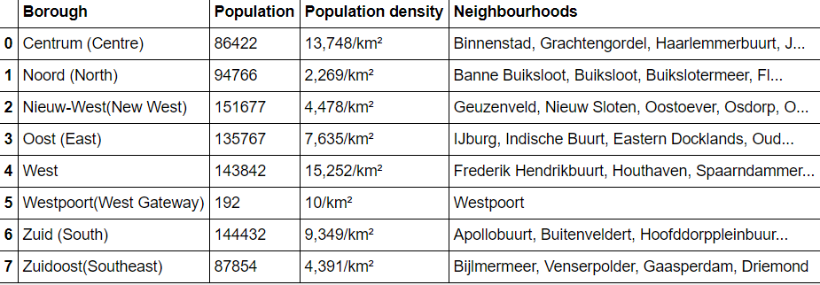

**3. Methodology and Analysis**

After the data preparation the Boroughs of Amsterdam looks like this.

Note: Maximum 100 venues are collected for each district because of the limitation for collecting the venue data.

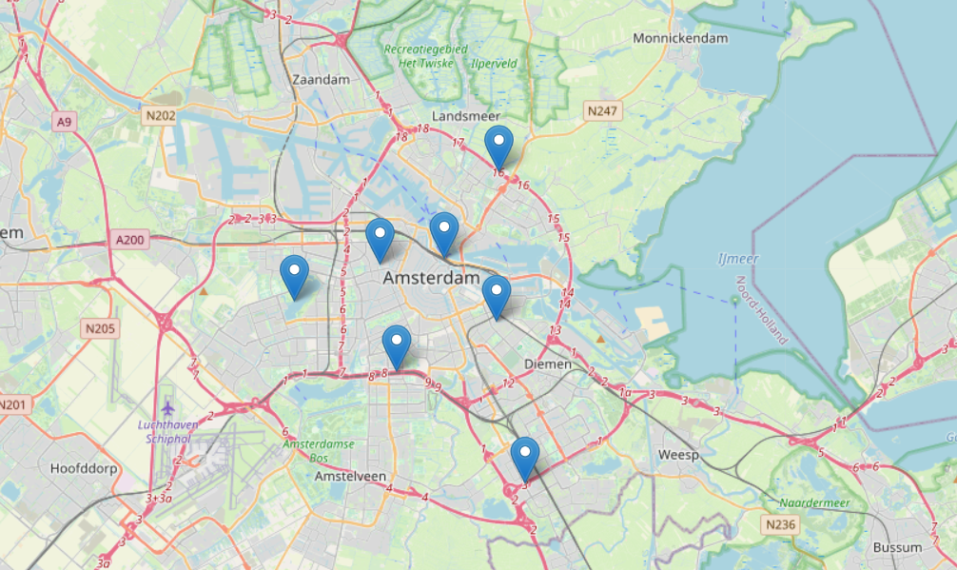

For the machine learning part, unsupervised technique K-means were used.

To obtain the best K, Elbow method was used.

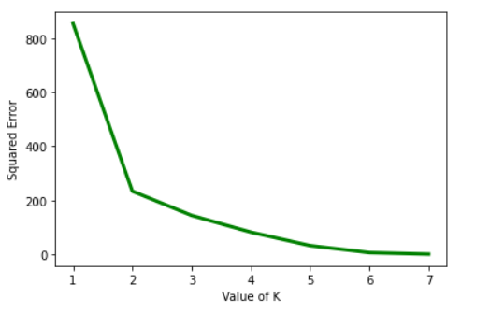

Based on the 2 clusters, the result as follows:

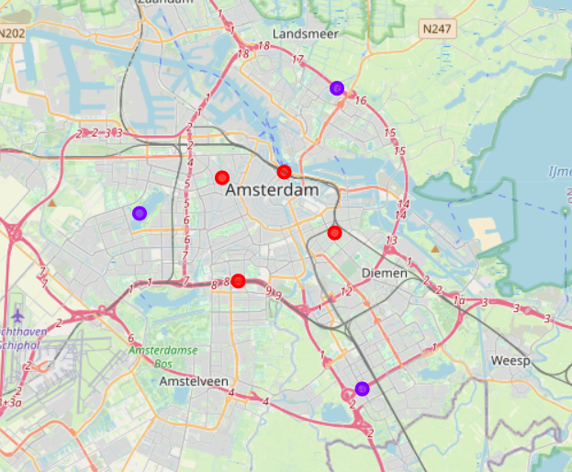

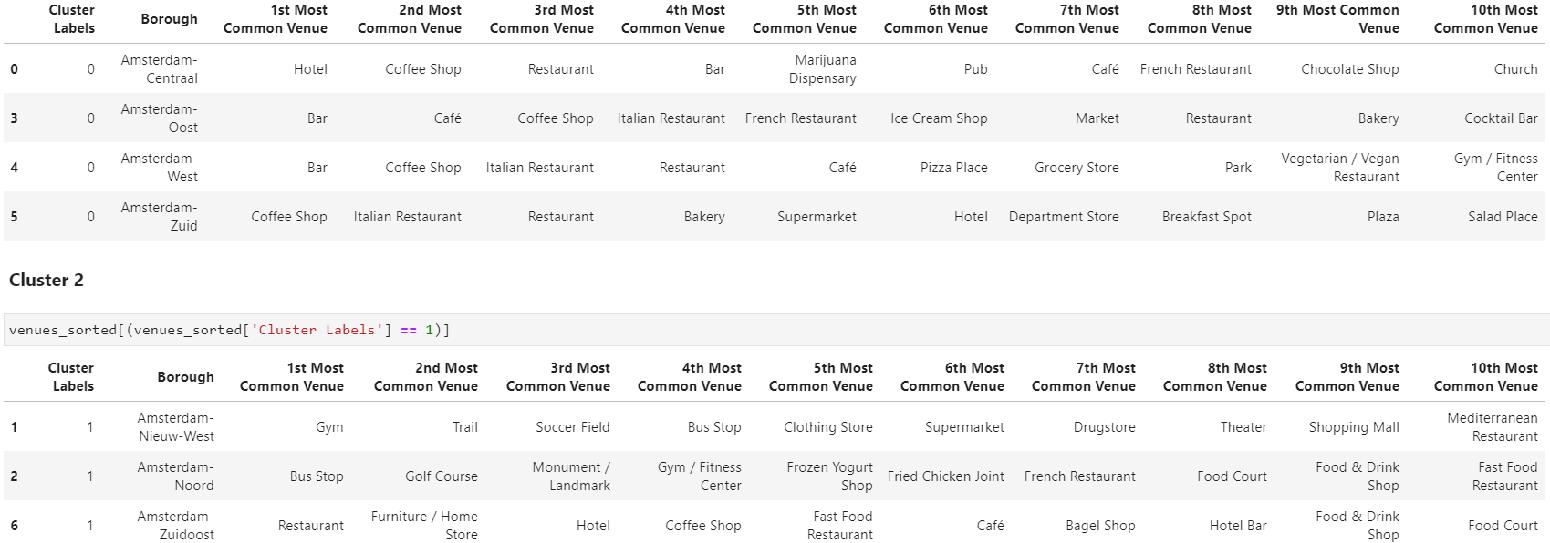

**4. Conclusion**

To conclude, two clusters were defined. Cluster 1 (Cluster Label = 0), which includes Centraal, Oost, West, and Zuid, has mostly Bars, Cafes and Restaurants. And Cluster 2 (Cluster Label = 1), which includes Nieuw-West, Noord, Zuidoost, mostly has Stores, Bus Stops, Gyms etc.

Since density rates in descending order as follows: West, Centraal, Zuid, Oost, we can say that:

* If s/he want to run a bar; s/he should prefer West, Centraal, Oost respectively,
* If s/he want to run a café; s/he should prefer Oost, West,
* If s/he want to run a restaurant; s/he should prefer West, Zuid, Oost, respectively.